Analysis of Health Levels Between Islands in Indonesia and Their Relationship with Socio-Economic and Environmental Factors

Abstract

This study aims to determine and assess the influence of gross domestic regional product (GDRP) per capita, education, poverty, and environmental quality on public health in Indonesia and to compare the levels of health complaints among four regions using panel data from 34 provinces in Indonesia during 2018-2023. This study employed a quantitative method using a Path Analysis model with dummy variables, categorizing the system into three regions (groups). In region 1, education and the environment negatively impacted health complaints, while GDRP per capita and poverty did not significantly impact these complaints. In region 2, the four independent variables included in the study showed that GDRB per capita, education, the environment, and poverty significantly affected health complaints. All four variables, except poverty, negatively affected health complaints. Selanjutnya diketahui bahwa pada region 2 ini pertumbuhan ekonomi tidak mempengaruhi keluhan kesehatan. Then in region 3, three variables have an effect on health complaints, the other two determining variables, namely GDRP per capita and poverty, do not have a significant influence on health complaints in this region. Finally, fluctuations in health complaints were largely determined by Covid-19, which peaked at the end of 2020. However, the determinants that are consistent from year to year and between islands are the environment and education.

Key Words:
GDRP per capita, Poverty, Education, Environment, Health complaints, Regions

JEL Classification: A10, A20, I15

- Introduction
Indonesia is one of the largest and most extensive countries with a population of 288.3 million in 2025, in addition to having abundant natural resources spread from Sabang to Merauke, consisting of four large islands, has less than 17,000 islands that are spread unevenly within the territory of the Republic of Indonesia. Administratively, Indonesia is divided into 38 provinces. Each province has several districts, and within the district, there are sub-districts to villages at the smallest level. Based on the division of time, Indonesia has a time zone for the Western region, the Central Region and the Eastern Region. However, based on natural resources and population, Indonesian resources in the study are grouped into 4 regions as shown in Figure 1. Furthermore, these three regions can have differences in terms of health levels.
Region 2
Region 4
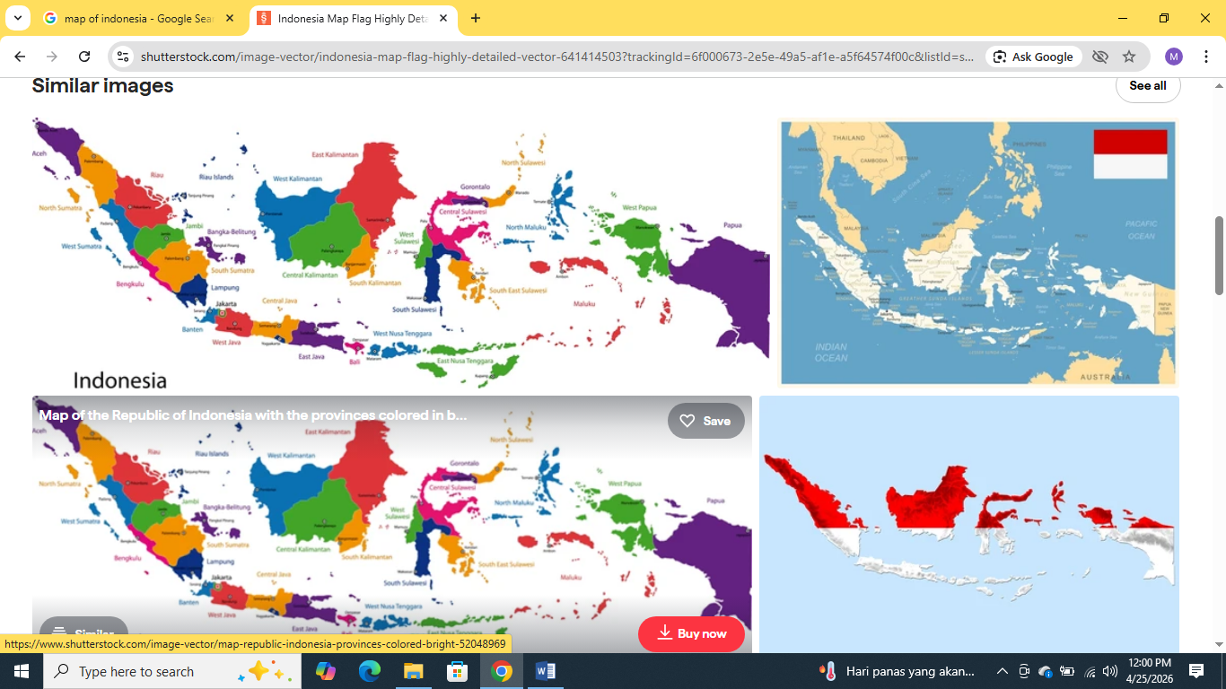
Region 3

Region 1

Region 2 2222222222 2

Figure 1. Map of Indonesia Divided into 3 Regions
Source: https://www.shutterstock.com/image-vector/indonesia-flag-map-670194319

Health is one of the main factors in development, especially in developing countries (Arief, 1999; Jhingan, 2021). Indonesia is one of the countries in the world that pays great attention to health development in which Health development is an integral part of human resource development (HRD) to achieve development goals as it is an effort to fulfill one of the basic rights of the people, namely the right to obtain health services in accordance with the mandate of the 1945 Constitution Article 28 paragraph 1 and Law Number 23 of 1992 concerning Health Thus, health development is an investment to improve the quality of human resources in supporting the acceleration of national development. Development in the health sector is also an important concern in international commitments, which are outlined in the Millennium Development Goals (MDGs) (Nyandekwe at al., 2018).

Economic development with one of its indicators is growth can be the main driver and motivator in health (Nafziger, 2006 & Cypher, 2020), because with growth, government and private spending, especially in terms of investment. It can increase production capacity which will lead to growth and employment opportunities, so that poverty can be suppressed or even eliminated through human development because this poverty can have a negative impact on various sectors, especially in the field of health. On the other hand, health is also believed to be one way to break the chain of poverty where Indonesia still has a percentage of poor people and even extreme poverty that still needs to be improved, especially through health.

WHO (2026) states that good health depends on clean air, a stable climate, a preserved natural environment, as well as access to adequate water, sanitation, and hygiene. It also requires protection from harmful radiation, unsafe chemical management, and unhealthy working conditions. A healthy environment could prevent nearly a quarter of the global disease burden. Furthermore, it states that the ongoing environmental crisis is profoundly affecting health as climate change intensifies, biodiversity declines, and pollution becomes ubiquitous. The health impacts of poor environmental conditions occur not only directly but also indirectly, through effects on food production, migration, economic instability, and social inequalities. By considering various national and global policies, to accelerate health development, clarity is needed regarding the current state of health development and its trends, as well as a clearer and more specific reference for long-term health development.

Health development is an effort to fulfill one of the basic rights of the people, namely the right to obtain health services in accordance with the mandate of the 1945 Constitution, Article 28 paragraph 1 and Law Number 23 of 1992 concerning Health. In the Human Development Index (HDI), the health status indicator is one of the main components besides education and per capita income. Thus, health development is an investment to improve the quality of human resources in supporting the acceleration of national development.

In accordance with Law No. 33 of 2004, in the context of implementing regional autonomy/decentralization, there is a division of roles and authorities between the central and regional governments. In health development, the central and regional governments. In health development, the central and regional governments provide equitable, affordable, and quality health services. The orientation of Health Development, which initially emphasized curative and rehabilitative efforts, has gradually changed to integrated health efforts towards healthy areas with active community participation. This new approach emphasizes the importance of promotive and preventive efforts without neglecting curative and rehabilitative efforts. A new understanding of the concept or definition of health and increased awareness of the factors that influence the level of public health has given rise to the belief that curative health services alone cannot possibly create a healthy Indonesia.

The health index refers to the overall quality of a country's health system worldwide. The assessment components include the competence of medical personnel such as doctors, nurses, and others, the quality of infrastructure such as hospitals and the availability of equipment, medical costs, the availability of medicines, and government readiness and support. When measured by the Health Care Index (HCI), Indonesia ranks 58th with a score of 61.2 out of 100 countries worldwide (Numbeo, 2026), far behind Thailand with a score of 77.5, which ranks 8th in the world. Health services in Indonesia, as measured by the Health Care Index (HCI), rank 58th with a score of 61.2 out of 100 countries worldwide far behind Thailand with a score of 77.5, which ranks 8th in the world. This condition can be caused by uneven and inadequate infrastructure, unequal distribution of services, and funding. The 2020 Population Census by BPS, the Maternal Mortality Rate (MMR) in Indonesia decreased drastically to 189 deaths per 100,000 live births, compared to 346 in the 2010 Population Census. Furthermore, although decreasing, this figure is still relatively high compared to other countries in Southeast Asia, with the main causes being bleeding and hypertension. So even though Indonesia is rich in natural resources, with health facilities that are always increasing and developing, but the tendency of diseases experienced by the population still shows a positive trend in various provinces in Indonesia, such as West Sulawesi and the Belitung Islands, with the worst health levels occurring in West Nusa Tenggara and East Nusa Tenggara, which reached 43% (Figure 2).

The Ministry of Finance of the Republic of Indonesia has set the State Budget (APBN) for the health sector at Rp97.42 trillion in 2024. This figure represents a slight increase from the previous year. Improving the quality of hospital services is a budget priority. It's no surprise that many Indonesians travel to other countries for medical treatment. Singapore is a popular destination for Indonesians. In fact, according to Ceoworld Magazine's World Health Index (2025), Singapore ranks second in quality in the world after Italy. Singapore scored 67.22 for its health sector. Another country frequently cited as a reference for Indonesians' healthcare is Malaysia. In Southeast Asia, Malaysia ranks second with a health index of 50.59. Thailand follows Malaysia with a health index of 49.15. Meanwhile, Indonesia ranks fourth with a health index of 46.74. Indonesia's health index is not far behind that of the Philippines. This country, which shares many similarities with Indonesia, scored 46.21.

Figure 2. Development of Health Complaints by Province
Sumber: Data diolah, 2026.

The dynamics of health complaints in Indonesia, which can be influenced by various social, economic, and environmental factors (Mutaqin, 2018). Suboptimal health conditions not only impact the quality of life of individuals but also can reduce productivity and worsen poverty levels (Ammar et al., 2024). Health is a major factor in life, because what if it is not healthy, it feels like everything is useless for oneself. Therefore, health is the main key to implementing economic development, especially the development of human resources as a basic element to achieve development goals, especially in the economic sector. The level of health can be determined by various factors including GDP per capita, education, poverty, and environmental conditions. Increased income will increase spending, including the health sector, which can increase work productivity through individual or community health. Higher education from the community is expected to gain a high awareness of various diseases, so that they can live healthily to carry out economic activities. Furthermore, poverty illustrates the inability to achieve socio-economic access, so that it can worsen public health, likewise an unhealthy environment will cause public health problems, due to both physical and mental disorders will cause diseases that will disrupt the level of public health in general.

Health Complaint
(Y)

1. Sumatra and Riau
Islands
2. Java and Bali Islands
3. Kalimantan, Sulawesi , Maluku,
Southeast Nusa, and Papua Islands

GDP/Capita
(X₁)
(Y((X1

Education
(X₂)

Poverty
(X₃)

(Y(

Environment
(X₄)
(Y(

Growth
(X₄)
(Y(

Figure 3. Framework

This research aims to analyze and examine the relationship between industrial sector growth and environmental quality in two regions through socio-economic factors in the form of: Compare the relationship between four groups in terms of health levels, per capita income, education, poverty, and environmental quality. Besides that, examine the effect of education levels, per capita GDP, poverty levels, and environmental quality on public health or health complaints.

2. Literature Review

2.1. Region
The concept of region can be divided into three types: homogeneous, functional, and planning (Nugroho et al. 2004). Functional regions can be either simple or complex systems. Simple regions include nodal, urban, and rural areas, while complex systems can encompass spatial, ecological, and political economic systems. Furthermore, planning regions can be special planning regions and political administrative planning regions. Special planning regions are planning regions specifically designated to accelerate the development and growth of a region, focusing on an integrated approach (social, economic, and environmental) to address development constraints in a specific area. Administrative regions, on the other hand, are regions designated based on the interests of government regions that are structurally interconnected. Furthermore, for regional development, there are many underlying theories, one of which is the growth pole theory.

Growth Pole Theory proposed by Francois Perroux in 1955, states that development or growth does not occur in all places, but only in certain places. Development does not occur simultaneously in all places, but is centered on certain locations (poles) that have a concentration of driving industries (Balchin and Bull, 1987). The theory of wanting a trickle down according to Albert O. Hirschman (1958) is a concept of economic development where growth is centered on developed or rich areas which are expected to have a downward development effect so as to create jobs, and increase the income of people in underdeveloped or peripheral areas. So according to Taringan (2005), the characteristics of a Growth pole are the existence of internal relationships between various activities, the existence of a multiplier effect, the existence of geographical concentrations and the driving force behind it. This theory emphasizes the importance of trickle-down or spread effects and backwash effects, and in fact, they drive inequality between regions.

Growth Pole Theory proposed by Francois Perroux in 1955, states that development or growth does not occur in all places, but only in certain places. Development does not occur simultaneously in all places, but is centered on certain locations (poles) that have a concentration of driving industries (Taringan, 2003). The theory of wanting a trickle down according to Albert O. Hirschman (1958) is a concept of economic development where growth is centered on developed or rich areas which are expected to have a downward development effect so as to create jobs, and increase the income of people in underdeveloped or peripheral areas. So according to (Adisasmita, 2005) The characteristics of a Growth pole are the existence of internal relationships between various activities, the existence of a multiplier effect, the existence of geographical concentrations and the driving force behind it.

The neoclassical economic view holds that market forces will ensure equilibrium in spatial distribution. However, the growth center theory fails because the trickle-down and spread effects do not occur, resulting from industrial activity being unrelated to the resource base in the hinterland. Furthermore, the growth response in the center is insufficient to reach the hinterland, as it only serves the interests of the urban hierarchy (Arsyad, 1999; Syafrizal, 2004). Thus, regional inequality will become a problem in development, especially in developing countries, necessitating comprehensive regional planning (Amstrong & Tylor, 1993). Based on these opinions, it can be said that regional inequality concentrates social, economic and political activities in a particular region so that the results of development cannot be evenly distributed, enjoyed by the upper economic strata while the lower strata of society find it difficult to escape the shackles of poverty.

2.2. Health and Economy

According to Law No. 23 of 1992, health is a state of mental, physical, and social well-being that allows each individual to be economically and socially productive. Notoatmojo (2011) states that a person's health cannot be measured solely by mental, physical, or social aspects, but also by productivity, which means work or income. A healthy lifestyle becomes a promotional activity in the context of implementing curative efforts. The higher the public's awareness of always living healthily, the lower the risk of health problems. Furthermore, if health conditions are low, human resources used for treatment are reduced and allocated to other development. Therefore, maintaining health is the responsibility of each individual, while the government is present to provide the community with various health facilities and treatments that are attempted to be accessible to the community as a whole.

Economic health is the study of how health can improve economic understanding and skills, which in turn can improve the economic well-being of individuals and society. However, health is full of problems and challenges because health is a complex enterprise and still requires efforts in the form of experience and practical judgment (Boissiere, M.X., 2004). Health can be developed through investment in human resources that can create quality humans. According to (Rastagi, 2002) who stated that human capital is knowledge, competence, attitude, health and nature possessed by humans. The second concept states that human capital is knowledge and skills obtained through various healthily activities such as schools, courses and training. The main concept of this model is that capital is something obtained through the accumulation of a certain process. Another opinion Romer (1999) states that human capital is a fundamental source of economic productivity. Human capital is also an investment made by humans to increase their productivity (Rosen, 1999). Furthermore, (Frank & Bemanke 2007) argue that human capital is a combination of health, experience, training, skills, habits, health, energy and initiative that affect human productivity. This concept assumes that human capital does not come from human experience. The third concept views human capital through the perspective of production orientation. Reinforced by Schultz (1961) who stated that human capital is one of the important factors in increasing economic productivity in a country. The core of Human capital theory uses the concept that the main human capital is health, skills, and health. Human investment theory uses the concept of sacrificing something now for more benefits in the future.

Human Development Theory or human development is a process to enlarge the choices for humans (UNDP, 1990). This theory was initiated by UNDP to improve the previous concept of human resource analysis based on gross domestic product or average per capita income. According to this opinion, the average does not describe in detail the condition of human resources in a region. This is due to the gap between rich and poor which tends to be high. The core of Human Development Theory is a process to enlarge the choices for humans. Sustainable Development Theory is a development concept that seeks to meet current needs without sacrificing future interests. Both theories explain the healthily process that is related to economic growth. The pattern of the relationship between health and economic growth, both directly and indirectly, such as the production function model, prepares jobs that health is carried out in order to seek knowledge to work. between economics and health and health has a close relationship. The economy is able to encourage health to run effectively and efficiently while the results of health will create humans who have quality so that they are able to explore and optimize economic resources, so that the rate of economic growth becomes better (Bloom at al., 2001).

Blaug, M., (1976) stated that a good case can now be made for the view that healthily expenditure does partake to a surprising degree of the nature of investment in enhanced future output. To that extent, the consequences of the health in the sense of skill embodied in people may be viewed as human capital, which is not to say that people themselves are being treated capital. In other word, the resources devoted to maintaining and increasing the stok of human beings, but the resources devoted to maintaining and increasing the stock of human beings remain consumption by virtue of the abolition of slavery”.

The argument goes that a good case can now be made for the view that healthily expenditure does take on a surprising share of the character of investment in improving future output. To that extent, the consequences of health in terms of the skills embodied in human beings can be viewed as human capital, which does not mean that human beings themselves are required as an investment in human beings, but that the resources devoted to maintaining and improving human joints are nevertheless consumed through the abolition of slavery. This is reinforced (Becker, G. S. 1994) which states that human capital can be analogized in some respects to physical capital because both are used together to produce a stream of income over some period of years". The opinion states that people have certain skills, habits, and knowledge, which they sell to employers in the form of wage labor, and which can be expected to provide them with a stream of income over their lives. Furthermore, human capital can be analogized in some respects to physical capital because both are used together to produce a stream of income over some period of years that can drive economic growth in various sectors. If growth happens to concentrate in sectors with scarce pro-poor potential, like commodity-driven growth, redistributive strategies are necessary to compensate for the weak effect on poverty (Berardi, N., and Marzo, F., 2017).

3. The Method
This type of research is quantitative, taking the type of study of comparative causality that processes numerical data that can be calculated using statistical formulas. The data analysis technique used in this study is path analysis which estimates influence of exogenous variables on endogenous variables, effects are available in the statistical program, AMOS used for estimation in this study. This study uses secondary data, namely data that is already available and collected by certain institutions and it is panel data. The data was taken from the Indonesia Central Statistics Agency (BPS), the Ministry of Finance of the Republic of Indonesia and the Ministry of Health of the Republic of Indonesia. The data used is secondary data from 2017 to 2025 which covers 34 provinces in Indonesia.
Based on the conceptual relationship within the framework of thinking, mathematically functional relationships can be written as
Y = f(X1, X2, X3, X4, D) …..(1)
Where:
X1 = GDP per capita (nominal GDP divided by population, rupiah)
X2 = Education (average length of formal schooling of residents of a province, years)
X3 = Poverty (percentage of poor people in each province, %)
X4 = Environment (environmental quality index, 0-100)
X5 = Growth (economic growth, change in GDP from year to year,%)
D = Dummy variable indicating regions
Y = Health complaints (percentage of population with health complaints or illnesses within one year, %)

Based on equation (1), an algebraic equation can be made as
.....(2)

Substituting the value of dummy variable in equation (2) obtained:

Group 1, Sumatra Island and Riau Islands, are given the values ​​D1 = 0; D2 = 0, so that from equation (2) it is obtained

……. (3)

Group 2, Java and Bali Island Region
D1 = 1, another zero; so that from equation (2) we obtain……. (4)
Group 3, the islands of Kalimantan and Sulawesi, Nusantara, Maluku dan Papua
D₂ = 1; another zero, so from equation (2), also it is obtained

……. (5)

4. Result and Discussions

4.1. Model fit test
Chi-square statistic, as stated earlier, is the most fundamental test to measure overall fit, it is very sensitive to the size of the sample used and the relation of exogenous variables, almost the same as the Multiple Linear Regression model in path analysis. The model is considered good if the chi-square value is small. The smaller the value, the more feasible the research, meaning that the more it describes the match between the variance of the sample taken and the research population. The results of data processing that have been carried out using the AMOS 18 program are as shown in Table 1. It can be seen in this table that the model built, statistically, can be used to estimate the influence of independent variables on dependent variables

Tabel 1. Goodness of Fit Index
No. | Goodness of fit Measure | Cut-off Criteria | Estimation  (cut off Value) | Fit Situation
1 | Chi-Square ()  Significance Probability (p) | smaller the better  0.05 | 5.537  0.477 | Fit
2 | RMSEA (the Root Mean Square Error of Approximation) | ≤ 0.05 | 0.000 | Fit
3 | NFI (Normed of Fit Index) | 0.95 | 0.985 | Fit
4 | IFI (Incremental Fit Indices) | 0.95 | 1.001 | Fit
`5 | CMIN/DF (the minimum Sample Discrepancy Function) | ≤ 2 | 0.923 | Fit
6 | FMIN (minimum of Discrepancy Function) | ≤ 0,95 | 0.028 | Fit
7 | CFI (Comparative Fit Index) | 0,95 | 1.000 | Fit
8 | Hoelter’s Index | 200 | 460 | Fit
Sources: John, 2010; Malkanthie, 2015; Wan, 2022 and Amos Result

4.2. Research findings
As is known, this research divides the data into three groups, so the estimation results consist of all 3 components. Thus, the estimation results for these groups using the Amos 18 statistical program can be seen in Figures 4, 5, and 6, respectively. The estimation results for group 1 (Region 1), group 2 (Region 2), group 3 (Region 3), will be explained in detail in sequence.

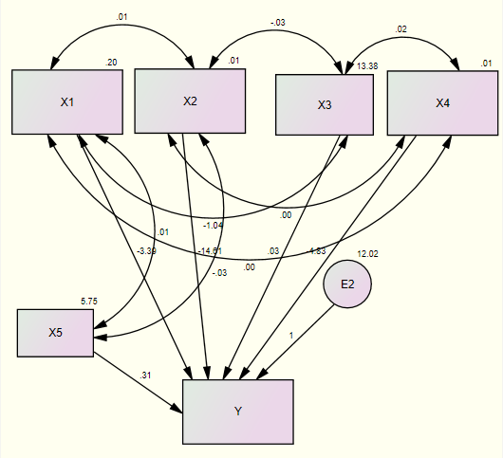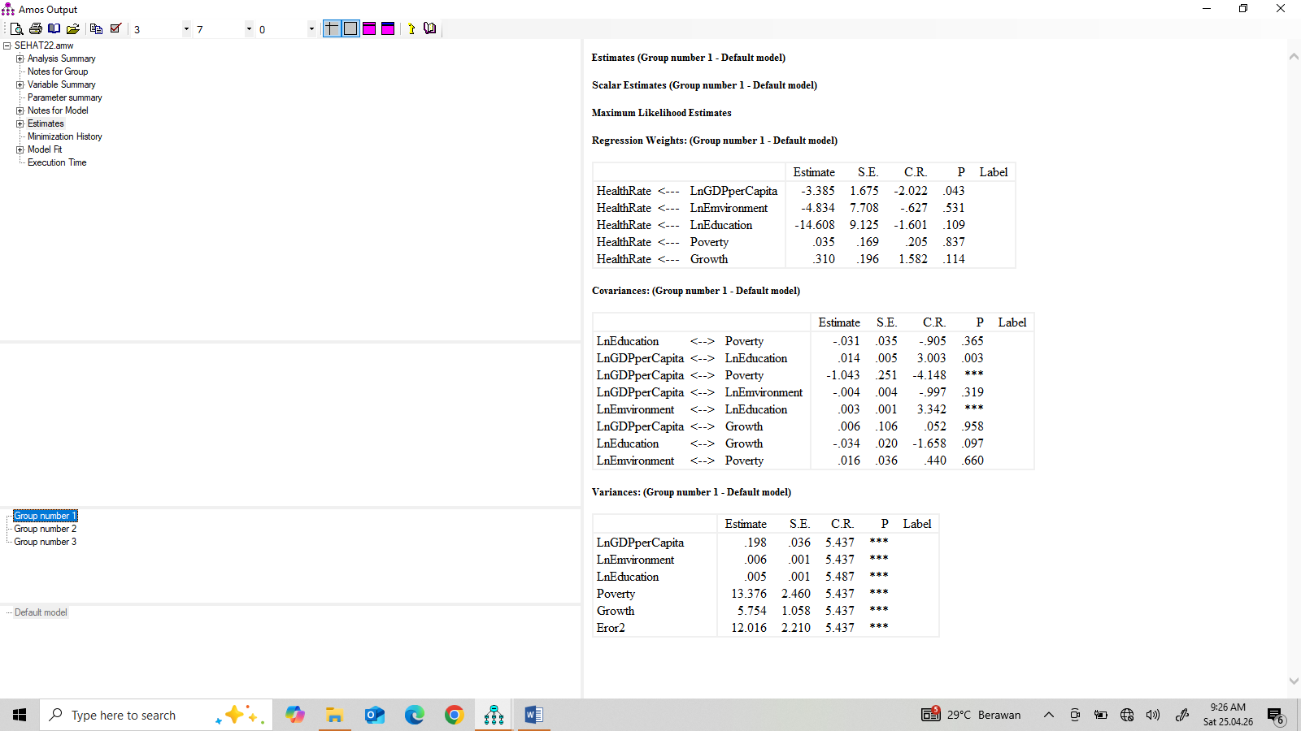

Figure 4. Relationship between Variables and Estimation Results in Region 1
Source: Data Processing Results, 2026

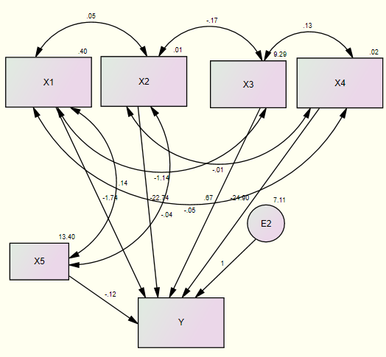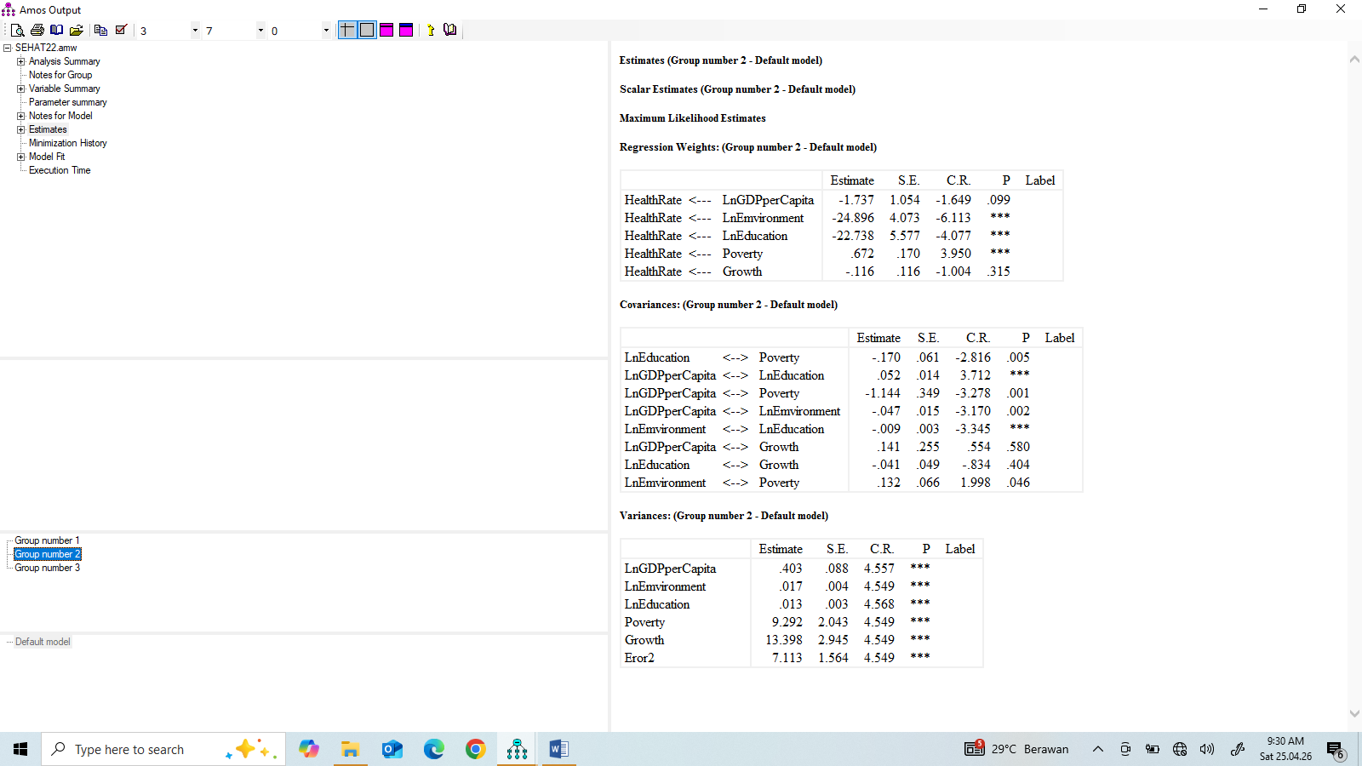

Figure 5. Relationship between Variables and Estimation Results in Region 2
Source: Data Processing Results, 2026

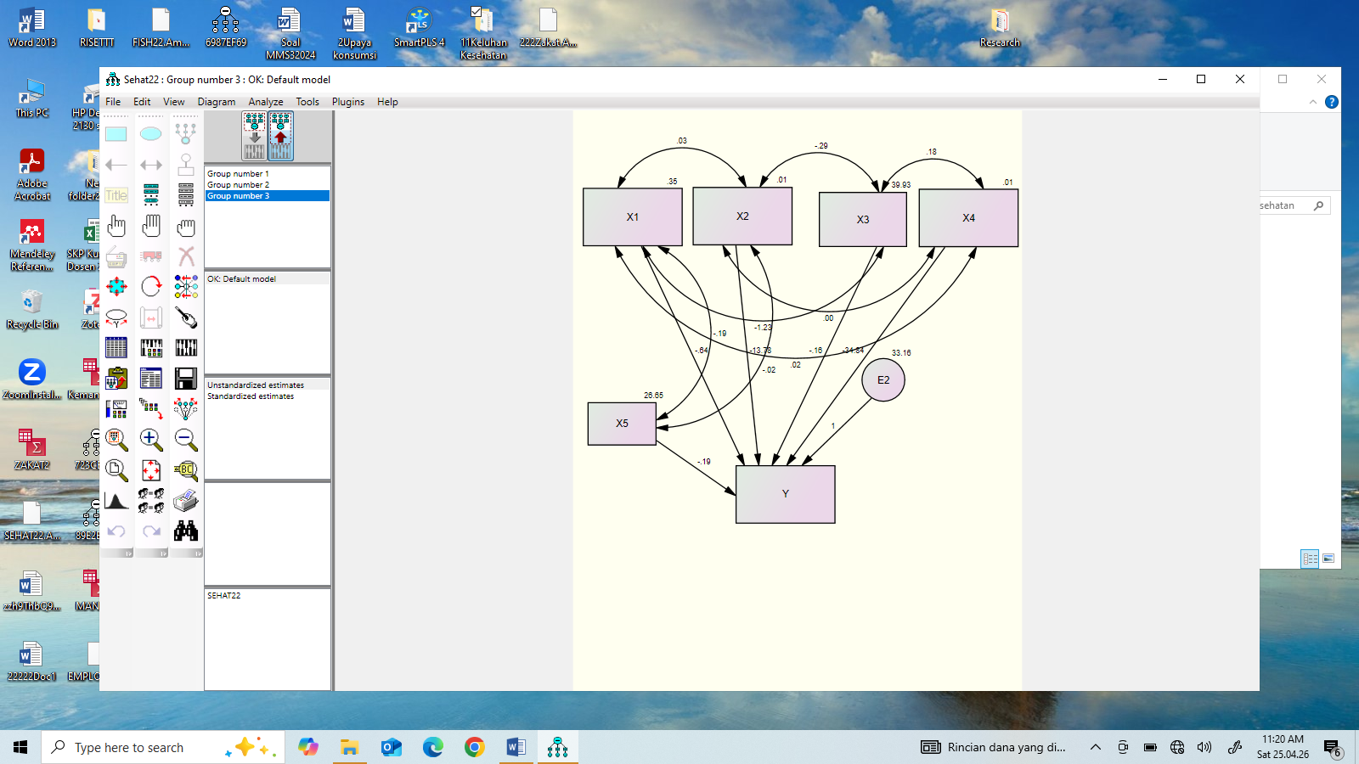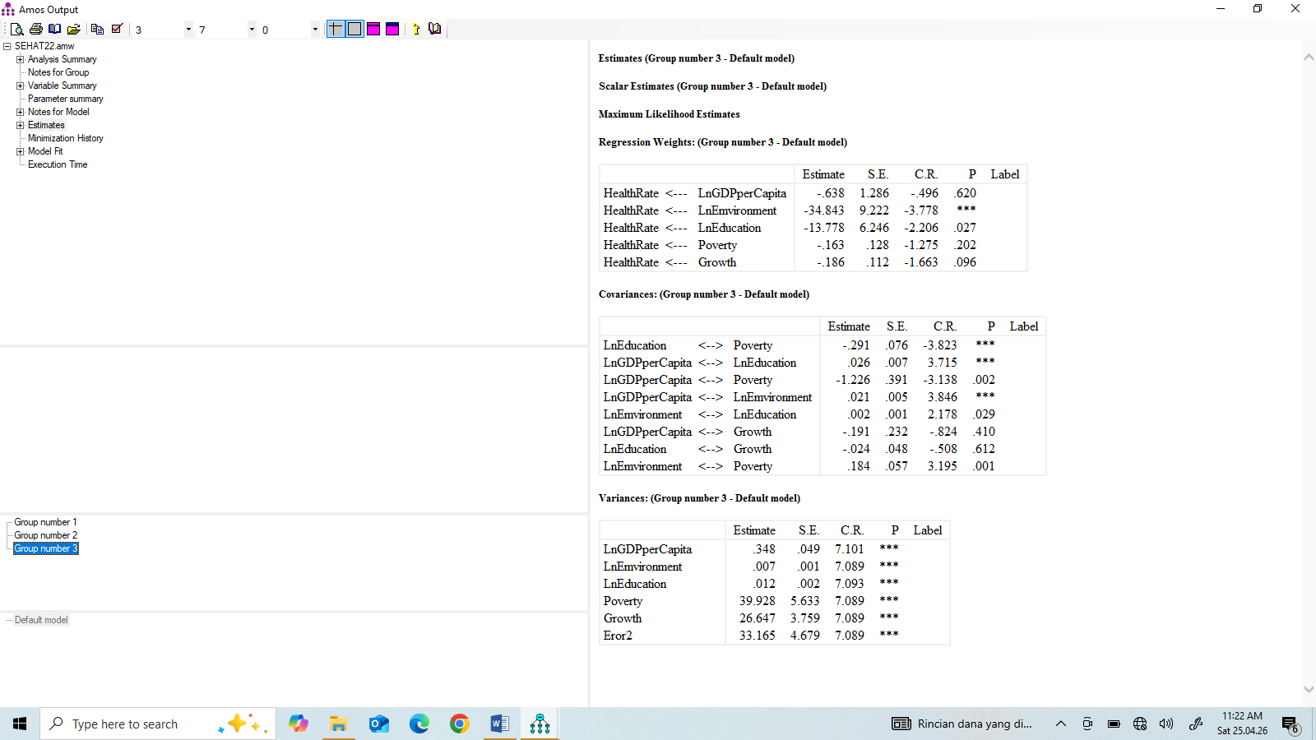

Figure 6. Relationship between Variables and Estimation Results in Region 3
Source: Data Processing Results, 2026

4.3. Discussion

Region 1
Region 1 covers all provinces on the island of Sumatra and the provinces in the surrounding islands with the second highest population density, thus explaining public health complaints. Furthermore, the region is more frequently hit by natural disasters than the other two regions. Figure 4 shows the estimated results of the study indicating that GDP per capita has a significant effect on health complaints in Region 1, at a confidence level of α = 0.05, which has an elasticity of -3.38, meaning that a one percent increase in GDP per capita will cause a decrease in public health complaints by 2.94%. The same figure also shows that poverty has a significant effect on public health complaints at a confidence level of α = 0.10, and also has a negative relationship (elasticity of -14.61), meaning that a lower level of poverty results in a higher level of public health complaints, or that a 1% increase in education will result in a 14.61% decrease in public complaints. Furthermore, it can also be seen that economic growth in this region does not have a significant effect on public health complaints. This can be caused by the exploitation of natural resources that exceed environmental thresholds such as uncontrolled deforestation, such as floods and landslides that claimed the lives of thousands of residents in early 2026 or late 2025 in North Sumatra and Aceh and other surrounding areas. Likewise, an increase in education decreases public health complaints with an elasticity of -14.61, which is significant at α = 0.10.

Meanwhile, in Region 2, it shows that socioeconomic factors consisting of education, health, environment, GRDP per capita, and poverty have an influence on public health complaints, Figure 5. If the confidence level is taken as α = 0.10, all variables, except economic growth have an influence on public health complaints, but if only α = 0.01, there are only three variables that influence public health complaints, namely the environment, education, and poverty. Environment and education have a negative influence on health complaints secara nyata pada taraf keyakinan at α = 0.05, while poverty has a positive influence on public health complaints in Region 3. This fact states that if poverty increases, it will also result in an increase in public health complaints. Poverty is one of the factors that hinders people from being physically healthy, according to the opinion of the chain of poverty concept. Furthermore, education and the environment have an impact on reducing public health complaints. The environment has a negative influence on health complaints. This finding is supported by research (Sundas et al., 2024) which states that the external environment constantly influences human health through many factors, including air quality, access to green spaces, exposure to pollutants, and climate change. Furthermore, (Firdaus & Rajiman, 2025) shows that most of the population works in the informal sector, has a low income, and lives in houses with poor conditions. These unfavorable environmental factors are closely related to high rates of respiratory tract infections, dengue fever, and diarrhea.

Poverty is negatively related to health levels or positively related to public health complaints. Therefore, if poverty can be reduced, public complaints will decrease. This is in line with the explanation by Murray (2006), who stated that health and poverty are inextricably intertwined. Furthermore, he stated that poverty also leads to increased dangers to health: working environments of poorer people often hold more environmental risks for illness and disability; other environmental factors, such as lack of access to clean water, disproportionately affect poor families. However, for poverty, the opposite effect occurs: if poverty reduction can be achieved, it will also have an impact on reducing public complaints. This indicates that the poverty program implemented by the government during the 2018-2023 period succeeded in reducing the number of public complaints, or that the community's health level will improve.

Health Complaints
Health complaints are health problems experienced by people in a particular area, whether physical or mental, due to illness or an abnormal physical condition. Physical conditions include weakness, dizziness, back pain, fatigue, insomnia, digestive problems, coughing, or shortness of breath, and mental/psychological conditions include severe stress, excessive anxiety, low mood, or emotional instability (Alodokter, 2026). The development of health complaints can be seen in Figure 7. In Region 3, Figure 6 shows that of the five independent variables included in the model, only GDP per capita and poverty show no effect on health complaints at α = 0.05. Education and environment are both independent variables that have a negative effect on public health complaints. This fact indicates that these two variables can reduce the level of public complaints in this region. This means that if education and a clean environment can be improved, public health complaints can be reduced, making these two variables among the determining factors for the level of public health complaints.. In the three regions, it has been stated that education has a negative effect on public health complaints, which means that the higher the level of public education, the lower the level of public complaints. This fact is supported by many research results such as Nurhidayatika et al., 2022), which states that the level of education is one of the variables that negatively affects the level of health complaints, while (Paradono 2014) states that individuals with higher levels of education tend to have lower health complaints and are better able to access adequate health services. This shows that improving education can serve as an important tool for improving overall public health in Indonesia. Therefore, in Region 3, yang meliputi (Maluku, North Maluku, West Nusa Tenggara, East Nusa Tenggara, Papua, and West Papua), the health level in this region is known to be very low, determined by its geographical conditions and very minimal transportation infrastructure. Similarly, other health indicators such as medical facilities and personnel, stunting and malnutrition, and sanitation and disease problems are also low (Ministry of Health of the Republic of Indonesia, 2025). Furthermore, it can be seen in the same figure that economic growth has a significant negative impact at the confidence level of α = 0.10 with an elasticity of -0.18, meaning that if economic growth increases by 1%, family health experiences a decrease of 0.18%, assuming all four variables remain constant. This fact shows that economic growth can increase output and employment opportunities. This results in increased community income, so that people have a greater opportunity to maintain their health.

Figure 7. Development of Public Health Complaints
Source: Processed Data, 2026

Figure 7 shows that in Region 1, the graph shows a downward slope with almost no decline from 2018 to 2023, indicating that during the peak of Covid-19 in 2020, there was no significant increase in health complaints and remained relatively stable at around 27%, despite relatively frequent natural disasters in Region 1. Furthermore, in Region 2, the same figure shows that health complaints increased slightly and continued to experience a downward trend after 2020, although the decline was slowing. The most striking thing happened in Region 3, where, in terms of quantity, the community experienced health complaints very sharply compared to other regions. This is due to the lack of health and education facilities and infrastructure in this region, especially in remote areas (Ariffin, 2025). So, the fluctuations in health complaints are largely determined by Covid-19, which peaked at the end of 2020. However, the determinants that are consistent from year to year and between islands are the environment and education.

5. Conclusions and Recommendations
5.1. Conclusions
Based on the previous discussion regarding the socio-economic influence on public health complaints, a conclusion can be drawn:
In region 1, it is known that education and the environment have a negative effect on public health complaints, while GDRP per capita and poverty do not have a significant effect on these complaints. Meanwhile, in region 2, it is shown that the four independent variables included in the model, namely GDRP per capita, education, environment, and poverty, have a significant effect on health complaints. All have a negative effect except poverty on public health complaints. Then in region 3, three variables have an effect on health complaints, the other two determining variables, namely GDRP per capita and poverty, do not have a significant influence on health complaints in this region. Finally, fluctuations in health complaints were largely determined by Covid-19, which peaked at the end of 2020. However, the determinants that are consistent from year to year and between islands are the environment and education.

5.2. Recommendations
The suggestions to be put forward based on the discussion and conclusions that have been stated, among others:
Overall, this study emphasizes the importance of formulating integrative health policies, taking into account per capita income, education, poverty, and environmental factors. Policies designed to improve health services, as well as always maintaining environmental cleanliness, especially efficient waste management, reducing single-use plastics, and planting trees can help reduce public health complaints. Furthermore, it was found that poverty has a positive influence on public health complaints, so that poverty programs are more intensified with productive activities such as training and development of small and medium industries. Finally, in the eastern region of Indonesia, special attention should be given because in terms of health, this region is very behind compared to other regions, so development needs to be focused on connectivity infrastructure, down streaming natural resource-based industries and more specifically on improving the quality of human resources through education and training, as well as providing nutritious food, especially for the younger generation so that they do not get sick easily and are found in the future to be healthy and high-achieving people.

Reference

Adisasmita, R. (2005). Fundamentals of Regional Economics. Jakarta: Graha Ilmu.

Ammar, Z., Hendra, H., & Yonnedi, E. (2024). Poverty in Riau Province: The Role of Economic Growth, Income Distribution, and Human Development. The Journal of Academic Science, 1(8), 1027–1035.

Alodokter,( 2026). Stres - Gejala, Penyebab, dan Pengobatan. Retrieved fromhttps://www.alodokter.com › stres

Armstrong, H. & Taylor, J. (1993). Regional Economic and Policy. Harverster Wheatsheaf, New York.

Ariffin, Sjamsul, 2025. General Bureau Performance Report 2025. Ministry of Health, Republic of Indonesia.

Arief, S. (1998). Development Theory and Policy. Center for Information and Development Studies (CIDES), Jakarta.

Arsyad, Lincolin, 1999. Introduction to Regional Economic Planning and Development. Faculty of Economics Publishing Agency (BPFE), 1999.

Balchin, Paul N. & Bul Gregory, H. 1987. Regional and Urban Economics. Harper & Row Ltd, Redwood Burn Ltd, Trowbridge.

Becker, G. S. (1994). Human Capital: A Theoretical and Empirical Analysis, with Special Reference to Education (3rd ed.). The University of Chicago Press.

Berardi, N., & Marzo, F. (2017). The Elasticity of Poverty with Respect to Sectorial Growth in Africa. Review of Income and Wealth, 63(1), 147–168.

Blaug, Mark. 1974. "An Economic Analysis of Personal Earnings in Thailand. Economic Development and Cultural Change University of Chicago Press, 23(1), 1–31.

Bloom, D. E., Canning, D., & Sevilla, J. (2001). Health, Human Capital, and Economic Growth. Working Paper. (Often cited as a foundational study on health as capital).

Boissiere, Maurice X. (2004). Determinants of Primary Health Outcomes in Developing Countries. World Bank. Independent Evaluation Group.

BPS. 2023. Gross Regional Domestic Product of Provinces in Indonesia by Expenditure, 2018-2022. Jakarta

BPS. 2023. Statistical Year Book of Indonesia. Catalog Number: 1101001, Publication Number: 03200.2303, ISSN/ISBN: 0126-2912, Jakarta..

Ceoworld's Magazine (2025). Countries With The Best Health Care Systems, 2025. Retrieved from https://ceoworld.biz/2025/09/21/countries-with-the-best-health-care-systems-2025/

Cypher, J.M., 2020. The Process of Economic Development. Imprint Routledge, 5th Edition, eBook ISBN9780429289248, DOI https://doi.org/10.4324/9780429289248.

BPS-Statistics of Indonesia, (2024). Statistical Yearbook of Indonesia. Publication Number: 03200.24003

BPS-Statistics Indonesia, (2023). Gross Regional Domestic Product of Provinces in Indonesia by Expenditure, 2018-2022. Jakarta

Firdaus & Rajiman (2025). The Impact of Environmental Quality on Public Health in Slum Settlements in Talang Kelapa District, Banyuasin Regency. Scientific Journal of Mechanical, Industrial, and Computer Engineering (Muara Teknik), 2(1). 1-20.

Frank, R. H., & Bernanke, B. S. (2007). Principles of Microeconomics (3rd ed.). New
York: McGraw-Hill/Irwin.

John W. C. (2010). Research Design: Qualitative, Quantitative, and Mixed Approaches (3rd Edition; Yogyakarta, Pustaka Pelajar)

Jhingan, M.L. (2021). The Economics of Development and Planning. Retrieved from: https://archive.org/details/in.ernet.dli.2015.118935

Murray, S. (2006). Poverty and Health. PMC PubMed Central. Retrieved from https://pmc.ncbi.nlm.nih.gov/articles/PMC1405857/

Muttaqin, A. (2018). Buku Ajar Asuhan Keperawatan Klien dengan Gangguan Sistem Pernapasan. Jakarta: Salemba Medika.

Mutaqin, Z. Z. (2018). Dynamics of health and economic aspects in carbonated beverage control policies in Indonesia. Quality: Health Journal, 12(1), 26–37

Nyandekwe, M., Kakoma, J.B. & Nzayirambaho, M. (2018). The health-related Millennium Development Goals (MDGs) 2015: Rwanda performance and contributing factors. Pan African Medical Journal. Retrieved from https://pmc.ncbi.nlm.nih.gov/articles/PMC6431417/pdf/PAMJ-31-56.pdf

Nafziger, E. Wayne. (2006). Economic Development. Pearson, Cambridge University Press, Cambridge, New York.

Notoatmodjo, S. (2010). Health Behavioral Science. Jakarta: Rineka.

Numbeo, (2026). Health Care Index by Country 2026. Retrieved from https://www.numbeo.com/health-care/rankings_by_country.jsp

Nugroho, Iwan, and Rokhmin Dahuri (2004). Regional Development (Economic, Social, and Environmental Perspectives). Jakarta: LP3ES

Nurhidayatika, F., Sumaryono, D., Andeka, W., Darwis, D., & Ningsih, L. (2022). The Effect of Health Promotion Using the Wheel of Intelligence (Roked) on Knowledge and Attitudes Regarding Gastritis Prevention among Students at Al-Karim Islamic High School, Central Bengkulu. Ministry of Health Polytechnic of Health, Bengkulu

Pradono, J., & Sulistyowati, N. (2014). The Relationship Between Education Level, Knowledge of Environmental Health, Healthy Living Behavior, and Health Status (Correlation Study on the Population Aged 10-24 Years in Central Jakarta). Health System Research Bulletin, 17(1), 89–95

Rastogi, P. N. (2002). Knowledge Management and Intellectual Capital as a Paradigm of Value Creation. Human Systems Management, 21(4), 229-240

Romer, P. M. (1999). "Endogenous Technological Change". Journal of Political Economy.

Rosen, H. S. 1999. Public Finance. New York: McGraw-Hill

Indonesian Statistics, (2025). Statistical Yearbook of Indonesia 2025. Directorate of Statistical Dissemination, Volume 53.

Syafrizal, 2004. Regional Economics Theory and Application, Padang, Baduose Media.

Schultz, T. W. (1961). Investment in Human Capital. The American Economic Review, 51(1), 1-17.

Sundas, A., Contreras, I., Mujahid O., Beneyto, A., & Vehi, J. (2024). The Effects of Environmental Factors on General Human Health, A Scoping Review. PudMed Disclaimer. Retrieved from https://www.mdpi.com/2227-9032/12/21/2123

Tarigan, R. (2003). Regional Development Planning. Jakarta: Rajawali Press.

Tarigan, Robinson, (2004). Regional Development Planning. Jakarta: Bumi Aksara

UNDP (United Nations Development Programme). (1990). Human Development Report 1990. New York: Oxford University Press.

United Nations, (2025). The Millennium Development Goals Report 2011, United Nations, New York, 2011, Ban Ki-moon, 2015. Retrieved from (https://www.un.org/millenniumgoals/pdf/(2011_E)%20MDG%20Report%202011_Book%20LR.pdf
.
Wan, T. T. H. (2002). Evidence-based health care management: Multivariate modeling approaches (1st ed.). Norwell, MA: Kluwer Academic Publishers.

Weiss, J. (2005). Poverty Targeting in Asia, Research Director, Asian Development Bank Institute, Tokyo, Japan.

WHO, 2026. Environmental Health, 2026. Retrieved from https://www.who.int/health-topics/environmental-health

