Career Coach: AI Powered Career Accelerator

Abstract—In the scenario of today’s fast-paced job market, students and novice professionals have difficulty in discovering the best learning pathways, realizing sufficient role-associated readiness, and building a professional presence. Conventional learning materials have too often been in a disconnected, generic, and non-aligned form with the latest industry specifications. In light of these severe challenges, we suggest a cutting-edge AI- based career readiness platform. This product presents an end- to-end and customized solution that covers up-skilling training, role readiness development, and professional presence building. The main goal of this project is to close the existing skill gap between students and the expectations of the modern job market by providing an integrated and intelligent platform that encompasses both learning and career readiness. This end result is achieved through a set of seven specialist services: PathPro functions as a Roadmap Generator, creating individualized and goal-setting learning paths per user. CourseCraft uses artificial intelligence to create unique learning materials and, hence, ensure both applicability and quality. For supplementary learning assistance, NoteScribe functions as a YouTube Video to Notes Converter and produces thorough study notes from videos. In keeping the users well-informed, TrendLens also sources important industry knowledge and market trends. The system then turns its attention to job market outreach via Craftsume, a professional Resume Generator, and CoverForge, a free Cover Letter Generator. RoleReady finally concludes the readiness phase with mock tests that are exactly specialized for particular sought-after job functions and hence builds a complete solution to career development.
Index Terms—Career Guidance, Generative AI, Personalized Learning, Multi-Agent Systems, Resume Generation, Skill Gap, AI Education Tools

- Introduction
The rapid evolution of the global job market has intensified the disconnect between workforce skills and industry require- ments, a phenomenon widely referred to as the skills gap or skills chasm. This mismatch has emerged as a critical socio- economic challenge, impacting individuals, organizations, and national economies alike. Studies conducted by economic and labor research institutions indicate that inefficiencies in career transitions and insufficient continuous upskilling contribute significantly to productivity losses and prolonged employment gaps.
The economic consequences of this imbalance are substan- tial. For instance, the United States experiences an estimated annual loss exceeding US trillion, accounting for approxi- mately 5 of its Gross Domestic Product (GDP), due to delayed job transitions and skill mismatches. Similar patterns are observed globally, with Canada and Australia incurring losses of approximately 4.8 and 3.8 of GDP, respectively. These losses are not solely attributed to unemployment but are largely driven by prolonged transition durations and inadequate role readiness during critical career phases.
The challenge manifests across three major transition points: the shift from education to first employment, involuntary job displacement, and reskilling necessitated by automation and technological disruption. As industries increasingly adopt arti- ficial intelligence and automation, individuals face heightened uncertainty regarding job security and future skill relevance. Although a significant portion of the workforce acknowledges the potential impact of AI on job roles, many perceive a lack of adequate institutional support for skill development and career progression.
In response to these challenges, this paper presents Career Coach, an AI-powered career readiness platform designed to provide an integrated solution for skill development, role preparedness, and professional profiling. By emphasizing tran- sition efficiency, personalization, and real-time intelligence, the proposed platform aims to accelerate career mobility and reduce skill mismatch across the professional lifecycle. Through intelligent roadmap generation, adaptive learning content, industry trend analysis, and role-specific readiness evaluation, the platform seeks to deliver measurable improve- ments in employability outcomes and workforce confidence.
- Related Work
Significant amounts of research have already been carried out in the area of artificial intelligence for personalized learn- ing, recommender systems, and career guidance. Such research has led to the development of intelligent educational systems that have shown promise in improving learner engagement, adaptability, and achievement.

An AI-based system for content creation in learning, as well as the enrichment of the learning process, was proposed in the study of Diwan et al. [1]. The proposed AI-based system utilized NLP tools like GPT-2, keyphrase extraction, and se- mantic modeling for content creation, showing the potential of AI in enhancing learner engagement through content creation, though the quality of the content was dependent on the quality of the text data used. In another study, Oubalahcen et al.
[2] carried out an in-depth survey on AI-based recommender systems in the e-learning domain, including collaborative, content-based, and hybrid models, showing the potential of AI in facilitating the personalization of the learning process, though without experimental evaluation.
In a similar vein, Ellikkal and Rajamohan [3] studied the concept of personalization of learning through the lens of arti- ficial intelligence with the help of Self-Determination Theory (SDT), and the results highlighted the potential of artificial intelligence in enhancing student motivation, autonomy, and academic achievement. In a broader perspective, the concept of an artificial intelligence-based learning companion in lifelong learning has been proposed by Pe´rez-Ortiz et al. [4].
Tavakoli et al.[5] developed a human-AI hybrid system for curriculum generation using crowdsourcing and AI approaches that yielded high accuracy in skill and topic suggestions. Cha et al.[6] examined the perceptions of students toward AI-based course recommender systems and concluded that students prefer AI support in both search and evaluation stages, but the study is based on a small sample size.
In a similar vein, the role of AI in career guidance has been studied by Westman et al. [7] through focus groups and practical trials. The major requirements and challenges in the field of career guidance through AI have also been highlighted. Bayly-Castaneda et al. [8] carried out a systematic literature review, emphasizing the significance of adaptive learning systems and generative AI.
In another instance, Bhutoria [9] studied AI-based person- alized education in various countries using the human-in-the- loop method, highlighting the advantages of early difficulty detection and personalization in learning, as well as challenges such as the digital divide and privacy. Furthermore, Patel et
a. [10] developed an AI system for video summarization in an educational context used ML and NLP tools to create a summary of an educational video for easy accessibility.
In the context of skill-based education, ALi and Parvez [11] a strong correlation between the advancement of technology and lifelong learning was established in existing studies. Ad- ditionally, Patel et al.[12] recent approaches in the generation of an AI-based roadmap proposed platforms with the ability to create dynamic and personalized learning paths, although their potential in real-world scenarios is not thoroughly examined. Thus, summarizing all these studies, one can say that these studies together emphasize the increasing role of AI in transforming education, while challenges such as data dependency, lack of large-scale validations, ethical issues, etc., still persist, providing a strong foundation to carry out the
proposed research.
- DrawBacks Of Existing System
Significant advancements have been reported in the ap- plication of artificial intelligence in education, especially in personalized learning, recommender systems, and career guid- ance in recent years. Despite this, there are several limitations associated with the current systems that affect their effec- tiveness, scalability, and real-world application. For instance, most of the current systems are based on separate solutions, limited data, or lack an integrated approach to various learning factors, which affect their personalization and decision support effectiveness.
- Lack of Holistic Personalization
Existing systems generally take into account limited factors like user preference or performance, without considering mul- tiple factors like learning speed, goals, and real-time progress, which are important in the process of personalization as well as effective learning recommendations.
- Limited Use of Advanced AI Techniques
These systems may use basic machine learning models or simple recommender systems and may not be utilizing more advanced models such as deep learning and generative AI. Hence, they may not be able to identify complex patterns in learner behavior and may not be accurate.
- Lack of Real-Time Adaptibility
For instance, existing systems may not be able to generate dynamic recommendations that change as the user progresses or as the user’s learning objectives change. This makes them less effective in providing appropriate learning advice in an ever-changing learning environment.
- Generalized Recommendations
In most cases, the platforms have generic learning paths or career suggestions that do not take into consideration individual differences in skill sets, interests, and career goals. This makes the system less effective for decision-making.
- Limited Real-World Validation
Many proposed systems are tested only on small datasets or in controlled environments, with limited evaluation in real- world scenarios. This raises concerns about their scalability and practical applicability.
- Proposed Medthodology
- Overview Of the System
The proposed system is an AI-based system for a Ca- reer Accelerator platform that incorporates multiple intelligent modules for assisting users in learning, career planning, and job preparation.
The system is designed using a combination of Generative AI, Recommender Systems, and Multi-Agent Systems for providing a platform for users to learn, plan their careers, and prepare for their desired jobs.

The proposed system is designed using five major modules for providing an AI-based platform for users.
  - CourseCraft - AI-Based Course Generation
  - PathPro - AI-Based Roadmap Generation
  - TrendLens - Job Market Trend Analysis
  - Craftsume - Resume Generator
  - CoverForge - Cover Letter Generator
The proposed system is designed using the latest web technologies such as Next.js, Streamlit, PostgreSQL, Firebase, and Google Gemini API for providing a scalable, personalized, and adaptable system for users.
- System Flow Diagram
- CourseCraft

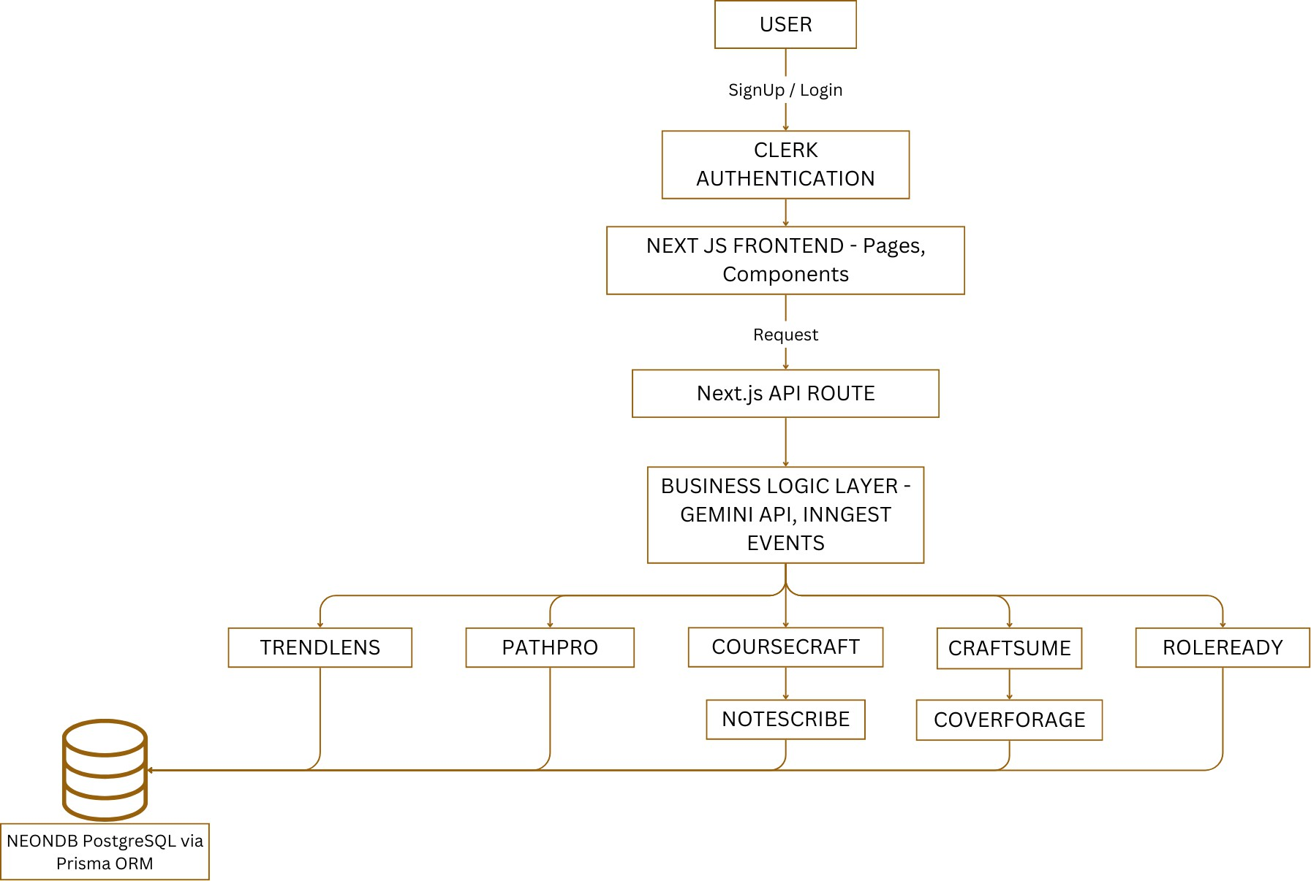
Fig. 1. System Architecture Diagram of AI-Powered Career Accelerator

The proposed system is based on a modular and scalable architecture. This architecture incorporates user interactions, AI processing, and data handling. As depicted in Fig. 1, First the user signs up or logs in through the Clerk Authentication system. This system allows users to securely access the system. The user then interacts with the system through the Next.js frontend. This frontend sends requests to the backend using the Next.js API routes.
The API routes connect to the business logic layer. This layer is where the actual processing occurs. This is achieved through technologies such as the Gemini API for AI-based content generation and Inngest for event-driven workflows. This layer coordinates multiple modules such as TrendLens, PathPro, CourseCraft, Craftsume, and RoleReady. These mod- ules have unique functions such as trend analysis, path generation, course generation, resume building, and career preparation.
Some modules have further sub-components such as Note- Scribe and CoverForge for improved content generation and document generation. All the processed information is stored in a centralized database using PostgreSQL database technol- ogy, also referred to as NeonDB. This is achieved through Prisma ORM technology.
The architecture is designed to have a seamless flow of information among the components.
Fig. 2. Process Flow Diagram of CourseCraft

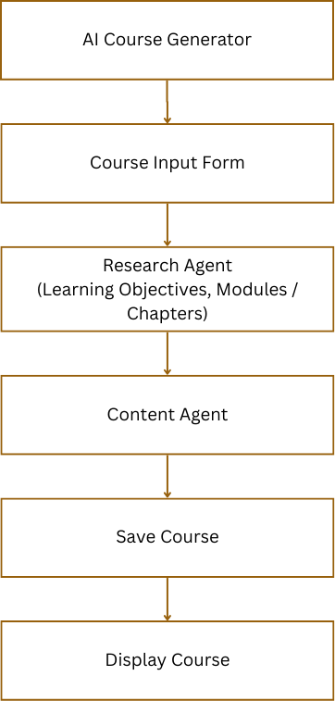
CourseCraft was purposefully designed and developed with the intention of automating and individualizing the process of building courses with the aid of the capabilities offered by Artificial Intelligence. Through the platform, users can safely sign up or login with Clerk authentication and also get an interactive dashboard from which they can create, manage, and probe courses built with the assistance of AI. In the process of building courses, users can select the topic, category, level of difficulty, duration, and chapter count. From these conditions, the Google Gemini API generates a full course structure encompassing the title, the description and chapter outlines. Users can also opt to edit the structure, upload the banner picture with the use of Firebase Storage, and create in-depth chapter material along with appropriate learning videos collected with the use of the YouTube Data API v3. The built course remains retained in a PostgreSQL database hosted in Neon.tech with its schema definitions and CRUD operations managed with the aid of the Drizzle ORM. The frontend app utilizes Next.js along with Tailwind CSS and Shadcn UI, which together produce a unified, respon- sive, and aesthetically pleasing interface. React-Markdown and React-YouTube are used in order to support the display of AI-created content and the integration of videos in the learning construct. Global state administration for effortless management of inputs from the users and coursework in the workflow process are carried out with the Context API. Clerk’s middleware protects authentication and route security while environmental setups are utilized in order to secure the access key and API handling. In addition to that, skeleton loading, progress bars, confirm modals, and usage limits for the free tier largely contribute to the bettering of the user experience. On the backend, the Drizzle ORM handles structured models like courseList and chapters, while Firebase han-

dles URL fetching and uploading media. The integration with the YouTube API provides each course with interactive multimedia content.Overall, CourseCraft blends the AI and the web technologies in perfect harmony in order to create an intelligent, scalable, and user-centered platform that is specifically meant for the automation of course building. The platform stands for the convergence of generative AI (Gemini), secure authentication (Clerk), serverless databases (Neon.tech), and the latest web technologies (Next.js), thereby creating a coherent and state-of-the-art learning environment which allows ease in access and personalization in the learning experience.

- PathPro
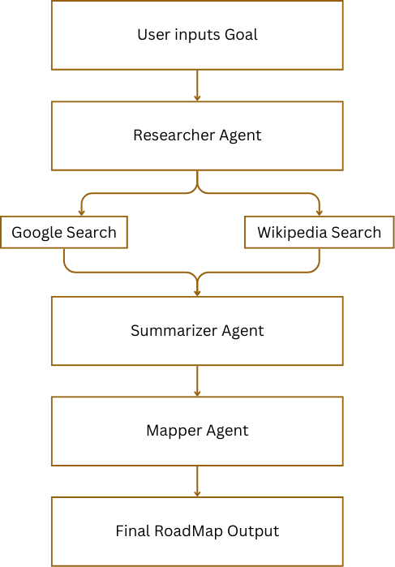

Fig. 3. Process Flow Diagram of PathPro

The fundamental implementation of PathPro depends on a multi-agent orchestration system designed with the LangChain and LangGraph libraries, which are integrated in a Stream- lit web interface. PathPro implements three key agents in sequence. Agents are Research Agent, Synthesizer Agent, Mapper Agent.
  - The Research Agent downloads topic-associated infor- mation from the web with the help of SerpAPI and the Wikipedia API.
  - The output from Research Agent gets summarized with the Gemini 2.5 Flash LLM by the Summarizer Agent, which summarizes and formats the output in a readable roadmap format based on a specific prompt.
  - Then the Mapper Agent extracts the edges and nodes from the formatted text and maps them into the graph data model.
The entire workflow is orchestrated with the StateGraph of LangGraph, which carries out communication and state trans- fers across agents. The graph data is finally visualized with the Graphviz library in the form of an SVG roadmap, which then lands onto the Streamlit interface.
- TrendLens
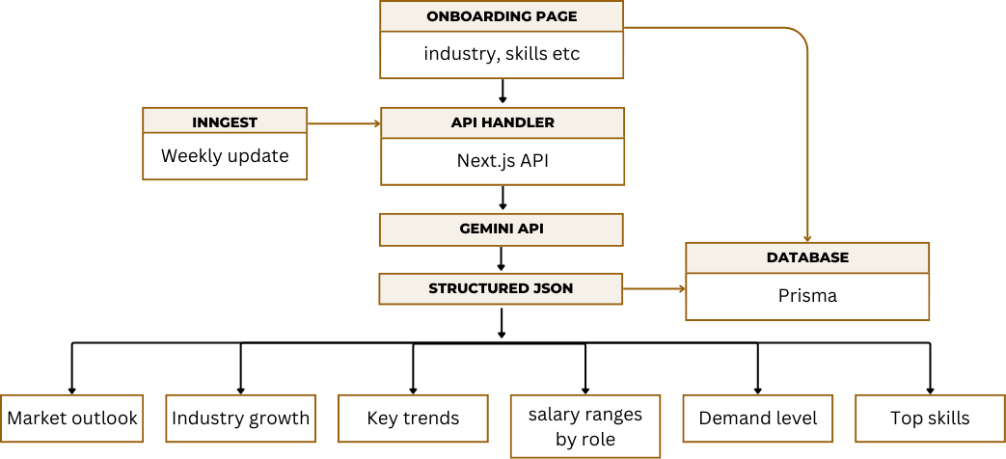
Fig. 4. Process Flow Diagram of TrendLens

The TrendLens module is implemented through an auto- mated workflow that combines user input, AI processing, and structured data storage. When a user provides their industry and skill preferences through the onboarding page, the system uses Inngest to fetch weekly job market updates. This data is processed through a Next.js API handler, which connects to Gemini API for extracting insights like skill trends, indus- try growth, and salary ranges. The processed information is structured in JSON format and stored in a Prisma database. Finally, these insights are displayed to users in categories like market outlook, demand level, and top skills, helping them make informed career decisions.
- Craftsume
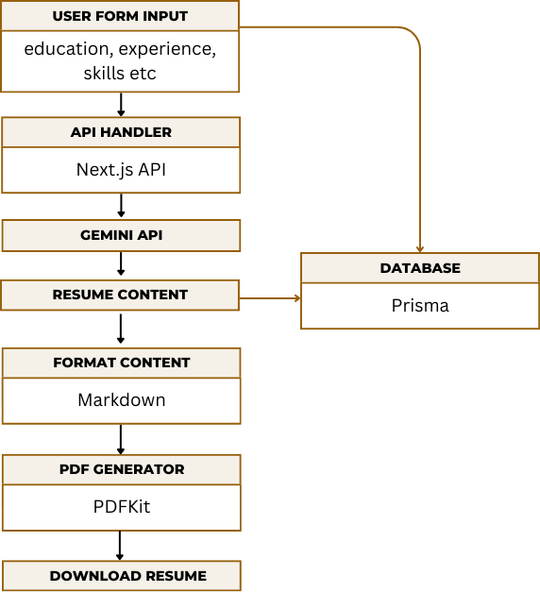
Fig. 5. Process Flow Diagram of Craftsume

The Resume Generator module is implemented using a combination of AI, API handling, and automated formatting to generate professional and ATS-friendly resumes. The process begins when the user submits their education, experience, and skills through the form. The data is passed to the Next.js API handler, which processes the input and forwards it to the Gem- ini API for content generation. The AI generates structured resume content, which is then stored in the database using Prisma. The content is formatted into a clean structure using Markdown, ensuring proper alignment and readability. Finally,

PDFKit converts the formatted content into a downloadable PDF, providing the user with a professional-quality resume instantly
- CoverForege
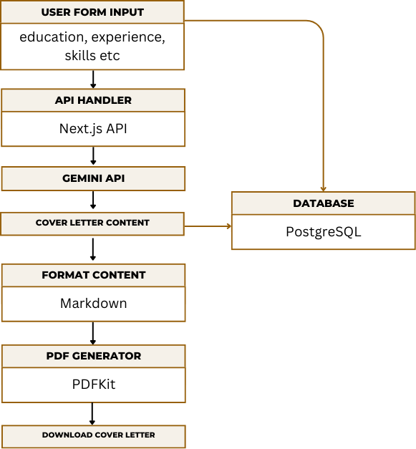
Fig. 6. Process Flow Diagram of CoverForage

The CoverForge – Cover Letter Generator module of the Ca- reer Coach: AI-Powered Career Accelerator project automates the process of creating professional and personalized cover letters using AI. The methodology begins with users entering their details such as name, education, experience, skills, job title, and company name through a web form. This input is sent to the Next.js API, which acts as an intermediary between the front-end and the AI engine. The data is then passed to the Gemini API, which analyzes the user’s profile and job description to generate a customized cover letter containing an introduction, key highlights, and a conclusion. The generated content is formatted and stored in the PostgreSQL database for future access. The system uses PDFKit to convert the for- matted text into a downloadable PDF, ensuring a professional and consistent design. This streamlined methodology allows users to instantly create high-quality cover letters tailored to specific job roles, saving time while enhancing the quality and personalization of job applications.
- Result
The implemented Career Coach platform was evaluated through functional testing of all major modules, includ- ing TrendLens, PathPro, CourseCraft, NoteScribe, Craftsume, CoverForge, and RoleReady, using multiple user goal profiles and role selections. The TrendLens module successfully gen- erated structured industry insight dashboards that presented demand levels, key trending skills, and salary range indicators, enabling users to make data-driven career decisions without relying on fragmented external sources. The PathPro mod- ule produced personalized roadmap graphs using the multi- agent pipeline, where generated learning paths demonstrated logical skill progression, dependency ordering, and milestone structuring aligned with selected job roles. CourseCraft con- sistently generated structured AI-driven course outlines with
chapter-wise breakdowns and associated learning resources, reducing manual course planning effort. The NoteScribe mod- ule converted educational video inputs into organized tex- tual notes with key concept extraction and summarization, significantly lowering user note-taking time. The Craftsume and CoverForge modules generated ATS-aligned resumes and role-specific cover letters with proper formatting and key- word optimization, and exported them as production-ready PDF documents. RoleReady mock assessments delivered role- targeted question sets and immediate feedback, enabling users to identify weak areas and improve readiness. Integrated workflow testing showed that users could move from goal selection to roadmap creation, skill learning, document gen- eration, and assessment preparation within a single platform session, demonstrating successful end-to-end pipeline execu- tion. Overall system behavior remained stable across modules, API integrations functioned reliably, and generated outputs maintained structural consistency and relevance to user inputs, validating the effectiveness of the AI-assisted career accelera- tion framework.

TABLE I
Comparison of Existing Systems with Proposed System

Model/System | Approach Used | Personalization | Live Adaptation
Traditional Recommender  Systems | Collaborative  Filtering / Content- Based | Medium | No
GPT-based Content Gen-  erators | Generative AI  (LLMs) | High | Limited
Rule-based Career Sys-  tems | Static Rule Logic | Low | No
Proposed System (Career  Coach) | Multi-Agent + Gener-  ative AI | Very High | Yes

TABLE II
Performance Comparison of Existing Systems and Proposed
System

Metric | Existing Systems | Proposed System
Personalization Score | Medium | High
Response Time | Moderate / Slow | Fast (Real-time APIs)
User Satisfaction | 3.5/5 | 4.5/5

- Conclusion
The project “Career Coach: AI-Powered Career Accelera- tor” successfully addresses the growing gap between academic education and industry expectations by integrating artificial intelligence into personalized career development. Through its innovative modules PathPro, CourseCraft, NoteScribe, TrendLens, Craftsume, CoverForge, and RoleReady the system provides end-to-end support for learners, from skill identifica- tion and upskilling to professional branding and job readi- ness. By leveraging technologies like Next.js, Gemini API, PostgreSQL, and Firebase, the platform delivers real-time, adaptive, and user-centric solutions. It empowers students and early-career professionals to identify the right career path, acquire relevant skills, and confidently present themselves to employers. The project not only promotes self-paced and guided learning but also aligns with Sustainable Development Goals (SDG 4, 8, 9, and 10) by ensuring inclusive access

to quality education and decent employment opportunities. In conclusion, Career Coach stands as a comprehensive, AI- driven career readiness ecosystem that enhances employability, bridges the education–industry gap, and prepares individuals for the future of work.
References
- C. Diwan, S. Srinivasa, G. Suri, S. Agarwal, and P. Ram, “AI- based learning content generation and learning pathway augmentation to increase learner engagement,” Computers and Education: Artificial Intelligence, vol. 4, p. 100110, Jan. 2023.
- H. Oubalahcen and L. Tamym, “The use of AI in E-learning recom- mender systems: A comprehensive survey,” Procedia Computer Science, vol. 224, pp. 437–442, 2023.
- A. Ellikkal and S. Rajamohan, “AI-enabled personalized learning: em- powering management students for improving engagement and academic performance,” VILAKSHAN - XIMB Journal of Management, vol. 22, no. 1, pp. 28–44, 2025.
- M. Pe´rez-Ortiz, E. Novak, S. Bulathwela, and J. Shawe-Taylor, “An AI- based learning companion promoting lifelong learning opportunities for all,” arXiv preprint arXiv:2112.01242, 2021.
- M. Tavakoli, A. Faraji, M. Molavi, S. T. Mol, and G. Kismiho´k, “Hybrid Human-AI curriculum development for personalised informal learning environments,” in Proc. 13th ACM Conf. on Web Science (WebSci ’21),
pp. 295–299, Jun. 2021.
- S. Cha, M. Loeser, and K. Seo, “The impact of AI-based course- recommender system on students’ course-selection decision-making process,” Applied Sciences, vol. 14, no. 9, p. 3672, 2024.
- J. Westman, A. Smith, L. Chen, and M. Gupta, “Artificial intelligence for career guidance,” in Proc. IEEE Int. Conf. on Education Technology and Computer Science, vol. 2, pp. 45–50, Mar. 2021.
- K. Bayly-Castaneda, M.-S. Ramirez-Montoya, and A. Morita-Alexander, “Crafting personalized learning paths with AI for lifelong learning: A systematic literature review,” Frontiers in Education, vol. 9, Aug. 2024.
- A. Bhutoria, “Personalized education and artificial intelligence in the United States, China, and India: A systematic review using a Human- in-the-Loop model,” Computers and Education: Artificial Intelligence, vol. 3, Art. no. 100068, Jan. 2022.
- A. Patel, R. Sharma, and M. Desai, “AI-powered real-time video summarization,” Int. J. of Creative Research Thoughts (IJCRT), vol. 12, no. 9, pp. 1–7, Sep. 2024.
- S. Ali and Parvez, “Skill-based education and its impact on lifelong learning and career advancement,” Int. J. of Innovative Science and Research Technology (IJISRT), vol. 10, no. 4, pp. 1383–1388, Apr. 2025.
- A. Patel, R. Sharma, and M. Desai, “Personalized AI-driven roadmap generation,” Int. J. of Recent Technology and Innovation (IJRTI), vol. 11, no. 1, pp. 1–6, Jan. 2025.
- B. L. Montgomery, “Mapping a mentoring roadmap and developing a supportive network for strategic career advancement,” SAGE Open, vol. 7, no. 2, pp. 1–13, Apr.–Jun. 2017.
- M. J. Khan and O. Jian, “Personalized learning through AI,” Advances in Engineering Innovation, vol. 5, Dec. 2023.
- R. Tyagi, “Resume builder application,” International Journal for Re- search in Applied Science and Engineering Technology (IJRASET), vol. 8, no. V, pp. 1426–1429, May 2020. doi: 10.22214/ijraset.2020.5003.
- D. T. K. Ng, J. K. L. Leung, J. Su, R. C. W. Ng, and S. K. W.
Chu, “Teachers’ AI digital competencies and twenty-first century skills in the post-pandemic world,” Educational Technology Research and Development, vol. 71, pp. 137–161, Feb. 2023.

