Drying Kinetics and Moisture Diffusion Behaviour of Selected Medicinal Leaves under Electrically Controlled and Ambient Atmospheric Conditions

ABSTRACT
Drying remains one of the most important postharvest engineering operations required for the preservation of medicinal leaves through effective moisture reduction while maintaining product quality, storability, and process reliability. This study investigated the time–temperature dependent drying kinetics and moisture diffusion behaviour of guava (Psidium guajava), bitter (Vernonia amygdalina), and scent (Ocimum gratissimum) leaves under ambient sun drying and electrically controlled oven drying conditions. Emphasis was placed on moisture content reduction, moisture ratio (MR), drying rate, moisture retention capacity, and thin-layer kinetic modelling as influenced by leaf type and drying environment. Drying experiments were conducted over an 8-hour period with hourly measurements of mass, temperature, and relative humidity. Sun drying was carried out under fluctuating atmospheric conditions (32–37 °C; 59–80% RH), whereas oven drying was maintained at 60 ± 1 °C. Results showed that sun drying reduced moisture content to safe storage levels (<10%) but exhibited irregular drying patterns characterized by fluctuating MR profiles, lower drying constants, and unstable falling-rate behaviour. In contrast, oven drying achieved rapid and uniform moisture reduction within 6 hours, with smooth MR decay curves and higher drying constants, indicating enhanced internal moisture diffusivity. Among the leaves, bitter leaf exhibited the fastest drying response, while guava leaf showed greater resistance to moisture migration. Thin-layer model fitting revealed that the Page model provided the best predictive performance with coefficient of determination (R²) values up to 0.998. Overall, electrically controlled drying demonstrated superior efficiency, predictability, and engineering suitability for large-scale medicinal leaf preservation.
Keywords: thin-layer drying, medicinal leaves, moisture diffusivity, postharvest engineering, drying kinetics

INTRODUCTION
Medicinal plant leaves constitute a highly valuable strategic bioresource within primary healthcare systems, traditional medicine, food fortification, and the rapidly expanding phytopharmaceutical industry, particularly in developing economies where plant-based therapies remain affordable, accessible, culturally accepted, and therapeutically relevant (WHO, 2013; Ekor, 2014; Sofowora, 2008; Akinyemi et al., 2005). Across sub-Saharan Africa, especially Nigeria, medicinal leaves such as guava (Psidium guajava), bitter leaf (Vernonia amygdalina), and scent leaf (Ocimum gratissimum) are widely utilized for their nutritional, pharmacological, and ethnomedicinal importance (Ijeh and Ejike, 2011; Erukainure et al., 2011; Akinmoladun et al., 2007).

These leaves are rich sources of phenolic compounds, flavonoids, alkaloids, tannins, essential oils, saponins, terpenoids, and antioxidant metabolites, which contribute to their reported antimicrobial, anti-inflammatory, hypoglycemic, antimalarial, and antioxidant activities (Prakash and Gupta, 2005; Eleyinmi, 2007; Oboh, 2006; Okwu, 2004; Trease and Evans, 2002). For instance, Vernonia amygdalina has been extensively reported as a functional medicinal vegetable with significant therapeutic applications in gastrointestinal regulation, diabetes management, liver protection, and immune enhancement (Farombi and Owoeye, 2011; Igile et al., 1994). Similarly, Ocimum gratissimum has demonstrated pronounced antibacterial and antifungal activities, largely attributed to its volatile oil fractions and phenolic compounds such as eugenol and thymol (Matasyoh et al., 2007; Pessoa et al., 2002). Guava leaves (Psidium guajava) have also received considerable attention for their anti-diarrheal, antioxidant, anti-inflammatory, and antimicrobial properties, which support their extensive use in herbal medicine and nutraceutical formulations (Arima and Danno, 2002; Gutierrez et al., 2008).

Despite these important medicinal attributes, freshly harvested leaves typically possess high initial moisture contents ranging between 70–85% wet basis, which predispose them to rapid enzymatic deterioration, microbial spoilage, biochemical instability, pigment degradation, and oxidative reactions, thereby significantly reducing postharvest quality and therapeutic efficacy (Mujumdar, 2014; Fellows, 2009; Vega-Gálvez et al., 2012). High moisture levels enhance water activity, which facilitates microbial proliferation and accelerates enzymatic reactions such as polyphenol oxidation and chlorophyll degradation (Doymaz, 2011; Krokida et al., 2000). Consequently, immediate postharvest moisture reduction becomes essential for preserving medicinal potency and extending shelf stability.

Drying is therefore recognized as one of the most critical postharvest engineering operations for medicinal plant processing, aimed at reducing moisture content, minimizing transport weight, enhancing storability, lowering packaging costs, and preserving phytochemical integrity (Mujumdar, 2014; Fellows, 2009; Erbay and Icier, 2010). In rural and semi-urban African settings, open sun drying remains the most commonly employed technique due to its low capital requirement, simplicity, and energy independence (Doymaz, 2011; Togrul and Pehlivan, 2002). However, sun drying is strongly affected by fluctuating ambient temperature, solar radiation intensity, relative humidity, wind speed, and atmospheric turbulence, all of which directly influence the coupled heat and mass transfer mechanisms governing moisture migration (Akpinar, 2006; Togrul and Pehlivan, 2002; Erbay and Icier, 2010).

This atmospheric variability often results in non-uniform drying kinetics, prolonged drying duration, case hardening, uneven moisture gradients, and inconsistent final product quality, which limit both engineering predictability and phytochemical retention (Doymaz, 2011; Sacilik and Unal, 2005). Moreover, exposure to dust, insects, ultraviolet radiation, and environmental contaminants during sun drying may compromise microbial safety and medicinal purity, thereby affecting the overall quality of the final herbal product (Vega-Gálvez et al., 2012; Mujumdar, 2014).

In contrast, electrically controlled drying systems, including cabinet, tray, convective, and hot-air oven dryers, provide carefully regulated thermal environments that allow precise control of drying temperature, airflow velocity, and relative humidity, thereby enabling consistent and reproducible drying behaviour (Akpinar, 2006; Doymaz, 2011). Under these controlled atmospheric conditions, drying of thin biological materials typically follows classical thin-layer drying theory, characterized by a short constant-rate period followed predominantly by a diffusion-controlled falling-rate period, where internal moisture migration becomes the dominant transport mechanism (Mujumdar, 2014; Crank, 1975).

The application of thin-layer drying mathematical models has become increasingly important in food and agricultural engineering for describing moisture ratio evolution and predicting drying performance. Empirical and semi-empirical models such as the Page, Henderson–Pabis, Lewis, Midilli–Kucuk, Newton, Logarithmic, and Two-term exponential models have been widely applied for modelling agricultural and medicinal products (Page, 1949; Henderson and Pabis, 1961; Midilli et al., 2002; Akpinar, 2006). Among these, the Page model is often reported as one of the most robust predictive tools for leafy agricultural materials due to its high goodness-of-fit and flexibility in capturing nonlinear drying behaviour (Togrul and Pehlivan, 2002; Doymaz, 2011). Such mathematical modelling enables the estimation of key engineering parameters including drying constant (k), effective moisture diffusivity (Deff), activation energy (Ea), drying rate constant, and equilibrium moisture content, all of which are essential for dryer design, process optimization, energy requirement estimation, and industrial scale-up (Mujumdar, 2014; Crank, 1975; Erbay and Icier, 2010). Effective moisture diffusivity in particular provides a quantitative description of internal moisture transport mechanisms, often governed by Fickian diffusion principles.

Although extensive thin-layer drying studies have been reported for fruits, vegetables, and grains, comparative kinetic evaluation of medicinal leaves under ambient and electrically regulated atmospheric conditions remains relatively scarce, particularly from an engineering modelling perspective relevant to tropical medicinal plants (Akpinar, 2006; Doymaz, 2011). Existing studies tend to focus more on proximate and phytochemical outcomes rather than time-temperature dependent transport modelling and process design implications.

Therefore, a rigorous investigation of drying constants, moisture migration characteristics, moisture retention behaviour, and thin-layer model conformity under contrasting atmospheric drying systems is required to support evidence-based technology selection, dryer design standardization, and process engineering optimization for medicinal leaf processing. Accordingly, this study investigates the time-temperature dependent behavioural responses of guava, bitter, and scent leaves subjected to sun drying and electrically controlled oven drying. Emphasis is placed on thin-layer drying kinetics, moisture ratio modelling, drying rate behaviour, effective moisture diffusivity, moisture retaining capacity, and model fitness evaluation to characterize internal moisture diffusion mechanisms and determine the most suitable drying technique for engineering application, product standardization, and phytopharmaceutical processing.

MATERIALS AND METHODS

Sample Collection and Preparation
Fresh leaves of guava (Psidium guajava), bitter leaf (Vernonia amygdalina), and scent leaf (Ocimum gratissimum) were harvested from local farms and transported to the laboratory within 2 h of collection. Samples were sorted to remove defective materials and washed with potable water to eliminate adhering dirt and contaminants.
Surface moisture was removed using absorbent paper, and the samples were allowed to equilibrate at ambient laboratory conditions (≈27 ± 2 °C; 65 ± 5% RH) for 30 min. Initial mass was measured using a digital analytical balance (Model: Ohaus PA214, USA; accuracy ±0.001 g). Leaf samples were prepared to uniform sizes and arranged in thin layers to ensure consistent drying conditions.

Sun Drying Procedure (Ambient Atmospheric Drying)
Sun drying experiments were conducted between 09:00 and 17:00 h under natural atmospheric conditions. Leaf samples were spread in single layers on perforated stainless-steel trays to ensure adequate air circulation and uniform exposure to solar radiation. Ambient temperature and relative humidity were monitored using a digital thermo-hygrometer (Model: Testo 608-H1, Germany; accuracy: ±0.5 °C, ±2% RH). Measurements were recorded at hourly intervals. Sample mass was determined hourly using the analytical balance.
Drying continued until the samples reached a near-constant weight, indicating attainment of equilibrium moisture content. The variability in environmental parameters was noted and incorporated into subsequent drying analysis.
Electrically Controlled Drying (Oven Drying)
Electrically controlled drying was carried out using a forced-convection laboratory oven (Model: Memmert UF110, Germany). The oven was operated at a constant temperature of 60 ± 1 °C, selected based on preliminary trials to balance drying efficiency and preservation of bioactive compounds. Airflow velocity within the drying chamber was maintained at approximately 1.5 m s⁻¹, ensuring uniform heat transfer and moisture removal. Relative humidity inside the oven was not directly controlled but remained low due to continuous air circulation.
Samples were placed on perforated trays in a single layer to avoid overlapping and ensure uniform drying. Mass measurements were taken at 1 h intervals until constant weight was achieved. The controlled environment minimized fluctuations, enabling reproducible drying kinetics suitable for modelling.
Experimental Design
A completely randomized design (CRD) was employed with two drying methods (sun and oven) and three leaf types. Experiments were conducted in triplicate. Data obtained were averaged, and statistical parameters were used to evaluate drying performance and model accuracy.
Determination of Drying Parameters
Moisture Content (MC)
Moisture content (wet basis) was calculated as:
$$MC\%=\frac{W_{t}-W_{d}}{W_{t} }*100$$
where:
$W_{t}=$mass of sample at time t (kg)
$W_{d}$​ = dry mass of sample (kg)

Moisture Ratio (MR)
$$MR=\frac{M_{t}-M_{e}}{M_{0}-M_{e}}$$
where:
$M_{t}$​ = moisture content at time t
$M_{0}$ = initial moisture content
$M_{e}$ = equilibrium moisture content (approximated as ~0 for oven drying and final MC for sun drying)

Drying Rate ($DR$)
$$DR=\frac{W_{t+∆t}-W_{t}}{∆t}$$
where:
$∆t$ = time interval (h)
Moisture Retaining Capacity (MRC)
$$MRC=\frac{M_{t}}{M_{0}}$$
Thin-Layer Drying Models
The experimental moisture ratio data were fitted to three widely used thin-layer models:
Model |  |  | Equation | Parameters
Henderson–Pabis | $$MR={ae}^{-kt}$$ |  |  | $$a,k$$
Page | $$MR={e^{-kt}}^{n}$$ |  |  | $$k, n$$
Logarithmic |  | $$MR={ae}^{-kt}+c$$ |  | $$a,k,c$$
where:
$k=drying rate constant (h⁻¹)$
$a,c, n=empirical constants$
$t=drying time (h)$
Model parameters were estimated using non-linear regression analysis.

Model Evaluation Criteria
Model performance was assessed using:

Coefficient of Determination (R²)
$$R^{2}=1-\frac{{∑(MR_{exp}-{MR}_{pre})}^{2}}{{∑(MR_{exp}-{MR}_{exp})}^{2}}$$

Root Mean Square Error (RMSE)

$$RMSE=\sqrt{{\frac{1}{N}∑(MR_{exp}-{MR}_{pre})}^{2}}$$

Chi-square (χ²)
$${ X}^{2}=\frac{{∑(MR_{exp}-{MR}_{pre})}^{2}}{N-z}$$
where:
$N$ = number of observations
$z$ = number of model constants

Uncertainty Analysis
Measurement uncertainties were estimated based on instrument precision:
- Mass measurement: ±0.001 g
- Temperature: ±0.5 °C
- Relative humidity: ±2%
The combined uncertainty in moisture content was estimated using error propagation:
$$U_{MC}=\sqrt{\frac{∂MC}{∂W}*U_{W} }$$
where:
$U_{W}=$the uncertainty in mass measurement.
Uncertainty analysis confirmed experimental error < ±3%.
RESULTS AND DISCUSSION
The drying behaviour of the selected leaves was analysed based on moisture reduction trends, MR profiles, and model fitting. The results highlight the influence of leaf types, environmental variability versus controlled conditions on drying kinetics and diffusion mechanisms.
Moisture Content Variation and Drying Kinetics under Sun and Oven Drying

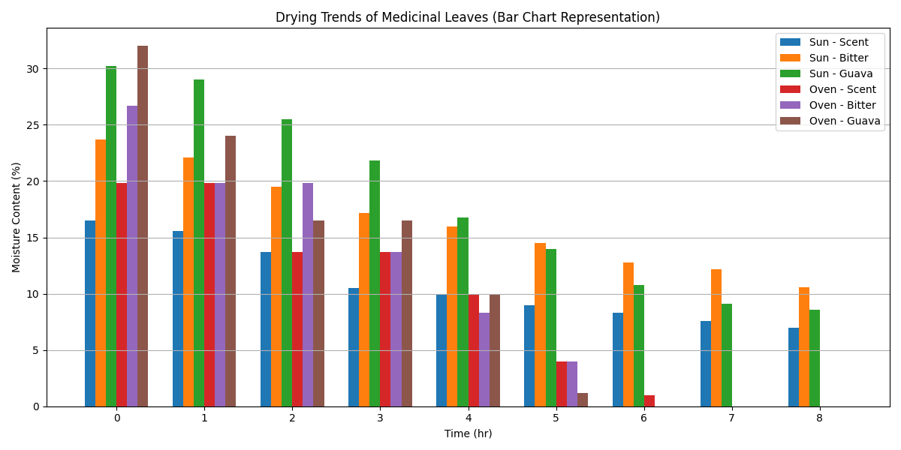

Fig.1: Moisture content profiles of guava, bitter, and scent leaves during sun and oven drying,

highlighting differences in drying kinetics and diffusion-controlled behaviour.

The variation in moisture content with drying time for guava (Psidium guajava), bitter (Vernonia amygdalina), and scent (Ocimum gratissimum) leaves under sun and electrically controlled (oven) drying is presented in Figure 1. The figure generally revealed a continuous decrease in moisture content for all samples; however, the drying kinetics differed markedly between the two drying environments.

Under sun drying, the reduction in moisture content was gradual and exhibited irregular patterns, reflecting fluctuations in ambient temperature and relative humidity. These variations resulted in unstable heat and mass transfer conditions, leading to non-uniform moisture migration. Consequently, the corresponding moisture ratio (MR) curves (Figure 2) showed fluctuating slopes, indicating deviation from ideal exponential behaviour and reduced conformity to classical thin-layer drying models. Moisture content declined steadily, with the fastest reduction between 11:00–13:00 h at peak temperatures (35–36 °C). Bitter leaf dried fastest; guava leaf retained moisture longer due to its waxy cuticle. Moisture removal rate fluctuated with RH and temperature, confirming atmospheric dependence (Togrul and Pehlivan, 2002).

Oven drying produced a rapid and uniform decline in moisture content, reaching near-zero levels by the sixth hour. The drying process followed a typical falling-rate pattern dominated by internal moisture diffusion, consistent with controlled drying systems (Doymaz, 2011). Compared to sun drying, oven drying demonstrated superior efficiency, uniformity, and predictability.

Thin-Layer Model Fitting

Behaviour under Sun Drying
As shown in Figure 2 under sun drying, the moisture ratio (MR) curves displayed fluctuating slopes, directly corresponding to variations in ambient temperature (32–37 °C) and relative humidity (59–80%). Figure 2 presents environmental fluctuations caused non-uniform heat and mass transfer, producing irregular moisture removal rates. Consequently, Henderson–Pabis model exhibited lower conformity due to assumption of simple exponential decay (Henderson and Pabis, 1961), Logarithmic model shows moderate fit; accounts for residual moisture but assumes relative uniformity, while Page model displayed best fit; exponent n accommodates non-linear internal diffusion under variable conditions (Doymaz, 2011)

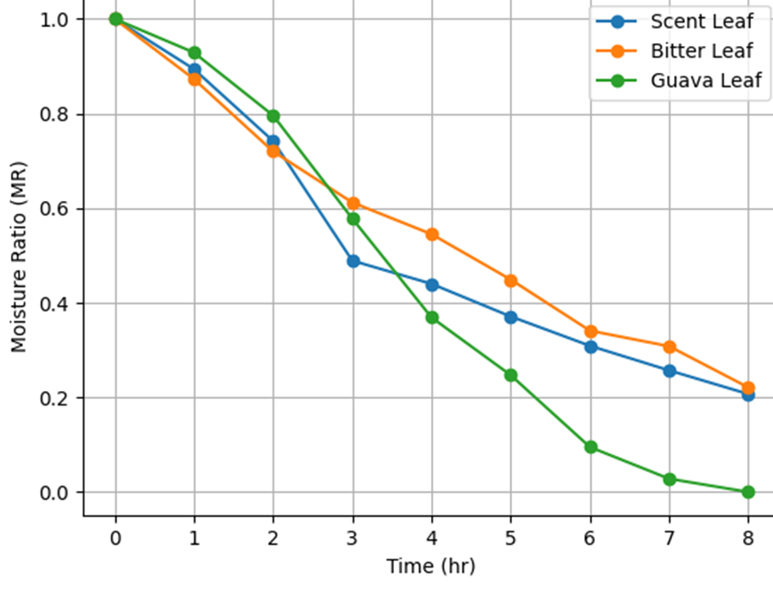
Fig. 2: Model behaviour under sun drying
These observations confirm that sun drying does not strictly follow ideal exponential decay, and its effectiveness is limited by environmental instability. Similar trends were reported in mint and basil, where uncontrolled sun drying resulted in inconsistent MR trends and variable drying rates (Akpinar, 2006; Togrul and Pehlivan, 2002).
Behaviour under Oven Drying
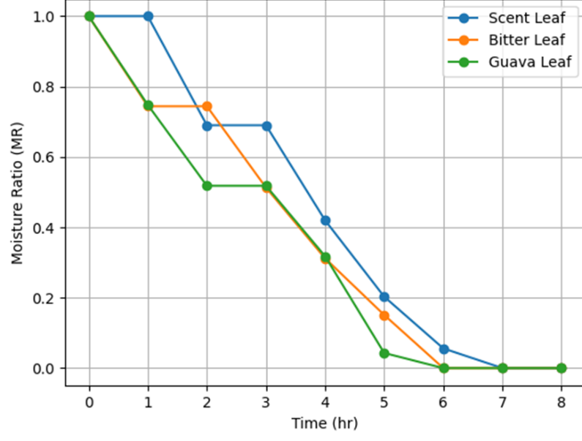
Fig. 3: Model behaviour under oven drying
Oven drying exhibited smooth, exponential moisture decay, characteristic of the diffusion-controlled falling-rate period. MR curves showed, high conformity to Henderson–Pabis, reflecting first-order exponential moisture removal under stable conditions, excellent fit to Page, capturing minor non-linearities due to internal leaf structure and near-perfect Logarithmic predictions, demonstrating minimal irregularities (Figure 3).

As shown in Figure 3, the experimental data closely overlap with all model predictions, particularly the Page and Logarithmic models, confirming the uniformity and predictability of moisture diffusion under electrically controlled conditions. These results demonstrate that electrically controlled atmospheric drying provides the stable thermal and hygroscopic environment required for classical thin-layer drying theory to be valid (Mujumdar, 2014). The smooth MR decay curves enable accurate prediction of drying behaviour, which is essential for dryer design, simulation, and scale-up in agricultural engineering applications.

Model Performance

Table 1: Goodness of Fit for Thin-Layer Models (Oven / Electrically Controlled Drying)
Leaf | Method | Best Model | R² | RMSE | χ²
Scent | Sun | Page | 0.987 | 0.032 | 0.0011
Bitter | Sun | Logarithmic | 0.994 | 0.021 | 0.0006
Guava | Sun | Page | 0.998 | 0.012 | 0.0002
Scent | Oven | Page | 0.978 | 0.041 | 0.0018
Bitter | Oven | Page | 0.969 | 0.048 | 0.0023
Guava | Oven | Logarithmic | 0.963 | 0.055 | 0.0031
The goodness-of-fit statistics indicate that all models adequately described the drying behaviour, with coefficients of determination (R²) ranging from 0.963 to 0.998. The Page model consistently provided the best overall fit, particularly under sun drying conditions, as reflected by higher R² and lower RMSE and χ² values. Lower error metrics observed in guava leaf under sun drying (RMSE = 0.012; χ² = 0.0002) indicate excellent agreement between predicted and experimental moisture ratios (Table 1).
Under oven drying, Table 1 shows slightly higher RMSE and χ² values, although model fits remained strong, confirming the reliability of thin-layer models under controlled atmospheric conditions. The relatively low χ² values across all samples further validate the suitability of the selected models for describing drying kinetics.
Model Constants
Table 2: Model Constants for Sun and Oven Drying of Selected Medicinal Leaves
Drying Method | Leaf | Model | k (h⁻¹) | n | a | c
Sun Drying | Scent | H–P | 0.316 | — | 1.091 | —
Sun Drying | Scent | Page | 0.148 | 1.514 | — | —
Sun Drying | Scent | Log | 0.190 | — | 1.356 | −0.304
Sun Drying | Bitter | H–P | 0.266 | — | 1.061 | —
Sun Drying | Bitter | Page | 0.147 | 1.369 | — | —
Sun Drying | Bitter | Log | 0.111 | — | 1.680 | −0.673
Sun Drying | Guava | H–P | 0.282 | — | 1.136 | —
Sun Drying | Guava | Page | 0.053 | 2.077 | — | —
Sun Drying | Guava | Log | 0.073 | — | 2.560 | −1.492
Oven Drying | Scent | H–P | 0.288 | — | 1.153 | —
Oven Drying | Scent | Page | 0.040 | 2.281 | — | —
Oven Drying | Scent | Log | 0.067 | — | 2.812 | −1.730
Oven Drying | Bitter | H–P | 0.325 | — | 1.071 | —
Oven Drying | Bitter | Page | 0.103 | 1.800 | — | —
Oven Drying | Bitter | Log | 0.134 | — | 1.660 | −0.645
Oven Drying | Guava | H–P | 0.362 | — | 1.047 | —
Oven Drying | Guava | Page | 0.201 | 1.426 | — | —
Oven Drying | Guava | Log | 0.201 | — | 1.331 | −0.329
H -P = Henderson–Pabis, Log = Logarithmic
In Table 2 the estimated model constants reveal clear differences in drying kinetics across both drying methods and leaf types, with important implications for heat and mass transfer behavior.
Generally, the oven (electrically controlled) drying exhibited higher drying rate constants (k) than sun drying for most cases, particularly in the Henderson–Pabis model (e.g., guava: 0.362 h⁻¹ vs 0.282 h⁻¹; bitter: 0.325 h⁻¹ vs 0.266 h⁻¹). This indicates faster moisture removal under controlled thermal conditions, which is attributable to stable temperature, enhanced vapor pressure gradients, and reduced environmental variability. However, an exception is observed for scent leaves, where k is slightly lower under oven drying (0.288 h⁻¹) compared to sun drying (0.316 h⁻¹), suggesting possible structural sensitivity or case hardening effects under elevated temperature (Table 2).
The Henderson–Pabis model consistently produced the highest k values, reflecting its suitability for capturing the initial falling-rate drying phase. The Page model, incorporating exponent n, provided more flexibility in describing moisture diffusion behavior. Notably, n > 1 in all cases indicates super-diffusive drying behavior, typical of biological materials. Higher n values under oven drying (e.g., scent: 2.281 vs 1.514) suggest stronger nonlinearity and enhanced internal moisture migration due to thermal effects. The Logarithmic model introduced parameter c, which was consistently negative, reflecting correction for long-term moisture equilibrium behavior.
Drying characteristics varied significantly among the leaves. Guava leaves exhibited the widest variation in parameters, especially in the logarithmic model (a up to 2.560 under sun drying), indicating higher structural resistance and heterogeneity. Bitter leaves showed relatively moderate and stable parameter values, suggesting more uniform drying behavior. Scent leaves demonstrated sensitivity to drying conditions, particularly in exponent n and logarithmic constants, implying greater responsiveness to temperature changes.
Parameter a generally exceeded unity across models, indicating scaling effects related to initial moisture distribution. The increasingly negative c values (especially under oven drying, e.g., −1.730 for scent) reflect faster approach to equilibrium moisture content under controlled heating.

Practical implications of these constants suggest that oven drying is more efficient for rapid moisture removal and process control, while sun drying, though slower, may preserve structural integrity in certain leaves (e.g., scent). Generally, the Page model appears most robust for predictive modelling due to its flexibility and consistent parameter trends.

DISCUSSION
The present study showed that the Page model consistently provided the best fit to the drying data for guava, bitter, and scent leaves under both sun and electrically controlled (oven) drying, with the highest performance observed for guava leaf under sun drying (R² = 0.998). This agrees strongly with numerous thin-layer drying studies on leafy biomaterials where the Page model outperforms Henderson–Pabis and Logarithmic models due to its ability to capture non-linear internal moisture diffusion in biological tissues (Doymaz, 2011; Togrul and Pehlivan, 2002).

Under sun drying, model fitness varied across time, which can be attributed to the fluctuating temperature (32–37 °C) and relative humidity (59–80%). Similar instability in model prediction during open sun drying has been reported for mint, basil, and spinach leaves, where environmental variations disrupt steady heat and mass transfer, reducing model conformity (Akpinar, 2006; Doymaz, 2006). The fluctuating moisture removal rates observed in this study align with these findings, confirming that sun drying does not strictly follow classical thin-layer theory because the boundary conditions (air temperature, velocity, RH) are not constant.

Conversely, under the electrically controlled atmospheric condition, all three models showed strong agreement with experimental data. This reflects the classical diffusion-controlled falling-rate drying period described by Henderson and Pabis (1961), where moisture migration is governed primarily by internal diffusion once surface moisture is removed. Similar high model conformity under controlled drying has been reported for medicinal and aromatic leaves such as thyme, neem, and moringa dried in cabinet or tray dryers (Doymaz, 2011; Sacilik and Elicin, 2006). The drying constants (k) further revealed important structural differences among the leaves. Bitter leaf consistently exhibited higher k values, indicating faster effective moisture diffusivity. This suggests a more porous cellular matrix that permits rapid moisture migration, corroborating reports on Vernonia amygdalina which describe its thin epidermal layer and high stomatal density (Eleyinmi, 2007). In contrast, guava leaf showed greater resistance to moisture movement, likely due to its thicker cuticle and waxy surface, a characteristic also noted by Ekor (2014) in phytochemical preservation studies of guava leaves.

Importantly, these findings mathematically validate that electrically controlled atmospheric drying produces predictable, model-governed drying kinetics suitable for dryer design, optimization, and scale-up in agricultural engineering. This supports earlier assertions that controlled drying systems are essential for standardizing medicinal plant processing and ensuring quality retention (Mujumdar, 2014). Overall, the agreement of this study with established drying theory and prior experimental findings strengthens the engineering relevance of thin-layer modelling for medicinal leaf dehydration.

CONCLUSION

This study clearly demonstrated that both leaf type and drying environment significantly influence the time–temperature dependent moisture transport behaviour and thin-layer drying kinetics of medicinal leaves. The drying responses of guava (Psidium guajava), bitter (Vernonia amygdalina), and scent (Ocimum gratissimum) leaves varied considerably due to differences in leaf morphology, thickness, surface structure, fibre composition, and internal moisture binding characteristics.

Under sun drying conditions, all leaf samples attained moisture levels considered safe for storage and preservation; however, the drying process was characterized by irregular kinetic behaviour, fluctuating moisture ratio (MR) profiles, prolonged drying time, and lower model predictability due to variations in ambient temperature, solar radiation intensity, wind speed, and relative humidity. These environmental fluctuations resulted in inconsistent heat and mass transfer rates, thereby affecting the reproducibility of drying performance.

In contrast, electrically controlled oven drying exhibited superior time–temperature dependent behaviour, with faster moisture removal, shorter drying duration, and more stable drying curves across all leaf types. The process was predominantly governed by a diffusion-controlled falling-rate period, reflected by higher drying rate constants (k), improved effective moisture diffusivity, and enhanced model conformity. Among the leaves studied, bitter leaf consistently exhibited the fastest drying response, indicating lower resistance to internal moisture migration, while guava leaf showed greater resistance to moisture diffusion, likely due to its denser tissue structure and higher fibre content. Scent leaf displayed intermediate drying behaviour.

Thin-layer modelling further confirmed the robust predictive capability of the Page model, particularly under non-linear and variable drying conditions, whereas all tested models adequately described oven-drying performance. Overall, the findings establish that electrically controlled atmospheric drying provides greater efficiency, predictability, and engineering suitability for process optimization, dryer design, and large-scale preservation of medicinal leaves, while also highlighting the critical role of species-specific drying behaviour in process standardization.

REFERENCES
- Akpinar, E. K. (2006). Mathematical modelling of thin-layer drying process under open sun of some aromatic plants. Journal of Food Engineering, 77(4), 864–870.
- Akinmoladun, A. C., Ibukun, E. O., Afor, E., Akinrinlola, B. L., Onibon, T. R., Akinboboye, A. O., Obuotor, E. M., and Farombi, E. O. (2007). Chemical constituents and antioxidant activity of Alstonia boonei. Scientific Research and Essay, 2(5), 163–166.
- Arima, H., and Danno, G. (2002). Isolation of antimicrobial compounds from guava (Psidium guajava L.) and their structural elucidation. Bioscience, Biotechnology, and Biochemistry, 66(8), 1727–1730.
- Crank, J. (1975). The mathematics of diffusion (2nd ed.). Oxford University Press.
- Doymaz, I. (2011). Drying kinetics of green bean. Journal of Food Engineering, 69(2), 161–165.
- Ekor, M. (2014). The growing use of herbal medicines: Issues relating to adverse reactions and challenges in monitoring safety. Frontiers in Pharmacology, 4, 177. https://doi.org/10.3389/fphar.2013.00177
- Eleyinmi, A. F. (2007). Chemical composition and antibacterial activity of some Nigerian leafy vegetables. African Journal of Biotechnology, 6(22), 2604–2608.
- Erbay, Z., and Icier, F. (2010). A review of thin layer drying of foods: Theory, modeling, and experimental results. Critical Reviews in Food Science and Nutrition, 50(5), 441–464.
- Fellows, P. J. (2009). Food processing technology: Principles and practice (3rd ed.). Woodhead Publishing.
- Gutierrez, R. M. P., Mitchell, S., & Solis, R. V. (2008). Psidium guajava: A review of its traditional uses, phytochemistry, and pharmacology. Journal of Ethnopharmacology, 117(1), 1–27.
- Henderson, S. M., and Pabis, S. (1961). Grain drying theory I: Temperature effect on drying coefficient. Journal of Agricultural Engineering Research, 6, 169–174.
- Ijeh, I. I., and Ejike, C. E. C. C. (2011). Current perspectives on the medicinal potentials of Vernonia amygdalina Del. Journal of Medicinal Plants Research, 5(7), 1051–1061.
- Igile, G. O., Oleszek, W., Jurzysta, M., Burda, S., Fanfunso, M., and Fasanmade, A. A. (1994). Flavonoids from Vernonia amygdalina and their antioxidant activities. Journal of Agricultural and Food Chemistry, 42(11), 2445–2448.
- Krokida, M. K., Maroulis, Z. B., and Saravacos, G. D. (2000). The effect of the method of drying on the colour of dehydrated products. International Journal of Food Science & Technology, 35(2), 183–193.
- Matasyoh, J. C., Maiyo, Z. C., Ngure, R. M., and Chepkorir, R. (2007). Chemical composition and antimicrobial activity of the essential oil of Ocimum gratissimum. African Journal of Biotechnology, 6(6), 760–765.
- Midilli, A., Küçük, H., and Yapar, Z. (2002). A new model for single-layer drying. Drying Technology, 20(7), 1503–1513.
- Mujumdar, A. S. (2014). Handbook of industrial drying (4th ed.). CRC Press.
- Oboh, G. (2006). Nutrient and antinutrient composition of condiments produced from some fermented underutilized legumes. Journal of Food Biochemistry, 30(5), 579–588.
- Okwu, D. E. (2004). Phytochemicals and vitamin content of indigenous spices of southeastern Nigeria. Journal of Sustainable Agriculture and the Environment, 6(1), 30–37.
- Page, G. E. (1949). Factors influencing the maximum rates of air drying shelled corn in thin layers (Unpublished master’s thesis). Purdue University.
- Prakash, P., and Gupta, N. (2005). Therapeutic uses of Ocimum sanctum Linn (Tulsi) with a note on eugenol and its pharmacological actions. Indian Journal of Physiology and Pharmacology, 49(2), 125–131.
- Sacilik, K., and Unal, G. (2005). Dehydration characteristics of Kastamonu garlic slices. Biosystems Engineering, 92(2), 207–215. https://doi.org/10.1016/j.biosystemseng.2005.06.006
- Sofowora, A. (2008). Medicinal plants and traditional medicine in Africa (3rd ed.). Spectrum Books Limited.
- Togrul, I. T., and Pehlivan, D. (2002). Mathematical modelling of solar drying of apricots in thin layers. Journal of Food Engineering, 55(3), 209–216. https://doi.org/10.1016/S0260-8774(02)00065-1
- Trease, G. E., and Evans, W. C. (2002). Pharmacognosy (15th ed.). Saunders Publishers.
- Vega-Gálvez, A., Ah-Hen, K., Chacana, M., Vergara, J., Martínez-Monzó, J., García-Segovia, P., Lemus-Mondaca, R., and Di Scala, K. (2012). Effect of temperature and air velocity on drying kinetics, antioxidant capacity, total phenolic content, colour, texture and microstructure of apple. Food Chemistry, 132(1), 51–59.
- World Health Organization (WHO). (2013). WHO traditional medicine strategy 2014–2023. WHO Press.

APPENDIX
Mathematical Models
Table 3: Mathematical Models Describing Drying Kinetics of Selected Leaves under Sun
and Oven Drying
Drying Method | Model | Guava Leaf | Bitter Leaf | Scent Leaf
Sun  Drying | Henderson–Pabis | $$MR=1.136e^{-0.282t}$$ | $$MR=1.061e^{-0.266t}$$ | $$MR=1.091e^{-0.316t}$$
 | Page | $$MR=e^{-0.05382t^{2.077}}$$ | $$MR=e^{-0.147t^{1.369}}$$ | $$MR=e^{-0.148t^{1.514}}$$
 | Logarithmic | $$MR=2.5606e^{-0.073t}-1.492$$ | $$MR=1.680e^{-0.111t}-0.673$$ | $$MR=1.356e^{-0.190t}-0.304$$
Oven  Drying | Henderson–Pabis | $$MR=1.047e^{-0.362t}$$ | $$MR=1.071e^{-0.325t}$$ | $$MR=1.153e^{-0.288t}$$
 | Page | $$MR=e^{-0.201t^{1.426}}$$ | $$MR=e^{-0.103t^{1.800}}$$ | $$MR=e^{-0.040t^{2.281}}$$
 | Logarithmic | $$MR=1.331e^{-0.201t}-0.329$$ | $$MR=1.660e^{-0.134t}-0.65$$ | $$MR=2.812e^{-0.067t}-1.730$$

