Bioefficacy of Indigenous Plant Extracts in Controlling Spiraling Whitefly (Aleurodicus dispersus) on Psidium guajava

Abstract
The adaptive relationship between insects and their host plants involves both behavioural and metabolic changes, contributing to the vast diversity of insect–plant interactions. The polyphagous species Aleurodicus dispersus (spiraling whitefly) is a major pest of many horticultural crops across tropical regions, including India, Sri Lanka, and Thailand. This study investigates the infestation of A. dispersus on guava (Psidium guajava) trees within the campus environment and evaluates the effectiveness of selected plant extracts as eco-friendly control agents. The major pests of guava tree are Oriential fruitfly, Red banded thrips ,Mites,Bark borerer and Spiral whitefly.Extracts from Diospyros chloroxylon and Mundulea sericea were tested against A. dispersus. Among these, D. chloroxylon extract significantly reduced the final population density and overall infestation levels of the pest. Biochemical analysis revealed the presence of rotenone,in both the plants, more so in Diospyos chloroxylon which inhibits NADH ubiquinone reductase in mitochondria, disrupting aerobic respiration in insects. The findings suggest that D. chloroxylon extract is an effective natural insecticide and highlight the sustainable use of plant-derived compounds for pest management in horticultural crops.
Keywords: Aleurodicus dispersus, Psidium guajava, Diospyros chloroxylon, plant extract, natural insecticide, rotenone

1. Introduction
Insect–plant interactions are highly adaptive, involving complex behavioral and metabolic adjustments. The spiraling whitefly, Aleurodicus dispersus (Hemiptera: Aleyrodidae), is a polyphagous pest known to infest a wide range of host plants. It has been reported from several tropical and subtropical regions, including India, Sri Lanka, and Thailand.
Guava (Psidium guajava L.) is a nutritionally rich fruit crop of economic importance, valued for its vitamins, antioxidants, and medicinal properties—attributes that gained particular recognition during the COVID-19 pandemic. However, infestations of A. dispersus can severely reduce plant vigor, causing leaf yellowing, silvering, curling, and premature defoliation, leading to yield loss.
Due to the environmental and health hazards associated with chemical pesticides, there is a growing need for sustainable pest management strategies. Botanical extracts are promising alternatives because of their biodegradability, availability, and selective toxicity. This study aims to evaluate the efficacy of Diospyros chloroxylon and Mundulea sericea leaf extracts against A. dispersus on guava plants.
The spiraling whitefly has a very wide host range, infesting numerous economically important crops such as banana, cassava, citrus, papaya, mango, custard apple, guava, tomato, capsicum, and eggplant. It also affects many ornamental plants, shade trees, and weeds. The adult female lays eggs on the undersides of leaves or on fruit surfaces in distinctive spiral patterns, which gives the insect its common name.
2. Materials and Methods

2.1 Study Area
The study was conducted within the biodiversity-rich campus area, where naturally infested Psidium guajava plants were identified for observation and experimentation.

2.2 Collection and Rearing of A. dispersus
Infested guava leaves showing typical symptoms of whitefly damage were collected. Adult and nymphal stages of A. dispersus were maintained under laboratory conditions for experimental use.
: Level of Infestation Assessment

Result - Maximum infestation (85-100%): Severe incidence of A.dispersus (pest) on the entire tree guava tree.
The observation and assessment of A.dispersus on guava tree,showed maximum level of infestation that ranged from 85-100 % inclusive of eggs, instar larvae and adults on all branches of the guava tree.
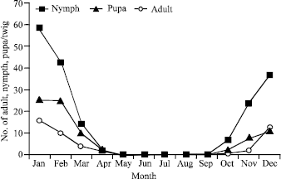
Level of Infestation Assessment

Result - Maximum infestation (85-100%): Severe incidence of A.dispersus (pest) on the entire tree guava tree.
The observation and assessment of A.dispersus on guava tree,showed maximum level of infestation that ranged from 85-100 % inclusive of eggs, instar larvae and adults on all branches of the guava tree.

2.3 Preparation of Plant Extracts

Leaves of Diospyros chloroxylon and Mundulea sericea were collected, shade-dried, and ground into fine powder. The powders were subjected to solvent extraction using ethanol. The extracts were concentrated under reduced pressure and stored at 4°C until use.
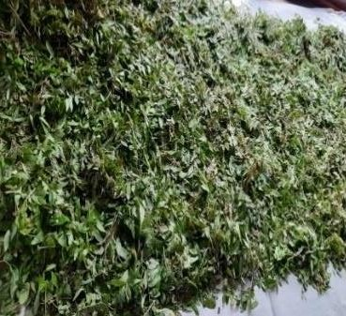

2.4 Bioassay ACUTE TOXICITY EVALUATION AND MORTALITY
Acute toxicity can be measured by taking into account the rate of mortality after a defined period of time as the increasing toxicant dosages (Ramade 1987). The LC50 (median lethal concentration ) is the most important parameter which causes 50% deaths in the population being studied. The eggs, Pupa and adults of A.dispersus were subjected to various concentrations for 24 hrs in the current investigation.The Mortality percentage was reported and statistical analysis was analyzed.

: STATISTICAL ANALYSIS
Acute tocxicity level of A.dispersus(adult,egg,and larva) among treatments were investigated by univariate comparison testing (ANOVA) with SPSS® software version

29.0 ), Chi-squared values, LC50 figures. were analysed from probit analysis (Robertson et al. 2007). Mortality probit regression equations were calculated for A. dispersus. The Data is subjected to statistical analysis using SPSS 29.0 software. The adult, egg and larval. the bioefficacies (Acute toxicity) were subjected to probit Analysis for calculating LC50 values of test compounds. Using Abbotts’s( 1987) formula, the acute toxicity of A.dispersus is determined.

2.5 Data Analysis
Percent mortality and reduction in population density were calculated. Statistical analysis was performed to determine significant differences among treatments.

Table- 13: Mortality of Egg of A.dispersus Dc ML (Diospyros chloroxylon Methanol extract Leaves)

Conc (ppm) | 24hrs % Mortality | Mean | Std Deviation | Std error | LC50(pp  m) | LCL-  UCL(ppm) | Regression equation | R2 | X2
Control | 0 | 0.00 | 0.000 | .419 | 104.621 | 76.383-  144.317 | y=2.62+1.29 x | 0.919 | 3.815
25 | 10.93 | 1.60 | .548
50 | 17.22 | 4.40 | .548
100 | 24.50 | 5.00 | .707
200 | 31.87 | 6.60 | .548
400 | 38.32 | 7.80 | .447

Table- 1 Acute Toxicity of Diospyros chloroxylon Methanol Leaves on Egg of Aleurodicus dispersus

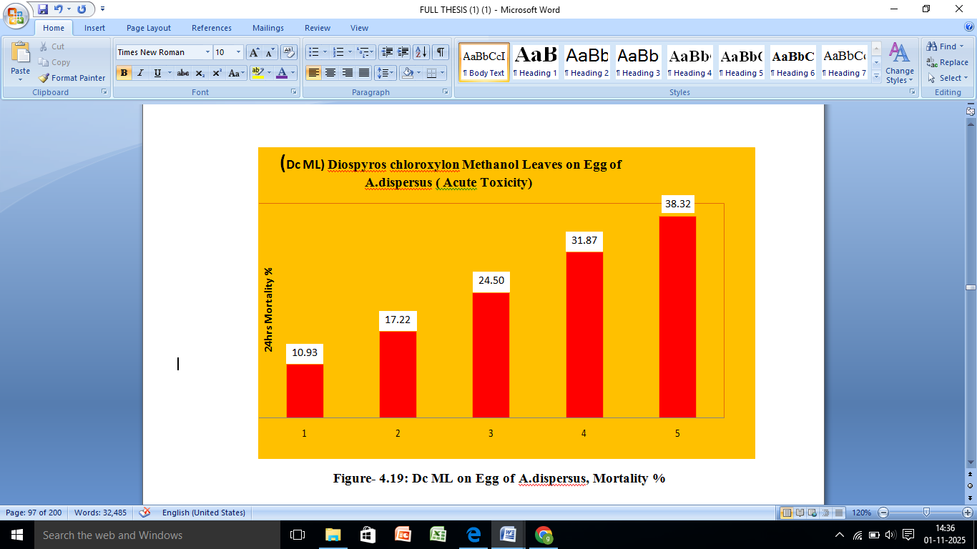

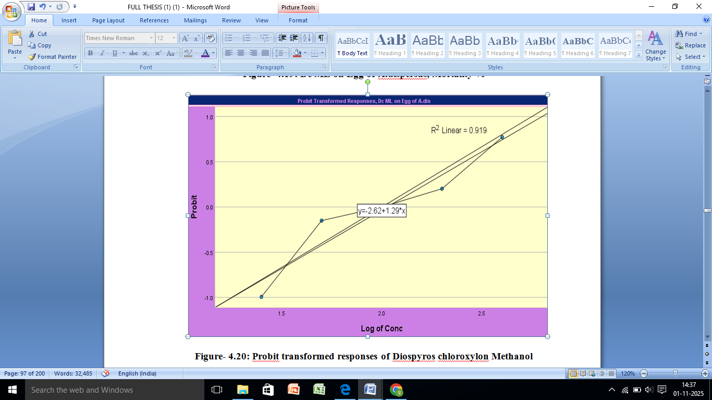

Figure-2 Probit transformed responses of Diospyros chloroxylon

Laboratory bioassays were conducted by spraying the prepared plant extracts on infested guava leaves. Control leaves were treated with distilled water. The number of live and dead whiteflies was recorded at 24, 48, and 72 hours post-treatment.

3. Results
Both plant extracts exhibited insecticidal activity against A. dispersus, but the effect of D. chloroxylon was significantly higher than that of M. sericea. The D. chloroxylon extract caused a pronounced reduction in final population density and infestation level on treated guava plants. Leaves treated with this extract showed reduced damage symptoms and improved plant vigor compared to untreated controls.

4. Discussion
The results demonstrate the potential of D. chloroxylon extract as an effective botanical pesticide against A. dispersus. The superior efficacy of this extract can be attributed to the presence of rotenone, a naturally occurring compound known to inhibit the mitochondrial enzyme NADH ubiquinone reductase. This inhibition blocks electron transport in the respiratory chain, thereby preventing oxygen utilization and leading to insect mortality.
The findings align with earlier studies reporting the insecticidal activity of plant-derived rotenoids. The use of such natural products offers an environmentally safe and sustainable alternative to synthetic pesticides, promoting healthy crop production and biodiversity conservation.

5. Conclusion
The study confirms that the leaf extract of Diospyros chloroxylon possesses significant insecticidal properties against Aleurodicus dispersus. Its active compound, rotenone, disrupts cellular respiration in the pest, leading to high mortality. This approach supports sustainable agriculture through the use of eco-friendly and naturally available plant resources. Further field trials and formulation studies are recommended to develop practical applications for pest control.
References
- A. Gibson, Colewart and the Cole Crops, University of California Los Angeles,LosAngeles, CA, USA, 2012.
- AbdEl Halim,A.Mohamed,Hafeez,R.Habeeb and Safwat,A.Azer-Taxonomic Revision of Ebenaceae in Egypt- Current Science International 3(4):414-425,2014
- Abottt, W.S. 1925. A method of computing the effective insecticide. Journal ofEconomicEntomology,18: 265-267.
- Ahamed,C.A.A.,Narayanaswamy, K.C. ,Ramegowda ,T., Chandrakala,M.
  - 1999.Impactoffeedingspirallingwhiteflyaffectedmulberryleafonnutritionalparametersandcocoonconversionefficiencyinthesilkworm,Bombyxmori L. during fifth instar. Mysore Journal of Agricultural Sciences,33: 355-360. Aishwariya, K. K., Manjunatha, M., Naik, M. 2007a. Biology and hostrange of spiralling whitefly. Karnataka Journalof Agricultural Sciences,20: 149-152
- Ahamed ,C.A.A. ,Narayanaswamy ,K.C., Ramegowda, T., Chandrakala,M.
  - 1999.Impactoffeedingspirallingwhiteflyaffectedmulberryleafonnutritionalparametersandcocoonconversionefficiencyinthesilkworm,Bombyxmori L. during fifth instar. Mysore Journal of Agricultural Sciences,33: 355-360.
- Ahmed L,KanthRH,ParvazeS,Mahdi SS, Agro- climatic and agro- ecologicalzones of India.In: Experimental Agrometeorlogy:A Practical Manual. Cham:Springer;2017pp99-118.
- Aishwariya, K. K., Manjunatha, M., Naik, M. 2007a. Biology and host range ofspirallingwhitefly.Karnataka JournalofAgriculturalSciences, 20:149-152.
- Aishwariya, K. K., Manjunatha, M., Naik, M. 2007b. Seasonal incidence ofspiralling whitefly Aleurodicusdispersus Russell and its natural enemies inrelation to weather in Shimoga. Karnataka Journal of Agricultural Sciences,20(1):Aiswariaya, K.K., Manjunatha, M. and Naik, M. 2007b. Seasonal incidence ofspiralingwhiteflyAleurodicusdispersusRussellanditsnaturalenemiesinrelation to weather in Shimoga. Karnataka Journal of Agricultural Sciences,20(1):146-148.
- Aiswariaya, K.K., Manjunatha, M. and Naik, M. 2007c. Evaluation of fungiFusariumsemitectumBerkandRavenelandVerticilliumlecanii(Zimm.)ViegasagainstspiralingwhiteflyAleurodicusdispersusRussellonguava.KarnatakaJournal of Agricultural Sciences, 20: 283-287
- Neuenschwander, P. (1994) Spiralling whitefly Aleurodicusdispersus, a recentinvader and new cassava pest in Africa. African Crop Sci. J. 2, 419–421.GoogleScholar
- Nijhof, B.W., Oudman, L., Torres, R. and Garrido, C. 2000. The introduction ofEncarsiaguadeloupae (Hymenoptera: Aphelinidae) for control of Aleurodicusdispersus and Lecanoideusfloccissimus (Homoptera: Aleurodidae) on Tenerife.In Proceedings of the Section Experimental and Applied Entomology of theNetherlandsEntomological Society.11:41-47
- Ranjith, A.M., Rao, D.S. and Thomas, J. 1996. New host records of the "MealyWhitefly", Aleurodicusdispersus Russell in Kerala. Insect Environment, 2(2):35-38.

