An Empirical Study on Consumer Awareness and Behavior Towards Sustainable Packaging in the FMCG Sector

This study aims to provide insights into consumer awareness, attitudes, and behavioural tendencies toward sustainable packaging, contributing to a better understanding of evolving preferences in the fast-moving consumer goods (FMCG) sector and offering implications for marketers and policymakers promoting environmentally responsible consumption. The research adopts a quantitative, descriptive, and cross-sectional design focusing on consumers in the urban context of Chandigarh. The target population includes individuals aged 18 years and above who regularly purchase FMCG products such as packaged food, personal care, and household items. Data were collected using a non-probability purposive sampling technique from 200 respondents through online and offline modes. After data cleaning, 144 valid responses were retained for analysis. A structured questionnaire was used, comprising three sections: demographic profile, awareness and perception of sustainable packaging, and behavioural practices related to eco-friendly packaging. The items were measured on a five-point Likert scale, adapted from established instruments and tailored to the Indian context.
A pilot study was conducted to ensure clarity and reliability of the instrument. Internal consistency was assessed using Cronbach’s alpha, with a threshold value of 0.70 considered acceptable. The findings of the study are expected to provide valuable insights into consumer perspectives on sustainable packaging and support strategic decision-making for promoting environmentally sustainable practices in the FMCG sector.
Keywords: Customer Awareness, sustainable packaging, FMCG products.
INTRODUCTION
The global shift toward environmental sustainability has prompted businesses and policymakers to reconsider traditional production and consumption practices, with packaging emerging as a critical area of ecological concern (Dangelico & Vocalelli, 2017). The Fast-Moving Consumer Goods (FMCG) sector, in particular, relies extensively on packaging for product preservation, branding, and consumer appeal, making it a significant contributor to plastic waste and environmental degradation. In India, the FMCG market is among the largest and fastest-growing globally, driven by rapid urbanization, rising disposable incomes, and expanding retail infrastructure (IBEF, 2023). However, this growth has been accompanied by a substantial increase in packaging waste—especially non-biodegradable plastics—posing serious environmental and public health challenges (CPCB, 2022).In response, sustainable packaging—encompassing recyclable, biodegradable, compostable, and reusable materials—has gained prominence as a strategic solution. While several FMCG companies in India have begun adopting such practices, their effectiveness largely depends on consumer acceptance and perception. Understanding how consumers perceive, interpret, and value sustainable packaging is therefore crucial, particularly in a diverse and price-sensitive market like India. Existing literature suggests that although environmental awareness among Indian consumers is increasing, actual behavioral change remains limited due to competing factors such as cost, convenience, aesthetics, and inadequate information (Biswas & Roy, 2015; Joshi & Rahman, 2019).
Despite the growing emphasis on green consumption, there is a lack of empirical research in the Indian context that quantitatively examines consumer perceptions and behaviors specifically toward sustainable packaging in FMCG products. This study aims to address this gap through a quantitative approach with three key objectives: (1) to evaluate consumer awareness and understanding of sustainable packaging; (2) to analyze its influence on purchase decisions; and (3) to examine the demographic and psychographic factors shaping consumer perceptions.
By identifying the key drivers and barriers to consumer acceptance, this research seeks to inform the development of targeted policies that align environmental sustainability with consumer behavior. Additionally, the findings will offer practical insights for packaging innovation, sustainable branding, and corporate social responsibility within the Indian FMCG sector. As India advances toward achieving its Sustainable Development Goals—particularly SDG 12 (Responsible Consumption and Production)—consumer-centric research on sustainable packaging is not only relevant but essential.
LITERATURE REVIEW

Understanding Sustainable Packaging in the FMCG Sector
Sustainable packaging involves the use of materials and design strategies that minimize environmental impact across a product’s lifecycle, including recyclability, biodegradability, reduced material usage, and energy-efficient production (Nordin & Selke, 2010). In the FMCG sector, packaging functions not only as protection and a marketing tool but also as a signal of environmental responsibility. Globally, FMCG firms are increasingly adopting sustainable alternatives in response to regulatory pressures and evolving consumer expectations (Dangelico & Vocalelli, 2017). In India, this transition is still emerging but gaining momentum due to rising environmental awareness and regulatory frameworks such as the Plastic Waste Management Rules (CPCB, 2022).

Consumer Awareness and Understanding
Consumer awareness is critical for the acceptance of sustainable packaging, encompassing knowledge of environmental impacts and familiarity with eco-friendly alternatives. Research indicates that environmentally informed consumers are more likely to support green products (Magnier & Schoormans, 2015). However, in emerging economies like India, awareness of sustainability concepts and certifications remains limited (Joshi & Rahman, 2015). Although Indian consumers often express concern for the environment, insufficient understanding of eco-labels and packaging attributes contributes to a gap between attitudes and actual behaviour (Biswas & Roy, 2015).

Influence on Purchase Behaviour
Sustainable packaging can influence purchase decisions by acting as both a visual and ethical cue, shaping brand perception and trust (Steenis et al., 2017). Despite stated preferences for eco-friendly packaging, actual buying behaviour is often constrained by factors such as price, convenience, and aesthetics (Van Birgelen et al., 2009). In India, high price sensitivity and skepticism toward green claims further limit consistent adoption (Gupta & Ogden, 2009). Therefore, affordability and transparent communication are essential for driving consumer acceptance.
Demographic and Psychographic Factors
Consumer perceptions of sustainable packaging are influenced by demographic factors such as age, education, and income, as well as psychographic variables like environmental consciousness and lifestyle orientation. Younger and more educated consumers tend to show stronger pro-environmental attitudes (Yadav & Pathak, 2016). Additionally, individuals with higher environmental concern and perceived consumer effectiveness are more likely to prefer and pay for sustainable packaging, provided its benefits are clearly communicated (Nguyen et al., 2020).

Indian Consumer Trends in Sustainable Consumption
The Indian market reflects a blend of traditional frugality and increasing environmental awareness. While concern for sustainability is rising, adoption remains largely urban-centric (Kumar & Polonsky, 2017). Behavioral inconsistency persists due to limited availability of sustainable options, fear of greenwashing, and lack of clear information (Roy & Sarin, 2019). These patterns underscore the importance of targeted communication and context-specific sustainability strategies in the FMCG sector.
RESEARCH OBJECTIVES
1. To examine consumer perceptions towards sustainable packaging
2. To study the impact of suitable packaging on demographic factors
METHODOLOGY
The present study adopts a quantitative, descriptive, and cross-sectional research design to examine consumer perceptions of sustainable packaging in FMCG products within the urban context of Chandigarh. The target population comprises consumers aged 18 years and above who regularly purchase FMCG items, including packaged food, personal care, and household products.Data were collected using a non-probability purposive sampling technique. A total of 200 responses were gathered through both online (Google Forms) and offline (physical surveys) methods; after data cleaning, 144 valid responses were retained for analysis.
A structured questionnaire was developed, consisting of three sections: (1) demographic profile, (2) awareness and perception of sustainable packaging, and (3) behaviour related to eco-friendly packaging practices. The items were measured using a five-point Likert scale and were adapted from validated instruments in prior studies, with modifications to suit the Indian context.A pilot study was conducted with 20 respondents to ensure clarity and reliability of the instrument. Internal consistency was assessed using Cronbach’s alpha, with a threshold of 0.70 considered acceptable.
RESULTS AND DISCUSSION
This section presents and analyses the findings of the study on consumer perceptions of sustainable packaging in FMCG products in Chandigarh. The results are structured across key areas, beginning with respondents’ demographic profiles, followed by their awareness and understanding of sustainable packaging, perceptions of eco-friendly packaging, and its influence on purchase intentions. The findings are interpreted in light of existing literature, with particular reference to the study’s research objectives. By integrating descriptive statistics with analytical insights, this section not only captures consumer attitudes but also highlights their implications for FMCG firms and sustainability-focused policymaking.
4.1 Age Distribution
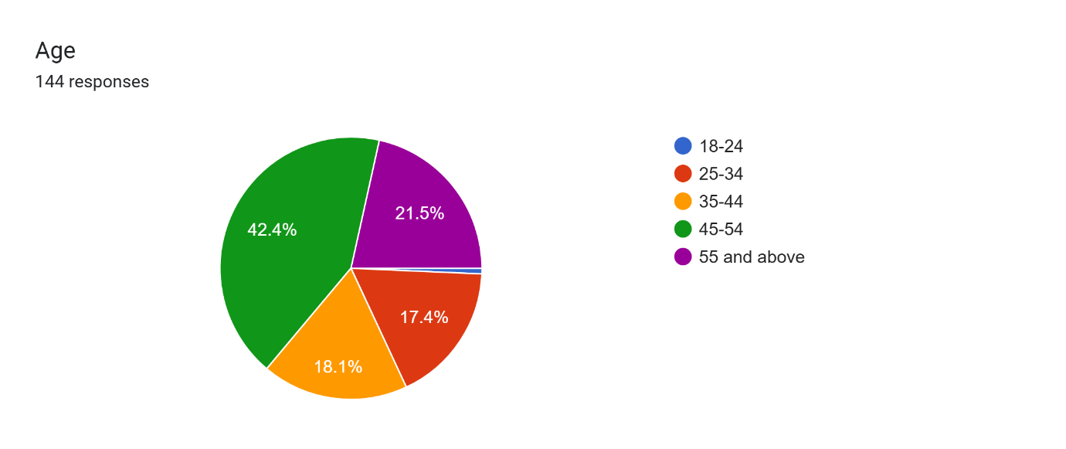
Source: Primary Data
The age distribution of respondents reveals that the largest segment falls within the 45–54 years category (42.4%), followed by those aged 55 years and above (21.5%). Respondents aged 35–44 years account for 18.1%, while 17.4% belong to the 25–34 years group. In contrast, the representation of younger consumers aged 18–24 is minimal (0.7%).
These findings indicate a sample predominantly composed of middle-aged and older consumers, suggesting that concerns regarding sustainable packaging in FMCG products extend beyond younger demographics. This has important implications for marketers, emphasizing that sustainable packaging strategies should not be limited to youth-focused segments but should also address the preferences and expectations of middle-aged and senior consumers, who constitute a substantial portion of the FMCG market in Chandigarh.
. 4.2 Gender Distribution
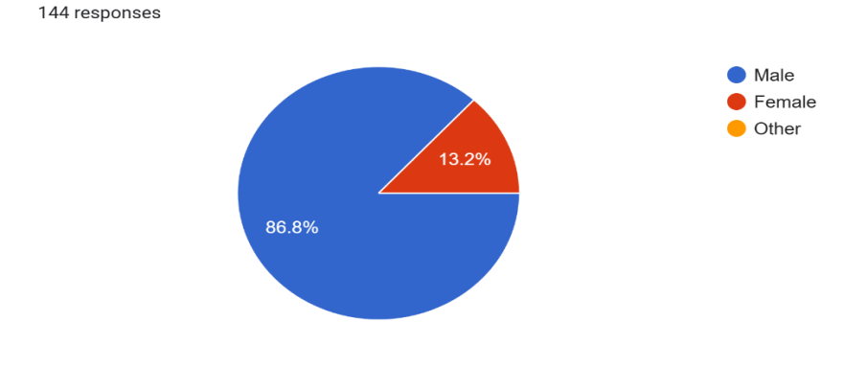
Source: Primary Data
The gender distribution of respondents indicates a strong male dominance, with 86.8% male and 13.2% female participants, while no responses were recorded under the “Other” category.Overall, the findings highlight the need for more balanced gender representation in future studies to better capture variations in sustainability-related attitudes and behaviours across different consumer groups.
4.3 Education Qualification Level
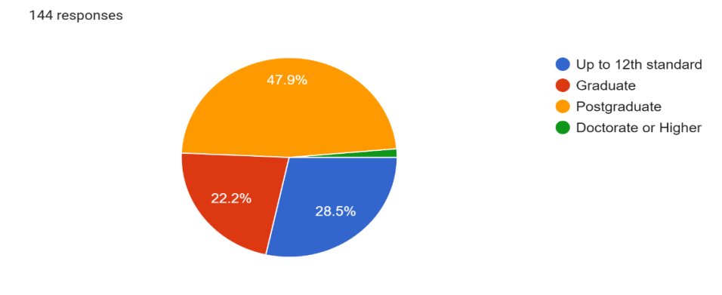
Source: Primary Data
The educational profile of respondents indicates that the largest segment comprises postgraduates (47.9%), followed by individuals educated up to the 12th standard (28.5%) and graduates (22.2%). Only a small proportion (1.4%) reported holding a doctorate or higher qualification.These findings imply that FMCG firms should tailor sustainability communication strategies according to educational levels—using simple and clear eco-label messaging for less educated consumers, while providing detailed and evidence-based information for highly educated individuals who actively seek environmental credibility.
4.4 Monthly Household Income Distribution
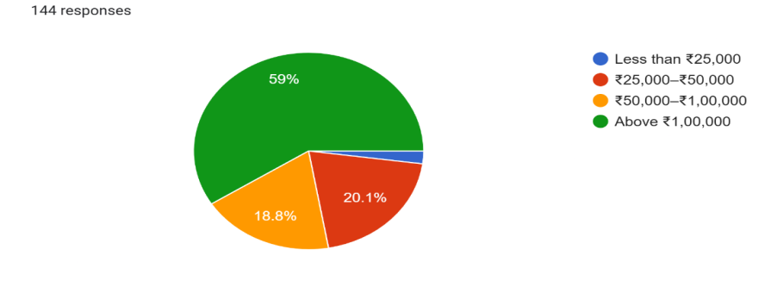
Source: Primary Data
The income distribution of respondents indicates that a majority (59%) belong to households earning above ₹1,00,000 per month, reflecting a relatively affluent urban sample. Approximately 20.1% of respondents fall within the ₹25,000–₹50,000 income range, while 18.8% report earnings between ₹50,000–₹1,00,000. Only 2.1% of respondents have a monthly household income below ₹25,000.
The findings therefore highlight the need for FMCG firms to balance sustainability with affordability, ensuring that eco-friendly packaging solutions remain accessible across diverse income segments in the Indian market.
4.5 Occupation Status
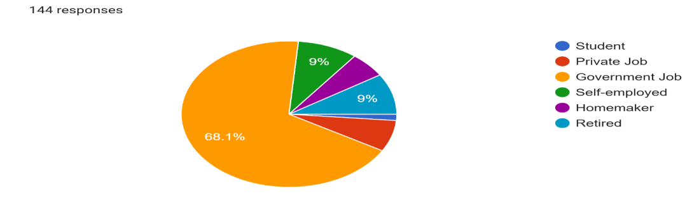
The occupational distribution of respondents indicates that a majority are employed in the government sector (68.1%), making it the most dominant category. The remaining respondents are evenly distributed among students (9%), self-employed individuals (9%), homemakers (9%), and retired persons (9%), while representation from the private sector is minimal.Overall, the findings imply that while sustainable packaging strategies should have broad appeal, targeted communication approaches can enhance effectiveness—such as awareness-driven campaigns for students and affordability-focused messaging for homemakers and retired consumers.
4.6 Frequency of Shopping for Necessity Goods
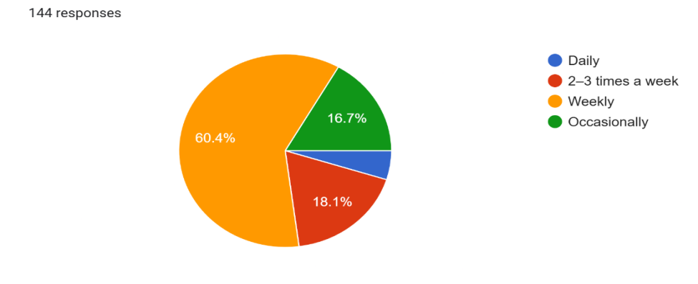
Source: Primary Data
The shopping frequency data indicates that the majority of respondents (60.4%) purchase FMCG necessities on a weekly basis, making this the most common shopping cycle. Around 18.1% shop 2–3 times a week, while 16.7% shop occasionally. Only 4.9% reported shopping daily for essential FMCG products.The findings also suggest that purchase frequency could moderate sustainable packaging choices. Regular weekly or multiple-time shoppers are more likely to encounter eco-friendly alternatives, thus increasing the likelihood of awareness and adoption.

4.7 Awareness of Sustainable Packaging
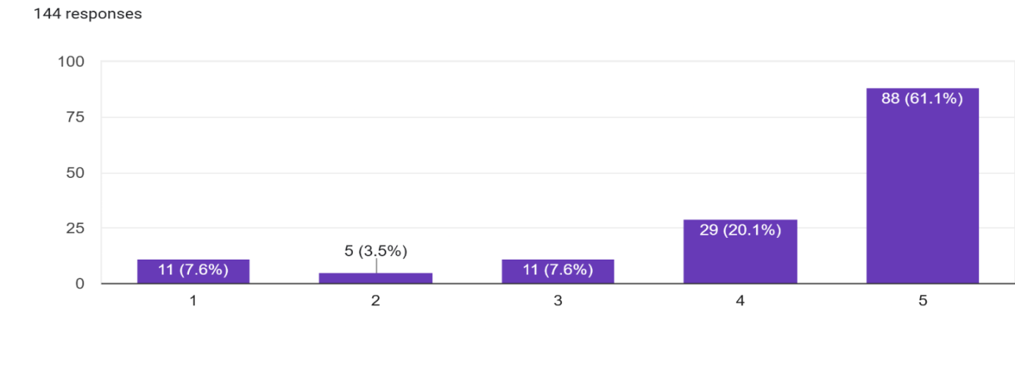
Source: Primary Data
The results indicate a high level of awareness among respondents regarding sustainable packaging. A majority of 61.1% (n=88) strongly agreed that they are aware of sustainable packaging, while an additional 20.1% (n=29) agreed with the statement. Smaller proportions were neutral (7.6%, n=11), disagreed (7.6%, n=11), or strongly disagreed (3.5%, n=5).This finding demonstrates that over four-fifths of the respondents (81.2%) expressed agreement or strong agreement about their awareness, reflecting that sustainable packaging is gaining visibility in Chandigarh’s consumer market.
4.8 Difference between Recyclable, Biodegradable, and Compostable packaging
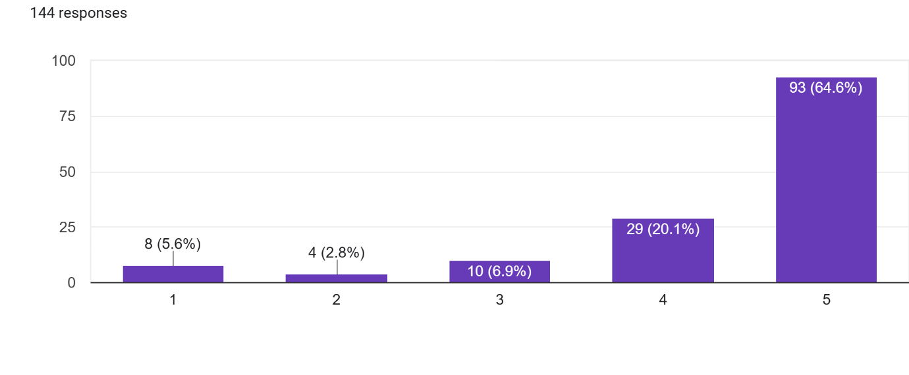
Source: Primary Data
The findings reveal that a significant majority of respondents claimed to understand the differences between recyclable, biodegradable, and compostable packaging. Specifically, 64.6% (n=93) strongly agreed, while 20.1% (n=29) agreed with the statement. A smaller portion remained neutral (6.9%, n=10) or disagreed (2.8%, n=4) and 5.6% (n=8) strongly disagreed.Overall, more than 84% of respondents expressed agreement or strong agreement, suggesting that Chandigarh consumers demonstrate relatively high awareness of packaging terminology. The results here suggest that exposure to sustainability campaigns, education levels, and greater availability of eco-friendly alternatives may have improved consumer literacy in this domain.
4.9 Observation of Eco-Friendly Symbols on Product Packaging
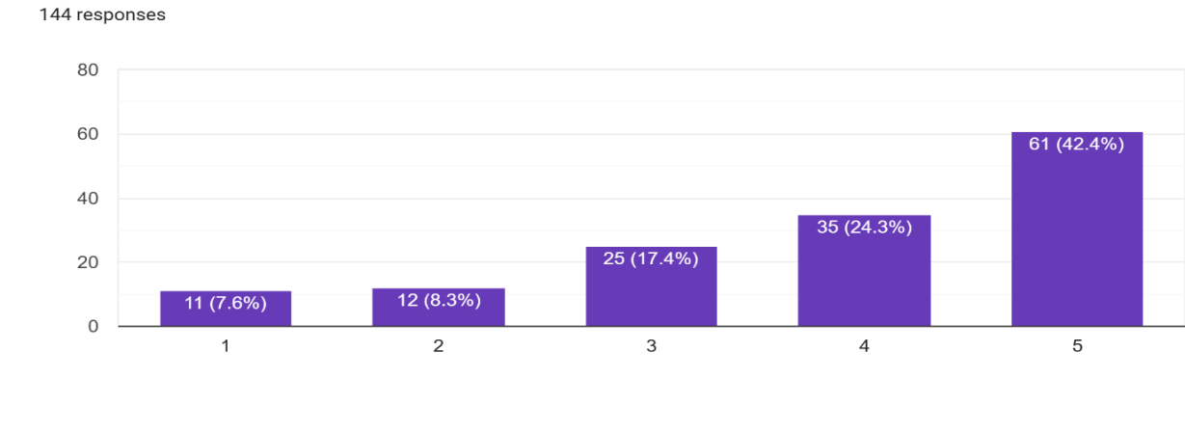
Source: Primary Data
The findings indicate that a majority of respondents reported noticing eco-friendly symbols on product packaging. Specifically, 42.4% (n=61) strongly agreed and 24.3% (n=35) agreed, showing that more than two-thirds of consumers actively recognize such labels. Meanwhile, 17.4% (n=25) remained neutral, and smaller proportions disagreed (8.3%, n=12) or strongly disagreed (7.6%, n=11).These results emphasize the need for FMCG companies to make eco-labels more visible, standardized, and trustworthy.
4.10 Active Search for Product Packaging Information Before Purchase
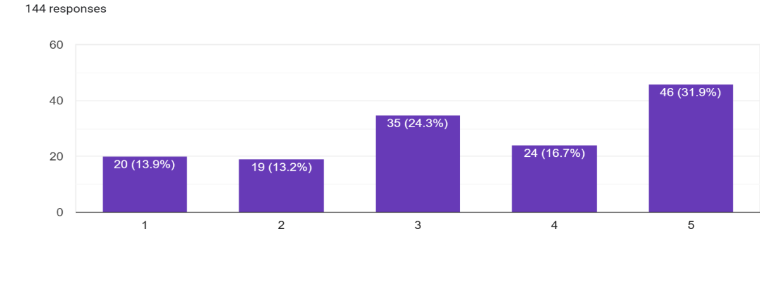

Source: Primary Data
The results indicate mixed behavior among consumers regarding their active search for packaging information prior to purchase. About 31.9% (n=46) strongly agreed and 16.7% (n=24) agreed, suggesting that nearly half of the respondents actively engage with packaging details. Meanwhile, 24.3% (n=35) were neutral, and a considerable share disagreed—13.2% (n=19) disagreed and 13.9% (n=20) strongly disagreed.
These findings show that while a sizeable proportion of consumers in Chandigarh are motivated to seek packaging information before making a purchase, a significant number either remain indifferent or do not prioritize such details
4.11 Belief that Unsustainable Packaging Causes Environmental Damage
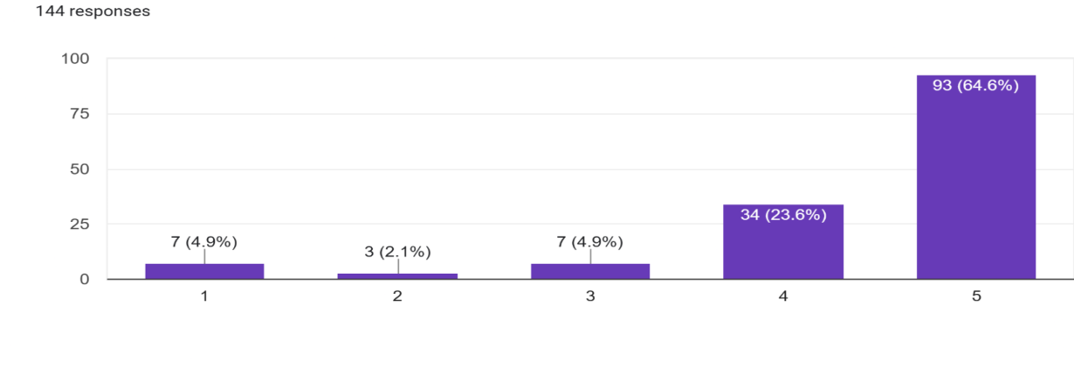
Source: Primary The results show overwhelming agreement among respondents that unsustainable packaging significantly contributes to environmental damage. A majority of 64.6% (n=93) strongly agreed, while 23.6% (n=34) agreed with this statement. Only small proportions were neutral (4.9%, n=7), disagreed (2.1%, n=3), or strongly disagreed (4.9%, n=7).Taken together, 88.2% of respondents expressed agreement or strong agreement, reflecting a clear recognition of the negative ecological impact of non-biodegradable and excessive plastic packaging
4.12 Sustainable Packaging: A Key to Environmental Protection
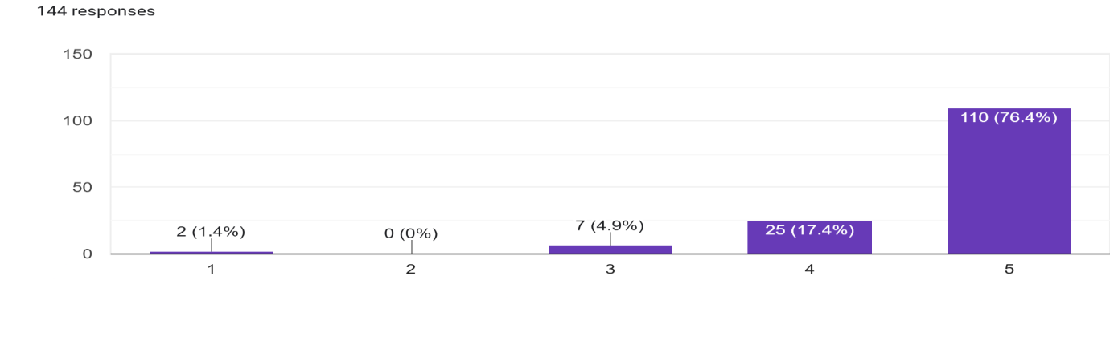
Source: Primary Data
The findings clearly demonstrate that respondents strongly perceive sustainable packaging as a key contributor to environmental protection. A vast majority, 76.4% (n=110) strongly agreed and 17.4% (n=25) agreed, while only 4.9% (n=7) were neutral. Minimal disagreement was recorded, with 1.4% (n=2) strongly disagreeing and none choosing simple disagreement.
Overall, 93.8% of respondents affirmed the role of sustainable packaging in environmental protection, showcasing a strong alignment with global narratives that emphasize packaging innovation as an essential strategy for achieving environmental sustainability (Dangelico & Vocalelli, 2017). This finding reinforces the belief that consumers in Chandigarh not only recognize the negative consequences of unsustainable packaging but also view sustainable alternatives as positive solutions.
4.13 Eco-Friendly Packaging Builds Consumer Trust
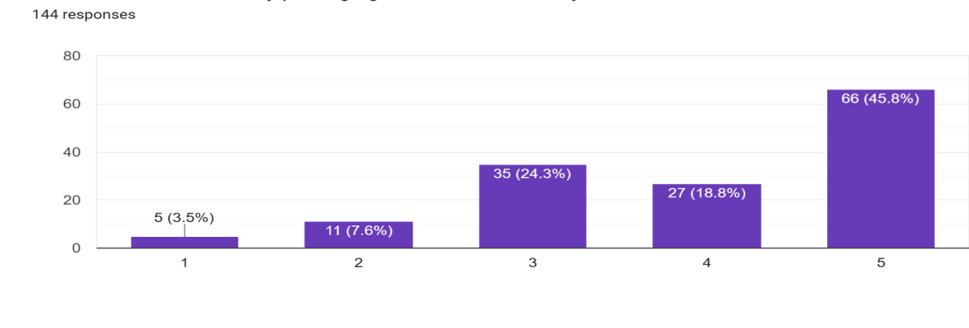
Source: Primary Data
The results highlight that a majority of respondents associate eco-friendly packaging with higher levels of trust in brands. Specifically, 45.8% (n=66) strongly agreed and 18.8% (n=27) agreed, while 24.3% (n=35) were neutral. A smaller share expressed disagreement, with 7.6% (n=11) disagreeing and 3.5% (n=5) strongly disagreeing.
Overall, nearly 64.6% of respondents expressed agreement or strong agreement, suggesting that eco-friendly packaging significantly contributes to enhancing consumer trust.
4.14 Brands Using Sustainable Packaging Reflect Social Responsibility
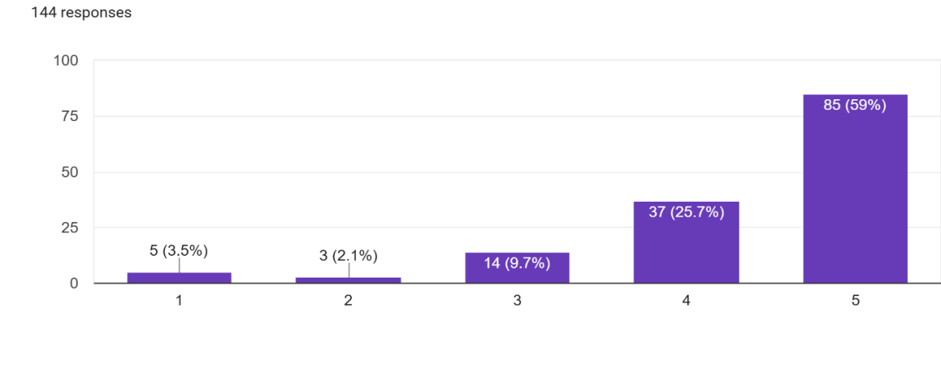

Source: Primary Data
The results show strong consumer agreement that brands adopting sustainable packaging are perceived as socially responsible. A clear majority of 59% (n=85) strongly agreed and 25.7% (n=37) agreed, while 9.7% (n=14) remained neutral. Very few respondents disagreed (2.1%, n=3) or strongly disagreed (3.5%, n=5).Altogether, 84.7% of respondents associated sustainable packaging with social responsibility, confirming that consumers view eco-friendly practices as an indicator of ethical and responsible corporate behavior.
4.15 Buying Products with Sustainable Packaging Feels Good
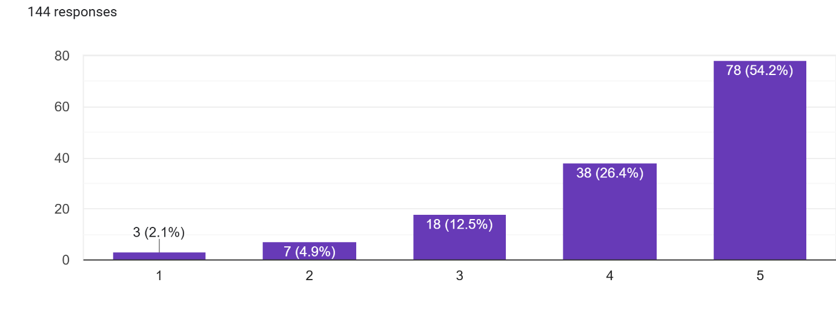
Source: Primary Data
The results highlight that consumers experience a strong sense of satisfaction when purchasing sustainably packaged products. A majority of 54.2% (n=78) strongly agreed and 26.4% (n=38) agreed, while 12.5% (n=18) remained neutral. Very few respondents disagreed (4.9%, n=7) or strongly disagreed (2.1%, n=3).
In total, 80.6% of respondents expressed positive feelings, indicating that sustainable packaging not only influences rational purchase considerations but also creates emotional value for consumers
The relatively small neutral and disagreeing group may represent consumers who prioritize price, convenience, or aesthetics over sustainability, and thus do not derive strong emotional benefits from eco-friendly choices. Nonetheless, the overall trend confirms that sustainable packaging positively impacts the consumer experience, making it a differentiating factor in brand positioning.
4.16 Sustainable Packaging Shapes Brand Perception
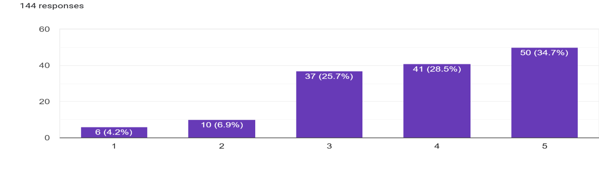
Source: Primary Data
The results indicate that a significant proportion of respondents believe that sustainable packaging shapes their perception of a brand. Specifically, 34.7% (n=50) strongly agreed and 28.5% (n=41) agreed, while 25.7% (n=37) were neutral. A smaller proportion expressed disagreement, with 6.9% (n=10) disagreeing and 4.2% (n=6) strongly disagreeing.
In total, 63.2% of respondents affirmed that sustainable packaging positively influences brand perception, suggesting that eco-friendly packaging is not only seen as an environmental necessity but also as a strategic branding tool.
4.17 Consumers Willing to Pay More for Sustainable FMCG Packaging
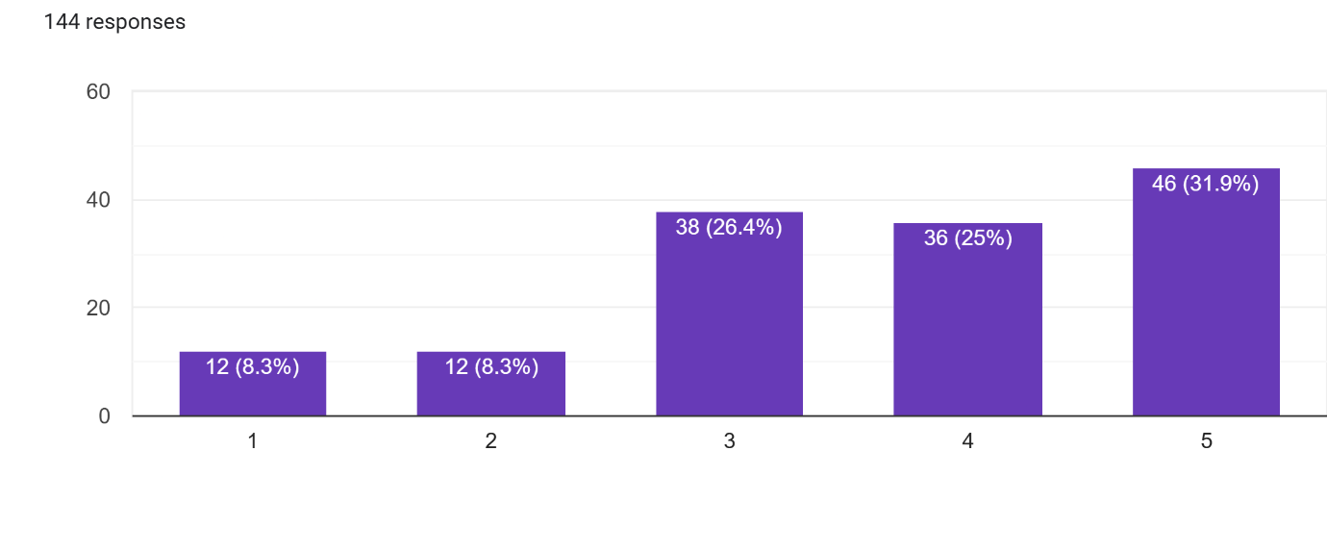
Source: Primary Data
The findings reveal that consumer willingness to pay extra for sustainable FMCG packaging is somewhat divided, though leaning positively. About 31.9% (n=46) strongly agreed and 25% (n=36) agreed, while 26.4% (n=38) remained neutral. On the other hand, 8.3% (n=12) disagreed and 8.3% (n=12) strongly disagreed.
Overall, 56.9% of respondents expressed agreement or strong agreement, indicating that more than half of consumers are open to paying a premium for eco-friendly packaging. However, the relatively high proportion of neutral (26.4%) and disagreeing respondents (16.6%) highlights the price sensitivity of Indian consumers, especially in FMCG purchases which are frequent and cost-driven
4.18 Preference for Eco-Friendly Packaging Over Cheaper Alternatives
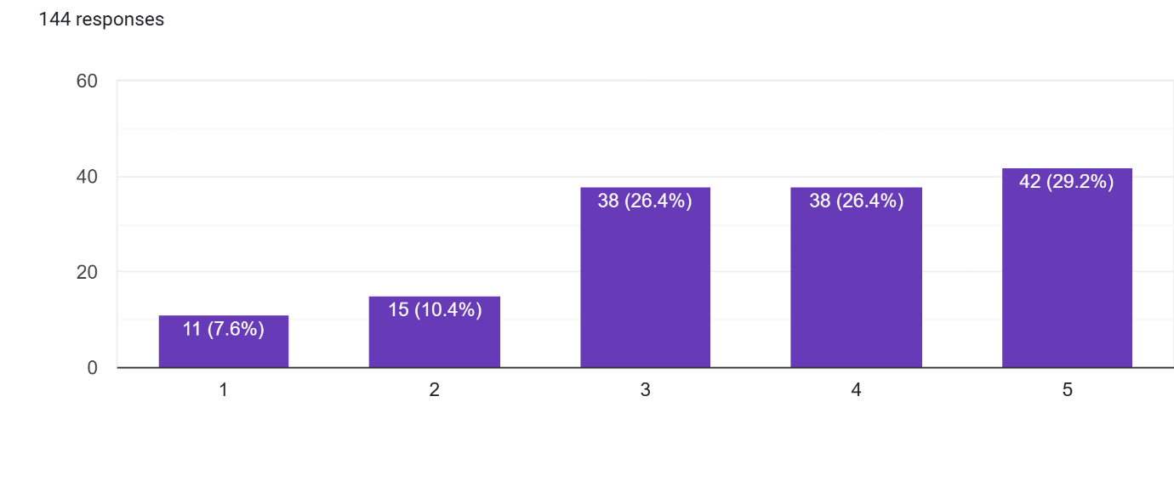
Source: Primary Data
The results show a balanced distribution of consumer preferences when it comes to choosing eco-friendly packaging over cheaper alternatives. About 29.2% (n=42) strongly agreed and 26.4% (n=38) agreed, while another 26.4% (n=38) were neutral. On the other hand, 10.4% (n=15) disagreed and 7.6% (n=11) strongly disagreed.
Altogether, 55.6% of respondents leaned toward preferring eco-friendly packaging even at higher prices, which suggests a moderate but promising level of commitment to sustainability.
4.19 Packaging Design Drives Purchase Decisions
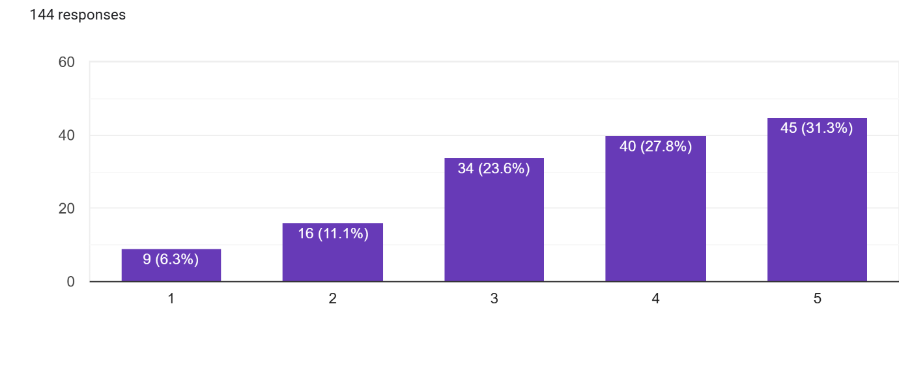
Source: Primary Data
The results indicate that packaging design plays a significant role in shaping consumer purchase decisions. About 31.3% (n=45) strongly agreed and 27.8% (n=40) agreed, while 23.6% (n=34) remained neutral. A smaller share expressed disagreement, with 11.1% (n=16) disagreeing and 6.3% (n=9) strongly disagreeing.
Overall, 59.1% of respondents acknowledged that packaging design influences their purchase behavior, underscoring the importance of visual and functional aspects of packaging in the FMCG sector

4.20 Consumers Avoid Products with Excessive Plastic Packaging
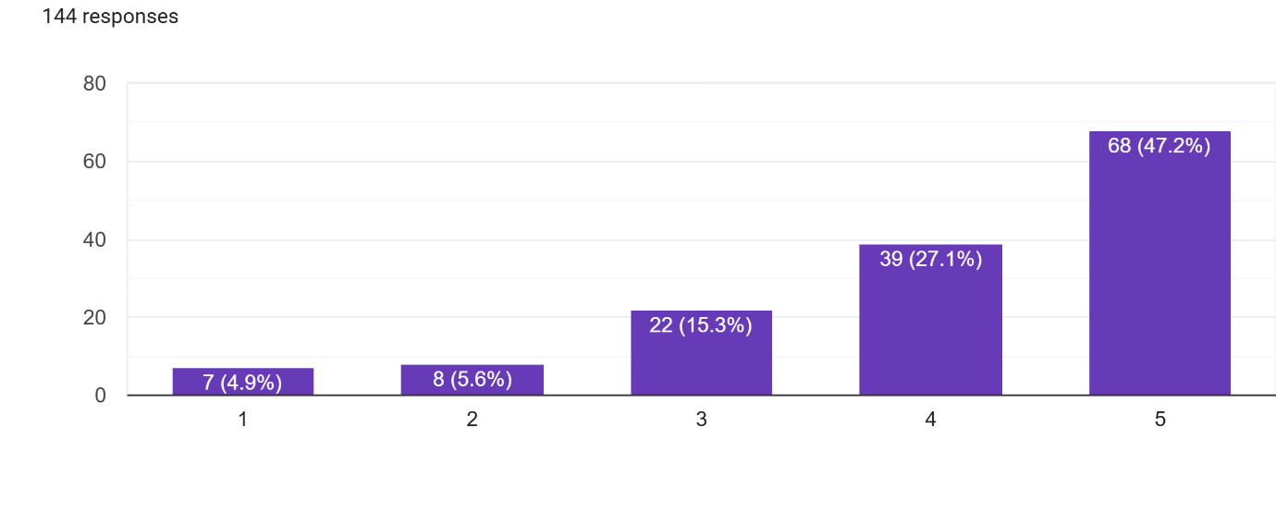
Source: Primary Data
The results show that a majority of respondents actively avoid products with excessive plastic packaging. Specifically, 47.2% (n=68) strongly agreed and 27.1% (n=39) agreed, while 15.3% (n=22) were neutral. A small proportion disagreed (5.6%, n=8) or strongly disagreed (4.9%, n=7).
Altogether, 74.3% of respondents expressed avoidance behavior, demonstrating strong consumer disapproval of excessive plastic use.
4.21 Shoppers Actively Look for Sustainability Labels on Packaging
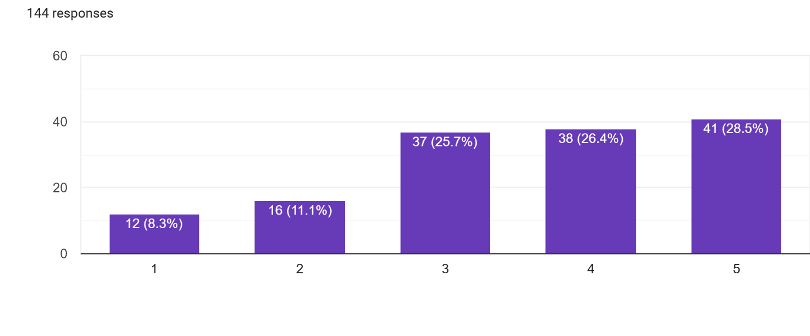
Source: Primary Data

CONCLUSION & FUTURE IMPLICATIONS
When we started this study, the main aim was simple: to see how people in Chandigarh actually think about sustainable packaging in FMCG products. And the first thing that jumped out? People already know quite a bit about it. Most participants understood that eco-friendly packaging isn’t just a nice idea – it’s necessary if we care about the environment. Many even said outright that harmful packaging does real damage, while sustainable options make a brand look more trustworthy, socially responsible, and modern.
But here’s the twist: knowing something doesn’t always mean you act on it. More than half of the respondents claimed they were fine with paying a little extra for eco-friendly packaging. On paper, that sounds great. Yet when you dig deeper, price is still a huge sticking point. People might like the idea of sustainability, but if the cheaper option is right there, many will still grab it. And then there were plenty of folks who didn’t have strong opinions either way – especially when asked whether they actually check eco-labels or compare packaging before buying.
Attitudes and willingness to spend weren’t evenly spread across the board. Income, education, and age all played a part. Younger or more educated groups often leaned more towards sustainability, while price-conscious groups hesitated. It’s a reminder that consumers aren’t one big block – they’re layered and different. To Summarize in three points: First, sustainable packaging has moved beyond being just an environmental issue. It’s starting to act like a bridge of trust between brands and consumers. Second, good intentions won’t carry the day if affordability isn’t in the mix. Companies need to strike a balance: something green, yes, but also something people at different income levels can realistically buy. And third, communication really matters. Unless eco-labels are clear and easy to spot, shoppers may not even notice them. Now, if you’re an FMCG company, the message is loud and clear: sustainable packaging isn’t just about doing the right thing for the planet – it’s also smart business. Brands that manage to combine affordability, honest labelling, and an appealing design with eco-friendly practices will likely win stronger, longer-lasting loyalty. Policymakers, for their part, have homework too. Stronger awareness drives, standardized labels, and supportive rules could push people toward making more sustainable choices. To put it simply, consumers in Chandigarh are willing to back eco-friendly packaging. The catch is that their actions will depend on how easy, affordable, and trustworthy businesses and regulators make the whole process

REFERENCES
- Biswas, A., & Roy, M. (2015). Green products: An exploratory study on the consumer behaviour in emerging economies of the East. Journal of Cleaner Production, 87(1), 463–468.
- Central Pollution Control Board (CPCB). (2022). Annual Report on Plastic Waste Management 2021–22. Ministry of Environment, Forest and Climate Change, Government of India.
- Dangelico, R. M., & Vocalelli, D. (2017). “Green Marketing”: An analysis of definitions, strategy steps, and tools through a systematic review of the literature. Journal of Cleaner Production, 165, 1263–1279.
- IBEF. (2023). FMCG Industry in India. India Brand Equity Foundation. https://www.ibef.org/industry/fmcg
- Joshi, Y., & Rahman, Z. (2019). Consumers’ sustainable purchase behaviour: Modeling the impact of CSR, self-brand connection, and environmental concern. Journal of Retailing and Consumer Services, 50, 30–39.
- World Economic Forum. (2020). The future of plastic packaging: From linear to circular.
- Ellen MacArthur Foundation. (2019). Reuse: Rethinking packaging.
https://ellenmacarthurfoundation.org/reuse
- McKinsey & Company. (2022). Sustainability in packaging: Inside the minds of globalconsumers.
- Dilkes-Hoffman, L. S., Pratt, S., Lant, P. A., & Laycock, B. (2018).
ublic attitudes towards bioplastics—Knowledge, perception and end-of-life management. Resources, Conservation and Recycling, 128, 61–70.
https://doi.org/10.1016/j.resconrec.2017.10.002
- Geueke, B., Groh, K., & Muncke, J. (2018).
Food packaging in the circular economy: Overview of chemical safety aspects. Journal of Cleaner Production, 193, 491–505.

