GYMX PRO – A NEXT-GEN FITNESS MANAGEMENT PLATFORM
POWERED BY AI

ABSTRACT

GymX Pro is a fitness management system that is better and is geared towards revolutionizing the relationship between the gym and trainers and the members through smart digital solutions. The platform is a blend of artificial intelligence technology and traditional gym management services to create an efficient and data-driven fitness experience. It will simplify the process of running gyms and will make workouts more entertaining as it will give smart recommendations and live feedback to its members. The primary characteristic of the GymX Pro is an AI Trainer which is a virtual fitness assistant to a user. The AI Trainer examines more personal parameters like fitness objectives, body measurements, exercise history, and performance improvement in order to create personalized exercise programs. It is able to prescribe exercises and modify the intensity of training as well as provide feedback to the users to enable them to be consistent and achieve improved results. This smart module gives the members a chance to be guided just like a personal trainer in the absence of professional trainers. The application also offers an all-embracive gym administration functionality like member enrolment, enrolment tracking, attendance check, instructor booking, and automatic payment and renewal notifications. Moreover, the GymX Pro also offers progress tracking dashboards, which enables users to see how their strength, endurance, and fitness have improved with time. Trainers and administrators are also able to obtain analytics in order to improve the understanding of engagement of members and the maximization of training programs. GymX Pro allows to improve the efficiency of the gym administration
and motivate the fitness enthusiasts by means of AI-based personalization, an advantageous digital interface, and the efficiency of operations of the gym owners. The system can be seen as a progressive solution to the present state of the fitness industry, using AI, it provides smarter exercise, better communication with members, and an even more connected fitness ecosystem.

KEYWORDS
Fitness Management System, Artificial Intelligence, AI Trainer, Personalized Workout Plans, Member Management, Fitness Analytics, Intelligent Training System, AI-Based Recommendations.

I. INTRODUCTION
Fitness industry has seen tremendous increase over the last couple of years with an increasing number of people appreciating the need to live a healthy lifestyle [1]. As the number of gym members and fitness centers are on the rise, the daily tasks of handling the registration of new members, workout plans, attendance and schedules of the several trainers has become a complex task. Conventional systems of gym management that may be based on manual recordings or on simple software systems may be inefficient and time-consuming. All these drawbacks mean that a more intelligent and automated solution is needed that can enhance the management of the gym and help users to have better fitness experience [2]. The new possibilities offered by digital technologies an artificial intelligence have offered new ways of changing the means of providing fitness services. The latest fitness websites are able to gather and process user data to give personalized recommendations and monitor personal progress throughout time. The implementation of artificial intelligence in fitness systems will allow creating intelligent capabilities that will help users reach their health and fitness targets more efficiently. The technologies do not only assist the administrators of the gym to manage the activities in an efficient way, but also offer the members a more interactive and personalized workout experience. GymX Pro is the new generation fitness management platform that is aimed to solve these issues by integrating the classical gym management tools with the new artificial intelligence features. The site provides a centralized control site. membership, attendance, scheduling of trainers. and overall gym activities. Besides these GymX Pro is an artificial intelligence-based administrative tool. virtual trainer that analyses information regarding the user, including fitness objectives, workout history, and physical performance and yields a person. training program. The AI Trainer option will be a fitness helper that will inform the user what to do. exercises to do, exercise modifications, and tracking of progress. This will assist the members to remain motivated and pursue well-organized fitness programs even in the absence of a human trainer. The system assists users of the system by offering intelligent insights and real-time feedback to help them be consistent and enhance their overall health. On the whole, the purpose of GymX Pro will be to develop a smarter and more efficient eco-system of fitness in which technology can improve the management and experience of the users. The platform offers a new form of service by combining the use of artificial intelligence and contemporary fitness management habits, which help gym owners, trainers, as well as members.

II. LITERATURE REVIEW
Fitness technologies have introduced a major change in the functioning of fitness centers, as well as in how people organize their health condition and physical activities. Other systems and research have delved into the creation of fitness management systems that will enhance the management of the gym, user interaction and more personalized training experiences. The systems accentuate the increased role of automation and smart technologies in contemporary training settings.
Traditional Gym Management Systems
The conventional gym management systems are mainly administrative like member registration, attendance tracking, payment management and scheduling of trainers. Most of the initial systems were created to minimize paperwork and enhance efficiency of operations to the gym administrators. These systems were effective in automating simple functions, but in many cases, they were not advanced to include more features including training guidance on a personalized basis and smart data analysis. Consequently, members continued to be very dependent on human trainers to plan their workouts and monitor their progress.
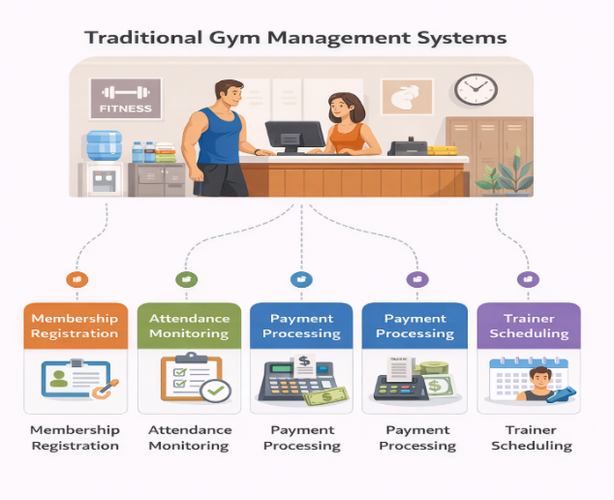
Fig. 1 Traditional Gym Management System
Fitness Applications & Web-Based Fitness Platform
The conventional gym management systems are mainly administrative like member registration, attendance tracking, payment management and scheduling of trainers. Most of the initial systems were created to minimize paperwork and enhance efficiency of operations to the gym administrators. These systems were effective in automating simple functions, but in many cases, they were not advanced to include more features including training guidance on a personalized basis and smart data analysis. Consequently, members continued to be very dependent on human trainers to plan their workouts and monitor their progress.
Artificial Intelligence in Fitness Platform
The latest research has been preoccupied with the introduction of artificial intelligence and data analytics to fitness applications to provide more intelligent and versatile solutions. Body measurements, workout history, and the performance trend may be included in the user data utilized in AI-based systems to develop personal workout plans and recommendations. These systems may serve as virtual trainers, which would be able to direct the users through the exercise, offer improvements and keep track of the progress at any rate. Such intelligent features help in enhancing user motivation and training performance and overall fitness. In addition, new fitness management systems also tend to be more familiarized with cloud-based technologies and mobile applications to gain better access and user interaction. The technologies allow the gym owners, trainers and members to access fitness information, schedules and performance reports anywhere.
Research Gap in Existing Fitness Management Systems
The entry of digital technology in the fitness. industry has altered the way fitness centres are how they work and the way in which people are able to take care of their well-being. The development of the fitness management platforms that are intended to improve the management of the gym, interactions among the users and improvement of the personalized training experiences have been discussed in different studies and systems. These systems refer to the growing importance of automation and smart technologies in the modern fitness environment. Despite the various digital solutions that are offered in the fitness sector, limitations still exist in the current fitness management systems.
The platforms available are largely designed to support the activities of the administrative gym or provide the user with personal monitoring of fitness. Nevertheless, there are hardly any systems that are able to merge both sides into one consolidated platform. The distance typically causes the management of the gym to be less efficient and eliminates the option of providing an utterly personalized fitness experience to the members. The most common activities of interest to most of the traditional gym management systems are membership registration, control of attendance, processing of payments, and scheduling of trainers. Though they help in automated work of administration, as a rule these systems are not highly developed and do not provide complex methods of giving individual training instructions or smart processing of data. This has made the members of the gym still rely a lot on the human trainers to plan and monitor their progress in the gym. Despite their usefulness in terms of tracking, such applications are usually at their best only with limited customization and do not necessarily fit individual’s needs and their development. These applications provide workout plans in most cases, rather than plans that are based on specific user data. The other important gap is that most of the current systems have little adoption of artificial intelligence and data analytics. Inadequate cleverness in considering user data and body. vital signs, exercise history and physical activity. use it hard to have right recommendations or follow-up on the performance over the long term. The lack of feedback and automated instructional support in real time reduces the chances of the users to perform frequent and proper exercises. Thus, an improved and much more integrated fitness management site that will bring together effective gym. training under the AI-based training assistance. The answer to these is. the gaps in research may result in the emergence of intelligent systems that will enhance the degree of engagement with users, enhance the results of training, and make the fitness setting more interconnected and data-oriented.
Proposed System
The system proposed, GymX Pro, is a new generation of the fitness management system developed to enhance the management of the gym and the fitness experience of its members by incorporating new modern technologies and artificial intelligence. The system will offer an intelligent digital platform which will ease the operation of a gym and also give smart advice to a user on fitness.
GymX Pro combines all the necessary functions that a gym requires including member registration, attendance tracking, membership management, payment tracking and scheduling of trainers within a single platform. This centralized will assist the gym administrators to effectively operate the day-to-day activities and to save on manual work and to have proper records of the members and services.It is also the platform on which trainers and administrators have easy access to information on their members and are able to update the information, which enhances efficiency in its operations. The main aspect of the suggested system is the AI-based trainer that will serve as a virtual fitness assistant of gym members.

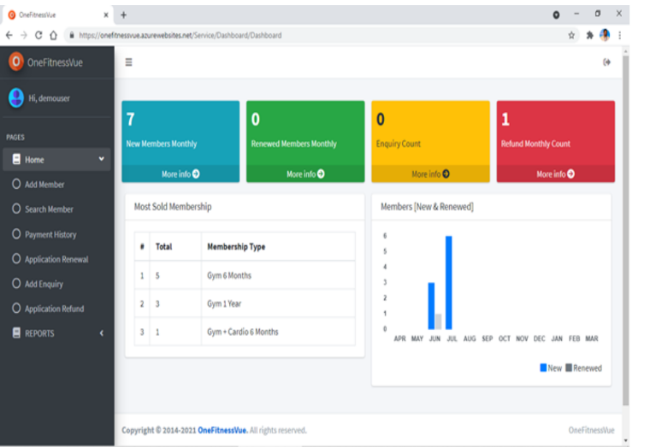
Fig. 2 GymX Pro Dashboard
The AI Trainer takes the user data such as fitness objectives, body measurements, workouts, performance trends, and formulates workout programs. With this analysis, the system prescribes appropriate exercises, modifies the training intensity, and gives directions that assist the users to adhere to the systematic exercise plans. A progress tracking mechanism is also included in the system which enables users to track their progress in terms of fitness improvement overtime.
A user-friendly dashboard enables the member to view his exercise history, performance, and health data. The feature allows people to be inspired and provide continuity. as the proposed system will in their fitness program. encompass automated gym management solutions as well as fitness aid to make with the help of artificial intelligence. the process more efficient and interactive. GymX Pro will do its best to improve the productivity of. administration, provide a more individual training. knowledge, and assist users to achieve their fitness. goals founded on instantaneous insights and suggestions.

III. METHODOLOGY
The designed system, GymX Pro is calculated with the assistance of a systematic approach that involves gym management characteristics with a fitness recommendation module implemented with the assistance of artificial intelligence. The methodology will include system architecture design, data processing, AI-based workout recommendation and system implementation.
System Architecture
GymX Pro has a three-layered architecture that comprises of user interface layer, application processing layer, and the database layer. The user interface enables the gym administrators and trainers as well as the members to communicate with the system using web or mobile interfaces. The application layer handles user requests and controls the operation of the gym and executes the workout recommendation module based on artificial intelligence. Database layer contains profiles and the history of workouts, attendance, and the list of membership.
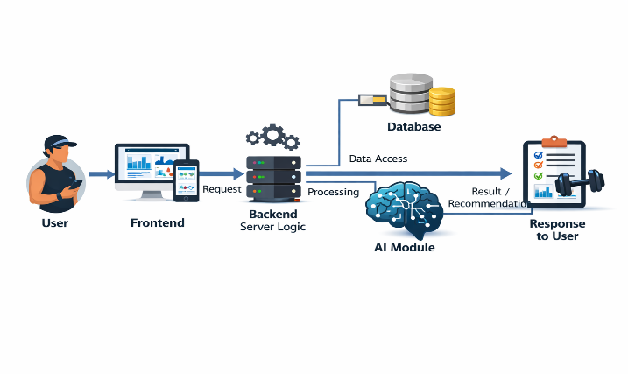
Fig.3 System Architecture Diagram
Data Collection and Processing
Data on users such as their personal information, body measurements, fitness objectives, favorite workouts, and previous performance history are all captured by the system. Such information is analyzed and stored in a system database. The preprocessing of data helped to organize and normalize the data in order that the AI trainer module would be able to use it successfully.
AI Trainer Module
The virtual fitness assistant is the AI trainer, which creates unique workouts plans depending on the user data. The module evaluates the parameters like fitness level, body metrics, workout history and training goals. According to this analysis, the system suggests what exercises, the level of training intensity, and the training frequency. The AI model is continuously updated according to the new information about the user in order to provide new recommendations on a continuous basis [4].
System Implementation
The site is deployed with the help of the latest web technologies and databases. The fundamental modules are member management, trainer management, attendance tracking, subscription management and workout monitoring. The AI trainer module is connected to these elements to offer smart workout plan and performance data.
System Evaluation
The measures that are used to determine how the system performs are the system efficiency, recommendation accuracy and usability. The performance measurements and the feedback of the users are assessed to see the extent to which the platform is serving its purpose of enhancing the running of the gym as well as advising on personal fitness.

IV. RESULTS AND DISCUSSION
GymX Pro implementation illustrates the high benefits in the efficiency of gym management and user engagement on the fitness aspect.The system is able to integrate all the administrative aspects with the AI-enhanced workout recommendations, creating one system to control all aspects of fitness. The AI trainer program would be a fine mechanism to design personal workouts based on the physical activity interests and user fitness goals. The performance metrics and history of the workouts are displayed on the visual dashboards to monitor progress of the users.
This property helps the members be consistent and motivates them to remain motivated in their workouts. The system simplifies the management of the gym administratively because most of the gym operations are automated such as membership control, attendance checking and monitoring of subscriptions. The centralized database allows access to the information about the users and the analysis of the trends in the fitness performance by trainers and administrators easily.All in all, the platform is user-friendly as it offers smart fitness suggestions besides increasing efficiency in the work of gym administrators.
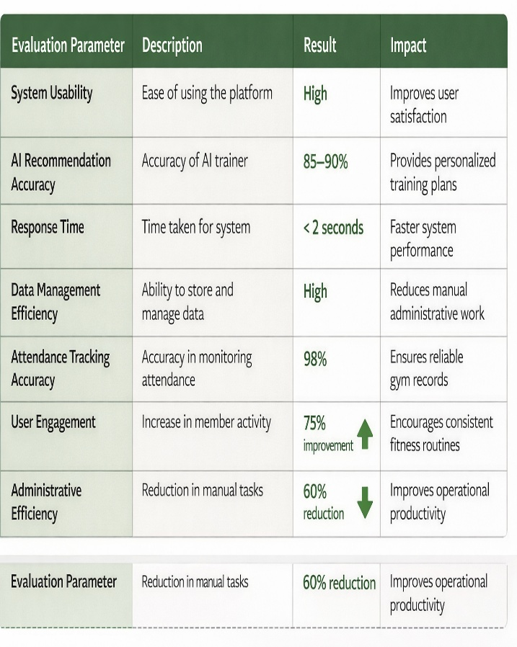
Fig. 4 System Performance and Efficiency Analysis

V. FUTURE WORK
Despite the fact that GymX Pro offers a full-fledged fitness management platform, there are a number of improvements which can be done to the future versions with the aim of adding more functionality to the system and making it user friendly. The enhancement of wearable fitness gadgets, like smart watches and fitness bracelets, can be put into use in the future to gather real time health information. Such integration would allow the AI trainer to produce more realistic and active recommendations on workouts.
The other potential improvement involves the use of advanced machine learning models to enhance the accuracy of prediction of fitness progress and injury prevention. In-time posture recognition with computer vision could also be included in the system to give exercise form feedback. In addition, a mobile version of the application of GymX Pro would be created to increase the level of accessibility and would allow users to receive instructions on how to perform workouts anywhere and anytime they could be. [7][9][10].

VI. CONCLUSION
GymX Pro is a new business in the management of fitness that integrates artificial intelligence with classic gym administration. The site offers a centralized site way of running gym business and provides an offer of individualized exercise plan with an AI-based. trainer. The analysis of user data and fitness goals allows the app to recommend the best workouts. AI trainer develops personal training plans that assist people achieve their fitness results. The system also enhances productivity by automating activities such as membership, attendance, and trainer scheduling. The results indicate that smart is used technologies and fitness management applications. can greatly enhance user engagement and improve. administrator productivity. GymX Pro is thus a good move towards creating more intelligent and interactive digital fitness ecosystems.[9].

VII. REFERENCES
[1] S. Patel and H. Park, “A review of wearable sensors and systems with application in rehabilitation,” Journal of Neuro Engineering and Rehabilitation, vol. 9, no. 21, pp. 1–17, 2012.
[2] J. Kim and S. Lee, “Smart fitness system using artificial intelligence,” IEEE Access, vol. 8, pp. 110–118, 2020.
[3] M. Thompson, “Digital transformation in fitness management systems,” International Journal of Computer Applications, vol. 182, no. 12, pp. 20–26, Computer Applications, vol. 182, no. 12, pp. 20–26, 2018.

[4] A. Gupta and R. Sharma, “AI-based personalized fitness recommendation system,” Proceedings of the International Conference on Intelligent Computing, pp. 145–152, 2021.
[5] L. Chen, “Machine learning applications in health monitoring systems,” IEEE Transactions on Biomedical Engineering, vol. 67, no. 4, pp. 1030–1038, 2020.
[6] R. K. Bedi and A. Singh, “Web-based gym management system,” International Journal of Computer Science and Information Technologies, vol. 7, no. 3, pp. 1204–1208, 2016.
[7] D. Smith and K. Brown, “Mobile health applications for fitness tracking and monitoring,” Journal of Medical Systems, vol. 41, no. 5, pp. 1–9, 2017.
[8] Y. Zhang, H. Wang, and L. Liu, “Artificial intelligence for personalized health and fitness recommendation,” IEEE Internet of Things Journal, vol. 7, no. 6, pp. 5435–5443, 2020.
[9] P. Kumar and S. Gupta, “Cloud-based health monitoring and fitness management systems,” International Journal of Advanced Computer Science and Applications, vol. 10, no. 4, pp. 210–216, 2019.
[10] T. Anderson, “Data analytics in smart fitness platforms,” Journal of Sports Technology, vol. 12, no. 2, pp. 95–103, 2021.

