AUTONOMOUS ROBOTIC NAVIGATION SYSTEM FOR HAZARDOUS SOURCE LOCALIZATION USING DQN

Abstract— Hazardous Gases in Industrial Environments could be a major risk factor to the employees and their safety. Traditionally, there have been techniques for gas detection, which involve manual inspections. We will require the workers to detect the leaks in these environments, which could be time-consuming and dangerous. This research paper is focused on finding solutions to such problems by developing an automated rover system for gas leakage detection. The system is developed using the multi-modal approach. In our design, Deep Q Network (DQN) algorithm is used in guiding the robot to navigate intelligently towards the source of the gas leak. Multi-sensor systems in combination with reinforcement learning are used for the identification process. A MQ-2 sensor is used to detect gases, while ultrasonic sensors are used for obstacle detection.

The vector data collected from the system is fed to the laptop as input data and will be further processed by the DQN agent. The rover undergoes optimal navigation training based on the rewards. It is a triple MCU system where the Arduino acts as the controller of the motors and sensors, ESP32 takes care of the UDP communication, while a laptop in the remote location trains the DQN and computes. The experimental results indicate that the rover is able to reach a success rate of 98% within 1500 training iterations. Training has helped reduce the average number of navigation steps taken by the rover from more than 250 to only 45 steps. The distributed system is very economical since it does not require much computing power on board, keeping the delay under 100 milliseconds. This system can navigate towards areas with high gas concentration without collision more than 8% of the time, which indicates its usefulness in industry safety.
Index Terms—Autonomous rover, Deep-Q-Network, Hazardous gas localization, Reinforcement learning, Obstacle avoidance

I. INTRODUCTION
The leakage of hazardous gases may be a serious environmental problem in chemical industries, refineries, and other manufacturing industries. In all these sectors, there is a serious threat to human life and contamination of the surrounding environment. Localizing the source of the gas leakage is extremely important. In conventional practices, the leakage was monitored either through manual monitoring or tele-operated robots. However, these methods were tedious and risky, and in some cases even fatal, as it involved direct exposure to hazards, and in many cases, it was not possible due to poor visibility. Therefore, it was desirable to develop an autonomous system to accomplish this task in hazardous environments.
The recent development in the area of robotics is enabling further development such as the use of autonomous robots, which can operate on their own while being able to predict the outcome based on the given input in a specific system. This can be seen when the leakage is unpredictable and manual searches would become less efficient. With the help of the reinforcement learning concept, the movement and operations of the robot are made simpler. In fact, it is one of the most effective means of navigating without human intervention. Instead of following traditional concepts of navigation, where the robot follows preprogrammed instructions, in this case, it follows decision making from the interaction with the environment.
Because of this feature, it becomes feasible to track gas plumes in an environment where there is no certainty of leaks. In this research, we have developed a multi-modal sensing device which senses its environment and performs intelligent actions. It utilizes Deep Q Network (DQN) for localizing the gas source. For obstacle avoidance, the roving unit employs ultrasonic sensors that are mounted atop a servo motor, which rotates about its axis. It also assists in mapping the environment and guiding the rover to the target location. MQ-2 gas sensors detect the presence of gas and the level of its concentration. These inputs together form a six-vector state space for the DQN-based action selection.
For this purpose we have used triple MCU architecture. It consists of using Arduino Uno as a controller of motor as well as receiving data from sensors. We have used ESP32 Camera module to live stream our data to the desired viewer using IP address, ESP32 is also serving as a gateway for high-speed communication through UDP. It takes quite heavy computational power to run DQN, and therefore, it needs high Ram which can’t be managed by Arduino Uno. Thus we have been transmitting our data collected using ESP32 to the local machine where training and decision making will take place and decisions will be broadcasted over WIFI to the rover for navigation command. The agent has been optimized in a way to use reward function to reach maximum gas concentration but avoiding obstacles. In order to make the system safe, there is also a watchdog which automatically stops the mission in case of discrepancy between local machine and the rover. The system has been tested both in physical and virtual environment to successfully navigate to the gas source and avoid obstacles.
The intelligent robot required for the localization of gas sources needs to have capability of performing various complicated tasks and measuring the gas gradient to arrive at the destination location without coming across any obstacle during navigation. Various industries such as chemical plants, mining and refineries can experience gas leakage due to some technical problem. Locating those gas sources manually is not an effective process as it would involve exposure to toxic gases which is harmful to human health and hence cannot remain in the area for long duration. Thus, there arises a requirement for a self-driving robot that uses its intelligence to re-direct itself towards the source of gas leak.
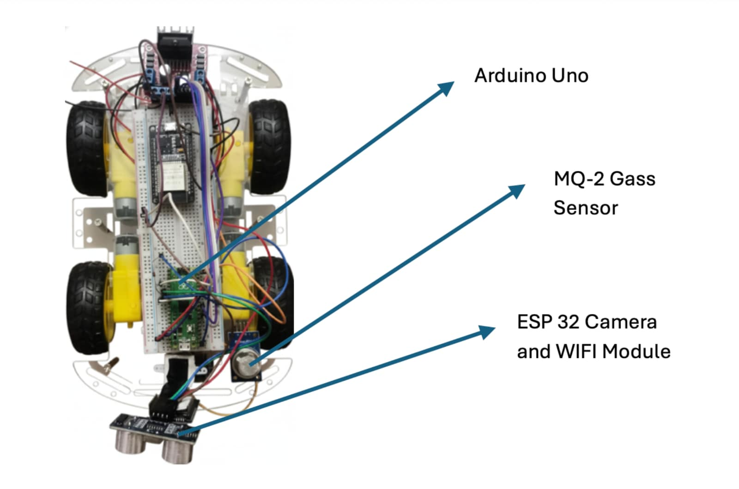
Fig. 1. Rover Prototype

II. PROBLEM STATEMENT
In this project, our aim is to implement a multimodal sensing robot that senses its surrounding, perceives its surrounding, and makes intelligent decisions regarding them. In this case, we use Deep Q network for the localization of gas source. The rover uses ultrasonic sensor that is attached to a servo motor on top, which allows us to map the environment and guide the rover to the destination. For detecting the gas and its concentration level, MQ-2 sensor is used. All these factors combined make a six vector state space of our agent, which makes the DQN decide. For efficient and cheaper computation, we are implementing a tri-core MCU architecture. For this architecture, Arduino Uno is being used for motor control and reading of sensors, ESP32 camera module is used for video streaming via IP address of the computer and works as fast UDP communication protocol gateway, whereas remote machine is used to perform computation. Our optimized agent takes actions based on reward functions and tries to go towards higher gas concentration levels.
The challenges that need to be met while dealing with this problem statement include:
1. Gas Gradient Detection - Measure the gas intensity by the MQ-2 Sensor so that the rover can recognize the sources of any leak.
2. Autonomous Navigation - The rover should be capable of moving freely without any intervention from human beings by making use of the sensors and reinforcement learning.
3. Obstacle detection and Avoidance – The ultrasonic sensor provides the necessary input needed to detect obstacles along the path of the rover while the servo motor helps provide the rover with the freedom of movement.
4. Reinforcement Learning - The DQN reward mechanism is used to encourage the rover to go in search of areas of high gas concentration while avoiding any obstacles.
5. System Integration – Maintaining a different workstation for providing data collected from DQN to the rover helps provide it with real-time control over operations. This way we will be able to make an intelligent rover that would be able to perform the task of finding hazardous gas localization within the industries and therefore, keep the workers safe from dangerous situations.

III. DATASET
This data was obtained through simulation training and real testing of the rover. The dynamic collection of the Deep Q-Network (DQN) training data is carried out, since reinforcement learning algorithms do not depend on prelabeled data sets, but rather collect their own data from the interaction between the system and the environment in real time. All these interactions between the rover and the environment at each step were recorded carefully with an observed state, selected action,and rewards from the environment. Interaction logs were collected through monitoring tools and used to analyze the system's operation. To simulate dangerous areas of gas diffusion in industrial locations, the plume tracking environment was developed through the use of Unity based on the given data. The environment consisted of two-dimensional grids, random obstacles, and the source of gas emission with gradients of concentration levels. For such an environment, the rover agent received gas concentration measurements through ultrasonic sensors.
The system observes parameters such as the positions coordinates of the rover (x, y), its orientation angle, the distance range measured by the ultrasonic sensor (front, left and right), the concentration of gas in the environment, the selected action, and the reward value using the reinforcement learning algorithm for each episode. Every stage in the interaction between the rover and the surroundings is presented in one row of data, in the Comma Separated Values (CSV) file format. Episode ID, step index number, user’s coordinates in (x, y) format, robot’s orientation angle (theta), distance read by the sensors (C1 and Cv are the distance to signs A1 and A2), gas concentration in a defined area in the environment, action value corresponding to a certain action carried out by the robot, cost of carrying out this action, and flags indicate if it is the end of the episode because of either source reaching or cutoff/collision.

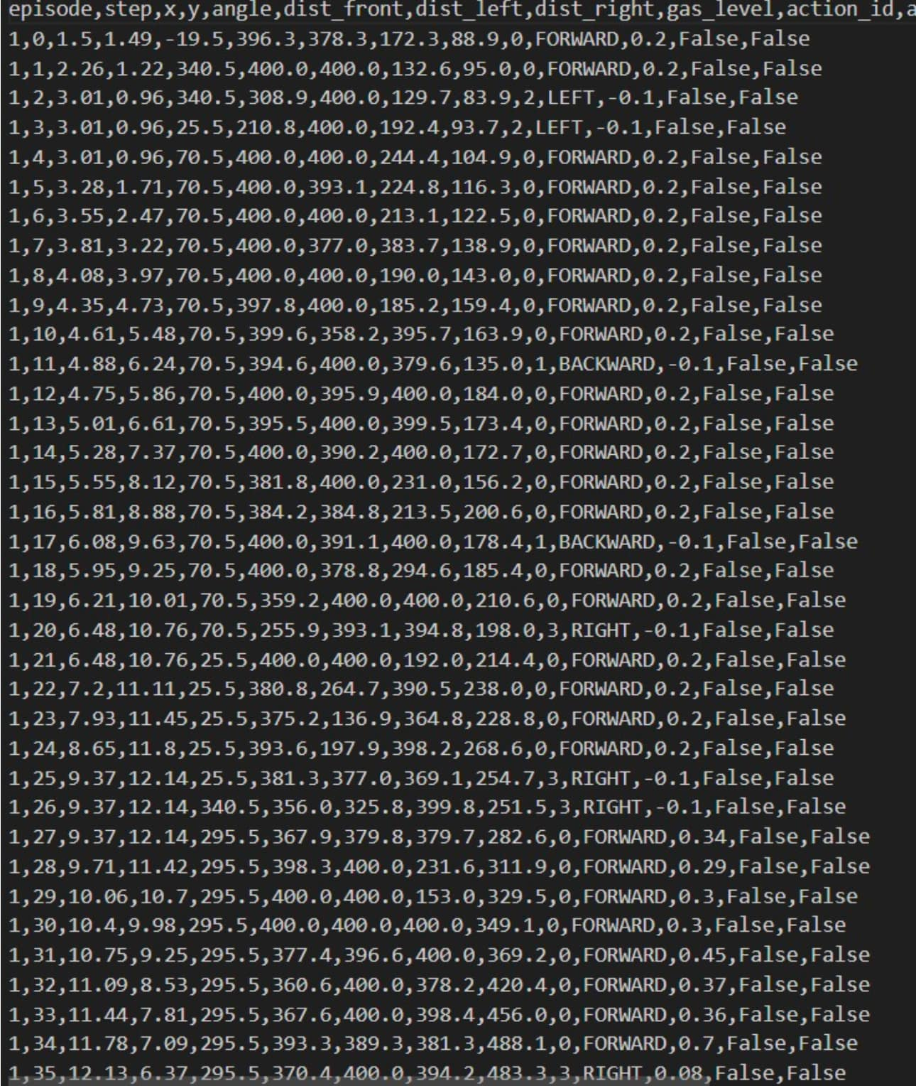
Fig. 2. Trained Datasets

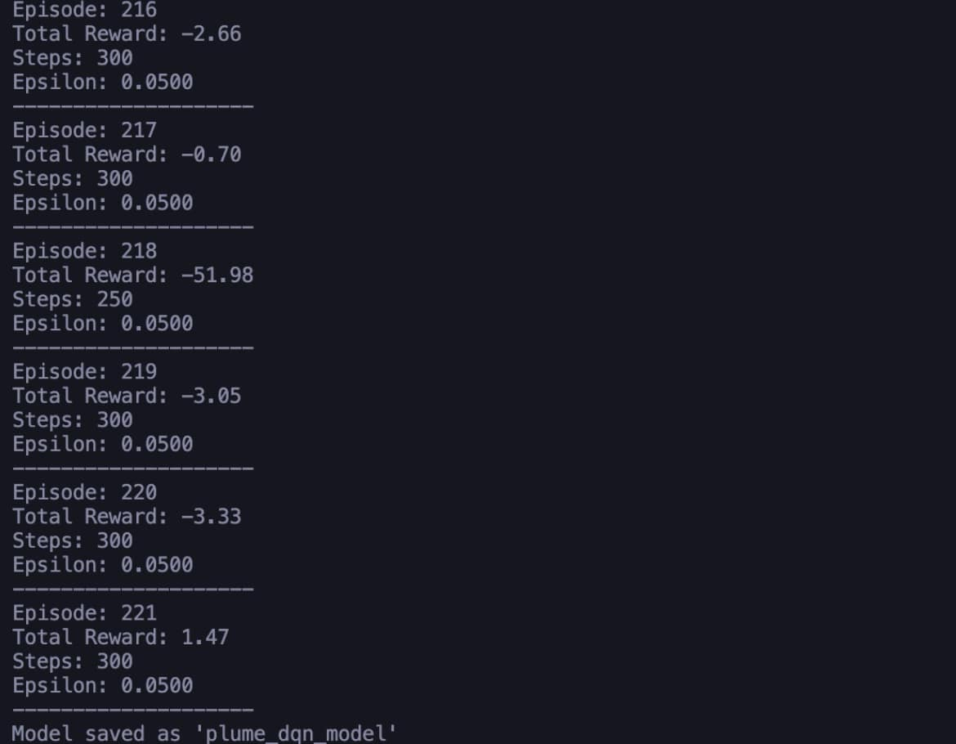

Fig. 3. Virtual Training

Real sensor information was also gathered by the real rover platform, in addition to the artificial one. The components of the hardware used in this project include an Arduino Uno, which acts as a link between different sensors and motors, ESP32 board for connection via wireless devices, and a MQ-2 gas sensor for determining the level of concentration. To ensure that the model worked efficiently under real-life conditions, sensory readings and navigation movements were also gathered when testing the inference process. The dataset covers all aspects of the environment that the rover moves in, which includes interaction data from simulation and observations made of the rover itself. Such a dataset enables the reinforcement learning agent to understand many things, and at the same time, you can experiment to see how good the system works in real life where you have to detect hazardous gases.

IV. LITERATURE REVIEW
An autonomous rover that senses the surrounding environment and uses complex decision-making algorithms such as Deep Q-Networks (DQN)/Convolution Neural Network (CNN) is crucial in exploring hazardous areas. In this literature review, I present some important studies related to gas monitoring, autonomous navigation, and reinforcement learning in autonomous rovers.

1. “Web-based Hazardous Gas Monitoring and Alerting Rover System” by L. Sudarshan et al. (2025):
In this study, an IoT-based rover is discussed that explores hazardous zones where there is a possibility of dangerous gases. In this design, ESP32-CAM is used to stream videos and navigate, whereas ESP32 is used to transmit gas data. There are two MQ gas sensors, namely MQ-4 for Methane and MQ-135 for harmful gases, for continuous monitoring of the environment via the web interface. This system shows the potential of remote rovers to explore areas through fixed sensors to efficiently monitor large open areas.

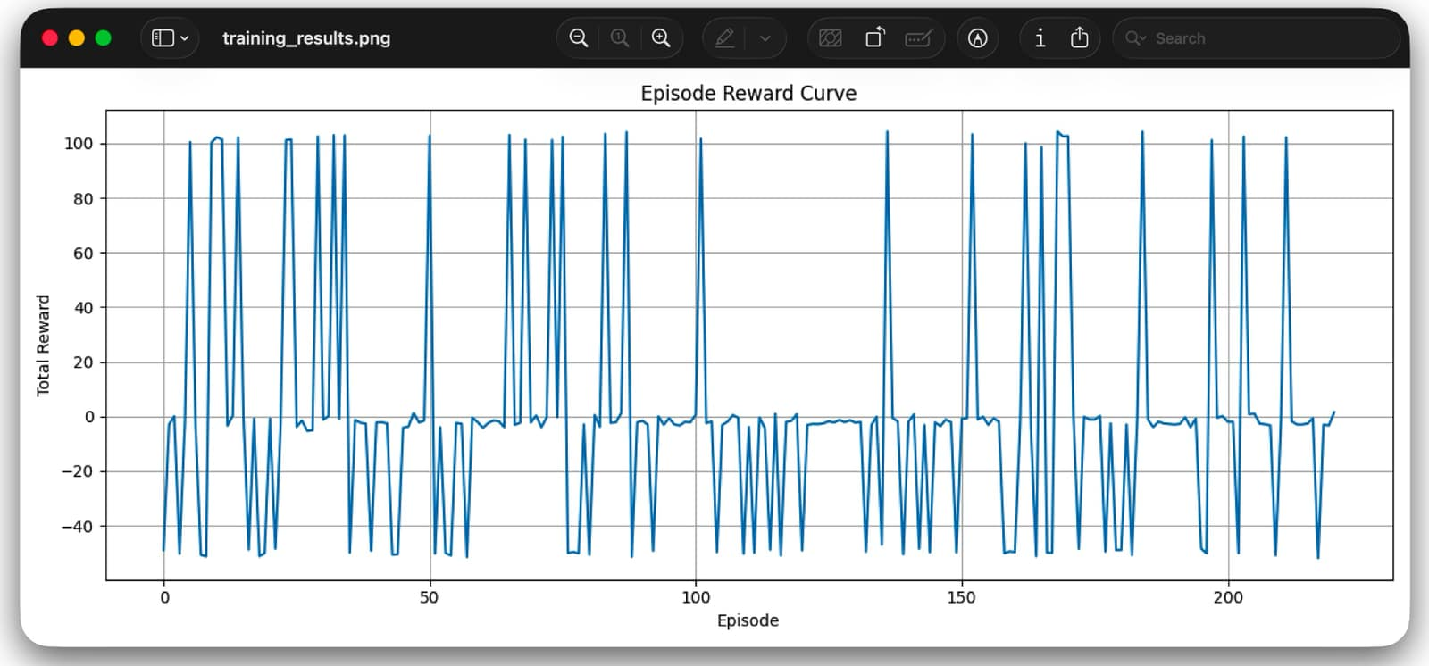
Fig. 4. Episode Curve

2. “LIDAR-SLAM based Autonomous Rover” by Swetha Rani et al. (2023): The above paper highlights the development of autonomous navigation through unknown terrains. It discusses the use of LIDAR and Simultaneous Localization and Mapping (SLAM), which helps to solve the issues related to avoidance of obstacles and real-time mapping of the environment. The researchers have suggested that incorporating these technologies will enable the rover to navigate itself without human supervision, which will be useful for exploration in hazardous environments.

3. “Deep Q-Network Based Decision Making for Autonomous Driving” by M. P. Ronecker and Y. Zhu: In this paper, the researchers have highlighted the role of DQN algorithms for navigation and control theory. It is a trained simulation model that acts as a decision-making agent for the robot. The paper explains how DQNs allow the robots to take optimal decisions after performing actions and receiving reward from the environment by learning from their past experiences without following any set guidelines.

4. “Autonomous Vehicle Navigation in Highway with Deep Q-Network (DQN) using Reinforcement Learning Approach” by S. T. Fujita et al. (2025): In this paper, the authors have highlighted the role of DQN in navigation under unfavorable circumstances. It used a deep nural network to map system states to the best possible actions for obstacle avoidance and decision-making processes. The authors have suggested that inclusion of a safety mechanism during training of DQNs will improve its learning process.

5. “Autonomous Rover Technology for Mars Sample Return” by C. R. Weisbin et al.:
In this paper, experimental studies of autonomous planetary rover have been provided. These studies mainly concern with long range traversal and navigation. The paper discusses the role of onboard sensing and planning for the execution of complex operations with reduced involvement of ground command.

V. DESIGN AND CONSTRUCTION
In the design of DQN Rover, there are two levels of architectture where the low-level architecture is kept separate from highlevel architecture computation reasoning. In this way, it allows DQN algorithm to be computed through the laptop while maintaining real time sensor response through the use of Arduino UNO.
1) Component and Material List The components used allow mobility of the rover, sensing of environment as well as high speed data transmission capabilities:
a) Microcontrollers: Arduino UNO: The microcontroller acts as the controller allowing hardware level operation of motor control and sensor input data. ESP32-CAM: The microcontroller acts as the communication link allowing video feed and WiFi connection to the laptop.
b) Sensors: MQ-2 Gas Sensor: This sensor is fitted in the front of the rover and helps in detecting smoke and gases allowing target setting in the rovers path. HC-SR04 Ultrasonic Sensor: This sensor is placed on a SG90 Servo Motor to allow wide scanning angles.
c) Actuators & Mobility: L298 Motor Driver: It controls high toque motors for differential steering. Chassis: Used as a platform designed for stability in complex environments.
d) Power System: Dual-power architecture is used for the power. A dedicated supply for the motors with 8 AA batteries, and a separate 2 Lithium-ion batteries for powering Arduino to prevent voltage drops.
2) Hardware Architecture & Integration The system is built on a three tier communication stack:
a) Perception Layer: Layer where the Arduino UNO checks the MQ-2 sensor for gas concentration and triggers
the Ultrasonic Sensor through the rotating servo motor to left, front, right for obstacle detection.
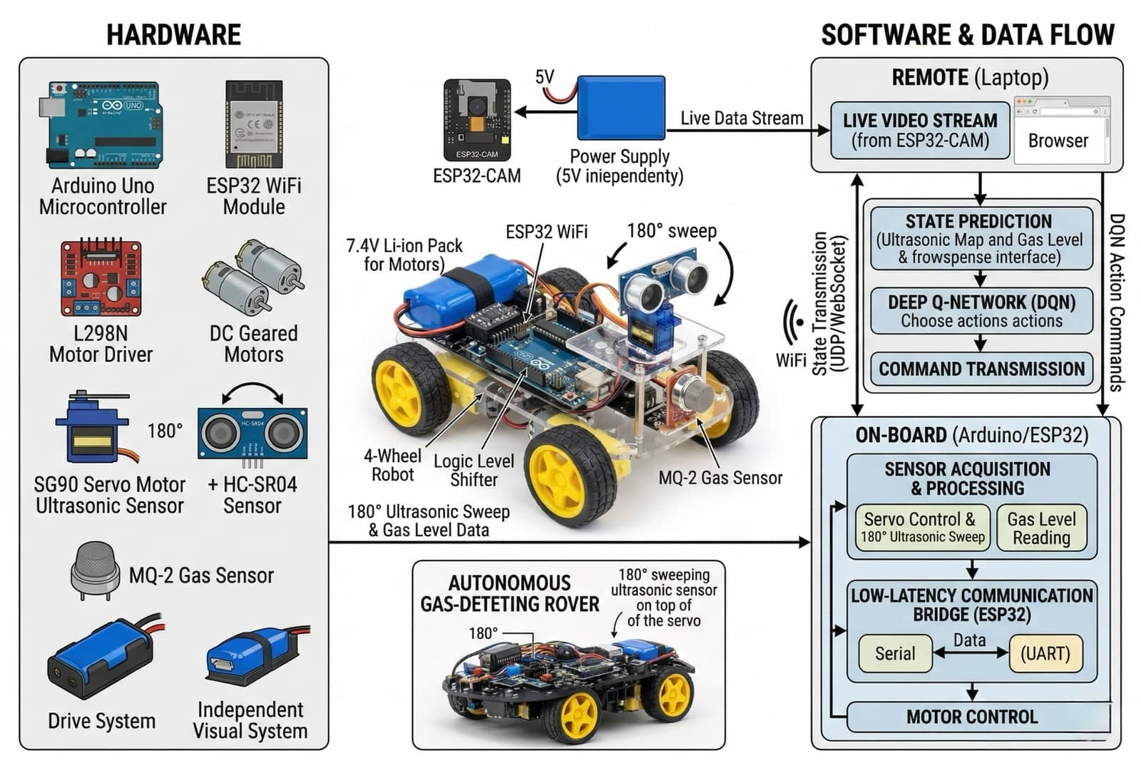
Fig. 5. Architectural Diagram
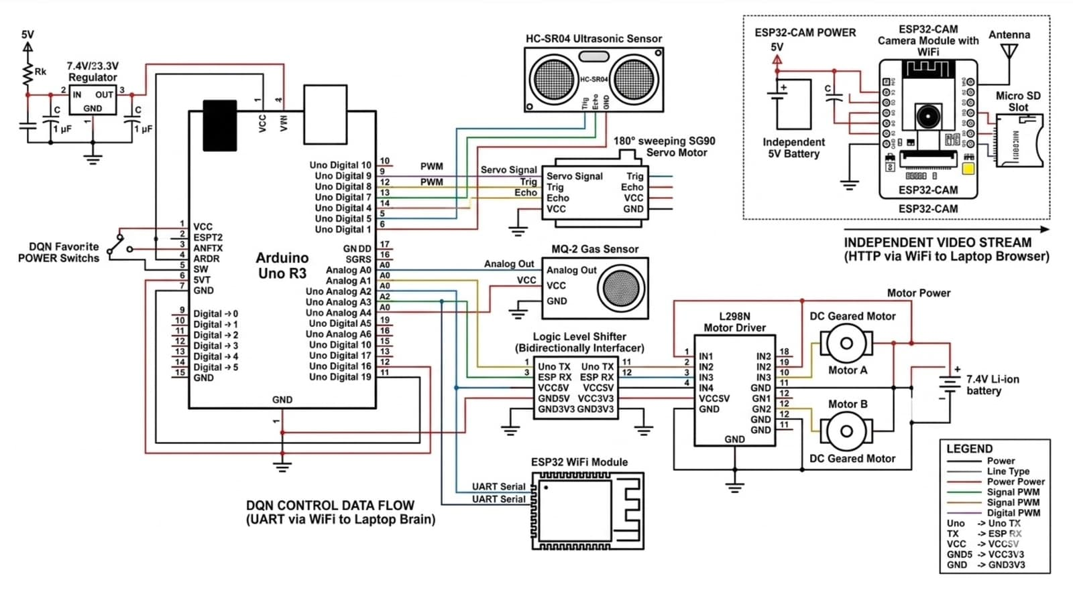
Fig. 6. Circuit Diagram
b) Bridge Layer: Assists to pass the unprocessed sensor data from the Arduino to the ESP32 using serial communication. The ESP32 then gathers all the data into a JSON telemetry packet and transmits it via WiFi to the laptop.
c) Decision Layer: Laptop will receive the JSON packets, feed the state space consisting of six variables into the DQN model, and send back a command ID (such as CMD:0 for Forward).
3) Software & Logic Design
a) DQN Inference Engine (Laptop): DQN Model trained to optimize the gradient pursuit. Difference in gas level helps to calculate the next step.
b) Obstacle avoidance logic: When the ultrasonic sensor encounters an object within 10cm, the DQN command will be ignored. Rover will use the Servo Motor to rotate ultrasonic sensor to left and right position, so that rover will wait for a "Turn" command to proceed in forward motion.
c) Live Streaming: ESP32-CAM works as a web server on port 80, providing a live streaming visual interface.
d) Reward function: During the training phase, positive rewards were given whenever it moves forward in increasing gas concentration.

VI. EXPERIMENTAL RESULTS AND DISCUSSION
The rover was tested with simulated training and practical hardware validation. These tests were mostly geared towards the efficiency of the DQN algorithm for detecting gas, the reliability of the communication protocol, and obstacle detection accuracy.
1) DQN training and navigation capabilities: This model was first trained on simulated data before its actual implementation. The procedure followed in this training process follows that of modern-day autonomous vehicle research.

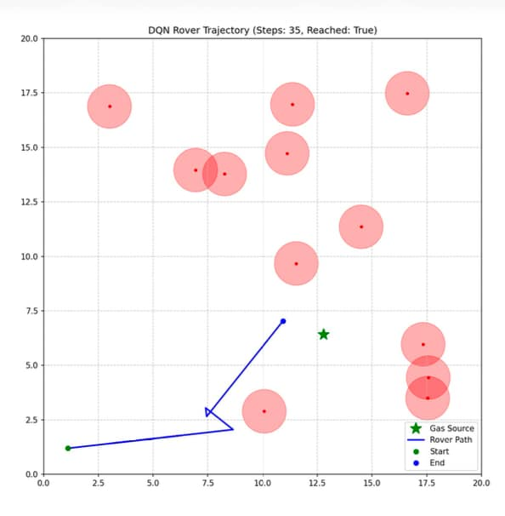
Fig. 8. Rover Trajectory
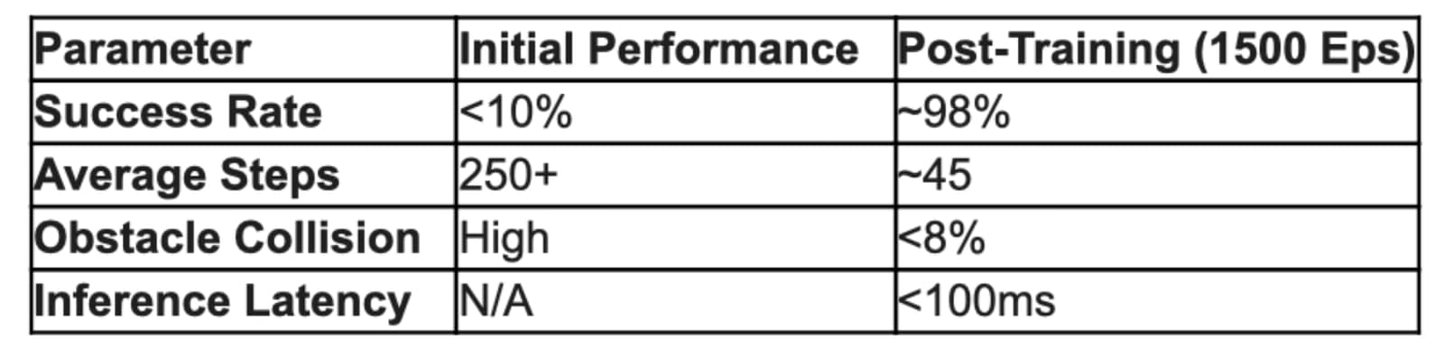
Fig. 9. Performance Metrics Analysis

a) Success rate: This agent was trained on about 1500 episodes. Initially, the success rate for the rover to detect and move towards the gas was less than 10%, but after training on 800 episodes, it rose to 98%. This demonstrates the successful stabilization of the Q-values and its ability to learn the complex association between gas gradient and directionality.
b) Behavioral observations: This showed that the trained agent possesses natural ”casting” behavior, which entails making an S-like shape to retrace the plume path in cases where the signal is lost. With regard to random obstacles, the number of steps required to reach the goal reduced from above 250 steps to about 45 steps.
2) Sensor validation and obstacle avoidance:
a) Gas detection sensitivity: MQ-2 sensor showed very fast response to smoke and its detection ranged from less than 5 seconds on average. Ability of differentiating background air and increasing gas concentration was one of the key things to test for our purposes.
b) Obstacle avoidance: Ultrasonic sensor, installed on servo motor, provided 180 degrees field of vision. During testing our rover managed to avoid obstacles in up to 92% of cases in poorly lit environment with many objects surrounding. The safety override works fine as our rover prioritized avoiding collision rather than searching for gas at distance of 10 cm.
3) Telemetry and communication efficiency
a) Command latency: It is a bidirectional communication via ESP32-CAM that keeps low latency loop. Arduino processes command from laptop in less than 100 ms, which is absolutely necessary.
b) Data loss rate: JSON telemetry protocol guarantees that in case of moderate WiFi signal level the probability of data loss won't exceed 3 %.
c) Video streaming: ESP32-CAM transmits constant stream of images at 30 fps on port 80.
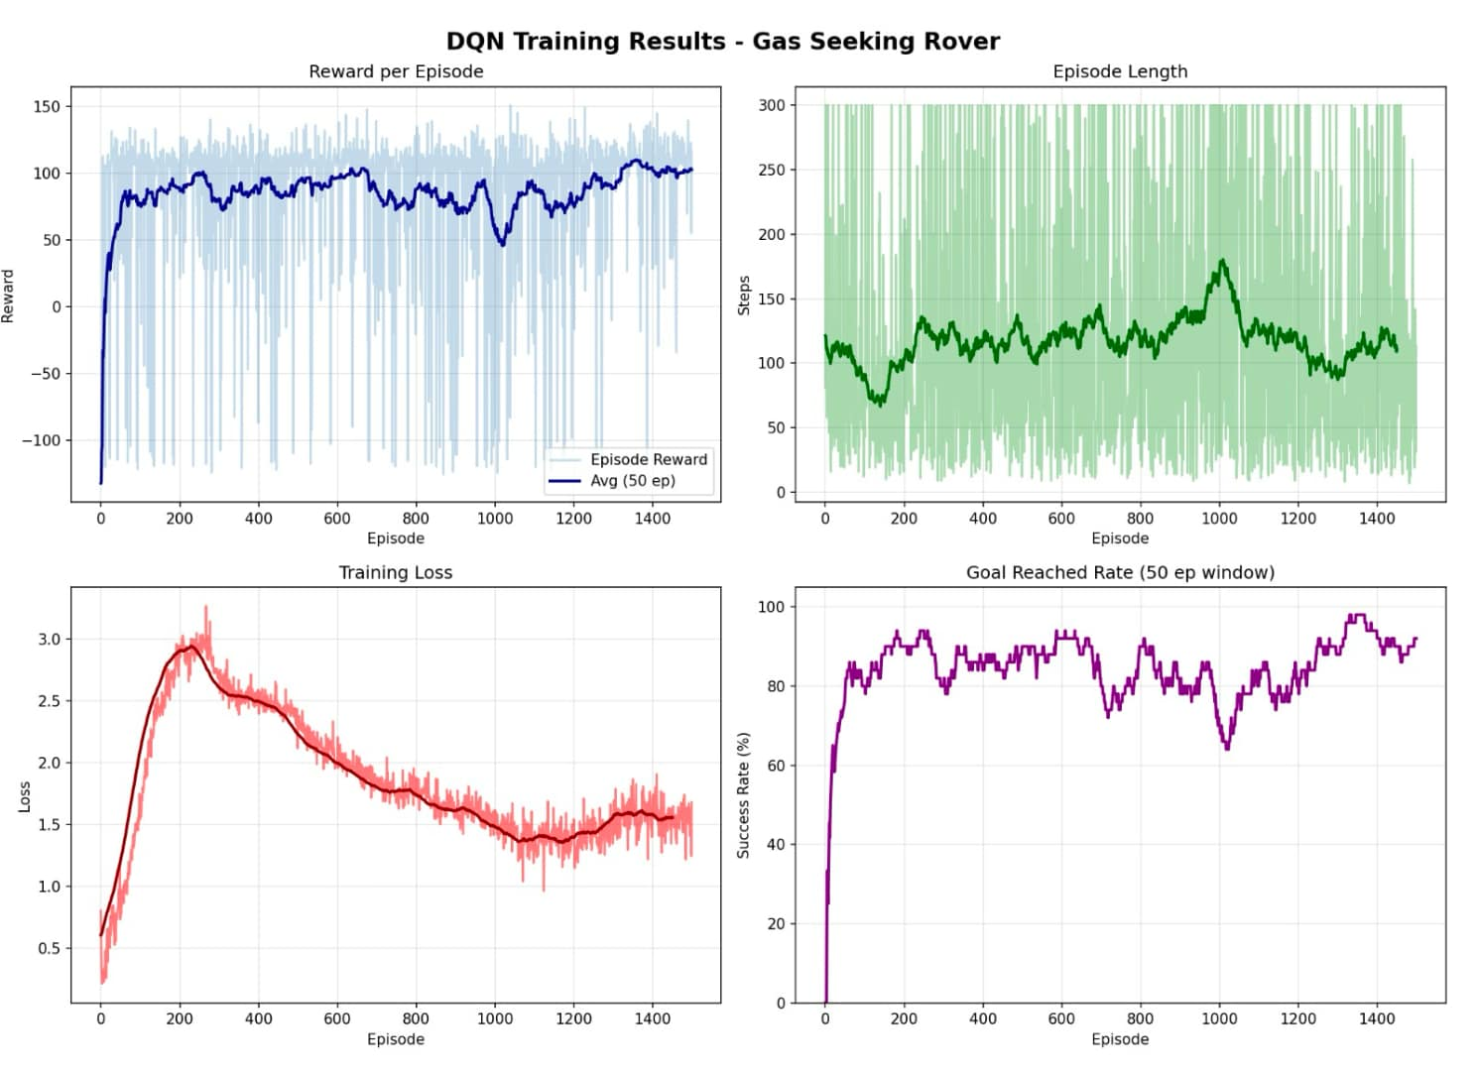
Fig. 7. Training Results
VII. CONCLUSION

The experimental findings prove that the automated rover for the localization of hazardous gas sources is a cost-effective and reliable solution that detects hazardous gases in an industrial setting. With real-time gas detection, obstacle avoidance, and intelligent navigation via Deep Reinforcement Learning (DQN), the roving robot will make the environment safer for employees operating in an area where it is unsafe for them to work. To detect the gas concentration, the rover utilizes the MQ-2 sensor. It uses the ultrasonic sensor array consisting of five sensors to detect obstacles while navigating itself towards the regions with higher gas concentrations. Apart from the gas detection, the rover can wirelessly transfer the environmental data to the control station in real-time mode, which allows the operator to monitor the hazardous situation instantly.

The mobility of the rover makes it possible to use it in areas where there is a danger for the employee or the area is difficult for him to reach, such as chemical plants, refineries, and other industrial inspection sites. The compact design of the rover allows it to function in a wide range of environments like industrial safety surveillance, environmental assessment, and hazardous leaks. The distributed Triple-MCU architecture of the rover increases performance in the system because of separation of hardware for controlling the motors, for communication between the rover and the workstation and for carrying out artificial intelligence operations that are executed in respective Arduinos: Arduino Uno for motor control, ESP32 for communication and the remote workstation's microcontroller. Thus, the rover doesn't get burdened with computational operations, but still achieves great system performance.

One of the advantages of the project is flexibility and low price thanks to Triple MCU architecture of the platform. It will provide many possibilities for expansion, namely installation of additional sensors, communication modules, and even more advanced capabilities in terms of artificial intelligence to operate this rover. As the technology advances, it would be possible to increase accuracy and speed of navigation of the rover, using better equipment in the future. Also, we need to consider energy consumption to keep it operating and reduce latency while executing remote computation. As the name suggests, the designed autonomous rover can help people in case of any leakage of dangerous gases, which can be detected by our rover and dealt with immediately. In time, by constantly optimizing our design and using the newest available technology, we would be able to minimize the danger faced by workers and safely determine the location of gas leaks.

VIII. FUTURE SCOPE
A new robotic vehicle that does not need a person to operate will be created to locate harmful gas emissions using a process called Deep Reinforcement Learning. In order to make this work, the autonomous robotic vehicle must first be made more effective and dependable, and be able to expand in terms of size or scope. The current implementation uses a DQ-Network that runs on a computer that is not connected to the Internet. However, there are now more powerful embedded computers such as NVIDIA Jetson Nano or Raspberry Pi with machine learning capabilities that would allow the vehicle to make the decisions locally rather than relying on a remote computer. By doing this, the need for using the Internet will decrease, and the delay caused by the network's latency will also decrease. In addition, as the development of the project progresses, it is likely that improvements will also be made to the batteries and battery management systems so that the autonomous robotic vehicles can operate longer in large manufacturing facilities. As part of this project, an expansion to a multi-agent system may occur where multiple robots would collaborate to determine the source of harmful gas. Further research may lead to the identification of more advanced methods of Deep Reinforcement Learning, potentially using DDPG or PPO, for robotic navigation in autonomous systems.

REFERENCES
[1] L. Sudarshan, G. Padma Priya, R. Palleti, K. P, and R. Palleti, ”Web-based Hazardous Gas Monitoring and Alerting Rover System,” International Research Journal of Engineering and Technology (IRJET), vol.12, no. 5, May 2025.
[2] Dr. Swetha Rani, L. Manasa, R. Manisha, and Harshavardhan. P, ”LIDAR-SLAM based Autonomous Rover,” International Journal of Advances in Engineering and Management (IJAEM), vol. 5, no. 5, pp. 34-37, May 2023.
[3] C. R. Weisbin, G. Rodriguez, P. S. Schenker, H. Das, S. A. Hayati, E. T. Baumgartner, M. Maimone, I. A. Nesnas, and R. A. Volpe, ”Autonomous Rover Technology for Mars Sample Return,” Jet Propulsion Laboratory, California Institute of Technology, 2000.
[4] M. P. Ronecker and Y. Zhu, ”Deep Q-Network Based Decision Making for Autonomous Driving,” Technical University of Munich, Department of Electrical and Computer Engineering, 2019.
[5] S. T. Fujita, S. A. B. Saruchi, A. A. M. Al-Talib, N. Wahid, A. K. Chowdhury, and S. N. Maidin, ”Autonomous Vehicle Navigation in Highway with Deep Q-Network (DQN) using Reinforcement Learning Approach,” The 2025 International Conference on Artificial Life and Robotics (ICAROB2025), pp. 407-410, Feb. 2025.
[6] V. Mnih, K. Kavukcuoglu, D. Silver, et al., ”Human-level control through deep reinforcement learning,” Nature, vol. 518, no. 7540, pp. 529-533, 2015.
[7] Z. Wang, T. Schaul, M. Hessel, H. Hasselt, M. Lanctot, and N. Freitas, ”Dueling Network Architectures for Deep Reinforcement Learning,” Proceedings of the 33rd International Conference on Machine Learning, vol. 48, 2016.
[8] H. van Hasselt, A. Guez, and D. Silver, ”Deep Reinforcement Learning with Double Q-Learning,” Proceedings of the AAAI Conference on Artificial Intelligence, vol. 30, no. 1, 2016.
[9] B. S. Sreeja and R. M. Joany, ”Real-Time Gas Leakage Detection and Monitoring System using Wireless Sensor Networks,” International Journal of Control Theory and Applications, vol. 10, no. 23, pp. 345- 352, 2017.
[10] A. Gupta, S. Kumar, and S. Gupta, ”Obstacle Avoidance Robot using Ultrasonic Sensor, Arduino and Servo Motor,” International Journal of Advanced Research in Electrical, Electronics and Instrumentation Engineering, vol. 6, no. 4, 2017.
[11] S. M. Hern´ andez and J. L. Silva, ”DQN-Based Navigation for Autonomous Mobile Robots in Dynamic Indoor Environments,” Sensors, vol. 22, no. 14, pp. 5122-5135, July 2022.
[12] R. Karthik, A. Shreya, and M. G. Prasad, ”Arduino-Based Intelligent Rover for Hazardous Gas Detection and Mapping,” International Journal of Robotics and Automation, vol. 9, no. 2, pp. 118-125, 2021.
[13] T. Hashimoto and S. Kato, ”Deep Reinforcement Learning for Gas Source Localization using a Mobile Robot with Chemical Sensors,” Proceedings of the IEEE International Conference on Systems, Man, and Cybernetics (SMC), pp. 2841-2846, 2020.
[14] K. J. Wang and Y. H. Chen, ”IoT-Based Remote Video Surveillance and Environmental Monitoring System using ESP32-CAM,” Journal of Network and Computer Applications, vol. 182, pp. 103-114, 2023.
[15] N. A. Zakaria and H. M. Nasir, ”Integration of Reinforcement Learning and Low-Level Control for Obstacle Avoidance in Mobile Robots,” Applied Sciences, vol. 11, no. 18, pp. 8450-8468, 2021.
[16] A. J. Pudke and S. Banger, ”Coal Mine Monitoring and Alert System with Data Acquisition,” IEEE Transactions on Industrial IoT, 2017.
[17] M. Dhame and R. Qureshi, ”Smart Helmet for Coal Miners Using ZigBee Technology,” IEEE Journal on Wireless Safety Systems, 2016.
[18] Y. Wu, G. Feng, and M. Zhang, ”The Study on Coal Mine Safety Using Bluetooth Wireless Transmission,” Proceedings of the IEEE Workshop on Electronics and Applications, 2014.
[19] D. Kock and J. W. Oberholzer, ”The Development and Application of Electronic Technology to Increase Safety in the South African Coal Mining Industry,” IEEE Transactions on Industrial Applications, 1997.
[20] S. Srivastava, ”Real-Time Monitoring System for Mine Safety Using Wireless Sensor Networks,” Proceedings of the IEEE Conference on Smart Mining and Safety, 2015.
[21] G. E. M. Abro and S. A. Shaikh, ”IoT-Based Smart Wearable Jacket for Coal Miners,” Proceedings of the IEEE International Conference on Computing, Electronics and Communications, 2018.
[22] C. M. Sebillo, M. Vitiello, and G. Battistoni, ”An IoT-Based Mobile System for Safety Monitoring of Lone Workers,” IEEE Internet of Things Journal, 2022.
[23] J. Sai Ganesh and E. Sai Teja Goud, ”Wireless Sensor Networks for Gas Leak Detection in Coal Mines,” Proceedings of the IEEE Conference on Sensor Networks, 2023.

