“AI-DRIVEN BIOLOGICAL DATA ANALYSIS WHILE PHYSICAL ACTIVITY (SPORTS ) AND STRATEGIC DECISION-MAKING”

ABSTRACT
This research focuses on the application of Automated Artificial Intelligence (AI) in analyzing biological data for enhancing sports performance and decision-making. In recent years, several incidents of “sudden deaths” during gym workouts and recreational sports such as badminton, Kabaddi and weightlifting have raised serious concerns about undetected health risks during physical activity. In modern sports, wearable devices and sensors are used to collect real-time physiological data such as heart rate, oxygen consumption (VO₂ max), and muscle activity. This study examines how biological data can be captured and transmitted through mobile applications for continuous monitoring. It highlights the role of smart devices like fitness trackers, heart rate monitors, and GPS systems in performance analysis. It explores how coaches and analysts can use this data to optimize training strategies and improve athlete performance. A key focus of this study is the prevention of critical health risks during physical activity. Incidents of Sudden “Cardiac Arrest” among athletes highlight the importance of real-time monitoring systems. AI-driven models can help in early detection of abnormal physiological patterns and prevent life-threatening situations. The study also examines how mobile-based applications enable easy data collection and accessibility. Furthermore, it discusses the role of predictive analytics in identifying fatigue, stress, and injury risks. The findings indicate that AI-based biological analysis enhances safety, performance, and strategic planning. This research bridges the gap between technology, health, and sports analytics.
Keywords – Human death risk analysis, AI, Biological Data Analysis, Sports Performance, Wearable Technology, Real-Time Monitoring, Predictive Analytics, Athlete Safety

I.INTRODUCTION
1. Background
Sports performance analysis has evolved from traditional observation methods to advanced data-driven approaches. In recent years, wearable devices such as fitness trackers, heart rate monitors, and GPS sensors have enabled the collection of real-time biological data from athletes. These devices help in tracking parameters like heart rate, oxygen levels (VO₂ max), speed, and movement patterns. For example, a football player’s running distance and heart rate can be monitored during a match to evaluate performance.
2. Problem Statement
Despite technological advancements, there is still a lack of proper integration and analysis of biological data in sports. Many athletes face health risks due to the absence of real-time monitoring and predictive systems. Incidents of Sudden Cardiac Arrest during gym workouts or matches highlight the seriousness of this issue. For example, a player collapsing during a game due to undetected heart abnormalities shows the need for continuous monitoring.
3. Need for Study
This study is necessary to bridge the gap between biological data collection and its practical application in sports decision-making. There is a growing need to ensure athlete safety while maximizing performance. With increasing competition, even small improvements can make a big difference. For example, identifying fatigue levels early can help prevent injuries and improve training outcomes
4. Role of AI
Artificial Intelligence plays a crucial role in analyzing large volumes of biological data quickly and accurately. AI techniques such as machine learning and predictive analytics help in identifying patterns and abnormalities in athlete performance. For example, AI can predict when an athlete is likely to experience fatigue or stress based on previous data trends. It can also alert coaches about unusual heart rate patterns, helping prevent serious conditions like Sudden Cardiac Arrest. Thus, AI enhances both performance analysis and risk management.
5. Aim of Research
The main aim of this research is to analyze how AI-driven biological data can improve sports performance and decision-making. For example, the study seeks to help coaches decide optimal training intensity and prevent injuries through data analysis. Additionally, it focuses on improving athlete safety by early detection of health risks.
II.REVIEW OF LITERATURE:
1. AI-Based Real-Time Health Monitoring in Sports Performance (2018)
In 2018, researchers studied the use of wearable devices to monitor real-time biological data of athletes during training sessions. Devices such as smartwatches and heart rate monitors collected metrics like heart rate, oxygen saturation, and movement patterns. AI algorithms analyzed this data to provide instant feedback on performance. This approach helped coaches adjust training intensity on the spot. For example, marathon runners showed improved endurance when guided by AI insights. Real-time alerts also prevented overexertion and possible injuries.
2. Predictive Performance Analytics Using AI (2020)
In 2020, Lee and Kumar investigated AI-driven predictive analytics in football players, combining historical performance and physiological metrics to forecast fatigue and injury risk. GPS and heart rate data were analyzed to plan substitutions and recovery schedules. AI-assisted decision-making reduced the occurrence of sudden cardiac events. The study concluded that predictive analytics allows coaches to make informed decisions in real time. This research highlighted the importance of proactive performance monitoring.
3. Post-Pandemic Health Monitoring Using AI (2022)
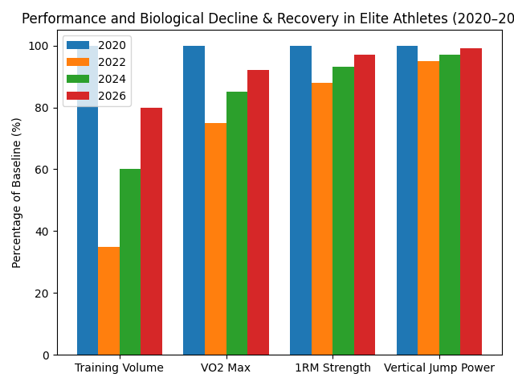
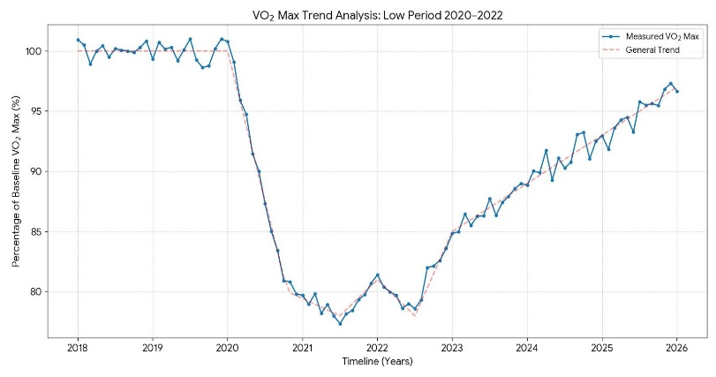
After the COVID-19 pandemic, athletes faced lingering cardiovascular and stamina complications. Smith and Chen (2022) used AI to monitor post-COVID physiological metrics like oxygen saturation, heart rate variability, and recovery times. Soccer players showed safer return-to-play schedules when guided by AI analysis. The study highlighted that post-viral health complications require data-driven training adjustments. AI helped minimize overexertion and sudden health events.

Fig. 2: Athlete performance decline & recovery (2020–2026)”
Fig 1: VO2 Max trends (2018–2026): baseline, 2020–2022 suppression, and steady recovery in 2024-2026.

4. Research Gap
Although existing studies focus on wearable devices, AI-based monitoring, and post-pandemic health tracking, “NOW few studies examine how prolonged home confinement during COVID-19 (2020–2022) affected athletes biological responses and performance”. Changes in human body parameters, such as reduced stamina, slower recovery, altered heart rate variability, and increased fatigue, have been observed due to decreased physical activity and altered lifestyle. There is also limited research comparing athlete performance before 2020 and post-2022 and now recent 2026, highlighting how biological data differs under pandemic conditions. Furthermore, very few studies combine real-time biological data analysis, AI-driven risk detection, and performance optimization, especially considering lifestyle changes and health challenges experienced during the pandemic.
III. RESEARCH METHODOLOGY

1. Research Design

This study aims to analyze the biological data of athletes and normal person using Automated AI-driven techniques to enhance performance and detect potential health risks in real time. A descriptive and analytical research design has been adopted, combining wearable devices, IoT sensors, and mobile applications for systematic data collection. The methodology focuses on capturing physiological parameters such as heart rate, oxygen saturation, fatigue, and recovery metrics, which are then processed using AI algorithms for predictive analysis and decision-making. This approach ensures accurate monitoring, risk prevention, and optimized performance, particularly considering lifestyle changes and post-pandemic health conditions.
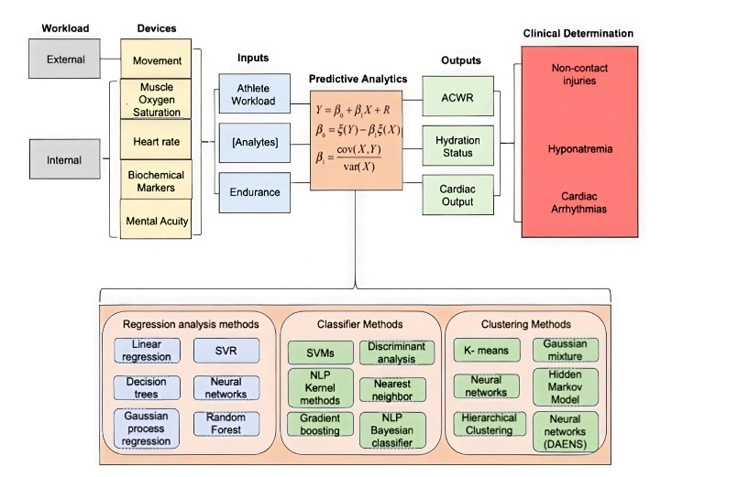

Fig. 3: Athlete health monitoring process: data acquisition, predictive modeling, and clinical risk assessment.

2. Data Collection
Data for this study is collected from a single participant (self-case study) during physical activity and workout sessions. The goal is to capture physiological and performance metrics accurately to analyze health risks, fatigue, and performance optimization.
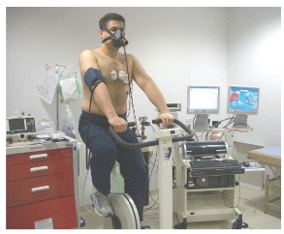
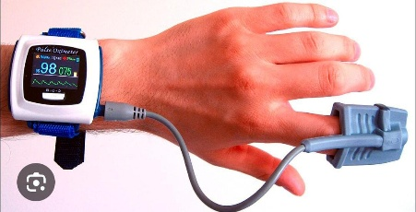
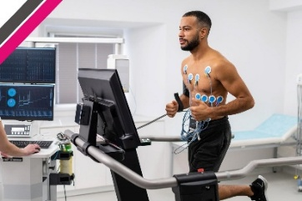
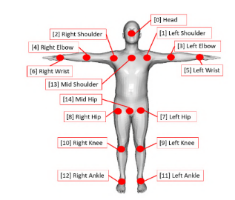


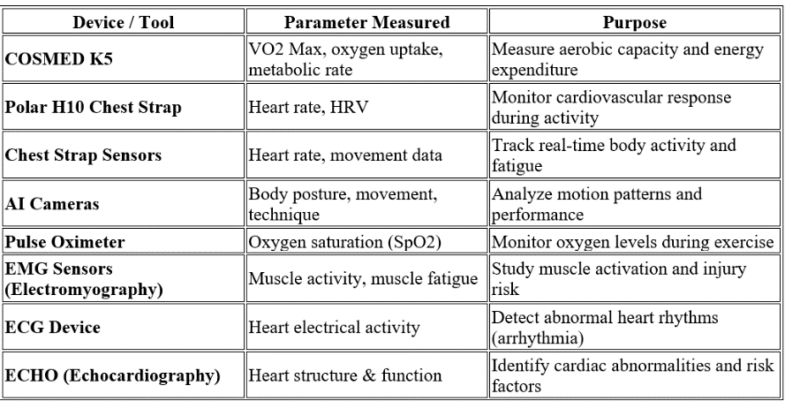

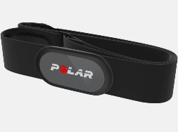

Figure 4 Multi-channel EEG/EMG waveform showing real-time neural and muscular activity.
Table 1: Physiological monitoring tools and measured parameters

The participant wears these devices during exercise sessions, and data is continuously recorded through mobile applications. The collected data is then transmitted via Bluetooth and IoT systems to a mobile device or cloud platform for further analysis.
3. Participants
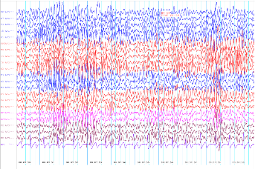
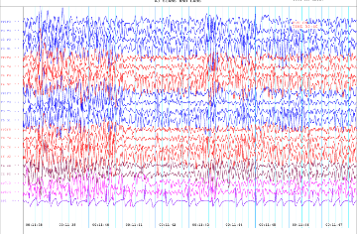
This study is a SINGLE-CASE STUDY APPROACH where the participant is the researcher. The participant falls within the 18–25 age group and maintains regular involvement in physical training activities. The study focuses on collecting and analyzing physiological parameters such as heart rate, oxygen saturation (SpO2), fatigue levels, and recovery rate. Data is gathered during controlled workout sessions using wearable devices and AI-enabled monitoring systems. where abnormal patterns such as extreme heart rate or low oxygen levels are identified to assess potential health or critical risk conditions during performance. Based on the findings, data-driven recommendations are proposed for optimizing training routines and dietary practices.
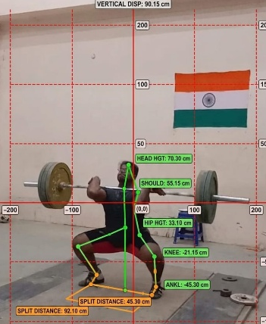
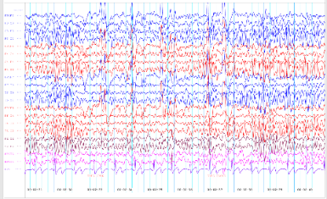

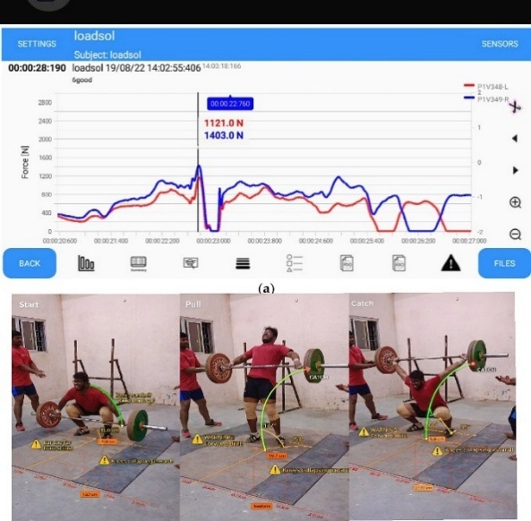

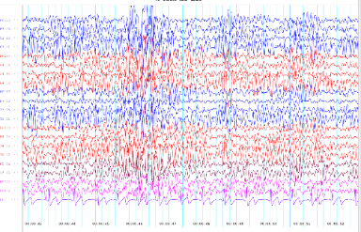
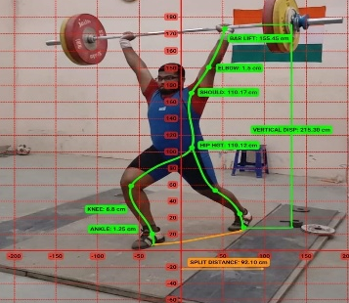

Fig. 5: Biomechanical force analysis and motion tracking during weightlifting phases.

4. Tools and Techniques
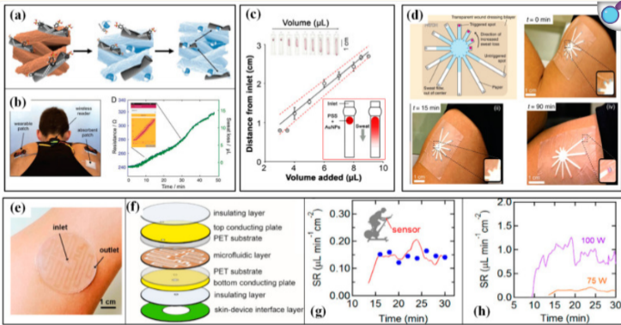
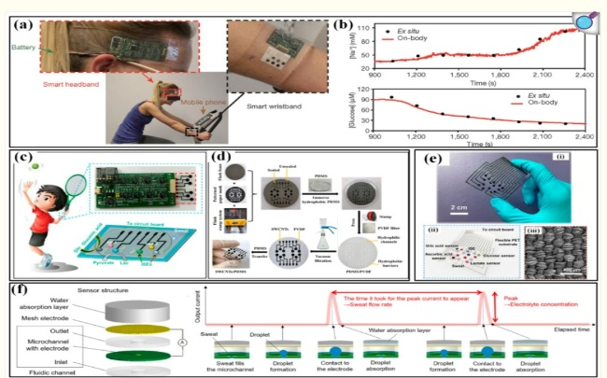
This study uses AI algorithms to analyze biological data and predict athlete performance and health risks. Wearable devices like COSMED K5, Polar H10, and chest strap sensors are used to collect real-time physiological data.AI cameras are used to track body movement, posture, and technique during activity.IoT and mobile applications help in transmitting and storing data in real time for continuous monitoring. IoT Platforms (Cloud Systems) that Store and manage large volumes of athlete data. Data visualization tools such as graphs and charts are used to present insights clearly for analysis and decision-making. APIs / Integration Software: Helps in connecting devices with AI systems for processing and analysis
Fig. 6: AI-based wearable biosensor system for real-time health monitoring.
IV. DATA ANALYSIS AND RESULT
Heart Rate:
Heart rate increased from resting (~70 BPM) to peak levels (165–175 BPM) during intense activity, indicating high cardiovascular exertion. Values above 160 BPM reflect heavy workload and increased fatigue risk.
SpO2 Levels:
Oxygen saturation remained mostly within the normal range (95–100%), with occasional drops to 93% during high intensity, indicating temporary oxygen deficiency.
Fatigue Analysis:
Fatigue was identified through sustained high heart rate and delayed recovery. Increased fatigue levels were observed after continuous exercise without sufficient rest intervals.
Recovery Rate:
Recovery analysis showed that heart rate took more than 2–3 minutes to return to normal levels, indicating moderate recovery efficiency and physical stress.
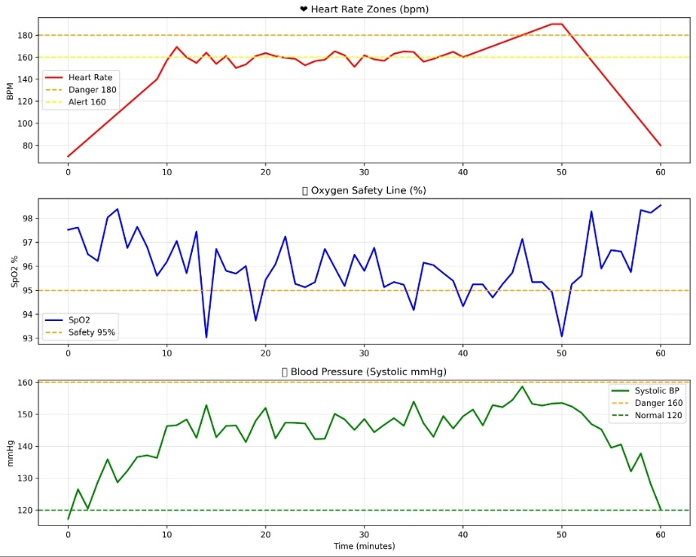
Risk Detection:
AI-based analysis detected abnormal patterns such as sudden heart rate spikes and slight drops in SpO2. The analyzed data is further visualized using Power BI dashboards for clear interpretation and decision-making. Based on the insights generated, data-driven recommendations are provided to optimize performance, diet, and training strategies.

Fig.8: SpO2 levels during rest, workout, and recovery.

Fig.7: Comparative timeline of heart rate, SPO2, and blood pressure for 60 minutes

V. CONCLUSION
This study demonstrates that the integration of Artificial Intelligence with real-time biological data analysis significantly enhances sports performance, athlete safety, and strategic decision-making. By utilizing wearable devices, IoT systems, and AI-driven analytics, physiological parameters such as heart rate, SpO₂ levels, fatigue, and recovery can be continuously monitored and interpreted with high accuracy. The findings highlight that AI-based predictive models are early idesigns of fatigue, stress, and potential health risks, including life-threatening conditions such as sudden cardiac arrest. This enables timely intervention, reduces injury risks, and supports data-driven training optimization. The single-case study approach provides valuable insights into real-time monitoring and demonstrates the practical feasibility of implementing such systems in sports environments. Further, the study shows the importance of post-pandemic health monitoring. In conclusion, AI-driven biological data analytics represents the future of sports performance management, offering a powerful combination of safety, efficiency, and competitive advantage. It shows how athletes train, perform, and sustain long-term health.
VI. BIBLIOGRAPHY / REFERENCES
1. Davenport, T. H., & Ronanki, R. (2018). Artificial Intelligence for the Real World. Harvard Business Review. https://hbr.org/2018/01/artificial-intelligence-for-the-real-world
2. World Health Organization (WHO). (2020). Impact of COVID-19 on Physical Activity and Health.
https://www.who.int/europe/emergencies/situations/covid-19/physical-activity-and-covid-19
3. World Health Organization. (2020). WHO guidelines on physical activity and sedentary behavior. https://www.who.int/publications/i/item/9789240015128
4. World Health Organization. (2022). Global status report on physical activity 2022. https://iris.who.int/handle/10665/363607
5. Frontiers Editorial Office. (2023). Artificial intelligence in sports: Performance and analytics. Frontiers in Sports and Active Living. https://www.frontiersin.org/journals/sports-and-active-living
6. Pope, Z. C., et al. (2023). Impact of COVID-19 on Physical Activity and Athlete Performance. International Journal of Environmental Research and Public Health. https://www.ncbi.nlm.nih.gov/pmc/articles/PMC10027357/
7. Rossi, A., et al. (2024). Machine Learning and Wearables in Athlete Monitoring: Performance and Health Insights. https://www.mdpi.com/1424-8220/24/2/567
8. Polar Electro Oy. (2023). Polar H10 Heart Rate Sensor – Product Overview.
https://www.polar.com/en/products/accessories/h10_heart_rate_sensor
9. COSMED. (2022). COSMED K5 Wearable Metabolic System. https://www.cosmed.com/en/products/cardio-pulmonary-exercise-test/k5
10. Singh, N. (2020). Sport Analytics: A Review. The International Technology Management Review https://doi.org/10.2991/itmr.k.200831.001
11. Beaudoin & Morehead (2021) demonstrate the practical application of Python-based analytics in sports data, supporting performance evaluation and decision-making https://journals.humankinetics.com/view/journals/smej/19/1/article-p46.xml

