REAL-TIME TRAFFIC SIGN CLASSIFICATION ON EDGE DEVICES USING LIGHTWEIGHT DEEP LEARNING MODELS

Abstract— Traffic sign recognition is one of the most important aspects of intelligent transportation systems and advanced driver assistance systems that affects the road safety and the reliability of autonomous vehicles directly. In this paper, the proposed AI-based traffic sign classification framework consists of YOLOv8, which is used to detect traffic signs in real-time and ResNet-50, which is used to classify traffic signs with a high level of accuracy. The given strategy capitalizes on the ability of YOLOv8 to detect traffic signs in a single stage due to its advantageous characteristics under the conditions of the real world, namely, different illumination, obstructions, weather, and sophisticated backgrounds. The regions of interest found then go through a deep convolutional neural network derived out of ResNet-50 that uses residual learning to allow further feature extraction and overcome the problem of vanishing gradient. The standard measures used to evaluate the performance include precision, recall, mean average precision (mAP), classification accuracy and inference latency. As experimental findings show, the YOLOv8 ResNet-50 hybrid architecture has a high level of detection accuracy and classification of objects at the expense of conventional CNN-based and single-model solutions, and retains the ability to process data in real time. The presented framework provides a scalable and efficient model to implement traffic sign recognition, and thus, it is perfectly applicable to the implementation of the autonomous driving platform and intelligent traffic monitoring system. This contribution helps the perception reliability and road safety by incorporating the state-of-the-art detection and classification networks, which will give the understanding of the traffic signs with high precision and reliability.
Keywords—Artificial Intelligence, Traffic Sign Classification, Deep Learning, Computer Vision, Intelligent Transportation Systems, Image Processing, Autonomous Vehicles, Road Safety, Real-Time Detection.

Introduction
The fast increasing number of vehicles in the road and the sophistication of the road networks have greatly become issues of concern in the world in terms of road safety and road management. Traffic signs are tools of quick visual communication that pass very important information, warnings and rules to the driver to allow them to navigate safely and effectively. Nonetheless, such monitoring as using human perception is also likely to contain flaws due to fatigue, distraction, low visibility, unfavorable weather conditions, or high velocity driving conditions. As the idea of smart transportation and autonomous driving technologies has appeared, the need to establish automated and dependable traffic sign recognition systems to support drivers and improve the overall safety in the road has increased. The combination of Artificial Intelligence (AI) with the development of computer vision and deep learning has become one of the most effective ways to overcome these issues and make machines look at traffic signs, interpret and react to them in the most appropriate manner.
Traffic sign classification systems that operate under AI can be used to automatically recognize and classify traffic signs on real-world images and streams of video. Among them, deep learning models, especially Convolutional Neural Networks (CNNs) have proven to be incredibly efficient because they are able to learn hierarchical features out of raw image data. In comparison to traditional rule-based approaches or handcrafted feature approaches, deep learning methods are resistant to changes in lighting, scale, orientation and cluttered backgrounds. This ensures that they are very appropriate in real-time applications like advanced driver assistance systems (ADAS) and autonomous vehicles. Being able to recognize road signs correctly, such systems can facilitate critical driving decision making, including speed control, lane control and avoidance of hazards, which will minimize the risk of accidents due to the omission or misinterpretation of road signs.Moreover, the introduction of AI-powered traffic sign classification into intelligent transportation infrastructure can transform the road safety and traffic efficiency. Besides increasing the autonomy of vehicles, these systems can also play a role in traffic monitoring, law enforcement, and urban planning by delivering appropriate data insights. Even with tremendous advancements, issues like the variability of the environment, degradation of signs as well as efficiency of computational processes are still active fields of study. The proposed project will investigate and deploy an AI-driven traffic sign classification system that utilizes advanced algorithms to deliver high accuracy and reliability and, eventually, make our roads safer and develop intelligent mobility infrastructure.

Literature Review
Pupezescu and Pupezescu (2022) [1] introduced a new automatic traffic sign system, which is a semi-supervised learning system, to overcome a problem of small number of labeled data in deep learning. They used the SimCLR architecture in their work with a contrastive learning based encoder initially trained on a large dataset of unlabeled images and subsequently fine-tuned on labeled data. Experimenting was done on the German Traffic Sign Recognition Benchmark (GTSRB) dataset which has 43 classes. The research proved that semi-supervised learning could help decrease the costs of labeling considerably without compromising the competitiveness of the classification, indicating the suitability of contrastive learning to traffic sign classification problems.
Jancy et al. (2023) [2] have created a traffic sign recognition system that is specific to autonomous vehicles and they focus on both detection and classification phases. The authors tested the aggregate channel features, integral channel features and the Convolutional Neural Networks (CNNs), using the LISA dataset. The proposed system had high detection performance as measured by the PASCAL metric by optimizing CNN layers, including convolution, max-pooling, and fully connected layers. The experiment supported CNNs as the best architectures in traffic sign detection in autonomous driving conditions.
Bhatt et al. (2022) [3] proposed real-time traffic sign detection and recognition system based on CNNs trained on a mixed dataset based on the GTSRB dataset and an Indian traffic sign dataset created by the authors. This work was motivated by the desire to have reduced driver distraction and improvement of road safety. On the hybrid dataset, the proposed model had an accuracy score of 95.45, 99.85 on the German dataset and Indian dataset respectively. These findings proved that the combination of regional datasets enhances the robustness and application to the real world of models.
H. K. P. P et al. (2024) [4] concentrated on solving some real-life issues like low-light conditions, motion blur, occlusion, and weather conditions when classifying traffic signs. They used a five-layer CNN model with image enhancement based on OpenCV. The system was able to classify 97.3% with the help of the GTSRB dataset. The research paper focused on the significance of preprocessing and the lightweight CNN architecture to enhance accuracy in classification and flexibility to adapt to different environmental conditions.
Pathi et al. (2025) [5] proposed a superior CNN-based traffic sign recognition system incorporating such deep architectures as ResNet, EfficientNet, and Vision Transformers (ViTs). The model had attention, data augmentation, and transfer learning to deal with the difficult conditions such as sign deterioration and occlusion. The proposed system was tested on GTSRB and BelgiumTS datasets and it was found to be more suitable to autonomous and smart transportation systems due to its higher precision, recall, and real-time performance, as compared to conventional CNN methods.
The system suggested by Namyang and Phimoltares (2020) [6] is a traffic sign classification system that is made specifically to classify Thai traffic signs by taking into account country-specific differences. Histogram of Oriented Gradients (HOG) and Color Layout Descriptors (CLD) were used in the system alongside Support Vector Machines (SVM) and Random Forest classifiers. Accuracy classification was achieved with 93.98 and then recognition phase was carried out in terms of OCR and template matching. This paper has shown that the conventional feature-based techniques can be used to localize traffic signs.
Uikey et al. (2024) [7] mentioned the absence of assessment of traffic sign recognition systems in the Indian environment. They suggested an integrated deep neural network system with the backbone models of AlexNet, VGG-19, ResNet-50, and EfficientNetV2 in parallel detection and classification. An Indian traffic sign dataset, which contained 4257 images, has been obtained recently. The system had a detection and classification accuracy of 85.5% and 98.5, respectively, which indicates the usefulness of multi-task deep learning models to region-specific tasks.
The research by Hongxing et al. (2023) [8] examined the classification of traffic signs with the help of the YOLOv5 object detection system. The paper also aimed at capitalising on the real-time performance and accuracy of YOLO to detect and identify traffic signs in a variety of real-life scenarios. The dataset consisted of images of various angles and positions in order to reflect the real traffic conditions. The YOLOv5 optimized model demonstrated higher recognition rates and appropriateness to serve in the real-time deployment.
Dai et al. (2024) [9] made a new step and used Reinforcement Learning based on Human Feedback (RLHF) in traffic sign classification. The model was trained using the LeNet-5 architecture first in a natural manner and then fine-tuned with human feedback in the form of a reward function. It was proven that the model with RLHF produces better results compared to the baseline LeNet-5 model, and human-in-the-loop learning can be used to enhance the classification performance.
The lack of data sets was tackled by Siniosoglou et al. (2021) [10] who suggested synthetic traffic sign datasets, so-called CTSD and CATERED, which were created with the help of the CARLA simulator. The authors used a deep autoencoder model to train a model that identifies and classifies distorted and occlusively covered traffic signs. The research also generalized the system to a federated learning system and services to show that it is applicable in distributed and decentralized smart transportation systems.

Zhou et al. (2022) [11] were interested in nighttime traffic signs detection and classification as, in this case, the image quality is negatively affected by low-light conditions. The authors have compared several methods used to improve low-light images and combined Zero-Reference Deep Curve Estimation (Zero-DCE) with an end-to-end CNN. The proposed method was shown to be more precise and recalls higher than the traditional methods and this was effective in night traffic conditions.
G. D. R et al. (2025) [12] suggested CNN-based traffic sign classification model that is tested on such benchmark datasets as GTSRB or the Belgian Traffic Sign Dataset. The research established the superiority of the deep learning methods over the traditional ones in regards to accuracy and strength. The findings supported the appropriateness of CNNs in autonomous driving in the real world.
In their study, Shyan et al. (2022) [13] have created real-time traffic sign detection and recognition through CNNs deployed on an embedded platform with a GPU. The system used a new multi-object suppression method in order to enhance the detection of the objects in complex backgrounds. Experimental tests demonstrated the accuracy of the models with training sample augmentation, which made the model able to be used in portable and real-time scenarios.

Proposed system.
A.Image Acquisition
The system initiates by acquiring road scene images through high-resolution cameras mounted on vehicles or traffic surveillance infrastructure. The captured images contain traffic signs under diverse real-world conditions such as varying illumination, motion blur, occlusion, and complex backgrounds. These images constitute the primary input for subsequent processing stages.
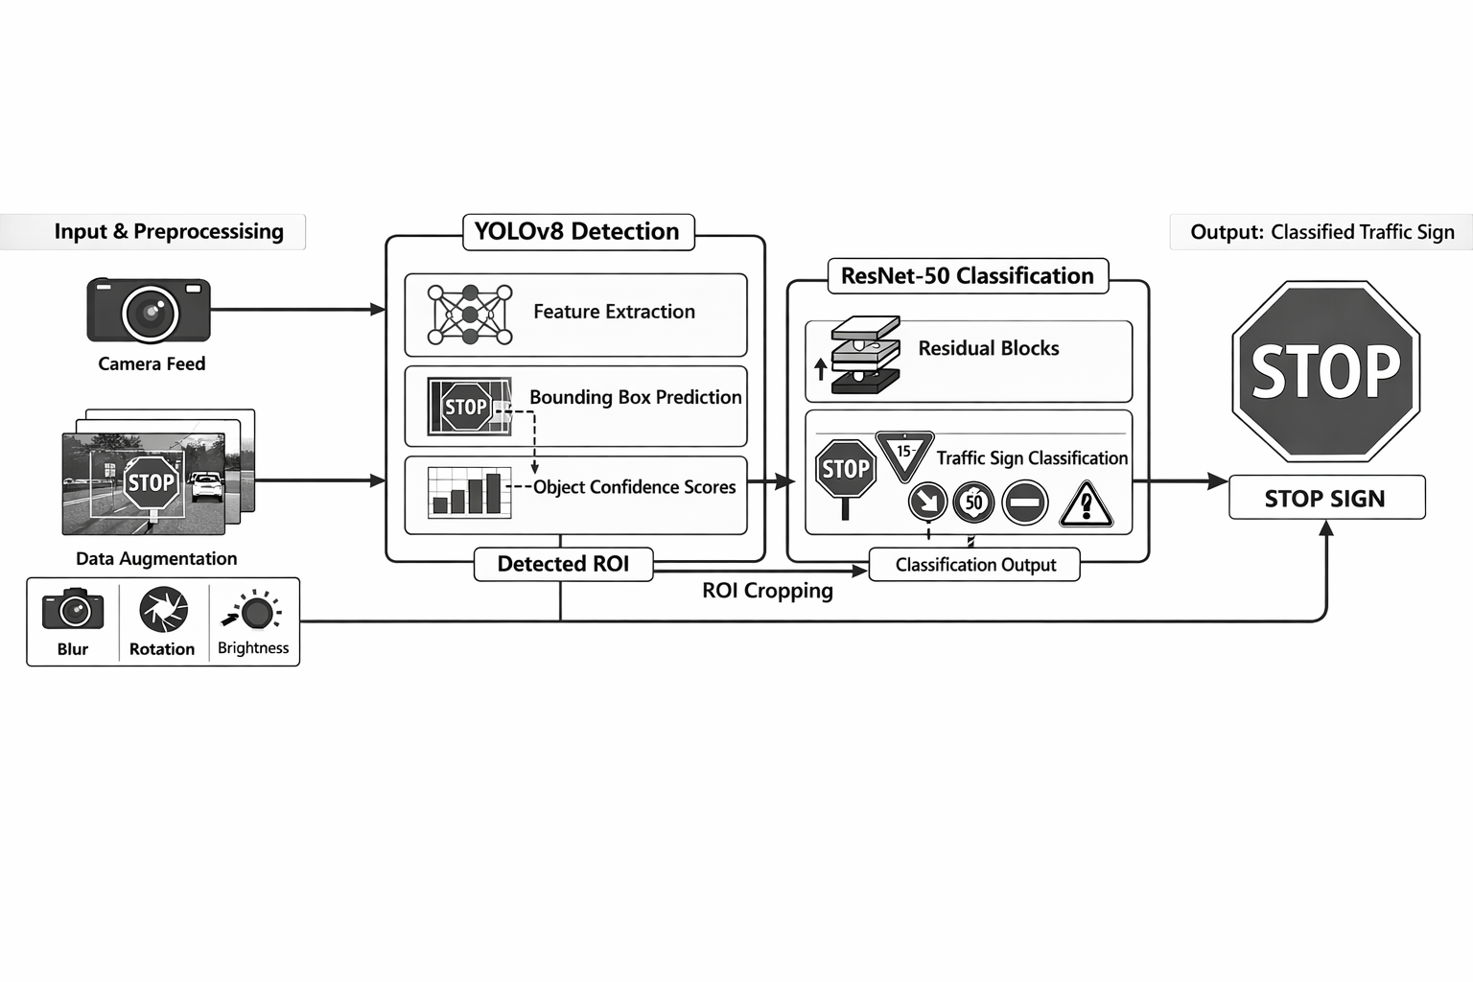

Fig:1 System Architecture
B. Image Preprocessing and Data Augmentation
To standardize the input data, preprocessing operations including image resizing, pixel normalization, and noise suppression are applied. These steps ensure compatibility with deep learning architectures and improve convergence during training. Data augmentation techniques such as geometric transformations (rotation, flipping), photometric adjustments (brightness and contrast variation), and blurring are employed to increase dataset diversity, enhance generalization capability, and reduce overfitting.
C.Traffic Sign Detection Using YOLOv8
Traffic sign localization is performed using the YOLOv8 object detection framework. YOLOv8 employs a one-stage detection architecture that integrates feature extraction, bounding box regression, and object classification within a single forward pass. Multi-scale feature maps are utilized to detect traffic signs of varying sizes, while confidence scores are generated to filter out low-probability detections. This approach enables high detection accuracy with low inference latency, making it suitable for real-time applications.
D.Region of Interest Extraction
Based on the bounding box coordinates predicted by YOLOv8, the detected traffic sign regions are cropped from the original images. This region of interest extraction eliminates irrelevant background information and ensures that only salient visual features are forwarded to the classification network. The cropped regions are resized to match the input dimensions required by the classification model.
E.Traffic Sign Classification Using ResNet-50
The extracted regions are classified using a ResNet-50 deep convolutional neural network. ResNet-50 incorporates residual learning through skip connections, enabling effective training of deep architectures by mitigating vanishing gradient issues. The network learns high-level discriminative features to accurately categorize traffic signs into predefined classes such as regulatory, warning, and informational signs. Transfer learning is employed by initializing the network with pretrained weights to accelerate convergence and improve classification performance.
F. Decision Making and Output Generation
The final output consists of the predicted traffic sign class along with its corresponding confidence score. This information can be integrated into advanced driver assistance systems or autonomous vehicle control units to support real-time decision-making processes, including speed regulation, driver alerts, and navigation assistance. The combined detection and classification pipeline ensures reliable and efficient traffic sign recognition in dynamic road environments.

Result and Discussion
In this section, the proposed AI-powered traffic sign classification system results are presented and the performance of the system is discussed in detail. To determine the accuracy, robustness and usefulness of the system in the real world, the benchmark datasets and the common measures of performance were used to test the effectiveness of the system.

Conclusion
This was an AI-based traffic sign classification system that was proposed to enhance road safety and assist in the intelligent transportation systems. Using the methods of deep learning, in particular, Convolutional Neural Networks (CNNs), the proposed system was able to learn the discriminative attributes of traffic sign images and showed high accuracy in the classification of a large variety of classes of traffic signs. The experimental findings proved that the model can work in various real-life conditions such as variations in lighting, orientation, and partial occlusion, which are significant.The comparison and analysis of the results indicated that the suggested CNN-based method is more accurate, robust, and scalable than the traditional rough handcrafted feature-based approaches. The dynamic feature extraction process allowed the model to learn well to complicated patterns of visual data in the absence of human interference, which is applicable in real-time systems like automated driving (advanced driver assistance systems (ADAS) and self-driving vehicles. The high results of the system on a range of benchmark datasets point to its high feasibility in current traffic conditions.Even after the promising results, some difficulties still exist especially under extreme conditions like driving at night and during bad weather. It is possible to improve it in the future with the use of low-light image enhancement methods, semi-supervised or reinforcement learning models, and more advanced architectures, including YOLO or Vision Transformers, to further enhance the detection and classification quality. On the whole, the presented system can prove the power of AI-based classification of traffic signs, as it can make driving more secure, decrease human error, and lead to the creation of safer and more intelligent transportation systems..

References
- M.-C. Pupezescu and V. Pupezescu, Novel automatic traffic sign classification system using a semi-supervised approach, 2022 23 rd International Carpathian Control Conference (ICCC), Sinaia, Romania, 2022, 177180, doi: 10.1109/ICCC54292.2022.9805952.
- S. Jency, S. Karthika, J. Ajaykumar, R. Selvaraj, and A. P. Aarthi, Traffic Sign Recognition System on Autonomous Vehicles based on Deep Learning, 203 th International Conference on Trends in Electronics and Informatics (ICOEI), Tirunelveli, India, 2023, pp. 11161121, doi: 10.1109/ICOEI56765.
- N. Bhatt, P. Laldas, and V. B. Lobo, A Real-Time Traffic Sign Detection and Recognition System on Hybrid Dataset using CNN, 2022 7th International Conference on Communication and Electronics Systems (ICCES) Coimbatore, India, 2022, pp. 13541358, doi: 10.1109/ICCES54183.2022.9835954.
- H. K. P. P., S. Ravindran and V. Vijean, Traffic Sign Classification to ensure Road Safety with CNN, 2024 International Conference on Emerging Systems and Intelligent Computing (ESIC), Bhubaneswar, India, 2024, pp. 462466, doi: 10.1109/ESIC60604.2024.10481587.
- A. M. V. Pathi, S. Abdulla, R. P. Sai, S. Sushanth Prince, T. Natraj, and P. Raju, Traffic Sign Recognition System with Advanced CNN Techniques, 2025 3 rd International Conference on Self Sustainable Artificial Intelligence Systems (ICSSAS), Erode, India, 2025, pp. 361365, doi: 10.1109/ICSSAS66150.2025.11
- O. Namyang and S. Phimoltares, Thai Traffic Sign Classification and Recognition System Based on Histogram of Gradients, Color Layout Descriptor, and Normalized Correlation Coefficient, 2020 5th International Conference on Information Technology (InCIT), Chonburi, Thailand, 2020, pp. 270275, doi: 10.1109/InCIT50588.2020.9310778.
- R. Uikey, H. R. Lone, and A. Agarwal, Indian Traffic Sign Detection and Classification Through a Unified Framework IEEE Transactions on Intelligent Transportation Systems, vol. 25, no. 10, pp. 1486614875, Oct. 2024, doi: 10.1109/TITS.2024.3411117.
- S. Hongxing, J. M. Caballero, and A. A. Hernandez, Traffic Sign Classification based on Deep Learning, 2023 IEEE International Conference on Automatic Control and Intelligent Systems (I2CACIS), Shah Alam, Malaysia, 2023, pp. 253 256, doi: 10.1109/I2CACIS57635.2023.10193379.
- T. Dai, Z. Chen, Z. Hu, and L. Zhou, Traffic Sign Classification based on reinforcement learning using human feedback, 2024 5 th International Symposium on Computer Engineering and Intelligent Communications (ISCEIC), Wuhan, China, 2024, pp. 169173, doi: 10.1109/ISCEIC63613.2024.10810206.
- I. Siniosoglou, P. Sarigiannidis, Y. Spyridis, A. Khadka, G. Efstathopoulos, and T. Lagkas, Synthetic Traffic Signs Dataset: Traffic Sign Detection and Recognition in Distributed Smart System, 2021, 17 th International Conference on Distributed Computing Sensor Systems (DCOSS), Pafos, Cyprus, 2021, pp. 302308, doi: 10.
- T. Zhou, H. Wang, C. Nie, H. Zhang, and Z. Sun, Design and Experimental Evaluation of Nighttime Traffic-Sign Detection and Classification Based on Low-Light Enhancement, 2022 6th CAA International Conference on Vehicular Control and Intelligence (CVCI), Nanjing, China, 2022, pp. 1 -6, doi: 10.1109/CVCI56766.2022.9964980.
- The article by G. D. R., R. D., J. Venkatagiri, P. R. Naidu, S. Supreeth and Y. T., Traffic Sign Classification Using Deep Learning Technique, 2025 International Conference on Computing Technologies Data Communication (ICCTDC), Hassan, India, 2025, pp. 01-05, doi: 10.1109/ICCTDC64446.2025.11158719.
- L. J. Shyan, T. H. Lim, and D. N. Pg Hj Muhammad, “Real Time Road Traffic Sign Detection and Recognition Systems based on Convolution Neural Network on a GPU Platform, 2022 International Conference on Digital Transformation and Intelligence (ICDI), Kuching, Sarawak, Malaysia, 2022, pp. 236240, doi: 10.1109/ICDI57181.2022.10007277.

