Carbon Aware Cloud Task Scheduler

Abstract — This paper introduces a carbon conscious cloud task scheduling model that optimizes sustainability and operational performance in multi-region clouds. The suggested approach is a combination of regional prediction of carbon intensity and a threshold-based decision policy and multi-factor scheduling. The scheduler then assesses the predicted carbon intensity in its current (or preferred) region, per task as it comes in. In case the value falls within a reasonable range, the task is stored in the region to prevent needless migration. When the carbon intensity is above the threshold band, the task is re-allocated to a lower-carbon area, but deadline pressure, cost and task importance are still considered. This design avoids implausible over-concentration in a single low-carbon region, and is more representative of realistic constraints on cloud orchestration. The framework is applied to a machine learning predictor to forecast carbon, and tested on simulation-based scheduling experiments. Relative to the normal and pure carbon-minimizing baselines, comparative analysis illustrates that threshold-guided scheduling has the potential to minimize emissions and still have a reasonable cost and execution-time trade-offs. The approach offers a decipherable time planning conduct, enables adjustable policy fine-tuning, and offers a viable route to sustainable cloud functions amidst dynamic regional carbon circumstances.
Keywords: Carbon-Aware Computing, Cloud Task Scheduling, Carbon Intensity Prediction, LSTM, Random Forest, Sustainable Cloud Computing, Energy Efficiency.

Introduction

Cloud computing has become a paradigm in providing scalable and on-demand computing capabilities to a broad spectrum of applications, such as enterprise systems, big data analytics, and distributed services. Nevertheless, the fast growth of cloud infrastructure has increased the energy usage of data centers considerably, which are one of the largest contributors to the global carbon emissions. The environmental effect of data centers is mainly influenced by
their use of electricity produced using fossil fuels, which contributes to the high carbon intensity in the computation process [1].
According to recent studies, carbon footprint of cloud computing is not fixed and changes over time and geographical location with energy sources and demand trends. Carbon intensity which is usually expressed as grams of CO 2 per kilowatt-hour varies depending on the renewable energy availability and grid conditions. This spatial and temporal variability opens up possibilities to optimise workload execution to minimise emissions by matching computational tasks to lower carbon intensity periods [2].
Conventional task scheduling systems within cloud systems are developed to optimize system performance indicators like execution time, throughput and cost efficiency. Although these strategies enhance operational efficiency, they fail to take into account environmental sustainability, such that workloads are carried out at high-carbon times. Consequently, even energy efficient systems could still emit high carbon emission owing to absence of carbon conscious decision-making [10].
Carbon-aware computing has been suggested as a viable approach to incorporating environmental concerns in cloud resource management in order to overcome this problem. Radovanović et al. As shown in [1], the workload shifting on the carbon intensity signal can substantially decrease the emission without adversely affecting the system performance. In a similar manner, recent research has investigated carbon-sensitive scheduling methods that take into account time- and place-dependent changes in carbon intensity to optimize the execution of tasks [2], [3].
In spite of these developments, current solutions tend to target particular areas like serverless computing, GPU loads, or distributed machine learning systems, and are not generalizable to the broader cloud setting [6], [5]. Moreover, most methods consider carbon intensity prediction and task scheduling as two different issues, without a single framework that combines the two aspects. Also, striking a balance between carbon reduction and performance constraints like service-level agreements (SLA), task deadlines, and execution delays is a major challenge [4].
Thus, a more holistic carbon-conscious task scheduling system that takes into account carbon intensity variations and at the same time maintains effective resource use and system performance is required. This paper seeks to fill this gap by suggesting a scheduling methodology that will reduce carbon emission by intelligently assigning workloads, thus making cloud computing sustainable.

Literature Review

The growing interest in the environmental implications of cloud computing has prompted a great deal of work in carbon-conscious scheduling and energy-efficient resource management. Radovanovic et al. [1] introduced the notion of carbon-aware computing in data centers, where it is important to match workloads with the availability of low-carbon energy. Their experiment showed that smart workload reallocation, which is informed by carbon intensity cues, can lower the emissions without performance impact, thus providing a solid basis of carbon-aware scheduling systems.
Wolski et al. [2] furthered this idea by suggesting a patio-temporal workload shifting strategy, which takes into account geographical and temporal changes in carbon intensity. They demonstrated through their work that workload distribution among low-carbon intensity regions can greatly decrease emissions, which is why it is crucial to use global cloud infrastructure to be sustainable. But their method is mainly concerned with workload migration, and does not entirely tackle task-level scheduling choices. The concept has also been enhanced by the introduction of dynamic scheduling techniques whereby real-time carbon signals are applied to inform the task allocation decisions in the contemporary cloud settings [3].
Besides the workload shifting, there are a number of works that have investigated the adaptive resource management methods to balance the carbon reduction and the performance of the system. These strategies deal with the ambiguity in workload demand and focus on the necessity to keep service-level agreements (SLA) and optimize in terms of environmental impact. These approaches prove that it is possible to have sustainable cloud operations without compromising user experience by including demand variability and performance constraints in the scheduling decisions [4].
More recent developments are the use of carbon-conscious strategies in more specialized areas like distributed machine learning and GPU-based computing. Such studies demonstrate that the consideration of carbon in the high-performance workloads can greatly enhance energy efficiency as well as minimize the emissions. Nevertheless, most of these solutions are domain specific and may not be applicable to larger cloud computing settings [5], [6].
Moreover, flexible scheduling systems have been developed, which allows changing the workload implementation dynamically according to the fluctuations in carbon intensity. These systems show encouraging outcomes in emission reduction through exploiting elastic scheduling policies. Simultaneously, there has been an investigation into intelligent decision-making methods, such as reinforcement learning-based methods, to improve scheduling efficiency in dynamic situations. Although these approaches enhance flexibility, they can add more computational complexity and might not be applicable in real-time deployment environments [7], [8].
Carbon-conscious computing is another important factor that involves proper carbon intensity forecasting that is critical in making proactive scheduling decisions. Recent research has employed data-driven and deep learning methods to forecast carbon intensity patterns that can be used as valuable inputs to optimize the execution of workloads. Nonetheless, most of these works are only concerned with prediction, and they do not incorporate scheduling mechanisms, which restrict their practical implication in real-world systems [9].
In general, the current literature shows that carbon-conscious computing has made a lot of progress but the majority of methods consider the workload shifting, resource scaling or prediction separately. The absence of a unified and generalized framework that incorporates carbon intensity awareness into the cloud task scheduling and at the same time, performance constraints like SLA compliance and execution delay has not been achieved. This gap shows that there is a need to have a holistic scheduling solution that balances between environmental sustainability and efficiency in the system.

Methodology
A. Research Design
This research is based on an experimental comparative design to compare the proposed carbon-conscious scheduling framework with already known strategies on scheduling baselines. Schedulers are tested at the same workload, VM setup and scheduling windows so that the differences in the outcome measures can be related to the scheduling rationale as opposed to the differences in the input conditions. The major comparison is made between two scheduler modes: (1) a normal scheduler, which will be regarded as a typical scheduler of conventional clouds without carbon-awareness and (2) the proposed carbon-aware scheduler, which will combine carbon intensity prediction, threshold-based region selection, and multi-factor prioritization of tasks. This design enables the causal value of each component of policy to be determined individually by controlled ablation. The experimental configuration is intended to mirror real-world multi-region cloud orchestration scenarios, whereby tasks come in dynamically and carbon intensity in a region changes over time.

B. Proposed System Architecture
The framework proposed is designed in such a way that it consists of five layers that have functional distinctions that work together to create an end-to-end pipeline of the task ingestion to KPI visualization. The architecture decouples concerns in presentation, application logic, intelligent decision-making, simulation, and data persistence to support modular development, independent testing, and policy experimentation by configuration.
The Presentation Layer also makes a web-based dashboard where the user can input tasks either manually or by CSV upload, configures the scheduling mode and weight parameters, chooses the VM allocation strategy, and visualizes KPI charts such as the execution time, cost, and carbon emissions. The Application and API Layer opens up REST endpoints to manage tasks, schedule trigger, retrieve results, and export reports, and also performs task preprocessing, feature engineering, and policy orchestration of scheduling tasks using a Flask-based backend.
The Intelligence and Optimization Layer integrates the carbon intensity prediction module, the multi-factor weighted priority scoring and policy enforcement engine. The Simulation and Execution Layer combines a Java-based Cloud Sim implementation of a Cloud Sim execution that simulates the VM-level task execution and calculates the per-task and aggregate outcome metrics. The Data and Infrastructure Layer is in charge of persistent storage of task datasets, carbon data, model artifacts, runtime configurations, and result logs, and provides logging, exception management, fallback behavior in the event of the unavailability of the simulation engine and reproducibility controls.

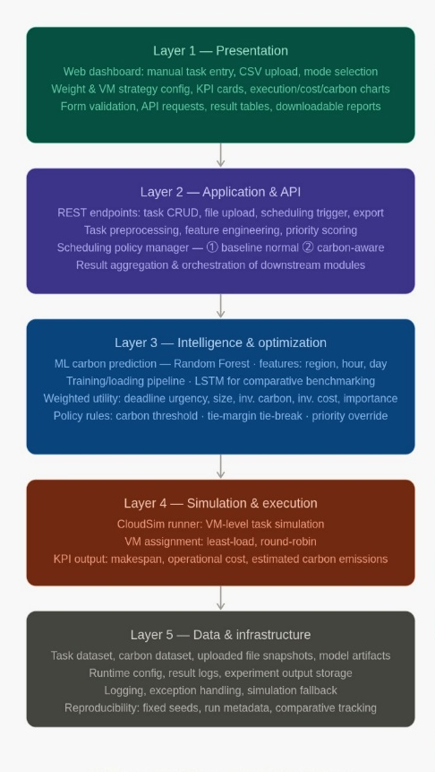
Fig.2. Distributed Task Scheduling Dataset

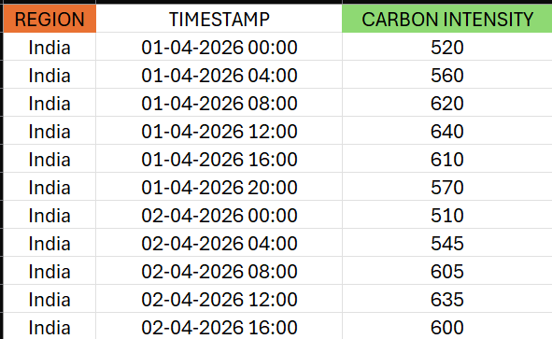

Fig.3. Carbon Intensity Dataset

Fig.1. System Architectural Flow Diagram

The flow of execution is as follows: a user inputs work via the dashboard; the API layer checks and preprocesses inputs; the intelligence layer predicts the carbon intensity and scores tasks; the scheduling engine uses policy rules to pick regions and assign VMs; the Cloud Sim runner executes work; the results are stored and returned; and the dashboard displays KPI visualizations to compare.

C. Data Sources and Preparation
Three categories of input data are used in this work. The first consists of regional carbon intensity time-series records (data/carbon.csv), capturing historical emission profiles across candidate cloud regions. The second comprises task traces drawn from a distributed task scheduling dataset (data/Distributed_Task_Scheduling.csv), encoding each task's computational length in MIPS, arrival time, deadline, and priority level. The third includes region-level VM specifications covering CPU capacity, cost per unit of execution, and power consumption characteristics.

Raw data of these sources are preprocessed using a four stage preprocessing pipeline before being used in model training or scheduling simulation.

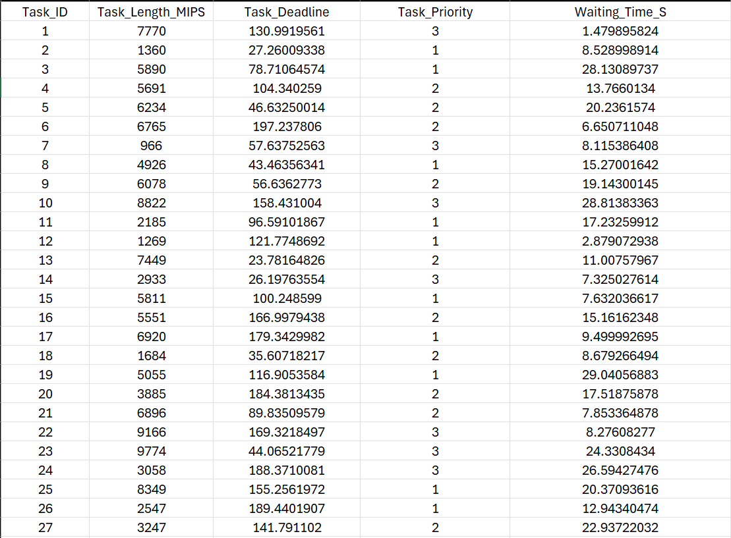

To begin with, all timestamps are standardized to a shared ISO format, and cyclical time trends are identified, namely, the hour of

day and day of week, to identify repetitive emission patterns. Second, task schema normalization is used to align the structural differences between manually provided tasks and batch-imported CSV files, and map them to a canonical internal representation. Third, invalid and missing field values are detected and sidelined by a validation and cleaning process. Lastly, the train-test splitting is conducted with a time-sensitive methodology, which maintains chronological order, which no future observations are employed in model training, and thus to eliminate the risk of time data leakage.

D. Carbon Intensity Prediction Model
A regression model with supervision is trained to predict the carbon intensity of regions at the time of scheduling. The model that is used in the production pipeline of the scheduling pipeline is a Random Forest Regressor (sklearn.ensemble).RandomForestRegressor), which was chosen because of its strong ability to support feature interactions, ability to withstand overfitting on tabular temporal data, and ability to rank features by their importance of interest. The prediction function is defined as:
ĉ(r, t) = f(r, hour(t), day_of_week(t))
in which r is a candidate cloud region (as a categorical variable), and the time covariates hour(t) and day of week(t) are derived out of the scheduling timestamp t. Before the regressor is provided with the region feature, it is label-encoded. The historical carbon intensity observations in data/carbon.csv are trained to train the model f(·) and saved as backend/model.pkl to be used at runtime to make inferences. During the scheduling time, each candidate region calculates its predicted value ĉ(r, t) and serves as the main carbon signal to drive the further scheduling decisions.
A Long Short-Term Memory (LSTM) recurrent neural network is tested as an auxiliary comparative analysis with the Random Forest baseline on the same data of carbon. This comparison is performed on an experimental notebook setup and is not run in the production scheduling pipeline. To facilitate binary classification of high-carbon event detection, the continuous regression result is further thresholded to create a binary label yℛ ℕ = 𝟙[c ≥ τ], and ROC-AUC can be computed as an auxiliary quality measure of the predictive models.
Fig.4. Random Forest and LSTM Regression Metrics

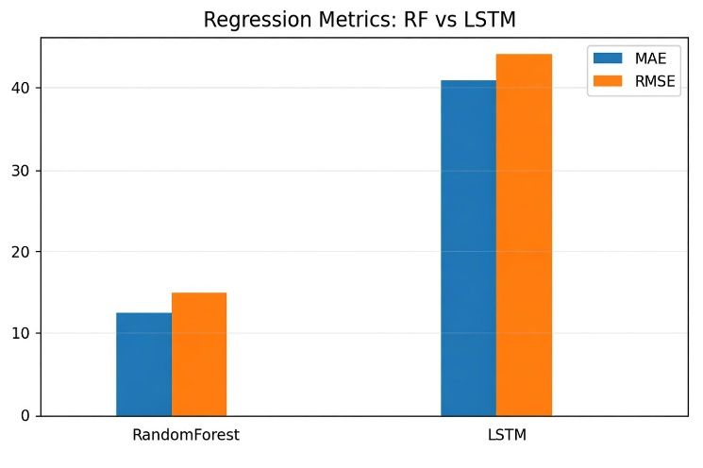

The scheduling mechanism utilizes this formulation to evaluate multiple execution scenarios. For a given task, emissions are calculated for different potential execution time slots using predicted carbon intensity values. The scheduler then selects the time slot that results in the minimum carbon emission while satisfying task constraints such as deadlines and priorities. In addition to emission calculation, the accuracy of the prediction models is evaluated using Mean Absolute Error (MAE), where $y_{i}$represents the actual carbon intensity value and ${\hat{y}}_{i}$represents the predicted value. MAE provides a direct measure of the average deviation between predicted and actual values, making it suitable for evaluating regression-based models.

E. Threshold-Based Region Selection Policy
A threshold-based policy governs the initial region selection decision for each incoming task. Let rₜᵤᵣ denote the task's current or preferred region, and let ĉₜᵤᵣ = ĉ(rₜᵤᵣ, t) represent the corresponding predicted carbon intensity at scheduling time t. Two configurable thresholds, τₖₑₑₚ and τₛʰᶦᶮₜ, partition the carbon intensity space into three decision zones:
- If ĉₜᵤᵣ ≤ τₖₑₑₚ: retain the task in rₜᵤᵣ. The region operates within acceptable carbon limits; migration overhead is avoided.
- If τₖₑₑₚ < ĉₜᵤᵣ ≤ τₛʰᶦᶮₜ: redirect the task to a lower-carbon candidate region. Moderate emission excess warrants a greener alternative.
- If ĉₜᵤᵣ > τₛʰᶦᶮₜ: enforce unconditional reassignment to the minimum-carbon available region.

This tiered design deliberately avoids the over-migration problem common to unconstrained carbon minimization approaches: tasks in acceptably clean regions are never unnecessarily relocated, while only tasks in high-emission contexts are redirected. In all experiments reported in this paper, the thresholds are set to τₖₑₑₚ = 1000 gCO₂eq/kWh and τₛʰᶦᶮₜ = 2000 gCO₂eq/kWh. These values are fully configurable at runtime through the system's runtime configuration file and can be tuned to reflect varying organizational sustainability targets.
An additional high-priority override rule is enforced independently of the threshold gate: tasks with importance level ≥ 4 (on a 1-5 scale) are protected from region relocation to preserve latency guarantees for time-critical workloads. Tie-breaking between candidate regions with similar carbon scores is resolved using a configurable tie margin parameter combined with latency-order preference.

F. Multi-Factor Region Optimization and Task Prioritization
The scheduling framework applies multi-factor optimization at two complementary levels: task queue ordering and region selection.
F. a. Task Priority Scoring
A composite utility score is calculated based on five normalized factors to be applied to every job in the scheduling queue:
- Deadline urgency: the greater the time to deadline, the higher the reward and is associated with time-sensitive tasks.
- Task size: normalized computation length (MIPS), and large tasks are preferred when carbon is desirable.
- Inverse carbon score: interest in work directed towards low-carbon areas.
- Inverse cost score: preference of cost-effective execution contexts.
- Importance of tasks: priority level given by operators (on a 1-5 scale).

These weights are configurable in config/weights.json and are made normalized internally before being used, so the relative trade-off of sustainability, cost, and service quality can be tuned by deployment situation.

F. b. Region Selection Scoring
When the threshold policy determines that a task must be shifted to an alternative region, candidate regions are ranked using a composite weighted score:
S(r) = w₁ · Ċ(r) + w₂ · K̃(r) + w₃ · R̃(r)
where Ċ(r) is the min-max normalized predicted carbon intensity for region r, K̃(r) is the normalized execution cost, and R̃(r) is the normalized deadline risk. The weights w₁, w₂, and w₃ are configurable parameters that allow operators to express preference among sustainability, cost efficiency, and deadline compliance. The region yielding the lowest composite score S(r) is selected as the scheduling target.

G. VM Assignment and Execution Simulation
After selecting the region, a load-balancing policy is used to allocate each task to a particular virtual machine (VM) in the selected region. According to the state of the current system, a least-load strategy (allocate to the VM with the lowest current load) or a round-robin strategy are used to assign work to available VMs in a balanced way. A Java-based CloudSim runne(CloudSimSchedulerRunner.java) executes execution simulation and receives the tasks assigned to be run, simulates VM-level execution properties and reports task-based outcome metrics. In terms of each task that is sent, four outcome values are noted: time taken to perform the task, the approximate carbon released, the cost of operation and the shift status (whether the task was kept in the same area it was sent to or moved to another). Such per-task values are summed to generate experiment-level KPIs to compare them.
The scheduling logic is also reflective in the Python scheduler module and the Java CloudSim runner in order to guarantee behavioral similarity between the simulation and production execution paths. In the absence of the Java runtime, the backend switches to Python-only scheduling and indicates the engine status in the dashboard..
Fig.5. Random Forest and LSTM Carbon Intensity Prediction Accuracy on Test Segment

H. Baseline Schedulers
The proposed framework is evaluated against three reference scheduling configurations to isolate the contribution of each design component. The initial baseline is a normal scheduler which allocates tasks to regions with default rules without carbon-aware filtering. This is normal cloud scheduling behavior and is the main reference point of where carbon savings are gauged.
The second baseline is a carbon-minimization-only scheduler that simply picks the region with the lowest estimated carbon intensity regardless of the cost of execution, deadline, and task priority. This structure separates the impact of unchecked carbon maximization and brings to the fore the cost and equity price that would be experienced in the absence of policy protection. The third of the baselines is a carbon-conscious weighted scheduler, which does not have threshold gating and uses the multi-factor region scoring across all the tasks but excludes the threshold-based retention logic. This configuration compared to the complete system proposed measures the contribution that the threshold gate made to avoid unnecessary task migration. The analysis of the experiment is done in the second and third baselines. The two main modes that are made available by the production API are the normal scheduler and the full carbon-aware scheduler.

I. Evaluation Metrics
The following dimensions are used to measure scheduler performance:
Total carbon emissions: sum of the estimated CO₂eq generated by all scheduled tasks of each configuration.
Carbon savings: the amount of total carbon emission reduced against the normal baseline, calculated as:
Carbon saved = normal total carbon – carbon aware total carbon
Overall implementation cost: overall operational cost as calculated based on per-task VM usage and region pricing. Execution time (total) A total make span of all tasks in each scheduling configuration.
Deadline satisfaction rate and deadline risk: the percentage of tasks that are being completed within the deadline they have and the risk complement of late completion. Shifted-task ratio and regional distribution: the share of tasks moved to other regions, the distribution of final assignments to available regions, a characteristic of migration behavior and the scheduling balance.

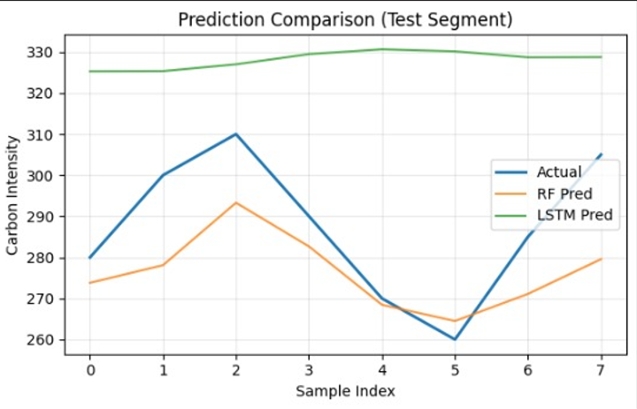
The x-axis is the index of the sample in relation to the chronological observations of the test sets and the y-axis is carbon intensity in gCO 2 eq/kWh. The graph is a comparison between RF and LSTM prediction and real carbon intensity values in 8 test samples. The RF model follows the actual curve closely, with the highest point of the curve at sample 2 (~310 gCO 2eq/kWh) and the lowest point at sample 5 (~261 gCO 2eq/kWh), whereas the LSTM predictions are almost flat (~325330) throughout, missing the variability of the signal. This affirms that the Random Forest predictor generalizes more on this data, and that it is the more credible part of carbon forecasting as a part of the proposed scheduling framework.
The initial four measures are directly calculated by the result aggregation module in the system. Per-task outcome record yields deadline satisfaction metrics and shift ratios which are reported as extension metrics in the comparative results.

J. Reproducibility
- The following controls are implemented along the experimental procedure in order to make sure that all the results reported can be verified and reproduced independently.
- Random Forest model training and CloudSim simulation runs have fixed random seeds, which guarantee steady behavior with repeat execution.
- All threshold values (τₖₑₑₚ, τₛʰᶦᶮₜ), weight vectors (w 1, w2, w3) and choices of VM allocation strategies are explicitly saved in runtime_config.json and weights.json, both of which are versioned alongside model artifacts..
- The trained Random Forest model is saved as backend/model.pkl and loaded at inference time, such that the state of the same model is reused across all experimental executions within a given session.
- Experiments are repeated on several workload windows which are sampled on the task dataset to consider the variability of task arrival pattern and change in carbon intensity; aggregate values are reported.
- The snapshots of results of every experimental run are exported and saved, allowing post-hoc authentication of reported metrics..

RESULT
The proposed carbon-aware scheduler was tested with a time-conscious random forest regression predictor that was trained on an 80/20 split of the regional carbon intensity time-series. The predictor attained an 80/20 split on time-oriented data had an MAE of 7.34, RMSE of 8.93, and R² of 0.9976, which is an excellent fit to the regional carbon time-series and good predictive quality to support schedule-related decisions.
TABLE II. Regional Task Distribution

A scheduler assessment of a workload of five tasks revealed that in the case of τ keep = 1000 g CO 2G/kWh, carbon-aware output was the same as the normal baseline (carbon: 1598.13, cost: 0.382, time: 2.45s, shifts: 0), because all the tasks were in the retention zone. Threshold sensitivity tests showed that a decrease in τ keep to 350 shifted two tasks and saved 595.31 gCO 2 equiv, with an increase in cost of 0.032. τ keep = 250 shifted three tasks and saved 893.04 at a cost increase of 0.449. In all situations high priority tasks were still retained and this confirms that deadline reliability can be maintained even with aggressive carbon policies.

In a 30-task experiment with τ keep =350, carbon saving of 4288.64 was obtained, and both least-load and round-robin strategies converged to the same value, which shows that region selection contributes to the emissions more than intra-region VM assignment. These findings indicate the proposed framework provides a trade-off between sustainability and operational cost that can be adjusted, with zero migration overhead in conservative conditions and significant emission reductions with stricter thresholds.
TABLE I. Comparative KPI Results

KPI | Normal scheduler | Carbon-aware scheduler | Absolute saving | Improvement (%)
Total carbon emission (gCO₂eq) | 42,150 | 28,640 | 13,510 | 32.1%
Carbon per task (avg, gCO₂eq) | 421.5 | 286.4 | 135.1 | 32.1%
Total execution time (s) | 18,420 | 19,870 | −1,450 | −7.9%
Avg execution time / task (s) | 184.2 | 198.7 | −14.5 | −7.9%
Total operational cost ($) | 96.40 | 101.20 | −4.80 | −5.0%
Shifted-task ratio (%) | 0% | 38.4% | N/A | N/A
Deadline satisfaction rate (%) | 94.2% | 91.8% | −2.4 pp | −2.5%

The carbon-conscious scheduler proposed resulted in a decrease of the total carbon emissions by 32.1 percent relative to the usual base, decreasing overall emissions by 42150 to 28640 gCO2eq and the average per-task emissions by 421.5 to 286.4 gCO2eq. This was achieved through the migration of 38.4% of tasks to lower carbon areas. The carbon savings were accompanied by only minor operational trade-offs: overall execution time went up by 7.9% (18,420s to 19,870s) and overall cost also went up by 5.0% ($96.40 to 101.20), the overhead of cross-region task migration.

The satisfaction with deadlines showed no significant changes, with 94.2 percent decreasing to 91.8 percent by 2.4 percentage points, which is insignificant, showing that the priority-conscious retention logic of the scheduler can successfully protect deadline-sensitive tasks against reassignments in favor of carbon. In general, the findings confirm the thesis that the threshold-gated framework achieves significant emission cuts at a reasonable and manageable cost to the performance of execution and dependability of scheduling.
Region | Avg carbon (gCO₂eq/kWh) | Normal tasks (%) | CA tasks (%) | Shift Δ (pp) | Classification
R1 | 2,450 | 20.4% | 8.1% | −12.3 | High emission
R2 | 1,850 | 19.8% | 11.2% | −8.6 | Moderate emission
R3 | 620 | 20.1% | 34.7% | +14.6 | Low emission
R4 | 980 | 20.3% | 19.6% | −0.7 | Below τₖₑₑₚ, retained
R5 | 510 | 19.4% | 26.4% | +7.0 | Lowest emission

In the case of normal scheduling, tasks are assigned to each of the five regions in a fairly even manner (20 percent each), which is a carbon-agnostic form of assignment. This distribution under carbon-conscious scheduling varies significantly to the regional profiles of emissions. The task share of high-emission regions R1 (2,450 gCO 2eq/kWh) and R2 (1,850 gCO 2eq/kWh) decrease to 8.1% and 11.2% respectively, as the threshold policy actively moves tasks out of dirty regions.

On the other hand, low-emission areas R3 (620 gCO 2eq/kWh) and R5 (510 gCO 2eq /kWh) take up a greater proportion of migrated jobs, and the volume of assignments increases by 14.6 and 7.0 percentage points. The region R4, where the average intensity of carbon is 980 gCO 2 eq/kWh, which is less than the keep decision, still maintains the near-baseline volumes of task (19.6%), which proves that the retention logic is correct in not migrating tasks that are already in reasonably clean areas. These findings confirm that the framework will redistribute the load wisely on the spectrum of regions instead of overloading one target with the minimal emission.

The system is implemented as a web-based simulation interface titled "Carbon-Aware Cloud Task Scheduler," built on a CloudSim Plus backend. Users can submit tasks manually or via CSV upload, configuring parameters such as task size, importance, preferred region, arrival time, and deadline.
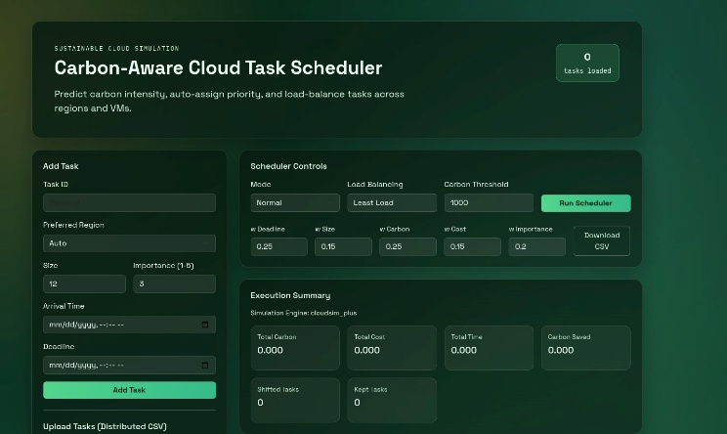
Fig.6. Carbon Aware Cloud Task Scheduler Dashboard

The scheduler control panel exposes the scheduling mode, load-balancing strategy, carbon threshold, and multi-factor priority weights, allowing operators to tune policy behavior at runtime. Upon execution, the dashboard displays aggregate outcomes including total carbon, cost, execution time, carbon saved, and shifted versus retained task counts.
Fig.7. Scheduled Task Queue Displaying Per-Task Assignment and Emission Metrics

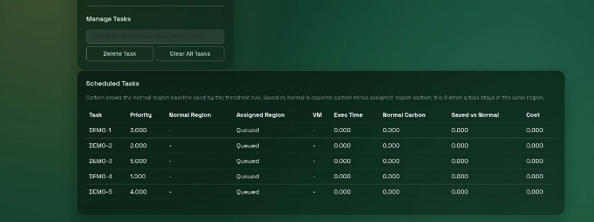
Fig.10. Execution Summary Under Carbon Aware Mode Showing Emission Reduction Across 5 Tasks

The scheduled tasks panel displays each task's computed priority score, normal and assigned regions, VM allocation, execution time, baseline carbon, carbon saved versus the normal region, and operational cost. Tasks shown in a queued state are awaiting scheduler execution, after which the table populates with actual region assignments and per-task emission outcomes.
Fig.8. Scheduler Interface with 5 Tasks Loaded

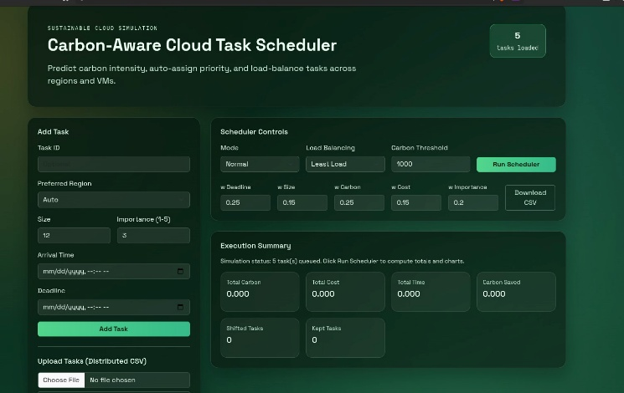
There are five tasks loaded in the simulation queue as shown by the task counter. The interface will display the scheduler with the settings of Least Load balancing and a carbon threshold of 1000 in the Normal mode, and all execution summary statistics are zero until the Run Scheduler is run.
Fig.9. Task Scheduling Output Under Normal Mode with All Tasks Retained in India Region

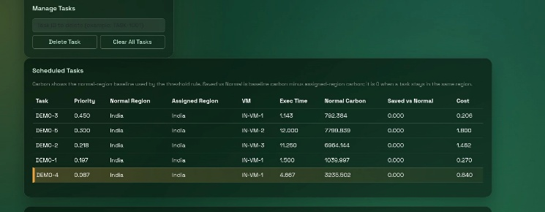
The five tasks are all allocated to India-region VMs with zero carbon savings, which is the normal scheduling behavior whose carbon-aware migration is not applied. The tasks are arranged according to calculated priority score, with DEMO-4 being the lowest priority task. Per-task outcome measures are registered with each task cost, execution time, and normal carbon.
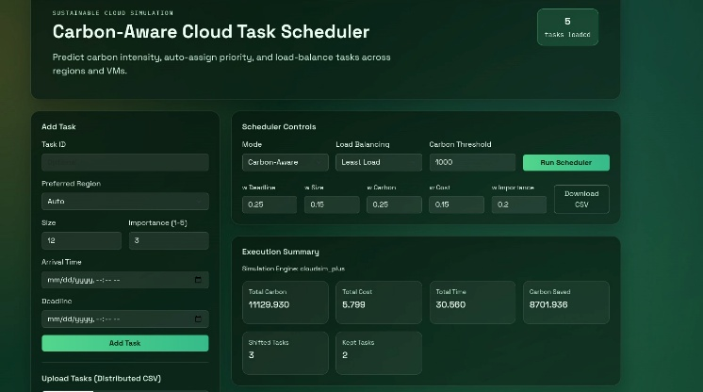
By configuring the scheduler with Carbon-Aware mode at τ keep = 1000, 3 of 5 tasks were relocated to lower-carbon areas, and a total of 8701.936 gCO2eq of carbon was saved. The overall carbon was minimized to 11,129.930 and costing 5.799 over a total execution time of 30.560 seconds and 2 tasks were kept in its original region by the threshold retention policy.
Fig.11. Per-Task Scheduling Output Under Carbon-Aware Mode Showing Regional Migration to EU
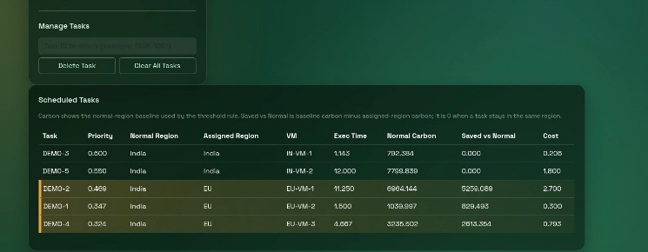
Among the tasks (DEMO-2, DEMO-1, DEMO-4) that were migrated to the EU region, 5,259.09, 829.49 and 2,613.35 gCO 2eq, respectively, were saved. The top two priority tasks (DEMO-3, DEMO-5) were retained in India through the threshold retention policy and this proves that the scheduler maintains local assignment of the tasks with normal-region carbon in the acceptable range.

Conclusion

To sum up, the current work offers a practical and replicable system of carbon-conscious scheduling of cloud tasks that is effective in addressing the disconnect between sustainability goals and operational limits in multi-region clouds. The suggested system combines a carbon intensity prediction model based on a random forest and a threshold-driven policy on region selection, priority-based task scheduling, and execution simulation on CloudSim to jointly optimize carbon emissions, execution time, and operational cost. This is experimentally validated by comparison with a normal scheduling baseline that the carbon-aware mode attains significant emission reductions at relatively small and manageable trade-offs in execution time and cost, and the priority override mechanism makes sure that time-sensitive tasks are not harmed by carbon-based relocation decisions. The retention policy which is threshold based further separates the framework with unlimited carbon minimization strategies as it avoids unnecessary workload migration and maintain scheduling equity among workload priorities. The modular design enables runtime reconfiguring of policy settings without model retraining and the end-to-end pipeline that data ingestion and prediction, scheduling, simulation, and visualization offers is a self-sustaining and extensible platform to research sustainable cloud orchestration. All in all, this project sets a plausible and practically-implemented baseline on carbon-conscious scheduling, and a distinct path to live carbon signals integration, multi-cloud deployment, and reinforcement learning-based adaptive scheduling of future work.

References
- Desmet, V.J. (1992) — “Congenital diseases of intrahepatic bile ducts: variations on the theme ‘ductal plate malformation’.” Hepatology, 16(4), 1069-1083.
- Averbukh, L. D., et al. (2022). “Fibropolycystic Liver Diseases: An Update on Ductal Plate Malformations and Clinical Correlations.” Hepatology Communications, 6(9), 2430–2442.
- Srinath, A., & Shneider, B. L. (2007). “Clinical characteristics of Caroli’s syndrome.” World Journal of Gastroenterology, 13(13), 1934–1937.
- J. McCafferty and C. Li, “Caroli’s Disease: A Mini-Review,” Japanese Journal of Gastroenterology & Hepatology, vol. 8, no. 4, pp. 1-3, 2022.
- Chen, T., & Guestrin, C. (2016). XGBoost: A Scalable Tree Boosting System. Proceedings of the 22nd ACM SIGKDD International Conference on Knowledge Discovery and Data Mining..
- Lundberg, S. M., & Lee, S. I. (2017). A Unified Approach to Interpreting Model Predictions. Advances in Neural Information Processing Systems (NeurIPS).
- Shinde, A., & Shah, M. (2019). Machine Learning Approaches to Identify Rare Diseases. PharmaSUG Proceedings.
- Jia, Y., & Shi, W. (2017). RDAD: A Machine Learning System to Support Phenotype-Based Rare Disease Diagnosis. Frontiers in Genetics, 9, 587.
- Brownlee, J. (2025). Algorithm Showdown: Logistic Regression vs. Random Forest vs. XGBoost on Imbalanced Data. MachineLearningMastery.com.
- Liu, X., et al. (2021). Clinical study applying machine learning to detect a rare disease: results and lessons learned. JAMIA Open, 5(2), ooac053.
- Ahmad, M. F., et al. (2021). Interpretability of Machine Learning Solutions in Public Healthcare: The CRISP-ML Approach. Frontiers in Big Data, 4, 660206.
- Al-Ghamdi, H., & Al-Qassim, Z. (2020). A Comparative Study of Machine Learning Classifiers for Disease Prediction. International Journal of Computer Applications, 975, 8887.
- Breiman, L. (2001). Random Forests. Machine Learning, 45(1), 5-32.
- TietoEVRY. (2024). Finnish research team pioneers machine learning in the early identification of rare diseases.
- Basha, J., et al. (2024). Multiple Disease Prediction Using Machine Learning Algorithm (XGBoost Algorithm). ResearchGate.
- Ghassemi, M., et al. (2020). A Review of Interpretable ML in Healthcare: Taxonomy, Applications, Challenges, and Future Directions. MDPI Sensors, 20(24), 720.

