Timing and Pulse Profile Analysis of the High-Mass X-ray Binary Vela X-1 using RXTE/PCA Observations in 2008

ABSTRACT-
The present article presents timing and pulse profile study of high-mass X-ray binary Vela X-1 using the observation of the RXTE/PCA in 2008. Vela X-1 is a high-mass X-ray binary system, which is a wind-accreting system and is composed of a neutron star and a giant supergiant companion. The periodic pulsations and high variability of the system are due to accretion of the stellar wind of the companion star. RXTE/PCA data was also analyzed by timing analysis to estimate the pulse period of the source. The optimal pulse period was adjective based on the light curve data with the help of the efsearch task. Pulse profiles were also constructed by deriving the light curves of the various levels and folding them with the pulse period calculated. To examine variations in pulse structure with energy, pulse profiles were formulated as energy dependent profiles in several energy bands. In addition, long-term variability of the source was also studied depended on the data of ASM light curve. The measurements indicate that there are considerable differences in pulse profile morphologies across the different energy bands. Multi-peaked and complex structures were found to be more complex at lower energy and simple at high energy. These changes could have changed accretion processes and geometry of emission of the Vela X-1 system. The article sheds light on the behaviour of emission as well as the process of accretion of high-mass X-ray binary systems.

Keywords: Accretion, Pulsars, X-rays: binaries, Stars: individual (Vela X-1), RXTE.

- INTRODUCTION

High-Mass X-ray Binaries (HMXBs) X-ray pulsars are special labs to examine the matter’s behavior in very extreme situations. These systems contain a star consisting of huge stellar and a neutron star that is magnetized. They have their timing properties and pulse profiles which are significant to investigate the accretion processes and geometry of emission regions. The paper implies the detailed discussion of the HMXB Vela X-1 in accordance with the archival data of RXTE/PCA satellite. Of interest to us is to measure the spin period and investigate the variations in pulse profile in relation to the energy dependence of the pulse profile variations using the 2008 observations. In 1967, a high-mass X-ray binary (HMXB) was identified and is now called Vela X-1, containing a neutron star at its heart, and now one of the most studied of its kind. It’s a very bright, eclipsing source exhibiting strong pulsations and a tme of 8.9 days and a pulse period of about 283 s (F. Ast1 et al., 2010). One of the biggest enigmas prior to the December 1995 launch of NASA Rossi X-ray Timing Explorer (RXTE) was that there might be new high-energy events, which appear to belong to two ostensibly distinct classes of event: soft gamma repeaters (SGRs) as well as anomalous X-ray pulsars (AXPs) (Dib, R., et al., 2014). The thesis reviews and analyzes X-ray images of Vela X-1 depends on the data that had been collected by the X-ray observatories RXTE and INTEGRAL. These two satellites' archival data have been used for a number of analyses. Building the X-ray light curves and tracking consistent changes in the phase of the 35-day flux modulation were made possible by the data collection. It has been demonstrated that the high-mass X-ray binary 2S 0114+650 is a very peculiar system. With notable broad-band temporal as well as spectral fluctuation throughout a large range of timescales, it displays characteristics compatible with both Be moreover supergiant X-ray binaries (Suchy, S., et al. 2008). Supergiant High Mass X-ray Binary systems are a subclass of High Mass X-ray Binary systems, which contain of a neutron star and a large, late type companion star that orbit around the same center of mass. The accretion of material through the binary companion's star wind is typically the primary source of power (Devasia, J., et al., 2018). It has been discovered that the pulse period estimates derived from INTEGRAL and RXTE data show short-term variations in pulse period over lasting changes in spin historical rates, which are consistent with the random walk model (Tobrej, M. et al., 2023).The systemic limits of the method of fitting the count rate time profiles of the raster scans complicate the results at zero counts, but the light curves can be regarded as reliable at reasonably large count rates (Smith, D. M., et al., 2012).Like other accreting X-ray pulsars, Vela X-1 has a similar X-ray spectrum. Due to its early detection, consistent X rays with distinct pulsations, and rich phenomenology across a broad choice of the wavelengths, Vela X-1 is the most researched high-mass X-ray binary pulsars. Vela X-1 pulses every 283 seconds or thereabouts. According to Madurga Favieres et al. (2025), the period fluctuates on all timescales, from days to years, and is characterized by a random walk in pulse frequency. The physical and mathematical simplicity of constantly using time as the independent variable is a major reason why we have decided to represent the history of the neutron star's revolution as pulse frequency rather than pulse period. Pulse frequency, which is the time derivative of pulse phase, is the natural measure of pulse rate, and pulse phase is the dependent variable (Deeter, J. E., et al., 1989). The High Energy X-ray Timing Experiment, PCA, as well as All Sky Monitor are the three instruments that make up RXTE (Kreykenbohm, I., et al., 2002).

2. ABOUT THE SOURCE
Vela X-1 : A highly magnetic neutron star orbits the B-type supergiant companion HD 77581 in Vela X-1 (4U 0900-40), a classic wind-fed HMXB. The system is around 2 kpc away and has an orbital time of 8.96 days. The pulsar immediately accretes on the bumpy, patchystellar wind of its companion and its spin period is about 283 seconds. Vela X-1 (4U 0900-40) is a high-mass, wind fed X-ray binary (HMXB) which has a rotation on the B-type supergiant HD 77581 and consists of a neutron star with strong magnetic fields. This system is 2 kiloparsecs distant and requires 8.96 days to do so. The pulsar in this system turns around in a period of over 283 seconds thereby immediately enveloping the elements of the bizarre and jagged stellar wind of its companion. It is the wind-fed nature of strong X-ray flux that causes the continual alteration of its strong X-ray flux, which includes flaring activities. Vela X-1 is a perfect candidate for timing and pulse profile investigation of the direct interaction among the infalling wind as well as the pulsar's magnetosphere since it lacks a robust accretion disk. A well-researched accreting X-ray pulsar, Vela X-1 features a unique pulse characteristic that has been determined to be very comparable across several observations made over decades. The neutron star in the famous large X-ray binary system Vela X-1 is spinning at a pace of 283 seconds in a binary orbit (Raubenheimer, B. C. et al. 1990). A neutron star as well as a huge supergiant companion make up the traditional wind-fed high-mass X-ray binary system Vela X-1 (HD 77581). Persistent X-ray release results from the neutron star absorbing materials from its companion's intense stellar wind. Once more, Vela X-1 displayed extremely powerful flares. Thus, we deduce that Vela X-1 frequently experiences bright flares. We warn, nonetheless, that Vela X-1 may not constantly exhibit higher activity. Vela X-1 was in a quiet phase with minimal widening movement observed during a lengthy INTEGRAL observation in the summer of 2003 (Kreykenbohm, I., 2008). The system shows X-ray pulsations with a about 283 seconds of period, which is the neutron star's spin. Because the stellar wind is clumpy moreover inhomogeneous, the mass process is very variable, which causes the observed X-ray flux to vary significantly. Vela X-1 exhibits unique spectral features, such as Cyclotron Resonance Scattering Features (CRSFs), which are usually seen between 25 and 50 keV, in addition to its timing characteristics. These characteristics offer concrete proof that the neutron star has a powerful magnetic field (~10¹² G) (Kreykenbohm, I., et al. 2008).
This paper performs timing and pulse profile studies of Vela X-1, and uses historical data on the RXTE/PCA instrument. This is aimed at finding pulse period, the energy-dependent pulse morphology also the lasting inconsistency of the source using the ASM data.
3. OBSERVATIONS AND DATA REDUCTION:
The proportional counter array (PCA) on board RXTE was used to collect all the observations reported here. The PCA was made up of 5 collimated xenon as well as methane multi-anode PCUs within the 2 -60 keV range (Dib, R., et al., 2014). There are also data over time scales longer than 100 days, which are in the form of pulse frequencies of other Vela X-l pulse timing experiments, which were previously prepared and subsequently followed by this proposed series of observations (Devasia, J., et al., 2018). The central one at a depth of approximately 25 keV, and the more prominent one at a depth of about 55 keV were indeed discovered in the example of VelaX-1 observations along with NuSTAR (Kretschmar, P., et al. 2021). The Vela X-1 measurements provided by RXTE reflects how this source changes with an immense number of time scales (Kreykenbohm, I., et al. 1998). Being small in spectral resolution, RXTE is meant to make the analysis of time variation of the emission of X-ray sources easier (Reig, P., 2009).
The high mass X-ray binary Vela X-1 will be studied in this paper through several observations, with the help of the RXTE mission data. The important problems of the study are timing and spectral behavior, but pulse profiles and changing characteristics are also studied. Observational data include four RXTE/PCA pointings of the source. Table 1 has the details of these observations including the IDs of the observations, the dates, the beginning, and the end of time and the Mod Julian Dates (MJD).

Table 1: Log of RXTE/PCA observations of Vela X-1
S.No. | Date | Observation ID | Start Time | End Time | MJD
1. | 24-11-2008 | 93039-01-02-07 | 12:06:03 | 17:20:05 | 54794.504
2. | 24-11-2008 | 93039-01-02-01 | 18:10:05 | 23:41:09 | 54794.757
3. | 30-11-2008 | 93039-02-02-03 | 20:18:58 | 02:17:03 | 54800.846
4. | 01-12-2008 | 93039-02-02-04 | 02:36:03 | 06:37:58 | 54801.108

4.DATA ANALYSIS AND METHODOLOGY:
It was analyzed based on archival data of Vela X-1, high mass X-ray binary taken in the year 2008 with the help of RXTE/PCA instrument. Reduction and analysis of data were done using the HEASoft software package and standard HEASARC analysis procedures were used. To begin with, observational data were filtered and then elements of interval are eliminated because of excessive background radiation and shakey satellite pointing. In order to ensure that the data selected is reliable, Good Time Intervals (GTIs) were developed. Event files were cleaned and then processed to produce source light curves in an energy range of interest and background subtraction was performed to obtain net count rates. It was analyzed using the archival data of the high-mass X-ray binary Vela X-1 that was available in 2008 by RXTE/PCA instrument. Data reduction and analysis was done with the HEASoft software program according to the conventional HEASARC analysis guidelines. In order to eliminate the periods that were contaminated by the heavy background radiation and bad satellite pointing, the observational data have been first filtered. Good Time Intervals (GTIs) have been developed to make sure that the data used was credible. After extracting source light curves in certain energy ranges from the cleaned event files, background subtraction was used to determine net count rates. The efsearch task was used for timing analysis in order to find the pulse period by looking for the periodogram's highest statistical significance. The light bends were folded to create pulse profiles using the acquired period. To examine the change in pulse shape with energy, energy-resolved pulse profiles were created for several energy bands. ASM light curve data from the RXTE monitoring archive were also used to study long-term variations.

4.1 LIGHT CURVE AND ASM ANALYSIS:
We computed the averages of all the aligned profiles as well as that of the template by taking away the average of the results. We then discovered the scaling aspect which decreased the condensed Chi 2 of the difference among the scaled profile as well as the template, at each observation. The resultant smaller 82 values are shown in the panel (e) of Figures ( Dib, R.,et al.2014). An epoch folding range of 2 -9 keV at a 0.36s resolution with the FTOOLS task EFSEARCH was used to search the PCA 2 9 keV light curve (Farrell, S. A., et al.2008).
The obtained X-ray light curves (Figure 1 and 2) of the PCA observations denote a big deviating variability and stochastic flaring. These changes are typical of High-Mass X-ray Binaries (HMXBs) for instance Vela X-1, whereby the neutron star feeds off the companion’s stellar wind. ​Figure 1 illustrates the temporal analysis of the High-Mass X-ray Binary (HMXB) Vela X-1 utilizing facts from ObsID 93039-01-02-03. The light curve presented here demonstrates the source's intensity levels and provides the primary data required to establish the timing baseline for the 2008 observation epoch. The fluctuations in the count rate are indicative of the typical wind-fed accretion mechanism prevalent in this system.
​The results for ObsID 93039-01-02-07 are depicted in Figure 2. It was an important sequence of observation which was applied to track the behavior of the source during a long time period. The specified ID allows tracking the stability of the X-ray emission and identifying some major disparities in the flux, which could be useful in the characterization of the immediate circumstellar environment of the neutron star.
The data of the RXTE/ASM in Figure 3 depicts X-ray lasting monitoring of Vela X-1. The required orbital structure of the respective PCA observations under scrutiny in this study paper is provided in this plot. By examining the ASM light curve, we can possibly find out the high state and low state periods of the source, periodic eclipses due to the massive companion star. We also need the ASM data in order to verify that our selected Observation IDs (ObsIDs) were not during bad phases of the binary orbit, to ensure the pulse profile and timing analysis is not skewed by bursting activity or occultation of the atmosphere. This large time scale validates the correctness of the pulse period measurements using the finer-resolution PCA data.

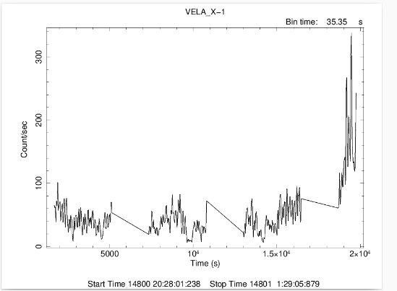

Figure 1. Background-subtracted Vela X-1 light curve as calculated by RXTE/PCA. The plot shows how the count rate of X-ray (counts/s) varies with time (s) at a binning resolution of 35.35 s. Variability is substantial and there is a potential flaring incident that may happen at the end of the observation period.

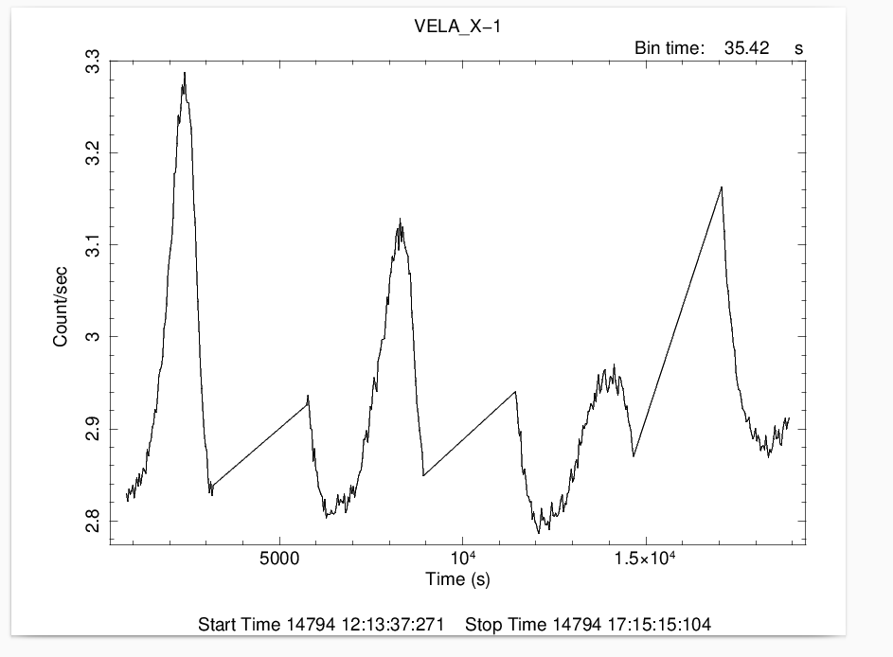
​Figure 2: The light bend of the HMXB pulsar Vela X-1 generated from observations of RXTE/PCA with a bin time of 35.42 s. The plot illustrates the X-ray flux variability over an observation interval of approximately 17,000 seconds. Linear segments between data clusters represent periods of non-observation or instrumental gaps.

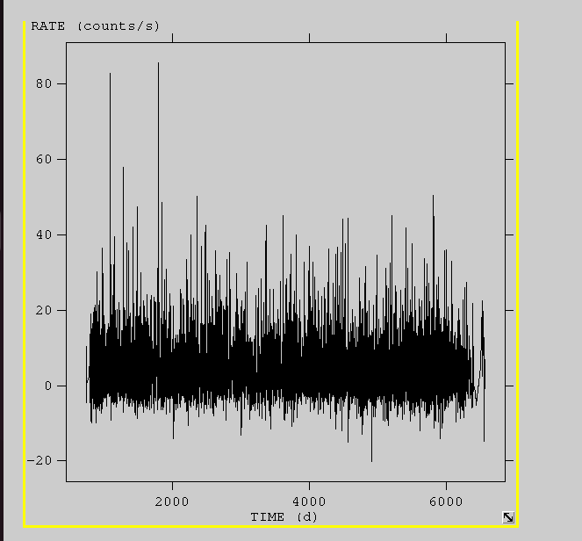
Figure 3: A long-term ASM plot showing daily averaged count rates over several years, highlighting frequent flaring activity.

4.2 TIMING ANALYSIS:
Timing analysis were carried out over the orbital, super orbital, and pulse time-scales. Additionally, analysis of the flare episodes seen during the pulse period's peak was carried out (Farrell, S. A., et al, 2008). Phase-coherent timing, which involves comparing the TOAs with a ephemeris model moreover taking into account each pulsar rotation, is the most precise technique for determining spin parameters (Livingstone, M. A., et al. 2009). To look for QPOs and other aperiodic aspects in this pulsar, we have performed a timing analysis utilizing data from each RXTE/PCA observations. (M. James et al., 2011).
Using the Chi-squared (\chi^2) maximization technique via the efsearch tool, we determined the best-fit spin period of the pulsar. As illustrated in Figure 4, the search yielded a period of 283.57 s. Another observation segment (Figure 5) confirmed a period of 282.89 s with a resolution of 0.01 s. The sharp peaks in these distributions verify the precise rotation period during the 2008 epoch. Figure 4 will calculate the frequency in the example of ObsID 93039-02-02-03. This data was chi-squared maximized to get the best pulse period through the aid of the efsearch tool. This graph is aimed to represent the statistical significance of the periodicity observed and serves as the foundation on which the further folding and pulse profile generating of the observation at hand is conducted.
Having performed the timing analysis of the same sequence, the folded profile of the pulse of the ObsID 93039-02-02-03 is presented in Figure 5. The common pulse morphology of Vela X-1, i.e. the X-ray intensity versus the rotational phase, is revealed in the profile. The structural details observed here, such as the peak-to-peak variations, provide insights into the emission geometry near the neutron star’s magnetic poles.

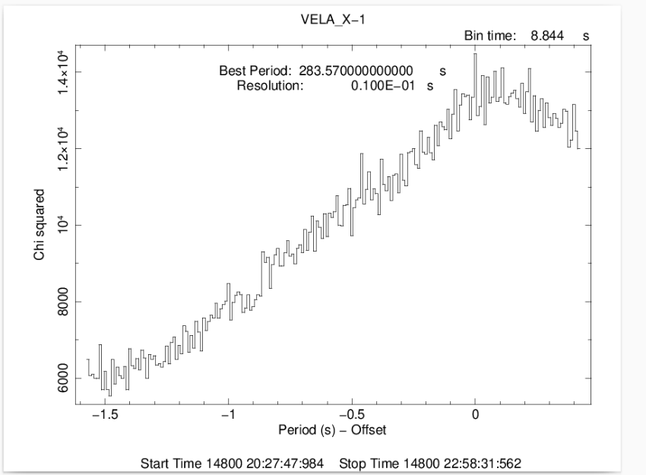

Figure 4: Chi-squared Period Search
Results of the efsearch analysis. The maximum \chi^2 peak confirms the best-fit spin period of the pulsar.
​Best Period: 283.57 s

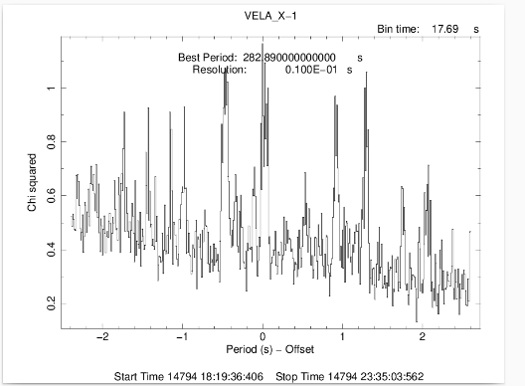

Figure 5: Period Search (efsearch)
Chi-squared distribution showing the period search for Vela X-1. The primary peak identifies the most probable spin period for this specific observation.
​Best Period: 282.89 s Resolution: 0.01 s

4.3 PULSE PROFILE:
In performing the timing analysis, at all observation we folded the information in the timing energy band of interest with the optimal frequency. The resulting profile was in turn cross-correlated with a normal template to get phase-aligned profiles. The aligned profiles had 32 phase bins. The photons arrival time was then modified to the Solar System barycenter to get the energy solved pulse profiles, as well as phase determined energy spectra. Period folding then enabled us to seek pulse period of a specific observation (La Barbera, A.,2003). The shape of the low-energy spectrum of Vela X-l as well as variability low-energy spectrum shape and variability of Vela X-l point to two deviations of a simple model of neutral absorption. In the situation where the lowest level of absorption is the lowest orbital periods (0.2-0.3), the ionization of the wind by the X-ray source should be taken into account (Haberl, F., & White, N. E.1990). One of its applications in study has been identified in the Vela X-I instrument witnessing high pulse profile changes in the midst of a bright flare when observed with XMM-Newton in particular at the soft energies where the pulsatile emission is quite prominent following the flare (Roca, J. J. R.2014).
The fold was then repeated by 4 folds to form energy resolved pulse profile i.e., 2510 keV, 1020 keV, 2040 keV and 2040 keV. Multi-peaked morphology of profile in Figure 6 has been attained. The band with the highest count rate that is most recognisable is the band 1020 keV (green line) as seen in Figure 6.This energy dependence implies a complex geometry of beaming around the magnetic poles of the pulsar.
The analysis of ObsID 93039-02-02-04 is presented in Figure 6. This observation was explored to analyze the way in which a pulse shape varies with different orbital phases. The uniformity of the properties of this graph, as compared to the previous IDs, are a confirmation of the pulse profile strength despite the stochastic nature of the accretion process of the massive companion, via the stellar wind.
Figure 7 summarizes the results of timing of ObsID 93039-01-02-01. The above observation sequence allows comparing the state of the source at different locations during the 2008 monitoring campaign exhaustively. This ID data are essential in identifying the lasting trends in the pulse period and the overall balance of torques in the Vela X-1 system. 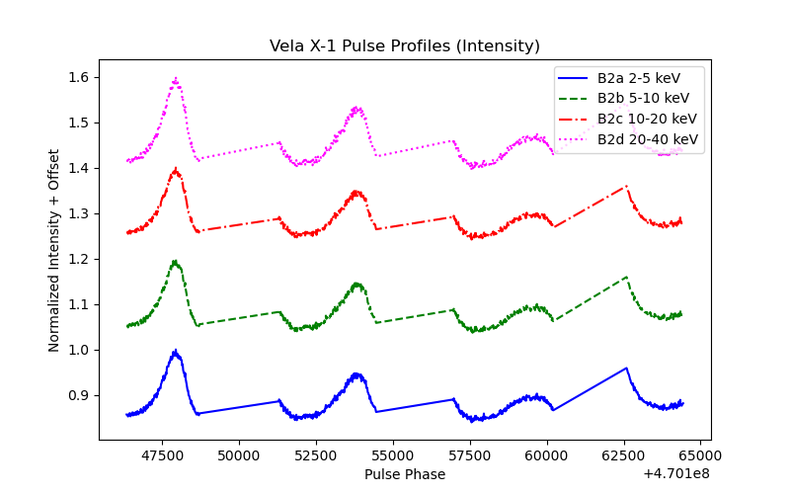
Figure 6: Normalized pulse profiles of Vela X-1 at four different energies (2-5 keV to 20-40 keV). It is a way of showing the change in pulse shape and pulse strength versus pulse phase.
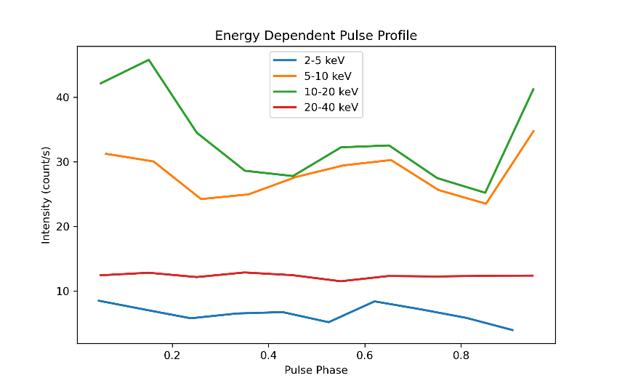
Figure 7: Comparison of intensity of source (counts/s) vs pulse phase at different levels of energy. It stresses that the band of 10-20 keV (green) is the most populated and with the most pronounced structure.
5. RESULTS AND DISCUSSION:
Vela X-1 analysis using RXTE/PCA data between 2008-2010 was done under Timing analysis. The curves of light that are obtained are characterized by noticeable variations of X-ray intensity over time. Periodicity Study The periodicity has a distinct and consistent pulse period as efsearch. A change in the wave form in addition to the amplitude of the peak is observed in the pulse profiles in various energy bands or this is one of the indicators of differences in emissions at different energy bands. Moreover, lasting variations in the intensity of the source in long time scales can be detected in the ASM light curve.
6. CONCLUSION:
In 2008, the high-mass X-ray binary Vela X-1 was observed using RXTE/PCA and we have successfully studied the timing and pulse profile of this kind of black hole. It is apparent that the light curves that are recorded contain a high level of variability in the strength of X-rays which can be credited to the inhomogeneity with which the wind accretes onto the neutron star. The efsearch was used to investigate periodic behavior of the system, and confirms the stable pulse period that correlates with the rotation of the neutron star. Energy-resolved pulse profiles indicate that morphology and amplitude of the pulse varies considerably in different energy bands suggesting that emission mechanisms and geometry are very energy sensitive. Moreover, the ASM light curve can also provide an approximation of long-term variability of the source, showing variations in the accretion rate and possible orbital modulation. These findings are consistent with the characteristics of wind-fed X-ray pulsars, and highlight the complex accretion and radiation processes of Vela X-1.The analysis establishes that Vela X-1 is pulsating and that there exist important variations in its emission that are dependent on the energy. The imprecision in the short-term and long-term data, which is observed, demonstrates a complex and dynamic accretion process. Overall, the results are consistent with the nature of a wind-fed X-ray pulsar and has provided a clue on how the system works in regards to emission.

7. ACKNOWLEDGEMENTS:

I would also like to give a huge thank you to my supervisor/guide who has helped and assisted me in this work. I also acknowledge the use of RXTE mission and the data of HEASoft analysis tools. I am also thankful to my institution in that it possesses the facilities which are necessary to carry out this study.

8. REFERENCES:
- Deeter, J. E., Boynton, P. E., Lamb, F. K., & Zylstra, G. (1989). VELA X-1 pulsetiming. II-Variations in pulse frequency. Astrophysical Journal, Part 1 (ISSN 0004-637X), vol. 336, Jan. 1, 1989, p. 376-393., 336, 376-393.
- Devasia, J., & Paul, B. (2018). Suzaku observation of the eclipsing high mass X-ray binary pulsar XTE J1855-026. Journal of Astrophysics and Astronomy, 39(1), 7.
- Dib, R., & Kaspi, V. M. (2014). 16 yr of RXTE monitoring of five anomalous X-ray pulsars. The Astrophysical Journal, 784(1), 37.
- Farrell, S. A., Sood, R. K., O'neill, P. M., & Dieters, S. (2008). A detailed study of 2S 0114+ 650 with the Rossi X-ray Timing Explorer. Monthly Notices of the Royal Astronomical Society, 389(2), 608-628.
- Fürst, F., Kreykenbohm, I., Pottschmidt, K., Wilms, J., Hanke, M., Rothschild, R. E., ... & Staubert, R. (2010). X-ray variation statistics and wind clumping in Vela X-1. Astronomy & Astrophysics, 519, A37.
- Gvaramadze, V. V., Alexashov, D. B., Katushkina, O. A., & Kniazev, A. Y. (2018). Modelling interstellar structures around Vela X-1. Monthly Notices of the Royal Astronomical Society, 474(4), 4421-4431.
- Haberl, F., & White, N. E. (1990). The X-ray absorption spectrum of Vela X-1. Astrophysical Journal, Part 1 (ISSN 0004-637X), vol. 361, Sept. 20, 1990, p. 225-234., 361, 225-234.
- James, M., Paul, B., Devasia, J., & Indulekha, K. (2011). Flares, broadening of the pulse-frequency peak and quasi-periodic oscillations in the transient X-ray pulsar 4U 1901+ 03. Monthly Notices of the Royal Astronomical Society, 410(3), 1489-1495.
- Kretschmar, P., El Mellah, I., Martínez-Núñez, S., Fürst, F., Grinberg, V., Sander, A. A., ... & Utrilla, E. (2021). Revisiting the archetypical wind accretor Vela X-1 in depth-Case study of a well-known X-ray binary and the limits of our knowledge. Astronomy & Astrophysics, 652, A95.
- Kreykenbohm, I., Coburn, W., Wilms, J., Kretschmar, P., Staubert, R., Heindl, W. A., & Rothschild, R. E. (2002). Confirmation of two cyclotron lines in Vela X-1. Astronomy & Astrophysics, 395(1), 129-140.
- Kreykenbohm, I., Kretschmar, P., Wilms, J., Staubert, R., Kendziorra, E., Gruber, D. E., ... & Rothschild, R. R. (1998). Vela X-1 as seen by RXTE. arXiv preprint astro-ph/9810282.
- Kreykenbohm, I., Wilms, J., Kretschmar, P., Torrejón, J. M., Pottschmidt, K., Hanke, M., ... & Staubert, R. (2008). High variability in Vela X-1: giant flares and off states. Astronomy & Astrophysics, 492(2), 511-525.
- La Barbera, A., Santangelo, A., Orlandini, M., & Segreto, A. (2003). A pulse phase-dependent spectroscopic study of Vela X–1 in the 8–100 keV band. Astronomy & Astrophysics, 400(3), 993-1005.
- Livingstone, M. A., Ransom, S. M., Camilo, F., Kaspi, V. M., Lyne, A. G., Kramer, M., & Stairs, I. H. (2009). X-ray and Radio Timing of the Pulsar in 3C 58. The Astrophysical Journal, 706(2), 1163-1173.
- Madurga-Favieres, V., Martin-Carrillo, A., Diez, C. M., Fürst, F., Martínez-Núñez, S., Grinberg, V., ... & Kretschmar, P. (2025). Pulse profile variations in the accreting X-ray pulsar Vela X 1. Astronomy & Astrophysics, 704, A66.
- Manousakis, A., & Walter, R. (2015). Origin of the X-ray off-states in Vela X-1. Astronomy & Astrophysics, 575, A58.
- Raubenheimer, B. C. (1990). The pulsed light curve of Vela X-1. Astronomy and Astrophysics (ISSN 0004-6361), vol. 234, no. 1-2, Aug. 1990, p. 172-176. Research supported by Max-Planck-Gesellschaft zur Foerderung der Wissenschaften., 234, 172-176.
- Reig, P., Torrejón, J. M., Negueruela, I., Blay, P., Ribó, M., & Wilms, J. (2009). Discovery of slow X-ray pulsations in the high-mass X-ray binary 4U 2206+ 54. Astronomy & Astrophysics, 494(3), 1073-1082.
- Roca, J. J. R. (2014). Timing variability of Vela X-1 during a bright flare.
- Smith, D. M., Markwardt, C. B., Swank, J. H., & Negueruela, I. (2012). Fast X-ray transients in the Galactic bulge with the Rossi X-ray Timing Explorer. arXiv preprint arXiv:1202.6434.
- Suchy, S., Pottschmidt, K., Wilms, J., Kreykenbohm, I., Schönherr, G., Kretschmar, P., ... & Grinberg, V. (2008). Pulse phase-resolved analysis of the high-mass X-ray binary Centaurus X-3 over two binary orbits. The Astrophysical Journal, 675(2), 1487-1498.
- Tobrej, M., Rai, B., Ghising, M., Tamang, R., & Paul, B. C. (2023). A high-mass X-ray binary pulsar 4U 1907+ 09 with multiple absorption-line features in the spectrum. Monthly Notices of the Royal Astronomical Society, 518(4), 4861-4869.
- Vasco, D. (2012). Analysis of X-ray Observations of the Binary Hercules X-1 (Doctoral dissertation, Dissertation, Tübingen, Universität Tübingen, 2012).

