Adaptive Energy-Efficient Routing with Real-Time Intelligence

a long time.When choosing the best path or the fewest hops, traditional routing methods don’t consider how much energy is left in the nodes. This strategy quickly drains the batteries of nodes on busy routes, which causes nodes to fail early, the network to split, and key hotspot areas to form around the base station, where forwarding loads are highest.Ant colony optimization (ACO) and other bio-inspired algorithms have become popular for WSN routing as a way to solve these problem. Ant Colony Optimization (ACO) is like ants looking for food by following pheromone trails to find the best paths without a central point of control. But classical ACO only cares about the length of the path or the latency, not the energy level of the nodes. This makes some nodes use too much energy, some nodes use too little, and the network converges too quickly to bad routes that don’t change when the network conditions change.This study suggests a better energy-aware ACO routing method for dynamic WSNs. These are the main contributions: Pheromone improvements that take energy into account and punish paths that go previous nodes with little energy to make sure that energy is spread out in a regular or equal way.The transition rule uses pseudo-random exploration to keep things from coming together too quickly and to find other paths that use less energy.A full evaluation shows that the packet delivery ratio, energy use, and network longevity have all gotten better compared to baseline approaches.Lightweight design that works well for sensor nodes with limited resources and can be used in the real world
- RELEATED WORK
- Old routing protocols for WSNs
Most of the early routing protocols for WSNs used shortest- path algorithms that saved energy by lowering the number of hops or the distance between transmissions. These methods helped lower the overhead for each transmission, but they

didn’t think about how energy was spread out differently across nodes, especially those that were close to the base station. This quickly drained the power through important forwarding nodes, which split the network into two parts and made it last less time overall.
- Methods that use clustering and energy balance.
Researchers made protocols based on clustering to fix energy imbalance. In these protocols, chosen clusters head collect and send information towards the central hub stations. Nguyen et al. came up with a way to use a Genetic Algorithm (GA) to choose the best cluster heads to save energy. But their plan didn’t work well for communication that needed more than one hop, which made it hard to make the network bigger or more complicated.Amorim et al. made a routing protocol that spread out the use of energy among nodes to keep the network going longer. Their method still didn’t completely solve the ongoing hotspot problem, where nodes that were closer to the base station were still overloaded because they had to send more data.Xie, Guo, and Xu developed a non- uniform clustering process that considered the nodes’ posi- tions, remaining energy, and the number of hops required to form a cluster. But using static weighted decision models made routing less than perfect in networks that were changing their traffic and layout.
- Classical Ant Colony Optimization
Ant Colony Optimization (ACO) is a bio-inspired way to find the best routes without needing a central authority. It picks things up from pheromones. People started using the standard ACO algorithm for routing in WSNs because it can find near- optimal solutions and adapt. But regular ACO implementations only cared about making the path as short as it could be. They didn’t care about how much power was left in the nodes, for example. Because of this mistake, ACO was able to take over nodes with low energy. This caused network failures and energy imbalances that happened too soon.
- Research Gaps
Routing protocols have come a long way, but they still have some big problems: Hotspots and nodes fail early because the classical ACO and shortest-path algorithms don’t take node energy into account.Methods that use clustering have a hard time growing and changing when things change.Nodes with limited resources can’t afford to use hybrid AI-based meth- ods. Current energy-aware ACO variations lack a lightweight implementation and comprehensive testing.
- Our Approach:
This paper discusses these issues and proposes a lightweight, energy-efficient ACO routing algorithm that in- corporates residual energy in both pheromone updates and state transitions. It also uses pseudo-random exploration to keep routing varied and gives a full performance evaluation that shows how dynamic WSN deployments can save energy and last longer in the real world.
- PROPOSED ENERGY-AWARE ACO ALGORITHM
  - System Model
We are looking at a Wireless Sensor Network with N sensor nodes that are randomly placed in a two-dimensional space and one base station that remains in one place. Each node has a limited amount of battery power and sends out data packets that need to be sent to the base station over multiple stages. Nodes can talk to their neighbors as long as they are sufficiently distant and know how much energy they have left. It takes a lot of energy to send a k-bit packet over a distance of d is: E_{tx}(k, d) = E_{elec} × k + ϵ_{amp} × k × d²
  - Classical ACO Limitations
    - Classical ACO constructs paths by selecting next-hop neighbors based on pheromone (τ ) and heuristic (η) information:
τ^{α} · η^{β}

P^{k} = Σ
ij
ij ij
τ^{α} · η^{β}

- Better ACO and Hybrid Methods
In the past few years, people have been trying to make ACO better for WSNs. Du et al. made a dynamic ACO variation for general computer networks that can change in real time. But their method didn’t work well because WSNs have strict rules about how much energy they can use.Swaminathan et al. combined Ant Colony Optimization (ACO) and Graph Neural Networks (GNNs) to make routing decisions smarter. These mixed methods look interesting, but they won’t work for small sensor nodes because they need a lot of memory and
l∈Ni il il
Pheromones are updated with evaporation (ρ) and deposi- tion (∆τ ). However, classical ACO ignores node energy, causing rapid depletion of frequently used nodes and premature convergence to suboptimal paths.
  - Enhanced Energy-Aware ACO
1. Energy-Aware Heuristic: We incorporate residual energy into the heuristic function:
ηij = Eresidual(j) × 1

Einitial dij +1

processing power.Recent research on wireless sensor networks (WSNs) has begun to incorporate energy awareness into ant colony optimization (ACO) through the use of residual energy parameters and pseudo-random exploration algorithms to en- hance load balancing and prevent stagnation. There is still a lot of work to be done on these methods, and there isn’t a lot of testing or standardization across different network conditions.
This encourages routing through high-energy nodes, balanc- ing load distribution.
- Pseudo-Random Exploration:
With probability q₀, ants exploit the best route; otherwise they explore probabilistically. This prevents premature conver- gence and discovers alternative energy-efficient paths.
- Energy-Aware Pheromone Update:

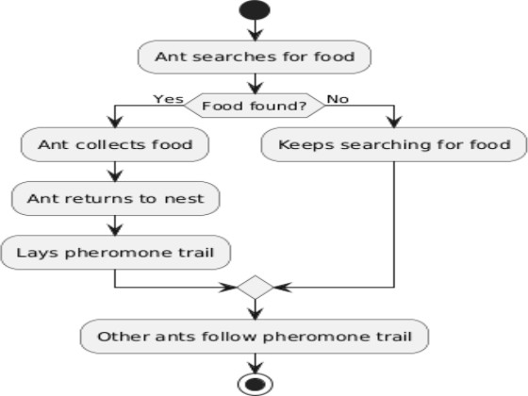
Pheromone deposition depends on both path length (L) and energy cost C_{energy}
∆τ^{k} = ^{Q}
ij L_{k}×(1+C_{energy}(P ))

Paths using low-energy nodes receive less pheromone, nat- urally steering future ants away from depleted regions.
- Literature Review
Routing is very important in Wireless Sensor Networks (WSNs) because it makes sure that data can be sent from the source sensor nodes to the base station or destination without any problems. Multi-hop routing is common in WSNs because they don’t need much processing power, bandwidth, or electricity. These methods let data pass through sensor nodes that act as intermediaries. This saves power and lets the network change shape. For sensor nodes to be able to talk to each other for a long time, the network needs to have good routing algorithms.
Nguyen et al. have proposed a routing methodology that employs a Genetic Algorithm (GA) to identify the optimal cluster head nodes within the network. The idea is based on ideas from evolution. Through cluster heads, the base station gets information from nodes that are close to it. The method above does help you pick the best cluster head, but it doesn’t work well for sending messages between the base station and the cluster heads over many hops. This can be a problem for WSNs that are big or complicated.
Amorim et al. created a routing protocol that spreads out energy use to fix the problem of uneven energy use. The goal was for everyone on the network to use the same amount of power. Some nodes run out of power too quickly when they send too much data. This plan will help with that issue. But cluster heads that are closer to the base station need more power to send data from clusters that are farther away. Over time, this makes the network less reliable.
Xie, Guo, and Xu are some other academics who have come up with non-uniform clustering algorithms to improve routing. These kinds of strategies take into account things like the nodes’ locations, how much energy they have left, how many hops they need to make, and the slope of the area. These methods are better at making changes than uniform clustering, but they usually use simple ways to give things weight. These kinds of methods might not show how advanced real-world WSN setups are, which could lead to bad routing choices and wasted energy.
Ant Colony Optimization (ACO) is an algorithm that works like how ants find food. Ants use pheromone trails to find the quickest way to get food from their colony in the wild. As ants move, they leave behind pheromones. Trails with more of these chemicals draw in more ants. Stigmergy is a way for people to talk to each other without actually talking to each other. It makes the pathways work better. Because of this, people have used ACO to fix problems with WSN routing.
When routing in WSNs, ACO-based algorithms help sensor nodes find paths that use less energy right away. But older routing systems often use simple weighing methods that don’t accurately show how things really are, like when traffic

Fig. 1. Ant Colony Optimization based routing in WSN

and energy levels change. Amorim et al. created an energy- balanced routing algorithm based on ACO that sends data over a lot of different channels. This method did help use energy more efficiently, but it didn’t completely solve the hot spot problem. Even though the cluster heads were close to the base station, they ran out of power quickly because they had too much to do.
This study utilized an advanced Ant Colony Optimization methodology that incorporates pseudo-random proportional principles to avert premature convergence to local optima. The better ACO algorithm is great for WSNs because it lets them move around and find new things. The main goal of this plan is to make sure that all parts of the network use the same amount of power. This will let people talk to each other, keep the network running longer, and use less power.
Result analysis
This study examined modifications to the Ant Colony Op- timization (ACO) algorithm, incorporating the energy-aware pheromone update rule and the pseudo-random scale-based state transition rule, to tackle critical issues in Wireless Sensor Networks (WSNs). The results show that these changes make the network work much better, use less energy, and last longer. These are very important for wireless sensor networks that work in areas where there aren’t many resources.The main way to measure performance in this study is by looking at the network’s lifetime, which is different from the energy used by the nodes. If you use less energy, you will live longer and spend less on energy. The new and improved ACO algo- rithm made nodes use less power, which helped the network last longer. The simulation results show that the new ACO algorithm is more efficient and uses less energy than other routing protocols. The pheromone update rule that took energy into account worked well to encourage routes that used less energy and discourage routes that had nodes with less energy left. This improved routing and helped the network use energy more evenly. The algorithm might also use a pseudo-random scale-based way to move from one state to another state. This made it more open to new ideas and kept it from making a fast decision . The algorithm was able to find better paths, avoid

getting stuck in suboptimal solutions, and speed up the whole routing process by changing the transition probabilities on the fly. The case study data also makes it possible to compare the better method to other well-known routing protocols, like static path planning and local message routing. The better algorithm still lost a lot fewer packets, even with broken nodes. This means that the new algorithm can better deal with network problems, which makes communication more reliable. The simulation results also showed that the optimization process made the network’s topology better. The plan made sure that data packets were sent over less busy alternate channels, which helped the network balance its load. The app might help ease traffic congestion, and this was possible because the network was always changing. This not only made things work better, but it also made it less likely that too many people would use the network and cause it to crash.
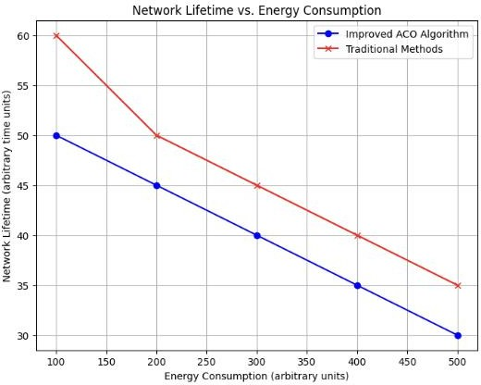

Fig. 2. Network lifetime versus energy consumption comparison

The graph in figure 2 shows how energy use changes when the ACO algorithm is improved compared to the standard method. The X-axis shows how much energy is being used. It goes up as the network uses more energy to talk to each other. The Y-axis shows how long the network will stay up before the power runs out. The blue line shows the better ACO algorithm, which means that the network’s lifetime goes down faster when it uses more energy. This shows that the better algorithm does a better job of balancing energy use, which makes the network last longer than other methods. The use of energy-aware pheromone modification rules and pseudo- random scale-based state transition rules is what makes this so efficient. These rules speed up the routing process and block paths that use a lot of energy. The red line for the typical approach, on the other hand, shows that the network’s lifetime is going down quickly because it uses more energy. This shows that regular routing methods aren’t very good at managing energy, which makes resources run out faster and shortens the network’s life. The graph clearly shows that the better ACO algorithm works better than older methods because it uses less energy and makes the network last longer. This is a better choice for wireless sensor networks (WSNs) because saving energy is very important. This paper examined modifications
to the Ant Colony Optimization (ACO) algorithm, including the energy-aware pheromone update rule and the pseudo- random scale-based state transition rule. These changes might help fix some big issues in Wireless Sensor Networks (WSNs). The results show that these changes make the network work better, use less power, and last longer. These are very impor- tant for wireless sensor networks that work in places where there aren’t many resources.The primary metric for assessing performance in this study is the network’s lifetime, distinct from the energy consumed by the nodes. You will live longer and spend less on energy if you use less of it. The network lasted longer because the new and improved ACO algorithm made nodes use less power. The modeling results show that the new ACO algorithm is better and uses less amount of energy than other ways to route. The pheromone update rule that took energy into account worked well to promote routes that used less energy and discourage routes that had nodes with less energy left. This made routing better and helped the network use energy more evenly. This algorithm may also use a pseudo-random scale-based method to move from one state to another statw which kept it from making a decision too quickly and made it more open to new ideas. By changing the transition probabilities on the fly, the method was able to find better paths, and avoid getting stuck in bad solutions, and also speed up the whole routing process. The case study data also lets you compare the better method to other well- known routing protocols, such as static path planning and local message routing. Even with broken nodes, the better method still lost a lot fewer packets. This means that the new algorithm can handle network problems better, which makes communication more reliable. The modeling at results also showed that the optimization process improved the network’s structure. The plan made sure that data packets were sent over less busy alternate channels, which helped the network handle its load better. The software could help reduce traffic jams because the network was always changing. This not only made things work better, but it also made it less likely that too many people would use the network and cause it to go down.
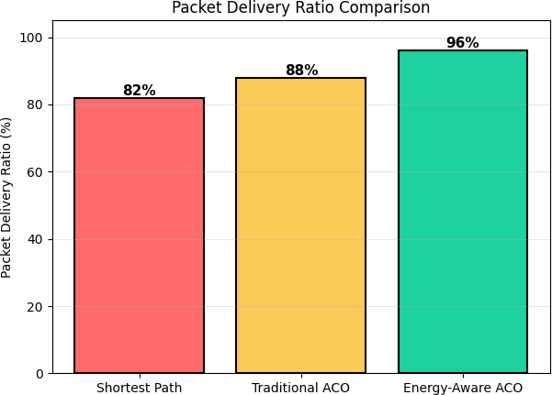

Fig. 3. Packet Delivery Ratio comparison of Shortest Path, Traditional ACO, and Energy-Aware ACO

The Packet Delivery Ratio (PDR) is a performance metric which shows how many data packets were sent and how many were delivered successfully. A higher PDR means that the network works better and is more reliable. From fig.3, it is observeb that the Energy-Aware ACO algorithm has the best PDR (96%), which is better than the Traditional ACO (88%) and the Shortest Path routing (82%). The fundamental purpose of the energy-aware method is to consume less energy, but it also speeds up the delivery of packets. delivery much faster. This works better because the energy-aware ACO doesn’t send messages through nodes that are busy or don’t have enough power which means that fewer packets are lost when routes or nodes go down. The algorithm keeps the lines of com- munication open and cuts down on unnecessary transmissions by choosing routes that are stable and have a good amount of energy. On the other hand, shortest path routing, only tries to make the distance shorter. This can overload some nodes and cause them to fail early, which lowers the PDR. Traditional ACO uses pheromone trails to help it make better routing decisions, but it doesn’t always take into account leftover energy, which makes it work only somewhat well. Overall, the results show that routing that takes energy into account not only makes networks last longer, but it also makes data delivery more reliable. This is better for wireless sensor networks because both reliable communication and energy efficiency are very important.
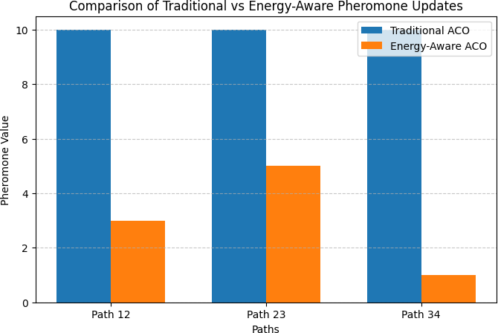

Fig. 4. Comparison of Traditional and Energy-Aware Pheromone Updates

On three paths—Path 12, Path 23, and Path 34—Figure
4 clearly shows how the pheromone levels differ between the traditional ACO and the energy-aware ACO algorithms. The standard ACO method gives every path the same high pheromone value of 10, no matter how much energy the nodes on that path have. This same job keeps choosing the same paths over and over again, without caring about how much energy the nodes have. This means that nodes that don’t have enough energy are used too much, which makes the network last less time and uses up energy resources faster. The energy- aware ACO algorithm, on the other hand, alters the amount of pheromones straight away based on how much energy each node has. Some nodes on Path 12 and Path 34 acquire a
considerably lower odor number because they don’t have as much energy left. This makes people less likely to utilize roads that are getting old. Path 23 has more pheromones because it has more nodes with energy left than Path 22. This strategy makes sure that routes with a lot of energy resources are used first. Routes with less energy can still help save energy. The accuracy of the energy-aware pheromone update system shows how well it controls the network’s energy utilization. And it notifies nodes that don’t need as much power that they won’t be needed as much. This lets you pick ways that utilize less energy. When the ACO knows about energy, nodes with low energy don’t make as many claims. This saves time and effort. These networks don’t just last a few years; they last a long time.
Conclusion
The suggested improvement to the Ant Colony Optimization (ACO) algorithm creates a Wireless Sensor Network (WSN) routing protocol that can change and uses less energy. The ACO algorithm uses the amount of energy each node uses in the pheroman update equation to punish paths that go through nodes with low energy. This makes the amount of communication that happens over the network equal. The algorithm sees it as a waste of energy when certain nodes get too busy and run out of energy. This cuts down on contact during disconnections caused by these kinds of early deple- tions, which makes the network last longer overall. Adding a pseudo-random scale-based state transference mechanism can also help the algorithm find a better balance between exploration and exploitation. This is clearly the opposite of what most typical ACO implementations accomplish, which is that they prefer to quickly find problematic paths in small areas.But here we introduce the pseudo-random scale, which lets the ant adaptively search multiple routes by changing its mind whenever it wants to. This makes the network more resilient to sudden changes in topology and stops ants from causing traffic jams near sink nodes. The new ACO is better than regular ACO-based routing methods because it routes better, uses less energy, and lasts longer. The program did a good job of making sure that the data sent from the different sensor nodes was always correct, even though they used different amounts of energy. The above results show that the strategy we recommended can be highly valuable for real-life uses of wireless sensor networks (WSNs), especially when the networks need to survive a long time, like when nature is being watched, disasters are being dealt with, or an industrial process is being regulated. This research tackles the fundamental problems linked to earlier ant colony optimization (ACO) approaches. This is the first step toward making WSN routing solutions that work better and can be used by more people.
References
- J. Du and L. Wang, “Uneven clustering routing algorithm for wireless sensor networks based on ant colony optimization,” in Proc. 3rd Int. Conf. Computer Research and Development (ICCRD), Shanghai, China, 2011, pp. 67–71, doi: 10.1109/ICCRD.2011.5764247.

- T. G. Nguyen, T. V. Phan, and D. T. Hoang et al., “DeepPlace: Deep reinforcement learning for adaptive flow rule placement in software- defined IoT networks,” Computer Communications, vol. 181, pp. 1–12, 2022.
- K. S. Amorim and G. S. Pavani, “Ant colony optimization-based distributed multilayer routing and restoration in IP/MPLS over optical networks,” Computer Networks, vol. 185, p. 107747, 2021.
- Y. Xie, S. Wang, and B. Wang et al., “Online algorithm for migration- aware virtualized network function placing and routing in dynamic 5G networks,” Computer Networks, vol. 194, p. 108115, 2021.
- H. Du, Z. Zhu, and S. Gu, “Research on optimization of computer network routing based on ant colony algorithm,” in Proc. 2nd Int. Conf. Artificial Intelligence and Autonomous Robot Systems (AIARS), Bristol, U.K., 2023, pp. 365–368, doi: 10.1109/AIARS59518.2023.00080.
- Y. Zhang and D. Yang, “RobustPay: Robust payment approximation algorithms for routing in blockchain-based payment channel networks,” IEEE/ACM Transactions on Networking, vol. 29, no. 3, pp. 1–11, 2021.
- M. Dorigo, M. Birattari, and T. Stu¨tzle, “Ant colony optimization,” IEEE Computational Intelligence Magazine, vol. 1, no. 4, pp. 28–39, Nov. 2006, doi: 10.1109/MCI.2006.329691.
- R. Goscien and M. Lozano, “Artificial bee colony for optimization of cloud-ready and survivable elastic optical networks,” Computer Com- munications, vol. 128, pp. 35–45, 2018.
- A. Swaminathan, M. Chaba, and D. K. Sharma et al., “GraphNET: Graph neural networks for routing optimization in software-defined networks,” Computer Communications, vol. 178, pp. 169–182, 2021.
- T. Shreya, M. M. Mulla, S. Shinde, and D. G. Narayan, “Ant colony optimization-based dynamic routing in software defined networks,” in Proc. 11th Int. Conf. Computing, Communication and Networking Tech- nologies (ICCCNT), Kharagpur, India, 2020, pp. 1–7, doi: 10.1109/IC- CCNT49239.2020.9225287.

