Integrating Technology Adoption and Workforce Training to Improve Indoor Environmental Quality in Hospital

Keywords: Evolving technologies, vocational training, workforce development, indoor environmental quality.
Abstract
Hospitals require optimal Indoor Environmental Quality (IEQ) to promote patient recovery, staff efficiency, and overall well-being. However, the integration of evolving construction technologies into hospital design, construction, operation, and maintenance in many developing regions remains hindered by workforce skill gaps. This paper assessed the level of awareness and adoption of IEQ technology by architects and the awareness level of the users of the space. A mixed-method approach was applied to examine the parameter readings, users’ perceptions, and awareness. Findings reveal that 20% of the selected hospitals made use of passive technology (buoyancy) to enhance air quality, systemic lighting failure, high noise levels, and varying humidity/thermal issues. Only 10% of architect respondents reported using enhancement technologies to improve IEQ metrics beyond air quality. One out of every four user respondents admitted to being unfamiliar with the concept, while only 15% reported being very familiar, and 52.6% of respondents reported being unaware of IEQ monitoring systems. Users are primarily concerned with ventilation, airborne pollutants, and infection control. Recommendations are proposed for embedding IEQ-focused competencies into training curricula and aligning construction policies with global sustainability and healthcare facility standards.
1. Introduction
Hospitals are critical infrastructure requiring high-performance environmental conditions. Conducive Indoor Environmental Quality (IEQ), refers to the psychological effects on patients as well as the physical elements within the setting, including architectural elements, furniture, design, lighting, and ventilation. These components, taken together, provide the general interior and outdoor stimuli and settings that mold a person's experience in a healthcare setting (Ackley et al., 2024). Indoor Environmental Quality parameters (air quality, thermal comfort, daylighting, and acoustics) significantly influence patient recovery and staff productivity (Nimlyat et al., 2024). Health buildings
are set apart from other types of buildings by their unique combination of emergency power, medical-

gas systems, and fire protection, which necessitate complex installation, operation, or maintenance
(District Health Facilities, 1998). It is controlled by a system of Heating, Ventilation, and Air Conditioning (HVAC), which maintains the temperature, humidity, airflow, and pressure within the building. It guarantees the confinement, diluting, and purging of pathogens/toxins within certain room conditions (Silva et al., 2024).
The application of evolving technologies, including AI-controlled ventilation, Building Information Modelling (BIM) simulations for IEQ optimization, and real-time monitoring systems, is increasingly essential for sustainable hospital environments(Jiang et al., 2025; Niza et al., 2024). Howbeit, it has been realized that skill shortages in the construction workforce, particularly in emerging economies, hinder optimal IEQ outcomes(Idris et al., 2024).
This paper addresses the integration of IEQ-centered technologies into vocational training and workforce development frameworks for sustainable hospital construction, management, and operation.
2. Literature Review
2.1 Indoor Environmental Quality in Hospitals
Early studies on Indoor Environmental Quality dates back to the fourth century BC in Greece when Vitruvius Pollio established building performance criteria (Efthymiou et al., 2021). Hospitals require strict compliance with environmental parameters due to their impact on health outcomes. Poor IEQ has been linked to increased infection rates, slower recovery, and reduced staff efficiency(John Agmada Bawa and Muhammad Ahmed Ismaila, 2025; Wu et al., 2023). Studies (Ackley et al., 2024; Mansouri et al., 2022) have repeatedly established that a healthy building may significantly benefit the well-being and comfort of its residents over its entire life cycle, satisfying social requirements and enhancing productivity. The indoor environment is a complex setting vital for the psychological health, happiness, and dignity of residents (Kalilu et al., 2022). Establishment of IEQ parameter paved the way for the scientific investigation of environmental impacts on buildings and the occupants (Perera et al., 2025; Vergerio and Becchio, 2022).

2.2 Technologies for IEQ Enhancement
Emerging construction technologies to improve the IEQ of an internal space could be passive or active.
Passive Technologies: strategies and techniques that improve IEQ without relying on active mechanical means (Xi et al., 2025). These include, the choice of materials (Antimicrobial coatings and low-VOC finishes), Zoning of spaces (space planning), Information Technology (Building Information Modelling (BIM), digital twins) and Design strategy (biophilic design).
Natural Ventilation: The indoor air circulation can be induced by horizontal air pressure difference (single-sided or cross ventilation), buoyancy phenomenon with the rising of vertical warm air (also known as stack effect) or concurrently both (Ahmed et al., 2021; Esfeh et al., 2021). Hence, natural ventilation uses very little energy, contrary to mechanical ventilation, which on fans or other mechanical equipment. The efficiency of natural ventilation can be enhanced through features and/or elements such as the atrium, windcatcher, solar chimney and window type (Obeidat et al., 2023).
Thermal Envelope Design: A thermal envelope is the part of a building's structure that separates the internal space from the external, to reduce thermal energy transfer and achieve optimum temperature. It's an important aspect of energy-efficient building design, involving walls, roofs, floors, windows, and doors. Effective thermal envelope design ensures that heat is retained during rainy season and kept out dry season, thus reducing the need for mechanical heating and cooling (Kalua, 2016; Rodríguez-Soria et al., 2014). Key Elements of a thermal envelope are :Insulation, Air Barrier, Vapor Retarder, Windows and Doors(Rathore and Shukla, 2021).
Passive Air Cleaning Materials: Nanomaterials could be used to improve the indoor environmental condition of hospitals by providing highly efficient solutions for pollutant prevention and removal (Vijayakumar et al., 2025). The unique nanoscale properties address contamination challenges more effectively compared to the normal ones. The introduction of nanotechnology in maintaining good IEQ requires preventing issues related to material toxicity, dispersion, and the long-term environmental impact (Nel et al., 2011; Ray et al., 2009).
Other passive means of enhancing IEQ include: Green Roofs and Vegetative Elements, Acoustic Enhancements, Adaptive Lighting, and Daylighting.
Nanomaterials hold great potential in transforming environmental remediation practices by providing highly efficient solutions for pollutant removal. Their unique nanoscale properties allow them to address contamination issues more effectively than conventional methods. However, the successful implementation of nanotechnology in environmental remediation requires overcoming challenges related to material toxicity, dispersion, and the long-term environmental impact.
Nanomaterials hold great potential in transforming environmental remediation practices by providing highly efficient solutions for pollutant removal. Their unique nanoscale properties allow them to address contamination issues more effectively than conventional methods. However, the successful implementation of nanotechnology in environmental remediation requires overcoming challenges related to material toxicity, dispersion, and the long-term environmental impact.
Nanomaterials hold great potential in transforming environmental remediation practices by providing highly efficient solutions for pollutant removal. Their unique nanoscale properties allow them to address contamination issues more effectively than conventional methods. However, the successful implementation of nanotechnology in environmental remediation requires overcoming challenges related to material toxicity, dispersion, and the long-term environmental impact
Active Technologies: Smart HVAC and AI control, air purifier technologies, circadian lighting systems, and automation systems, IoT monitoring, and advanced ventilation systems have the ability to improve IEQ conditions actively.
Smart HVAC and Artificial Intelligence (AI) control: AI can enhance IAQ management by continuously monitoring and establishing real-time air quality parameters. These sensors are built into elements of construction like floor and wall finish, window and door openings etc to adjust ventilation and filtration Systems as the sensor deems fit based on machine learning (Dong et al., 2019; Rudavskyi et al., 2024).
Adaptive glazing technology: By adjusting its optical and thermal properties in response to environmental conditions, such as sunlight and temperature (to optimize daylighting, reduce solar
heat gain, and improve thermal comfort within a building. This could be through thermochromic, electrochromic, Photochromic (Liu and Wu, 2022; Wijewardane and Santamouris, 2025).
Circadian lighting systems: this optimizes illumination exposure to be in tandem with the human nature, which can enhance rest, attitude, brain activity, and total health. Circadian lighting reduce stress and improve patient recovery times, while also contributing to a more comfortable and efficient work environment for healthcare professionals.
BIM and digital twins: Pre-construction simulation of environmental performance. The hospital's HVAC system can be digitally simulated and used to predict and manage the IEQ of the hospital.
2.3 Gaps
While the benefits of improved IEQ, such as enhanced patient and staff well-being (Ackley et al., 2024; Perera et al., 2025), are increasingly recognized, barriers related to cost, complexity, and a lack of clear understanding of the technology's value hinder widespread implementation among
professionals and technical workers, leading to underutilization of available innovations.
3. Methodology
Mixed-methods study was employed to provide a comprehensive understanding of the effectiveness of the technologies deployed in enhancing Indoor Environmental Quality (IEQ), using both qualitative and quantitative strategies. The collection of quantitative data involved organized surveys, environmental monitoring, and standardized measurement of significant IEQ factors such as thermal comfort, air quality, acoustics, lighting, etc. Those objective measurements provided reliability and allowed for statistical analysis of trends and correlations. The indoor environment was analyzed through qualitative methods like interviews, and observational studies to determine users' perceptions, experiences, or satisfaction. By combining quantitative evidence with qualitative insights, the results were triangulated to account for both
building performance and occupant experience. This was done through measurement. The methodological integration provided a more comprehensive evaluation of IEQ, which reinforced the study's conclusions.

3.1 Study Area
Five public and private hospitals in Kwara State were selected based on size, service type, and recent construction or renovation.
3.2 Data Collection
Field Measurements: CO₂ levels, temperature, relative humidity, noise levels, and illuminance.
Questionnaire: Construction professionals and hospital workforce.
3.3 Analysis
Table 1. 0 Parameter Readings of Selected Hospitals in Ilorin Metropolis
Parameter | H1 | H2 | H3 | H4 | H5 | Key Insights
Temp (°C) | 26.2 | 25.4 | 27.0 | 27.3 | 24.6 | H5 best (comfort band). H3 and H4 warmest (above 27 °C).
Humidity (%) | 63.1 | 63.1 | 59.6 | 57.0 | 54.7 | H1 and H2 too high (≥63%). H5 closest to ideal 45–55%.
AQI | 33 | 34 | 34 | 34 | 34 | All “Good” outdoors (<50). Indoor pollutants (CO₂, PM₂.₅, TVOCs) still unverified.
Daylight (lx, natural) | 2 | 13 | 9 | 1 | 1 | All very poor (<100 lx). H2 slightly better due to higher window ratio.
Electric light (lx, ON) | 13 | 27 | 27 | 13 | 15 | All far below hospital needs (≥100–300 lx). Critical deficiency.
Acoustics (dB) | 49 | 47.2 | 61.8 | 70.1 | 50 | H3 and H4 very noisy (severe issue). H1, H2, H5 slightly high (>45 dB).
Window-to-wall ratio (WWR) | 0.11 | 0.34 | 0.33 | 0.75 | 0.11 | H4 very high (not delivering daylight). H1 and H5 very low (explains darkness).
Source: Author’s compilation; 2025.

Table 1.0 shows the readings across the 5 hospitals exhibiting systemic lighting failure, high noise levels, and varying humidity/thermal issues.
Use of Passive IEQ Technologies: Among architects, 90% reported using passive techniques to enhance IEQ. This demonstrates strong support for design-driven, low-energy solutions such as
natural ventilation, daylight optimization, thermal massing, shading devices, and strategic material choices that promote non-toxic indoor environments. This tendency towards the passive suggests both a conscious design of sustainable practices, and also sensitivity to cost within the context of
architectural forms commonly found in Nigeria. Passive strategies are more suited to climatic conditions in Ilorin,
where solar radiation and ventilation issues are prevalent, making them both environmentally sustainable and economically viable.
Use of Active IEQ Technologies: In comparison, 60% of architects surveyed reported using active technologies, but these were primarily focused on improving indoor air quality (IAQ). Examples of this are mechanical ventilation systems, HVAC units and air purifiers installed. It implies less consideration of the role of active systems and more emphasis on adequate air flow and reduction of aerosol pollutants rather than a holistic integration across all relevant IEQ parameters. Certain architects prioritize immediate functionality and user comfort over operational energy due to the reliance on active systems.
Only 10% of respondents reported using enhancement technologies to improve IEQ metrics beyond air quality, including acoustics, lighting, and occupant comfort, using advanced materials or smart technology. This demonstrates a considerable gap in the implementation of complete IEQ strategies in reality. It means that, while awareness of IEQ exists, its practical implementation is mostly focused on air quality, leaving other crucial aspects unexplored.
The outcomes indicate three crucial elements:

The focus on passive design is a significant factor in the success of architects in Ilorin, as they align with global sustainability standards. Still, it may indicate inadequate access to or affordability of modern active technologies.
Focusing on Indoor Air Quality: This indicates general awareness of the health relates to IEQ, but it shows limited knowledge across all areas of IEQ (thermal, acoustic and visual comfort, psychological comfort).
Insufficient understanding in Holistic IEQ Integration: With only 10% utilizing comprehensive IEQ technologies, there's a clear need for professional training, updated design guidelines, and policy frameworks to promote wider adoption. Additionally, effective implementation of holistic IQC technologies is highly sought after.
According to the study, architects in Ilorin and other similar environments are accustomed to passive IEQ methods, but the utilization of active and inventive technologies is still restricted and uneven.
Building project design education and professional practice should emphasize the integration of holistic approaches that incorporate both passive and active solutions, with the aim of enhancing occupant well-being and environmental sustainability.
Despite architects being familiar with passive IEQ approaches in environments like Ilorin, the study indicates that the utilization of active and inventive technologies is still limited and uneven. The focus of future design education and professional practice should be on educating architects on holistic approaches to balancing passive and active solutions, with the aim of enhancing occupant well-being and environmental sustainability in building projects.

Study Analysis of Users’ Perception and Awareness of IEQ
Demographic Characteristics of Respondents.
Figure 1.0 shows, there was a nearly equal number of responses from females (47.4%) and males (52.6%). The results were similar. Gender bias in IEQ perception is lessened by this balance. Middle age distribution shows a significant concentration in middle adulthood, with 65% falling
within the age range of 36-45 years, 15% between 46-55 years and only 10% between 26-35 years. There was a small percentage of individuals aged between 18-25 years, with the highest age group being 56 years and above (5%).
Figure 1.0 Perception and Awareness of IEQ by Age
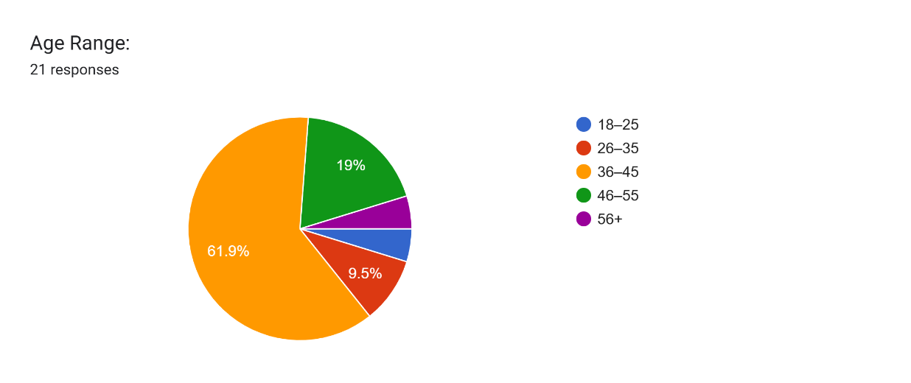
The majority of users are in their prime working years, as indicated by this profile, which is a crucial stage where indoor environments have repercussions on health (and therefore productivity), and require professional training, updated design guidelines, and policy frameworks to encourage wider implementation.
Of those surveyed, 85 per cent were medical professionals and 15 percent were administrative or support staff, figure 2.0. This corresponds to the hospital environment examined and suggests that the perceptions largely reflect the experiences of actual healthcare professionals. Those who responded had different experience years, which meant that the responses were representative of both junior and senior staff.

Figure 2.0 Professional Perception and Awareness of IEQ
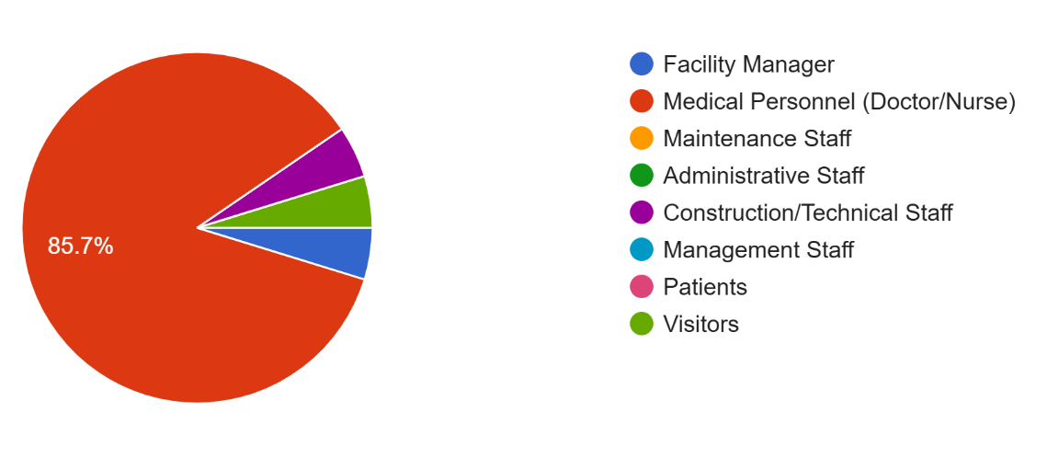
Awareness and Familiarity with IEQ.
The study shows that IEQ is not widely understood by users. One out of every four respondents admitted to being unfamiliar with the concept, while only 15% reported being very familiar. The overall framework and terminology of IEQ may not be well-defined, but users do have some knowledge about the specific factors that affect their work environment.
Despite the lack of training and technological integration, only 52.6% of respondents reported being unaware of IEQ monitoring systems.

Perceptions of Key IEQ Parameters.
Regarding, the most important factor, the selection of air quality and ventilation was made by 75%, 12.5% chose light quality, 8.3% mentioned acoustic quality others 4.3%, was thermal comfort, figure 3.0.
Users' concerns about ventilation, airborne pollutants, and infection control are reflected in the strong emphasis on improving air quality within healthcare settings. The lack of attention given to thermal comfort, lighting and acoustics suggests that these factors are either less important in the current workplace or more subtle but still have disproportionate effects on health and productivity. However, there is little evidence to support this conclusion.

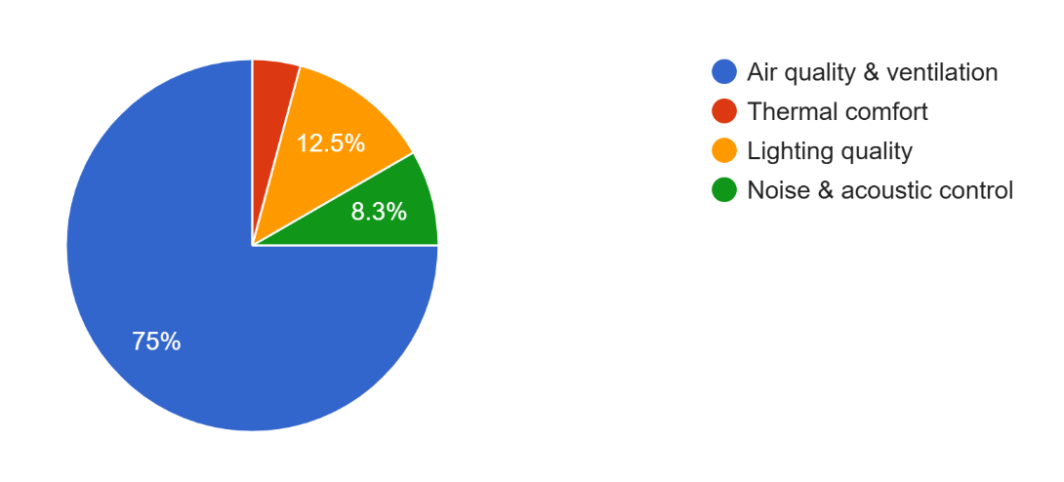
Figure 3.0 Perception of IEQ Parameters

Challenges in Maintaining IEQ.
Respondents identified several impediments to achieving and maintaining satisfactory IEQ levels in the facilities, Figure 4.0. These barriers included:
- Poor maintenance practices lead to the downfall of building systems.
- Limited demand for IEQ improvements due to staff being uninformed.
- Financial constraints, which hinder investment in modern technologies and regular upkeep.
- Outdated building materials and systems that do not meet current IEQ benchmarks.
- Technical expertise, which makes it difficult to install and operate high tech systems.
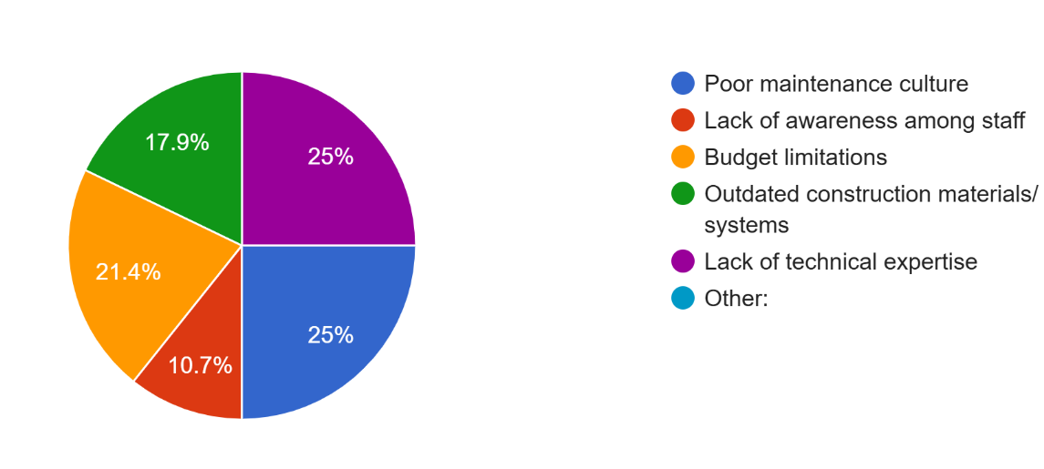
Figure 4.0 Barriers of Maintaining IEQ in Hospitals

The difficulties highlight the systemic challenges that hinder the long-term viability of IEQ initiatives in hospital infrastructure within the study area.
Health care professionals make up the majority of participants, so occupational health priorities, specifically infection control and ventilation are likely to impact perceptions. The insufficient
knowledge of IEQ monitoring systems and the identified hindrances implies a requirement for Staff development and capacity building based on IEQ principles. The reforms in policy and finances to focus on IEQ-related advancements. Modernized building materials and systems to ensure their quality meets current requirements. Institutional changes that promote regular observation and proactive upkeep.
Analysis of Adoption Potential and Workforce Development Gaps for IEQ.
Overall, the respondents expressed a positive attitude towards technology adoption. The percentage of people who were willing to adopt automated IEQ solutions varied, with 35% being very open, 50% moderately open and only 15% not ready for adoption. Despite the enthusiasm for technology-based advancements, there is still a lack of willingness among some due to cost, technical skills, or uncertainty about long-term benefits. The combination of strong moderate and high openness (85%) provides a solid foundation for the gradual implementation of automated systems through appropriate sensitization and training.

Training Exposure and Gaps.
Findings reveal a significant gap in IEQ practices regarding knowledge and abilities: Figure 5.0 shows, an overwhelming 81% of those polled admitted to not having received any prior training for improving their IEQ, 19% of them had undergone some form of training, either through on-the-job learning or formal vocational certification.
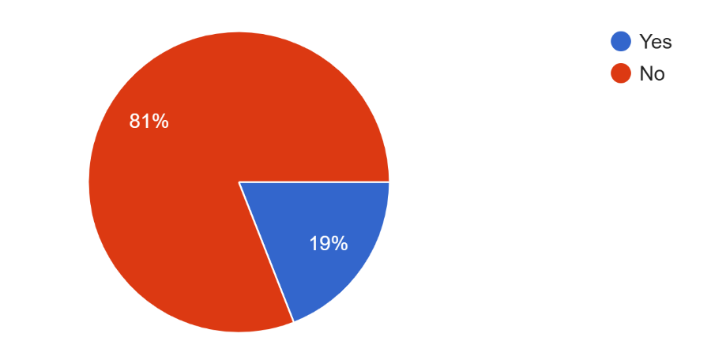
Figure 5.0 Knowledge and Training on IEQ
Even though architects and healthcare workers have a daily interaction with indoor environments, the importance of systematic IEQ training is seldom acknowledged. Structured education and professional retooling are now essential components of workforce development initiatives.

Enhanced IEQ Training Areas with better training outcomes.
The preferences of respondents regarding the most effective training to enhance IEQ in their facilities were divided into different areas. In healthcare facilities, infection control is a significant environmental issue, leading to 28.6% emphasis on waste management and hygiene best practices.
Figure 6.0 shows, energy efficient lighting and thermal control were emphasized as the primary focus for 21.4% of respondents, reflecting a recognition of the importance of both energy efficiency and occupant comfort.
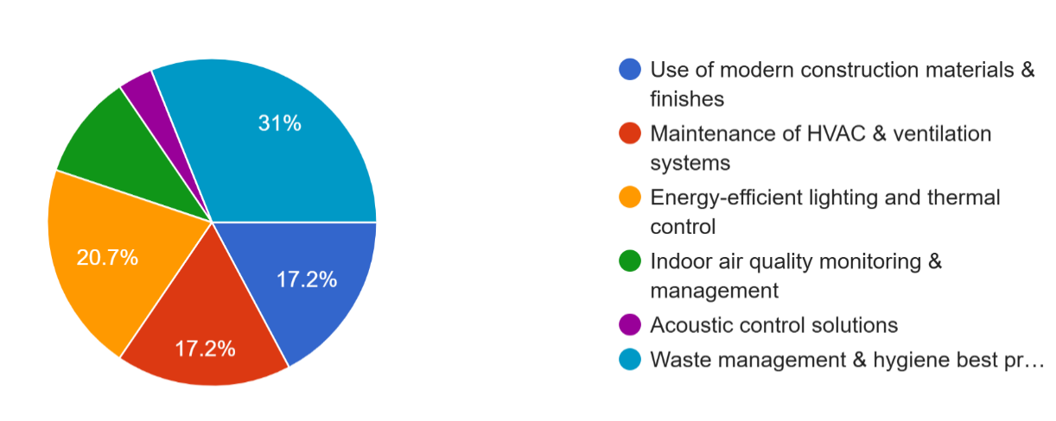
Figure 6.0 IEQ Training Areas in Hospitals
Users' perceptions of IEQ are primarily influenced by air circulation and cooling, which is why 17.2% preferred training on HVAC and ventilation system maintenance. Among the respondents, 17.2% reported using contemporary construction materials and finishes. This suggests some familiarity with material off-gassing, its durability, and ease of maintenance. Although indoor air quality monitoring and acoustic control were noted in 10.3% of cases, there was less emphasis on sophisticated methods like advanced monitoring or sound design, possibly due to limited exposure.
Based on their responses in this spread, respondents perceive that basic operational practices (waste and hygiene management) and technical building system maintenance are equally important. A
Real-time monitoring and acoustic comfort are not given as much importance, suggesting knowledge and exposure gaps.

Continuous Workforce Development.
In terms of the importance of ongoing workforce development, the study shows as revealed by Figure 7.0 that 71.4% rated it as highly significant. Both groups expressed strong support. This agreement emphasizes the importance of continuous training, retraining, and institutional support to achieve sustainable improvement in IEQ, rather than solely using one-time interventions. 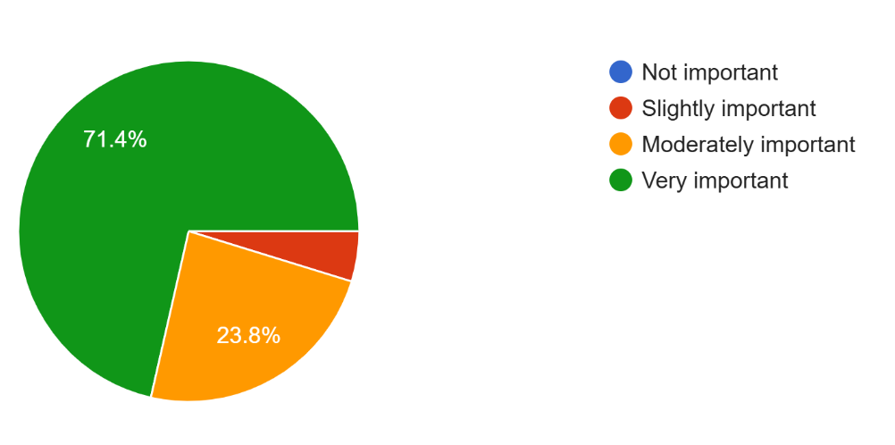
Figure 7.0 Continuous Workforce Development Importance
Preparation for Innovation
Despite constraints in infrastructure and funding, the majority of users are willing to adopt automated IEQ technologies. The possibility of gradually integrating smart solutions exists, starting with low-cost systems like low energy ventilation sensors or automated lighting.
Only 85% of respondents reported receiving structured IEQ training, which highlights the urgent
need for vocational programs, professional workshops, and policy frameworks that mandate IEQ awareness in the healthcare sector.
Practical interventions are prioritized over waste management, HVAC maintenance, and energy-efficient lighting by respondents, indicating that their priorities are primarily focused on immediate, practical issues. The infrequent use of acoustics and monitoring systems highlights the necessity for broadening the overall IEQ scheme. This is particularly evident in this context.
Consistent training and professional development programs for healthcare staff and facility managers are crucial in achieving sustainable IEQ, as they are widely recognized.

Conclusion
Evidence from hospital indoor environmental assessments demonstrates the pressing need for deliberate improvement of Indoor Environmental Quality (IEQ) as an integral part of healthcare delivery. In hospitals with such buildings, temperature and humidity as well as lighting, acoustics and air quality have important effects on patient safety/comfort levels and overall health of the staff. To make significant improvements, interventions must be implemented across multiple dimensions.
Pedagogical system.
Awareness of IEQ principles is fostered through training and education among architects, engineers, medical planners and facility managers. The foundational knowledge ensures that IEQ considerations are not optional but fundamental to healthcare architecture and building performance.
The Construction system.
It is necessary to implement these principles in practice through deliberate design strategies:
Passive technologies
Strategies such as optimal window-to wall ratios, natural ventilation techniques (such as acoustic insulation and thermal massing), daylighting strategies, etc.
Active technologies
Integrated HVAC systems with filtration and dehumidification, artificial lighting controls, and noise-reduction equipment are essential for making hospital facilities resilient and adaptable.
Operation system.
Contributes to the preservation of IEQ quality over time. Maintaining ventilation systems is essential for the continued safety, comfort and sustainability of hospitals after construction is completed. This is achieved through regular maintenance checks of indoor pollutants, adjustments to lighting and temperature controls, and ongoing evaluation of environmental parameters. Hospitals can establish healthier, more sustainable environments by integrating IEQawareness into pedagogy, intentionally incorporating it into construction practices and

maintaining strong operational management. In addition to improving clinical outcomes, this tripartite approach synchronizes healthcare infrastructure with worldwide standards of sustainable building performance.

Acknowledgements
The author acknowledges the support of hospital administrators and the Nigerian Institute of Architects in Kwara State for their cooperation during data collection.

Reference
Ackley, A., Olanrewaju, O. I., Oyefusi, O. N., Enegbuma, W. I., Olaoye, T. S., Ehimatie, A. E., Ukpong, E., and Akpan-Idiok, P. (2024). Indoor environmental quality (IEQ) in healthcare facilities: A systematic literature review and gap analysis. Journal of Building Engineering, 86, 108787. https://doi.org/10.1016/j.jobe.2024.108787
Ahmed, T., Kumar, P., and Mottet, L. (2021). Natural ventilation in warm climates: The challenges of thermal comfort, heatwave resilience and indoor air quality. Renewable and Sustainable Energy Reviews, 138, 110669. https://doi.org/10.1016/j.rser.2020.110669
District health facilities: Guidelines for development and operations. (1998). World Health Organization, Regional Office for the Western Pacific.
Dong, B., Prakash, V., Feng, F., and O’Neill, Z. (2019). A review of smart building sensing system for better indoor environment control. Energy and Buildings, 199, 29–46. https://doi.org/10.1016/j.enbuild.2019.06.025
Efthymiou, C., Barmparesos, N., Tasios, P., Ntouros, V., Zoulis, V., Karlessi, T., Salmerón Lissén, J. M., and Assimakopoulos, M. N. (2021). Indoor Environmental Quality Evaluation Strategy as an Upgrade (Renovation) Measure in a Historic Building Located in the Mediterranean Zone (Athens, Greece). Applied Sciences, 11(21), 10133. https://doi.org/10.3390/app112110133
Esfeh, M. K., Sohankar, A., Shahsavari, A. R., Rastan, M. R., Ghodrat, M., and Nili, M. (2021). Experimental and numerical evaluation of wind-driven natural ventilation of a curved roof for various wind angles. Building and Environment, 205, 108275. https://doi.org/10.1016/j.buildenv.2021.108275
Idris, A. S., Mohammed, I. Y., Kunya, U. S., and Usman, N. (2024). The Severity of Skill Shortages in the Nigerian Building Construction Artisans. International Journal of Civil Engineering, Construction and Estate Management, 12(3), 95–109. https://doi.org/10.37745/ijcecem.14/vol12n395109
Jiang, F., Xie, H., Gandla, S. R., and Fei, S. (2025). Transforming Hospital HVAC Design with BIM and Digital Twins: Addressing Real-Time Use Changes. Sustainability, 17(8), 3312. https://doi.org/10.3390/su17083312

John Agmada Bawa and Muhammad Ahmed Ismaila. (2025). An Assessment of the Impact of Poor Indoor Air Quality on Public Health in Nigerian Urban Environments; Case Study of FCT, Abuja.
International Journal of Latest Technology in Engineering Management and Applied Science, 13(12), 49–56. https://doi.org/10.51583/IJLTEMAS.2024.131205
Kalilu, R., Ayinla, A., and Amole, D. (2022). The Factor of House Forms in Indoor Environmental Quality of Houses in Selected Cities in Oyo State, Nigeria, International Journal of Energy and Environmental Research. Vol.10, No.2, pp.,40-58.
Kalua, A. (2016). Envelope Thermal Design Optimization for Urban Residential Buildings in Malawi. Buildings, 6(2), 13. https://doi.org/10.3390/buildings6020013
Liu, X., and Wu, Y. (2022). A review of advanced architectural glazing technologies for solar energy conversion and intelligent daylighting control. Architectural Intelligence, 1(1), 10. https://doi.org/10.1007/s44223-022-00009-6
Mansouri, A., Wei, W., Alessandrini, J.-M., Mandin, C., and Blondeau, P. (2022). Impact of Climate Change on Indoor Air Quality: A Review. International Journal of Environmental Research and Public Health, 19(23), 15616. https://doi.org/10.3390/ijerph192315616
Nel, A., Grainger, D., Alvarez, P. J., Badesha, S., Castranova, V., Ferrari, M., Godwin, H., Grodzinski, P., Morris, J., Savage, N., Scott, N., and Wiesner, M. (2011). Nanotechnology Environmental, Health, and Safety Issues. In M. C. Roco, M. C. Hersam, and C. A. Mirkin, Nanotechnology Research Directions for Societal Needs in 2020 (pp. 159–220). Springer Netherlands. https://doi.org/10.1007/978-94-007-1168-6_5
Nimlyat, P. S., Salihu, B., and Wang, G. P. (2024). The impact of indoor environmental quality (IEQ) on patients’ health and comfort in Nigeria. International Journal of Building Pathology and Adaptation, 42(4), 510–530. https://doi.org/10.1108/IJBPA-06-2021-0089
Niza, I. L., Bueno, A. M., Gameiro Da Silva, M., and Broday, E. E. (2024). Air quality and ventilation: Exploring solutions for healthy and sustainable urban environments in times of climate change. Results in Engineering, 24, 103157. https://doi.org/10.1016/j.rineng.2024.103157

Obeidat, L. M., Alrebei, O. F., Nouh Ma’bdeh, S., Al-Radaideh, T., and Amhamed, A. I. (2023). Parametric Enhancement of a Window-Windcatcher for Enhanced Thermal Comfort and Natural Ventilation. Atmosphere, 14(5), 844. https://doi.org/10.3390/atmos14050844
Perera, I., Hewage, K., Rana, A., and Sadiq, R. (2025). Combining Energy Performance and Indoor Environmental Quality (IEQ) in Buildings: A Systematic Review on Common IEQ Guidelines and Energy Codes in North America. Energies, 18(7), 1740. https://doi.org/10.3390/en18071740
Rathore, P. K. S., and Shukla, S. K. (2021). Enhanced thermophysical properties of organic PCM through shape stabilization for thermal energy storage in buildings: A state of the art review. Energy and Buildings, 236, 110799. https://doi.org/10.1016/j.enbuild.2021.110799
Ray, P. C., Yu, H., and Fu, P. P. (2009). Toxicity and Environmental Risks of Nanomaterials: Challenges and Future Needs. Journal of Environmental Science and Health, Part C, 27(1), 1–35. https://doi.org/10.1080/10590500802708267
Rodríguez-Soria, B., Domínguez-Hernández, J., Pérez-Bella, J. M., and Del Coz-Díaz, J. J. (2014). Review of international regulations governing the thermal insulation requirements of residential buildings and the harmonization of envelope energy loss. Renewable and Sustainable Energy Reviews, 34, 78–90. https://doi.org/10.1016/j.rser.2014.03.009
Rudavskyi, I., Klym, H., Kostiv, Y., Karbovnyk, I., Zhydenko, I., Popov, A. I., and Konuhova, M. (2024). Utilizing an Arduino Uno-Based System with Integrated Sensor Data Fusion and Filtration Techniques for Enhanced Air Quality Monitoring in Residential Spaces. Applied Sciences, 14(19), 9012. https://doi.org/10.3390/app14199012
Silva, B. V. F., Holm-Nielsen, J. B., Sadrizadeh, S., Teles, M. P. R., Kiani-Moghaddam, M., and Arabkoohsar, A. (2024). Sustainable, green, or smart? Pathways for energy-efficient healthcare buildings. Sustainable Cities and Society, 100, 105013. https://doi.org/10.1016/j.scs.2023.105013
Vergerio, G., and Becchio, C. (2022). Pursuing occupants’ health and well-being in building management: Definition of new metrics based on indoor air parameters. Building and Environment, 223, 109447. https://doi.org/10.1016/j.buildenv.2022.109447

Vijayakumar, G., Thangavel, E., Alshamsi, D., Sherif, M., Murad, A. A., and Sangaraju, S. (2025). A critical review on the prospective role of nanomaterials in the effectual removal of radionuclides from wastewater – State of the art and future challenges. Environmental Technology and Innovation, 38, 104129. https://doi.org/10.1016/j.eti.2025.104129
Wijewardane, S., and Santamouris, M. (2025). Smart glazing systems: An industrial outlook. Solar Compass, 14, 100114. https://doi.org/10.1016/j.solcom.2025.100114
Wu, Q., Li, N., Cai, X., He, Y., and Du, Y. (2023). Impact of indoor environmental quality (IEQ) factors on occupants’ environmental perception and satisfaction in hospital wards. Building and Environment, 245, 110918. https://doi.org/10.1016/j.buildenv.2023.110918
Xi, T., Sa’ad, S. U., Liu, X., Sun, H., Wang, M., and Guo, F. (2025). Optimization of Residential Indoor Thermal Environment by Passive Design and Mechanical Ventilation in Tropical Savanna Climate Zone in Nigeria, Africa. Energies, 18(3), 450. https://doi.org/10.3390/en18030450

