A Unified Framework for Data Hiding: Embedding Text, Image and Video payloads

-------------------------------------------------------***-------------------------------------------------------
Abstract: The rapid growth of digital communication requires data security. Steganography is most used method for data hiding. Steganography is an art of hiding secrete data for secure communication. Among various methods of steganography video steganography is widely used due to its high embedding capacity. Video signal is a combination of frames so it brings maximum possibilities to hide maximum amount of data. This paper presents unified framework of video steganography. The proposed method includes video steganography where we can used text, image or small video as a secrete data. Huffman coding is used to compress secrete data, reducing the embedding capacity requirements and enabling a higher payload. Huffman coding is lossless compression technique. The compressed secrete data then embedded into the cover video by transform domain technique. The effectiveness of the proposed technique is given by experimental results. Peak signal to noise ratio (PSNR), Mean square error (MSE), Signal to noise ratio (SNR), Pixel similarity accuracy are some of output terms which are compared for different size of secrete data.
Key Words: Video steganography, Huffman coding, transform domain, Embedding Capacity, Lossless compression.

1. INTRODUCTION

Steganography is an art of hiding data. The word steganography is of Greek origin and means concealed writing. The Greek word stegons means covered or protected and graphy means writing. Steganography includes the concealment of information within computer file. It is an art and science of writing messages which is used to hide behind original messages or file and this may be audio, image or video file. Steganography can be done using audio, video or image files. For image steganography only one frame is available, so not widely used. In video file there are number of frames so more data can be hidden. Therefor mostly video steganography is used for security purpose.
1.1 Video Steganography
Video steganography is the practice of hiding secret information within a video file, such that the very existence of the secret information is not apparent. This is achieved by exploiting the properties of video files, such as the redundancy of video data, to conceal the secret information. In this the cover file or carrier file should be video file and secrete message will be in terms of text, sound, image or video.
Video steganography is a powerful and often challenging form of steganography due to the sheer size and complexity of video files. A video file is a combination of a sequence of images (frames) and an audio track. This provides a vast amount of space and redundancy to hide information, but also presents unique challenges, especially when dealing with video compression.
The main challenge in video steganography is to embed data that can survive the constant compression and decompression that videos undergo during storage and transmission. Simply hiding data in the raw pixel values of each frame (a spatial domain technique) would likely be destroyed by the compression algorithm. For this reason, most effective video steganography techniques operate in the transform domain or compressed domain.
To address these challenges, this paper proposes a novel video steganography method which includes Huffman coding. Huffman coding is lossless compression technique that can effectively compress the secrete data, reducing the embedding the capacity requirements. Fig 1 shows the block diagram of basic steganography.
Quantization
Transform Domain Embedding
Post processing
Rebuild Video
Data Collection
Preprocessing
Huffman Coding
Cover Video
Secrete Data

Fig 1- Basic Block Diagram of Steganography

    - Techniques of Video Steganography
Video is nothing but a no of frames or we can say it is a sequence of frames. In the video steganography process, digital video is converted to number of frames. Each frame can be used as a cover frame or carrier frame to conceal the hidden data. There are different techniques used for video steganography. But widely used techniques are Spatial Domain technique & Transform Domain technique.
In Spatial domain Technique, data hiding is based on pixel values. Video steganographic technique that are based on Spatial domain are LSB substitution, Bit Plain Complexity Segmentation (BPCS), Spread Spectrum, Region of Interest (RIO), Histogram Manipulation, Matrix Encoding, and Mapping Rule. Out of these technique LSB substitution is widely used method.
In Transform Domain Technique, after extraction of frames from video each frame is individually transformed into frequency domain. Fast Fourier Transform (FFT), Discrete Cosine Transform (DCT), Discrete Wavelet Transform (DWT), Format based Technique are some of different Transform Domain Techniques. In spatial domain techniques, there are some chances of losses of data while compression or mapping in process of image processing so to avoid this Transform Domain Technique is mostly used.

  - Huffman Coding
Huffman code is invented by David A. Huffman in 1952. It is an algorithm with lossless data compression. It is constructed using binary tree known as Huffman tree. The tree is built by combining the two nodes with the lowest frequencies until only one node remains. Huffman code provides high compression ratio for text data. Huffman codes are simple to implement. It can be encoded and decoded very easily and quickly. In our proposed system secrete message is encoded using Huffman coding, then it embedded in frames of cover video file.

2. PROPOSED WORK:

2.1 Methodology:

The proposed system aims to design video steganography system using Huffman coding, quantization and Transform Domain Technique. The secrete data can be text, image or small video. If secrete data is in form of video then that video should be always small in size than the cover video. Fig 2 shows the steps of proposed video steganography technique.
Data Collection
Preprocessing
Huffman Coding
Quantization
Transform Domain Embedding
Post Processing
Get secrete Data
Preprocessing
Huffman Coding
Quantization
Transform Domain Embedding
Post Processing
Get Cover Video
Get secrete Data
Preprocessing
Huffman Coding
Quantization
Transform Domain Embedding
Post Processing
Get Cover Video

Fig 2- Steps for Proposed System
Data collection includes the selection of carrier video and secrete data. We have to select secrete data type i.e whether data is in form of text or image or video. The carrier video file must be in .avi or .mp4 format. If secrete data is video file then it should be small video than carrier video. In the preprocessing stage, carrier video and secrete data both are prepared for compression and embedding process. In carrier video preprocessing, video was broken into individual frames. The extracted frames were converted from RGB to YCbCr. In secrete data preprocessing if datavis video then same procedure done carrier video. If secrete data is image then single frame or image was converted from RGB to YCbCr.
After preprocessing, Huffman coding was done on secrete data to compress frames. Huffman tree was build based on the frequency of pixel. Huffman tree was used to encode the secrete data. After this, further to reduce the embedding capacity quantization was implemented. Here we used uniform quantization. It is straight forward and widely used method to convert continuous signals into discrete digital representations. The quantized secret data were embedded into the cover video frames using a Discrete Cosine Transform (DCT). The last step is post-processing where stego video was generated which was visually imperceptible and robust against attacks.
2.2 Figures, Results:
Mean Square Error (MSE), Peak Signal-to-Noise Ratio (PSNR), Signal to Noise Ratio and Pixel similarity accuracy are the performance parameters of steganography techniques.
MSE (Mean Square Error) is a risk function. MSE has the same units of measurement as the square of the quantity being estimated.
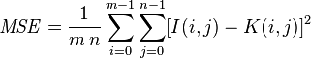
Peak Signal to Noise Ratio (PSNR) is a common term to calculate the difference between the carrier and stego data.
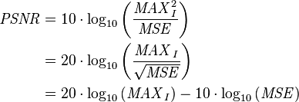
Signal to Noise Ratio (SNR) measures the ratio of desired signal intensity (actual information) to undesired background noise, determining image quality.
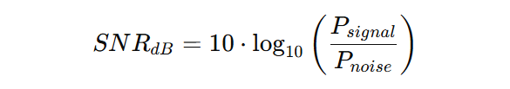
Pixel similarity accuracy measures the proportion of correctly classified pixels in an image compared to original image pixels. It represents the percentage of pixels in a predicted map assigned to the correct class.
When we used text as a secrete data then character to character accuracy is gets checked. Fig 3 shows the original and recovered bit value histogram.
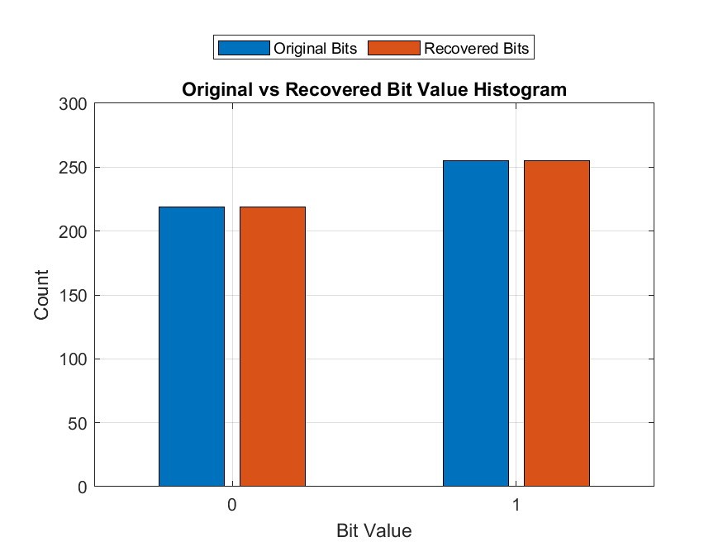
Fig 3- Bit Value Histogram
Table 1 gives the set of secrete images.
Lenna | Pepper | Baboon
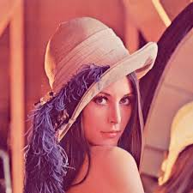 |  | 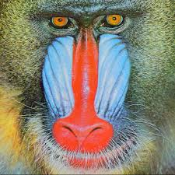
Table 1- Different Secrete Images
Table 2 gives the experimental result for the different size of secrete image.
Image Name | Size | MSE | PSNR | SNR | Pixel Accuracy Similarity
Lenna | 8.05 KB | 44.913132 | 31.60707 dB | 26.454446 dB | 98.670961%
Pepper | 8.63 KB | 44.45385 | 31.651710 dB | 25.696450 dB | 98.691871%
Baboon | 12.7 KB | 52.562247 | 30.924064 dB | 25.524957 dB | 98.014714%
Table 2- Comparison Table for different size of Secrete Image File
Table 3 gives the experimental result for the different size of secrete video.
Size of Video File | MSE | PSNR | SNR | Pixel Accuracy Similarity
61 KB | 5.341938 | 40.853815 dB | 23.197262 dB | 99.508394%
316 KB | 10.253425 | 38.022114 dB | 29.436653 dB | 99.275446%
630 KB | 50.8417 | 31.068603 dB | 23.392251 dB | 98.023337%
Table 3- Comparison Table for different size of Secrete Video file

3. CONCLUSION:
The proposed video steganography method using Huffman coding provides a high-quality stego video with a high degree of similarity to the cover video. The proposed method is robust against various attacks. In this method we can hide secrete data which is in any form like secrete text or image or small video. The main aim of the project is to develop a system that processes a secret data by encrypting it and then hiding it in a video file using MATLAB as the language for technical computing. The algorithm ensures optimal data hiding while maintaining video quality. Also, the decryption algorithm gives the good quality of recovered data. The results, evaluated using MSE, PSNR, SNR and pixel accuracy similarity, gives the performance of the algorithm, producing stego video with minimal distortion and high fidelity.

REFERENCES
[1] Shruthi, Sharath. M N., “AFF_PAL_AutoCNN: Construction of Autoencoder Convolution Neural Network for Video Steganography Analysis”, 2025 2nd International Conference on Intelligent Algorithms for Computational Intelligence Systems (IACIS)
[2] Laijin Meng;Xinghao Jiang;Qiang Xu;Tanfeng Sun, “A Robust Coverless Video Steganography Based on Two-Level DCT Features Against Video Attacks”, IEEE TRANSACTIONS ON MULTIMEDIA, VOL. 27, 2025
[3] Sangeeta; Sunita Dhingra, “Image Steganography: A Comprehensive Review of Conventional and Modern Techniques”, Proceedings of the International Conference on Sustainable Communication Networks and Application (ICSCN-2025) IEEE Xplore Part Number: CFP25DW8-ART; ISBN: 979-8-3315-9420-6
[4] Gede Totok Suryawan; Made Sudarma; Ketut Gede Darma Putra; Anak Agung Kompiang Oka Sudana, “Comparative Analysis of Image Steganography Based on Convolutional Neural Network and Canny Edge Detection on Digital Images”, 2025 4th International Conference on Electronics Representation and Algorithm (ICERA)
[5] Geetaniali Kale; Atharva Joshi; Ishaan Shukla; Abhishek Bhosale, “A Video Steganography Approach with Randomization Algorithm Using Image and Audio Steganography”, 2024 International Conference on Emerging Smart Computing and Informatics (ESCI) AISSMS Institute of Information Technology, Pune, India. Mar 5-7, 2024
[6] Si Liu, Yunxia Liu, Hongguo Zhao, Zhenghang Zhao, “A HEVC Video Steganography Algorithm Based on 8×8 QDCT Coefficients”, 2024 4th International Conference on Blockchain Technology and Information Security (ICBCTIS)
[7] Abdellatif Zouak, Krishna Busawon, Xicong Li, “Video Steganography System Based on Optical Flow for Object Detection”, 2024 14th International Symposium on Communication Systems, Networks and Digital Signal Processing (CSNDSP)
[8] Kori Madhura Jagadish, Nagamani K, “Secured Information Transmission Using Audio and Video Steganography”, 2023 7th International Conference on Computation System and Information Technology for Sustainable Solutions (CSITSS)
[9] Sushma R B;Manjula G R, “An Adaptive Steganography Approach for Live Video Streams Based on Edge Analysis and Frame Variability”, 2023 International Conference on Recent Advances in Information Technology for Sustainable Development (ICRAIS)
[10] H. A., Dr. Uma S. V., “Video Steganography Techniques for Data Hiding – A perspective”, International Journal of Creative Research Thoughts (IJCRT), Volume 9, Issue 5 May 2021, ISSN:2320-2882

