Ethical Issues and Challenges in Generative AI: A Review

Abstract—
Generative Artificial Intelligence (AI) has emerged as one of the most significant advancements in recent years, enabling machines to generate human-like content such as text, images, audio, and video. These systems are based on advanced deep learning models trained on large-scale datasets, which allow them to perform complex tasks across various domains. Generative AI is widely used in fields such as education, healthcare, software development, and entertainment, where it enhances productivity, creativity, and efficiency.

However, along with its advantages, generative AI also raises several ethical concerns that cannot be ignored. Issues such as data privacy, bias in decision-making, misinformation through deepfake content, and misuse in academic environments have become increasingly prominent. These challenges not only affect individuals but also have a broader impact on society, including loss of trust in digital content and potential harm to social and economic systems.

In this paper, we present a comprehensive review of the major ethical issues and challenges associated with generative AI. Various research studies are analyzed to understand the root causes and implications of these problems. Additionally, the paper discusses possible solutions, including ethical frameworks, regulatory measures, and technological improvements aimed at ensuring responsible use of generative AI systems. The study also highlights future trends that focus on transparency, fairness, and accountability in AI development.
Index Terms—
Generative AI, Ethics, Bias, Privacy, Deepfake, AI Challenges, Responsible AI

INTRODUCTION

In recent years, Generative Artificial Intelligence (AI) has gained significant attention due to its ability to create new and meaningful content. Unlike traditional AI systems that are primarily designed for data analysis and prediction, generative AI focuses on producing original outputs such as text, images, audio, and video. These systems are typically built using advanced deep learning techniques, including neural networks and transformer-based models, which are trained on large-scale datasets collected from various sources [1].

The rapid advancement of generative AI has led to its widespread adoption across multiple domains. In the field of education, AI tools assist students in generating study material, solving problems, and improving learning efficiency. In healthcare, generative AI is used for medical report generation, disease prediction, and drug discovery. Similarly, in software development, it helps programmers by generating code, debugging errors, and automating repetitive tasks. In the entertainment industry, generative AI is used to create digital content such as images, music, animations, and videos, thereby enhancing creativity and production efficiency [2].

Despite these benefits, the increasing use of generative AI has raised several ethical and social concerns. Since these systems are trained on large datasets that may include personal, sensitive, or biased information, there is a risk of privacy violations and unfair outputs. For example, AI models may unintentionally generate biased content

due to biased training data, which can negatively affect decision-making processes in areas such as recruitment, education, and finance. Furthermore, the ability of generative AI to create realistic fake content, such as deepfake videos and misleading information, poses a serious threat to trust and authenticity in digital communication [3].

Another major concern is the misuse of generative AI in academic environments. Students may rely heavily on AI tools to generate assignments and reports, which can reduce their understanding of the subject and affect their learning process. Additionally, issues related to copyright and ownership of AI-generated content are still not clearly defined, leading to legal challenges. The lack of proper regulations and guidelines further complicates the responsible use of generative AI technologies.
Moreover, generative AI systems are not always reliable, as they may produce incorrect or misleading outputs, commonly known as hallucinations. These errors can have serious consequences, especially in critical applications such as healthcare and decision-making systems. Therefore, it is essential to develop methods to ensure the accuracy, transparency, and accountability of AI systems.
Considering these challenges, it becomes important to study the ethical issues and limitations of generative AI in detail. In this paper, we have reviewed various research studies to identify key ethical concerns and challenges associated with generative AI. The paper also discusses possible solutions and future directions to ensure the responsible and safe use of this technology.

LITERATURE SURVEY
Several researchers have explored the ethical challenges associated with generative AI systems. This section presents a review of some important research works in this domain.

- M. Smith et al. (2024) discussed the ethical challenges in generative AI, focusing mainly on
privacy and data security issues. The study highlights that AI models are often trained on large datasets that may include personal and sensitive information. This can lead to data leakage and misuse if proper precautions are not taken. The authors suggest implementing strong data protection mechanisms to address these concerns.

- R. Kumar et al. (2024) analyzed the use of generative AI in academic environments. The study found that many students use AI tools to complete assignments, which leads to plagiarism and reduced learning outcomes. The authors recommend developing guidelines for the ethical use of AI in education.

- H. Lee et al. (2023) focused on the issue of deepfakes and misinformation. The research explains how generative AI can create highly realistic fake images and videos, making it difficult to distinguish between real and fake content. This can have serious consequences in areas such as politics, media, and public trust.

- A. Brown et al. (2024) proposed an ethical framework for responsible AI usage. The framework includes principles such as transparency, accountability, fairness, and privacy. Although the framework provides a strong foundation, its practical implementation remains a challenge.

- P. Patel et al. (2025) studied the real-world challenges [5] of implementing generative AI systems. The paper highlights issues such as lack of regulation, difficulty in controlling AI outputs, and social concerns like job displacement. The authors emphasize the need for collaborative efforts between researchers, developers, and policymakers.

From the above studies, it is clear that while generative AI offers many benefits, it also introduces significant ethical challenges that need to be addressed through proper research and regulation.

Table 1: Summary of Literature Review

Sr. No | Author/Year | Focus Area | Key Findings | Remarks
1 | Smith et al. (2024) | AI Ethics | Privacy & Bias issues | Needs regulation
2 | Kumar et al. (2024) | Academic AI | Plagiarism risk | Misuse possible
3 | Lee et al. (2023) | Media AI | Deepfake problem | Hard to detect
4 | Brown et al. (2024) | AI Framework | Ethical guidelines | Complex
5 | Patel et al. (2025) | AI Challenges | Real-world issues | Needs improvement

ETHICAL ISSUES
Generative AI systems introduce several ethical concerns that affect individuals, organizations, and society as a whole.

Privacy and Data Security
One of the major concerns in generative AI is privacy. These systems are trained on large datasets that may include personal information such as images, text, and user data. If proper safeguards are not implemented, this information can be exposed or misused. This creates serious risks related to data security and user privacy [1].

Bias and Fairness
Another important issue is bias in AI systems. Since AI models learn from existing data, any bias present in the data can be reflected in the outputs. This can lead to unfair or discriminatory results, especially in applications such as hiring, lending, and decision- making systems [2].

Misinformation and Deepfakes
Generative AI has the capability to create fake content that appears real. This includes deepfake videos, manipulated images, and false news articles. For example, AI-generated videos of public figures can be used to spread misinformation and influence public opinion. This poses a serious threat to trust and authenticity in digital media [3].

Copyright and Ownership Issues
The ownership of AI-generated content is still unclear. Since AI models are trained on existing data, which may include copyrighted material, it raises questions about intellectual property rights.
There is currently no clear legal framework to address these issues.

Academic Integrity
The use of generative AI in education has raised concerns about academic integrity. Students may use AI tools to generate assignments, which reduces their understanding of the subject and affects their learning process. This also leads to plagiarism and unfair academic practices [2].

AI Hallucination
Generative AI models sometimes produce incorrect or misleading information, a phenomenon known as hallucination. Since these outputs are often presented confidently, users may trust them without verification, leading to misinformation.

Job Displacement
The increasing use of generative AI in various industries may lead to job displacement. Tasks that were previously performed by humans, such as content writing, design, and customer support, are now being automated. This can have a significant impact on employment opportunities.

CHALLENGES IN GENERATIVE AI
Despite its rapid growth and wide range of applications, generative AI faces several important challenges that limit its effectiveness and raise concerns among users and researchers.

Technical Challenges

One of the major challenges is the lack of accuracy and reliability in generated outputs. Sometimes, AI models produce incorrect or misleading information, which is commonly known as hallucination. Additionally, controlling the behavior of AI models is difficult, as they may generate unexpected or inappropriate responses.
Another issue is the high computational cost. Training large generative models requires powerful hardware and significant energy consumption, making it expensive and less accessible for smaller organizations.

Ethical Challenges
Ensuring ethical use of generative AI is a complex task. AI systems may unintentionally produce biased or harmful content due to biased training data. Preventing such issues requires continuous monitoring and improvement.
Moreover, there is a challenge in maintaining transparency and accountability. It is often difficult to understand how AI systems make decisions, which reduces trust among users.

Legal Challenges
Currently, there are limited laws and regulations governing the use of generative AI. Issues such as copyright, data ownership, and liability are not clearly defined.
For example, if AI generates harmful or false content, it is unclear who should be held responsible—the developer, the user, or the system itself.

Social Challenges
Generative AI also creates social concerns such as loss of trust in digital content. With the rise of deepfakes and fake news, people may find it difficult to trust online information.
Another major issue is job displacement, as automation may replace certain roles, especially in creative and repetitive tasks.

METHODOLOGY / ANALYSIS
The following flowchart represents the process of identifying and handling ethical issues in generative AI systems.
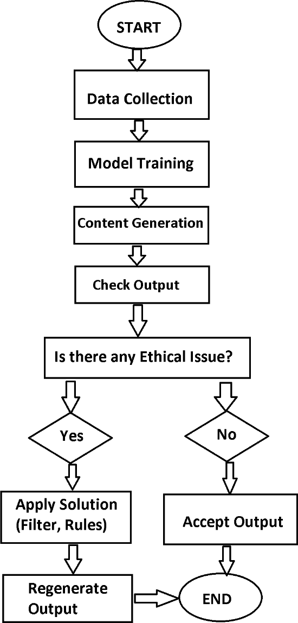

Fig 1: Flowchart of Ethical Issue Detection in Generative AI
This study is based on a systematic review of existing research work related to ethical issues in generative AI.
The methodology followed in this study includes the following steps:

Data Collection:
Relevant research papers, journals, and conference articles were collected from reliable sources.

Paper Selection:
Papers focusing on ethical issues, challenges, and applications of generative AI were selected.

Analysis of Content:
Each paper was carefully studied to identify key ethical concerns such as privacy, bias, misinformation, and academic misuse.

Comparison of Findings:
The findings from different papers were compared to understand common patterns and differences.

Conclusion and Insights:
Based on the analysis, major challenges and possible future solutions were identified.
This approach helps in providing a clear understanding of the current state of generative AI ethics.
This methodology ensures that the analysis is systematic, reliable, and based on previously validated research work.

FUTURE TRENDS

As generative AI continues to evolve, several future trends are expected to shape its development in a more ethical and responsible direction.

Development of Ethical AI Frameworks
Organizations and researchers are working on creating guidelines and frameworks to ensure that AI systems are developed and used responsibly.

Explainable AI (XAI)
Future AI systems will focus on transparency, where users can understand how decisions are made. This will increase trust and accountability.

Strong Government Regulations
Governments are expected to introduce laws and policies to regulate the use of generative AI, especially in areas like data privacy and misinformation.

Improved Bias Detection
Advanced techniques will be developed to detect and reduce bias in AI models, ensuring fairness in outputs.

Human-AI Collaboration
Instead of replacing humans, AI will work alongside humans to improve efficiency and productivity.

ADVANTAGES AND DISADVANTAGES

Advantages
- Reduces time and effort in content creation
- Improves productivity in various fields
- Supports creativity and innovation
- Useful in education, healthcare, and business

Disadvantages
- Ethical and privacy concerns
- Risk of misuse and misinformation
- Job displacement in certain sectors
- Overdependence on AI tools

CONCLUSION

Generative AI is a powerful and rapidly evolving technology that has the potential to revolutionize multiple industries. It offers numerous benefits such as automation, efficiency, and creativity. However, it also introduces serious ethical challenges, including privacy risks, bias, misinformation, and academic misuse.
This paper reviewed various research studies and identified key issues and challenges associated with generative AI. It is clear that while the technology is advancing rapidly, there is a strong need for proper regulations, ethical guidelines, and awareness among users.
In the future, the focus should be on developing responsible AI systems that are transparent, fair, and secure. By addressing these challenges, generative AI can be used effectively for the benefit of society.

If these ethical challenges are not properly addressed, the misuse of generative AI may create serious risks for individuals and society in the future.

REFERENCES
- M. Smith, J. Brown, “Ethical Challenges in Generative AI,” Journal of AI Research, 2024.
- R. Kumar, S. Patel, “Bias and Fairness in AI Systems,” International Conference on AI, 2024.
- H. Lee, D. Park, “Deepfake Technology and Misinformation,” IEEE Transactions, 2023.
- A. Brown, K. Wilson, “AI in Education and Academic Integrity,” Springer, 2024.
- P. Patel, R. Sharma, “Challenges in Generative AI Implementation,” Elsevier, 2025.

