Neuro Imaging Assisted Cognitive Disorder Detection: A Deep Learning and Machine Learning Approach

ABSTRACT
Cognitive disorders like Alzheimer’s disease and vascular dementia are global health concerns affecting millions of people worldwide. It is important to diagnose these disorders at an early stage to effectively intervene and provide treatment. This research proposes a complete computational framework for the detection of cognitive disorders using sophisticated deep learning and machine learning techniques. The proposed system is based on the combination of MRI analysis and CNN feature extraction VGG16 and Support Vector Machine (SVM) classification tech niques. This proposed system can classify Alzheimer’s disease into four different stages: No Impairment, Very Mild Impairment, Mild Impairment, and Moderate Impairment. Moreover, the pro posed system can classify the presence or absence of vascular de mentia. This proposed system includes an explanation mechanism using Grad-CAM to offer visual explanations for the predictions made bythe system. A Flask-based web application is proposed to offer user-friendly access to the proposed diagnostic system with complete reporting capabilities. Analysis of the proposed system shows promising results in terms of accuracy, precision, recall, and F1-measure values. This work is a significant contribution to the new area of medical image analysis.
Keywords - Alzheimer’s Disease, Vascular Dementia, MRI, CNN, VGG16, Support Vector Machine, Grad-CAM.

INTRODUCTION
One major issue around the world today involves problems with thinking and memory, such as vascular dementia and Alzheimer’s disease. Over millions of people now live with some form of dementia- a number expected to triple by 2050. While poor blood flow in the brain drives vascular dementia, another path lies behind most cases: gradual shrinking of brain tissue, along with tangled proteins and swelling inside nerve cells. Alzheimer’s makes up well over half of all dementias, marked clearly by clumps of amyloid-beta and twisted strands of tau. Unlike sudden strokes, these changes creep slowly, eroding function piece by piece without clear warning signs early on. Finding changes in the brain tied to thinking prob lems relies heavily on MRI scans. Because they show clear images without needing surgery, these scans help spot issues Y. Vaagdevi Student, IT Department Mahatma Gandhi Institute of Technology(MGIT) Hyderabad, Telangana, India Email: yvaagdevi csb223262@mgit.ac.in sooner while tracking how conditions progress over time. Still, automated diagnosis tools become necessary because reading vast brain scans by hand takes too much time, demands expert training, yet often differs between readers. Tricky spots show up when spotting brain issues automatically- data gets too big, differences too small, and rare cases get overlooked. Doctors expect answers they can trust, so systems must hit two targets: getting it right, plus making their reasoning clear. From MRI scans, this research introduces a unified digital approach that automatically sorts Alzheimer’s stages while spotting signs of vascular dementia. Instead of just listing f indings, it shows active brain regions through visuals built into a browser tool. Built on layered algorithms, part smart models and part transparent rules, the method aims to clarify predictions about how patients may progress. By linking clear reasoning with complex pattern detection, it offers insights meant for real medical settings. Accessible online, the setup targets remote care support, sharper forecasts, and better informed choices during consultations. Visual feedback comes along each result, grounding conclusions in visible changes seen across brain images.
LITERATURE SURVEY
Alam and Latifi [1] investigated various neuroimaging modalities like MRI, PET, and CSF biomarkers for the di agnosis of Alzheimer’s disease using various neuroimaging modalities. The study showed that deep learning methods like CNN and CNN-LSTM produced very high accuracy of 99.95% and 99.92%, respectively. Traditional methods like SVM are also successful for small datasets, but these methods are restricted by the high computational cost and the need for large datasets. Alruily et al.
[2] built a smart system that spots Alzheimer’s through brain scans. Instead of relying on one method, they stitched together traits from three known models- VGG16, MobileNet, along with InceptionResNetV2. Before anything ran, the MRI pictures got cleaned up via resizing, balanced out by oversampling, then normalized and stripped down to key details. Results landed near the top: 97.93% correct calls over all. Out of healthy cases, nearly 98% were properly flagged as such. When sickness existed, it caught about 95.89% of those moments. Right guesses among all positive reads settled at 95.94%. Awang et al. [3], have developed a model by using DenseNet-201 architecture to classify Alzheimer’s disease by using MRI brain image. In this paper, AD5C dataset is used, which contains 2381 classifications of MRI brain images in four classes. Various preprocessing techniques are used to perform the proposed system. DenseNet-201 architecture is used to classify the feature and stages of the disease. The proposed system is able to attain an accuracy of 98.24%, with high precision, F1-score, and recall values. This shows that the proposed system is able to attain high accuracy in the diagnosis of Alzheimer’s disease by using transfer learning and DenseNet-201 architecture. Tufail et al. [4] introduced a deep learning model for the classification of vascular dementia from MRI and rs-fMRI brain images. The authors have employed different transfer learning models such as DenseNet121, VGG16, VGG19, In ceptionResNetV2 for the detection of the disease. The authors have processed and balanced the data using different sampling methods. The authors have split the brain images into training, validation, and testing sets (80%, 10%, 10%). Activation functions such as ReLU and Leaky ReLU have also been used to overcome the vanishing gradient problem. Among all the models, DenseNet121 has been found to perform better for the classification problem. The proposed model has been found to achieve 84.67% accuracy for multi-class classification for the detection of vascular dementia using MRI brain scans. In the review by Morgan and McAuley [5] on the patho biology, risk factors, and emerging research perspectives in vascular dementia (VaD), it is stated that VaD is the 2nd most common form of dementia, usually resulting from cerebrovas cular abnormalities in brain blood flow. It is caused by various risk factors like hypertension, obesity, diabetes, smoking, di etary habits, and physical inactivity. It is also caused by various pathological mechanisms like oxidative stress, inflammation, and breakdown of the blood–brain barrier. It is mentioned that emerging research perspectives include epigenetics, mi crobiome interactions, and various potential compounds like metformin, rapamycin, and resveratrol. Sampath and Baskar proposed the Fly Optimized Densely Connected CNN (FODC-CNN) [6], which is a method for the prediction of Alzheimer’s disease from the MRI images of the brain. The method employs adaptive histogram enhancement and weighted median filters for the enhancement of the quality of MRI images and the removal of noise from the images. The extraction of features is done by the convolutional clustering method, and the areas affected by Alzheimer’s disease are detected. The parameters of the CNN are optimized by the fly optimization algorithm for the improvement of the classifica tion accuracy. The results achieved by the proposed method on the Kaggle MRI dataset with more than 6400 images proved the efficiency of the proposed method for the diagnosis of AD. Chouliaras and O’Brien [7] conducted a study that reviewed the role of neuroimaging techniques and the differential di agnosis of dementia. The study highlights the different neu roimaging techniques such as PET, MRI, and SPECT scans that are used for the detection of abnormalities in the brain that are associated with Alzheimer’s dementia, vascular dementia, and Lewy body dementia. The study concludes that the use of neuroimaging and computational techniques can enhance the accuracy of dementia diagnosis. A deep learning framework was proposed by Nithya et al. [8] based on ResNet-50 for early classification of Alzheimer’s disease using MRI brain image data. In this proposed frame work for image classification, different preprocessing tech niques such as BADF and CLAHE are used for image enhancement. In this proposed framework for image classi f ication, K-means clustering techniques are used for image segmentation. In this proposed framework for image classi f ication, the ResNet-50 model with shortcut connections is used to extract features from brain image data and to classify normal and Alzheimer’s disease image data. In this proposed framework for image classification, an accuracy of 95% is achieved in classification with low loss using ADNI image data. In the paper published by Yao et al. [9], a brief idea about the use of Ai in the diagnosis of Alzheimer’s disease by analyzing the MRI image data was provided. The various models of Ml such as Attention Networks, Auto-Encoders, CNN, GANs, Deep Belief Networks, etc. have been discussed for the identification of the structural changes that take place in the brain due to Hippocampal Atrophy and Cortical De generation. The various advanced techniques such as Transfer Learning, Contrastive Learning, Meta Learning, Federated Learning, Multimodal Data, etc. have been discussed for the early diagnosis of Alzheimer’s disease. A model for the classification of Alzheimer’s disease using MRI brain images has been proposed by Sharma et al. [10] using CNN-MobileNetV2. The authors have utilized differ ent preprocessing methods such as median filtering, FFT, and DWT for enhancing the quality of the image. Feature extraction methods such as HOG, GLCM, and PSO-SURF have also been utilized. The extracted features have been employed for the classification of images into Normal Control, Mild Cognitive Impairment, and Alzheimer’s Disease. The proposed model has achieved 97% accuracy on the Kaggle MRIdataset compared to other models such as VGGNet, CNN and MobileNetV2. Lampe et al. [11] has developed a ML model using volumet ric MRI imaging to predict and distinguish multiple dementia syndromes. The models have been trained using T1-weighted MRI scans of 426 patients and 51 healthy participants. The binary models have demonstrated 71% to 95% accuracy in the models, and the multi-syndrome classifier demonstrated an accuracy of 47.4% in distinguishing seven different dementia syndromes. The models have demonstrated higher accuracy in models with distinct brain atrophy patterns like svPPA, bvFTD, and PSP. Sharma et al. [12] proposed a model using deep learning with CNN for detecting Alzheimer’s disease by analyzing the MRI scans of brain images. The proposed model was trained on two different datasets of MRI scans, one containing 6400 images and the other containing 6330 images. The images were categorized into various stages, such as Non-Demented, Very Mild Demented, Mild Demented, and Moderate De mented. The VGG16 model was employed to extract features from MRI scans, and a neural network was employed to classify images. The proposed model attained an accuracy of 90.4%, precision of 0.905, recall of 0.904, F1 score of 0.904, and area under the curve of 0.969 on the first dataset. The proposed model validated that deep learning using VGG16 is efficient for diagnosing early-stage Alzheimer’s disease. Lee et al. [13] proposed the brain imaging abnormalities in mixed Alzheimer’s disease and subcortical vascular dementia using advanced MRI techniques such as T2-FLAIR MRI, DTI, QSM, and R2 relaxation. They analyzed the data from 17 participants (5 AD, 5 SVaD, 7 mixed dementia) and observed that the patients suffering from mixed dementia have higher white matter signal abnormalities, especially in the frontal lobes, and lower R2 values compared to the patients suffering from Ad and subcortical Vd. It has been observed that the mixed dementia shows imaging characteristics of both Alzheimer’s and vascular brain damage, which indicates that the MRI biomarkers can help in the differential diagnosis of the different types of dementia. Alizadeh et al. [14] in the study have proposed a deep learning method based on the analysis of the rs-fMRI data for the classification of Alzheimer’s disease, Mild Cognitive Impairment, and normal controls. In the proposed method, the BOLD signal in 39 brain regions, according to the MSDL atlas, has been used. A 1D CNN has been proposed in the study to classify Ad and normal controls. The dataset, which consists of 15 Alzheimer’s disease patients, 17 Mild Cognitive Impairment patients, and 10 normal controls, has been used in the proposed method. The signal augmentation has been used in the study to increase the size of the dataset. The experimental results show that the overall accuracy of the proposed method is 68.5%, the precision is 0.681 and the F1 score is 0.663. In the paper presented by Basheer et al. [15], a novel model named MCapNet, which is a modified deep neural network using capsule network architecture, has been introduced for predicting dementia using the OASIS MRI dataset. The dataset considered has 373 samples with 15 clinical and imaging features. The dataset has been classified into demented and non-demented. The EDA analysis has shown that age and gender play a significant role in predicting dementia. The model introduced, i.e., MCapNet, has shown 92.39% accuracy compared to other Ml classifiers such as Decision Trees, Random Forest, SVM, Gradient Boosting, etc.
METHODOLOGY
Proposed Architecture
The proposed system will employ a complete system for the automated detection of cognitive disorders. The system’s architecture will comprise five major components:
Preprocessing and Image Acquisition
MRI images ac quisition from clinical settings followed by normalization to a standard size of 224x224 pixels with histogram equalization for optimal contrast.
Feature Extraction
Convolutional neural networks pre trained are used as the feature extractor to produce compact and fixed-sized feature vectors by processing representations from MRI images. The proposed system uses the VGG16 model as the backbone, whereas others are tested as the baseline backbones. The classification head is excluded from each backbone, making each one a deep feature extractor. This is done by performing global average pooling on the feature vector maps of the last convolutional layer and passing them to classical machine learning models.
Classification
Features will be classified into disease types by employing a SVM with a radial basis function kernel.
Explainability and Visualization
Grad-CAM will be used to generate heatmaps for the input images to highlight the most influential areas of the images for the prediction task.
Reporting and User Interface
A web interface will be developed to enable easy usage of the system.
Data Preparation and Preprocessing
Dataset Structure
The system uses two different data sets with the following structure:
Alzheimer’s MRI Dataset - Includes MRI images that fall under 4 different classes based on the stages of Ad:
- No Dementia- Control baseline
- Very Mild Dementia- Early changes
- Mild Dementia- Mild Cognitive Impairment stage
- Moderate Dementia- Alzheimer’s diagnosis
Vascular Dementia - Dataset Binary classification dataset with the following two classes:
- Present- Presence of vascular pathology
- Absent– Absence of vascular disease indicators
Image Preprocessing Pipeline
Standardized processing for each image obtained from the MRI scan:
Loading: Images are loaded in grayscale format
Histogram Equalization: Equalization is performed for image contrast enhancement
Resizing: Images are resized to 224x224 pixels for CNN input
Normalization: Normalization of pixel intensities in the range of [0,1] and pre-processing by backbone’s own func tions
Feature Extraction Architecture
The extraction of features is done using the pretrained deep learning networks such as VGG16, VGG19, ResNet50, and MobileNetV2. In the proposed method, the VGG16 network is used as the primary feature extractor, while other networks are considered as baseline methods. The last classification layer is discarded, and global average pooling of the extracted convoluted features yields a fixed-size feature vector. Key features of the model include:
Architecture
The efficiency and effectiveness of this model are ensured through the use of depthwise separable convolutional layers and inverted residual blocks in its architecture. It comprises a total of 28 convolutional layers, ensuring a decrease in complexity while increasing efficiency in feature extraction. Furthermore, it utilizes pre-trained weights from the ImageNet dataset, ensuring a boost in learning potential through transfer learning.
Output Specification
Global average pooling of the last convolutional feature maps to generate fixed-size 1280-dimensional feature vectors while discarding spatial resolution while preserving semantic content.
Explaining Models Using Grad-CAM
To improve clinical interpretability, this system also pro vides visual explanations in the form of Grad-CAM images:
Mechanism
- Compute gradients of class scores with respect to activa tion in the convolutional layer
- Weight activation maps using gradient magnitude
- Produce high-resolution heatmaps using bilinear interpo lation.
- Overlays heatmaps on original MRI images using JET colormap (red = high relevance)

Clinical Utility
The heatmaps help doctors verify the decision-making process of the model and pinpoint patholog ical features.
Training and Validating Models
Data Splitting
Training and evaluation process follows the stratified cross-validation approach:
- Training Set: 80
- Test Set: 20
- Stratified Cross Validation: This ensures that the class distribution is preserved.
- Random Seed: 42
Training Process
During training, disease classification models go through several stages laid out here. Starting off, image features come from MRI scans by way of the VGG16 system. Following that stage, those captured traits feed into a Support Vector Machine, shaping how the model learns to sort conditions. Once learning finishes, real testing begins using unseen data to check how well it works. From there, scores get worked out to show just how accurate things turned out. To wrap up, both the trained setup and its results get stored ready for later deployment down the line.
Web Application Architecture
A web interface for the end-user to interact with the diag nostic system is implemented by creating a web application with the Flask web application framework:
Backend Components
- Flask web application framework for handling HTTP requests.
- SQLite database for patient record management.
- Image processing pipeline for handling uploaded images containing MRI scan results.
- Model inference engine with caching mechanisms imple mented.
- ReportLab PDF generation for creating reports for the patient
Frontend Features
- Drag-and-drop interface for image upload.
- Real-time prediction with confidence level visualization.
- Interactive heatmap display.
- Patient record management history.
- PDF report download.

RESULTS AND DISCUSSION
Measuring the model Performance
Classification Metrics
Classification metrics to measure the effectiveness of classifications were applied to the held-out test set.
Accuracy
The most basic measure of effectiveness is the accuracy of the classification system as a measure of the proportion of samples that were correctly predicted. A total accuracy of a classification system in this context can be expressed as:
Accuracy = (TP + TN) / (TP + TN + FP + FN)
Precision
The precision metric represents the reliability of the positive prediction. The total precision of a classification system can be represented as:
Precision = TP / (TP + FP)
Recall
Recall metric represents the ability of the model to identify the true positives. Total recall of the model can be expressed as:
Recall = TP / (TP + FN)
F1-Score
The F1-Score is a combined measure of recall and precision. The F1-Score of the model can be expressed as:
F1 Score = 2 × (Precision × Recall) / (Precision + Recall)
Where, TP = True Positives, TN = True Negatives, FP = False Positives, FN = False Negatives.
Performance Results
The results suggest that the choice of using the VGG16 as the feature extractor and the SVM as the classifier offers adequate diagnostic capability to support clinical decision support systems.
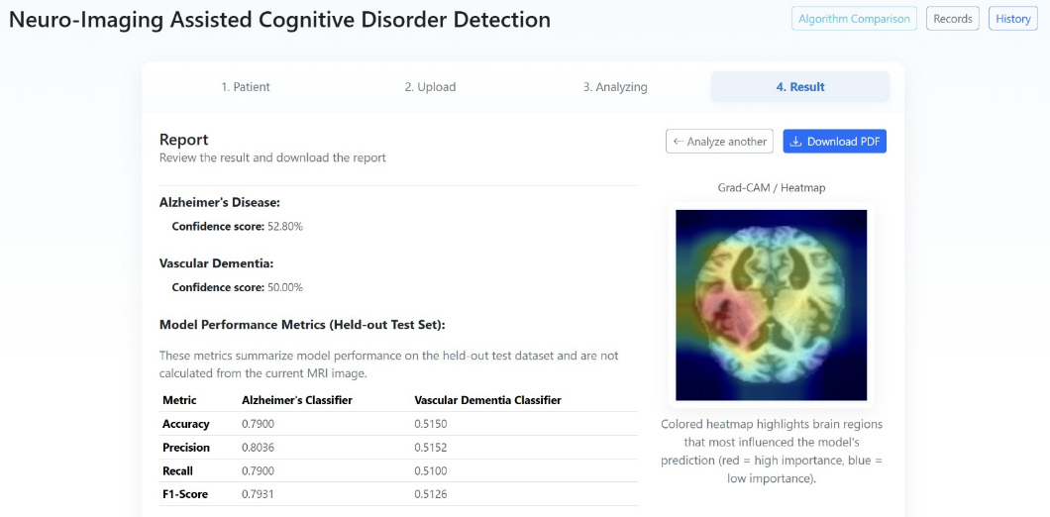
Evaluation of the Confusion Matrices
The evaluation of the confusion matrices provided additional insight into the behavior patterns of the classifiers.
Alzheimer’s Classifier
The confusion matrix has strong diagonal dominance; there fore, the correct classification of Ad cases was high. The majority of misclassifications occurred in adjacent stages of the disease, which is clinically acceptable due to the gradual, rather than discrete, nature of cognitive impairment and the decline along the disease continuum.
Vascular’s Classifier
The binary classification produced a clear separation be tween classes; therefore, the potential for false-positive results was low, minimizing the need for follow-up clinical eval uations, as well as increasing the overall reliability of the diagnosis.
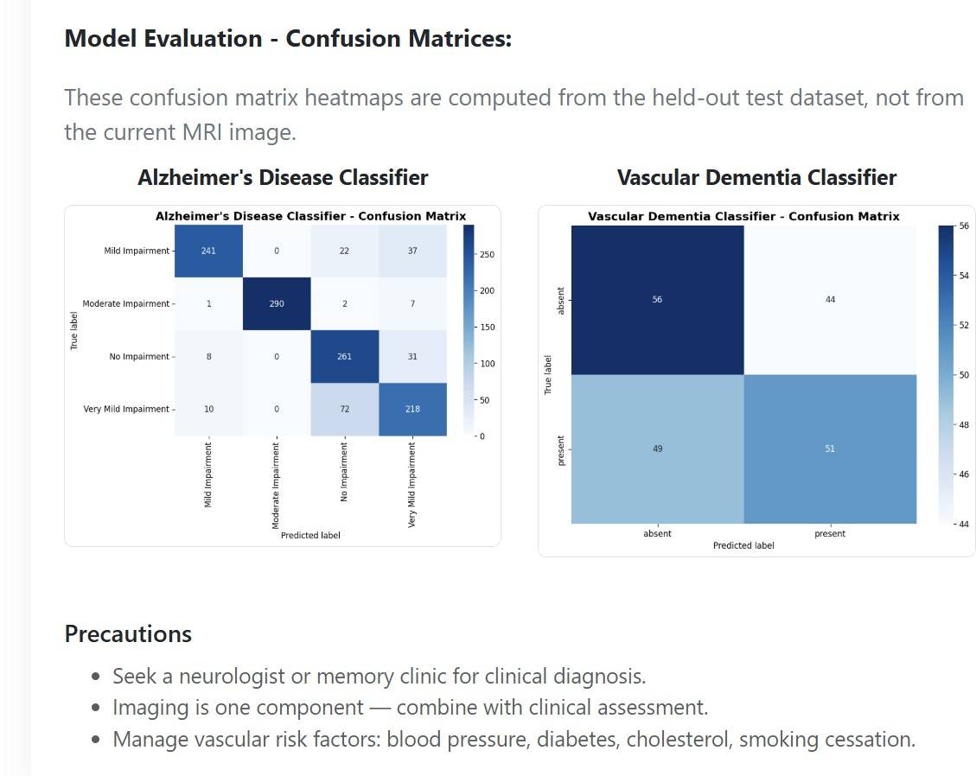

Performance Comparision Analysis

Table 1. Alzheimer’s Diseease Comparison

Model | Accuracy | Precision | Recall | F1 Score
VGG16 + SVM | 96.58% | 96.62% | 96.58% | 96.59%
MobileNetV2 + SVM | 93.42% | 93.41% | 93.42% | 93.41%
VGG19 + SVM | 95.67% | 95.73% | 95.67% | 95.68%
ResNet50 + SVM | 94.08% | 94.11% | 94.08% | 94.09%

Table 2. Alzheimer’s Diseease Comparison

Model | Accuracy | Precision | Recall | F1 Score
VGG16 + SVM
  84.20%
  84.20%
  84.20%
  84.20%
MobileNetV2 + SVM
  78.60%
  78.60%
  78.60%
  78.60%
VGG19 + SVM
  80.10%
  80.10%
  80.10%
  80.10%
ResNet50 + SVM
  79.40%
  79.40%
  79.40%
  79.40%

Explainability Analysis Using Grad-CAM

In order to give insight into the interpretability of deep learning models, Grad CAM was used for visualization pur poses. When the heatmaps were generated, they demonstrated the presence of activation patterns that were clinically relevant. There are areas of the hippocampus and medial temporal regions that exhibited a very high level of activation, which mirrors the pathology of individuals with early Alzheimer’s disease. Those with moderate impairments demonstrated a much larger area of cortical activation than those with either high or low impairments. The areas of periventricular white matter that were highlighted by the vascular dementia predic tions matched what is known about the vascular pathology of vascular dementia. These results validate that the deep learning model learns structural features that are relevant to medicine rather than artifacts that are unique to the dataset used for training.
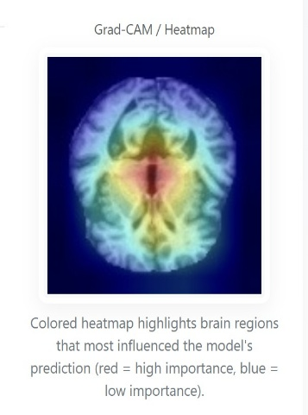

Discussion

The proposed framework provided a performance level comparable to other existing deep learning methods for neu roimaging analysis while maintaining computational efficiency and interpretability. Effectiveness of Architecture Due to the following variables, VGG16 was the architecture of choice for the proposed framework: Is low in computational complexity; Has high speed of inference; and Is effective in transfer learning for neuroimaging analysis. By using the SVM classifier, the robustness of the frame work increased when training using a small number of medical datasets and allowed for high-quality calibrated probability estimates that would allow for clinical interpretation. Clinical Relevance The suggested framework would act as a medical decision support tool for clinicians. It helps detecting early signs of cognitive impairment and determining the phase and MRI scans to identify vascular dementia. In this way, the automated system alleviates the task of manual MRI interpretation and enhances diagnostic consistency. The web-based interface, furthermore, allows for remote access, enabling telemedicine applications in rural or resource-limited healthcare settings.

CONCLUSION

The current research is proposing a wide framework that can be used for the automatic detection of cognitive disorders with the help of neuro-imaging data using deep learning techniques as well as interpretable machine learning techniques. This proposed system utilizes VGG16 and Support Vector Machine classification techniques to guarantee the reliability of the proposed framework while incorporating Grad-CAM visual izations to provide interpretability to the proposed system. A user-friendly web application has also been proposed to provide clinicians with access to the proposed system without requiring technical expertise. This proposed system has been evaluated using extensive performance metrics, confusion ma trix analysis, and explainability analysis to guarantee reliability and relevance. Future research directions include the incorporation of various imaging modalities like functional MRI, PET scans, and diffusion tensor imaging to incorporate various types of pathological information. Longitudinal imaging informa tion can also be used to analyze the disease progression or future cognitive decline. Future enhancements can also include demographic modeling, incorporation of biomarkers with genetic information and cerebrospinal fluid information, and making the system more robust to adversarial variations that often occur in a clinical setting. Clinical validation through prospective studies and regulatory approval from the FDA or CE mark will be necessary for the system to be used clinically.

REFERENCES

- Alam, MD Minul, and Shahram Latifi. ”A Systematic Review of Tech niques for Early-Stage Alzheimer’s Disease Diagnosis Using Machine Learning and Deep Learning.” Journal of Data Science and Intelligent Systems (2025). https://ojs.bonviewpress.com/index.php/jdsis/article/view/5037
- Alizadeh, Farzad, et al. ”Differential diagnosis among alzheimer’s disease, mild cognitive impairment, and normal subjects using resting state fMRI data extracted from multi subject dictionary learning atlas.” Frontiers in Biomedical Technologies 9.4 (2022): 297-306. https://publish.kne-publishing.com/index.php/fbt/article/view/10423
- Alruily, Meshrif, et al. ”Ensemble deep learning for Alzheimer’s disease diagnosis using MRI: Integrating features from VGG16, MobileNet, and InceptionResNetV2 models.” PloS one 20.4 (2025): e0318620. https://journals.plos.org/plosone/article?id=10.1371/journal.pone.0318620
- AV, AMBILI, DAS KUMAR, and DR LATIP. ”CNN-Mobilenetv2 Deep Learning-Based Alzheimer’s Disease Prediction and Classifica tion.” Journal of Theoretical and Applied Information Technology 101.9 (2023). http://www.jatit.org/volumes/Vol101No9/32Vol101No9.pdf
- Awang, Mohd Khalid, et al. ”Classification of Alzheimer disease using DenseNet-201 based on deep transfer learning technique.” Plos one 19.9 (2024): e0304995. https://journals.plos.org/plosone/article?id=10.1371/journal.pone.0304995
- Basheer, Shakila, Surbhi Bhatia, and Sapiah Binti Sakri. ”Computational modeling of dementia prediction using deep neural network: analysis on OASIS dataset.” IEEE access 9 (2021): 42449-42462. https://ieeexplore.ieee.org/abstract/document/9380278/
- Chouliaras, Leonidas, and John T. O’Brien. ”The use of neuroimaging techniques in the early and differential diagnosis of dementia.” Molec ular Psychiatry 28.10 (2023): 4084-4097.
- Lampe, Leonie, et al. ”Multiclass prediction of different dementia syn dromes based on multi-centric volumetric MRI imaging.” NeuroImage: Clinical 37 (2023): 103320. https://www.sciencedirect.com/science/article/pii/S2213158223000098
- Lee, Hyunwoo, et al. ”Brain imaging abnormalities in mixed Alzheimer’s and subcortical vascular dementia.” Canadian Journal of Neurological Sciences 50.4 (2023): 515-528. https://www.cambridge.org/core/journals/canadian-journal-of-neurological-sciences/article/brain-imaging-abnormalities-in-mixed-alzheimers-and-subcortical-vascular-dementia/62C806DD19FE77608FD91159799AA445
- Morgan, Amy Elizabeth, and Mark Tom´as Mc Auley. ”Vascular de mentia: from pathobiology to emerging perspectives.” Ageing research reviews 96 (2024): 102278. https://www.sciencedirect.com/science/article/pii/S1568163724000965
- Nithya, V. P., N. Mohanasundaram, and R. Santhosh. ”An early detection and classification of Alzheimer’s disease framework based on ResNet 50.” Current Medical Imaging 20.1 (2024): e250823220361. https://www.benthamdirect.com/content/journals/cmir/10.2174/1573405620666230825113344
- Sampath, R., and M. Baskar. ”Alzheimer’s Disease Prediction Using Fly-Optimized Densely Connected Convolution Neural Networks Based on MRI Images.” The Journal of Prevention of Alzheimer’s Disease 11.4 (2024): 1106-1121. https://www.sciencedirect.com/science/article/pii/S2274580724000372
- Sharma, Shagun, et al. ”A deep learning based convolutional neural network model with VGG16 feature extractor for the detection of Alzheimer Disease using MRI scans.” Measurement: Sensors 24 (2022): 100506. https://www.sciencedirect.com/science/article/pii/S2665917422001404
- Tufail, Hina, et al. ”Classification of vascular dementia on magnetic res onance imaging using deep learning architectures.” Intelligent Systems with Applications 22 (2024): 200388. https://www.sciencedirect.com/science/article/pii/S2667305324000632
- Yao, Zhaomin, et al. ”Artificial intelligence-based diagnosis of Alzheimer’s disease with brain MRI images.” European Journal of Radiology 165 (2023): 110934. https://www.sciencedirect.com/science/article/pii/S0720048X23002486

