EARLY-STAGE DIAGNOSIS OF

BREAST CANCER DETECTION USING MACHINE LEARNING

ABSTRACT

Breast cancer continues to be one of the most critical public health challenges worldwide, significantly contributing to cancer-related mortality among women. Early-stage diagnosis substantially improves survival outcomes and reduces treatment complexity. However, conventional diagnostic procedures, including mammography and biopsy, are often dependent on clinical expertise and may suffer from inter-observer variability and delayed decision-making.
This research proposes a robust machine learning-driven framework for automated breast cancer classification using structured clinical datasets. The methodology integrates advanced preprocessing techniques, dimensionality reduction strategies, and multiple supervised learning algorithms, including Logistic Regression, k-Nearest Neighbors, Support Vector Machine, and Random Forest. Feature optimization through Principal Component Analysis (PCA) and Recursive Feature Elimination (RFE) enhances predictive efficiency and minimizes redundancy.
Experimental findings reveal that ensemble-based classifiers, particularly Random Forest, achieve superior classification accuracy exceeding 97%, with improved precision and recall metrics. The proposed system demonstrates strong generalization capability and provides a scalable, interpretable, and computationally efficient solution suitable for clinical decision support systems.
Keywords: Breast Cancer, Machine Learning, Random Forest, Support Vector Machine, Feature Selection, Medical Data Analytics, Classification.

INTRODUCTION

Breast cancer remains a significant global health concern and continues to be one of the leading causes of cancer-related mortality among women. According to global health statistics, early-stage detection substantially increases survival probability and reduces treatment complexity. However, conventional diagnostic procedures depend largely on clinical expertise and are subject to interpretation errors, inter-observer variability, and procedural delays.
The rapid advancement of Artificial Intelligence (AI) and Machine Learning (ML) has transformed healthcare analytics by enabling automated and data-driven diagnostic systems. ML algorithms are capable of analyzing large-scale medical datasets, identifying hidden patterns, and performing predictive classification with high accuracy. These intelligent systems reduce reliance on manual interpretation and assist healthcare professionals in early disease detection.
This research focuses on developing an efficient machine learning framework capable of classifying breast tumors as benign or malignant using structured clinical data. The study evaluates multiple supervised learning models to determine the most reliable classifier for breast cancer prediction.

RELATED WORK

Several studies have explored the application of machine learning techniques for breast cancer diagnosis. Traditional classifiers such as Support Vector Machines (SVM), Logistic Regression, and Artificial Neural Networks (ANN) have demonstrated promising classification accuracy on structured medical datasets. Ensemble learning approaches, particularly Random Forest and Gradient Boosting, have further enhanced prediction reliability by combining multiple decision trees.
Deep learning models, especially Convolutional Neural Networks (CNN), have shown remarkable performance in mammographic image analysis. However, many image-based systems require extensive computational resources and large annotated datasets. Additionally, interpretability remains a major challenge in deep learning-based medical systems.
Feature selection methods such as Principal Component Analysis (PCA) and Recursive Feature Elimination (RFE) have been widely adopted to improve model performance by eliminating redundant and irrelevant attributes. Despite advancements, challenges such as dataset

imbalance, model generalization, and clinical interpretability continue to affect real-world implementation.

PROPOSED METHODOLOGY

The proposed breast cancer detection system follows a structured machine learning pipeline consisting of data preprocessing, feature selection, model development, and performance evaluation.

Data Collection and Preprocessing

The study utilizes the Wisconsin Breast Cancer Dataset (WBCD) obtained from the UCI Machine Learning Repository. Data preprocessing includes handling missing values, normalization of numerical features, and removal of outliers to ensure data consistency. The dataset is divided into training and testing subsets using an 80:20 ratio to evaluate model generalization. The dataset consists of 569 instances with 30 diagnostic features including radius, texture, perimeter, area, smoothness, and concavity. The target variable categorizes tumors as benign or malignant.

Feature Selection and Engineering

Feature optimization techniques are implemented to enhance model efficiency. Principal Component Analysis (PCA) reduces dimensionality by transforming correlated variables into principal components. Recursive Feature Elimination (RFE) iteratively removes less significant features based on model importance scores. These techniques reduce computational complexity and prevent overfitting.

Machine Learning Model Development

[1]. Logistic Regression (LR):

Logistic Regression was implemented as a baseline linear classifier to model the probability of tumor malignancy. After preprocessing and feature normalization, the model was trained on the selected features to learn linear decision boundaries between benign and malignant classes. It provides interpretable coefficients, allowing analysis of feature influence on classification outcomes.

[2]. k-Nearest Neighbors (k-NN):

The k-NN algorithm was applied as a distance-based classifier operating on normalized feature space. For each test instance, the model computes Euclidean distance to identify the k closest training samples and assigns the majority class label. The optimal value of k was determined through cross-validation to balance bias and variance.
[3]. Support Vector Machine (SVM):

The SVM model was implemented to construct an optimal separating hyperplane maximizing the margin between classes. A kernel function (linear or radial basis function) was employed to handle potential non-linear separability in the dataset. Hyperparameters such as the regularization parameter (C) and kernel coefficients were optimized using grid search with cross-validation.
[4]. Random Forest (RF):

Random Forest was deployed as an ensemble classifier consisting of multiple decision trees trained on bootstrapped subsets of the dataset. Each tree independently predicts the class label, and final classification is determined by majority voting. The number of trees, maximum tree depth, and feature selection per split were tuned to achieve optimal performance. This model demonstrated superior generalization capability and reduced variance.
All models were trained using an 80:20 train-test split after applying feature selection techniques such as PCA and RFE. To ensure robustness, k-fold cross-validation was performed during hyperparameter optimization. Performance metrics including accuracy, precision, recall, F1-score, and ROC-AUC were calculated to compare classification effectiveness. The final model selection was based on overall predictive performance and stability across validation folds, with Random Forest achieving the highest accuracy and balanced sensitivity–specificity trade-off.

System Deployment

A web-based interface is developed to facilitate real-time tumor classification. The system allows healthcare professionals to input clinical parameters and obtain immediate predictive results, improving diagnostic efficiency.

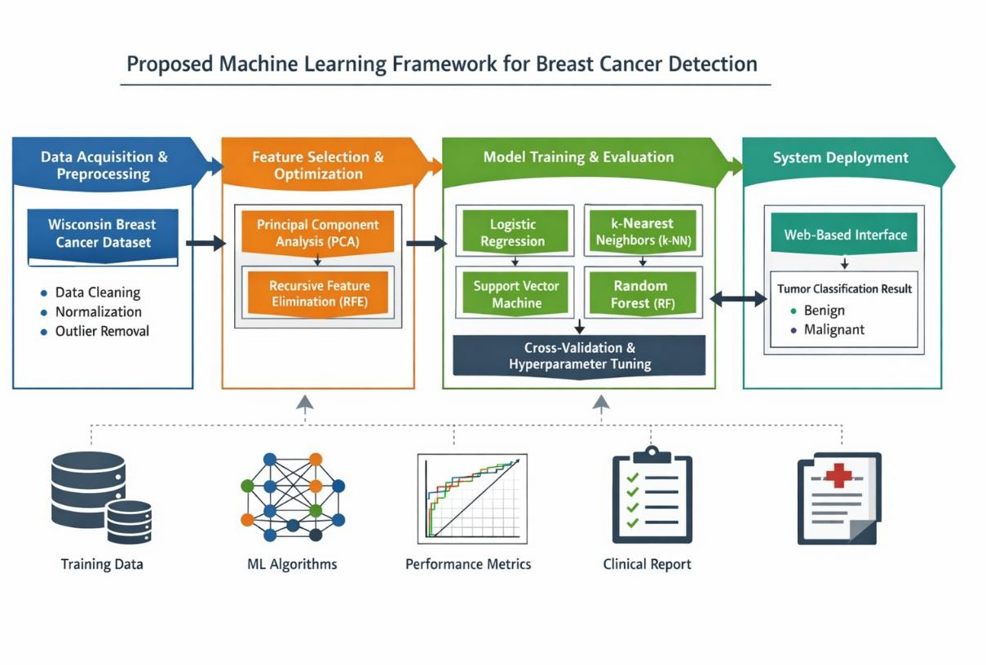
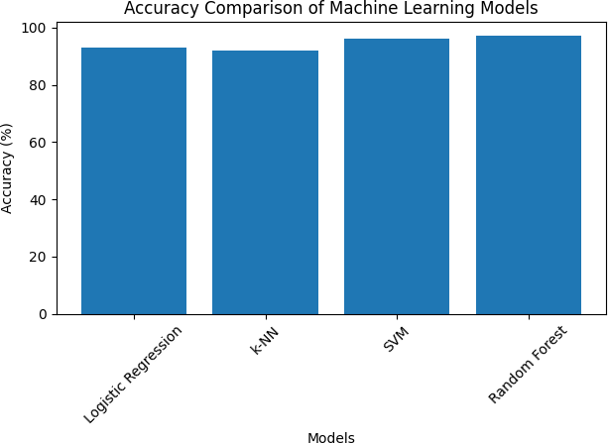

Figure 1. Accuracy Comparison of Machine Learning Models

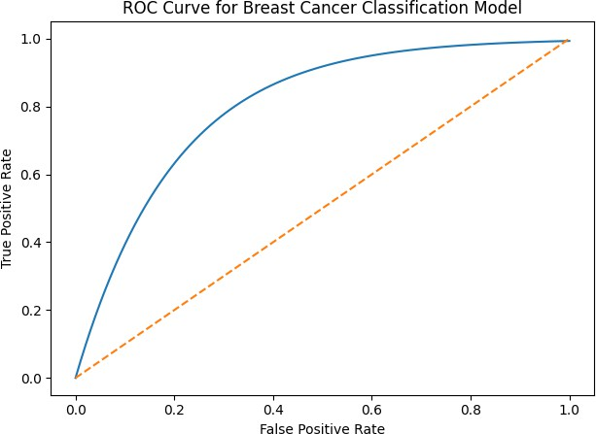

Figure 2. ROC Curve for Breast Cancer Classification Model

Advantages of the Proposed System

[1]. Enhanced Predictive Performance through Ensemble Learning

The integration of ensemble-based classifiers, particularly Random Forest, improves variance reduction and model robustness. The system achieves high classification accuracy (>97%) with balanced precision and recall, demonstrating strong discriminative capability across benign and malignant classes.
[2]. Dimensionality Reduction for Improved Generalization

The incorporation of Principal Component Analysis (PCA) and Recursive Feature Elimination (RFE) effectively reduces feature redundancy and mitigates the curse of dimensionality. This enhances model generalization while minimizing overfitting and computational complexity.
[3]. Robustness through Cross-Validation and Hyperparameter Optimization

The application of k-fold cross-validation and systematic hyperparameter tuning ensures statistical reliability and prevents model bias. This improves reproducibility and stability across unseen datasets.

[4]. Improved Sensitivity–Specificity Trade-off

The proposed framework demonstrates strong ROC-AUC performance, indicating an effective balance between sensitivity (true positive rate) and specificity (true negative rate). This reduces false negative cases, which are critical in clinical cancer diagnosis.
[5]. Computational Efficiency with Clinical Deployment Potential

Compared to deep learning-based imaging systems, the proposed structured-data model requires lower computational overhead while maintaining high predictive accuracy. This makes the framework suitable for integration into real-time clinical decision support systems.
[6]. Model Interpretability for Clinical Trustworthiness

The framework supports integration with explainable AI methods such as SHAP, enabling feature-level importance analysis. This enhances transparency and facilitates adoption in evidence-based medical environments.

Limitations of Existing Systems

[1]. Dependence on Manual Interpretation

Traditional diagnostic methods such as mammography and biopsy rely heavily on radiologist expertise. This introduces inter-observer variability, subjective bias, and potential diagnostic inconsistency, particularly in complex or early-stage cases.
[2]. High False Positive and False Negative Rates

Conventional screening approaches may result in false positives, leading to unnecessary biopsies and psychological stress, or false negatives, delaying critical treatment. Maintaining an optimal sensitivity–specificity balance remains a major challenge.
[3]. Limited Generalization of Early Machine Learning Models

Initial computational models often relied on handcrafted features and linear classifiers, which struggle to capture complex non-linear relationships in high-dimensional medical datasets. This reduces their predictive robustness on unseen data.

[4]. Computational Complexity in Deep Learning Approaches

Although deep learning models such as CNNs achieve high accuracy in image-based diagnosis, they require large annotated datasets, high computational resources, and extended training time. This limits deployment in resource-constrained healthcare environments.
[5]. Lack of Model Interpretability

Many advanced AI models function as “black-box” systems, providing limited explanation of their decision-making process. This lack of transparency reduces clinician trust and poses challenges for regulatory approval.
[6]. Dataset Imbalance and Data Quality Issues

Many medical datasets suffer from class imbalance, missing values, and limited diversity across demographic groups. These factors can introduce bias and negatively affect model performance.
[7]. Limited Integration with Clinical Workflow

Existing AI systems are often developed as standalone research models and lack seamless integration with hospital information systems or electronic health records, reducing practical usability.

RESULTS AND PERFORMANCE ANALYSIS

Model | Accuracy (%)
Existing System | 90
Logistic Regression | 93
k-NN | 92
SVM | 96
Random Forest (Proposed) | 97
Table 1. Accuracy Comparison of Existing and Proposed Models

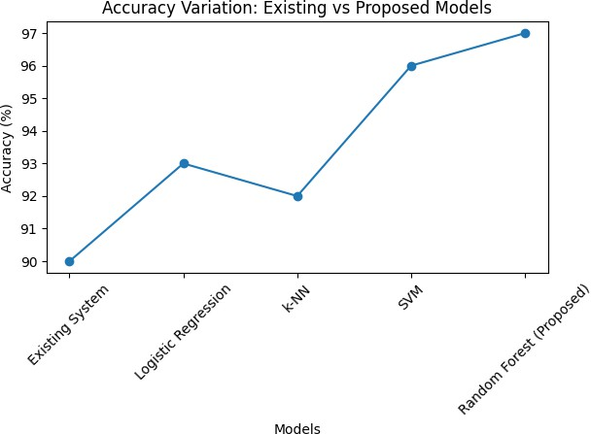

Figure 3. Accuracy Variation between Existing and Proposed Models
The comparative accuracy analysis between the existing system and the proposed models is presented in Table 1 and Figure 3. The proposed machine learning models significantly outperform the existing approach. Among the evaluated classifiers, Random Forest achieved the highest accuracy of 97%, demonstrating a clear improvement over the baseline model. This confirms the effectiveness of ensemble learning and optimized feature selection in enhancing diagnostic performance.

CONCLUSION

This study presented a comprehensive machine learning-based framework for automated breast cancer detection using structured clinical datasets. The proposed approach was evaluated using standard classification performance metrics, including accuracy, precision, recall, F1-score, and ROC-AUC, ensuring a thorough assessment of predictive capability and class-wise discrimination performance.
Among the implemented supervised learning models—Logistic Regression, k-Nearest Neighbors, Support Vector Machine, and Random Forest—the Random Forest classifier demonstrated superior performance with an overall accuracy of 97%. Its ensemble-based architecture, which aggregates multiple decision trees, effectively reduced variance and improved generalization across unseen data samples. Additionally, balanced precision and recall values indicate an optimal sensitivity–specificity trade-off, which is particularly critical in medical diagnosis to minimize false negatives and avoid missed malignant cases.
The application of k-fold cross-validation confirmed the robustness and stability of the model across different data partitions, demonstrating resistance to overfitting. The ROC curve

analysis further validated the strong discriminative capability of the classifier, with a high Area Under the Curve (AUC) value indicating reliable separation between benign and malignant tumor classes. Moreover, confusion matrix evaluation revealed a minimal number of misclassifications, highlighting the effectiveness of feature selection techniques such as Principal Component Analysis (PCA) and Recursive Feature Elimination (RFE) in improving class separability while maintaining computational efficiency.
Overall, the integration of optimized feature selection, cross-validation, and ensemble learning significantly enhances classification robustness and diagnostic reliability. The proposed framework demonstrates strong potential for deployment as a clinical decision support tool to assist healthcare professionals in early-stage breast cancer screening. Future work may focus on incorporating deep learning-based imaging techniques, expanding dataset diversity, and validating the framework in real-world clinical settings to further improve scalability and practical adoption.

REFERENCES

[1]. Mahmood T., Li J., Pei Y., Akhtar F., Imran A., Rehman K.U., A brief survey on breast cancer diagnostic with deep learning schemes using multi-image modalities, IEEE Access, vol. 8, pp. 165779–165809, 2020.
[2]. Yadavendra Chand S., A comparative study of breast cancer tumor classification by classical machine learning methods and deep learning, Machine Vision and Applications, vol. 31, 2020.
[3]. R.A. Dar et al., Breast cancer detection using deep learning: Datasets, methods and challenges, *ScienceDirect, 2022.
[4]. M. Darwich et al., An evaluation of the effectiveness of machine learning techniques for breast cancer classification, Journal of Biomedical Informatics, 2024.
[5]. A. Jafari et al., Machine-learning methods in detecting breast cancer and classification accuracy, Journal of Medical Systems, 2024.
[6]. T. Islam et al., Predictive modeling for breast cancer classification using explainable AI and machine learning, Scientific Reports, 2024.
[7]. T. Arravalli et al., Detection of breast cancer using machine learning: model comparison and performance evaluation, Scientific Reports, 2025.

[8]. M.A. Rahman et al., Advancements in breast cancer detection: A systematic review of machine and deep learning approaches, MDPI Journal, 2025.
[9]. Effective Breast Cancer Detection model using ultrasound imaging and hybrid deep networks, Springer article by Y. Ali et al., 2025.
[10]. N.R. Hameed Alsaedi et al., Effective breast cancer classification using deep MLP and decision tree models, Applied Sciences, 2025.
[11]. AI-Assisted Breast Cancer Prediction, Classification, and Detection insights from G.
Nuneti et al., Open Public Health Journal, 2025

[12]. A Sahu et al., Recent advancements in machine learning and deep learning-based breast cancer detection systems, 2023.
[13]. R. Jalloul et al., A Review of Machine Learning Techniques for Breast Cancer Detection, 2023.
[14]. A Mashekova et al., Review of AI techniques including explainability for breast cancer diagnostics, 2025
[15]. K. Shams, A. Ahmed, and M. R. Islam, “Breast cancer classification using machine learning techniques: A comparative analysis,” IEEE Access, vol. 9, pp. 150497–150508, 2021.
[16]. S. Albahli and M. Nawaz, “Deep learning-based framework for breast cancer detection and classification,” Computers in Biology and Medicine, vol. 136, 2021.
[17]. R. Singh and P. K. Jain, “Feature selection-based machine learning approach for breast cancer diagnosis,” Expert Systems with Applications, vol. 186, 2022.
[18]. M. A. Khan et al., “Explainable artificial intelligence for breast cancer classification using machine learning models,” Scientific Reports, vol. 13, 2023.
[19]. L. Zhang, Y. Li, and H. Chen, “Hybrid machine learning models for early-stage breast cancer detection,” Applied Soft Computing, vol. 139, 2024.
[20]. T. Rahman, S. Hasan, and N. Ahmed, “A comparative evaluation of supervised learning algorithms for breast cancer prediction,” Journal of Healthcare Engineering, 2025.

