Smart Boiler Monitoring System for Co-Generation Plant in Sugar Industry

Abstract: In India sugarcane is a valuable crop that contributes specifically to chemical synthesis, energy production and refueling. Sugar mills use bagasse, a waste product to make energy and ethanol. Bagasse is a sugarcane factory’s energy – rich byproduct that has substantial, commercial and technological promise for producing grid power. Co- generation is the process of producing two distinct forms of energy from a single source. In sugar mills the power is generated in co-generation plant using bagasse as a fuel. For generating power steam turbines are rotated by steam and electrical energy is created from mechanical energy. To rotate the turbines, boiler is the primary source of steam. In this study, boiler was monitored remotely. Thermocouple and pressure sensors were used to detect the steam's pressure and temperature. PIC 16F877A was the processing unit and ESP 8266 Wi-Fi module was used for remotely sharing of data on Thing Speak channel. User on remote access easily monitor the boiler. Thing Speak channel shows the results of temperature and pressure.
Keywords: Co-generation, thermocouple, steam-turbine, ESP 8266, Thing Speak.
1. INTRODUCTION
The sugar industry is among the biggest in the world, with the country being the second-biggest sugar manufacturer globally, following only Brazil. India's sugar industry contributes significantly to the agricultural sector and the economy as a whole [1]. India's sugar industry is primarily based on sugarcane cultivation. Sugarcane is grown in various states across the country, with Uttar Pradesh, Maharashtra, Karnataka, Tamil Nadu, Gujarat, Andhra Pradesh, Telangana, Bihar, and Haryana being the principal states that produce sugarcane [2]. Uttar Pradesh and Maharashtra are the top two states in terms of sugarcane production and sugar mills. The sugar industry has a major impact in the economy of many countries, including India [1,3]. The sugar industry makes a substantial contribution to the gross domestic product (GDP) of the country. This includes the value generated by sugarcane cultivation, sugar production and the sale of byproducts, including molasses and ethanol. The revenue created by the sugar industry also contributes to government taxes and revenues [4,9].
Sugar mills often utilize bagasse, a byproduct of the processing of sugarcane, as a fuel for cogeneration of electricity. This helps in meeting the energy needs of the sugar processing plants and can also generate surplus electricity that can be supplied to the grid or used for other industrial purposes [5]. Fig. 1 depicts the power generation system in sugar industry.
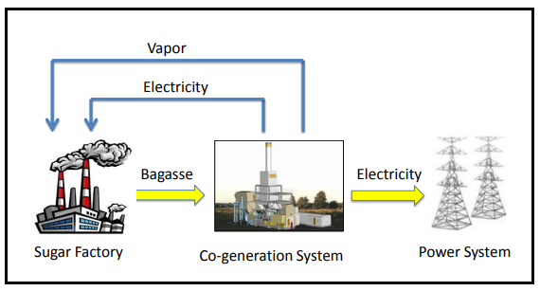
Fig. 1 Power generation in sugar industry
In the sugar industry, a cogeneration plant, often called an establishment also known as a combined heat and power (CHP) plant uses bagasse, a by-product of processing sugarcane to simultaneously produce electricity and useable heat [6].

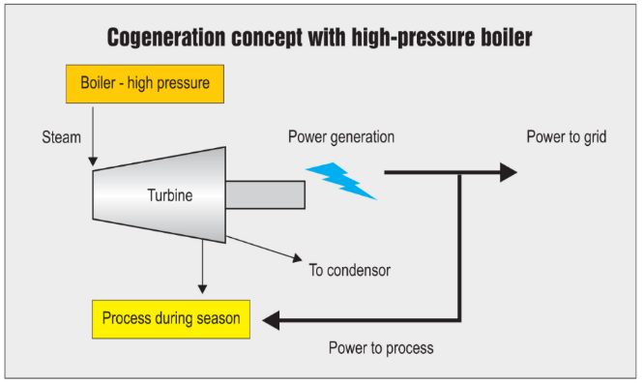
Fig. 2 Working of Cogeneration Plant
The working of a cogeneration plant, also known as a combined heat and power (CHP) plant, entails using a single fuel source to simultaneously produce heat and useful electric power. [4]. Working of cogeneration plant is shown in fig. 2.
1.Fuel Input: Depending on the particular plant layout and availability, the cogeneration facility usually uses one primary fuel source. Natural gas, coal, biomass (such as bagasse or wood chips), and waste heat from industrial operations are examples of common fuel sources.
2.Combustion or Heat Source: In a boiler, furnace, or other heat source, the fuel is burned or produces heat in another way. A by-product of processing sugarcane, bagasse is frequently utilized as the main fuel in biomass-based cogeneration units used in the sugar trade.
3.Steam Generation: High pressure steam is generated using the heat produced during combustion. The usual method of producing this steam in boilers is by transferring heat to water, which causes it to boil and produce high-pressure steam [7].
4.Turbine operation: An electric generator is linked to a turbine that is powered by the high-pressure steam. The steam releases its energy and loses pressure as it expands through the turbine blades, spinning the turbine rotor.
5.Electricity Generation: Using the principle of electromagnetic induction, the rotating turbine rotor rotates the generator rotor inside an electromagnetic field to produce energy.
6.Heat Recovery: Cogeneration plants gather and employ the heat produced during combustion in addition to producing electricity.
7.Useful heat utilization: Within the plant or other surrounding facilities, the recovered heat energy is used for a variety of industrial processes or heating applications.
8.Energy distribution: The useful heat and power produced is transmitted as needed, either within the cogeneration facility for internal use or via localized distribution systems or the grid to neighbouring business, industrial, and residential areas [5].

1.2 SIGNIFICANCE OF THE RESEARCH
Temperature and boiler pressure have a significant impact on a cogeneration plant's overall performance, safety, and efficiency.
Steam generating efficiency: The energy content of the steam produced in the boiler is directly influenced by its temperature and pressure. Greater energy density in the steam produced by higher pressures and temperatures leads to more effective energy conversion in the steam turbine. Because of this improved efficiency, the cogeneration plant's total efficiency is raised since more electricity may be produced for a given quantity of fuel input.
Electricity generation: An electric generator is linked to a steam turbine, which is powered by steam produced in the boiler. Greater steam volumes and velocities from increasing boiler pressures and temperatures lead to an increase in the turbine's rotational speed and power production. Therefore, keeping the boiler's pressure and temperature at their ideal levels ensures that enough power will be produced to either meet the plant's need or supply excess electricity to the grid.
Heat Recovery: Cogeneration plants recover and use the thermal energy from the steam produced in the boiler in addition to producing electricity. The amount and quality of heat that is available for different industrial processes or heating applications depends on the pressure and temperature of the steam that is exiting the boiler. Cogeneration plants can improve their total energy efficiency by optimizing heat recovery and usage by adjusting these factors.
Safety Considerations: Maintaining the cogeneration plants and its employees' safety depends on operating boilers within predetermined pressure and temperature limits. Overly high pressures or temperatures can cause boiler problems, steam leaks, or even catastrophic failures, which put plant operations and worker safety at high risk. Consequently, it is crucial to monitor the boiler temperature and pressure within safe operating limits in order to avoid problems and assure plant dependability.
Regulatory Compliance: Regulations and emissions rules, which frequently include specifications for boiler performance and operation, must be followed by cogeneration plants. Ensuring compliance with environmental standards can be facilitated by maintaining ideal pressure and temperature settings, as this can reduce emissions related to combustion processes, including particulate matter and nitrogen oxides (NOx).
Energy Integration: The boiler's outlet pressure and temperature have an impact on the steam's suitability for use in downstream equipment and processes, including industrial heaters, heat exchangers, and steam turbines. Cogeneration facilities can maximize overall plant performance and efficiency by optimizing energy integration and ensuring seamless operation across multiple system components by regulating boiler settings [6,7,8].
In the conclusion, boiler temperature and pressure are crucial to a cogeneration plant's overall performance, safety, efficiency, and compliance with regulations. In order to achieve a sustainable and economical functioning of the plant, it is essential to maintain optimal conditions within the boiler. In cogeneration plants in the sugar sector, smart boiler monitoring systems are crucial for this reason.

2. LITERATURE SURVEY
Tarwaji Warsokusumo and et.al. [10] proposed internet surveillance in real time to keep the power generation system's energy-effective performance. This research revealed a methodology for tracking the power generation system's energy performance. Making use of online monitoring in real time, the primary operator is able to immediately carry out navigation and maintain one measure of energy efficiency is the Net Plant Heat Rate. This work established real-time online performance monitoring indicator measures to raise the power generation systems' energy efficiency.
Jakrit Upakool and Prapita Thanarak [11] described CO₂ emissions and energy efficiency from cogeneration power plants are tracked and evaluated. Through a survey in the sugar processing business, this study determined the standard parameters to monitor and regulate the operation of cogeneration facilities, notably biomass cogeneration plants. In order to optimise the power plant's overall performance, the study established metrics that are utilized to track and regulate a variety of plant operating variables, including operating pressures, temperatures, and steam production flow rates.
Xuehua Zhang and Jeremy Schreifels [12] focused Enhancing SO2 emission measurement through systems for continuously monitoring emissions at Chinese power resources. The report offers a summary of research conducted by the Utilizing the open-source machine learning package Keras and the open-source programming languages Python and R, the prediction Emissions Monitoring System (PEMS) creates prediction models for NOx emissions from a natural gas-fired cogeneration unit.
Isabel M. Moreno-Garcia and et.al. [13] explained A utility-scale photovoltaic power plant's real-time monitoring system. This introduces PV-on time, a system designed to monitor a Grid-Linked Utility-Scale Photovoltaic Power Plant’s operating mode to guarantee supply continuity and dependability. A new system has been put in place and configured to accomplish the thorough and in-depth supervision of every part of a utility-level photovoltaic power plant that is linked with the grid. The system tracks the production at designated locations dispersed across the vicinity of a photovoltaic plant by adding more sensors—both programmable controllers and wired and wireless systems.
Lingkai Zhu and et.al. [14] proposed, Building an online monitoring system for Shandong Energy Grid's self-supplied power plants. The creation of a Self-contained power plants with a web-based surveillance system is suggested. This system would enable automated data collection, standardise functioning and systematic development of self-supplied power plants, as well as the provision of quantitative and scientific monitoring instruments and realise online energy generation and consumption monitoring as well as online power generation and consumption analysis behaviour features.
Lu, X. and et.al.[15] developed a WSN-based platform for real-time energy tracking in workplaces. To facilitate sustainable, energy-effective production in a hierarchical network-based industrial workshop, this research study explains how a remote energy monitoring system is developed, carried out and validated. This system integrates wireless sensor networks (WSNs) using online interaction to create a platform for knowledge and information services.
D. Bhagyalakshmi and et. al. [16] proposed temperature tracking for high-performance computer clusters using WSN technology. The authors of this work described the WSN-based temperature monitoring application's implementation in detail. This network's primary job is to constantly check the temperature within the cluster of 128 high-performance computing nodes to ensure smooth operation. The base station receives the temperature reading from the wireless sensor node.
A. A. Rahmanda and et.al. [17] explained Combustion Control and Monitoring System Optimization in Furnace Boiler Prototype at Industrial Steam Power Plant: A Comparison of Neural Network (NN) and Extreme Learning Machine (ELM) Techniques. This study compares the effectiveness of neural networks and extreme learning machines (ELM) in controlling combustion. The results will be applied to a microcontroller prototype. This prototype controls the flow of fuel oil and air by measuring the smoke and temperature sensor values in the furnace as heat parameter. The type K thermocouple is used as the temperature sensor in this study. MQ sensor is the smoke sensor. Pump and fan oil were also utilised as actuators in this prototype.
3.MATERIALS AND METHODS
3.1 Hardware Designing
In the present research work, the boiler's pressure and temperature is monitored remotely. By using Wi -fi module on ThingSpeak platform. For the present research 36 MW cogeneration power plant is considered and for this plant The boiler should have a temperature of 850⁰C and a pressure of 110 kg/cm². The fig. 3 shows the architecture of the system.
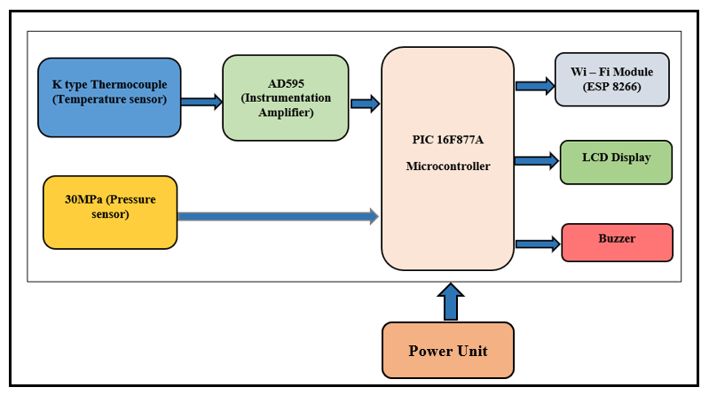
Fig. 3 Architecture of the system
For high temperature and pressure monitoring K type thermocouple (temperature sensor) and 30 MPa pressure sensor is used respectively. At a given temperature, the thermocouple junction generates a particular millivoltage across it. A thermocouple is made up of two junctions that are coupled against each other. The voltage produced by the thermocouple is in millivolts so its need to be amplify to convert into digital. The AD595 is a monolithic device that combines a thermocouple cold junction compensator and an entire instrumentation amplifier. A thermocouple signal is converted into a high level (10 mV/°C) output using a pre-calibrated amplifier and an ice point reference. [18]. AD595 is compatible with K-type thermocouple. Pressure measurement is another task for the monitoring of the co-generation plant. To measure the high pressure for the research work 30 MPa pressure sensor was used. A 30 MPa pressure sensor is designed to measure pressures within the range of 0 to 30 Mpa. This is the analog type pressure sensor. an analog pressure sensor is a sensor that provides a continuous output signal proportional to the pressure applied to it. This pressure sensor provides a voltage output which varies linearly with the applied pressure.
For processing of the data PIC 16F877A microcontroller is used. This microcontroller is quite easy to use, and it's also simpler to code or program. It has inbuilt 10-bit ADC, so there is no need of external ADC. Its ability to write and erase data as often as possible is one of its primary benefits due to the usage of FLASH memory technology. There are 33 pins for input and output out of the total 40 pins. [19]. ESP8266-01 Wi-Fi module was interfaced with PIC 16F877A microcontroller for wireless communication. It consists of total 8 pins such as TX, RX, VCC, GPIO0, GPIO2, RST, GND, CH_PD. Users can take advantage of the ESP8266 AT Commands to carry out tasks such as connection testing, mode setting, Wi-Fi connection establishment, IP address determination, and so. To ensure the digital readout the display section is designed by employing smart LCD. A 16x2 alphanumeric LCD module is preferred over other modules. Two lines of sixteen characters each are displayed on a 16x2 LCD. There are two registers on this LCD: Command and Data. The command instructions recorded in the Command Register and sent to the LCD. An LCD is given instructions to perform specific tasks, such as initializing, cleaning its screen, adjusting the display, and so on. These instructions are known as commands. The information that will be shown on the LCD is kept in the data register. The buzzer circuit is employed to alert the concerned workers that the values of the temperature and pressure of the boiler is beyond the limit. For this purpose, the buzzer is interfaced with PIC microcontroller. Fig. 4 shows the circuit schematic of the system.
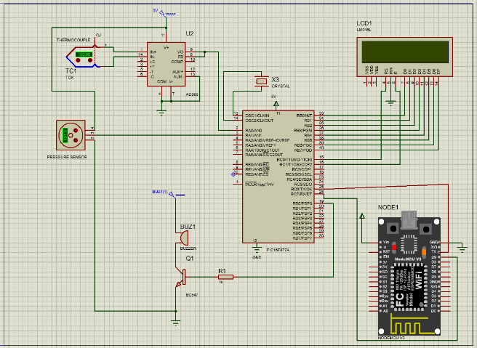
Fig. 4 Circuit schematic of the system
3.2 Firmware Designing
To perform this predefined task, the microcontroller has to play with the real world. For this purpose, embedded software is required. On synchronization of operations of hardware resources, with the help of software, the system ensures the completion of tasks for which it has been defined. Therefore, it is essential to develop firmware. The present system is designed about PIC microcontrollers. Therefore, the software required for present system is designed in embedded ‘C’ environment by using MPLAB IDE. According to embedded philosophy, to process necessary information and to synchronize the operation of on-chip as well as off-chip resources, the firmware is required. Employing MPLAB IDE, the firmware is developed in embedded C environment. The flash of the microcontrollers was programmed by using PICKit 3 programmer. Algorithm of the firmware, the flow of execution is depicted in fig. 5.
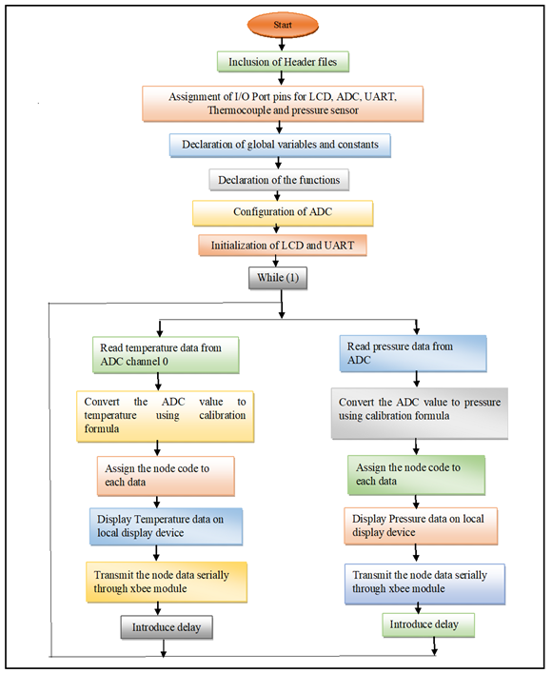
Fig. 5 Flowchart of the system
4. IMPLEMENTATION OF THE SYSTEM
4.1 Calibration
As discussed earlier, the system is designed to monitor the boiler of the cogeneration plant parameters such as temperature and pressure. The system under investigation is developed for monitoring high pressure and high temperature of the boiler in the cogeneration plant. K type thermocouple is used for high temperature measurement. The thermocouple produces analog emf proportional to the temperature. The output of thermocouple is in mV. Therefore, AD 595 instrumentation amplifier is used to amplify the thermocouple output.
The system under investigation is calibrated to the respective unit by employing scientific process. It is known that various method has been suggested by the researchers to calibrate the measuring instruments. However, present system is calibrated to the temperature in degree centigrade wherein continuous range of investigation is ensured. For calibration of the system to the temperature in degree Celsius and pressure in Kg/cm² the method of least square fitting to the straight line is adopted.
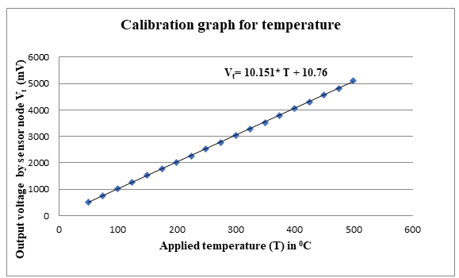
Fig. 6 Calibration graph for temperature
the process of calibrating the AD595 output using the measured data the linear regression method is used to find the calibration coefficients (slope and y-intercept).
Using statistical software, the linear regression performed to find the values of m (slope) and b(y-intercept). Then the regression equation is
V_{t}= 10.151* T + 10.76 …. (1)
From equation 1, the temperature can be expressed as
T = Vt - 10.76 /10.151 …. (2)
This expression is employed in the firmware for the output in ⁰C. on the execution of the firmware the sensor node produces the temperature values of the steam continuously.
The second parameter for which the sensor node is designed is the pressure of the steam. The sensor produces emf proportional to the applied pressure. By adopting the calibration method, the sensor nodes have been designed to produce output, in Kg/cm². The experiment of the calibration of the pressure sensor is performed at automobile shop using the air compressor.
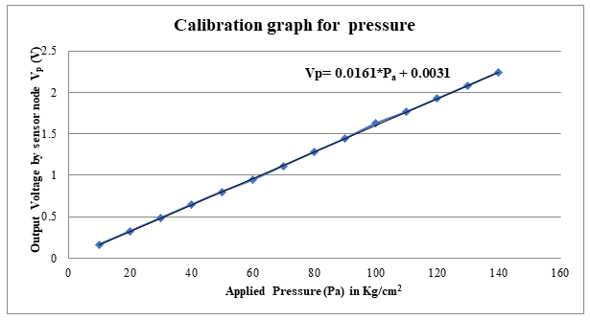
Fig. 7 Calibration graph for pressure
The data recorded is subjected for least square fitting process, which results into an empirical relation given by expression 3

V_{p} = 0.0161*P_{a} + 0.0031 …. (3)
From equation 3, it is found that, the graph shows the slope (16.1mV/Kg/cm²), which can be attributed to the pressure coefficient of the pressure sensor. It is also found that, the system is revealing an offset of about 3.1mV. From equation 3 the pressure can be expressed as
P_{a =} (V_{p} - 3.1)/ 16.1 …. (4)
This expression is employed in the firmware for the output in Kg/cm². on the execution of the firmware the sensor node produces the pressure values of the steam continuously.
The system was implemented in the building where certain obstacles were present. For the implementation, temperature was given to the system by heating torch and pressure is given by oxygen cylinder. An experimental arrangement for measurement of the parameters is depicted in fig. 8.
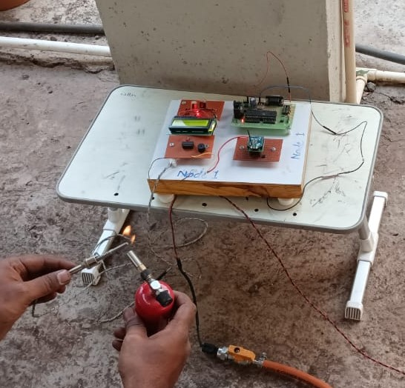
Fig. 8 Implementation of the system
5. RESULT AND DISCUSSION
To achieve the remote monitoring of cogeneration plant parameters ESP8266 Wi-Fi module is interfaced with the microcontroller. For that purpose, ThingSpeak platform is used. For monitoring the data and control the system over the internet ThingSpeak provides a very good tool like channels and web-pages, to analyse and visualize the data and acts by triggering a reaction.
To monitor the status of the temperature and pressure values in the cogeneration sector remotely the ThingSpeak platform was used. An open-source Internet of Things (IoT) platform called ThingSpeak enables the gathering, analysis, and action of data from sensors or devices. Users can create channels to store and analyse their data, and ThingSpeak provides a web interface for visualization and analysis.
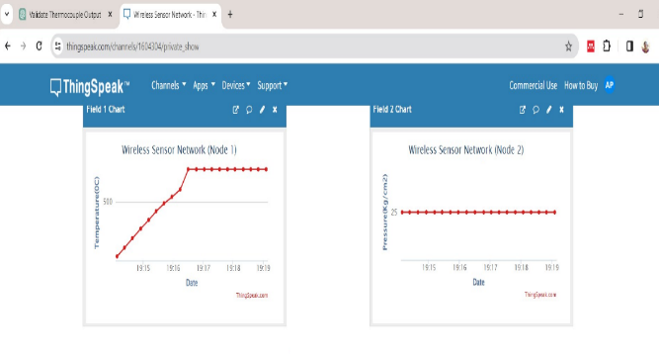
Fig. 9 Result of the system on thingspeak channel
The fig.9 shows the real time values of the temperature and pressure of the implemented system. Total 2 fields were displayed on the ThingSpeak website. The fig. 9 shows live temperature and pressure of the implemented system. Field 1 and filed 2 depicts the temperature and pressure of the system respectively. The temperature varied according to the input of the sensors. Pressure input is constant as the given pressure for the pressure sensor kept constant. The collected information is stored on the ThingSpeak channel. One can download all of this Channel's feeds in CSV format.
The instantaneous values of these parameters were demonstrated and recorded as well. Values of these parameters are plotted against time and presented in fig. 10.
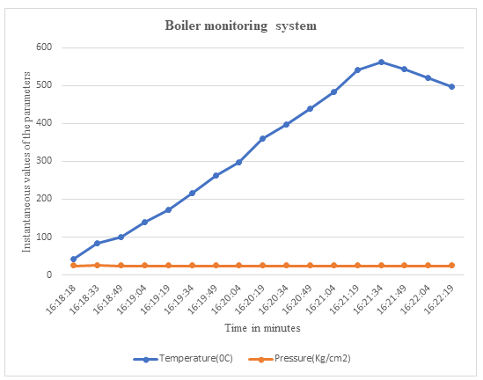
Fig. 10 Instantaneous values of the temperature and pressure
The trend of variations in the parameter values, shown by the system is depicted in fig. 10. Indeed the values of the temperatures at different time are different. As previously described, the values of the pressure are kept constant. From figures it is observed that the variation in the parameters are clearly uploded on the thingspeak channel. Thus, it can be concluded that the system under investigation can be successfully deployed.
6. CONCLUSION
The system under investigation was established providing cogeneration plant environment with the high temperature and pressure inputs to the sensors. An experiment of collection of data was carried out. The ThingSpeak channel successfully updates the data on the channel. The present research deals with the design of simple, low cost, low power real time wireless monitoring system for the cogeneration power plant. The system can be considered as the simple solution integrated into cogeneration system to remote monitoring the steam turbine parameters. Specially the system designed is more suitable when the subsectors of the steam turbine cogeneration plant exceed its limit because it is observed that the variation in temperature and pressure of the steam turbine plant affects into power output of the plant. Also, the system is targeted for remote monitoring of cogeneration parameters that can be monitor by anyone using user id and password of the Thing Speak platform.

ACKNOWLEDGMENT
I would like to acknowledge and give my warmest thanks to the Deccan Education society, Pune and Willingdon College, Sangli for supporting this project.

REFERENCES
[1] https://www.ibef.org/industry/agriculture-india
[2] O. Sahu, “Assessment of sugarcane industry: Suitability for production, consumption, and utilization,” Annals of Agrarian Science, vol. 16, no. 4, pp. 389–395, Dec. 2018.
[3] M. J. B. Kabeyi, O. A. Olanrewaju, “Bagasse Electricity Potential of Conventional Sugarcane Factories,” Journal of Energy, vol. 2023, pp. 1–25, May 2023.
[4] A. Shukla, S. Y. Kumar, “Life Cycle Analysis of Sugar Production Process in Central India,” International Journal of Scientific & Technology Research, vol. 8, no. 11, pp.2347-2350, 2019, Available: www.ijstr.org
[5] C. Dinakaran, S. Purushothama, S.M. Harikrishna, “Study of a Cogeneration Plant in Sugar Mill by using Bagasse as a Fuel,” International Electrical Engineering Journal (IEEJ), vol. 7(2016) No.6, pp. 2226-2240, Available: http://www.ieejournal.com/
[6] S. D. Mane, “Cogeneration in Indian Sugar Industry: A Review,” International Journal of Scientific Engineering and Applied Science (IJSEAS), vol.2, no. 10, pp.30-40, Oct.2016, Available: www.ijseas.com
[7] D. Janghathaikul, S. H. Gheewala, “Bagasse-A Sustainable Energy Resource from Sugar Mills,” Asian Journal on Energy and Environment, vol. 7, no. 03, pp. 356–366, 2006, Available: www.asian-energy-journal.info
[8] S. A. Nebra, M. A. Lozano, L. M. Serra, A. V Ensinas, S. A. Nebra, L. Serra, “Analysis of cogeneration systems in sugar cane factories-Alternatives of steam and combined cycle power plants,” Proceedings of ECOS 2006Aghia Pelagia, Crete, Greece, pp.1177-1184, July 12-14, 2006, Available: https://www.researchgate.net/publication/256115717
[9] A. S. Patil, S. R. Patil and S. R. Kumbhar, "Development of A Cloud-Based Real-Time Sugar Warehousing Factor Analysis Platform," 2023 International Conference on Emerging Smart Computing and Informatics (ESCI), Pune, India, 2023, pp. 1-7, doi: 10.1109/ESCI56872.2023.10100256
[10] T Warsokusumo I. Wayan, Arimbawa Y. S, M. Aditya, T. Prahasto, I Haryanto, A.Widodo, “Real-time online monitoring for maintaining energy efficiency performance of power generation system”, AIP Conf. Proc. 2296, 020054, pp. 1-11, Nov. 2020.
[11] J. Upakool, P.Thanarak, “Monitoring and Assessment of Energy Efficiency and CO₂ Emissions from Cogeneration Power Plants”, International Energy Journal, vol. 21, Issue 3, pp. 323-338, Sept.- 2021.
[12] X. Zhang, J. Schreifels, “Continuous emission monitoring systems at power plants in China: Improving SO₂ emission measurement”, Energy Policy, vol.39, issue 11, pp. 7432-7438, Nov.- 2011
[13] I. M. Moreno-Garcia, E. J. Palacios-Garcia, V. Pallares-Lopez, I. Santiago, M. J. Gonzalez-Redondo, M. Varo-Martinez, R. J. Real-Calvo, “Real-Time Monitoring System for a Utility-Scale Photovoltaic Power Plant”, Sensors2016, vol.16, issue 6, pp. 1-25, May -2016.
[14] L. Zhu, H. Zhang, W. Zheng, Q. Wang, W. Wang, Y, Z. H. Li, X. Ren, “Construction of on-line monitoring system for self-provided power plants in Shandong Power Grid”, Asia Conference on Geological Research and Environmental Technology, IOP Publishing, IOP Conf. Series: Earth and Environmental Science 632, 2021, pp. 1-25.
[15] Lu, X., Wang S., Li W., Jiang P., Zhang C., “Development of a WSN based Real-Time Energy Monitoring Platform for Industrial Applications”, 19th International Conference on Computer Supported Cooperative Work in Design, CSCWD, IEEE, 2015, pp. 337- 342.
[16] D. Bhagyalakshmi, J. Ebenezer, S.A.V. Satyamurty, “WSN based Temperature Monitoring for High Performance Computing Cluster”, International Conference on Recent Trends in Information Technology, ICRTIT, IEEE, 2011, pp. 1105 – 1110.
[17] A. A. Rahmanda, A. Soeprijanto, A. Muhammad, M. Syaiin, R.Y. Adhitya, B. Herijono, J. Endrasmono, A. Singgih, E. A. Zuliari, S. I. Haryudo, F. Afandi, B. S. Kaloko, “Control and Monitoring System Optimalization of Combustion in Furnace Boiler Prototype at Industrial Steam Power Plant with Comparison of Neural Network (NN) and Extreme Learning Machine (ELM) Method”, 2017 International Symposium on Electronics and Smart Devices, 2017 IEEE, pp.123-128.
[18] https://www.sparkfun.com/datasheets/IC/AD595.pdf
[19] Al Issa H. A., Thuneibat, S., Abdesalam M., “Sensor’s application using PIC16F877A microcontroller” American Journal of Remote Sensing, vol.4, issue 3, pp.13-18, July 2016.

[20] Patil A. S., Kumbhar S.R. “Design and simulation of wsn system for monitoring the temperature of furnace and boiler in co-generation plant of sugar industry using cisco packet tracer.” International Conference On 6G And Wireless Network Technologies, 2023, July, Book Rivers, pp. 39-46.

