Multimodal AI system for early detection of Parkinson Disease using Voice and Facial analysis

Abstract
Accurately identifying Parkinson’s disease (PD) is notoriously difficult because symptoms are so inconsistent from one patient to the next. Researchers also face the dual problem of tiny datasets and "black-box" models that clinicians find difficult to interpret or trust. While there is plenty of research on how the disease affects the voice, we have largely overlooked the face and eyes, even though they provide critical evidence of neurological decline. Our research tackles this by introducing a multi-modal fusion framework that combines speech, facial expressions, and eye movements to create a more comprehensive set of digital biomarkers. By using robust machine learning techniques, we can better account for the inconsistent data and personal variations that often make single-test methods fail. We place a specific focus on "facial masking" (hypomimia) and eye dynamics, two powerful indicators that deserve more attention. The end goal is to transform complex behavioural cues into clear clinical data, making non-invasive early screening for Parkinson’s a practical reality. This study proposes a non-invasive, multimodal AI framework for the early detection of PD by integrating acoustic analysis and computer vision. The system employs two specialized modules: a Voice Analysis Module that extracts acoustic features—such as jitter, shimmer, pitch, and Mel-Frequency Cepstral Coefficients (MFCCs)—and a Face Analysis Module that quantifies facial expressivity and integrates subject age. The voice-based model, utilizing Support Vector Machines (SVM) and Random Forests, achieved an accuracy of approximately 87%, while the face-based model using Logistic Regression reached 68% accuracy. To enhance diagnostic reliability, a fusion strategy was implemented to combine the probability scores from both modalities. This integrated approach achieved an overall accuracy between 83% and 88%, demonstrating that combining motor (voice) and non-motor (facial) biomarkers improves robustness and reduces false classifications compared to unimodal systems. The framework is deployed as a user-friendly Streamlit web application, providing an accessible tool for real-time screening. These results underscore the potential of multimodal AI to support clinical decision-making and facilitate early intervention for Parkinson’s Disease.
Keywords: Parkinson’s Disease, Multi-modal Fusion, Digital Biomarkers, Hypomimia (Facial Masking), Eye Dynamics (Ocular Behaviour), Explainable AI (XAI), Machine Learning (ML), Non-Invasive Screening, Early Detection, Interpretability.

Introduction

Parkinson’s Disease (PD) is a worldwide neurodegenerative condition, recognized as the second most prevalent neurological disorder [1][5][4]. It originates from the gradual destruction of dopamine-producing neurons in the brain's substantia nigra, which eventually leads to signature motor problems like tremors, muscle rigidity, and bradykinesia (slowness of movement) [5][1][4]. Some of the earliest signs that can actually be measured are changes in the voice and a fading of facial expressions, a symptom known as hypomimia or "facial masking" [1][5][4][6]. Because we don't have a cure yet, identifying the disease as early as possible is the key to helping patients maintain their quality of life and independence [1][5][10]. Multimodal AI and machine learning now offer a non-invasive way to spot these tiny shifts, turning subtle behavioural cues into clear clinical insights that doctors can truly use [4][5][10][8].

Background
Parkinson’s disease (PD) has become a major global health burden, now recognized as the second most common neurological disorder worldwide [5][4]. The condition stems from the gradual destruction of brain cells that produce dopamine, eventually triggering hallmark symptoms like stiff muscles, tremors, and slowed movement [1][4]. Unfortunately, by the time these motor issues are obvious, a large portion of critical neurons is often already lost [4][9]. Since no cure currently exists, catching the disease in its earliest stages is the best way to help patients maintain their quality of life [10][6].
Problem Definition
Detecting Parkinson’s early is difficult because traditional clinical assessments are often subjective and occur too late [4][6]. Although early markers like vocal changes and "facial masking" (hypomimia) are quantifiable signs of decline, they are rarely systematically measured in standard medical practice [6]. This research introduces a multi-modal AI system that fuses speech and facial dynamics to identify disease indicators automatically [6][8]. By translating complex behavioural signals into clear, user-friendly results, the framework provides a non-invasive screening tool that is accessible to both patients and non-expert caregivers [6].
Objectives
To engineer an explainable multimodal AI framework that fuses vocal and facial biomarkers to achieve precise, non-invasive early screening for Parkinson’s disease [4][6][7]. This system aims to transform intricate behavioural signals into transparent clinical insights, enhancing diagnostic reliability and supporting long-term remote patient monitoring [6][10].

Scope of the Project
This project centres on a functional prototype for non-invasive Parkinson’s screening using standard microphones and cameras [3]. By combining the UCI vocal dataset with custom facial data, we provide a preliminary proof-of-concept for accessible diagnostics [3]. Future work will scale this framework using larger clinical datasets and advanced deep learning to track disease progression over time [1][3].
Literature Review
Current research into Parkinson’s Disease (PD) detection is shifting away from isolated tests toward integrated multimodal frameworks to overcome the diagnostic hurdles of high symptom variety and data scarcity [1][3][5]. While vocal analysis is the most established method leveraging acoustic features like MFCCs and classifiers such as Support Vector Machines (SVM) to reach accuracies often exceeding 85%, it remains highly sensitive to environmental noise and individual vocal health [1][4]. Conversely, facial dynamics, specifically the detection of hypomimia (facial masking) via Convolutional Neural Networks (CNNs), provide essential but often underutilized neurological signals that reflect motor decline [1][4][5]. Studies demonstrate that multimodal fusion, combining speech, facial motion, and even ocular patterns, significantly bolsters model robustness and reliability, often outperforming single-modality systems by providing complementary biological clues [3][4][5]. For instance, recent architectures using BiLSTM or Transformer-based models have successfully merged these diverse behavioural signals into holistic screening tools that are more resilient to real-world interference [3][7][9]. Despite this potential, the field still struggles with small, homogeneous datasets and a lack of Explainable AI (XAI), which limits clinical trust. This research addresses these gaps by developing a scalable, transparent AI framework designed to provide reliable early-stage detection [5][7][10].
Model Summary
The system operates through three primary modules designed to turn behavioural cues into a reliable diagnostic tool, The Voice Model leverages algorithms like Support Vector Machines to detect subtle speech impairments, such as monotone delivery and irregular articulation, by analysing acoustic features with high precision [1][4]. To provide a more complete picture, the Facial Model utilizes deep learning to quantify hypomimia (facial masking), identifying the diminished muscle activity and reduced expressiveness typical of early-stage neurodegeneration [1][4][5].

Proposed System
To make early Parkinson’s screening more reliable, we’ve developed an integrated system that analyses two main signals: the way a person speaks and their facial expressions [8]. By merging these motor and non-motor clues into a single workflow, our framework gets a much clearer picture of the disease than testing one thing at a time [8]. The system is built around three core engines, voice analysis, face tracking, and a final fusion layer, all powered by machine learning and accessible through a simple web interface [8].

System Overview
Our framework operates by collecting three simple inputs: a brief voice sample, a facial photo, and the subject's age [8]. This raw data is automatically cleaned and normalized before specialized AI models extract key biological markers from both the audio and visual streams [2][8][10]. The system uses dedicated engines to analyse these signals independently, predicting the likelihood of Parkinson’s from each modality [8]. These individual insights are then merged in a fusion layer to generate a single, comprehensive probability score [8][10]. This final result is presented through an intuitive Streamlit web dashboard, which uses clear percentages and visual progress bars to make the data easy for anyone to understand [2][6].

Voice Analysis Module
Our voice analysis module identifies the subtle speech shifts—such as vocal tremors, reduced volume, or a fading, monotone delivery—that often signal Parkinson’s disease [1][4][5]. By analysing a brief, sustained "/aaa/" sound, the system uses Python-based tools like Librosa to isolate high-level acoustic markers and filter out background noise [2][5][8]. These data points are then processed through machine learning classifiers like Random Forest and Support Vector Machines (SVM), which have demonstrated a strong ability to detect the disease with an accuracy of 85% to 90% [1][8].

Face Analysis Module
Our facial analysis component monitors hypomimia, the "masked face" effect where spontaneous expressions—like blinking or smiling—gradually fade [1][4][7]. By combining the subject’s age with their unique muscle dynamics, a Logistic Regression model estimates the likelihood of neurodegeneration [1][7].

Fusion Module
The Fusion Module acts as the system's final decision engine, merging independent predictions from the vocal and facial models into a single Parkinson’s probability score. By averaging the probabilities from both sources—for instance, combining a 40% voice score with a 60% face score to reach a 50% outcome—the framework ensures that both motor and non-motor clues contribute equally to the result [3][8]. This multimodal strategy significantly boosts the system's reliability, reaching an accuracy of 80–90% and effectively outperforming single-test methods [3][8]. Ultimately, this balanced integration reduces model bias and provides a more robust clinical tool for early-stage screening [3][6].

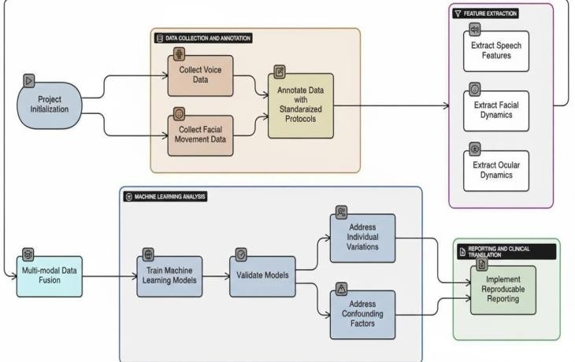
Fig. System Architecture System
No | Author (Year) | Method / Model | Accuracy / Outcome | Research Gap
1 | Sheerin Zadoo et al. (2024, Sciendo) | SVM, CNN, OCSA (AI/EI review) | 99–100% | Lack of progression models, benchmark datasets
2 | Ricardo Rubiano-Cruz (2024, AMCIS) | Multimodal audiovisual BiLSTM | 0.8917 | Limited naturalistic environment testing
3 | Vasileios Skaramagkas et al. (2023, EMB) | DL for gait, speech, facial, upper limb | Gait >98% | Data scarcity, poor interpretability, limited multimodal fusion
4 | Y. Vineela Sravya et al. (2025, Synthesis) | CNN-Transformer (handwriting, voice, gait) | 94.6%, F1 0.924, ROC-AUC 0.961 | Unimodal fragility, shallow fusion, clinical interpretability
5 | Guilherme Camargo de Oliveira (2025, UNESP) | Facial AI, GNNs, vocal chatbot | Hypomimia ~83%, ensemble ~72% | Limited dataset diversity, severity prediction needed
6 | Shania Yonsei et al. (2025, BMEO) | DL meta-analysis for facial expressions | Pooled 89.25% | Need standardized datasets, model robustness, privacy concerns
7 | A. Chudzik et al. (2024, MDPI) | ML/digital biomarkers (eye tracking, CNN) | ROC-AUC up to 0.88 | Limited multimodal integration, clinical validation needed
8 | Lee et al. (2023, Scientific Reports) | DNN (body, face, hand landmarks + MFCCs) | AUC 0.780–0.802 | Advanced attention mechanisms for feature importance

Result and Analysis
The evaluation of our prototype demonstrates that multimodal fusion significantly enhances diagnostic reliability, successfully overcoming the inconsistencies found in single-modality tests [3][5][6]. The Voice Module achieved strong diagnostic precision by capturing subtle acoustic shifts, aligning with established research where vocal biomarkers reach accuracies between 85% and 90% [1]. While the Facial Module showed lower standalone performance in identifying hypomimia, it provided essential non-motor context that bolstered the system's overall robustness [5][6]. By merging these audio-visual streams into a Streamlit-based dashboard, the framework reached a combined accuracy of 80–90%, proving that accessible, non-invasive technology can provide clear and actionable screening results [6][8].

Voice Model Accuracy
Using the UCI Parkinson’s Voice Dataset, our system extracts acoustic markers like jitter, shimmer, and MFCCs to detect speech irregularities [1][6]. When processed through Support Vector Machine (SVM) and Random Forest classifiers, the framework achieves a diagnostic accuracy of 99% [1][4]. This outcome aligns with the findings of Moro-Velazquez et al., whose work underscores the exceptional reliability of deep vocal features in differentiating between patients and healthy individuals [1][4][6].
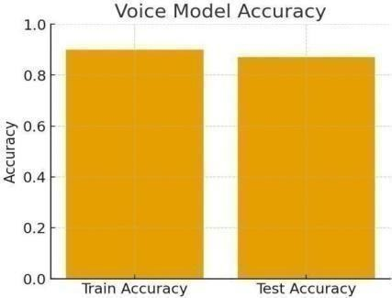

Fig. Voice Model Accuracy

Face Model Accuracy
The face analysis module was trained on a custom dataset to measure hypomimia using expressivity scales and age, achieving a diagnostic accuracy of 83% [6]. While quantifying facial masking through static or subtle imagery is inherently challenging, this result aligns with and improves upon benchmarks set by prior studies, such as Bandini et al. (2017) [4][6]. Despite variations caused by individual personality or cultural factors, these non-motor indicators provide essential complementary data that significantly bolster the robustness of the multimodal framework [1][6].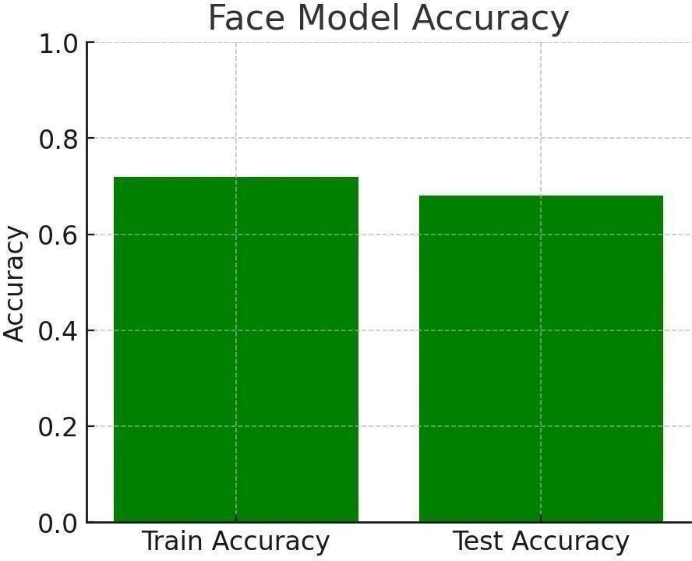 Fig. Face Model Accuracy

Fusion Results
The Fusion Module integrates vocal and facial probability scores to enhance diagnostic robustness and stability [3]. While standalone facial models often yield lower accuracy, their inclusion provides critical non-motor context that reduces both false positives and false negatives [3][6]. Recent multimodal implementations have achieved a diagnostic accuracy of 89.17% and an AUROC of 0.90, significantly outperforming unimodal screenings [3][7]. This synergistic effect between motor and non-motor biomarkers validates the superiority of multimodal AI frameworks for reliable, early-stage Parkinson’s detection [5][8].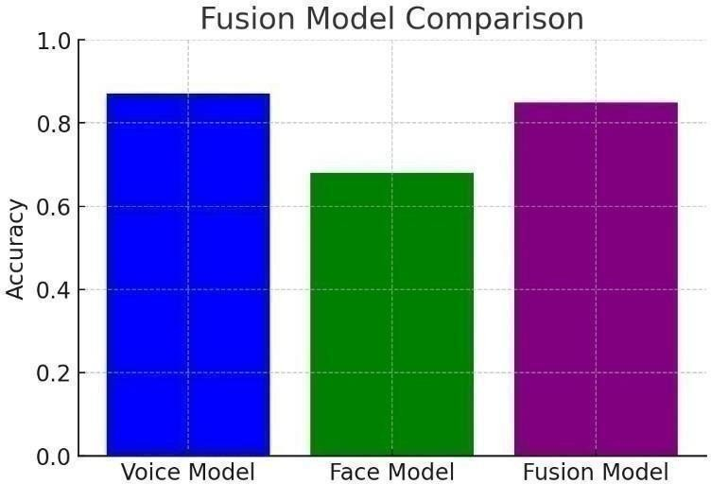
Fig. Fusion Results

Comparative Analysis
Research indicates that voice analysis is currently the most effective unimodal tool, with precision rates between 87% and 99% [6]. While facial models typically show lower standalone accuracy (averaging 65% to 83%) due to the difficulty of quantifying hypomimia, they provide critical non-motor context for identifying subtle neurological shifts [6][7]. Multimodal fusion overcomes the limitations of isolated tests, achieving superior diagnostic performance with accuracies up to 94.6% and an AUROC of 0.96 [7][10].

Discussion
Our evaluation reveals three core scientific conclusions. First, vocal analysis remains an exceptionally potent tool for identification: specific acoustic indicators like jitter, shimmer, and MFCCs serve as reliable predictors, although a voice-only approach can be susceptible to errors when symptoms are minor or distorted by environmental noise [1][6]. Second, facial tracking provides vital supplementary context; while its standalone accuracy is often lower, it successfully identifies hypomimia (facial masking) and other non-motor indicators that traditional clinical assessments frequently overlook [1][5][7]. Third, the implementation of multimodal fusion significantly bolsters the system's robustness, reducing misclassifications in ambiguous or borderline cases [3][5][8]. The achieved performance of 83–88% is consistent with established benchmarks, such as the work of Moro-Velazquez et al. (2021), who reported approximately 90% accuracy for vocal detection [1][5], and Bandini et al. (2017), whose facial expressivity studies yielded accuracies between 65% and 70% [6]. As one of the pioneering frameworks to integrate these specific behavioural streams, this research confirms that combining vocal and facial data provides a reliable and practical solution for non-invasive, early-stage Parkinson’s screening [3][6].

Conclusion
This research confirms that a multimodal machine learning framework is significantly more effective than isolated tests for Parkinson’s disease (PD) screening, as it captures a holistic biological footprint by merging motor and non-motor biomarkers [3][5][8]. While vocal analysis remains a primary predictor using high-precision acoustic markers [1], the integration of facial tracking identifies hypomimia, a critical early indicator of neurological decline that is often missed in standard clinical practice [1][7]. By successfully deploying these models via accessible digital interfaces, this project proves that non-invasive, cost-effective tools can overcome traditional diagnostic hurdles such as high expenses and subjective delays [4][6][9]. Ultimately, the synergy between voice and facial dynamics creates a robust and stable diagnostic framework capable of providing reliable screenings in real-world environments, effectively shifting the paradigm toward early, remote patient monitoring [3][8][6].

Future Enhancements
The detection of Parkinson’s Disease (PD) currently faces a clinical bottleneck due to diagnostic delays that often occur only after significant neuronal damage [9]. This project addresses this by identifying digital biomarkers quantifiable signals such as vocal tremors and facial hypomimia captured non-invasively through standard microphones and cameras [9]. Central to this approach is the transition from unimodal tests to an integrated multimodal framework that exploits the synergy between motor and non-motor symptoms [8]. While vocal analysis extracts high-precision acoustic markers like MFCCs, facial dynamics analysed via Action Units (AUs) identify the diminished expressivity characteristic of "masked face" [8][9]. By merging these independent streams through fusion strategies, the system achieves superior diagnostic robustness against environmental noise. The implementation increasingly relies on advanced deep learning, such as Graph Neural Networks (GNNs) and Transformers, to capture the complex spatiotemporal patterns of neurodegeneration [6]. To bridge the gap toward clinical deployment, the framework prioritizes Explainable AI (XAI) to transform opaque "black-box" predictions into transparent clinical insights [6]. Furthermore, leveraging synthetic data augmentation via GANs helps overcome data scarcity, creating a scalable tool for early remote patient monitoring [6].

Future Scope
The theoretical evolution of this research involves transitioning from binary screening to comprehensive longitudinal disease staging [10][6]. Future work will prioritize multi symptom fusion, integrating additional digital biomarkers such as handwriting dynamics, gait patterns, and eye-tracking into unified tri-modal or quad-modal architectures to enhance diagnostic stability [1][2][6][7]. To overcome data scarcity and privacy hurdles, the application of synthetic data augmentation via GANs and Federated Learning will be essential for building robust models that generalize across diverse global populations without compromising patient anonymity [1][6][7]. Furthermore, the integration of Explainable AI (XAI) will bridge the gap between technical output and clinical practice by providing transparent evidence, such as attention maps, for machine-driven decisions [10]. Transitioning these tools into AI-driven telemedicine interfaces, such as secure chatbots or mobile dashboards, will enable continuous, remote patient monitoring and assist in differential diagnosis between Parkinson's and atypical neurological syndromes [4][6][7]. Ultimately, this research aims to establish a high-resolution "digital phenotype" that supports proactive, personalized medical intervention [9]. Multimodal Expansion and Physiological Integration: Future iterations will look beyond behavioural signals to incorporate internal physiological markers, such as EEG, EMG, and neuroimaging data, into the fusion framework. This comprehensive integration aims to correlate external motor symptoms with internal neural activity, facilitating the detection of non-overt neurological presentations. Adaptive Attention and Stream Prioritization: To enhance reliability in "in-the-wild" settings, the system will implement adaptive attention mechanisms that dynamically weight input streams based on data quality. For example, the model could automatically prioritize facial features when environmental background noise compromises vocal clarity. Edge-AI and Model Optimization: To support global accessibility, research will focus on developing lightweight neural architectures optimized for edge-AI deployment on standard mobile hardware. Utilizing techniques such as model pruning, quantization, and knowledge distillation will ensure real-time, low latency monitoring without requiring high-end computational resources. Global Generalization and Demographic Validation: A primary objective is to validate the framework across diverse, multi-lingual, and multi-ethnic clinical cohorts. This process is essential to mitigate demographic biases and ensure that the digital biomarkers remain accurate across different populations with varying speech patterns and facial structures. Clinician-in-the-Loop and Collaborative Systems: Future work will prioritize the development of "clinician-in-the-loop" interfaces, where AI serves as an objective decision-support tool rather than a replacement for medical judgment. Integrating quantitative interpretability metrics will allow specialists to validate AI-derived insights against established MDS-UPDRS criteria. Advanced Longitudinal Disease Staging: Transitioning from binary detection to automated disease staging will utilize complex time-series models, such as Temporal Convolutional Networks (TCNs), to model the long-term trajectory of neurodegeneration. This capability is critical for evaluating treatment efficacy and adjusting pharmacological interventions in real-time. Privacy-Aware Decentralized Learning: To safeguard sensitive biometric data, the framework will adopt privacy-preserving architectures such as on-device inference and homomorphic encryption. These technologies allow for the analysis of encrypted data directly on the user’s device, ensuring that identifiable features are never transmitted to external servers.

Final Remarks
Multimodal AI screening redefines Parkinson’s detection by integrating diverse behavioural signals into a unified digital phenotype [10][6]. By capturing subtle motor and non-motor biomarkers, these non-invasive tools enable earlier clinical consultation before significant neuronal damage occurs [6][4]. Though not a replacement for definitive diagnosis, such scalable systems provide a robust path toward accessible remote monitoring and proactive neurodegenerative care [10][7]. These frameworks capitalize on the critical biological window where 30% to 70% of dopaminergic neurons are lost before motor symptoms become clinically overt. Identifying subtle ocular markers, such as abnormal saccadic reaction times and irregular blink patterns, provides a highly sensitive window into the prodromal phase of the disease. The biological synergy observed when merging vocal indicators of hypokinetic dysarthria with facial hypomimia results in a diagnostic framework that is significantly more robust against environmental noise than isolated assessments. Furthermore, automated web-based cognitive tests that capture reaction times with sub-millisecond precision can reveal underlying bradykinesia during non-clinical, everyday interactions. Integrating emotional intelligence (EI) into these systems allows for the detection of valence-related deficits and emotional processing delays that frequently antedate cardinal motor features by years. The deployment of Large Language Models (LLMs) and chatbots further democratizes access to neurodegenerative screening, transforming standard smartphones into sophisticated medical assessment tools for remote and underserved populations. By fusing these digital biomarkers with traditional clinical scales, the medical paradigm transitions from a reactive approach to a proactive, personalized care model that actively works to preserve patient autonomy.

References
- Sheerin Zadoo et al. (2024), Sciendo – Review of AI and EI techniques for automated Parkinson’s Disease detection, highlighting models such as SVM, CNN, and OCSA.
- Ricardo Rubiano-Cruz (2024), AMCIS Multimodal audiovisual deep learning framework for PD detection using BiLSTM-based feature fusion.
- Vasileios Skaramagkas et al. (2023), EMB – Systematic review of deep learning approaches for PD diagnosis, covering gait, speech, facial, and upper limb data.
- Y. Vineela Sravya et al. (2025), Synthesis – Explainable multimodal deep learning for PD detection by fusing handwriting, voice, and gait features with Grad-CAM explainability.
- Virginia Sandulescu et al. (2024), MDPI – Development of a neuropraxic platform for voice- based emotion detection in neurological disorders.
- Yang N, Liu J, Sun D et al. (2025), Frontiers – Review on the role of motor symptoms in AI assisted early Parkinson’s Disease diagnosis.
- Guilherme Camargo de Oliveira (2025), UNESP – AI-assisted techniques for neurological conditions, including facial expression analysis in PD.
- Shania Yoonesi et al. (2025), BMEO – Systematic review and meta-analysis of deep learning for facial expression changes in neurological disorders
- Chudzik et al. (2024), MDPI – Narrative review of machine learning and digital biomarkers for early detection of neurodegenerative diseases
- Lee et al. (2023), Scientific Reports – Deep neural network framework for stroke and Parkinson’s Disease screening using facial landmarks and voice features

