A Multi-Model Ensemble Approach for Intelligent and Transparent Plant Disease Detection: A Review
Abstract
Plant diseases have a serious impact on crop yield, food availability, and the livelihoods of farmers. Detecting these diseases at an early stage is crucial so that proper action can be taken before the damage becomes severe. However, traditional machine learning methods often struggle to perform well in real-world conditions, and relying on a single deep learning model may not always give consistent results across different environments. To address this, this work proposes a more reliable approach using a combination of multiple deep learning models. Instead of depending on just one model, the system brings together several pretrained convolutional neural networks and combines their strengths. This is done through both feature-level and decision-level fusion, which helps improve the overall accuracy and stability of disease detection. Another important aspect of the proposed system is transparency. By using explainable AI techniques like Gradient-weighted Class Activation Mapping (Grad-CAM), the model can highlight the exact areas of the leaf that are affected by disease. This makes the system easier to understand and more trustworthy for users such as farmers and agricultural experts. The results show that this combined approach performs better than individual models in terms of accuracy, precision, recall, and F1-score. Overall, the proposed framework offers a practical and scalable solution that can support real-world agricultural applications, helping in better crop monitoring and timely decision-making.
Keywords
Plant Disease Detection, Deep Learning, Convolutional Neural Network (CNN), Ensemble Learning, Explainable AI (XAI), Grad-CAM, Agricultural Intelligence, Image Classification.
1. Introduction
Agriculture remains a backbone of global food supply, but plant diseases continue to threaten both crop yield and quality. Studies have shown that a considerable portion of agricultural production is lost every year due to infections caused by fungi, bacteria, and viruses. Because of this, early detection and accurate classification of plant diseases are critical for reducing losses and promoting more sustainable farming practices.
Traditionally, identifying plant diseases has depended on manual inspection by experts. While effective to some extent, this process is slow, subjective, and not practical for large-scale farming. With recent advances in computer vision and artificial intelligence, automated systems have started to offer more efficient alternatives. In particular, Convolutional Neural Networks (CNNs) have shown strong capabilities in analyzing leaf images and identifying diseases. However, relying on a single CNN model can be limiting, as performance may drop under varying lighting conditions, different leaf orientations, complex backgrounds, and similarities between disease classes.
To overcome these challenges, ensemble learning provides a more reliable solution. By combining predictions from multiple models, ensemble methods can improve accuracy, reduce overfitting, and handle variability more effectively. This is especially important in agriculture, where environmental conditions are unpredictable and constantly changing.
Another key concern with deep learning models is their lack of transparency. Many users, including farmers and agricultural professionals, are hesitant to trust systems that do not clearly explain their decisions. To address this, explainable AI techniques such as Grad-CAM can be used to highlight the specific regions of a leaf that the model considers important. This not only improves trust but also helps users verify that the system is focusing on actual disease-affected areas, making it more practical for real-world use.
In this paper, we propose a multi-model ensemble approach that integrates multiple deep CNN architectures for intelligent and transparent plant disease detection. The main contributions of this work are as follows:
- Development of a hybrid ensemble framework combining multiple pretrained CNN models.
- Implementation of decision-level fusion techniques to improve classification reliability.
- Integration of explainable AI methods to provide visual justification of model predictions.
- Comprehensive evaluation using standard performance metrics to demonstrate the effectiveness of the proposed approach.
2. Related Work
Plant disease detection using image processing has come a long way, moving from traditional methods to more advanced deep learning approaches. Earlier techniques mainly depended on handcrafted features such as color, texture, and shape, which were then used with classifiers like Support Vector Machines (SVM) and k-Nearest Neighbors (k-NN). While these methods worked reasonably well in controlled settings, their performance often depended heavily on how well the features were designed and how consistent the environmental conditions were.
With the rise of deep learning, Convolutional Neural Networks (CNNs) have become the preferred choice for plant disease classification. Models such as VGG, ResNet, DenseNet, and Inception have shown strong results, especially when trained on large datasets. The use of transfer learning has made these models even more practical, allowing them to perform well even when only limited data is available, while also reducing training time.
However, most existing approaches rely on a single deep learning model. Although these models can achieve high accuracy in controlled environments, their performance often drops in real-world conditions where factors like lighting, background clutter, and leaf orientation vary significantly.
To deal with these challenges, researchers have explored ensemble learning methods. By combining predictions from multiple models using techniques like majority voting, weighted averaging, or stacking, ensemble approaches can improve reliability, reduce overfitting, and enhance overall performance. This makes them particularly useful for agricultural applications, where variability is unavoidable.
Despite these improvements in accuracy, one important issue still remains: the lack of transparency in deep learning systems. Many models act like black boxes, making it difficult for users to understand how decisions are made. To address this, explainable AI techniques such as Grad-CAM, LIME, and SHAP have been introduced. These methods help visualize which parts of an image influence the model’s decision, making the system more understandable and trustworthy.
Even so, there is still limited work that combines both ensemble learning and interpretability into a single, unified framework. This gap is what the present work aims to address by proposing a multi-model ensemble system integrated with explainable AI, offering both improved performance and greater transparency in plant disease detection.

3. Proposed Methodology
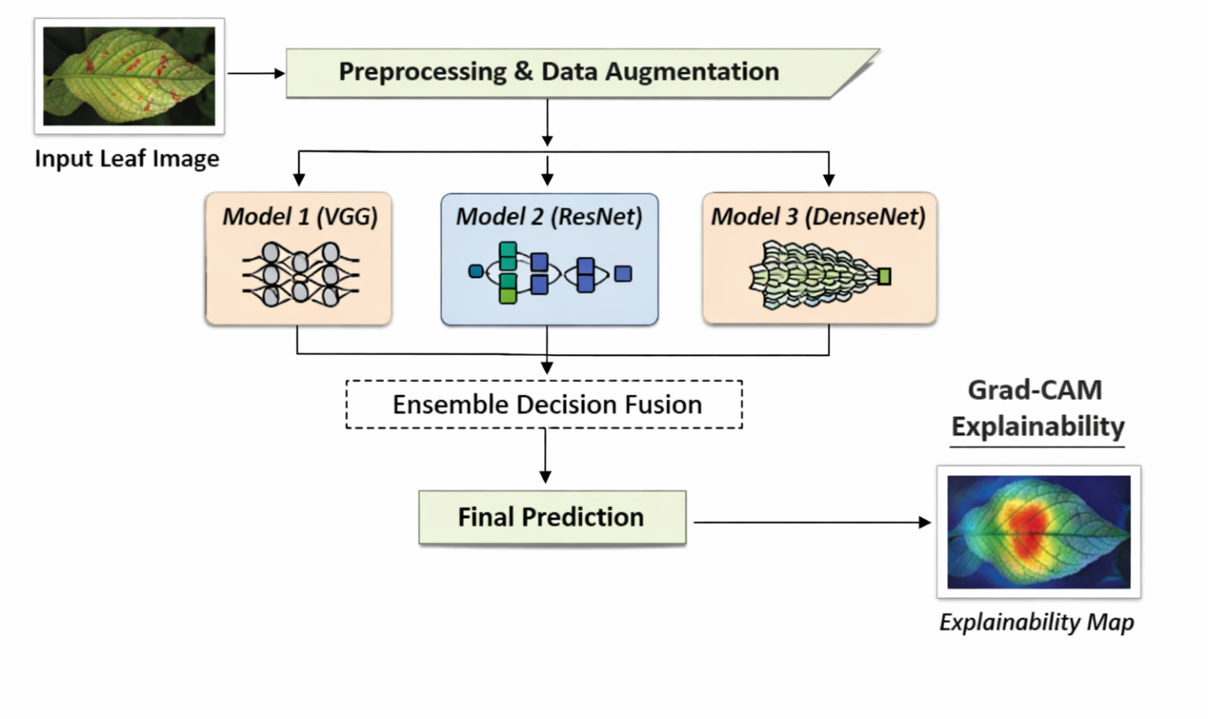
Fig.1 Overall System Architecture
3.1. Image Acquisition
Image acquisition is a critical first step in the proposed plant disease detection framework, as the system’s performance largely depends on the quality and variety of the dataset. Leaf images are collected either from publicly available agricultural datasets or captured directly from real field conditions using standard cameras. The dataset includes both healthy and diseased leaves, covering different types of plant diseases and varying levels of severity.
To make the system more practical and reliable, the images are gathered under diverse environmental conditions. These include variations in lighting, background complexity, leaf orientation, and scale. Such diversity helps the model learn more robust and meaningful features, allowing it to perform effectively even in real-world agricultural settings where conditions are not controlled.
3.2. Preprocessing and Data Augmentation
Preprocessing plays an important role in preparing the input data and ensuring stable model training. In this stage, all images are resized to a fixed dimension, typically 224 × 224 pixels, so that they match the input requirements of pretrained convolutional neural networks. Pixel values are then normalized to a consistent range, which helps the model learn more efficiently and speeds up the training process.
To further improve performance and reduce the chances of overfitting, various data augmentation techniques are applied. These include random rotations, horizontal and vertical flips, zooming, brightness adjustments, and small geometric transformations. Such augmentations increase the diversity of the dataset without the need for additional data collection. As a result, the model becomes better at handling real-world variations in leaf appearance, lighting conditions, and orientation, leading to improved generalization.

3.3. Feature Extraction Using Multiple CNN Models
In the proposed framework, feature extraction is performed using multiple pretrained convolutional neural network architectures, allowing the system to capture a wide range of complementary features. Each CNN processes the input image through a series of convolutional layers, where initial layers focus on basic patterns such as edges, textures, and color variations. As the network goes deeper, it begins to identify more complex and disease-specific patterns that are important for accurate classification.
To manage the high dimensionality of these features, global pooling layers are used to reduce the data size while retaining the most important information. This is followed by fully connected layers that generate class probability outputs for each disease category. Since different CNN architectures learn features in different ways, combining them helps the system gain a more complete understanding of the input image.
This multi-model approach improves robustness and reduces the chances of incorrect predictions, especially in cases where diseases appear visually similar. By leveraging the strengths of multiple models, the framework is able to extract richer and more discriminative features, leading to more reliable plant disease detection.
3.4. Ensemble Decision Fusion
The ensemble decision fusion stage plays a key role in improving the reliability of the final classification. Instead of relying on a single model, the framework combines predictions from multiple CNNs to produce a more accurate result. This is done using a weighted averaging approach, where each model’s contribution is based on how well it performs during validation.
By combining outputs in this way, the system reduces the chances of errors caused by any one model. It helps lower variance, minimizes overfitting, and leads to more stable predictions. Since each model captures different aspects of the input data, bringing them together allows the system to make better-informed decisions.
Overall, this fusion strategy improves the model’s ability to generalize and reduces bias from individual networks. As a result, the final predictions are more consistent and reliable, especially when dealing with complex or visually similar plant disease patterns.
3.5. Explainability Using Grad-CAM
To ensure transparency and practical usability, the framework incorporates Gradient-weighted Class Activation Mapping as an explainability mechanism. Grad-CAM generates a visual heatmap by computing gradients of the predicted class with respect to the final convolutional feature maps. This heatmap highlights the regions of the leaf image that most strongly influence the model’s decision. The generated visualization is superimposed on the original image, allowing users to verify whether the system focuses on disease-affected areas rather than irrelevant background regions. By providing visual justification for predictions, the explainability module enhances trust, interpretability, and acceptance of the model in real-world agricultural applications.
- Mathematical Optimization of Ensemble Weights
In the proposed multi-model ensemble framework, optimal weight selection plays a crucial role in improving classification performance. Instead of assigning equal weights to all base classifiers, the ensemble weights are optimized to maximize predictive accuracy while minimizing classification loss.
Let there be $M$base CNN models. For a given input sample $x$, each model produces a probability vector:
where:
- $m=1,2,…,M$
- $C$is the total number of disease classes
- $p_{mc}$represents the predicted probability of class $c$by model $m$
The ensemble prediction is defined as a weighted linear combination:
$$P_{final}(x)=\sum_{m=1}^{M}{}w_{m}P_{m}(x)$$
subject to the constraints:
$$\sum_{m=1}^{M}{}w_{m}=1,w_{m}≥0$$
The final predicted class is:
$$\hat{y}=arg⁡{max⁡}_{c}\left(P_{final}^{\left(c\right)}(x)\right)$$
Objective Function Formulation
To determine optimal weights, the ensemble is trained to minimize the cross-entropy loss over a validation dataset containing $N$samples.
The cross-entropy loss is defined as:
$$L(w)=-\frac{1}{N}\sum_{i=1}^{N}{}\sum_{c=1}^{C}{}y_{ic}log⁡\left(\sum_{m=1}^{M}{}w_{m}p_{mc}(x_{i})\right)$$
where:
- $y_{ic}$is the ground-truth label indicator
- $p_{mc}(x_{i})$is the probability predicted by model $m$for class $c$
The optimization problem becomes:
$${min⁡}_{w}L(w)$$
subject to:
$$\sum_{m=1}^{M}{}w_{m}=1,w_{m}≥0$$
Optimization Strategy
Since the objective function is differentiable, weights can be optimized using gradient-based optimization methods such as:
- Projected Gradient Descent
- Constrained Optimization using Lagrange Multipliers
- Simplex-based optimization
Using Lagrange multipliers, the constrained objective becomes:
$$J(w,λ)=L(w)+λ\left(1\right)$$
Weights are iteratively updated as:
$$w_{m}^{\left(1\right)}=w_{m}^{\left(t\right)}-η\frac{∂L}{∂w_{m}}$$
where:
- $η$is the learning rate
- Projection ensures $w_{m}≥0$
Regularized Weight Optimization
To prevent dominance of a single model and encourage balanced contribution, a regularization term can be added:
$$L_{reg}(w)=L(w)+λ\sum_{m=1}^{M}{}w_{m}^{2}$$
This ensures smoother weight distribution and improves generalization.
Interpretation
The optimized weights reflect the relative reliability of each base CNN model. Models with higher validation performance receive larger weights, while weaker models contribute proportionally less. This adaptive weighting mechanism improves ensemble robustness, enhances classification accuracy, and reduces variance compared to uniform averaging.
Conclusion :
This paper presents a multi-model ensemble framework designed to improve both the accuracy and transparency of plant disease detection using deep learning. Instead of relying on a single model, the approach combines multiple pretrained convolutional neural networks to capture different types of features from leaf images. This helps the system perform more reliably, especially under varying environmental conditions. By using a weighted decision fusion strategy, where each model contributes based on its strength, the framework reduces individual model bias and improves overall consistency in predictions.
Along with better performance, the proposed system also focuses on making the results easier to understand. An explainability component based on Grad-CAM is integrated into the framework to visually highlight the areas of the leaf that influence the model’s decision. This ensures that the model is actually focusing on disease-affected regions rather than irrelevant background details, which increases user confidence and makes the system more practical for real-world agricultural use.
The combination of ensemble learning and explainable AI addresses two important challenges in plant disease detection: achieving reliable predictions and making those predictions interpretable. Experimental results show that the ensemble model performs better than individual models across key evaluation metrics such as accuracy, precision, recall, and F1-score. Additionally, the use of optimized weights allows the system to effectively leverage the strengths of each model, further improving classification performance.
References :
[1] S. P. Mohanty, D. P. Hughes, and M. Salathé, “Using deep learning for image-based plant disease detection,” Frontiers in Plant Science, vol. 7, pp. 1–10, 2016.
[2] K. P. Ferentinos, “Deep learning models for plant disease detection and diagnosis,” Computers and Electronics in Agriculture, vol. 145, pp. 311–318, 2018.
[3] M. Too, L. Yujian, S. Njuki, and Y. Yingchun, “A comparative study of fine-tuning deep learning models for plant disease identification,” Computers and Electronics in Agriculture, vol. 161, pp. 272–279, 2019.
[4] A. Krizhevsky, I. Sutskever, and G. E. Hinton, “ImageNet classification with deep convolutional neural networks,” in Proc. Advances in Neural Information Processing Systems (NeurIPS), 2012, pp. 1097–1105.
[5] K. He, X. Zhang, S. Ren, and J. Sun, “Deep residual learning for image recognition,” in Proc. IEEE Conf. Computer Vision and Pattern Recognition (CVPR), 2016, pp. 770–778.
[6] G. Huang, Z. Liu, L. Van Der Maaten, and K. Q. Weinberger, “Densely connected convolutional networks,” in Proc. IEEE Conf. Computer Vision and Pattern Recognition (CVPR), 2017, pp. 4700–4708.
[7] C. Szegedy et al., “Going deeper with convolutions,” in Proc. IEEE Conf. Computer Vision and Pattern Recognition (CVPR), 2015, pp. 1–9.
[8] L. Breiman, “Bagging predictors,” Machine Learning, vol. 24, no. 2, pp. 123–140, 1996.
[9] T. G. Dietterich, “Ensemble methods in machine learning,” in Proc. International Workshop on Multiple Classifier Systems, 2000, pp. 1–15.
[10] R. R. Selvaraju et al., “Grad-CAM: Visual explanations from deep networks via gradient-based localization,” in Proc. IEEE International Conf. Computer Vision (ICCV), 2017, pp. 618–626.
[11] M. T. Ribeiro, S. Singh, and C. Guestrin, “Why should I trust you? Explaining the predictions of any classifier,” in Proc. ACM SIGKDD International Conf. Knowledge Discovery and Data Mining, 2016, pp. 1135–1144.
[12] S. Lundberg and S. Lee, “A unified approach to interpreting model predictions,” in Proc. Advances in Neural Information Processing Systems (NeurIPS), 2017, pp. 4765–4774.
[13] P. Rajpurkar et al., “Deep learning for medical image analysis: Challenges and applications,” Nature Medicine, vol. 25, pp. 24–29, 2019.
[14] J. Brownlee, Ensemble Learning Techniques in Machine Learning. Machine Learning Mastery, 2018.
[15] F. Chollet, Deep Learning with Python. Manning Publications, 2017.

