Generative AI for Intelligent Customer Relationship Management: Applications Within the Salesforce Ecosystem

Abstract
Customer Relationship Management (CRM) is a fundamental part of business in today’s economies to have good information management, to keep track of customer interactions and to form long-standing relationships. The phenomenal advancement of Artificial Intelligence (AI) has modernized the CRM system with more and more functionalities such as predictive analytics, automation, informed recommendations and more. In particular, Generative Artificial Intelligence (Generative AI) has become a powerful means of producing content, automating communication, and helping with complex decision-making.
This study discusses the incorporation of Generative AI into the Salesforce ecosystem, specifically focusing on solutions like Salesforce Einstein, Einstein Copilot, Prompt Builder and Agentforce. It looks at how these AI technologies improve CRM tasks as far as sales automation, customized marketing, customer support and data-centric decision-making. This paper provides a framework for the entire research which encompasses system design, integration of AI models, data collection and preprocessing, and evaluating strategies. It also covers the problems and ethical issues that must be addressed when deploying AI in CRM systems like data privacy, algorithmic bias, and responsible AI governance.
Research results indicate that operational efficiency, customer interaction and effective decision-making are significantly enhanced with the integration of Generative AI and agent-based AI platforms. Using autonomous AI agents and state-of-the-art generative models, enterprises can make the CRM systems in traditional applications of enterprise intelligent environments and capable of predicting customer needs and performance in highly complex workflows. This study demonstrates the impact of Generative AI on CRM and anticipates the future trends for artificial intelligence-powered businesses.

Keywords
Generative AI, Customer Relationship Management, Salesforce, Agentforce, Einstein Copilot, Prompt Builder, CRM automation, AI-driven decision-making

1. Introduction
Business has to work with, and manage customer, relations with their various stakeholders, thus, customer relationship management (CRM) is essential in all modern business strategies. In competitive world today organizations are emphasizing personalized experience, increasing satisfaction and increasing loyalty. CRM systems acquire, process, and evaluate customer-related information, such as from sales or services teams to marketing and digital communications providers. With central data, customers can be more easily comprehended, opportunities are recognized, and engagement and loyalty are enhanced. Payne and Frow (2005) note that CRM combines people, processes, and technology to create value for customers and businesses.
As a result of the increased complexity of data to be added in organizations‘ records due to the digitization of companies’ processes, standard CRM systems that are predominantly manual or rule-based have fallen victim to the growth of these large quantities of customer data, thus, the requirement to increase a customer’s data is difficult to be accommodated in an organization. To address these drawbacks, a lot of enterprises incorporate Artificial Intelligence (AI) applications within their CRM programs. AI lets us study big data, spot patterns, and provide strategic insights to guide choices. AI capabilities within CRM like predictive analysis, automated segmentation and workflow automation enable firms to predict customer requirements, increase sales velocity and performance through improved sales efficiencies (Davenport & Ronanki, 2018).
Generative Artificial Intelligence (GenAI) presents a new paradigm that develops content and human-like answers based on large volumes of data. GenAI does not rely on prediction or classification in the usual sense of AI, instead the same technology can make automated reports and messages (such as emails, marketing copy, product descriptions, or customer service answers). Evidence suggests generative AI could revolutionize digital ecosystems, through the generation of intelligent content and a new model of speaking at the same time (Bommasani et al., 2021). In CRM, this enables automated, personalized communication with customers.
Salesforce, a CRM leader integrated into cloud applications, has leveraged AI with products like Salesforce Einstein, Einstein Copilot, Prompt Builder and Agentforce. Salesforce Einstein delivers predictive analytics and machine learning for decision-making and operational automation. Einstein Copilot is a conversational AI assistant that allows users to engage with their CRM data in natural language commands. Prompt Builder helps companies craft well-structured prompts that direct the AI to deliver correctly and contextually relevant content in AI with the help of prompts. Agentforce utilizes generative AI with autonomous agents for more complicated tasks to include things like updating our accounts, generating service tickets, and automating tasks.
These tools are also used to make CRM better by improving customer service, increasing sales automation, creating tailored marketing materials, and by supporting data-driven decision-making. It investigates how a combination of generative AI technologies in the Salesforce ecosystem can change the way CRM works, boost organizational performance and enable more intelligent, efficient customer interaction.

1.1 Research Purpose
Therefore, the aim of this research is to explain how Generative Artificial Intelligence (GenAI) can contribute to the improvement in Customer Relationship Management (CRM) in the Salesforce ecosystem. Increasingly, companies are moving to digital platforms for interacting with their customers, generating a call for intelligent systems to process enormous volumes of data to perform routine tasks and make data-driven decisions.
Here we will discuss how generative AI can revolutionize CRM operations through its support for communication automation, personalised content engagement, and proactive decision-making processes. Such generative AI models, or large language models for that matter, can generate information based on context, such as emails, product recommendations, marketing messages and responses to customer support inquiries lessening manual work and enhancing operational efficiency.
The study also explores AI within Salesforce features, such as Salesforce Einstein (predictive analytics), Einstein Copilot (conversational interaction), Prompt Builder (structured prompt management), and Agentforce (autonomous AI agents for CRM workflow activities). The research investigates them and proposes a concept for such technologies on how organizations can utilize generative AI to improve sales automation, customer service, and marketing personalization. In this research, AI will help you to understand how these CRM products would help in enhancing customer engagement, improve the operational efficiency and make strategic decisions in the current enterprises.

1.2 Research Questions
This study is focused on the following questions in order to understand how generative AI integrates in CRM systems:
RQ1: How can generative AI improve CRM processes?
• Examines AI's ability to automate communication, analyze customer data, and personalize interactions.
RQ2: How do Salesforce AI tools improve CRM performance?
• Deals with Salesforce Einstein, Einstein Copilot, and Prompt Builder to enhance automation and insights.
RQ3: What role do autonomous AI agents play in CRM workflows?
• Explores Agentforce agents to do CRM tasks, improving efficiency, and supporting decision-making.
RQ4: What are the benefits and challenges of generative AI in CRM?
• Examines the practical benefits (automation, personalization, predictive insights) as well as the challenges (data privacy, integration, model accuracy).
By addressing these questions, the study provides insights into leveraging generative AI for intelligent, automated, and efficient CRM operations.

1.3 Contributions and Research Significance
This research sheds light on the integration of generative AI and autonomous agents in Salesforce and adds to the understanding of AI applications within CRM systems.
Key contributions include:
- Understanding the potential use of Agentforce as a novel solution for deploying intelligent AI agents that automate CRM tasks and support employees.
- Showcasing how Salesforce generative AI tools can contribute to better CRM processes, more efficient CRM workflows, greater customer interactions, improved customer engagement, and data-driven decision-making.
- Putting insights and best practices on how to make an organisation utilize AI-driven CRM into practice using ethical standards of CRM solutions without compromising security and ensuring human oversight.
- Enhancing academic understanding in AI-driven CRM and digital transformation in enterprise systems.
This paper demonstrates how generative AI can help transform traditional CRM systems into systems that are smarter, faster, and focused around the customer.

2. Literature Review
Customer Relationship Management (CRM) is a well known strategic method which helps organizations in managing customer relationships; it also plays a critical role in the long-term performance of the business. CRM platforms enable companies to gather, structure, and analyze such information from a variety of contact lines, such as sales channels, marketing, customer service communication, etc. CRM solutions are driven by combining data from multiple systems, allowing for a stronger understanding of customer behaviour, preferences and expectations in order for companies to formulate strategic initiatives that enhance engagement and establish longer-term partnerships. As Payne & Frow (2005) emphasize, CRM includes business processes, people, and technology which bring benefit to customers and organizations; it is an integral business model to align operational capabilities with the needs of the customers.
Now, the emergence of Artificial Intelligence (AI) has greatly enhanced the capabilities of CRM applications. Organizations with AI capabilities can examine volumes of structured and unstructured data in large volumes to gain meaningful insight that is helpful for company strategy-making. Using machine learning algorithms, organizations can spot trends in consumer actions and sales data, forecast the next step towards a business action or purchase decision based on purchase behavior, so companies advance from reactive to proactive communication with customers. According to Davenport and Ronanki (2018), AI technologies allow organizations to take insights from large amounts of data, benefiting decision-making and operations.
Business systems AI frameworks are classified as either generative or discriminative models. While the discriminative models are centered around predictions of labels or categories from the data input, generative models analyze the underlying distribution of the data, capable of creating new content (text, images, recommendations, etc.). Discriminative models are typically used for classification and prediction, while generative models are suited for content creation and conversational applications. The procedure variants of these two models are indicated in below Figure (Goodfellow, Bengio, & Courville, 2016).
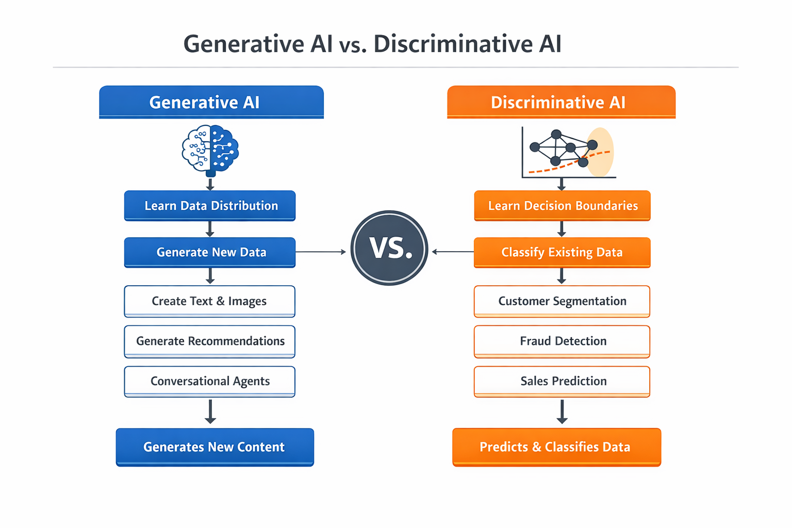

Generative AI, a family of AI models that can generate new content from learned patterns, has extended CRM applications for AI in this context. These AI models can produce text, summary text, visual images, and conversation responses, making it possible for tasks that involve natural language recognition and human-like communication skills to be accomplished. Bommasani et al. (2021) note that generative AI can revolutionize digital platforms by empowering intelligent content production and sophisticated conversational interactions. For companies who work with CRM systems, generative AI can also be helpful in automating customer responses, creating more tailored marketing messages, sending personalized messages to customers, and giving a voice to employees and other businesses with context analysis of the customer experience.
Generative AI, a family of AI models that can generate new content from learned patterns, has extended CRM applications for AI in this context. These AI models can produce text, summary text, visual images, and conversation responses, making it possible for tasks that involve natural language recognition and human-like communication skills to be accomplished. Bommasani et al. (2021) note that generative AI can revolutionize digital platforms by empowering intelligent content production and sophisticated conversational interactions. For companies who work with CRM systems, generative AI can also be helpful in automating customer responses, creating more tailored marketing messages, sending personalized messages to customers, and giving a voice to employees and other businesses with context analysis of the customer experience.
Salesforce has been the front-runner in facilitating intelligent CRM in a highly evolving industry. Salesforce is the cloud-based platform that combines sales, marketing, customer service, and analytics together. AI capabilities (like predictive analytics, automation, and intelligent recommendations) enable businesses to help organizations make better decisions and streamline processes. Salesforce Einstein, for instance, enables predictive analytics that can help predict customer behavior, discover sales opportunities using models and optimize marketing strategies.
Recent features at Salesforce include generative AI tools used for engaging in chat and auto content creation. Einstein Copilot enables users to engage with CRM data through natural language prompts, streamlining tasks and extracting insights. Prompt Builder helps organizations create structured prompts to align AI outputs to organizational goals. Agentforce moreover uses smart AI agents to help employees and communicate with customers dynamically; it can also automate workflows, summarize business conversations, make suggestions, and execute CRM processes in sales, marketing, and service operations.
The combination of generative AI and AI agent technologies is a way of CRM disruption, supporting continuous help, faster response, and better productivity. But, challenges are still there involving data privacy, security, ethical issues as well as AI-generated outputs transparency. Good CRM practices require a balance between AI automation and human expert skills. Thus, we still need to maintain the relationship with our customers.
The literature overall underscores the growing importance of AI and generative AI on CRM systems. While integrating generative AI and the autonomous agent Agentforce into Salesforce is an emerging research area, it merits further study: Does this technology help boost customer engagement, operational efficiency and business performance?

3. Research Methodology

3.1 Research Design
This study employs a system-oriented research methodology, through the Salesforce agent framework Agentforce, for the use of Generative Artificial Intelligence (GenAI), to explore how GenAI brings benefits for CRM by means of Salesforce's system and application methods. Advanced AI capabilities and technologies have completely revolutionized business software by allowing people to automate, predict demand, predict future events, make customer contacts more sensitive and personalized.
Traditional CRM systems gather and organize customer data primarily from sales, service, marketing, and digital channels – and most often, their decisions are not made on a real-time basis. Generative AI can turn this data into intelligent systems that support automated workflows, personalized communication, and proactive business methods.
The research takes a system-building approach, proposing a system architecture that is a visual illustration of how Generative AI models interact with CRM data, enterprise workflows, and autonomous agents within Salesforce. That study also investigates how we can build a scalable framework for CRM leveraging AI analytics, cloud-based data management, and agent-based automation to increase CRM efficiency and customer engagement.
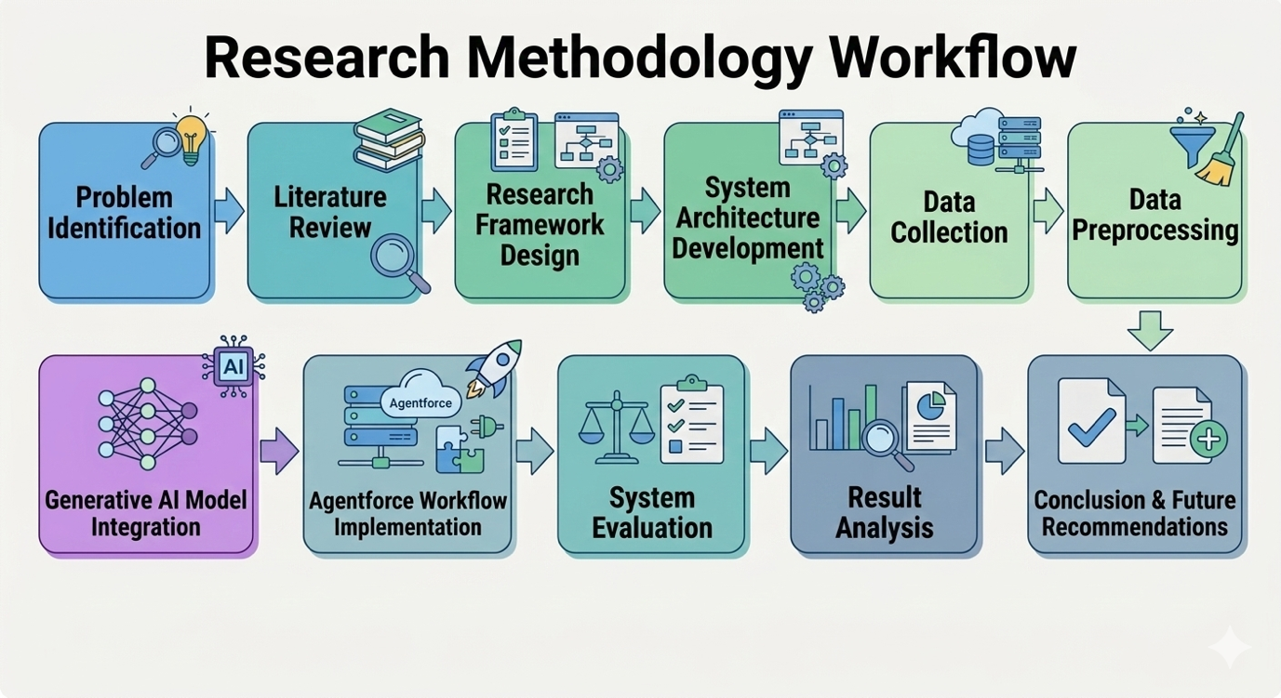
Figure 3.1: Research Methodology Process Flow

3.2 System Architecture Design
One of the core components of the methodology is designing a comprehensive architecture that integrates generative AI with Salesforce CRM. The framework is created to outline data flow between the data collection layer, AI processing layer, and agent execution layer and how AI-generated outputs support CRM activities.
Architecture Layers:
- Data Data Collection Layer: gathers structured (customer records, purchase history) and unstructured data (emails, chats, social media).
- Data Processing Layer: preprocessing tasks such as cleaning, normalization, duplicate removal, text preprocessing, and feature extraction ensure high-quality inputs for AI analysis.
- AI Processing Layer: Integrates generative AI models that can:
  - Customer query interpretation
  - Automated response generation
  - Sales recommendations
  - Sentiment analysis
  - Personalized marketing messages
- Agent Execution Layer: AI-generated outputs are executed via Agentforce agents, automating tasks such as:
  - Responding to inquiries
  - Creating support tickets
  - Updating records
  - Sending follow-ups or triggering campaigns
The intelligent automation is achieved as an agent-based architecture while maintaining coordination with enterprise workflows.

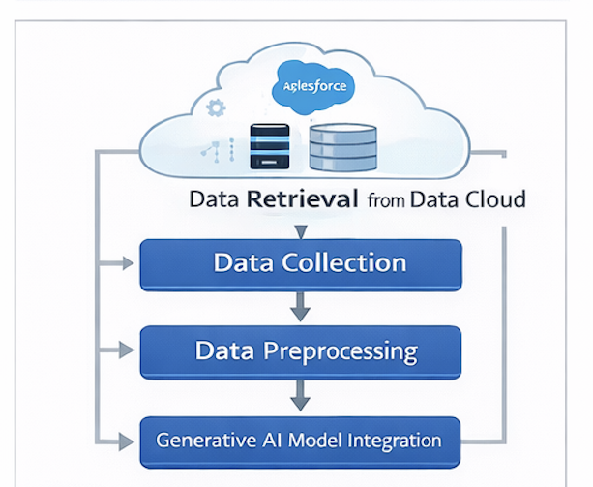
Figure 3.2: AI-Enabled CRM System Architecture using Generative AI and Salesforce

3.3 Data Collection and Preprocessing
CRM data is categorized as:
- Structured Data: Customer profiles, purchase histories, sales records, service requests, campaign responses
- Unstructured Data: Emails, live chats, feedback, social media posts, support tickets
Preprocessing techniques include: removing duplicates, standardizing fields, tokenizing text, eliminating noise, and converting data into machine-readable formats. These steps improve AI analysis and output accuracy.

3.4 AI Model Integration
Generative AI models are configured to perform tasks such as:
- Responding to customer inquiries
- Producing personalized recommendations
- Creating marketing content
- Summarizing conversations
- Providing predictive insights
Outputs are executed by Agentforce agents within CRM workflows, enabling a human–AI collaborative environment where employees focus on complex decisions while AI handles routine tasks.
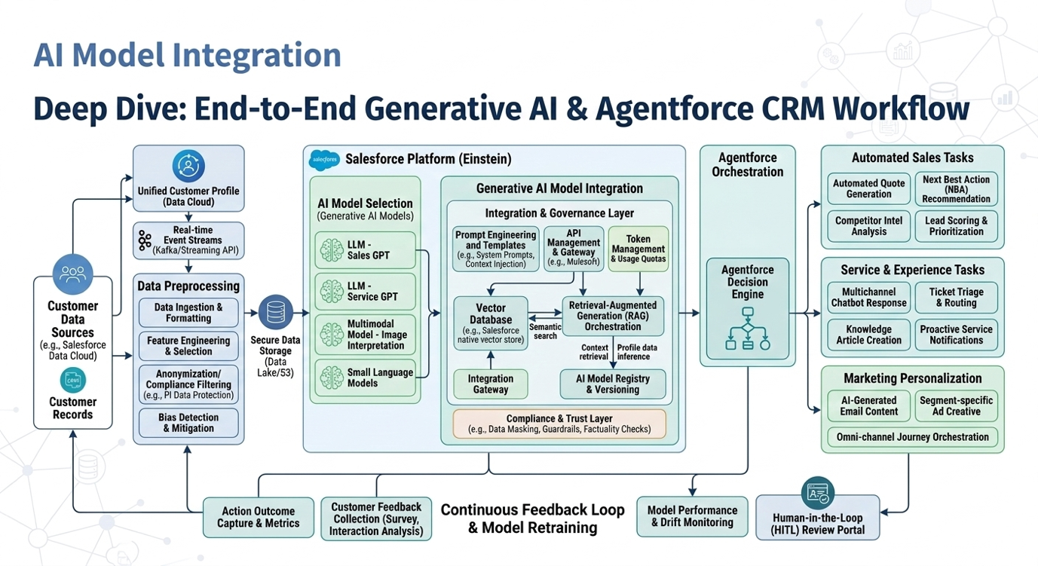
Figure 3.3: Workflow of Generative AI and Agentforce in CRM

3.5 Cloud Data Integration
Salesforce Data Cloud consolidates customer data from multiple sources, ensuring AI models access comprehensive, up-to-date information. Cloud infrastructure provides scalability, secure storage, real-time synchronization, and reliable enterprise access, enhancing AI-generated insights and system performance.

3.6 System Evaluation
Evaluation metrics include:
- Response Accuracy: Correctness of AI-generated replies
- Automation Efficiency: Extent of task automation by AI agents
- Customer Satisfaction: Improvements due to faster, personalized responses
- Task Completion Rate: Percentage of tasks executed without human intervention
These metrics determine whether generative AI and Agentforce improve CRM performance relative to traditional systems.

3.7 Reproducibility
The framework is documented to ensure replication across different organizations, including:
- System architecture
- Data preprocessing methods
- AI model configurations
- Salesforce integration procedures
- Evaluation methods
Transparent documentation allows future researchers to extend the framework, experiment with alternative AI models, and apply it to other enterprise systems.

3.8 Summary of Methodology
In this work, we present the research process and overall framework for implementing generative AI in the Salesforce CRM. By combining AI models, cloud-based data management, and autonomous agents, companies can transform traditional CRM systems into intelligent platforms capable of automated decision-making and proactive customer engagement. The approach connects theoretical research of AI with real applications where enterprises can put into action, providing a structured method for designing, implementing and assessing AI-driven CRM solutions.

4. Generative AI and Salesforce Architecture

4.1 Overview of Generative AI in CRM Systems
Generative Artificial Intelligence (Generative AI) has emerged as a transformative technology in enterprise applications. Unlike traditional AI, which focuses on prediction and classification, generative AI can create new content, including text, recommendations, summaries, and conversational responses. This makes it particularly valuable in Customer Relationship Management (CRM), where large volumes of customer interactions need timely, personalized, and contextually accurate responses across multiple communication channels.
By integrating generative AI with CRM platforms, organizations can convert customer data into actionable insights and automated responses. These models analyze historical interactions, detect behavior patterns, and generate recommendations that support sales, marketing, and customer service decision-making. Additionally, generative AI models can continuously learn from new interactions, improving the accuracy of predictions and enabling adaptive customer engagement strategies over time.

4.2 Salesforce Ecosystem for AI-Driven CRM
Salesforce is a cloud-based CRM platform that connects sales, service, marketing, and analytics in a single environment. Sales Cloud, Service Cloud, and Marketing Cloud enable organizations to monitor interactions, manage requests, and effectively launch targeted campaigns.
Salesforce applies advanced AI capabilities to predictive analytics, workflow automation, and real-time insights for personalizing customer engagement. Generative AI enables automated response generation, pattern recognition in communications, content personalization, and scenario-based decision-making to enable businesses to anticipate customer needs proactively.

4.3 Salesforce Data Cloud Integration
Salesforce Data Cloud consolidates customer data from multiple sources into a centralized environment, including CRM databases, service platforms, e-commerce, and marketing applications. This unified platform allows generative AI models to access accurate, up-to-date information, ensuring highly relevant outputs. Integration with Data Cloud enhances scalability, supports multi-channel interactions, and allows real-time AI-driven analysis for rapid decision-making.

4.4 Generative AI Model Integration
Generative AI models use transformer-based machine learning architectures to process large datasets and generate natural language outputs. Integrated with Salesforce, these models can:
- Generate automated responses to customer queries
- Create personalized marketing messages
- Summarize interactions and service histories
- Provide product recommendations
- Assist sales representatives with insights for decision-making
By continuously analyzing structured and unstructured CRM data, AI models help organizations maintain consistency and personalization across interactions, while automating repetitive tasks to improve overall efficiency.

4.5 Agent-Based Architecture with Agentforce
Agentforce allows deployment of autonomous digital agents that execute CRM tasks on behalf of users. Acting as intermediaries between AI models and operational systems, these agents can:
- Create support tickets
- Update customer records
- Send automated responses
- Trigger follow-up actions
This architecture ensures operational automation while aligning with enterprise workflows and maintaining human oversight for critical decisions.

4.6 AI-Driven CRM Workflow
The workflow begins when a customer interacts via email, chat, or social media. Salesforce stores and manages the data, which the generative AI model processes to generate actionable responses or recommendations. Agentforce agents execute these actions within the CRM system. This approach ensures rapid, personalized, and context-aware customer service, enhancing service quality, response times, and customer satisfaction. Over time, continuous AI learning improves predictive capabilities, allowing the system to anticipate and proactively address customer needs.

4.7 Benefits of Generative AI and Salesforce Integration
Key advantages of this integration include:
- Automation of routine CRM tasks, reducing manual workload
- Personalized customer interactions based on historical and behavioral data
- Faster response times and improved operational efficiency
- Continuous learning for adaptive and proactive engagement
- Scalable cloud infrastructure for managing large datasets securely
This integration also empowers employees by reducing repetitive tasks, allowing them to focus on higher-value strategic activities, and enhances organizational competitiveness in a digital-first marketplace.

4.8 Summary
Integrating generative AI with Salesforce transforms traditional CRM into intelligent, automated platforms. Generative AI models, combined with Data Cloud and Agentforce, enable proactive engagement, automated workflows, and enhanced operational efficiency. The architecture supports personalized communication, faster response times, continuous learning, and scalable AI-driven solutions, ultimately improving customer experience and driving business growth.

5. Applications of Generative AI in CRM
Generative Artificial Intelligence is redefining Customer Relationship Management (CRM) with its ability to automate communication, analyze customer interactions, and provide insights. Generative AI models are capable of generating human-like text, recommendations, and summaries from large datasets, unlike traditional analytical AI. This enables CRMs to support intelligent automation, personalized customer engagement, and data-driven decision-making.
Contemporary CRM systems, such as Salesforce, are using generative AI more and more to manage interactions more effectively and more efficiently with customers. By examining structured and unstructured customer information, these models produce meaningful results that can empower employees to better handle relationships.Key applications include:

5.1 Customer Communication Automation
It automates communications with customers by offering automated responses to customer requests on email, chat, and messaging platforms as part of the process that automatically responds to customer requests. AI models analyze conversation context and CRM records to propose or even build answers for individual replies automatically. It minimizes response times, accelerates service efficiency, and frees representatives to work on complex or high-value interactions.

5.2 A Brief Report of Customer Interaction
Customer relationship management (CRM) systems are extremely detailed and have extensive interaction histories, so there are no easy ways to review customer engagement information manually. Generative AI converts long conversations, emails, or support tickets to short briefs summarizing past issues, requests, and feedback. Workers can access the right information almost seamlessly, so they can respond more quickly and at a more personalized level.

5.3 Sales Prediction
Generative AI assists sales teams by looking at past sales activity, engagement metrics, and purchase history in order to discover potential leads and opportunities. AI-driven recommendations help to prioritize prospects, establish focused strategies, and personalize communication promoting the conversion rates and performance in terms of sales.

5.4 Marketing Content Creation
The marketing team also uses it to help them create content automatically for campaigns, emails, advertisements, and promotions. Based on customer analysis and preferences, AI models produce personalized content which allows for fine-tuned campaigns and heightened engagement and campaign results.

5.5 Intelligence of Customer Support
Generative AI further contributes to support by allowing AI to help customer support by classifying customers’ service requests, generating proposed solutions, as well as enabling conversational chatbots to provide instant solutions. The human agent can focus on very complicated issues, whereas AI can easily manage the generic but mundane type of queries, ensuring higher-quality service while reducing complexity and workload.

Table 1: Business Benefits of Generative AI in CRM
Department | Impact
Sales | Automated follow-ups, lead prioritization, opportunity insights
Marketing | Personalized campaign content, targeted messaging
Customer Service | AI-generated case summaries, chatbots, automated support
Management | Data-driven decisions, strategic insights

5.6 Cumulative Impact on CRM Performance
When combined with generative AI, productivity grows, machines become automated, and user engagement increases. AI-driven CRM technologies help you move faster to customer requirements, provide personalized experiences, and enhance business processes. We can expect potential improvements like fully autonomous CRM workflows, more sophisticated conversational agents, and predictive decision-support systems to further enhance success in CRM.

6. Challenges and Ethical Considerations
Although generative AI will substantially enhance CRM systems in many ways, its adoption means facing both technical, ethical, and organizational problems. Apps like Salesforce Einstein, Einstein Copilot, Prompt Builder, and Agentforce should be utilized responsibly to ensure customer trust and regulatory compliance.

6.1 Privacy and Security of Data
Data from CRM System: Personal, transaction, and communication information. Data protection in AI must be adhered to such as GDPR, global data protection standards, secure processing, storage, access control and so forth. Salesforce’s secure cloud is great, but internal governance policies are still needed.

6.2 Algorithmic Bias and Fairness
Fairness. Generative AI learns from data that, traditionally, can contain bias. In CRM, biased outputs may affect marketing or sales promotion ranking in particular areas such as service priorities—and may have the potential to discriminate against particular customer groups. The constant surveillance and evaluation of both fairness and bias of AI outputs are essential.

6.3 Transparency and Explainability
As such, complex AI systems are rarely transparent and it is often difficult to see how, why, or by what reasons they make the recommended courses. Understanding why explainable AI approaches work gives insights on the decision-making of decisions and increases trust and accountability. Interpretable AI solutions can even be used by Salesforce as part of those dashboards and help facilitate the comprehension of users.

6.4 Data Quality Dependence
AI outputs rely on a high-quality, complete, and consistent set of data. When data management is poor, recommendations or predictions are misleading. Companies need to use data cleaning, standardization, and validation methods in order to keep AI performant on a reliable basis.

6.5 Ethical Use of AI in Customer Interactions
AI-generated communications can communicate with customers without revealing automation, which is a matter of ethical concern. Enterprises should keep human oversight, measure automated outputs, and disclose AI involvement where applicable to maintain transparency and trust.

6.6 Governance and Responsible AI Frameworks
Einstein Trust Layer enables Salesforce secure interactions with AI, compliance, and protection of customer data. To minimize risks and maximize benefits of AI, organizations need to combine governance frameworks with internal controls.

6.7 Overview
Generative AI enhances CRM by automating processes, providing predictive insights and personalization. Still, careful management is needed to address issues like privacy, bias, transparency, data quality, and ethics. By managing it properly, companies can take full advantage of the generative promise of AI in the Salesforce ecosystem and still manage to retain trust — and keep to the law.

7. Future Trends
The evolution of Customer Relationship Management (CRM) is increasingly being determined by artificial intelligence, with respect to Generative AI and agent-based systems. Organizations expected to obtain automation, predictive insights and hyper-personalized customer experiences will lead to intelligent AI agents able to proactively operate, managing workflows and interacting with customers in natural, dynamic conversational interfaces on next-generation CRM platforms.

7.1 Intelligent Agent-Driven CRM
Intelligent Agent-Driven CRM is based on the principle of intelligent agent-based CRM. CRM in the future will be led by smart AI agents that are capable of operating independently within enterprise systems. Software like Salesforce Agentforce illustrates this trend, which lets AI agents execute multi-step operations in the sales, service and marketing functions. In addition to replying to customer queries, these agents will anticipate customer wants by analyzing historical and current data. AI agents, for instance, can follow up on high-value leads, recommend personalized offers and trigger service interventions before problems crop up, essentially, transforming CRM from reactive management to proactive engagement.

7.2 AI for Hyper-Personalization
Generative AI will allow for highly automated customer engagement across platforms. Future CRM systems will be able to instantly create content dynamically – like promotional messages, product recommendations and customer service instructions as well as support replies responding to user preference and behavior on demand to tailor content to the consumer. Solutions such as Salesforce Einstein Copilot or Prompt Builder will help organizations achieve brand voice and consistency and automate content creation automatically.
Through the use of real-time data analytics and generative AI features, companies will realise an incredible and highly personalized level of personalization with results that will be unparalleled and create more customer satisfaction and loyalty. There will be no substitute for the use of Artificial Intelligence – or even more automation – in the future.

7.3 Improved Decision-Making with Higher-Level Productive Decision Making and Prediction
Predictive and prescriptive analytics will be deployed more frequently on CRM solutions driven by AI with advanced tools of forecasting and predictive analytics on AI-powered CRM tools. Generative AI agents will emulate potential solutions, model, suggest potential results, predict customers’ behavior and suggest optimal sales, marketing and service operations strategies for sales, marketing and service operations. All of these agents will continue to learn from interactions and performance curves to get more accurate and reliable over time. The outcome will be an extremely data-centric CRM system, where strategic choices are based on near contemporaneous information and AI-powered suggestions.

7.4 Incorporation with Emerging Technologies
However, the future of CRM platforms aims to combine Generative AI with emerging technologies such as IoT, AR and advanced analytics. AI agents could be trained on IoT-generated data to make personalized recommendations, whereas AR interfaces would allow customers to interact and be immersive with the agent. Such convergence of technologies will further improve decision-making, quality customer interaction, and operational efficiency.

7.5 Ethical AI and Responsible Automation
In the future, as AI agents gain autonomy, ethical considerations along with responsible AI governance will be increasingly important as AI agents develop autonomy. Subsequent CRM systems will integrate compliance, explainable AI frameworks, and remediation strategies to counteract biases and implement embedment of compliant, understandable rules in CRM systems that promote AI adoption by implementing mechanisms of fairness, transparency, and privacy for AI. Salesforce’s current efforts like their Einstein Trust Layer already provide a good case of well-crafted trustworthy AI. Firms will have to reconcile an automated AI with human eyes on the product to be able to maintain trust and ensure a high-value customer experience.

7.6 Summary
CRM of the future could be a self-made smart and hyper-personalized one. Leveraging generative AI agents in platforms like Salesforce, businesses will keep pace with customer wants, automate complex processes, produce contextually relevant content, and provide immediate insight. In this way, it will transform CRM from an inefficient marketing system into a predictive system, for prompting salespeople with meaningful engagement, personalization, and strategic decision about large-scale decisions.

8. Conclusion
The establishment of Generative Artificial Intelligence (Generative AI) in CRM systems, and especially in the Salesforce context, is a game changing step forward for enterprise technology. The tools Salesforce Einstein, Einstein Copilot, Prompt Builder, and Agentforce provide companies with the ability to automate repetitive jobs, increase their operational efficiency, and create incredibly personal customer experiences. The ability of generative AI to analyse structured and unstructured data, create context-aware content, and assist with intelligent decision-making has substantially transformed modern CRM.
AI agents enable greater customer engagement by connecting in real time, writing automated responses and predicting customer demand. This proactive strategy helps organizations to keep closer relations with the customer, increased level of satisfaction and loyalty. On the other hand, AI can also be used by sales and marketing teams to automate repetitive tasks, surface insights to prioritize leads, and to create very personalized campaigns to cater to individual preferences.
Generative AI also adds value to organizations in how we make decisions – predictive and prescriptive analytics can be added to our analytics tools, and a great place to start. By utilizing these recommendations, AI models enable businesses to optimise resource utilization as well as react to market patterns and enhance operational efficiency. As a result, Agentforce makes sure that when there are given recommendations, these will be executed by an AI agent himself/herself, further facilitating workflows and also boosting productivity.
These benefits come with the challenge of data privacy, algorithmic bias, transparency but also ethical use that organizations must solve. Strong governance frameworks, secure data protocols, and human oversight mechanisms will be needed to ensure AI deployment is done responsibly. Using these protections will help companies maximize the value of AI-enabled CRM and ensure trust and regulatory compliance.
Conclusion Generative AI is a game changing and transforming CRM into a smart and adaptive tool. The Salesforce ecosystem – from predictive analytics, conversational AI tools, prompt management to autonomous agents – is the embodiment of how AI can improve customer engagement, drive operational efficiency, and ensure informed decision-making. Those which make full use not just of these capabilities, by leveraging them effectively, become more competitive and profitable in the digital economy, where the organization has opportunities for customer and business alike.

References (APA Style)
Bommasani, R., Hudson, D. A., Adeli, E., Altman, R., Arora, S., von Arx, S., ... & Liang, P. (2021). On the opportunities and risks of foundation models. arXiv preprint arXiv:2108.07258. https://arxiv.org/abs/2108.07258
Davenport, T., & Ronanki, R. (2018). Artificial intelligence for the real world. Harvard Business Review, 96(1), 108–116. https://hbr.org/2018/01/artificial-intelligence-for-the-real-world
Payne, A., & Frow, P. (2005). A strategic framework for customer relationship management. Journal of Marketing, 69(4), 167–176. https://doi.org/10.1509/jmkg.2005.69.4.167
Syam, N., & Sharma, A. (2018). Waiting for a sales renaissance in the fourth industrial revolution: Machine learning and artificial intelligence in sales research and practice. Industrial Marketing Management, 69, 135–146. https://doi.org/10.1016/j.indmarman.2017.12.019

