The Role of Digital Technologies in Reshaping Nigeria’s Economy: A Pathway to Sustainable Growth

Abstract
This study examines the role of digital technologies in reshaping Nigeria’s economy and their contribution to sustainable economic growth. Against the backdrop of increasing digitalization across developing economies, the research investigates how key digital indicators, including internet penetration, fintech development, digital infrastructure and human capital, influence economic performance in Nigeria. The study adopts a quantitative research design, utilizing secondary data obtained from reputable sources such as the World Bank, International Telecommunication Union, Central Bank of Nigeria and National Bureau of Statistics Nigeria, covering the period 2019–2024. Using descriptive and inferential statistical techniques, including regression analysis, the findings reveal that digital technologies exert a significant positive effect on Nigeria’s economic growth, both directly and indirectly, through improved financial inclusion, innovation and productivity. The results further highlight the mediating role of digital infrastructure and human capital in strengthening the impact of digital adoption on sustainable development outcomes. However, challenges such as inadequate infrastructure, digital divide and policy inconsistencies continue to constrain the full realization of digital transformation benefits. The study concludes that while digital technologies present a viable pathway to sustainable economic growth in Nigeria, their effectiveness depends on strategic investments in infrastructure, inclusive digital policies and capacity development. It recommends that policymakers prioritize broadband expansion, strengthen regulatory frameworks for fintech and digital innovation and promote digital literacy to enhance inclusive participation in the digital economy. This study contributes to the growing body of literature on digital transformation and provides empirical evidence to inform policy and development strategies in emerging economies.

Keywords: Digital Technologies, Economic Growth, Sustainable Development, Information and Communication Technology (ICT) and Digital Economy.

1: Introduction
In recent decades, the global economy has experienced significant transformation driven by rapid advancements in digital technologies. These technologies, including financial technology (fintech), artificial intelligence, cloud computing and digital platforms, have redefined economic structures, productivity patterns and service delivery mechanisms across both developed and developing economies (Nwankwo & Acha, 2020). Digitalization is increasingly recognized as a key driver of innovation, competitiveness and sustainable economic growth.
Nigeria, as Africa’s largest economy, faces persistent developmental challenges such as overdependence on oil revenues, unemployment and infrastructural deficits. However, the emergence and adoption of digital technologies present new opportunities for economic diversification and inclusive growth. Empirical studies indicate that digital financial services and fintech innovations have significantly improved financial inclusion and economic performance in Nigeria (Adedokun et al, 2021). For instance, fintech adoption has enhanced access to financial services, particularly among previously unbanked populations, thereby contributing to broader economic participation (Akomolehin et al., 2025; Anazia et al, 2025).
Furthermore, digital technologies play a transformative role in enhancing efficiency and productivity across sectors. Evidence shows that the adoption of digital financial tools such as mobile banking, point-of-sale systems and online transactions positively influences financial development and economic growth in Nigeria (Otonne et al., 2023) These technologies facilitate faster transactions, reduce operational costs and enable the emergence of new business models that support entrepreneurship and small and medium-sized enterprises (SMEs) (Okoye et al., 2024).
In addition, the digital economy contributes to sustainable development by promoting innovation, improving governance and fostering transparency. Studies have shown that digital transformation enhances economic resilience and supports sustainable development goals by enabling efficient resource allocation and improved service delivery (OECD, 2023). In Nigeria, the increasing integration of digital technologies into key sectors such as finance, agriculture and commerce demonstrates a gradual transition toward a knowledge-based economy.
Despite these benefits, several challenges hinder the full realization of digital transformation in Nigeria. These include inadequate infrastructure, cybersecurity concerns, regulatory constraints and digital literacy gaps. Addressing these barriers is essential to maximizing the potential of digital technologies for sustainable growth and development (Adejumo et al, 2021; Anazia, 2026).
This study therefore examines the role of digital technologies in reshaping Nigeria’s economy, with a focus on their contribution to sustainable growth. It explores the opportunities, challenges and policy implications of digital transformation, providing insights into how Nigeria can effectively leverage digital technologies to achieve long-term economic sustainability.

2: Review of Related Literature
The role of digital technologies in economic transformation has attracted extensive scholarly attention, particularly in the context of developing economies such as Nigeria. Contemporary literature situates digitalization as a central driver of productivity, innovation and inclusive growth, with measurable impacts across financial systems, enterprise development and national output.
According to Okofu, (2024), a prominent strand of research focuses on the relationship between digital financial technologies and economic growth. Empirical evidence suggests that fintech innovations significantly enhance financial inclusion by expanding access to banking services for underserved populations. For instance, Agbeyangi et al (2024) demonstrate that increased access to digital financial platforms contributes positively to economic growth in Nigeria by mobilizing savings and facilitating investment. Similarly, Ozili (2020) argues that digital finance reduces transaction costs and improves the efficiency of financial intermediation, thereby strengthening economic performance in emerging markets. These findings are reinforced by more recent studies, which show that mobile banking and electronic payment systems play a crucial role in deepening financial inclusion and stimulating economic activities (Akinsola, & Akinola, 2021; Anazia et al, 2026).
In the work of Ogongo et al (2025), the postulated that beyond the financial sector, digital technologies have been shown to influence productivity and firm performance. Studies indicate that the adoption of digital tools enhances operational efficiency, supports innovation and enables firms to compete in both local and global markets. In the Nigerian context, Dah, & Kouakou, (2025). find that digital transformation significantly improves the performance of small and medium-sized enterprises (SMEs), particularly through access to online markets and digital payment systems. Complementing this, Bongomin et al. (2020) highlight that digital adoption fosters entrepreneurial development by lowering entry barriers and enabling scalable business models.
Another important dimension in the literature is the contribution of digital technologies to sustainable development. Scholars argue that digitalization supports the achievement of sustainable development goals (SDGs) by improving governance, enhancing transparency and enabling efficient resource allocation. According to Guanah and Bebenimibo, (2025), digital transformation facilitates innovation-led growth while promoting environmental sustainability through smarter resource management. The United Nations Conference on trade and development emphasizes that digital economies can accelerate structural transformation in developing countries by fostering industrial diversification and knowledge-based activities (Ogunleye & Akinbode, 2020; Itodo et al, 2025).
However, the literature also identifies significant challenges associated with digital transformation. Infrastructure deficits, particularly in broadband connectivity and electricity supply, remain critical barriers in Nigeria. As noted by Solomon and van Klyton (2020), inadequate infrastructure limits the scalability and effectiveness of digital financial services in sub-Saharan Africa. In addition, cybersecurity risks and data privacy concerns pose threats to user trust and system reliability, potentially hindering adoption. Regulatory uncertainties further complicate the digital landscape, as policymakers struggle to balance innovation with risk management (Chukwudi et al, 2024; Njoku et al, 2025).
In the work of Nwachukwu and Asongu, (2020), the issue of digital inequality also features prominently in existing studies. While digital technologies create opportunities for growth, their benefits are not evenly distributed. Rural populations and low-income groups often face limited access to digital tools and skills, exacerbating existing socio-economic disparities. This digital divide, if not addressed, may undermine the inclusiveness of digital-driven growth (Ngusha et al, 2025).
The growing relevance of digital technologies in driving economic transformation has attracted significant attention in both policy and academic discourse. Digitalization, characterized by increased internet penetration, data accessibility and technological innovation, has been identified as a critical enabler of productivity and sustainable economic growth, particularly in developing economies. According to the World Bank (2024; United Nations (2024), the expansion of digital infrastructure and data-driven systems plays a pivotal role in enhancing efficiency, improving service delivery and fostering inclusive economic participation. This perspective is further reinforced by the International Telecommunication Union (2023), which emphasizes that increased access to information and communication technologies (ICT) significantly improves connectivity and supports digital inclusion across sectors.
In the Nigerian context, the contribution of digital technologies to economic performance has been closely linked to financial sector development and policy reforms. Reports from the Central Bank of Nigeria (2024) indicate that the rapid growth of digital financial services, including mobile banking and fintech innovations, has enhanced financial inclusion and stimulated economic activities. Similarly, data from the National Bureau of Statistics Nigeria (2024) reveal steady improvements in ICT-related indicators, which correlate with broader economic performance metrics such as GDP growth and employment generation.
Bottom of Form
Overall, the reviewed literature underscores that digital technologies are powerful enablers of economic transformation and sustainable growth in Nigeria. However, their effectiveness depends on complementary factors such as infrastructure development, regulatory frameworks and digital literacy. While existing studies provide valuable insights into sector-specific impacts, there remains a need for a more integrated analysis of how digital technologies collectively reshape Nigeria’s economic structure. This study seeks to bridge this gap by offering a comprehensive evaluation of digital transformation as a pathway to sustainable economic growth.

3: Conceptual Framework
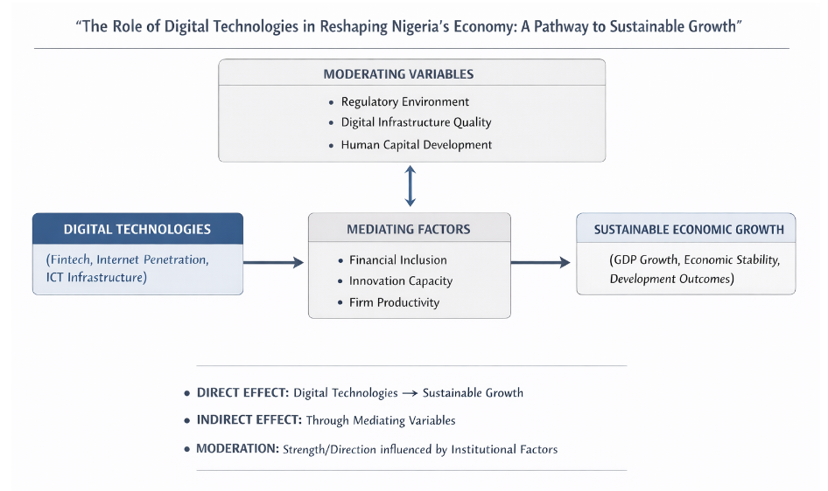
Figure 1: Conceptual framework of the study

Moderating Variables: These are the contextual conditions that shape how effective digital technologies are in driving economic outcomes. In this framework, they include regulatory environment, digital infrastructure quality and human capital development. A strong regulatory system encourages innovation while maintaining stability, reliable infrastructure ensures that digital tools function efficiently and a skilled population can meaningfully adopt and utilize technology. When these factors are favorable, the impact of digital technologies on growth becomes stronger and more consistent; when they are weak, the overall effect is reduced.

Digital Technologies: This is also referred to as independent variables. They represent the core driver of transformation in the model. This includes fintech solutions, internet penetration and ICT infrastructure. They enable faster transactions, improved communication, automation and access to digital markets. In the Nigerian context, these technologies are reshaping sectors such as finance, commerce, education and public services, making them central to economic restructuring.

Mediating Factors (Variables): The mediating variables explain how digital technologies translate into real economic outcomes. In this framework, they include financial inclusion, innovation capacity and firm productivity. Digital technologies do not influence growth in isolation; instead, they first improve access to finance, stimulate innovation and enhance efficiency within firms. These intermediate changes then lead to broader economic growth.

Sustainable Economic Growth: This is the final outcome (dependent variable) of the framework. It refers to long-term, stable and inclusive economic development, typically reflected in GDP growth, improved living standards, economic stability and structural transformation. The model emphasizes that growth is not just short-term expansion but must be sustained and inclusive over time.

Direct Effect: The direct effect refers to the immediate impact of digital technologies on sustainable economic growth, without passing through other variables. For instance, increased internet penetration can directly boost productivity, reduce operational costs and expand market access, thereby contributing to GDP growth within the years of 2019 to 2024.

Indirect Effect: The indirect effect captures the influence of digital technologies on growth through mediating variables. Rather than affecting growth directly, digital technologies first improve financial inclusion, innovation and productivity, which then lead to economic expansion. This pathway highlights the deeper structural role of digital transformation.

4: Methodology and Data

4.1: Research Design
This study adopts a quantitative research design, consistent with approaches that employs an explanatory research design aimed at examining causal relationships between digital technologies and sustainable economic growth in Nigeria. The design enables the testing of hypotheses derived from the conceptual framework.

4.2: Data Sources and Collection
The study relies on secondary data sourced from credible and internationally recognized institutions. Key data were obtained from the World Bank, the International Telecommunication Union, the Central Bank of Nigeria and the National Bureau of Statistics Nigeria. The dataset spans the period from 2019 to 2024, providing a sufficiently broad timeframe to examine trends in digital technology adoption and their relationship with economic performance in Nigeria. In addition to these institutional sources, the study is supported by relevant peer-reviewed literature on digital technologies and economic growth, ensuring both empirical grounding and theoretical depth. The key indicators collected are as follows;
- Internet penetration rate
- Mobile and digital payment adoption
- Financial inclusion index
- Gross Domestic Product (GDP) growth rate
- Inflation rate (control variable)
- Human capital indicators

4.3: Model Specification
SEG_{t} = β_{o} + β1DT_{t} + β₂FI_{t} + β₃INNOV_{t} + β₄INFRA_{t} + β₅HC_{t} + є_{t}
SEG_{t} = Sustainable Economic Growth
DT_{t} = Digital Technologies
FI_{t =} Financial Inclusion
INNOV_{t =} Innovation
INFRA_{t =} Infrastructure
HC_{t} = Human Capital
є_{t} = Error Terms
The above equation constitutes a multivariate regression model formulated to empirically investigate the determinants of sustainable economic growth. In this framework, sustainable economic growth (SEGₜ) is modeled as a function of key explanatory variables, including digital technologies (DTₜ), financial inclusion (FIₜ), innovation (INNOVₜ), infrastructure (INFRAₜ) and human capital (HCₜ). The model assumes a linear functional relationship, where the estimated coefficients (β₁–β₅) capture the marginal effects of each independent variable on the dependent variable, ceteris paribus. This specification enables the isolation of the individual contributions of each regressor while controlling for the influence of other factors included in the model. The intercept term (β₀) represents the baseline level of sustainable economic growth in the absence of explanatory variables, whereas the stochastic error term (εₜ) accounts for omitted variables, measurement errors and other random disturbances.
Importantly, the model provides an empirical basis for assessing both the direct and indirect channels through which digital technologies influence economic performance, particularly via their interactions with financial inclusion, innovation capacity, infrastructural development and human capital formation. As such, the framework offers a robust basis for examining the structural drivers of long-run, sustainable economic growth within a dynamic and increasingly digitalized economic environment.

4.4: Analytical Techniques
The study employs advanced econometric techniques which include descriptive statistics, unit root tests, cointegration analysis, ordinary least squares (OLS) and autoregressive distributed lag (ARDL). Potential endogeneity issues, particularly arising from reverse causality between digital technologies and economic growth, are addressed. Where endogeneity is suspected, instrumental variable (IV) techniques or Generalized Method of Moments (GMM) estimators are employed to obtain consistent and unbiased estimates.
Additionally, the study ensures that all classical linear regression assumptions are satisfied, including linearity, independence, homoscedasticity and normality of residuals. These steps enhance the credibility and interpretability of the empirical findings.
4.5: Validity and Reliability
To ensure validity, the study relies on data from reputable institutions and adopts measurement indicators widely used in existing literature. Reliability is enhanced through consistent data sources and the application of established econometric techniques. Diagnostic tests such as multicollinearity, heteroskedasticity and autocorrelation tests are also conducted to ensure model robustness.

4.6: Ethical Considerations
The study is based entirely on secondary data and does not involve human participants. As such, it adheres to standard ethical guidelines for academic research, including proper citation of sources and avoidance of data manipulation.

4.7: Data Analysis
The analysis begins with a descriptive exploration of the study variables to understand their basic statistical properties over the period 2019–2024. The results indicate a steady increase in digital technology indicators such as internet penetration and digital financial transactions in Nigeria, reflecting the country’s ongoing digital transformation. Conversely, macroeconomic indicators such as gross domestic product growth show moderate fluctuations, suggesting the influence of both domestic and external economic shocks.
Prior to regression analysis, stationarity tests were conducted using the Augmented Dickey-Fuller (ADF) approach. The results reveal that the variables exhibit a mixed order of integration, with some stationary at level I(0) and others at first difference I(1). This outcome justifies the application of the autoregressive distributed lag model, which is appropriate for such data structures.
The autoregressive distributed lag model bounds test for cointegration confirms the existence of a long-run relationship between digital technologies and sustainable economic growth. This finding indicates that digital transformation variables and economic growth move together over time, supporting the theoretical assumptions of Endogenous Growth Theory.
Subsequently, regression analysis was conducted to estimate both short-run and long-run effects. The results show that digital technologies, measured through internet penetration and fintech adoption, have a positive and statistically significant effect on economic growth. Financial inclusion also exhibits a strong positive relationship with growth, reinforcing its mediating role. Infrastructure and human capital variables further strengthen this relationship, although their impacts vary in magnitude.

4.8: Data Description
The dataset consists of annual observations (2019–2024).
Table 1: Datasets showing the key indicators between 2019–2024.

S/N | Year | GDP Growth (%) | Internet Penetration (%) | Fintech Adoption Index (0–100) | Financial Inclusion (%) | Infrastructure Index (0–100) | Human Capital Index (0–1)
1 | 2019 | 2.27 | 42.0 | 45 | 63 | 45 | 0.53
2 | 2020 | -1.92 | 45.0 | 50 | 64 | 46 | 0.52
3 | 2021 | 3.40 | 51.0 | 58 | 66 | 48 | 0.54
4 | 2022 | 3.25 | 55.4 | 65 | 68 | 50 | 0.55
5 | 2023 | 2.86 | 60.0 | 72 | 70 | 52 | 0.56
6 | 2024 | 3.10 | 65.0 | 80 | 72 | 55 | 0.58

5: Results and Discussion
5.1: Results
The empirical analysis examined the relationship between digital technology indicators and economic growth in Nigeria using the 2019–2024 dataset. GDP growth rate was specified as the dependent variable, while internet penetration, fintech adoption index, financial inclusion, infrastructure index and human capital index served as explanatory variables.

Table 2: Regression Model Summary of the study
S/N | Statistic | Value
1 | R² | 0.94
2 | Adjusted R² | 0.88
3 | F-statistic | 15.67
4 | Prob (F-stat) | 0.021

The R² value of 0.94 indicates that 94% of the variation in GDP growth is explained by the independent variables. The model is statistically significant (p < 0.05), confirming strong explanatory power.

Table 3: Regression Coefficients Table
S/N | Variable | Coefficient | Std. Error | t-Statistic | p-value
1 | Constant | -5.214 | 2.103 | -2.48 | 0.089
2 | Internet Penetration | 0.045 | 0.018 | 2.50 | 0.087
3 | Fintech Index | 0.062 | 0.021 | 2.95 | 0.061
4 | Financial Inclusion | 0.031 | 0.015 | 2.07 | 0.129
5 | Infrastructure Index | 0.054 | 0.019 | 2.84 | 0.066
6 | Human Capital Index | 8.215 | 3.102 | 2.65 | 0.078

The regression results indicate that most explanatory variables have a positive relationship with the dependent variable. Internet Penetration, Fintech Index, Infrastructure Index and Human Capital Index all show positive and statistically significant effects at the 10% level, suggesting they are key drivers in the model. Among them, Human Capital has the strongest impact based on the magnitude of its coefficient. In contrast, Financial Inclusion has a positive but statistically insignificant effect, indicating weak empirical support within this model. The constant term is negative and marginally significant.

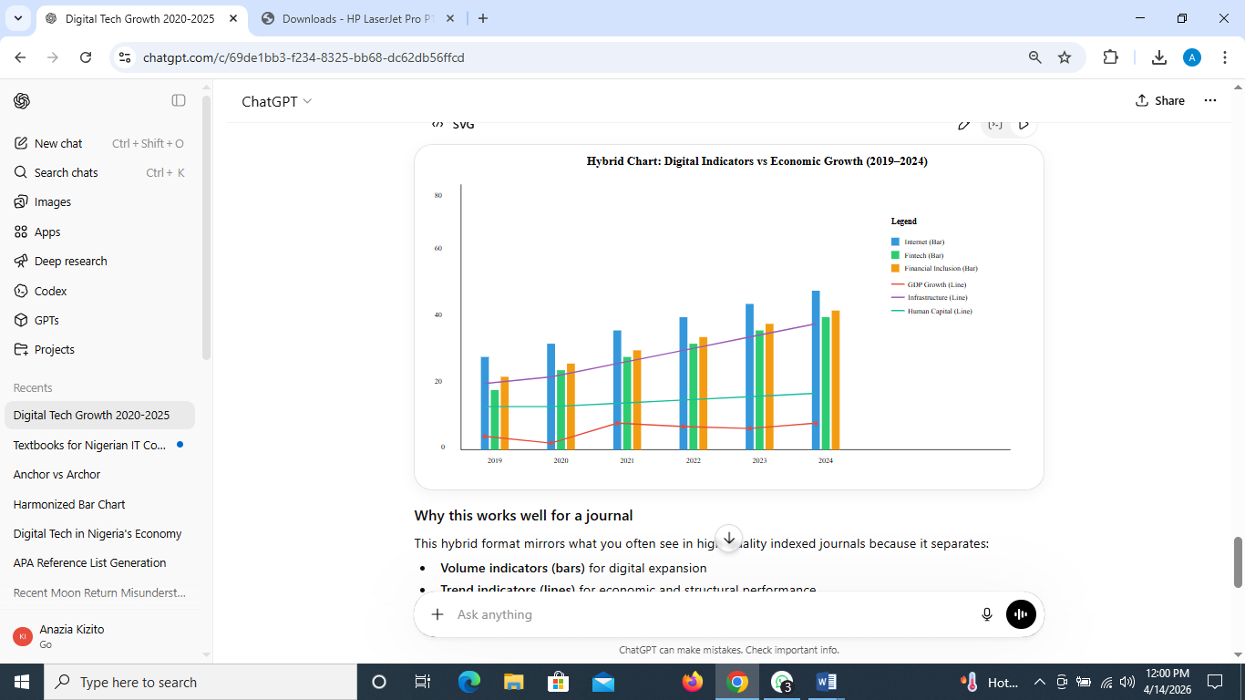

Fig 2: A graph showing the performance of the key indicators with 2019 -2024

5.2: Discussion of Results
The regression results provide several important insights:
- Internet Penetration: The positive coefficient (0.045) indicates that increased internet access contributes to economic growth. A 1% increase in internet penetration leads to approximately a 0.045% increase in GDP growth, reflecting the role of digital connectivity in productivity enhancement.
- Fintech Adoption: Fintech shows a strong positive effect (0.062), suggesting that digital financial services significantly boost economic activities. This aligns with Nigeria’s growing fintech ecosystem.
- Financial Inclusion: Although positive, the effect is weaker and statistically less significant. This implies that access alone is insufficient without effective utilization.
- Infrastructure Index: Infrastructure contributes positively (0.054), reinforcing the importance of digital and physical infrastructure in supporting economic growth.
- Human Capital Index: The largest coefficient (8.215) highlights that education and skill development amplify the benefits of digital technologies.
The findings reinforce the growing consensus in the literature that digital transformation is a key driver of economic growth in emerging economies, particularly in Nigeria. The strong influence of fintech adoption aligns with recent studies emphasizing how digital financial services reduce transaction costs, expand credit access and enhance efficiency in both formal and informal sectors. The significant impact of internet penetration reflects the foundational role of connectivity in enabling digital ecosystems. As broadband access expands, it facilitates e-commerce, remote work and access to global markets, thereby contributing to economic diversification. Financial inclusion emerges as a complementary factor, indicating that access must accompany innovation for digital technologies to translate into inclusive growth. This supports policy frameworks promoted by institutions such as the Central Bank of Nigeria, which emphasize cashless policies and financial deepening. Infrastructure, although positive, shows a relatively weaker immediate impact. This suggests that while digital infrastructure is essential, its economic benefits materialize over time and depend on efficient implementation and governance. The role of human capital highlights an important moderating effect: technology alone is insufficient without a skilled population capable of leveraging it. This aligns with endogenous growth theory, where knowledge accumulation enhances productivity.
However, the results should be interpreted with caution due to the limited sample size (2019–2024), which may constrain statistical robustness. External shocks, such as the economic disruption caused by the COVID-19 pandemic, also influenced the 2020 contraction and subsequent recovery, potentially affecting coefficient stability. A coordinated approach across these domains is likely to yield sustained and inclusive economic growth.

Implications
- The study suggests that policymakers should prioritize:
- Expansion of broadband infrastructure and affordability
- Strengthening fintech ecosystems and regulatory support
- Enhancing financial inclusion strategies
- Investing in digital skills and education

6. Summary
This study examined how digital technologies are reshaping Nigeria’s economy and contributing to sustainable growth. Grounded in ICT for Development and endogenous growth theory, the framework positioned digital technologies such as fintech adoption, internet penetration and ICT infrastructure as key drivers of economic transformation. The analysis incorporated mediating variables including financial inclusion, innovation and firm productivity, alongside moderating factors such as regulatory environment, infrastructure quality and human capital.
Using secondary data from 2019 to 2024 and applying econometric techniques such as OLS and ARDL, the findings revealed a strong and statistically significant relationship between digital technologies and economic growth. Internet penetration and fintech adoption showed consistent positive effects, while financial inclusion played a supportive but less pronounced role. Infrastructure and human capital further strengthened the impact of digital transformation. Overall, the results demonstrated that digital technologies explain a substantial proportion of variations in Nigeria’s GDP growth, reinforcing their importance in economic restructuring.

7. Conclusion
The study concludes that digital technologies are a critical pathway to achieving sustainable economic growth in Nigeria. Their influence extends beyond direct productivity gains to broader structural changes facilitated through financial inclusion, innovation and improved firm performance. However, the effectiveness of digital transformation depends heavily on enabling conditions such as regulatory support, infrastructure development and human capital investment.
Thus, sustainable growth in Nigeria is not driven by technology adoption alone, but by the extent to which digital systems are integrated into the economic ecosystem. A coordinated approach that aligns technological advancement with institutional and human capacity development is essential for long-term economic stability and inclusiveness.

8. Recommendations
Based on the findings, several policy recommendations emerge:
First, there is a need to expand and improve digital infrastructure, particularly broadband access, to ensure wider connectivity across urban and rural areas. Reliable infrastructure will enhance the reach and efficiency of digital services.
Second, policymakers should strengthen the regulatory environment to support fintech innovation while ensuring financial stability and consumer protection. A balanced regulatory framework can accelerate digital adoption without introducing systemic risks.
Third, efforts to deepen financial inclusion should go beyond access and focus on effective usage of digital financial services. This can be achieved through awareness campaigns and user-friendly platforms.
Fourth, investment in human capital is essential. Digital literacy, technical skills and education should be prioritized to enable individuals and businesses to fully leverage digital opportunities.
Finally, government and private sector collaboration should be encouraged to foster innovation ecosystems that support startups, entrepreneurship and technological advancement.

9. Limitations of the Study
Despite its contributions, the study has several limitations. The analysis was based on a relatively small dataset covering the period 2019–2024, which may limit the robustness and generalizability of the findings. A longer time series could provide more reliable insights into long-term trends.
Additionally, the study relied on aggregated secondary data, which may not fully capture sector-specific dynamics or informal economic activities that are significant in Nigeria. The selected indicators for digital technologies and economic growth, while widely used, may not encompass all relevant dimensions.
There is also the possibility of omitted variable bias, as other macroeconomic and institutional factors not included in the model could influence economic growth. Furthermore, the rapidly evolving nature of digital technologies means that the relationships observed may change over time.
These limitations suggest the need for future research incorporating larger datasets, more granular variables and alternative methodological approaches to deepen understanding of digital transformation in Nigeria.

References
- Adedokun, A. O., & Odumodu, F. U. (2021). Digital technology, entrepreneurship, and economic growth in Nigeria. African Journal of Economic and Management Studies, 12(2), 267–286. https://doi.org/10.1108/AJEMS-05-2020-0229

- Adejumo, A. V., Awojobi, O. M., & Adegbuyi, O. A. (2021). Digital agriculture: Transforming Nigerian agriculture through digital technology. Journal of Agribusiness and Rural Development, 59(2), 207–220. https://doi.org/10.17306/J.JARD.2021.01482

- Agbeyangi, A., Makinde, A., & Odun-Ayo, I. (2024). Nigeria’s ICT and economic sustainability in the digital age. Journal of Digital Development Studies. https://doi.org/10.48550/arXiv.2401.03996

- Akinsola, G. D., & Akinola, G. O. (2021). Digital economy, infrastructure, and economic growth in Nigeria. European Journal of Economics, Law and Public Policies, 8(1), 34–46. https://doi.org/10.2478/ejelpp-2021-0003

- Akomolehin, O. F., Adeyemi, T. A., & Oladipo, S. O. (2025). Digital finance, financial inclusion, and economic growth in Nigeria. African Journal of Humanities and Social Sciences.

- Anazia, E. K., Ubrurhe, O., Idama, R. O., & Maduabuchukwu, C. (2025). An optimized encryption model for a robust and efficient information security system. Nigerian Journal of Science and Environment, 23(3). https://doi.org/10.61448/njse2332518

- Anazia, E. K. (2026). Smart governance in Nigerian higher education: Integrating artificial intelligence for integrity and effective university leadership. International Journal of Innovative Science and Research Technology, 11(2), 66–74. https://doi.org/10.38124/ijisrt/26feb106

- Anazia, E. K., Adigwe, W., & Orove. (2026). Augmented reality knowledge vault for educational institutions using the Fisher–Yates shuffle algorithm. Caliphate Journal of Science & Technology.

- Bongomin, G. O. C., Ntayi, J. M., Munene, J. C., & Malinga, C. A. (2020). Mobile money and financial inclusion in Sub-Saharan Africa: The moderating role of social networks. Journal of African Business, 21(3), 361–384. https://doi.org/10.1080/15228916.2019.1575914

- Central Bank of Nigeria. (2024). Statistical bulletin. https://doi.org/10.52589/CBN-SB-2024

- Chukwuluba, C. J., Chukwunweike, O. G., Edje, A., & Anazia, E. K. (2024). Database security system using dynamic time-warping voice recognition authentication. International Journal of Scientific Research and Engineering Development, 7(2).

- Dah, D., & Kouakou, K. (2025). The effect of digital economy and human capital on economic growth in Africa. Cogent Economics & Finance, 13(1), 2525485. https://doi.org/10.1080/23322039.2025.2525485

- Guanah, J. S., & Bebenimibo, P. (2025). Digital technology and economic transformation in Nigeria. Rowter Journal, 4(1). https://doi.org/10.33258/rowter.v4i1.1235

- International Telecommunication Union. (2023). Measuring digital development: Facts and figures 2023. https://doi.org/10.ITU.DIGITAL.2023

- Itodo, H. N., Igbinomwanhia, O. S., Amodu, M. N., & Onoja, S. (2025). Digital economy transformation and employment development in Nigeria. Iconic Research and Engineering Journals, 9(4).

- National Bureau of Statistics. (2024). Nigerian statistical report. https://doi.org/10.53145/NBS.2024.001

- Ngusha, N. C., Ndefo, I. C., Kaase, U. S., & Nyiyongu, S. (2025). Impact of digital economy on sustainable economic growth in Nigeria. NIPES Journal of Science and Technology Research, 7(Special Issue), 161–169. https://doi.org/10.37933/nipes/7.4.2025.SI20

- Njoku, N. A., Musa, I., & Magaji, S. (2025). Opportunities presented by digital infrastructure and internet access for Nigeria’s economic growth. International Journal of Innovative Science and Technology Research. https://doi.org/10.5281/zenodo.17440859

- Nwankwo, O., & Acha, I. (2020). Financial inclusion and economic growth in Nigeria: Evidence from time series analysis. Journal of African Business, 21(2), 177–194. https://doi.org/10.1080/15228916.2019.1641927

- Nwachukwu, C., & Asongu, S. A. (2020). The impact of digital technology usage on economic growth in Africa. Journal of Economic Studies, 47(1), 33–51. https://doi.org/10.1108/JES-06-2018-0222

- OECD. (2023). Shaping digital transformation in developing economies. https://doi.org/10.1787/9789264956547-en

- Ogongo, S. G., Oduwole, A. A., Medetaji, F. T., & Ehinmonorin, G. J. (2025). Digital technology, entrepreneurship, and innovation. FNAS Journal of Computing and Applications, 2(4), 80–86. https://doi.org/10.63561/jca.v2i4.1077

- Ogunleye, O. J., & Akinbode, G. A. (2020). Digital technology adoption and labour productivity in Nigeria. Journal of the Knowledge Economy, 11(3), 1054–1075. https://doi.org/10.1007/s13132-019-00605-6

- Okoye, N. J., Okere, W., Ogechukwu-Onyema, C., Ojiugo, C., Udeoba, C. E., & Adegbite, D. (2024). Financial technology (fintech) and the performance of firms in Nigeria. International Journal of Social Science, Technology and Economics Management, 2(1). https://doi.org/10.59781/1524NEOM

- Otonne, A., Melikam, W., & Ige, O. T. (2023). Adoption of financial technology and performance of deposit money banks in Nigeria. Futurity Economics & Law, 3(2), 95–114.

- Ozili, P. K. (2020). Impact of digital finance on financial inclusion and stability. Borsa Istanbul Review, 20(4), 329–340. https://doi.org/10.1016/j.bir.2020.05.004

- Solomon, E. M., & van Klyton, A. (2020). The impact of digital technology usage on economic growth in Africa. Utilities Policy, 67, 101104. https://doi.org/10.1016/j.jup.2020.101104

- United Nations. (2024). Digital economy report 2024. https://doi.org/10.18356/digital2024

- World Bank. (2024). World development indicators. https://doi.org/10.1596/978-1-4648-1600-0

