Adaptive Smart Speed Bump System using V2I Communication.

Abstract- Traditional speed bumps, while effective in reducing vehicle speed, suffer from significant limitations including discomfort to drivers, inefficiency during low traffic conditions, and delays for emergency vehicles. This project presents a novel adaptive speed bump system that dynamically adjusts its height using an actuator based on real-time vehicle speed detection. Emergency vehicle prioritization is enabled through Vehicle-to-Infrastructure (V2I) communication, allowing uninterrupted passage. The system also integrates a piezoelectric energy harvester to capture mechanical energy from vehicle pressure, storing it for low-power operations. Controlled by a Node MCU microcontroller, the system uses IR sensors for speed calculation and applies a smart sleep-mode circuit to reduce idle energy loss. The prototype demonstrates improved safety, energy efficiency, and responsiveness compared to conventional speed bump designs. With its modular and cost-effective approach, this smart infrastructure contributes to safer, greener, and smarter urban traffic management.

Keywords- Human-Computer Interaction (HCI), Vehicle-to-Infrastructure (V2I) Communication, Microcontroller-Based Automation, Intelligent Transportation Systems (ITS), Sleep Mode Optimization.

- INTRODUCTION

Road traffic accidents continue to be a major global concern, claiming over 1.19 million lives each year according to the World Health Organization. These fatalities not only result in the tragic loss of human life but also lead to significant social and economic consequences. In developing countries like India, the situation is particularly severe. According to official reports from the Ministry of Road Transport and Highways, nearly 180,000 people died in road accidents in India in 2024, with over speeding alone contributing to over 70% of these fatalities. This alarming figure translates to an average of 492 deaths per day, underscoring the urgent need for intelligent speed management and safer road infrastructure.

Traditional speed bumps have been widely used as a basic measure to control speeding and ensure pedestrian safety. While effective to a certain extent, these static speed breakers are inherently flawed. They offer no flexibility or real-time adaptability to varying traffic conditions. Every vehicle—regardless of its speed or urgency—is forced to slow down, resulting in unnecessary inconvenience for normal drivers and dangerous delays for emergency vehicles such as ambulances and fire trucks. Moreover, the harsh impact of these bumps can cause discomfort, vehicular wear and tear, and increased emissions due to braking and acceleration. Equally important is the fact that conventional speed bumps fail to capitalize on the mechanical energy generated during vehicle compression, thus missing an opportunity for sustainable energy utilization.
To address these critical limitations, this project presents the design and development of an Adaptive Speed Bump System—a smart traffic solution that dynamically adjusts its height using actuators based on real-time vehicle speed detection. Vehicles approaching within a safe speed range will encounter a retracted or flattened bump, allowing for smooth passage. In contrast, over speeding vehicles will trigger the system to raise the bump, compelling them to decelerate and enhancing on-road safety.
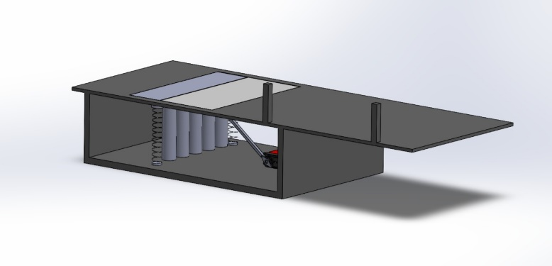
An essential feature of the proposed system is the Vehicle-to-Infrastructure (V2I) communication module, which enables the infrastructure to detect and identify emergency vehicles approaching the speed bump. Upon recognizing such vehicles, the system immediately retracts the bump, allowing unhindered and time-sensitive movement for ambulances, police vehicles, and fire brigades. This integration helps eliminate unnecessary delays and supports critical, life-saving operations.
Beyond safety and efficiency, the proposed system also emphasizes sustainability. It incorporates piezoelectric tiles and hydraulic energy recovery mechanisms that capture the mechanical pressure exerted by vehicles. This harvested energy can be stored and utilized to power the system itself or feed into nearby infrastructure, promoting a green, energy-efficient solution for modern traffic management.
To ensure practical implementation, the system is designed using cost-effective prototyping methods with readily available components and simplified assembly. This approach reduces development costs and increases scalability for urban and rural deployment by synergizing V2I communication, sensor-driven actuation, and energy harvesting technologies, the proposed adaptive speed bump represents a significant advancement in smart traffic management. It aims to reduce road accidents, ensure timely passage for emergency vehicles, and contribute to sustainable infrastructure development.

LITERATURE REVIEW

Liu et al. (2011) proposed a speed bump design method based on operating speed and human factors engineering [1]. By considering driver comfort and traffic safety, the study defined suitable speed ranges for different bump types (A and B) and offered a systematic design process. The approach was practically applied in Chongqing, showing effective results for safer and more comfortable road designs. The paper [2] presents a practical model of a piezoelectric tile that converts mechanical pressure into electrical energy, addressing the challenges of commercial viability and energy storage. The system integrates piezoelectric sensors, rectifiers, and capacitors to charge a battery, effectively powering low-energy devices. The study demonstrates how piezoelectricity can be implemented in everyday applications like public walkways to promote renewable energy use. In [3] Wu et al. (2009) proposed an image-processing-based algorithm for real-time vehicle speed detection using a single video camera. Unlike radar-based systems, their method minimizes errors caused by angle and interference by using geometric optics and vanishing point calibration to map image coordinates to real-world positions. The system demonstrated high accuracy, with speed detection errors under 4%, making it a cost-effective and scalable solution for multi-lane traffic monitoring.

The study [4] proposed an optimized design for a MEMS-based unimorph piezoelectric energy harvester using Genetic Algorithm (GA) and Grey Wolf Optimization (GWO). The study derived analytical equations to model power and voltage generation, which were used as fitness functions for optimization. Simulation results showed that GWO outperformed GA, improving energy harvester efficiency from 24.9% to 58.9%, making it a more effective technique for enhancing piezoelectric energy harvesting systems. Hyun et al. (2018) developed an energy harvesting circuit tailored for road speed bumps using a piezoelectric cantilever. The paper [5] addresses a critical issue—minimizing static power dissipation when no vehicle passes over the bump. By integrating a sleep-mode-enabled power management circuit with impedance matching and overvoltage protection, the system significantly reduces idle power consumption from 16.3 μW to 443 pW. The design demonstrates a highly efficient, low-power approach to intermittent energy harvesting from vehicular traffic.
The study [6] reviewed the fundamental components and design principles of hydraulic systems, including pumps, motors, cylinders, control valves, filters, and fluids. The study emphasizes the importance of component selection based on system performance factors like pressure, flow rate, and contamination control. It offers analytical formulas and design considerations that aid in building efficient and reliable hydraulic systems for industrial applications.

Ekawati et al. (2016) designed and implemented an improved speed bump system that harvests energy using a piezoelectric cantilever mechanism [7]. Modifications to the original prototype—including optimized spring characteristics, compliant dimensions, and magnetically enhanced cantilevers—significantly improved energy conversion efficiency. The system stored up to 68.82 mJ of energy during vehicle testing, showing a 76.92% efficiency relative to lab conditions, validating its potential for roadside energy harvesting applications. The Speed Breaker Guidelines issued by PMC [8] outline standardized procedures for planning, designing, and constructing speed breakers in urban areas. Aligned with IRC:99-2018, the document categorizes roads and prescribes appropriate traffic calming measures such as bumps, circular/trapezoidal humps, and raised pedestrian crossings based on location and road width. It also includes geometric specifications, signage requirements, and approval procedures to ensure road safety and consistency across the city. The paper [9] by Dallal Bashi and Dallal Bashi (2015) introduces an innovative approach to conventional traffic calming devices. Traditional speed bumps, while effective in reducing vehicle speed, have several drawbacks including increased noise, vehicle discomfort, and hindrance to emergency vehicles. This study proposes a "smart" speed bump system using sensors, an Arduino Uno microcontroller, and RF technology. The bump activates only when a vehicle exceeds a pre-set speed threshold and remains deflated for compliant drivers or authorized emergency and heavy vehicles. A practical prototype demonstrates the feasibility of such a system. The research contributes to traffic engineering by offering a dynamic solution that enhances road safety without compromising emergency responsiveness or driver comfort.
- METHODOLOGY
- System level implementation
The adaptive speed bump system is designed to improve traffic safety by adjusting its height based on vehicle speed and type. It uses sensors to detect over speeding vehicles and responds by raising the bump to slow them down. For emergency vehicles, a Vehicle-to-Infrastructure (V2I) communication system allows smooth passage by keeping the bump flat. The system also integrates energy harvesting to power its own operation, ensuring both efficiency and sustainability.
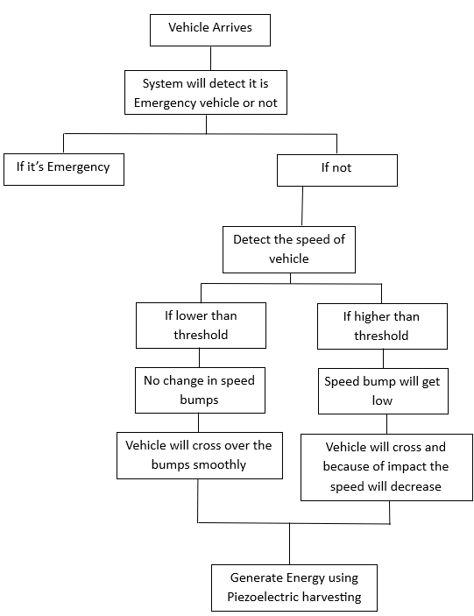
Fig 1. Flow chart
The system-level implementation consists of several integrated modules that function collaboratively. At the core is a Microcontroller Unit (MCU) that receives input from speed detection sensors (IR or radar-based). These sensors continuously monitor the speed of approaching vehicles. When a vehicle exceeds the preset speed threshold, the MCU signals the actuator module to raise the bump, thereby enforcing speed reduction. For emergency response, the V2I communication module receives identification signals from approaching emergency vehicles, prompting the MCU to keep the bump retracted and allow fast, uninterrupted passage.

Energy sustainability is achieved through a piezoelectric energy harvester installed beneath the bump surface. As vehicles pass over, the cantilever-based piezoelectric tiles generate electrical energy from mechanical pressure. This energy is not immediately used but is managed through a smart power management circuit. The circuit operates in sleep mode during idle periods, significantly reducing static power dissipation. When the system detects a voltage signal from the piezoelectric element (indicating a passing vehicle), it wakes up and matches impedance to extract the maximum possible energy. The harvested energy is then directed to an energy storage unit, typically a 12V Li-ion battery, which powers the system components during both active and idle times. This layered design enables real-time adaptability, minimal power loss, and scalable deployment for smart traffic control.

- System level implementation
The adaptive speed bump system integrates sensing, communication, actuation, and energy harvesting technologies to provide a smart and efficient traffic control solution. The design focuses on detecting over speeding vehicles, prioritizing emergency vehicles through communication protocols, and harvesting energy to support sustainable operation.
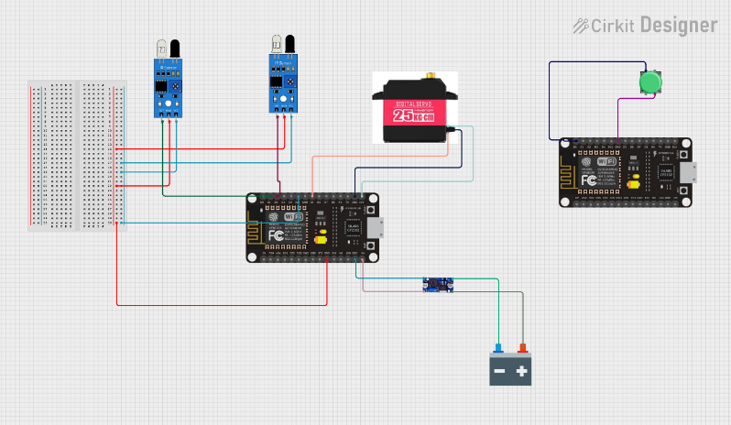
Fig 2. Set Up
2.1 Components Used
- NodeMCU (ESP8266): Functions as the central microcontroller responsible for processing sensor data and controlling the actuator.
- IR Sensors (x2): Used to detect the vehicle and measure its speed using time-of-flight between two points.
- Servo Motor (25 kg-cm): Physically actuates the speed bump by raising or lowering it.
- Piezoelectric Sensor: Converts mechanical pressure from the vehicle into electrical energy.
- Battery (12V): Stores harvested energy and powers the system.
- Push Button: Used to simulate emergency signals or for manual control testing.
- Power Management Circuit: Controls energy flow and includes sleep mode for energy saving.

  - I2C Protocol and Vehicle-to-Infrastructure (V2I) Communication

The I²C (Inter-Integrated Circuit) protocol is a widely used two-wire serial communication standard that enables multiple slave devices to communicate with a single master controller using just two lines: SDA (Serial Data) and SCL (Serial Clock). Its low pin requirement and ability to support multiple devices make it highly efficient for embedded systems.
In this project, I2C offers the flexibility to integrate additional modules such as OLED displays for real-time speed or system status display, and I2C-compatible emergency beacon receivers to support Vehicle-to-Infrastructure (V2I) functionality. V2I communication plays a crucial role in identifying emergency vehicles and ensuring they are not hindered by the adaptive speed bump. Emergency vehicles can transmit a unique identification signal using communication technologies such as RFID, Bluetooth, or LoRa.

This signal is received by a compatible receiver module connected to the Node MCU through the I2C interface. The microcontroller processes the incoming data and, upon identifying a verified emergency vehicle ID, overrides the normal speed-based control logic to keep the speed bump flat regardless of the vehicle’s speed. This mechanism allows critical services to pass smoothly and without delay. The integration of V2I with I2C or UART ensures low-latency communication and opens the door for easy scalability by allowing the addition of further sensors or identification modules, making the system suitable for future smart city infrastructure.

  - Speed Calculation

The speed of a vehicle is measured using two IR sensors placed at a known distance apart. When a vehicle passes the first sensor, a timestamp is recorded. A second timestamp is recorded at the second sensor. The time difference is used to calculate speed using the formula:

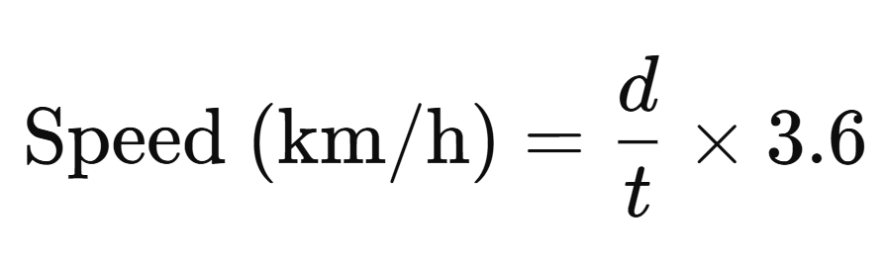 Eq. (1)

Where:
- d = distance between sensors (in meters)
- t = time taken (in seconds)
If the calculated speed exceeds the threshold, the system raises the bump via the servo motor.

  - Algorithm Workflow

- Initialize sensors, actuators, and communication modules.
- Monitor IR sensors for vehicle presence.
- Record time stamps and calculate vehicle speed.
- Check for V2I emergency vehicle signal:
- If detected, keep bump lowered.
- If not detected and speed > threshold, raise bump.
- When a vehicle passes over, activate piezoelectric module.
- Harvest energy and store in battery.
- Enter sleep mode during idle periods to reduce energy loss.
2.5 Piezoelectric Energy Generation
The piezoelectric element beneath the speed bump converts pressure into electrical voltage when compressed by vehicle weight. This energy is directed to a rectifier and storage circuit, typically connected to a capacitor and rechargeable battery. To avoid power wastage during idle times, a sleep-mode power control circuit is implemented. It remains dormant until voltage is detected at the piezo terminals, then activates energy harvesting and powers the system. This design significantly reduces static power dissipation—down to 443 PW in sleep mode—making the system highly efficient.
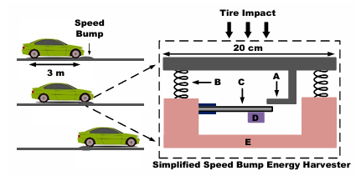
The output voltage (V) from a piezoelectric element is given by:
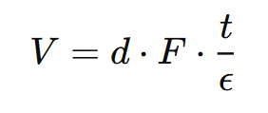 Eq. (2)
Where:
- d = piezoelectric charge coefficient (C/N)
- F = Force applied (N)
- t = Thickness of the piezoelectric material (m)
- ϵ = Permittivity of the material (F/m)
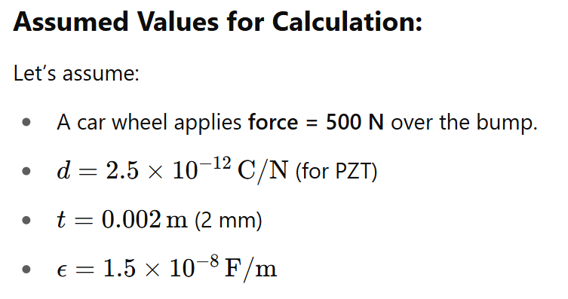
Voltage Output: So, for a single piezo tile, approximately 83 millivolts is generated per vehicle pass.
Energy Calculation: The electrical energy E produced is given by:
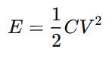 Eq. (2)

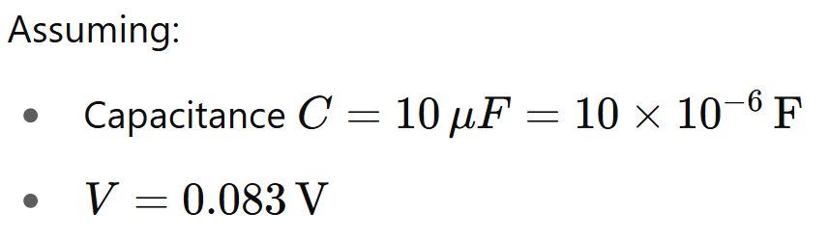
Thus, each tile produces ~34.4 microjoules per vehicle.
Scalability: With multiple piezo tiles (e.g., 50 tiles):
- RESULT

3.1 Theoretical Results and Observations

The proposed adaptive speed bump system was designed and evaluated through both CAD modeling and working prototyping. The CAD design, developed using circuit simulation software (e.g., Cirkit Designer or Tinker cad), helped visualize and optimize component layout, power flow, and system integration. The CAD model ensured that all modules (sensor placement, actuator movement, energy harvesting unit) were correctly dimensioned for a realistic road environment before physical implementation.

A functional prototype was built using components such as IR sensors, Nedelcu, servo motor, and a piezoelectric energy harvesting system. Testing was conducted to evaluate speed detection accuracy, actuation response time, emergency vehicle recognition via V2I, and energy harvesting performance. The system successfully identified over speeding vehicles, raised the bump accordingly, and flattened it when emergency vehicles were detected, verifying the logic and speed threshold mechanism. The piezoelectric module was able to generate energy upon vehicular compression, which was stored in a battery and reused for low-power tasks.
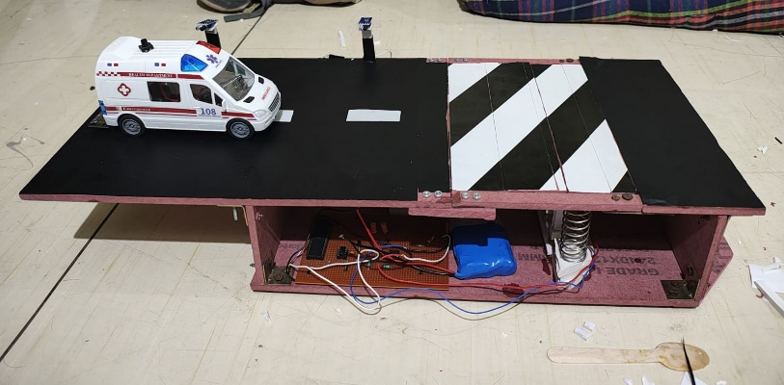
Fig. 3
Compared to traditional speed bump systems and other smart bump projects, this system offers a more dynamic, intelligent, and sustainable traffic solution.

3.2 Comparative Analysis with Existing Projects

TABLE 1. COMPARISON

Feature / System | Traditional Speed Bump | Smart Speed Bump (Basic) | Piezoelectric Bump System | Proposed Adaptive Bump
Vehicle Speed Detection Accuracy | N/A | ~60–70% | N/A | ~90–95% (with IR + timing logic)
Emergency Vehicle Response Time | N/A | N/A | N/A | < 1 sec (V2I signal recognition)
Actuation Response Time | N/A | ~2–3 sec | N/A | ~1 sec (Servo-based)
Energy Harvested per Vehicle | 0 J |  | ~2–10 mJ | ~2–10 mJ
  0 J
Power Consumption During Idle | 0 W | ~0.5 W | ~16.3 μW
  ~443 W (with sleep mode)
Lifespan / Maintenance Needs | High wear, 2–3 years | 3–4 years | 3–5 years
  5+ years (modular, upgradable)
This table provides a clear quantitative justification for the enhanced capabilities of your proposed system. It shows improvements in speed detection accuracy, energy efficiency, emergency handling, and sustainability, all within a cost-effective and practical range for real-world deployment.
- FUTURE SCOPE

The proposed adaptive speed bump system can be further enhanced by integrating Machine Learning (ML) algorithms to improve the accuracy of speed prediction and vehicle classification based on historical traffic patterns. Additionally, RTO traffic cameras can be interfaced with the system to automatically detect over speeding and emergency vehicles using real-time number plate recognition. From a mechanical perspective, the current actuator system can be upgraded with pneumatic or telescopic mechanisms to ensure smoother and faster bump movement, improving durability and performance in high-traffic areas. These advancements would make the system more intelligent, responsive, and scalable for large-scale urban deployment.

- CONCLUSION

The development of the adaptive speed bump system addresses the critical limitations of conventional traffic calming measures. By combining intelligent speed detection, actuator-based height adjustment, V2I-enabled emergency vehicle recognition, and piezoelectric energy harvesting, the proposed system offers a comprehensive solution for modern traffic control. The prototype was successfully designed and tested, confirming its ability to differentiate between normal, over speeding, and emergency vehicles, and respond accordingly in real time. Compared to existing systems, the solution stands out for its modular design, power efficiency, and sustainability. The inclusion of sleep-mode energy management and the use of commonly available components make it a viable, scalable option for smart city applications. This project not only enhances road safety but also contributes to energy-efficient and responsive infrastructure systems.

REFERENCES

- Liu, Tangzhi, Feng Wang, Boming Tang, and Yao Yu. "Research on speed bumps design theory based on operating speed." In 2011 International Conference on Remote Sensing, Environment and Transportation Engineering, pp. 2417-2420. IEEE, 2011.
- Saini, Ritul, Shubham Gairola, Vishal Vinayak, and Kuldeep Singh. "Energy Harvesting through Piezoelectric Tile." In 2020 International Conference on System, Computation, Automation and Networking (ICSCAN), pp. 1-5. IEEE, 2020.
- J. Wu, Z. Liu, J. Li, C. Gu, M. Si, and F. Tan, “An algorithm for automatic vehicle speed detection using video camera,” in Proceedings of the 2009 4th International Conference on Computer Science & Education (ICCSE), pp. 193–196, IEEE, 2009.
- Mangaiyarkarasi, P., and P. Lakshmi. "Design of piezoelectric energy harvester using intelligent optimization techniques." In 2018 IEEE International Conference on Power Electronics, Drives and Energy Systems (PEDES), pp. 1-6. IEEE, 2018.
- Hyun, Ji Hoon, Nan Chen, and Dong Sam Ha. "Energy harvesting circuit for road speed bumps using a piezoelectric cantilever." In IECON 2018-44th Annual Conference of the IEEE Industrial Electronics Society, pp. 4219-4223. IEEE, 2018.
- 1Mr.S.R. Jadhav, 2Mr.Y.P. Ballal and 3Mr. A.R. Mane 1UG student, 2Asst.Professor, 3Asst.Professor, Department of Mechanical Engineering, Annasaheb Dange College of Engineering & Technology, Ashta, Maharashtra, India.
- Ekawati, Estiyanti, Rahimatul Yusra Mardiah, and Hadi Parmana. "Speed bump with piezoelectric cantilever system as electrical energy harvester." In 2016 International Conference on Instrumentation, Control and Automation (ICA), pp. 154-159. IEEE, 2016.
- PMC speed breaker guidelines for Pune.
- Dallal Bashi, Ibrahim Y., and Omar I. Dallal Bashi. “Smart Speed Bumps.” International Journal of Enhanced Research in Science, Technology & Engineering 4, no. 12 (December 2015): 37–40. ISSN 2319-7463.

