LEARNING ACROSS BORDERS

A Comparative Case Study of Belgian and Indian Education Systems

Abstract

International student exchange programmes provide valuable opportunities for prospective educators to observe and reflect upon different educational systems. Exposure to alternative curriculum structures, teaching approaches, and assessment methods enables teacher trainees to develop a broader understanding of how education functions in diverse institutional contexts.

The present study examines the organisation of curriculum and assessment practices within the Belgian higher education system through a semester-long academic exchange programme at UCLL University of Applied Sciences, Leuven. Using a qualitative observational approach, the study analyses course selection processes, interdisciplinary learning experiences, learner autonomy, and evaluation methods observed during the exchange semester. These observations are then compared with the general structure and practices of the Indian education system.

The analysis indicates that the Belgian system places considerable emphasis on curriculum flexibility, interdisciplinary learning, and diversified assessment methods such as project work, oral examinations, and portfolio evaluation. These practices encourage learner autonomy, reflective engagement, and practical application of knowledge. In contrast, the Indian education system largely follows a more structured curriculum framework and relies predominantly on written examinations to maintain standardised evaluation across institutions.

The study highlights how differences in curriculum organisation and assessment philosophy influence student learning experiences and professional preparation within teacher education programmes. While both systems address distinct educational priorities, the findings suggest that selected elements such as experiential learning, flexible curriculum pathways, and varied assessment practices may contribute positively to ongoing educational reforms in India.

Keywords: Student exchange programme, Teacher education, Curriculum comparison, Assessment practices, Learner autonomy, Experiential learning

Introduction

The increasing interconnectedness of societies has significantly influenced educational systems across the world. Globalisation has encouraged institutions to engage in international collaboration, academic mobility, and comparative educational research. Within this context, student exchange programmes have emerged as valuable platforms that allow prospective educators to experience different curriculum structures, teaching methodologies, and assessment practices beyond their own national education systems.
Teacher education programmes particularly benefit from such exposure because teaching is not limited to the transmission of subject knowledge; it also involves understanding diverse pedagogical approaches, cultural perspectives, and learning environments. Observing educational practices in different institutional contexts enables teacher trainees to critically examine their own educational systems and reflect upon alternative approaches that may contribute to improving teaching and learning processes.

The present study is based on an academic exchange programme undertaken at UCLL University of Applied Sciences in Leuven, Belgium. During the semester-long exchange, the researcher engaged with interdisciplinary courses and observed curriculum organisation, classroom interactions, and assessment practices within the Belgian higher education system. These observations provided an opportunity to examine how curriculum flexibility, learner autonomy, and diversified evaluation methods operate within a European academic framework.

Rather than presenting a personal narrative of the exchange experience, the study adopts a comparative academic perspective. It seeks to analyse key features of the Belgian education system and compare them with the general structure of the Indian education system. Such a comparison is particularly relevant in the context of current educational reforms in India, which emphasise learner-centred approaches, experiential learning, and greater flexibility in curriculum design.

By examining similarities and differences between the two systems, the study aims to generate insights that may contribute to ongoing discussions on curriculum development, assessment practices, and teacher education within the Indian educational context.

Need of the Study

In the contemporary era of globalisation, educational systems across the world are undergoing significant transformation to respond to evolving societal, technological, and professional demands. Teacher education, in particular, requires continuous adaptation to ensure that future educators are equipped with the competencies necessary to function effectively in diverse and dynamic learning environments.

Despite ongoing educational reforms, the Indian education system continues to face challenges related to curriculum rigidity, examination-oriented assessment practices, and limited opportunities for learner autonomy. While recent policy initiatives such as the National Education Policy (NEP) 2020 emphasize flexibility, experiential learning, and competency-based assessment, there remains a need to examine how such educational principles are implemented within established international education systems.
International student exchange programmes provide unique opportunities for prospective educators to directly observe and analyse alternative curriculum models, pedagogical approaches, and assessment frameworks in real institutional settings. However, there is limited research documenting experiential academic observations of European higher education systems from the perspective of Indian teacher trainees.

The present study is therefore needed to bridge this gap by providing a structured comparative case study analysis of curriculum organisation and assessment practices within the Belgian higher education system, as observed through a semester-long exchange programme at UCLL University of Applied Sciences, Leuven. By comparing these practices with the Indian education system, the study seeks to generate insights that may contribute to ongoing discussions on educational reform, learner-centred pedagogy, and professional preparation within teacher education programmes.

Aim of the Study

The present study aims to examine and compare curriculum structure and assessment practices within the Belgian higher education system and the Indian education system. The study seeks to understand how differences in curriculum flexibility, learner autonomy, and assessment methodologies influence teaching-learning processes, student engagement, and professional preparation of future educators.

Objectives of the Study

The study is conducted with the following objectives:

To analyse the curriculum organisation and course selection framework followed at UCLL University of Applied Sciences, Belgium.
To examine the academic contribution of interdisciplinary exchange courses in developing teacher education competencies.
To investigate assessment and evaluation approaches adopted within the Belgian higher education system.
To conduct a comparative analysis between the Belgian and Indian curriculum and assessment frameworks.
To explore the relevance of learner-centred and experiential learning practices for strengthening the education system in India.

Research Questions

The study attempts to address the following research questions:

- How does curriculum organisation within the Belgian education system differ from the Indian education system?
- How do assessment and evaluation practices in Belgian higher education compare with those followed in India?
- To what extent does learner autonomy influence curriculum design and learning outcomes in the Belgian education system?
- How does interdisciplinary learning contribute to teacher education in Belgium compared to India?
- What implications do the Belgian curriculum and assessment practices hold for reforms in Indian education?

Research Methodology

  - Research Design

The present study adopts a qualitative observational comparative case study design, grounded in direct academic experience gained during a semester-long student exchange programme at UCLL University of Applied Sciences, Leuven, Belgium. The research is primarily experiential in nature, based on systematic academic observation of curriculum organization, classroom practices, and assessment frameworks within a real educational setting.

This design was selected because it enables an in-depth, contextual understanding of educational practices as they naturally occur within an institutional environment. Rather than relying on surveys or experimental methods, the study emphasizes reflective academic observation and comparative interpretation of educational systems.

Nature of the Study
The study is experience-based, observational, and comparative. It is not a personal narrative but a structured academic investigation grounded in direct participation within the Belgian higher education system through the exchange programme.
The exchange semester functioned as a natural research setting, allowing systematic observation of:

Curriculum flexibility and course selection processes
Teaching-learning approaches and classroom interactions Assessment practices and evaluation frameworks
Interdisciplinary and intercultural learning environments
These observations were then comparatively analyzed with reference to the Indian education system.

Sources of Data
The study relies entirely on primary experiential data and institutional academic documents collected during the exchange programme. Data sources include:

Direct classroom observations across selected interdisciplinary courses Personal academic engagement within the UCLL learning environment Course syllabi, brochures, and curriculum guidelines
Assessment formats, rubrics, and evaluation criteria
Institutional academic schedules and learning agreements
Reflective comparative analysis based on prior knowledge of the Indian education system These sources collectively formed the qualitative data base for analysis.

Data Collection Method
Data were collected through structured academic observation conducted throughout the exchange semester. The observation process involved:
Attending lectures, workshops, and collaborative learning sessions Examining curriculum documents and course structures
Observing assessment methods and evaluation processes
Recording reflective academic notes to document key educational practices
The observation was non-interventional, focusing on understanding institutional functioning rather than influencing educational processes.

Data Analysis Method
The collected data were analyzed using a thematic qualitative analysis approach. Observational findings were systematically categorized into key educational dimensions, including:
Curriculum organization and flexibility
Learner autonomy and pedagogical orientation Interdisciplinary learning practices
Assessment strategies and evaluation frameworks

These themes were then comparatively interpreted in relation to the Indian education system to identify similarities, differences, and educational implications.

Scope of the Study
The scope of the study is limited to:
Educational practices observed during the exchange programme at UCLL University Teacher education-related interdisciplinary courses undertaken during the semester
Curriculum structure and assessment frameworks within the Belgian higher education context Comparative reference to the Indian education system

Limitations of the Study
The study has the following limitations:
It is confined to a single institutional setting and exchange programme experience Findings are context-specific and not intended for statistical generalization
The study relies primarily on observational qualitative data without large-scale sampling
Comparative insights regarding the Indian system are based on academic knowledge rather than field observation.

Answering the Research Questions

The study aimed to examine curriculum organisation and assessment practices within the Belgian higher education system and to compare them with the Indian education framework. Based on observations made during the academic exchange programme at UCLL University of Applied Sciences and a comparative reflection on the Indian education system, the research questions are addressed as follows:

How does curriculum organisation within the Belgian education system differ from the Indian education system?
The Belgian higher education system demonstrates a considerable degree of curriculum flexibility and institutional autonomy. During the exchange programme at UCLL University of Applied Sciences, students were provided with a course information brochure listing subjects from different departments along with their respective credit values. In order to fulfil the academic requirements of the semester, exchange students were required to complete a total of 24 credits.

Unlike traditional degree programmes where students follow a fixed course structure, exchange students were allowed to select courses from multiple departments according to their academic interests and professional goals. Students were also permitted to attend introductory classes before finalising their course selections. Once the courses were confirmed, the Individual Study Programme (ISP) was approved by the academic coordinator, resulting in a personalised timetable for each student.

This flexible approach contrasts with the structure commonly followed in the Indian education system. In India, curricula are generally predetermined by universities and regulatory authorities, and students often follow a fixed sequence of subjects within their academic programme. Although such standardisation ensures uniformity across institutions, it provides comparatively fewer opportunities for interdisciplinary course selection.

The structural differences between the Belgian and Indian education systems can be summarised in the following table.

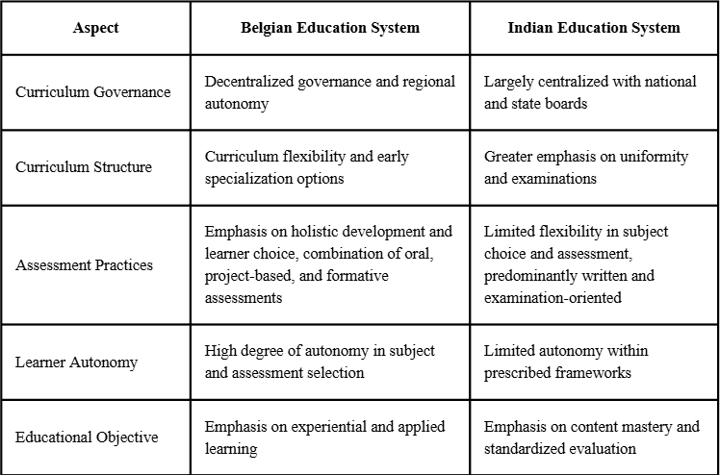

This comparison illustrates how the Belgian system prioritises flexibility and learner participation in academic decision-making, while the Indian system emphasises structured learning pathways and standardised academic progression.

How do assessment and evaluation practices in Belgian higher education compare with those followed in India?
Assessment practices observed at UCLL University reflect a competency-based and learner-centred evaluation framework. Rather than relying solely on traditional written examinations, the assessment system incorporates various forms of evaluation such as oral examinations, group projects, presentations, reflective assignments, and portfolio submissions.

These methods are designed to evaluate not only students’ theoretical understanding but also their ability to apply knowledge in practical contexts. For instance, oral examinations encourage students to explain concepts clearly and demonstrate analytical thinking, while project-based assignments require students to work collaboratively and examine real-world issues. Portfolio assessments allow students to document their learning process and reflect upon their academic progress throughout the semester.

In contrast, the Indian education system relies predominantly on written examinations for assessing student performance. This approach helps maintain consistency and comparability across a large and diverse educational system. However, the strong emphasis on examination-based evaluation can sometimes limit opportunities for practical application, creativity, and reflective learning.

The broader differences in educational priorities and learning approaches between the two systems can also be illustrated through the following comparative overview.

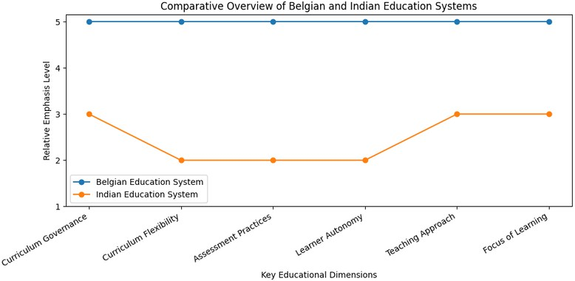

Figure 1: Comparative Overview of Belgian and Indian Education Systems

The comparison highlights how diversified assessment methods in the Belgian system support continuous learning and deeper conceptual understanding, while the Indian system focuses more strongly on uniform assessment procedures.

To what extent does learner autonomy influence curriculum design and learning outcomes in the Belgian education system?
Learner autonomy plays an important role in shaping curriculum design within the Belgian higher education system. Students are encouraged to take responsibility for their academic choices and learning processes. The opportunity to select courses across departments allows students to explore areas that align with their interests and professional aspirations.

Several courses undertaken during the exchange programme also reflected this emphasis on autonomy. Students were often given flexibility in determining the format of their assessments, which could include presentations, written reflections, or project-based work. Such practices encourage students to actively participate in the learning process rather than simply preparing for examinations.

This autonomy contributes positively to learning outcomes by fostering motivation, responsibility, and independent thinking. Students become more engaged with the subject matter and develop stronger analytical and reflective skills.

In comparison, the Indian education system provides fewer opportunities for such autonomy. Course structures and evaluation methods are generally predetermined, which may limit the scope for individualised learning experiences within the curriculum.

How does interdisciplinary learning contribute to teacher education in Belgium compared to India?
Interdisciplinary learning formed an important aspect of the academic experience during the exchange programme. The courses undertaken covered diverse areas such as intercultural communication, sustainable development, ethical issues in information technology, comparative education, and professional communication.

These subjects provided opportunities to examine educational issues from multiple perspectives and encouraged students to engage with social, cultural, and ethical dimensions of education. Classroom discussions often included students from different countries and academic backgrounds, creating a diverse and collaborative learning environment.

Such interdisciplinary exposure is particularly valuable in teacher education, as it helps future educators develop broader perspectives on teaching, communication, and global educational challenges. Exposure to multicultural learning environments also strengthens intercultural competence and encourages reflective thinking about educational practices.

Although interdisciplinary approaches are gradually emerging in Indian education through recent reforms, traditional teacher education programmes have historically focused more strongly on subject- specific learning.

What implications do the Belgian curriculum and assessment practices hold for reforms in Indian education?

The comparative analysis suggests that certain elements of the Belgian education system may offer useful insights for strengthening educational practices in India. Flexible curriculum structures and interdisciplinary learning opportunities can support the development of critical thinking and broaden students’ academic perspectives.

Similarly, incorporating diversified assessment methods such as project work, presentations, and reflective assignments may allow educators to evaluate student learning in a more comprehensive manner. Such approaches encourage students to apply knowledge, engage actively with course content, and develop practical skills relevant to professional life.

However, it is also important to recognise that the Indian education system operates within a large and diverse national context. Standardised curricula and examination systems play an important role in maintaining consistency and equitable evaluation across institutions.

Recent policy initiatives, particularly the National Education Policy (NEP) 2020, indicate a growing emphasis on experiential learning, flexibility in subject choice, and competency-based assessment. The gradual integration of these principles within existing educational frameworks may contribute to more balanced and learner-responsive educational practices in India.

Educational Implications and Concluding Observations

The present study highlights meaningful differences in curriculum organization and assessment practices between the Belgian and Indian education systems, reflecting distinct educational priorities shaped by contextual, structural, and policy considerations. The Belgian higher education framework, as observed through the semester exchange programme, emphasizes learner autonomy, experiential learning, and diversified assessment strategies, while the Indian education system prioritizes standardization, scalability, and comparability across a broad and diverse learner population.

Rather than positioning one system as superior, the findings underscore how educational structures are designed to respond to specific social, institutional, and demographic needs. The Belgian model illustrates how flexible curriculum pathways and formative assessment practices can support sustained academic engagement and reflective learning. At the same time, the Indian system demonstrates the importance of maintaining uniform standards to ensure equitable access and consistent evaluation outcomes.

The findings suggest that curriculum models emphasizing autonomy, reflection, and applied learning may offer viable alternatives to exclusively examination-driven approaches, particularly within professional preparation programmes. Integrating such elements in a context-sensitive manner, without undermining standardization or equity, may contribute to more balanced and learner-responsive educational frameworks.

These findings align with international perspectives advocating experiential and learner-centered approaches in teacher education (Dewey, 1938; UNESCO, 2015).

Conclusion and Recommendation

- Conclusion

The present study examined curriculum organisation and assessment practices within the Belgian higher education system and compared them with the Indian education framework. The findings of the study highlight several important differences in how the two systems structure learning opportunities, evaluate student performance, and support the professional development of future educators.

One of the most notable differences lies in the level of curriculum flexibility. The Belgian education system allows students to select interdisciplinary courses and engage in personalised learning pathways. Such flexibility enables students to explore diverse academic perspectives and take greater responsibility for their learning. In contrast, the Indian education system generally follows a more structured curriculum framework where course selection and academic progression are predetermined by institutional guidelines.

The comparison of assessment practices also reveals significant differences. The Belgian system employs a variety of evaluation methods, including oral examinations, project-based assignments, presentations, and portfolio assessments. These approaches encourage continuous engagement with academic material and focus on the application of knowledge. In contrast, assessment within the Indian system remains largely examination-oriented, relying primarily on written tests to ensure uniform evaluation across institutions.

Learner autonomy emerged as another key feature of the Belgian system. Students are encouraged to make decisions regarding course selection, learning strategies, and assessment formats. Such autonomy promotes self-directed learning and reflective academic engagement. While the Indian education system provides a strong academic structure, opportunities for independent decision-making within the curriculum are relatively limited.

Interdisciplinary learning also plays a significant role in the Belgian teacher education framework. Courses addressing communication, sustainability, ethical issues, and global education perspectives contribute to the development of well-rounded professional competencies. Such interdisciplinary exposure is less common in traditional teacher education programmes in India, which tend to emphasise subject-specific learning.

Overall, the study demonstrates that both education systems reflect different educational priorities. The Belgian model emphasises flexibility, autonomy, and experiential learning, while the Indian system prioritises standardisation, accessibility, and consistent evaluation. Understanding these differences provides valuable insights for improving curriculum design and assessment practices within teacher education programmes.

Recommendation

Based on the findings of the study, several recommendations may be considered for strengthening educational practices within the Indian education system.

  - Introducing greater curriculum flexibility
  - Educational institutions may consider providing students with more opportunities to select interdisciplinary courses and explore diverse academic areas. Such flexibility can support broader intellectual development and encourage student engagement.
  - Promoting experiential and applied learning approaches
  - Incorporating project-based activities, collaborative assignments, and real-world learning experiences can help students develop practical understanding alongside theoretical knowledge.
  - Diversifying assessment methods
  - While written examinations remain important for standardised evaluation, introducing additional forms of assessment such as presentations, portfolios, and applied projects may provide a more comprehensive evaluation of student learning.
  - Encouraging learner autonomy
  - Allowing students greater responsibility in choosing learning activities and assessment formats may enhance motivation, critical thinking, and independent learning skills.
  - Strengthening interdisciplinary perspectives in teacher education
  - Integrating subjects related to communication, cultural understanding, ethics, and global education issues can help future educators develop a more holistic understanding of teaching in diverse educational contexts.

It is important that any such changes be implemented in a context-sensitive manner that recognises the scale and diversity of the Indian education system. A balanced approach that combines flexibility with institutional standardisation may help create more responsive and effective educational frameworks.

R e f e r e n c e s

Dewey, J. (1938). Experience and education. New York: Macmillan. https://books.google.com/books?id=Yt0KAAAAIAAJ

European Commission/EACEA/Eurydice. (2023). The structure of the European education systems: Belgium. Luxembourg: Publications Office of the European Union. https://eurydice.eacea.ec.europa.eu/national-education-systems/belgium

Kolb, D. A. (1984). Experiential learning: Experience as the source of learning and development. Englewood Cliffs, NJ: Prentice Hall.
https://books.google.com/books?id=jp beBQAAQBAJ

Ministry of Education, Government of India. (2020). National Education Policy 2020. New Delhi: Government of India. https://www.education.gov.in/sites/upload_files/mhrd/files/NEP_Final_English_0.pdf

OECD. (2020). Education policy outlook: Belgium. Paris: OECD Publishing. https://www.oecd.org/education/policy -outlook/country -profile-belgium-2020.pdf

UNESCO. (2015). Education 2030: Incheon declaration and framework for action. Paris: UNESCO. https://unesdoc.unesco.org/ark:/48223/pf0000245656

