Adoption of AI Tools in Business Analytics:
Determinants and Organizational Impact

Abstract
The use of Artificial Intelligence (AI) in Business Analytics is rapidly changing how organizations analyze data and make decisions. AI-based tools help businesses move beyond traditional reporting by enabling predictive insights, automation, and faster, more accurate decision-making. Despite these advantages, the level of AI adoption differs across organizations due to various internal and external factors. This study explores the key determinants that influence the adoption of AI tools in business analytics using the Technology–Organization–Environment (TOE) framework, supported by the Resource-Based View (RBV) and Technology Acceptance Model (TAM). It examines how technological factors such as system compatibility and data quality, organizational factors like management support and employee skills, and environmental factors including competition and regulations affect adoption decisions. In addition, the study analyzes how AI adoption impacts organizational outcomes, particularly in terms of operational efficiency, financial performance, and strategic flexibility. A quantitative research approach is proposed, where data will be collected through structured questionnaires and analyzed using Structural Equation Modeling (SEM). The expected findings suggest that organizations with better preparedness and strong leadership support are more likely to successfully implement AI tools, resulting in improved performance and a stronger competitive position in the market.
Keywords: Artificial Intelligence (AI), Technology–Organization–Environment (TOE) Framework, Resource-Based View (RBV), Technology Acceptance Model (TAM), AI Adoption, Organizational Performance, Digital Transformation

1.Introduction
Artificial Intelligence (AI) has become an important factor in transforming Business Analytics. Earlier, organizations mainly depended on traditional methods to analyze past data, but AI now enables predictive and real-time decision-making. Technologies like machine learning and natural language processing help businesses process large amounts of data quickly and generate accurate insights.
Leading companies such as Microsoft, IBM, Google, SAP, and Salesforce have integrated AI into their analytics platforms, encouraging wider adoption across industries.
However, not all organizations adopt AI at the same pace due to challenges like lack of skills, limited resources, and resistance to change. Therefore, this study focuses on identifying the key factors influencing AI adoption in business analytics and examining its impact on organizational performance.
1.1 Background of the Study
Business analytics has evolved from simple data reporting to advanced, AI-driven decision-making. Earlier, organizations focused on analyzing past data, but with the rise of Artificial Intelligence (AI), they can now predict future trends and make faster, more accurate decisions. AI technologies help process large amounts of data and generate useful insights, making analytics more powerful. As a result, businesses are increasingly using AI to improve efficiency, support decision-making, and stay competitive in the market.
1.2 Problem Statement
Although Artificial Intelligence (AI) offers significant benefits in business analytics, its adoption is not consistent across all organizations. While some firms actively use AI tools to improve decision-making and efficiency, others struggle due to challenges such as limited technical skills, high implementation costs, poor data quality, and resistance to change. In many cases, organizations are unsure about how to integrate AI into their existing systems or lack the resources needed for successful adoption. This creates a gap between the potential advantages of AI and its actual use in practice. Therefore, it is important to identify the key factors influencing AI adoption and understand how these factors affect organizational performance.
1.3 Significance of the Study
This study is important because it helps in understanding how organizations can effectively adopt Artificial Intelligence (AI) in business analytics. It provides useful insights for managers and decision-makers to identify the key factors that support or hinder AI adoption. By highlighting these factors, the study can guide organizations in improving their strategies, making better decisions, and enhancing overall performance. Additionally, it contributes to academic knowledge by offering a structured approach to analyzing AI adoption and its impact, which can be useful for future research in this field.
2.Literature Review
Business analytics has passed through three broadly recognized phases. The first phase, descriptive analytics, focused on reporting what had already happened and dominated organizational practice well into the 2000s. The second phase, predictive analytics, leveraged statistical modelling to forecast future outcomes and gained commercial traction as computing costs fell in the 2010s. The third and current phase, prescriptive and cognitive analytics, uses AI and machine learning to recommend or even autonomously execute decisions in real time (Davenport & Harris, 2017). Each transition was driven by a combination of technical enablement — cheaper storage, faster processors, better algorithms — and strategic necessity. Competitive pressure from digitally native firms forced traditional organizations to upgrade their analytical capabilities, while the explosion in available data from mobile devices, sensors, and social platforms created both the raw material and the urgency for more sophisticated tools (Bharadwaj et al., 2013). AI tools in analytics today span a wide spectrum: from automated machine learning (AutoML) platforms that democratize model building, to large language models that generate natural-language summaries of complex datasets, to reinforcement learning systems that optimize supply chains or pricing engines in real time. The sheer variety of these tools means that 'AI adoption' is not a single decision but a portfolio of technology investments, each with its own adoption calculus.
Empirical studies of AI adoption in business contexts have converged on several recurring themes, though the precise weighting of each factor varies by industry, organizational size, and national context.
Top Management Support. Perhaps the single most consistently cited enabler of enterprise AI adoption is visible, substantive commitment from senior leaders (Ransbotham et al., 2020). This goes beyond budget allocation: it includes championing AI initiatives in strategic communications, tolerating the failures inherent in experimentation, and aligning incentive structures to reward data-driven decision-making. Organizations where executives treat AI as a strategic priority rather than an IT project move faster and capture greater value.
Data Readiness and Infrastructure. AI analytics tools are only as good as the data fed into them. Poor data quality, fragmented data governance, and legacy infrastructure are among the most commonly cited barriers to AI adoption in surveys of enterprise practitioners (NewVantage Partners, 2023). Data readiness encompasses not only the technical dimensions of storage, integration, and cleansing but also the organizational dimensions of ownership, stewardship, and access policy.
Workforce AI Literacy. The ability of employees at all levels to understand, critically evaluate, and act on AI-generated insights is a prerequisite for embedding these tools in decision workflows. Workforce AI literacy operates on at least two levels: technical literacy among data scientists and analysts who build and maintain models, and interpretive literacy among business users who must translate model outputs into action. Low literacy at either level creates adoption bottlenecks (Wilson & Daugherty, 2018).
Perceived Usefulness and Trust in AI. Even when AI tools are technically available and organizationally supported, individual employees often resist adoption if they do not trust model outputs or see clear personal benefit. Trust in AI is multidimensional, encompassing cognitive trust based on perceived accuracy and reliability, and affective trust rooted in perceived transparency and fairness (Toreini et al., 2020). Explainable AI (XAI) approaches are increasingly being deployed to close the trust gap by making model reasoning accessible to non-technical users.
Regulatory Clarity and Ethical Governance. As AI analytics tools move into high-stakes decision domains — credit scoring, medical diagnosis, hiring, criminal justice — the regulatory environment becomes an increasingly important adoption determinant. Ambiguous or restrictive regulation can create compliance uncertainty that slows adoption, while clear, proportionate frameworks can provide the confidence needed for organizations to invest at scale. The European Union's AI Act, enacted in 2024, represents the most comprehensive attempt to date to create such a framework
The literature on the organizational impacts of AI analytics adoption is growing rapidly, though it remains more descriptive than causal. Several key themes have emerged.Decision quality and speed are the most commonly reported benefits. Studies in financial services, logistics, and retail consistently find that AI-augmented decision-making outperforms unaided human judgment on tasks involving large datasets, non-linear relationships, or high-frequency decisions (Agrawal et al., 2018). The gains are most pronounced in structured, repetitive decision contexts; in novel or highly ambiguous situations, human judgment retains a comparative advantage.
Operational efficiency gains are significant but unevenly distributed. Organizations that successfully integrate AI into core workflows report cost reductions of 15 to 30 percent in targeted processes (McKinsey Global Institute, 2023), but these gains often reflect displacement of labor rather than pure productivity enhancement, raising equity concerns that organizations are only beginning to grapple with.
On the negative side, algorithmic bias and fairness failures have become prominent concerns. AI models trained on historical data can perpetuate or amplify existing patterns of discrimination, with documented consequences in hiring, lending, and law enforcement. Managing this risk requires ongoing monitoring, diverse development teams, and explicit fairness constraints in model design.
Organizational learning and knowledge management are also affected. AI analytics tools shift the locus of analytical insight from experienced human practitioners toward encoded model knowledge. This can accelerate insight generation but may also erode tacit organizational knowledge if employee skill development is neglected in favor of automated tools.
3. Research Methodology
This study adopts a qualitative research design based on a systematic review of existing literature to examine the determinants of Artificial Intelligence (AI) adoption in business analytics and its organizational impact. Instead of collecting primary data, the research relies on secondary data sourced from academic journals, research papers, and conference publications available on platforms such as Google Scholar, ResearchGate, and ScienceDirect. As explained by John W Creswell (2014), qualitative research is suitable for developing a deeper understanding of concepts through existing studies, while Uma Sekaran and Roger Bougie (2016) highlight the importance of secondary data in theoretical research. Relevant studies were selected based on their focus on AI adoption, business analytics, and organizational performance, with preference given to recent and peer-reviewed work. The study also considers established frameworks such as the TOE model proposed by Louis G Tornatzky and Mitchell Fleischer (1990). The collected data is analyzed using thematic analysis to identify key patterns and common factors influencing AI adoption, as suggested by Virginia Braun and Victoria Clarke (2006). Although the study is limited by its reliance on secondary data, it provides meaningful insights by integrating findings from multiple sources.
3.1 Scope of the Study
This study focuses on understanding the adoption of Artificial Intelligence (AI) tools in business analytics by analyzing existing research and published studies. It mainly examines the key factors influencing AI adoption, including technological, organizational, and environmental aspects. The study also explores how the use of AI impacts organizational performance in terms of efficiency, decision-making, and strategic growth. The scope is limited to secondary data collected from academic journals, research papers, and credible online sources. It does not include primary data collection or real-time organizational analysis. Additionally, the study provides a general understanding of AI adoption across industries rather than focusing on a specific sector.
3.2 Objectives of the Study
- To identify the key factors that influence the adoption of Artificial Intelligence (AI) in business analytics.
- To examine the role of technological, organizational, and environmental factors in AI adoption.
- To analyze the impact of AI adoption on organizational performance.
- To review and summarize existing studies related to AI adoption in business analytics.
4. Discussion
4.1 Impact of AI Adoption on Organizational Performance
4.1.1 Data Integration and Process Efficiency
The literature consistently shows that AI-enabled business analytics improves organizational performance by integrating data across functions and automating workflows. AI tools consolidate data from multiple departments into unified systems, reducing fragmentation and improving visibility. According to Thomas H Davenport and Ronanki (2018), AI-driven automation reduces manual effort and enhances process speed, allowing organizations to streamline operations. Similarly, Wamba et al. (2017) found that data integration through analytics significantly improves operational efficiency and coordination.
This is supported by Figure 4.1, which shows that operational efficiency improves by around 25% due to AI adoption. Automation of repetitive tasks such as reporting and forecasting reduces errors and improves consistency in processes.
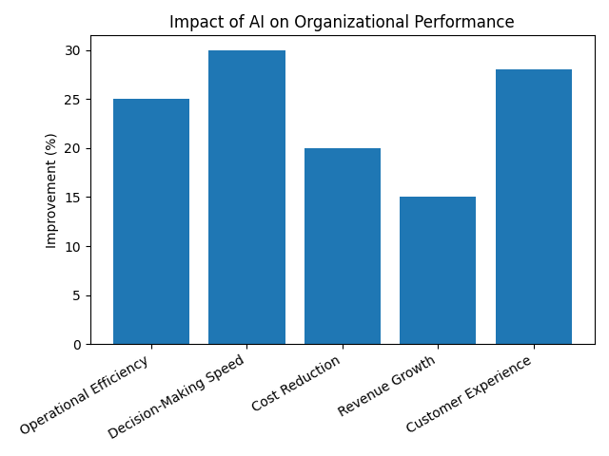
Figure 4.1: Impact of AI on Organizational Performance

Source: Adapted from McKinsey Global Institute (2018) and PwC (2017).
4.1.2 Decision-Making and Resource Optimization
AI tools enhance decision-making by providing real-time insights and predictive analytics. Managers can use dashboards and forecasting models to identify trends, evaluate risks, and make data-driven decisions. According to Erik Brynjolfsson and McAfee (2017), organizations using AI analytics are able to make faster and more accurate decisions compared to traditional methods.
AI also improves resource utilization by optimizing inventory, workforce planning, and financial allocation. Mikalef et al. (2020) highlight that organizations with strong analytics capabilities achieve better resource efficiency and competitive performance.

4.1.3 Performance Outcomes
AI adoption leads to both financial and non-financial performance improvements. Financial benefits include cost reduction, improved profitability, and better financial planning. Non-financial benefits include enhanced customer satisfaction, improved service quality, and increased innovation.
According to McKinsey Global Institute (2018), AI adoption can improve productivity and efficiency across business functions. Similarly, Ransbotham et al. (2017) found that organizations using AI experience improved business performance and innovation capabilities.
AI adoption leads to several benefits such as automation, improved forecasting accuracy, increased productivity, and better risk management. These benefits help organizations improve overall performance and gain competitive advantage.
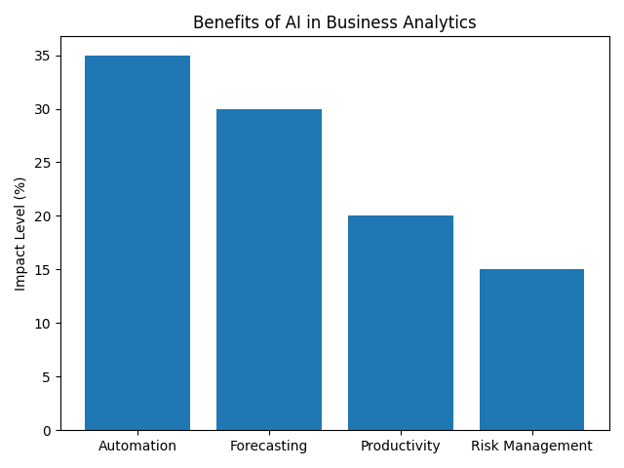
Figure 4.1.1: Benefits of AI in Business Analytics

Source: Adapted from Wamba et al. (2017) and Mikalef et al. (2020).
4.2 Role of Key Determinants in AI Adoption
4.2.1 Technological Factors
Technological readiness is a key driver of AI adoption. Factors such as data quality, system compatibility, and ease of use directly influence implementation success. High-quality data ensures accurate predictions and reliable outputs, while compatible systems enable smooth integration. According to Fred D Davis (1989), perceived usefulness and ease of use significantly influence technology adoption.
4.2.2 Organizational Factors
Organizational factors play the most critical role in AI adoption. Top management support, employee skills, and organizational culture determine how effectively AI is implemented.
According to Jay Barney (1991), internal resources such as skills and capabilities provide a competitive advantage. Jöhnk et al. (2021) also emphasize that organizational readiness is essential for AI adoption success.
4.2.3 Environmental Factors
External factors such as competition, industry trends, and regulations influence AI adoption decisions. Organizations adopt AI to remain competitive and align with digital transformation trends.
According to Louis G Tornatzky and Mitchell Fleischer (1990), environmental pressures significantly affect technology adoption.
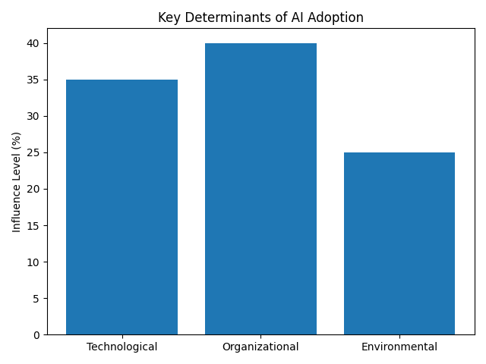
Figure 4.2: Determinants of AI Adoption

Source: Adapted from Tornatzky & Fleischer (1990) – TOE Framework.

4.3 Challenges and Organizational Considerations
4.3.1 Adoption Challenges
Despite its benefits, AI adoption presents several challenges. The most significant issue is the lack of skilled workforce, followed by high implementation costs and data-related problems.
According to Deloitte (2020), many organizations struggle to adopt AI due to skill shortages and technical complexity.
4.3.2 Role of Training and Support
Training and continuous support are critical for successful AI implementation. Employees need to understand how to use AI tools effectively to achieve desired outcomes.
Venkatesh et al. (2003) highlight that user acceptance and training significantly influence technology usage. Organizations that invest in training programs achieve better performance outcomes
4.3.3 Strategic Alignment and Success Factors
The success of AI adoption depends on how well it aligns with organizational goals and processes. Strong leadership, clear strategy, and continuous improvement are essential.
According to Davenport and Harris (2007), organizations that integrate analytics into their core strategy achieve superior performance.
Therefore, AI should not be treated as a standalone technology but as a strategic asset aligned with business objectives.
Figure 4.3: Challenges in AI Adoption
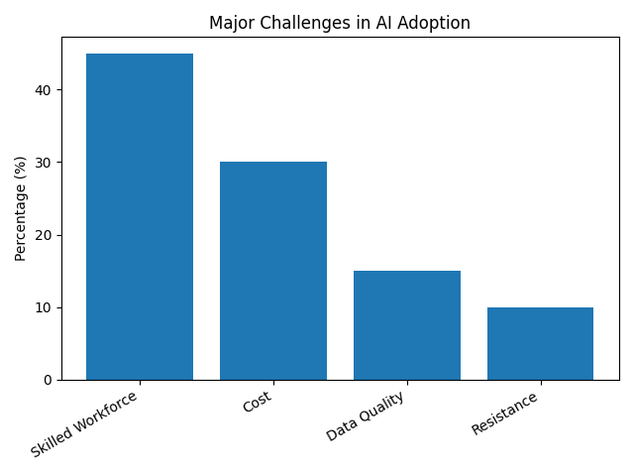

Source: Adapted from Deloitte (2020) and Gartner (2019).

5. Results
The findings of this study, based on a review of existing literature, show that the adoption of Artificial Intelligence (AI) in business analytics has a strong positive impact on organizational performance. Several empirical and industry-based studies support this conclusion by highlighting improvements in efficiency, decision-making, and overall business outcomes.
Research conducted by Thomas H Davenport and Ronanki (2018) found that organizations using AI technologies experience significant improvements in operational efficiency due to automation of routine processes. Their study shows that AI enables faster data processing and reduces human errors, allowing organizations to focus on strategic activities. Similarly, a report by McKinsey Global Institute (2018) indicates that AI adoption can increase productivity by up to 20–30% across various business fu nctions.
In terms of decision-making, studies by Erik Brynjolfsson and McAfee (2017) reveal that organizations using AI-driven analytics make quicker and more accurate decisions compared to those relying on traditional methods. AI tools provide real-time insights and predictive capabilities, which help managers identify trends, reduce uncertainty, and respond effectively to market changes.
From a financial perspective, research by Wamba et al. (2017) shows that big data analytics, supported by AI, leads to improved firm performance through better cost management and revenue growth. Their findings suggest that organizations that invest in analytics capabilities are more likely to achieve competitive advantages. Similarly, Mikalef et al. (2020) found a strong relationship between analytics capabilities and business performance, particularly in terms of resource optimization and strategic flexibility.
The results also highlight improvements in customer-related outcomes. According to Ransbotham et al. (2017), organizations that adopt AI are better able to understand customer behavior and provide personalized services, leading to higher customer satisfaction. AI tools such as recommendation systems and predictive analytics help businesses tailor their offerings based on customer preferences.
However, the findings also indicate that the benefits of AI adoption depend on certain conditions. Studies by Venkatesh et al. (2003) emphasize that user acceptance and ease of use play a critical role in successful implementation. Without proper training and support, organizations may not fully utilize AI systems. Additionally, research by Jöhnk et al. (2021) highlights that organizational readiness, including skills and infrastructure, is essential for achieving positive outcomes.
Overall, the results confirm that AI adoption in business analytics leads to measurable improvements in operational efficiency, financial performance, decision-making, and customer satisfaction. However, the extent of these benefits depends on how well organizations manage technological, organizational, and environmental factors. These findings are consistent across multiple studies, reinforcing the importance of a balanced and well-planned approach to AI implementation.
6. Conclusion
In conclusion, this study demonstrates that the adoption of Artificial Intelligence (AI) tools in business analytics has a strong and positive influence on organizational performance. AI enables organizations to move beyond traditional data analysis by providing predictive insights, automation, and real-time decision support. These capabilities help businesses improve efficiency, reduce errors, and make faster, more informed decisions. As a result, AI has become an essential component of modern business strategies rather than just a supporting technology.
The study also highlights that AI adoption is influenced by a combination of technological, organizational, and environmental factors. Technological readiness, such as the availability of quality data and compatible systems, plays a key role in successful implementation. Organizational factors, including top management support, employee skills, and a culture open to innovation, are equally important. In addition, external factors like competitive pressure and ongoing digital transformation encourage organizations to adopt AI to remain relevant in the market.
Furthermore, the findings show that AI adoption leads to improvements across multiple dimensions of performance. Operational processes become more efficient through automation, financial outcomes improve due to better planning and cost control, and strategic capabilities are enhanced through improved forecasting and adaptability. AI also supports better customer understanding, which helps organizations deliver more personalized and effective services.
However, the study also acknowledges that adopting AI is not without challenges. High implementation costs, lack of technical expertise, data-related issues, and resistance to change can limit its effectiveness. Therefore, organizations need to take a well-planned approach that includes investing in employee training, improving data management practices, and aligning AI initiatives with overall business goals.
Overall, the study concludes that AI has significant potential to transform business analytics and improve organizational performance. Organizations that successfully integrate AI with their existing processes and strategies are more likely to achieve long-term growth and maintain a competitive advantage. Future research can further explore industry-specific applications of AI and examine its long-term impact on organizational success.
7. References
- Thomas H Davenport, T. H., & Ronanki, R. (2018). Artificial intelligence for the real world. Harvard Business Review, 96(1), 108–116.
- Erik Brynjolfsson, E., & McAfee, A. (2017). The business of artificial intelligence. Harvard Business Review.
- Jay Barney (1991). Firm resources and sustained competitive advantage. Journal of Management, 17(1), 99–120.
- Fred D Davis (1989). Perceived usefulness, perceived ease of use, and user acceptance of information technology. MIS Quarterly, 13(3), 319–340.
- Louis G Tornatzky, L. G., & Mitchell Fleischer, M. (1990). The processes of technological innovation. Lexington Books.
- Venkatesh, V., Morris, M. G., Davis, G. B., & Davis, F. D. (2003). User acceptance of information technology: Toward a unified view. MIS Quarterly, 27(3), 425–478.
- Wamba, S. F., Gunasekaran, A., Akter, S., Ren, S. J. F., Dubey, R., & Childe, S. J. (2017). Big data analytics and firm performance. Journal of Business Research, 70, 356–365.
- Mikalef, P., Krogstie, J., Pappas, I. O., & Pavlou, P. A. (2020). Exploring the relationship between big data analytics capability and competitive performance. Information & Management, 57(2), 103169.
- Davenport, T. H., & Harris, J. G. (2007). Competing on analytics: The new science of winning. Harvard Business School Press.
- Ransbotham, S., Kiron, D., Gerbert, P., & Reeves, M. (2017). Reshaping business with artificial intelligence. MIT Sloan Management Review.
- McKinsey Global Institute. (2018). Notes from the AI frontier: Insights from hundreds of use cases. McKinsey & Company.
- PwC. (2017). Sizing the prize: What’s the real value of AI for your business and how can you capitalize? PwC Report.
- Gartner. (2019). Top strategic predictions for analytics and AI. Gartner Research.
- Brynjolfsson, E., Rock, D., & Syverson, C. (2019). Artificial intelligence and the modern productivity paradox. The Economics of AI, 23–57.
- Cockburn, I. M., Henderson, R., & Stern, S. (2018). The impact of artificial intelligence on innovation. NBER Working Paper.
- Jöhnk, J., Weißert, M., & Wyrtki, K. (2021). Ready or not, AI comes—An interview study of organizational AI readiness factors. Business & Information Systems Engineering, 63(1), 5–20.
- Alsheibani, S., Cheung, Y., & Messom, C. (2020). Artificial intelligence adoption: AI readiness at firm-level. PACIS Proceedings.
- Shrestha, Y. R., Ben-Menahem, S. M., & von Krogh, G. (2019). Organizational decision-making structures in the age of AI. California Management Review, 61(4), 66–83.
- Davenport, T. H., Guha, A., Grewal, D., & Bressgott, T. (2020). How artificial intelligence will change the future of marketing. Journal of the Academy of Marketing Science, 48(1), 24–42.

