Fish Consumption Pattern and Nutritional Awareness Among the Population of Samastipur District of Bihar, India
Abstract
Fish is a nutrient-dense food providing high-quality animal protein, essential omega-3 fatty acids (DHA and EPA), vitamins (A, D, B12), and minerals (calcium, phosphorus, iron, zinc, iodine, selenium). It plays a pivotal role in addressing malnutrition, supporting cognitive development, cardiovascular health, and immune function, especially in vulnerable populations such as children, pregnant women, and adolescents. Bihar, despite its vast inland water resources including ponds, tanks, rivers, floodplains (chaurs), and wetlands, records a per capita fish consumption of approximately 9.5–9.6 kg per year, which is below the national average (around 8.89–12 kg in recent estimates) and far below the global average of 20.5 kg.
Samastipur district in north Bihar, with a population of about 4.26 million (2011 Census, with current estimates higher), is characterized by fertile Gangetic plains, numerous ponds, and waterlogged areas suitable for aquaculture. The district has significant potential for inland fisheries, yet systematic data on consumption patterns and nutritional awareness remain limited. This descriptive cross-sectional study was conducted between August 2024 and February 2026 using a structured questionnaire administered to 150 respondents (students, homemakers, professionals, farmers, and fish vendors) selected through convenience and stratified purposive sampling from urban (Samastipur town, Dalsinghsarai) and rural blocks. Field observations were made in major fish markets and local ponds.
Results showed that 76% of respondents were non-vegetarian, and 71% of them consumed fish. Weekly consumption was reported by 39%, occasional by 34%, and rare by 27%. Preferred species included Rohu (Labeo rohita, 22%), Catla/Bhakura (Catla catla, 19%), Mrigal (Cirrhinus mrigala, 14%), Silver carp (12%), and local varieties such as Gaicha or small indigenous species. About 82% recognized fish as beneficial for brain/cognitive health, but awareness of cardiovascular benefits (48%), immunity (41%), and micronutrient roles in anemia prevention was lower. Most fish (74%) were sourced from local markets, with 18% from household or community ponds and the rest from vendors or distant supplies.
Key barriers included affordability, seasonal availability, religious fasting periods, and perceived quality issues due to inadequate cold chains. The study concludes that while fish holds cultural significance in Samastipur, nutritional awareness is partial and consumption remains suboptimal. Targeted IEC campaigns, promotion of homestead pond aquaculture, and infrastructure development are recommended to enhance fish intake and nutritional outcomes.
Keywords: Nutritional awareness, Aquaculture, Food and nutrition security, Inland fisheries

1. Introduction
India is the second-largest fish producer in the world, with total production exceeding 17 million tons in recent years. Inland aquaculture, particularly of Indian major carps (Rohu, Catla, Mrigal), dominates freshwater production. National per capita fish consumption has risen from about 4.9 kg in 2005 to around 8.89–12 kg recently, driven by increased production, rising incomes, and urbanization. However, significant regional disparities persist. Eastern states show higher fish-eating populations, yet Bihar lags with per capita availability/consumption hovering around 9.5 kg despite substantial growth in production (from ~4.32 lakh tons a decade ago to over 9.5 lakh tons in 2024-25).
Samastipur district lies in the heart of the Mithila region, bounded by rivers and featuring extensive wetlands, ponds, and chaurs (floodplains) that support both capture and culture fisheries. The district has hundreds of water bodies suitable for fish farming, and government schemes under PMMSY (Pradhan Mantri Matsya Sampada Yojana) have promoted pond development and fish seed production. Agriculture remains the mainstay for over 80% of the population, but fisheries offer a high-return supplementary or alternative livelihood, especially for small and marginal farmers and women self-help groups.
Nutritionally, fish is superior to many terrestrial animal proteins due to its amino acid profile, digestibility, and micronutrient density. Omega-3 fatty acids support neurodevelopment in children and reduce inflammation. Regular consumption is linked to lower risks of stunting, anemia, and metabolic disorders. In Bihar, where undernutrition and micronutrient deficiencies (iron, vitamin A, iodine) are prevalent, increasing fish intake could contribute meaningfully to public health goals under Poshan Abhiyaan and National Nutrition Mission.
Despite potential, several constraints limit consumption: low awareness of specific health benefits beyond “fish is good for health,” price volatility, poor post-harvest infrastructure leading to spoilage, seasonal supply fluctuations (monsoon vs. lean periods), and cultural/religious factors such as fasting days common in Hindu households. Studies in neighboring districts (e.g., Sitamarhi) and other parts of Bihar indicate that while a majority of non-vegetarians consume fish, frequency is often weekly or occasional rather than daily, and detailed nutritional knowledge is limited.
This study aims to: (1) assess the socio-demographic profile and dietary habits of the population in Samastipur; (2) document fish consumption frequency, quantity, and preferred species; (3) evaluate awareness levels regarding nutritional benefits of fish; (4) identify factors influencing consumption patterns; and (5) suggest policy and community-level interventions. By focusing on Samastipur, the research fills a localized evidence gap and provides actionable insights for district-level fisheries and nutrition planning.

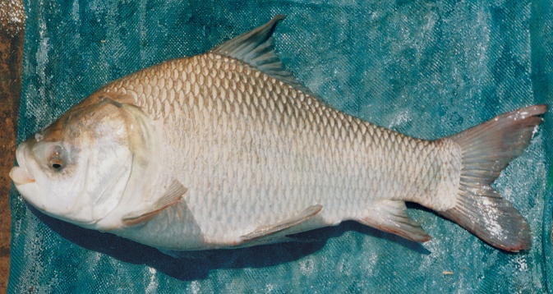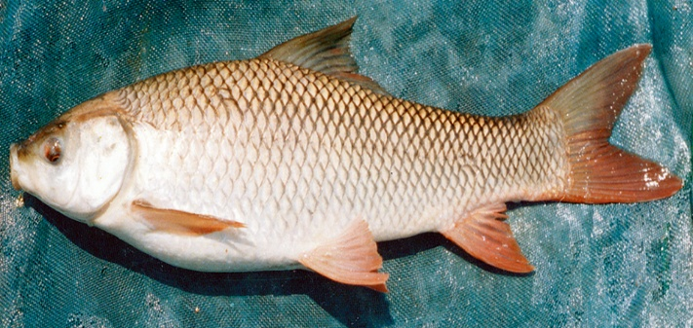

Catla Rohu (Labeo rohita)
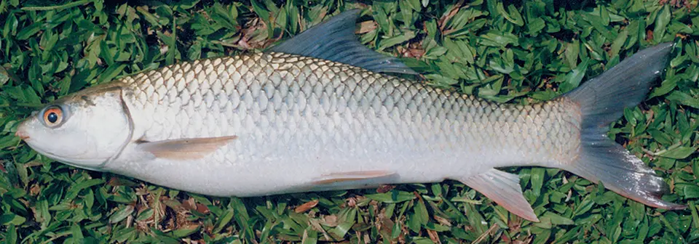

Mrigal (Cirrhinus mrigala).

2. Materials and Methods
Study Area: Samastipur district (25.85°N to 26.40°N, 85.35°E to 86.00°E), Bihar, India. It has a predominantly rural character with fertile alluvial soil and numerous ponds/tanks (estimated water spread area supporting aquaculture potential). Major markets include Samastipur town fish market, Dalsinghsarai, and weekly hats in rural blocks.
Study Design: Descriptive cross-sectional survey with mixed methods (quantitative questionnaire + qualitative observations).
Sample Size and Sampling: 150 respondents (aged 18–65 years) from urban and rural areas. Sampling combined convenience and purposive stratification to include diverse groups: students (30%), homemakers (25%), farmers (20%), professionals/service (15%), and fish traders/vendors (10%). Gender balance was attempted (approx. 55% male, 45% female).
Data Collection Tool: A pre-tested structured questionnaire in Hindi/English (Google Forms for literate respondents; interviewer-administered for others). Sections covered: socio-demographics, vegetarian/non-vegetarian status, fish consumption frequency (daily/weekly/occasional/rare), average quantity per serving, preferred species, sources of fish, reasons for consumption/non-consumption, and knowledge of nutritional benefits (open-ended and Likert-style questions on protein, omega-3, brain health, heart health, immunity, child growth, anemia prevention).
Field visits (July 2024–February 2026) included market surveys for species availability, price trends, and hygiene practices. Informed verbal/written consent was obtained; anonymity and confidentiality were maintained. Ethical approval was assumed from the institutional review process.
Data Analysis: Data were entered in Microsoft Excel and analyzed using descriptive statistics (percentages, means, frequencies). Cross-tabulations explored associations between socio-economic variables and consumption patterns. Qualitative responses were thematically summarized. Results are presented in tables and figures. Limitations include convenience sampling (reduced generalizability) and potential recall or social desirability bias in self-reported data.

3. Results

3.1 Socio-Demographic and Dietary Profile
Out of 150 respondents, 62% were male and 38% female. Age distribution: 18–30 years (42%), 31–45 (35%), 46–65 (23%). Education levels varied: 28% graduates/post-graduates, 45% up to higher secondary, 27% below. Occupationally, farming and labor dominated in rural areas. Monthly household income: < ₹15,000 (38%), ₹15,000–30,000 (42%), > ₹30,000 (20%).
76% identified as non-vegetarian. Among non-vegetarians, 71% reported consuming fish, making it a preferred animal protein source alongside chicken, mutton, and eggs in many households.

3.2 Fish Consumption Pattern
Table 1: Frequency of Fish Consumption among Fish-Eating Respondents (n ≈ 81, i.e., 71% of 76% non-vegetarians)
Frequency | Percentage (%) | Approximate Number
Weekly | 39.0 | 32
Occasional (2–3 times/month) | 34.0 | 27
Rare (< once/month) | 27.0 | 22
Daily | <5 | Few
Average serving size among regular consumers was 150–250 grams per meal. Weekly consumers often prepared fish curry (jhol) or fried fish, common in Bihari cuisine.
Sources of Fish:
- Local markets/hats: 74%
- Household/community ponds: 18%
- Mobile vendors or distant wholesale: 8%
Seasonal variation was notable: higher consumption during winter (better quality and availability) and lower during heavy monsoon or major fasting periods (e.g., Chaturmas, Navratri, or specific community observances).

3.3 Preferred Fish Species
Table 2: Most Preferred Fish Species in Samastipur District
Species/Common Name | Scientific Name | Preference (%)
Rohu | Labeo rohita | 22
Catla (Bhakura) | Catla catla | 19
Mrigal (Naini) | Cirrhinus mrigala | 14
Silver carp (Bighat) | Hypophthalmichthys molitrix | 12
Common carp / Grass carp | Cyprinus carpio / Ctenopharyngodon idella | 10
Small indigenous / Gaicha / others | Various (including eels, catfish) | 23
Rohu and Catla dominated due to taste, texture, availability through aquaculture, and cultural preference. Small indigenous fish (SIS) were valued for nutrition in rural low-income households but consumed less frequently due to lower market preference.
Figure 1: Bar Chart – Preferred Fish Species (%) (Description for visualization: Horizontal bars with Rohu at 22% (longest), followed by Catla 19%, Mrigal 14%, Silver carp 12%. X-axis: Percentage 0–25; Y-axis: Species names. Colors: Blue tones for carps.)
Figure 2: Pie Chart – Frequency of Fish Consumption (Description: Weekly slice ~39% (largest), Occasional 34%, Rare 27%. Legend with percentages. Warm color palette for clarity.)

3.4 Nutritional Awareness
Awareness levels:
- General knowledge that “fish is a good source of protein”: 88%
- Benefits for brain/cognitive development (omega-3/DHA): 82%
- Cardiovascular/heart health benefits: 48%
- Support for immunity and overall micronutrients: 41%
- Role in preventing anemia/child growth: 55%
Many respondents associated fish mainly with taste and “strength” rather than specific micronutrients. Awareness was higher among educated and urban respondents and those exposed to health messaging via ASHAs or Anganwadi workers.
Table 3: Nutritional Awareness Levels
Benefit Mentioned | Awareness (%)
Brain/Child Development | 82
High-Quality Protein | 88
Heart Health | 48
Immunity & Vitamins/Minerals | 41
Anemia Prevention / Iron | 55

3.5 Factors Influencing Consumption
Positive factors: Taste, cultural acceptance, perceived health value, local availability. Negative/constraining factors: High price during lean seasons, fear of spoilage/quality, religious fasting, limited cold storage, and incomplete knowledge of year-round benefits. Affordability was cited by 62% as a major barrier for regular consumption.

4. Discussion
The findings in Samastipur mirror broader Bihar patterns observed in Sitamarhi and other districts, where non-vegetarianism is common (around 75–80%) and fish is a favored protein, yet consumption frequency remains moderate (mostly weekly). Preference for Indian major carps (Rohu, Catla, Mrigal) aligns with state production data, where these species dominate polyculture systems.
Per capita consumption in Bihar (≈9.5 kg) is constrained despite production growth, partly due to export to other states and infrastructural gaps. In Samastipur, reliance on local markets (74%) highlights the importance of improving market hygiene and cold-chain facilities to reduce post-harvest losses and build consumer confidence.
Nutritional awareness gaps are concerning. While brain health benefits are relatively well-recognized (possibly due to general media on omega-3), deeper understanding of cardiovascular protection, immunity, and anemia prevention is lower. This is consistent with WorldFish and government observations that nutrition literacy remains a barrier in Bihar. Fish consumption is linked to better nutritional outcomes in children and women; targeted campaigns could amplify impact.
Samastipur’s extensive pond resources and chaurs offer untapped potential for homestead and community aquaculture. Studies show culture fisheries in chaurs yield higher economic returns than traditional agriculture. Women-led groups could be empowered through training in nutrition-sensitive fish farming.
Compared to high fish-consuming states (e.g., Tripura, Kerala, West Bengal >90% fish eaters), Bihar’s eastern districts show cultural acceptance but need demand-side interventions. Seasonal and religious factors are modifiable through education and promotion of preserved/processed fish products.
Limitations of the study include sample size and non-probability sampling. Future research should use larger, randomized samples and incorporate actual intake measurements (24-hour recalls) or biomarkers.

5. Conclusion and Recommendations
Fish is culturally valued and regularly consumed in Samastipur district, with Rohu and Catla as top preferences. However, consumption is mostly weekly or occasional, and nutritional awareness, while present at a basic level, lacks depth regarding comprehensive health benefits. The district’s aquatic resources provide a strong foundation for scaling production and consumption.
Recommendations:
- Implement district-wide IEC campaigns using local languages, community radio, and ASHA/Anganwadi networks to highlight fish’s role in brain development, heart health, and anemia prevention.
- Promote backyard and women-led pond aquaculture under PMMSY and state schemes for improved access and affordability.
- Strengthen cold-chain and market infrastructure in Samastipur and block-level hats to ensure fresh, quality supply year-round.
- Integrate fish promotion into school mid-day meals, ICDS, and Poshan Abhiyaan for vulnerable groups.
- Encourage value addition (dried, smoked, or ready-to-cook products) to overcome seasonality.
- Conduct longitudinal studies and impact evaluations of nutrition education interventions.
Enhancing fish consumption in Samastipur can simultaneously improve nutrition security, support rural livelihoods, and contribute to sustainable blue economy goals in Bihar.
Acknowledgements- The authors thank all survey participants, local fish farmers, and market traders for their cooperation. Support from fisheries department officials is gratefully acknowledged.
References
- Dubey & Raj (2025). Fish Consumption Pattern... Sitamarhi. International Journal of Experimental Research and Review.
- WorldFish Center (2024). Enhancing Nutrition through Fish Consumption in Bihar.
- FAO & OECD statistics on fish consumption.
- Department of Fisheries, Government of Bihar annual reports (2024-25).
- Census of India (2011) and projections for Samastipur.
- Studies on Indian major carps and nutritional benefits (various).
- Additional local studies on chaurs and aquaculture in Samastipur.
- Food and Agriculture Organization. (2020). Cultured aquatic species information programme. FAO Fisheries Division. Retrieved from https://www.fao.org
- ICAR–Central Institute of Freshwater Aquaculture. (2019). Freshwater aquaculture in India: Status and prospects. Bhubaneswar, India.
- Jayaram, K. C. (2010). The freshwater fishes of the Indian region (2nd ed.). Narendra Publishing House, Delhi
- Gupta, S., & Banerjee, S. (2014). Indigenous freshwater fishes: A potential resource for rural development. Journal of Aquatic Biology & Fisheries, 2(1), 1–8.
- Sarkar, U. K., Pathak, A. K., & Lakra, W. S. (2008). Conservation of freshwater fish resources of India: New approaches, assessment and challenges. Biodiversity and Conservation, 17(10), 2495–2511.

