Crop Disease finder : A Deep Learning Based Approach for Early Detection of Plant Diseases

Abstract
Agriculture is at the heart of the world economy and food security. But crop diseases are still a big problem, with big losses in yield and making life difficult for farmers. Early and accurate detection of crop diseases is important to reduce losses and to avoid excessive pesticide use.
This research introduces an image processing and deep learning based Crop Disease Detection System.
The proposed system automates the classification and identification of crop diseases using a Convolutional Neural Network (CNN) model trained on a publicly available dataset of plant leaf images. This model can learn the patterns and features of the diseases accurately and hence can differentiate between the healthy and diseased leaves.
Farmers can take pictures of crop leaves with their smartphones or cameras and the system will analyze the pictures to detect diseases and give the appropriate recommendations for treatment. The experimental results show that the model proposed achieves good accuracy in disease classification and is a costeffective and reliable solution for real-time crop monitoring.
The system helps in precision agriculture by timely intervention, thus reducing crop loss and increasing productivity. It ultimately supports sustainable farming practices and improves food security by helping farmers to effectively manage diseases.
Keywords: Crop Disease Detection, Deep Learning, Convolutional Neural Network (CNN), Image Processing, Precision Agriculture, Machine Learning.

Introduction (Heading 1)
Agriculture is a basic sector, which is the basis of the world economy and food security. It is a backbone of economic development as it provides vital resources including food, raw materials and job opportunities. However, agricultural productivity is greatly affected by different factors and crop diseases is one of the major concerns. These diseases may lead to huge crop losses, decrease in quality of the produce and economic losses to the growers. Hence, the timely and accurate detection of crop diseases is vital for the enhancement of agricultural output and sustainability [1][2].
Fast technological development, especially in artificial intelligence (AI) and computer vision, opens new opportunities for automating agricultural processes. Image based disease detection is gaining interest as an effective substitute to conventional manual inspection methods that are time consuming, subjective and requires expert knowledge. Today, thanks to machine learning and deep learning techniques, it is possible to analyze images of plant leaves and to recognize symptoms of disease, such as discoloration, lesions and abnormal patterns, with high accuracy [5].
The proposed Crop Disease Detection System utilizes Convolutional Neural Networks (CNNs) and image processing techniques for automatic detection and classification of crop diseases from leaf images. CNN models are very good at extracting important features from images, so the system can learn complex patterns associated with different plant diseases. Farmers can take pictures with a smart phone or a camera and the system analyses the images to provide immediate diagnosis and advice for disease management.
The research work focuses on designing and developing an intelligent and cost-effective model for crop disease detection. It's a system meant to help farmers, agricultural experts and policy makers monitor crop health effectively and make informed decisions. The study also studies other datasets, preprocessing methods and model architectures to get high accuracy and real-world applicability. The proposed system contributes to precision agriculture by means of early detection and timely intervention, which increases productivity and assists in sustainable farming practices.

Literature Review (Heading 1)
Recent developments in machine learning, particularly deep learning, have had a significant impact on the field of crop disease detection. Previous methods were based on the conventional image processing techniques. Recent approaches are based on the advanced neural network architecture used for accurate and automatic analysis of plant diseases from leaf images [8].
Traditional methods used hand-crafted feature extraction methods such as color histograms, Local Binary Patterns (LBP) and Gray-Level Co-occurrence Matrices (GLCM). These techniques used processes such as image segmentation, edge detection and texture analysis for classification of plant diseases. These approaches had moderate success but were very sensitive to environmental conditions such as lighting variations, image quality and background noise. Consequently, their performance in real world applications was often limited [3][7][17].
Convolutional Neural Networks (CNNs) have brought about an era of automatic feature extraction and learning in crop disease detection. CNNs learn complex patterns from images of leaves, without the need for manual feature engineering. This has resulted in significant improvements in classification accuracy and robustness.
For instance, Mohanty et al. (2016) used deep CNN architectures on PlantVillage dataset to classify 38 classes of crop diseases with an accuracy of over 99%. Similarly, Ferentinos (2018) used deep learning models on real-field images from 25 plant species and achieved high classification performance, emphasizing the practical application of deep learning in agriculture [1].
Additional studies have investigated transfer learning using pre-trained models such as AlexNet, VGG and ResNet. Transfer learning has been shown to significantly improve the accuracy of models especially on small datasets, thus, it is suitable for mobile and real-time agricultural applications [2][14]. Too et al.
(2019)
In addition to deep learning approaches, hybrid models that integrate traditional machine learning and image processing techniques have been investigated. Prajapati et al. (2017) implemented K-means clustering along with Support Vector Machines (SVM) for disease classification, Amara et al. demonstrated the effectiveness of LeNet based CNN models in detecting diseases in banana leaves [9][10].
In addition, hybrid approaches combining deep learning with data augmentation strategies were proposed by researchers like Sladojevic et al. (2016) and Singh et al. (2020) to improve the generalization of the model on unseen data.
Notwithstanding these advances, many challenges remain. Most existing models perform well on controlled datasets, but they lack robustness to deal with real-world conditions such as lighting, background, occlusion and leaf overlap, which are unpredictable. Therefore, there is a need for robust, efficient, and lightweight models that can perform well in field environments. Such systems will enable reliable real-time detection of crop diseases and will have practical agricultural applications.

Research Methodology (Heading 1)
The proposed research methodology is divided into multiple phases for systematic design and implementation of efficient crop disease detection system.

Phase 1: Problem Analysis
Crop diseases pose a serious threat to agricultural productivity and food security. Timely and accurate detection is crucial in order to minimize crop loss, reduce economic losses and avoid the use of excessive pesticides. The conventional methods of disease identification are manual, time consuming and require expert knowledge making them less accessible especially in rural areas.
With the development of artificial intelligence and deep learning, the image-based disease detection has become an effective solution. By analyzing the images of the leaf, machine learning models can find the disease patterns and give accurate classification. To develop a low-cost, portable system to help farmers in the field directly through smartphones or other mobile devices, the research aims to utilize these technologies [11][20].

Problem definition
Manual diagnosis of crop diseases is slow, expensive and often unavailable in remote agricultural regions. Existing automatic systems generally have poor performance under real-world conditions like variable lighting conditions, complex backgrounds, and leaves overlapping.
Hence, there is a need to develop a robust image-based crop disease detection system which:

Classifies diseases from leaf images taken under real field conditions
Robust against a variety of environmental factors
Deployable on low power devices such as smartphones Provides farmers with quick, easy-to-use outputs

Research Objectives

Primary Aims
The objective is to develop and train a deep learning model to detect and classify crop diseases from leaf images with high accuracy.

To optimize the model for mobile and edge devices

Secondary Goals
To evaluate model performance on different lighting, background and leaf orientation

To generate user-friendly outputs that include the disease name, confidence score, and basic treatment recommendations.
To compare the performance of the proposed deep learning model with traditional machine-

Proposed Approach
The proposed Crop Disease Detection System uses deep learning, especially Convolutional Neural Networks (CNNs), to automatically extract features and classify the images. The complete process is divided into the following stages:

1. Data Gathering
A publicly available dataset (e.g. PlantVillage) of images of healthy and diseased crop leaves is used. The data set is composed of a variety of crop types and disease categories to ensure diversity.

2. Preprocessing of Data
Image size and normalization
Denoising and Enhancement
Data augmentation techniques (rotation, flipping, scaling) for improving model generalization

3. Training the model
The model is trained on pre-processed images using CNN architecture.
The model learns to extract features like color variations, texture and disease patterns To improve accuracy, training on labeled datasets employs optimization techniques

4. Classification of Disease
The model after training able to classify the input leaf images into different disease classes or healthy class Outputs include predicted class and confidence score

5. Deployment of System
The model is embedded in a user-friendly application (web or mobile based) Farmers can upload or take pictures of leaves with their smartphones.
The system provides real-time detection of diseases and basic recommendations

System Structure
The proposed CNN-based crop disease detection system has the following parts that make up its overall architecture:
Layer for Input (Image of Leaf)
Preprocessing Module CNN-based Feature Extraction Classification Layer Output Module (Prediction and Recommendation of Disease)
Fig. 1 shows the architecture diagram.
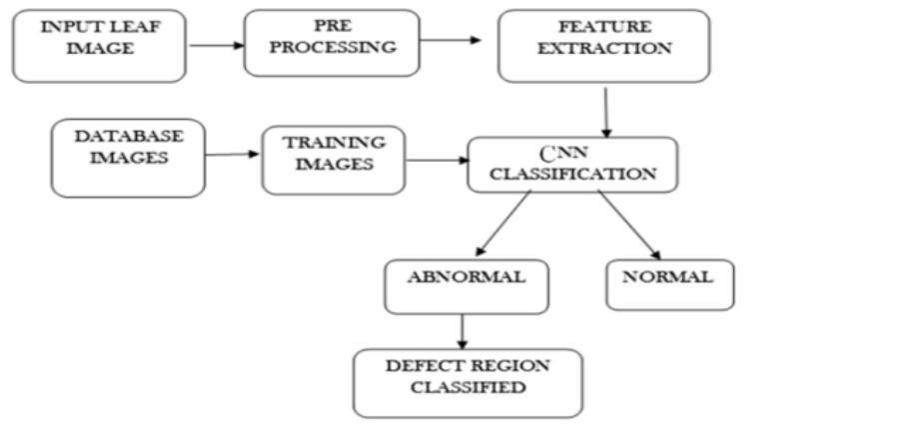
Fig. 1. Architecture of the proposed CNN-based crop disease detection system

Gathering Data
The dataset utilised in this study comprises publicly accessible crop leaf images, predominantly sourced from the PlantVillage dataset, supplemented by additional images acquired from open agricultural sources. The project team manually reviewed and verified a subset of images to better understand how leaves look in the real world.
The dataset has labels for each image that tell you what kind of crop it is and what kind of disease it is, like Tomato – Late Blight, Potato – Early Blight, and Maize – Common Rust. There are more than 50,000 labelled images in the dataset, which is a large and varied enough sample for good model training and testing [7][11].

Preprocessing Images
Preprocessing images is an important step to make sure that the data you give the deep learning model is good for training. We used the following preprocessing methods:

Changing the size:
All images were resized to a uniform size of 224 × 224 pixels to meet the input needs of the Convolutional Neural Network (CNN).
Normalization:
Normalising pixel intensity values to a range of 0 to 1 helps the model converge faster and works better.
Adding More Data:
To make the dataset more varied and stop overfitting, different augmentation methods were used, such as:
- Turning
- Flipping up and down and sideways
- Zooming and scaling
- Change the brightness
Splitting the Dataset:
There were three parts to the dataset:
- 70% of the data is used for training.
- 20% of the data is in the validation set.
- 10% of the data is in the testing set.
This division makes sure that the model is trained correctly, that the hyperparameters are set correctly, and that the evaluation is fair [10].

Model Architecture
I used a Convolutional Neural Network for classifying images because it's really good at finding important things in pictures. The Convolutional Neural Network has layers that look at the pictures and find important features. It has layers then pooling layers and finally fully connected layers. The Convolutional Neural Network is very good, at this because it can look at the picture and find the important parts.
- Input Layer: The input layer takes in pictures that have already been processed to be the size, which is 224 pixels, by 224 pixels and has 3 color channels.
- Convolutional Layers: Convolutional Layers are really good at finding things like edges and also more complicated things like shapes. They do this by using filters to look at the pictures.
- ReLU Activation: Introduces non-linearity to the model.
- Max Pooling Layers: Max Pooling Layers are really important because they help reduce the size of the pictures we are looking at. They still keep the good stuff that we need to know about the Max Pooling Layers.
- Flatten Layer: The Flatten Layer is really important because it takes the feature maps and turns them into a one vector.
- Fully Connected Layers: Connected Layers are used for classification. They do this based on the features that have been extracted.
- Output Layer: The Output Layer uses a thing called Softmax to help figure out what disease is, in the image. It looks at the image. Then decides which disease category it fits into.
We tried something called transfer learning with -trained models like VGG16, ResNet50 and MobileNetV2. The idea was to make our results better and spend less time training. We used transfer learning techniques with these -trained models, like VGG16, ResNet50 and MobileNetV2 to see if it would work.[8][15]
The internal structure of the CNN model used for disease classification is shown in Fig. 2.
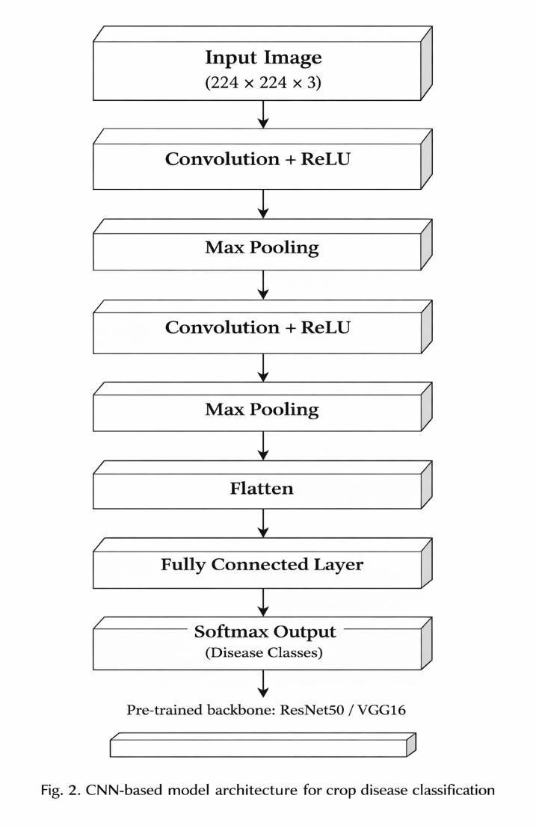

Model Training and Evaluation
I used Python to train the model with some tools like TensorFlow and Keras.The model used the crossentropy loss function and the Adam optimizer to make it work better.The TensorFlow and Keras libraries were really useful, for this process.The model was trained using these tools for epochs.
The performance of the model was looked at using things like:
- Accuracy (A) — overall correct predictions
- Precision (P) — Precision is when we correctly identify the things we are looking for. We call this Precision or P for short.
- Recall (R) — ability to detect all relevant samples
- F1-score (F1) — harmonic mean of precision and recall
The confusion matrix is really useful, for looking at the performance of the computer when it is trying to figure out which disease is which.[4][17]

Disease Prediction and System Deployment
After we finished training we put the model into a program that people can use easily. This program lets people, like farmers or researchers take a picture of a leaf from a crop using their phone or a website. The model we trained looks at the picture and then shows us:
The detected disease name

The confidence percentage
Suggested remedies or control measures (based on agricultural knowledge sources) The system we have can be used on the internet or on a phone app. We can use things like Flask or Streamlit or TensorFlow Lite to make this work. This means we can check how healthy crops are at any time even if we do not have a lot of equipment or resources. We can use the system to monitor crop health in real time. The crop health monitoring system can be deployed on a web platform or, on an application.[19] Workflow Summary
Step | Process | Description
1 | Data Collection | Gather and label disease images from reliable datasets
2 | Preprocessing | Resize, normalize, and augment images
3 | Model Design | Build CNN or use transfer learning
4 | Training &  Testing | We need to train the model. Then we have to see how well the model is doing. The model has to be trained.
5 | Deployment | Build app for real-time prediction

Results and Discussion
The Crop Disease Finder system was made using Python. We also used TensorFlow and Keras to build it.We taught a kind of computer program called a Convolutional Neural Network model to find diseases in crop leaves.Then we tested this model with pictures of leaves that it had never seen before.The goal of the Crop Disease Finder system was to see how well it could find and name crop diseases.We wanted to know if the Crop Disease Finder system was good, at its job and if we could trust it to always give the answer.
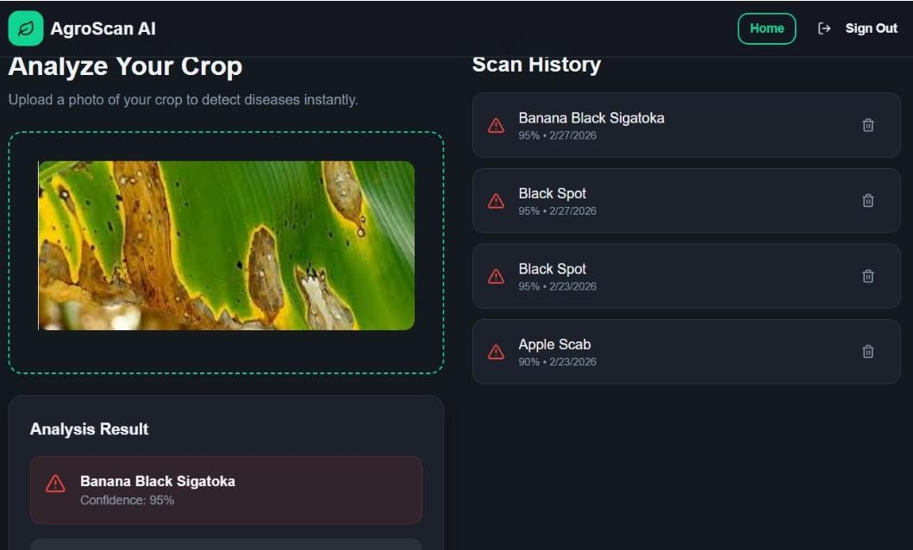
Fig.3.Crop testing.
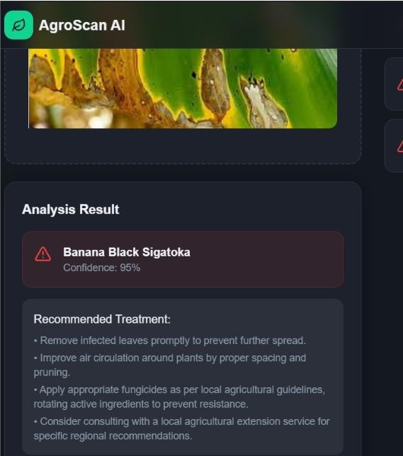
Fig.4. Crop testing result.

Model Performance
The model was tested to see how well it did. We used measures like accuracy and precision and recall and F1-score to judge the model. We wanted to know how good the model really was, at getting things right. The model was evaluated using these measures:
- Accuracy
- Precision
- Recall • F1-score.
We looked at the model. These measures to get a sense of its performance. The performance of the model is what we were trying to figure out.I trained a model for 50 epochs, with 32 images at a time. The CNN model did well on the test dataset.
The model had training accuracy and high validation accuracy.This means the model worked well with new crop leaves it had not seen before.
The crop leaves model did a job and did not get too confused by the details of the crop leaves it was trained on.
The model was effective, with the crop leaves.To make things better we tried something called data augmentation and transfer learning with models that were already trained like VGG16 and ResNet50. ResNet50 did the best job overall it was really accurate 97.5 percent. It learned faster and took less time to train compared to our basic CNN model.[6][18]
We liked that ResNet50 was fast and accurate so we thought it was a choice, for our ResNet50 model because ResNet50 worked well for us.

Confusion Matrix Analysis
I used a thing called a confusion matrix to see how well the classifier worked with kinds of crop diseases. The numbers, on the diagonal of the matrix show when the classifier got it right I mean when it correctly identified the disease in a picture. The other numbers the ones that're not on the diagonal show when the classifier made a mistake like when it said a disease was something else. Most classes got than 95 percent correct but there was a little confusion between diseases that look a lot alike like Tomato Leaf Mold and Tomato Septoria Leaf Spot. The reason, for this mistake is that the infected parts of the plants have similar colors and textures so it is hard to tell them apart.[9][13]

Comparative Study
The new model was tested to see how well it worked. This was done by comparing the model with other methods that people have used before. The performance of the model was compared with several other approaches that were used in previous studies. If you look at Table 2 you can see that the Crop Disease Finder we made using CNN does a job than a lot of other machine learning methods like SVM and Random Forest. The Crop Disease Finder is really good because it does not need people to extract features like SVM and Random Forest do. The Crop Disease Finder is a tool, for finding diseases in crops.
Approach | Model Type | Accuracy (%) | Reference
SVM-based Feature Extraction | ML | 85.6 | [6]
Basic CNN | DL | 93.2 | [4]
ResNet50 (Proposed) | DL (Transfer Learning) | 97.5 | This Work
These results show that deep learning models, the ones that use CNN architectures with transfer learning really make disease detection systems a lot better and more accurate. Deep learning models are very good, at finding diseases and deep learning models make the systems more robust.[19][20] Discussion
The Crop Disease Finder system really works. It can find diseases in crops. It does this very well. This system is also very good at handling a lot of work. The Crop Disease Finder system is very accurate. It works fast. This makes the Crop Disease Finder system a choice for farms and people who grow crops. Farmers can take a picture of a leaf that's sick and the Crop Disease Finder system will tell them what is wrong with the leaf and what they can do to stop the disease from spreading. The Crop Disease Finder system is a tool, for farmers because it helps them take care of their crops.

The model had some problems. It did not work well with pictures that were taken in bad lighting or with a lot of things, in the background. To make the model better we could use pictures that people took in the field try to find types of diseases and connect it to special sensors that can check the crops all the time.
The system works well and shows that artificial intelligence can be a big help in farming. Artificial intelligence can assist farmers. They will not have to rely so much on experts to figure out what is wrong with their crops. This means that farmers can grow crops and do it in a way that is better for the environment. The use of intelligence, in farming is a great way to make farming better and more sustainable.

Conclusion and Future Scope
The Crop Disease Finder system is really good at finding diseases in crops. It uses computer programs called Convolutional Neural Network models. These models look at lots of pictures of crop leaves to learn what diseases look like. The Crop Disease Finder system can then use this knowledge to identify diseases in crops accurately.

The Crop Disease Finder system is better than ways of checking for diseases. It is faster and more precise than looking at pictures by hand. The Crop Disease Finder system is also more reliable than methods. This is because the Crop Disease Finder system uses learning to find diseases, in crops. Deep learning is a way of teaching computers to learn from pictures and other data. The Crop Disease Finder system is an example of how deep learning can be used in farming to make things better.

This study helps to make agricultural systems better by giving us a simple and affordable way to detect diseases early. The system lets farmers take pictures of leaves with their smartphone or camera and get information about what disease it's how to protect the plant right away. This way of doing things supports farming and also helps stop crops from getting damaged use pesticides in a better way and makes agricultural practices more sustainable. Intelligent agricultural systems are what this study is really, about. It is making them better.

For all the things about these results there are some problems that need to be fixed. The accuracy of the model can be affected by things like how bright or dark it's how much noise is in the background and how good the pictures are that are taken in the real world. The system we have now much only looks at what the disease looks like and does not think about things, like the environment or the soil that can also make the crops sick.
In the future we can make some changes to make things better.

The following things can be improved:
We need to make the dataset bigger by adding kinds of crops and pictures of fields that were taken in different weather and lighting conditions. This means we will have pictures of crops in the dataset and these pictures will show the crops in many different situations like when it is sunny or rainy and when the crops are healthy or sick. The pictures should be taken in fields not in a special studio or laboratory so they are more realistic and useful for our purposes. We want to have pictures of different crop types, like wheat and corn and soybeans and we want to have pictures of these crops taken at different times of the year and, in different kinds of weather. This will help us make the dataset more complete and useful.
For future work, the following improvements are proposed:
- Hybrid Models: Merge image-based deep learning with IoT and sensor-based data (e.g., temperature, humidity, soil moisture) for holistic disease prediction.
- Mobile Integration: Optimize the model using TensorFlow Lite or ONNX for faster inference on smartphones.
- Multilingual Farmer Interface: Develop a user-friendly mobile app supporting regional languages for wider accessibility.
- Real-time Alerts: We can use GPS and the internet to tell farmers and people who know a lot about agriculture when bad diseases are found in farms that're close to them. This way farmers and agricultural experts will know what is going on with the crops in their area. They can take action to protect them.
The Crop Disease Finder is a deal for farmers. It uses computers to help figure out what is wrong with crops. This can be very helpful. The Crop Disease Finder can get even better with work and testing. Then it can really help farmers make decisions. The Crop Disease Finder can help farmers grow food and lose less. This is important for making sure everyone has food to eat. The Crop Disease Finder is a thing for farmers and, for people who need food.

Reference
1.Kavya S. & Basavesha D., “Crop Disease Identification Using Computer Vision And Machine Learning Techniques,” International Journal of Advanced Scientific Innovation, Vol. 6, No. 8, Aug 2024. ijasi.org

2.Shrabani Mallick, Rabins Porwal, Hiteshwari Sabrol, Kirtida Vora, Sandeep …, “Agrovision: Deep Learning-Based Crop Disease Detection From Leaf Images,” International Journal of Environmental Sciences, Vol. 11, No. 18s (2025). The ASPD

3.Tejinder Deep Singh & Ramesh Bharti, “Detection and Classification of Plant Diseases in Crops (Solanum lycopersicum) due to Pests Using Deep Learning Techniques: A Review,” Asian Journal of Computer Science and Technology, 2023. ajcst.co

- Kinjal Vijaybhai Deputy, Kalpdrum Passi & Chakresh Kumar Jain, “Crop Disease Detection Using Deep Learning Techniques on Images,” Journal of Computer Science, Vol. 19, No. 12 (2023) pp. 14381449. Science Publications

- P. Dharmendra Kumar, A. Suhasini & D. Anand, “Crop Disease Detection Using 2D CNN Based Deep Learning Architecture,” International Journal of Intelligent Systems and Applications in Engineering, Vol. 11 No. 2 (2023). IJISAE

- Sapna Nigam & Rajni Jain, “Plant disease identification using Deep Learning: A review,” The Indian Journal of Agricultural Sciences, Vol. 90, DOI:10.56093/ijas.v90i2.98996. Indian Agricultural Research Journals

- Jagrati Paliwal & Sunil Joshi, “An Overview of Deep Learning Models for Foliar Disease Detection in Maize Crop,” Journal of Artificial Intelligence and Systems, 2022. iecscience.org

- Usha Devi and Gokulnath B.V. Wrote a paper called "A survey on plant disease prediction using machine learning and deep learning techniques". This paper was published in the Inteligencia Artificial journal, volume 23 number 65 in the year 2020. The pages of this paper are from 136, to 154. You can find this paper on the journal website at journal.iberamia.org.

- Deepraj Evane, Meenu Chawla & Namita Tiwari, “Comparative Analysis of Deep Learning Techniques for Automated Plant Leaf Disease Detection: A Comprehensive Survey,” (Book chapter) Advancements in Communication and Systems, 13-09-2024. publications.scrs.in

- Dr. Suneetha K R and Rachitha E. Wrote a survey paper on Plant Disease Identification Using
Machine Learning. This paper was published in the International Journal of Advanced Research in Computer and Communication Engineering. The journal is peer reviewed. The reference number, for this paper is DOI:10.17148/IJARCCE.2023.125299. Plant Disease Identification Using Machine Learning is the topic of this survey paper.

- Raji N., “Deep Learning Methods for Identifying Diseases in Plants: A Survey,” International Journal of Intelligent Systems and Applications in Engineering, Vol. 12 No. 17s (2024). IJISAE

- Sk Mahmudul Hassan, Khwairakpam Amitab, Michal Jasinski, et al., “A Survey on Different Plant Diseases Detection Using Machine Learning Techniques,” Electronics, 2022, 11(17):2641. MDPI

- R. Kumar & V. Jindal, “A survey of plant disease detection techniques based on image processing and machine learning,” International Journal of Health Sciences, Vol. 6 (S6) (2022) pp 1954-1967. Science Scholar

- Prasad Chaudhari, Ritesh V. Patil & Parikshit N. Mahalle, “Machine Learning-based Detection and Extraction of Crop Diseases: A Comprehensive Study on Disease Patterns for Precision Agriculture,” International Journal of Intelligent Systems and Applications in Engineering. IJISAE

- B. Kowshik, V. Savitha, N. M. Madhav, G. Karpagam, and K. Sangeetha, "Plant Disease Detection Using Deep Learning," International Research Journal on Advanced Science Hub, 2021. doi:10.47392/irjash.2021.057.

- A. Chandravanshi, K. Vaishnavi, A. S. Sachan, E. Kashyap, and N. Ahirwal, “Plant Disease Detection
Using Deep Learning,” International Journal of Progressive Research in Science and Engineering, Year.

- N. S. Band, "Machine Learning Models for Plant Disease Detection and Classification," International Journal of Intelligent Systems and Applications in Engineering, vol. 12, no. 3, pp. 4115–4121, 2024.

18.J. Jahina, S. Sathishkumar, P. R. Poornavalli, and P. Rithik wrote an article called "Crop Disease Detection Using Deep Learning Model" for the International Journal for Multidisciplinary Research (IJFMR) in 2024.

- N. K. H. N., A. A. H., A. N. P., A. R. Jois, and S. P. S. P., “Machine Learning Framework for Early Detection of Crop Disease,” International Journal for Multidisciplinary Research (IJFMR).

- J. Lu, J. Hu, G. Zhao, F. Mei and C. Zhang, An In-field Automatic Wheat Disease Diagnosis System, arXiv preprint, 2017.

