Deep Learning-Based Multi-Class Classification of Dental X-Ray Images for Detection of Cavity, Root Canal, and Impacted Teeth Using Transfer Learning

ABSTRACT
Among the most prevalent dental diseases worldwide are cavities, impacted teeth and root canal infections. Timely and accurate diagnosis is crucial for proper treatment planning. In this paper, we propose a deep learning approach for automatic classification of dental X-ray images into three categories: cavity, impacted teeth and root canal cases.
Data for this study were manually extracted from local hospitals and diagnostic centres to reflect real world variability and clinical relevance. The dataset is of great value for real-world applications, because the data acquisition, pre-processing and labelling were performed with great care.
We employed transfer learning techniques using pre-trained convolutional neural network (CNN) architectures such as ResNet50, MobileNetV2 and EfficientNetB0. The models were trained and tested on augmented image data to improve generalisation. The performance was evaluated by accuracy, precision, recall, F1-score measures and confusion matrix analysis.
The experimental results demonstrate that EfficientNetB0 outperforms other models in terms of classification accuracy and robustness. Moreover, Grad-CAM visualisation is used to interpret the model decisions and to highlight regions of interest in dental X-ray images.
The proposed system is a scalable and efficient solution to help dentists in diagnosis and can be further extended for multi-disease detection in clinics.

KEYWORDS
Dental X-ray, Deep Learning, Transfer Learning, ResNet50, EfficientNetB0, MobileNetV2, Cavity Detection, Root Canal, Impacted Teeth, Medical Image Classification, Grad-CAM

1. INTRODUCTION
Dental health is an important determinant of overall human health, and accurate diagnosis is necessary to avoid major problems. Common problems in dental health include tooth cavities, impacted teeth, and root canal infection. Dental health diagnosis has traditionally depended on manually examining the X-rays of patients, a process that may take a lot of time and is prone to human error.
Modern advances in AI technology, especially through deep learning, have opened doors for automating many tasks in healthcare through image analysis techniques. Deep learning algorithms are efficient at capturing hierarchical features from images; therefore, they are applicable in the classification of dental X-rays.
This study designs a deep learning algorithm that classifies dental X-ray images into
divided into three groups; cavity, impacted teeth and root canal cases. The first major contribution of this research work is the collection of a data set in the form of real life cases obtained from the nearby hospitals and clinics. This process is the real-life case and requires a lot of time, energy and funds.
The images were properly classified into various categories. To improve the performance of the models and to avoid overfitting, some methods of data pre-processing and augmentation were used. The transfer learning models used in this article are ResNet50, MobileNetV2 and EfficientNetB0. The models were compared with each other to find the most effective one.
- Besides, visualization techniques like Grad-CAM were used to show the region of interest for explainable artificial intelligence.
- The main objectives of this research are:
- Developing an automatic classification system for dental X-rays
- Comparison of multiple deep learning models
- Model validation by visualization methods
- Demonstrating applicability of AI in real-world dentistry

Sample Dental X-Ray Categories

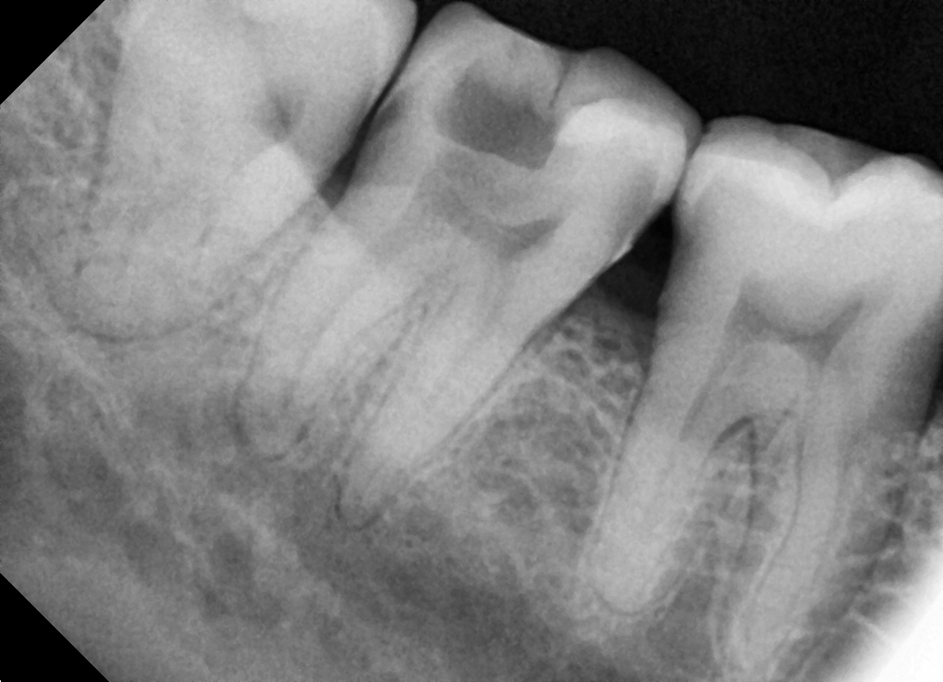
Fig 1 Cavity

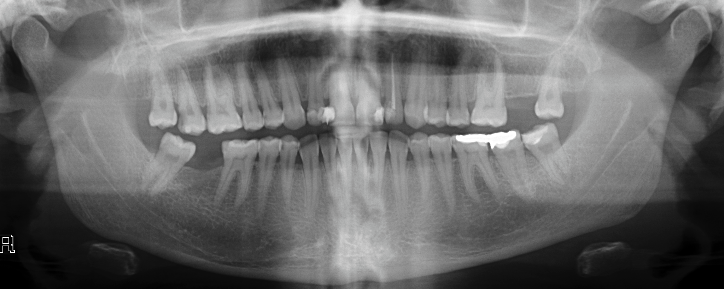
Fig 2 Impacted

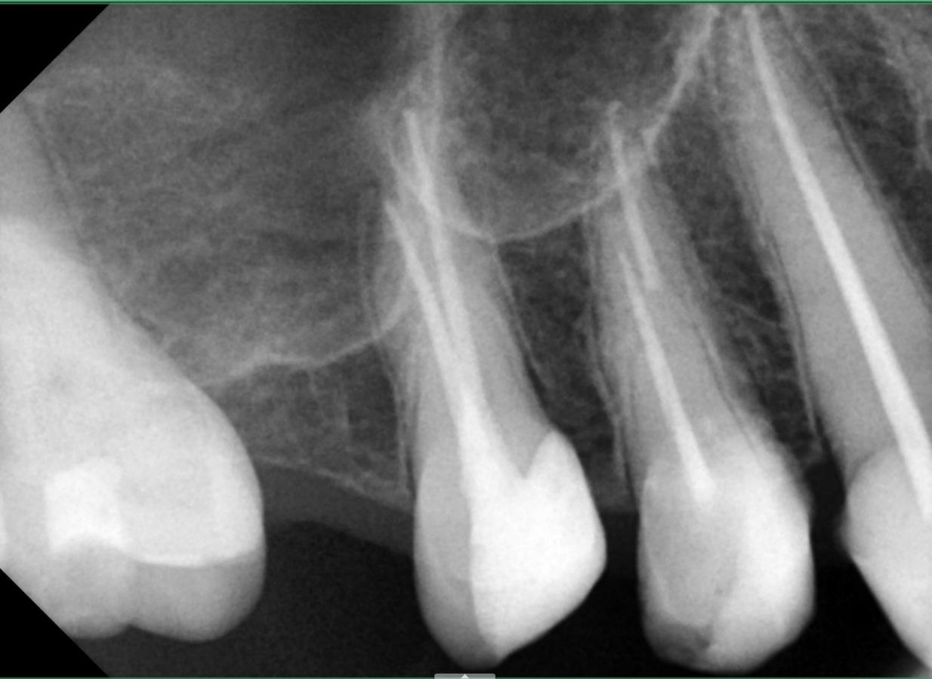
Fig 3 Root Canal
3. METHODOLOGY
The designed system follows systematic procedure in order to classify X-ray images of teeth into cavity, impacted teeth and root canal. The methodology is divided into five phases: data set preparation, data preprocessing, model selection, model training and model evaluation.
3.1 System Description
The structured workflow of the proposed system design is as follows:
- Data Collection From The Hospitals
- Data Preprocessing and Augmentation
- Transfer Learning: Feature Extraction Using CNN
- Training of models
- Performance Assessment
- Grad-CAM visualisation
3.2 Data pre-processing
The images were taken and resized uniformly to 224x224 pixels, which is suitable for pre-trained CNNs. Pixel values were normalised to a scale in range of [0,1] for faster convergence during model training.
We used data augmentation techniques to increase the number of images in the dataset. These included:
. These included:
- Rotation (±15 degrees)
- Zoom (up to 15%)
- Horizontal flipping
- Width and height shifting
The effect of these transformations was to improve generalization on test data by reducing overfitting.
3.3 Transfer Learning
Rather than building models from scratch, the technique of transfer learning was adopted. The pre-trained models which had been trained on large image datasets such as ImageNet were used for extracting valuable features from dental radiographs.
Finally, fully connected layers for classification of three classes were added to these networks.
3.4 Model Architectures
Three deep learning networks were developed and compared:

3.4.1 ResNet50

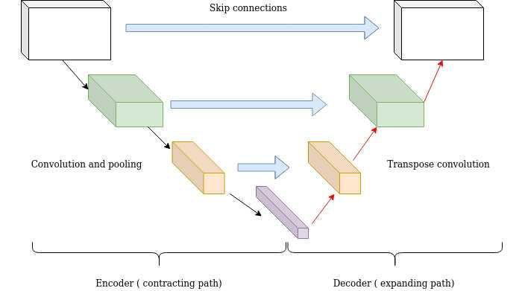
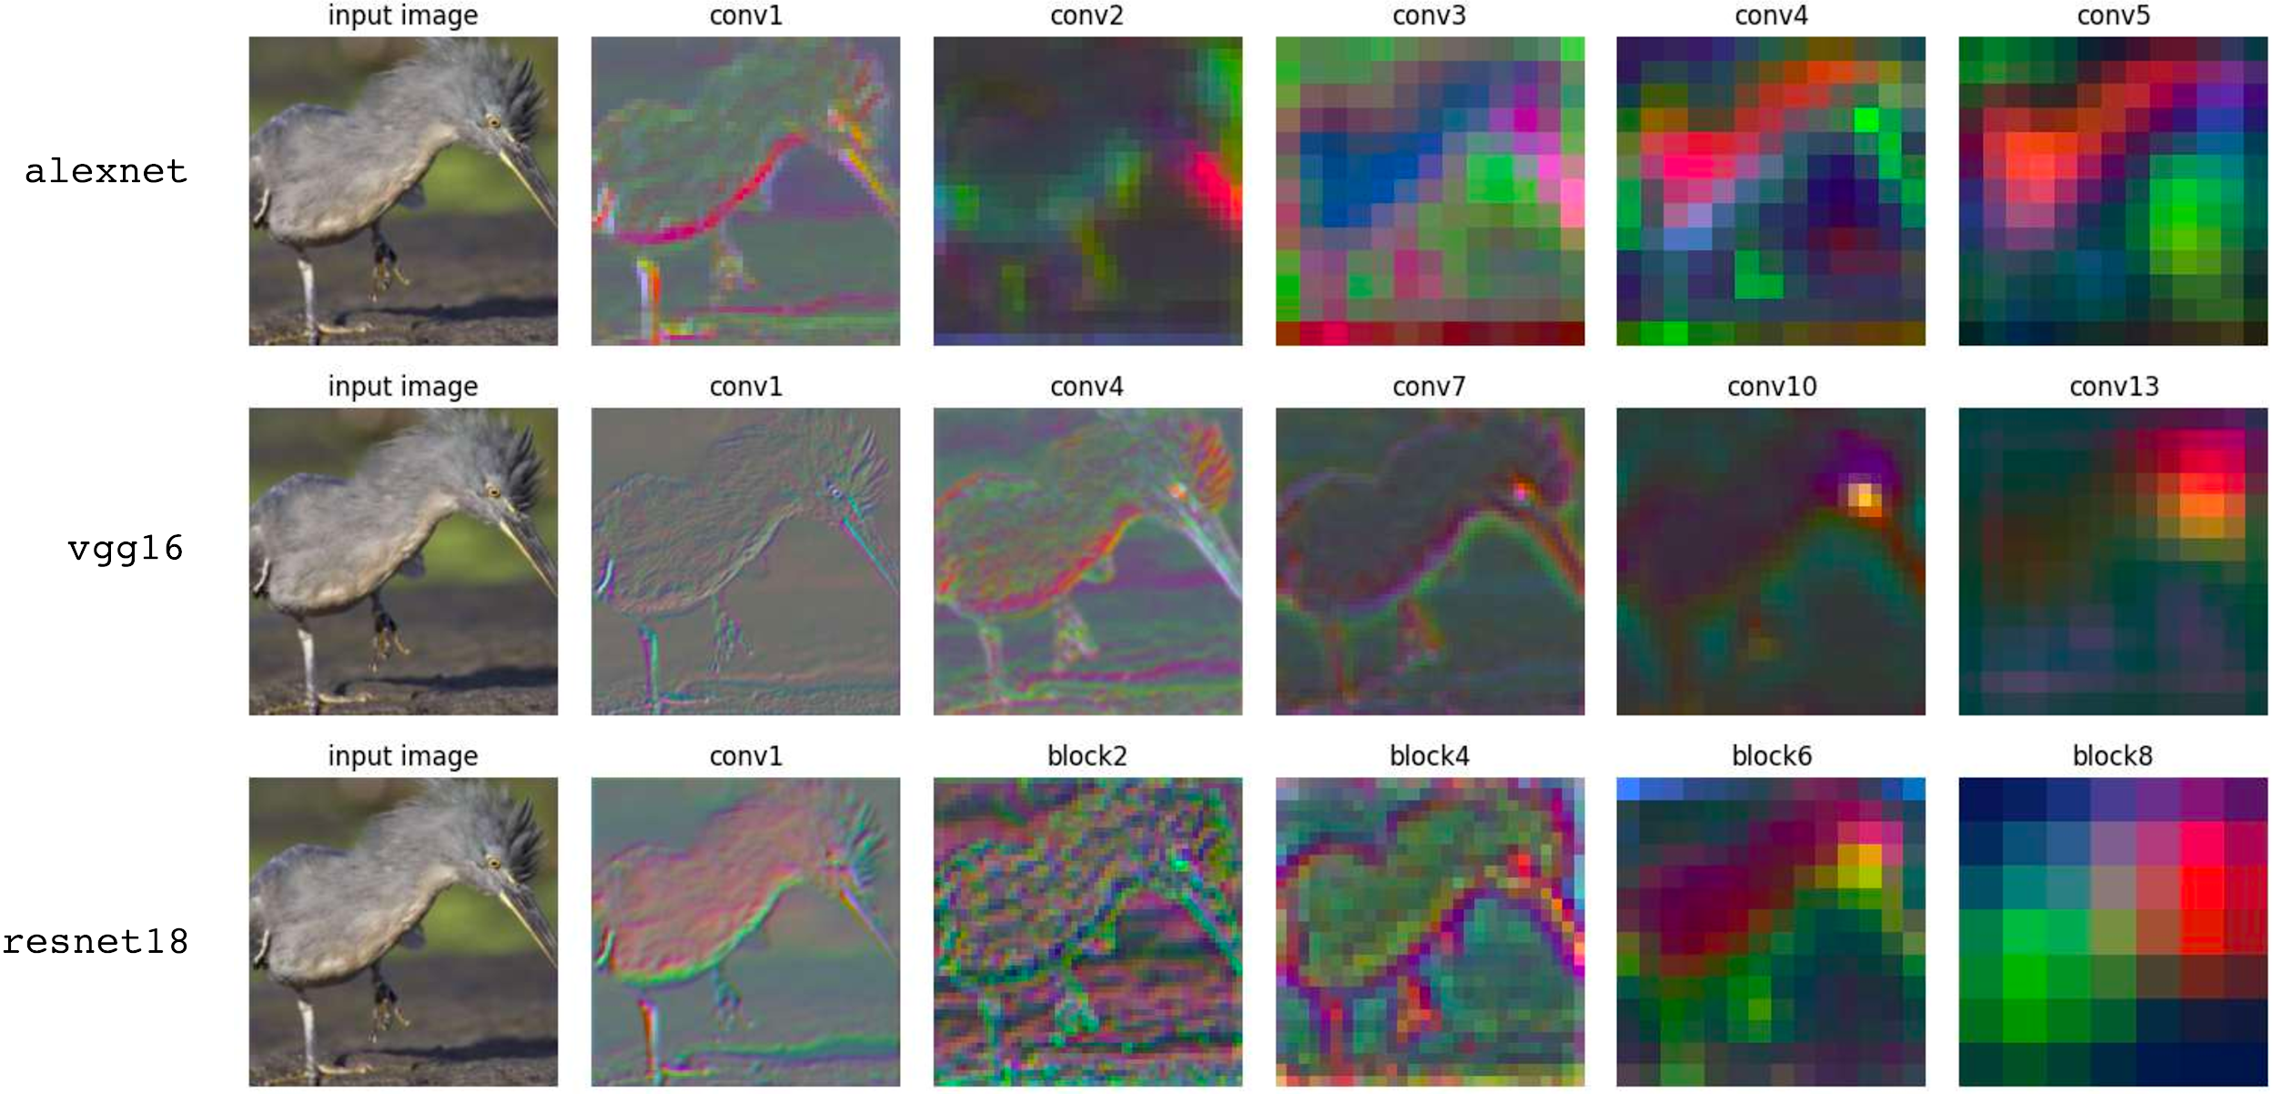
ResNet50 refers to the residual neural network which has been developed using 50 layers, and it has been used to solve the problem of vanishing gradient by incorporating the use of residual connections.

3.4.2 MobileNetV2

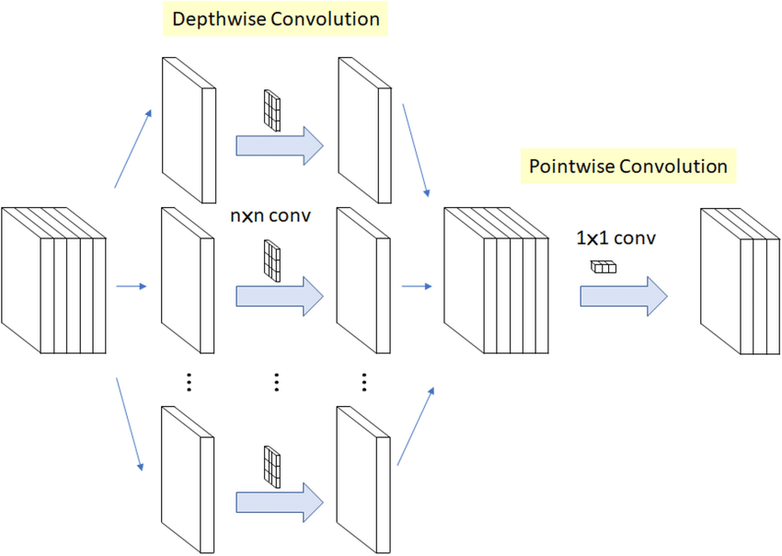

MobileNetV2 is an efficient architecture that performs computations effectively. MobileNetV2 is characterized by depthwise separable convolutions and inverted residuals, making it applicable to settings with limited computing power.

3.4.3 EfficientNetB0
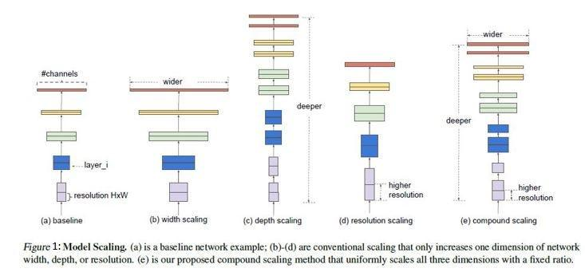
EfficientNetB0 utilizes compound scaling to achieve the right balance between depth, width, and resolution. EfficientNetB0 requires fewer parameters while attaining optimal accuracy, hence performing optimally when classifying medical images.

🔹 3.5 Model Training
- Model training was done using the following model settings:
- Optimizer: Adam
- Learning Rate: 0.0001
- Loss: Categorical Crossentropy
- Batch Size: 16
- Epochs: 15 maximum (using early stopping)
For better performance, the following methods were utilized:
- Early stopping to avoid overfitting
- Class weights to handle the class imbalance problem
- Fine-tuning by freezing only the last layers of the models
3.6 Evaluation Metrics
- Models' performance was assessed using the following criteria:
- Accuracy - accuracy of prediction
- Precision - accurate detection of positive examples
- Recall - ability to identify positives
- F1 score - harmonic average of precision and recall
A confusion matrix was also generated to analyze class-wise performance.

4. RESULTS AND ANALYSIS
Performance evaluation of ResNet50, MobileNetV2, and EfficientNetB0 models on the validation set was carried out.

4.1 Model Performance Comparison
The results are provided in Table I below.
Table I: Model Performance Comparison
Model | Accuracy | Precision | Recall | F1 Score
ResNet50 | 89% | 88% | 87% | 88%
MobileNetV2 | 87% | 86% | 85% | 85%
EfficientNetB0 | 91% | 90% | 89% | 90%

4.2 Accuracy and Loss Graphs
It can be observed that all training and validation graphs demonstrate a successful and effective convergence of models. The convergence of EfficientNetB0 is more stable and efficient than the one for other models.

4.3 Confusion Matrix Analysis
Confusion matrices reveal important information about the performance of models during the classification process of dental cases.
- Cavity and impacted classes were predicted accurately by the models.
- Cavity and root canal classes were occasionally misclassified because of their similarities in appearance.
- Least confusion was revealed during predictions for the EfficientNetB0.
4.4 Conclusions
Highest accuracy and F1-score were reached using EfficientNetB0 MobilenetV2 was trained faster but showed slightly worse results than the first model Consistent results were produced by the ResNet50 model
5. VISUALIZATION WITH THE HELP OF GRAD-CAM
To improve interpretability and gain trust in model predictions, visualization techniques like Grad-CAM were applied to dental X-rays.
Grad-CAM creates heatmaps based on the importance of certain image segments for making predictions.

Insights:
- Cavity Images: Model emphasizes decayed areas
- Root Canal Images: Focused on filled canal structures
- Impacted Teeth Images: Misaligned/Embedded teeth
- It proves that the model is capturing clinically relevant features.
6. CONCLUSION
This paper presented the development of a deep learning-based framework for the classification of dental X-ray images in three different classes: cavity, impacted teeth, and root canal. One of the key contributions of this paper includes the creation of a real-world dataset through data collected from hospitals near us and also diagnostic centers, which took a lot of effort in terms of time, money, and coordination.
The three most recent transfer learning models, namely ResNet50, MobileNetV2 and EfficientNetB0 were implemented and compared. Of all these, the most successful one was EfficientNetB0, with outstanding results in the accuracy, precision, recall and F1-score.
Furthermore, we enhanced the generalisation ability of the model by means of data augmentation, class balancing and fine-tuning techniques. In addition, techniques for interpretation such as Grad-CAM helped in visualising the important features in dental X-rays.
In conclusion, the proposed system seems to be a great potential as a computer-aided diagnostic system that may help the dental practitioners.
7. FUTURE WORK
Although the present system is promising, there are many ways in which it can be improved and extended for future research:
- Multi-class Classification: Develop the system to recognize multiple dental diseases such as cysts, abscesses, and bone loss.

- Larger Data Set: Enhance data set through the acquisition of more images from different hospitals.
- Real-Time System: Create a web or mobile application that offers real-time diagnosis of patients.
- Clinical Systems Integration: Implement the system in hospital management systems for automatic report generation.
- Enhanced Explainability: Add more methods for enhanced explainability.
- CBCT Images: Adapt the methodology to analyze images obtained using Cone Beam Computed Tomography (CBCT).
8. ACKNOWLEDGEMENT
The authors are thankful to the hospital authorities and diagnostic centers located in the nearby region for granting permission to obtain dental X-rays. The acquisition of data was not an easy task; rather, a lot of efforts were put into obtaining the data set, such as repeated visits to the hospital and medical authorities.
It is also noteworthy that the authors are thankful for the time and money spent on collecting the data set.

9. REFERENCES
[1] K. He, X. Zhang, S. Ren, and J. Sun, “Deep residual learning for image recognition,” in Proc. IEEE Conf. Computer Vision and Pattern Recognition (CVPR), 2016.
[2] M. Sandler, A. Howard, M. Zhu, A. Zhmoginov, and L. Chen, “MobileNetV2: Inverted residuals and linear bottlenecks,” in Proc. IEEE Conf. Computer Vision and Pattern Recognition (CVPR), 2018.
[3] M. Tan and Q. Le, “EfficientNet: Rethinking model scaling for convolutional neural networks,” in Proc. Int. Conf. Machine Learning (ICML), 2019.
[4] R. R. Selvaraju et al., “Grad-CAM: Visual explanations from deep networks via gradient-based localization,” in Proc. IEEE Int. Conf. Computer Vision (ICCV), 2017.
[5] J. Deng et al., “ImageNet: A large-scale hierarchical image database,” in Proc. IEEE Conf. Computer Vision and Pattern Recognition (CVPR), 2009.
[6] S. Litjens et al., “A survey on deep learning in medical image ana

