Smart Traffic Lights Control for Smart Cities: Conceptual Framework

Abstract
Traffic control lights have being in use for more than a century and are positioned at road intersections and pedestrian crossings to control the flow of traffic. The operation of traffic lights has been time-based and therefore open-loop in nature. The traffic lights only change state after and according to the pre-set time intervals irrespective of traffic situation. Today, the number of vehicles, the volume of traffic, and human activities have made time-controlled traffic lights inadequate in many situations. In this work, traffic lights that operate based on the volume of traffic, that is one with a feedback system or sensor is developed for a four-way road intersection. Sensors are placed at the different roads of the intersection to gather traffic information on the roads. The controller, Arduino in this work, coordinates signals from the sensors and controls the traffic lights intelligently such that priority is given to the busiest road of the intersection and emergency vehicles.
Keywords – Traffic lights, Smart city, Arduino, Feedback system, Sensors

- Introduction
Transportation is the intentional movement of people or goods from one place to another by various modes through various means. Modes of transportation includes land (road and rail), water, air, cable, and space. Means of transportation on land include walking, riding animals (beasts of burden), cycling, biking, trains, trams, vehicles. By far, means of transportation by vehicles, that is road transportation, is the most common means of transportation [1]–[3]. Road transportation has always played important roles in trade, social interaction, and general well-being of any society. The major reasons for transportation has always been economic, exploration, personal fulfilment, social interaction, educational, and improvement of a society or a nation. The growth (or otherwise) of a society is directly related to the quality of its transportation system. Transportation in a society is akin to the network of veins in the human body. A clog, in this context traffic congestion, in the system (i.e. society) could render the system incapacitated to function well in providing enabling environment for different human activities necessary for growth and development of the society. Figure 1 shows the analogy between the network of human veins and road transport network.
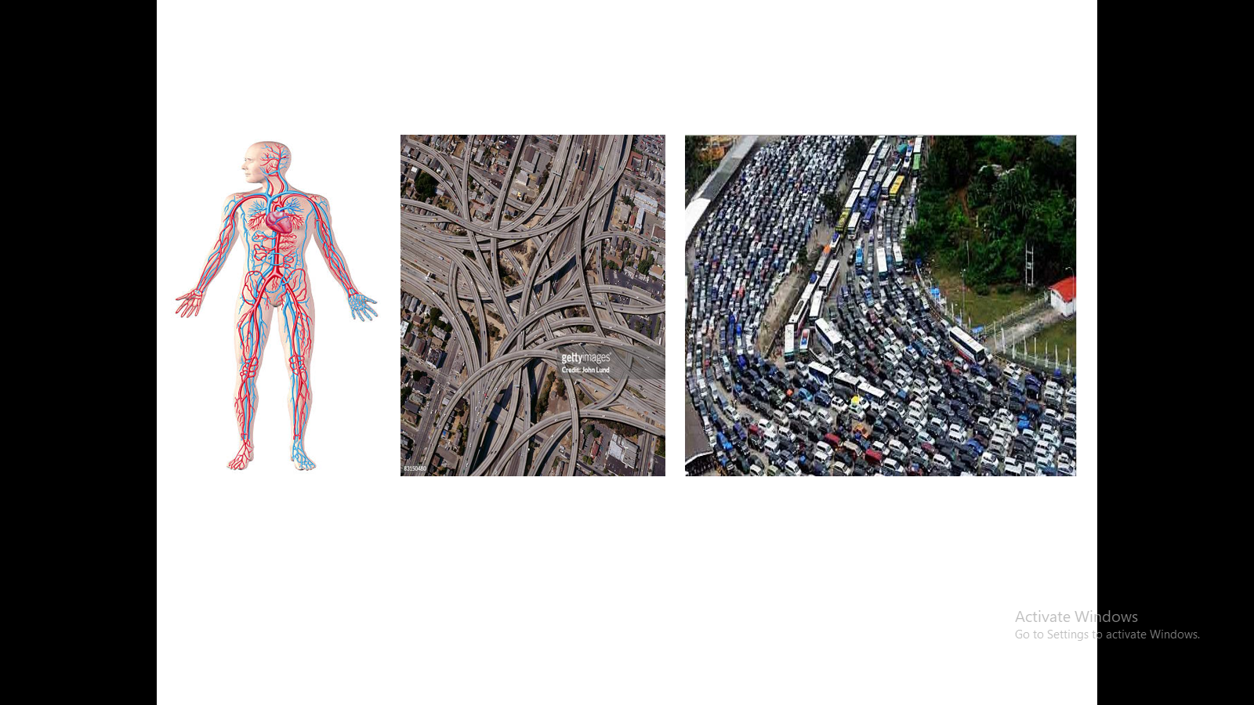
Figure 1: Analogy between the network of human veins and road transport network
The importance of good quality and congestion-free road transportation are numerous and interwoven with cascading benefits. Figure 2 illustrates some of the importance of good quality and congestion-free road transportation.
Figure 2: Importance and benefits of good quality and congestion-free road transportation
Most cities in the world are facing problems of traffic congestions due mainly to the significant increase in the number of vehicles plying the limited-capacity road networks and ineffective traffic management system [4], [5]. Ineffective traffic management system resulting into traffic congestions causes both economic and human losses [6], [7]. Medical ambulances and other emergency services vehicles could be delayed and/or slowed down in traffic jam. Economic losses due to traffic congestions include amongst others reduction of productive hours of the populace, more fuel consumption than necessary, and the costs of repair of damages and insurance due to bashing/crashing of cars. One way of ameliorating the problems of traffic congestions is by making the control of traffic lights smart such that the control of vehicles on the roads especially at busy intersections is dynamic and adaptive according to real-time situations. Most traffic lights in many cities of the world are time-based and open-loop in their operations [8], [9]. The change of state of these traffic lights and the time intervals for such change are pre-set and fixed irrespective of traffic situation. The fast rate of urbanisation and urban population growth with increased human activities has led to heavier vehicular traffic thereby rendering the once-effective conventional time-based traffic lights ineffective in coordinating smooth road traffic.
The deployment of Internet of Things (IoT) in the evolving smart cities is one way to alleviate the issues arising from increased and fast rate human activities due to rapid urbanisation and urban population growth. For a truly smart city, IoT must be deployed in many areas of applications such as smart grids, smart homes, e-commerce, e-health, etc., to reduce human involvement in their operations and make their operations adaptive with real-time situations. Thus, the control of the traffic lights must also be smart indeed for a smart city.
Many solutions of smart traffic lights controls have been proposed in studies. In [10], a vehicle to infrastructure (V2I) communication is proposed to ease congestions at road intersections. Traffic light controllers at intersections communicate traffic light cycle information to approaching vehicles so that the drivers can, based on the information, determine their optimal speed and other actions to cross the intersections with minimum delays. However, this proposed solution does not address making the actual operation of traffic lights controllers smart and adaptive to real-time traffic situation but only communicate traffic light cycle to approaching vehicles, which must have means of receiving such information, for them to adjust their speed accordingly. Reinforcement learning algorithm was used in [11] and [12] to solve the traffic light control problem. Reinforcement learning algorithm takes the traffic condition (queue length of waiting cars and updated waiting time) as state, and try to make actions that can improve the traffic condition based on the current state. However, reinforcement learning algorithm requires huge storage space when tested on real traffic condition. Researchers in [13] focussed on giving priority to ambulances and other emergency vehicles while also protecting the IoT-based traffic light controller from cyber-attacks. Some studies [14]–[16] proposed the use of live video feeds from cameras at road intersections for real-time traffic density calculation and transmission of signals via internet to the respective microcontrollers for appropriate actions on the traffic lights. The shortcomings of such systems include poor visibility in bad weathers and vulnerability of such systems to cyber-attacks.
In this study, a smart traffic light control, which takes action based on the state of real-time traffic conditions and override all events to give priority to ambulance and other emergency vehicles, is proposed. The proposed solution is stand-alone, sensor-based, and requires neither internet nor wireless on-board communication with vehicles except with emergency vehicles.
The rest of the paper is organised as follows: Section II discusses urban growth and the challenge of the traffic management. Section III gives the proposed smart traffic light control with its algorithm and working principle. The prototype of the conceptualised smart traffic light control is implemented in Section IV and tests and performance evaluation of the implemented prototype is carried out in Section V. Conclusion and recommendations for future work are given in Section VI.
- Urban Growth and Traffic Management Challenge
Significant exodus of people from suburban to urban areas began at the start of industrial revolution between 1760 and 1860 in the Great Britain and the trend spread to other parts of the world. People started drifting to urban areas for economic opportunities and to enjoy the better life (standard of living) that comes with industrialisation. Thus, in the Great Britain, the first traffic control system – a semaphore signal, was installed in London in 1868 as an alternative to police officer controlling vehicular traffic [[17]]. The semaphore traffic signals soon spread to other civilised parts of the world and in 1912, the first electric traffic light was developed in the United States of America (USA).
Many cities of the world have introduced various measures to curtail the traffic challenge that comes with urbanisation and urban growth. In Lagos, Nigeria during the 1970s, the authority came up with an odd-even number plate road access [18]. Under the policy, private vehicles are allowed or restricted on the roads based on whether the last digit of their number plate is even or odd on alternate days. However, the policy did not stop the gridlock as people circumvented the policy by acquiring second vehicles or illegal second number plate for the same vehicle. Another measure taken by some cities, for example Bristol, United Kingdom, is dedicating lanes in some busy areas for vehicles having two or more occupants to encourage co-commuting and reduce the number of vehicles on the roads. Other measures in many major cities include running of efficient mass transit bus network, imposing payment of tolls in busy areas, especially city centres, and fairly high parking fees to discourage people from commuting on their cars at all times.
All the measures enumerated above are indirect approach to traffic management. Direct approach to traffic management include expansion of erstwhile narrow roads, building of new and wider roads, and the using of technology to monitor and control traffic.
- The Proposed Smart Traffic Light Control
The proposed smart traffic light control with its algorithm and working principle is presented in this section. The proposed smart traffic light control is for four-way road intersections but could also be suitable for other numbers of road intersections with some modifications of the algorithm. The four intersection roads are assigned either numbers 1, 2, 3, and 4 or letters A, B, C, and D for identification. Since the average length of cars is approximately 14.7ft, that is 5m [19], sensors are fixed, at a span of 5m apart, on each of four intersection roads beginning from 100m to the traffic light at the main junction. Thus, there are 20 sensors on each of the four intersection roads. The sensors are strategically fixed on the road such that they are activated by vehicles queuing at the intersection waiting for traffic signal to move on. For any of the four intersection roads to be considered for priority all its 20 sensors must be activated and must not be the turn of the vehicles on the road to pass in the next change of traffic signal.
A unique feature of this smart traffic light control is the provision of wireless long range radio frequency (RF) communication between emergency vehicles (which must have previously registered with and given remote control by the Traffic Management Authority of the City) and the control unit of the traffic light. At a distance of between 200m and 150m to the intersection, the emergency vehicle sends an RF signal (by pressing the ON button on the remote control) to the control unit of the traffic light such that immediate priority is given to the road the emergency vehicle is plying toward the intersection.
The working logic of the smart traffic light are as follows:
- The normal sequence of passage at the intersection shall be 1-2-3-4 or A-B-C-D when no priority is initiated.
- Stop the road (i.e. flash red light) on which no sensor is activated.
- No priority is given (except for emergency vehicles) if at least three roads of the intersection are having at least 20 vehicles waiting on queue to pass.
- Give priority if at most two of the roads (i.e. one or two roads) are having at least 20 vehicles waiting on the queue to pass.
The flowchart of the working logic and algorithm is given in Figure 3.
Figure 3: The flowchart of the algorithm of the smart traffic light control

- Implementing A Prototype Of the Conceptualised Smart Traffic Light Control
The most important components required for implementing the proposed smart traffic light control are sensors, radio frequency (RF) remote control system and microcontroller. Infrared (IR) sensor system used as motion detection is ideal for the implementation of the concept. IR sensor system is made up of two parts. The IR transmitter consisting of IR led emitting diode (LED) and the IR receiver consisting of photodiode. When the IR sensor system is energised, the infrared LED emits infrared light that travels through air and get reflected in the photodiode when the infrared light hits an object. Figure 4 shows the diagram of the IR sensor system.
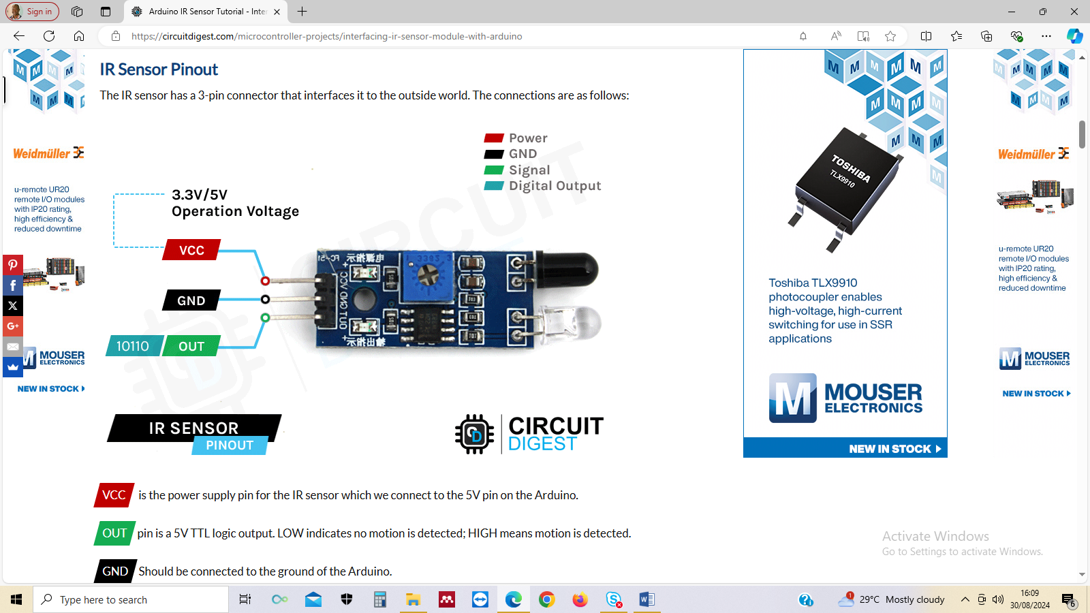
Figure 4: The IR sensor system [20]
When the infrared light gets reflected in the photodiode sensor, a corresponding signal is sent via the output pin to a microcontroller for appropriate action. Specifically, in the implementation of this concept, four infrared sensors are placed on each road of the four-way road intersection. The outputs of all the four infrared sensors on a road must be high for the controller to recognise there is a traffic build up on the road and appropriate action is taken according to the logic flow based on the conditions on other roads.
The component responsible for giving priority to emergency vehicles is RF remote control system. A one-receiver-multiple-transmitter type is ideal. The receiver is centrally fixed at the intersection of the four roads. Registered emergency vehicles are given transmitters which the drivers would operate (by pressing of button) at a distance from the intersection to get priority on the road the emergency vehicles are plying toward the intersection. The roads have been assigned numbers 1, 2, 3, and 4 and the driver of the emergency vehicle would press the appropriate button number (corresponding to the inbound road to the intersection) on the RF transmitter at a distance to the intersection. When the RF receiver receives signal from an incoming emergency vehicle, the controller overrides all other actions and give immediate priority to that road before resetting to normal control operation.
Arduino Nano ATmega328P microcontroller is a good controller for implementing this concept. Two Arduino Nano ATmega328P microcontrollers are used in the control circuit. The first Arduino Nano ATmega328P is used in the master control circuit which coordinates the logic operations of the IR sensors (placed on each road of the four-way road intersection) and the RF receiver. The second Arduino Nano ATmega328P is used in the slave control circuit which controls and coordinates the traffic lights (Red, Yellow, and Green LEDs) on each road of the four-way road intersection. The master and the slave Arduino Nano ATmega328P controllers are interconnected through their 12C serial ports for communication. Figure 5 and Figure 6 show the Master and the Slave control circuits of the concept respectively.
Figure 5: Master Control Circuit
Figure 5: Slave Control Circuit

The source code for the control actions of the system is presented in the appendix. The implemented prototype of the conceptualised smart traffic control light is shown in Figure 6.
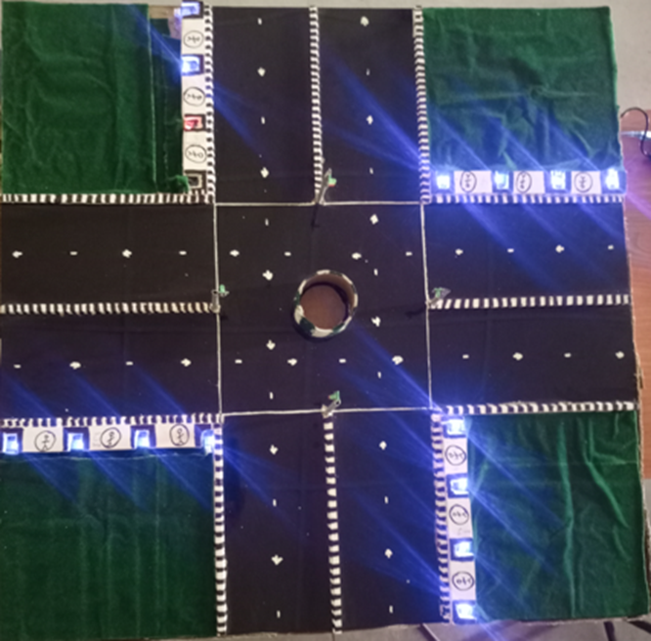
Figure 6: The implemented prototype of the conceptualised smart traffic control light

- Test and Performance Evaluation
The implemented prototype of the smart traffic light control is put to test and its performance evaluated. In its operation, the green light is ON for 30 seconds and the yellow light for 3 seconds. By the time the green light has been ON for 27 seconds, the yellow light of the next road comes ON and exactly 3 seconds later the green light of the road comes ON. Thus, the longest waiting time for any road is 90 seconds.
The prototype is tested for identifying and giving priority to the road with highest traffic volume. Three cars are placed on one road, two cars on another road, and one car each on other roads as seen in Figure 7. The road with three cars is given priority being the road with highest number of cars on queue. In addition, the prototype is tested for overriding all traffic conditions and giving priority to emergency vehicle. Three cars are placed on one road, two cars each on two roads and an ambulance on one road as seen in Figure 8. The road with the ambulance is given priority notwithstanding three cars on one of the roads.
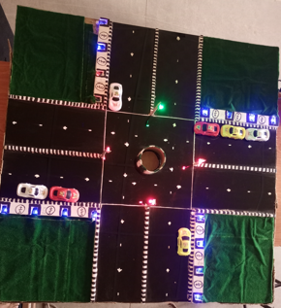
Figure 7: Testing the prototype for identifying and giving priority to road with highest traffic volume

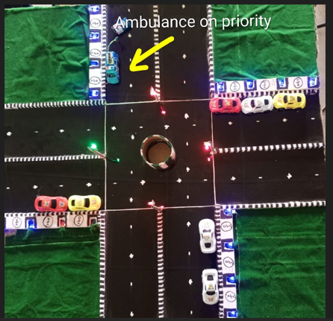
Figure 8: Testing the prototype for identifying and giving priority to emergency vehicle

- Conclusion
In this work, the conceptual framework for smart traffic light control for smart cities is developed. The uniqueness of the concept is the coordination and control of traffic at intersections based on real traffic situations, giving priority to the roads according to traffic volume, and overriding of all other actions to give immediate priority to emergency vehicles. The concept was implemented making use of Arduino Nano ATmega328P as the controller. Tests were conducted to evaluate the performance of the prototype and the outcomes were satisfactory.
The outlook of the work is to develop an actual smart traffic light control from the prototype for real life traffic control at road intersections.

References
1. Idrisu, I., & Osoba, S. B. (2015). Travel characteristics and commuting pattern among residents of Lagos metropolis, Nigeria: An assessment. Ethiopian Journal of Environmental Studies and Management, 8(5), 579–592.
2. Le Vine, S., Polak, J., & Humphrey, A. (2017). Commuting trends in England 1988–2015. London.
3. Department for Transport. (2016). National travel survey: 2015 report. London.
4. Ghazal, B., ElKhatib, K., Chahine, K., & Kherfan, M. (2016). Smart traffic light control system. In Third International Conference on Electrical, Electronics, Computer Engineering and their Applications (EECEA) (pp. 140–145).
5. Wu, N., Li, D., & Xi, Y. (2019). Distributed weighted balanced control of traffic signals for urban traffic congestion. IEEE Transactions on Intelligent Transportation Systems, 20(10), 3710–3720.
6. The Economist. (2014, November). The cost of traffic jams. The Economist. London.
7. Guerrin, F. (2014, October). Traffic congestion costs Americans $124 billion a year, report says. Forbes. Jersey City.
8. Li, L., Lv, Y., & Wang, F. Y. (2016). Traffic signal timing via deep reinforcement learning. IEEE/CAA Journal of Automatica Sinica, 3(3), 247–254.
9. Djahel, S., Doolan, R., Muntean, G. M., & Murphy, J. (2015). A communications-oriented perspective on traffic management systems for smart cities: Challenges and innovative approaches. IEEE Communications Surveys & Tutorials, 17(1), 125–151.
10. Djahel, S., Jabeur, N., Barrett, R., & Murphy, J. (2015). Toward V2I communication technology-based solution for reducing road traffic congestion in smart cities. In International Symposium on Networks, Computers and Communications (ISNCC) (pp. 1–6).
11. Wei, H., Zheng, G., Yao, H., & Li, Z. (2018). IntelliLight: A reinforcement learning approach for intelligent traffic light control. In KDD ’18: The 24th ACM SIGKDD International Conference on Knowledge Discovery & Data Mining.
12. El-Tantawy, S., Abdulhai, B., & Abdelgawad, H. (2013). Multiagent reinforcement learning for integrated network of adaptive traffic signal controllers (MARLIN-ATSC): Methodology and large-scale application on downtown Toronto. IEEE Transactions on Intelligent Transportation Systems, 14(3), 1140–1150.
13. Sumia, L., & Ranga, V. (2018). Intelligent traffic management system for prioritizing emergency vehicles in a smart city. International Journal of Engineering (IJE), IJE Transactions B: Applications, 31(2), 278–283.
14. Saini, S., Nikhil, S., Konda, K. R., Bharadwaj, H. S., & Ganeshan, N. (2017). An efficient vision-based traffic light detection and state recognition for autonomous vehicles. In 2017 IEEE Intelligent Vehicles Symposium (IV) (pp. 606–611).
15. Kanungo, A., Sharma, A., & Singla, C. (2014). Smart traffic lights switching and traffic density calculation using video processing. In 2014 Recent Advances in Engineering and Computational Sciences (RAECS) (pp. 1–6).
16. Javaid, S., Sufian, A., Pervaiz, S., & Tanveer, M. (2018). Smart traffic management system using Internet of Things. In 2018 IEEE 20th International Conference on Advanced Communication Technology (ICACT) (pp. 393–398).
17. McShane, C. (1999). The origins and globalization of traffic control signals. Journal of Urban History, 25(3), 379–404.
18. Nwakunor, G. A. (2015, October 4). Lagos lockdown: In search of a way out. The Guardian. Lagos.
19. carparts.com. (2017). Why does the length of the average car matter? Newsletter. Retrieved from https://www.carparts.com/blog/why-does-the-length-of-the-average-car-matter/
20. Circuit Digest. (2018). Microcontroller-based projects: Interfacing IR sensor with Arduino. Retrieved from https://circuitdigest.com/microcontroller-projects/interfacing-ir-sensor-module-with-arduino
Available: https://circuitdigest.com/microcontroller-projects/interfacing-ir-sensor-module-with-arduino.

APPENDIX
CODE
#include <Wire.h>

const int roadSensors[4][4] = {
{2, 3, 4, 5}, // Road 1
{6, 7, 8, 9}, // Road 2
{10, 11, 12, 13},// Road 3
{A0, A1, A2, A3} // Road 4
};

// --- TIMING CONSTANTS ---
const unsigned long MIN_GREEN_TIME = 5000; // 5 seconds minimum
const unsigned long TIME_PER_CAR = 3000; // 3 seconds extra per car

struct Road {
int id;
int density;
};

void setup() {
Wire.begin();
Serial.begin(9600);

for(int r=0; r<4; r++) {
for(int s=0; s<4; s++) {
pinMode(roadSensors[r][s], INPUT);
}
}
}

void loop() {
Road roads[4];

// 1. Scan All Roads
for (int r = 0; r < 4; r++) {
roads[r].id = r;
roads[r].density = 0;
for (int s = 0; s < 4; s++) {
if (digitalRead(roadSensors[r][s]) == LOW) {
roads[r].density++;
}
}
}

// 2. Sort by Density (Descending)
for (int i = 0; i < 3; i++) {
for (int j = 0; j < 3 - i; j++) {
if (roads[j].density < roads[j + 1].density) {
Road temp = roads[j];
roads[j] = roads[j + 1];
roads[j + 1] = temp;
}
}
}

// 3. Process each road in priority order
for (int i = 0; i < 4; i++) {
// Only pass if there's at least one car (optional)
if (roads[i].density > 0) {
// Calculate dynamic time
unsigned long duration = MIN_GREEN_TIME + (roads[i].density * TIME_PER_CAR);

Serial.print("Clearing Road: "); Serial.print(roads[i].id);
Serial.print(" | Cars: "); Serial.print(roads[i].density);
Serial.print(" | Time: "); Serial.print(duration / 1000); Serial.println("s");

sendData(roads[i].id, roads[i].density);

delay(duration); // Keep the road green for calculated time
}
}

delay(1000); // Short gap before next full scan
}

void sendData(int roadID, int value) {
Wire.beginTransmission(8);
Wire.write(roadID);
Wire.write(value);
Wire.endTransmission();
}

**SLAVE**
#include <Wire.h>

// Traffic Light Pins {Red, Yellow, Green}
int lights[4][3] = {
{2, 3, 4}, {5, 6, 7}, {8, 9, 10}, {11, 12, 13}
};

const int emergencyPins[4] = {A0, A1, A2, A3};

// Initialize with 0 to ensure skip logic works
volatile byte roadDensities[4] = {0, 0, 0, 0};
int activeEmergencyRoad = -1;

void setup() {
Wire.begin(8);
Wire.onReceive(receiveEvent);
Serial.begin(9600);

for(int i=0; i<4; i++) {
for(int j=0; j<3; j++) pinMode(lights[i][j], OUTPUT);
pinMode(emergencyPins[i], INPUT_PULLUP);
}
allRed();
Serial.println("--- System Online: Awaiting Master Density Data ---");
}

void loop() {
// 1. Check for Emergency
activeEmergencyRoad = -1;
for(int i=0; i<4; i++) {
if(digitalRead(emergencyPins[i]) == LOW) {
activeEmergencyRoad = i;
break;
}
}

if (activeEmergencyRoad != -1) {
handleEmergency(activeEmergencyRoad);
} else {
// 2. Normal Traffic Cycle
for (int i = 0; i < 4; i++) {
if (checkAnyEmergency()) break;

// --- LOGGING FOR DEBUGGING ---
Serial.print("Checking Road "); Serial.print(i + 1);
Serial.print(" | Density Value: "); Serial.println(roadDensities[i]);

// --- SKIP LOGIC ---
if (roadDensities[i] == 0) {
Serial.print("SKIP: Road "); Serial.println(i + 1);
continue; // If density is exactly 0, move to next road
}

// 3. Calculation & Execution
int greenTime = (roadDensities[i] > 2) ? 10000 : 5000;

Serial.print("GREEN ON ROAD "); Serial.print(i + 1);
Serial.print(" for "); Serial.print(greenTime / 1000); Serial.println("s");

runTrafficCycle(i, greenTime);
}
}
}

bool checkAnyEmergency() {
for(int i=0; i<4; i++) {
if(digitalRead(emergencyPins[i]) == LOW) return true;
}
return false;
}

void receiveEvent(int howMany) {
if (howMany >= 2) {
byte roadID = Wire.read();
byte val = Wire.read();
if (roadID < 4) {
roadDensities[roadID] = val; // Store the new value
}
}
}

void runTrafficCycle(int road, int duration) {
allRed();
digitalWrite(lights[road][0], LOW); // Red Off
digitalWrite(lights[road][2], HIGH); // Green On

for(int i=0; i<duration/100; i++) {
if(checkAnyEmergency()) return;
delay(100);
}

digitalWrite(lights[road][2], LOW); // Green Off
digitalWrite(lights[road][1], HIGH); // Yellow On
delay(2000);
digitalWrite(lights[road][1], LOW); // Yellow Off
allRed(); // Ensure all red before moving to next road
}

void handleEmergency(int road) {
allRed();
digitalWrite(lights[road][0], LOW);
digitalWrite(lights[road][2], HIGH);
while(digitalRead(emergencyPins[road]) == LOW) { delay(100); }
delay(2000);
}

void allRed() {
for(int i=0; i<4; i++) {
digitalWrite(lights[i][0], HIGH); // Red On
digitalWrite(lights[i][1], LOW);
digitalWrite(lights[i][2], LOW);
}
}

