SmartFlow Vision: IoT and AI-Based Crowd Movement and Density Monitoring

Abstract—Ensuring public safety in high-footfall environments such as transit terminals, entertainment venues, and commer-cial centres demands robust, automated mechanisms for crowd oversight. Human-supervised surveillance systems frequently fall short due to inherent error rates and limited scalability. To address these deficiencies, this paper presents SmartFlow Vision
- an embedded, edge-computing solution that fuses Internet of Things (IoT) connectivity with artificial-intelligence-driven video analytics for real-time crowd density estimation and movement tracking. A Raspberry Pi microcomputer serves as the sole processing node, paired with a USB-connected camera that delivers continuous video input. Person detection is accomplished through the YOLO (You Only Look Once) neural network, whose single-pass inference design yields processing speeds well-suited to constrained embedded hardware. Occupancy data is relayed simultaneously to a ThingSpeak cloud channel for remote trend visualisation and to a locally mounted LCD for on-site display. A dual-tier alert subsystem activates whenever the detected headcount surpasses a configurable safety limit: a piezoelec-tric buzzer signals nearby personnel, while a SIM900A GSM module dispatches SMS notifications to designated authorities. Prototype evaluations conducted in a controlled corridor environ-ment achieved people-counting accuracy between 90–95% across crowd densities of one to ten individuals, with local alert latency consistently below 0.5 seconds. The complete hardware bill of materials totals approximately eighty-five US dollars, positioning SmartFlow Vision as a viable, privacy-preserving alternative to proprietary surveillance infrastructure, particularly in resource-constrained deployment contexts.
Index Terms—IoT, Crowd Monitoring, YOLO, Raspberry Pi, ThingSpeak, GSM, Public Safety

  - Introduction
- Motivation
Rapid urbanisation and the increasing frequency of mass-gathering events have intensified safety risks associated with dense crowds in confined settings [1]. When crowd flow becomes unregulated — whether at railway concourses, pil-grim sites, or sports arenas — consequences can escalate from minor congestion to life-threatening crush incidents
[2]. Conventional crowd-management practices, which depend primarily on stationed personnel and simple entry counters, are ill-equipped to furnish a continuous, area-wide picture of occupancy in real time [3]. The driving impetus for this research is the requirement for an autonomous, intelligent plat-form capable of both monitoring crowd density continuously and initiating proactive countermeasures before hazardous conditions develop [4].
- Problem Statement
Supervising large open areas manually is both labour-intensive and error-prone, particularly during peak-load pe-riods or staff handovers [5]. Although closed-circuit televi-sion (CCTV) networks provide broad spatial coverage, they predominantly operate in passive recording mode, furnishing raw footage that is rarely interrogated until after an incident has already occurred [6]. The absence of real-time analytical capability means that actionable intelligence reaches decision-makers with unacceptable delays [7]. Furthermore, commer-cially available smart-camera solutions with built-in analytics entail prohibitive hardware and licensing costs, restricting deployment to well-funded installations [8].
- Objectives of the Study
This project targets the design and deployment of a com-prehensive, low-cost crowd-monitoring platform [9]. Specific goals pursued include:
  - To deploy the YOLO detection pipeline on a Raspberry Pi for frame-by-frame person counting without reliance on cloud-side inference.
  - To transmit occupancy metrics to ThingSpeak, enabling web-accessible dashboards and retrospective trend anal-ysis.
  - To construct a two-tier alert chain — immediate audible warning via buzzer and remote SMS dispatch via GSM

— triggered whenever occupancy exceeds the configured safety threshold.
  - To keep per-unit expenditure at a level accessible to developing-region municipalities and small-scale event organisers.
- Contribution Overview
The principal contribution of this work is an end-to-end prototype that closes the loop between detection, decision-making, and notification — a capability absent in passive CCTV deployments [10]. By co-locating sensor, processing, and communication functions on a single low-cost node, the architecture avoids raw-video transmission to external servers, thereby providing inherent privacy preservation. The system demonstrates that acceptable detection performance can be achieved on constrained edge hardware without the need for dedicated GPU resources.
  - Background and Fundamentals
- System Overview
At the heart of the proposed platform lies the Raspberry Pi, which orchestrates data acquisition, algorithmic inference, local display, and network communication. An attached USB camera continuously feeds video frames into the system. Pro-cessed headcounts drive three distinct output pathways: cloud publication to ThingSpeak, physical alert actuation through the buzzer and GSM peripherals, and occupancy display on the LCD panel.
- Core Concepts
  - Object Detection: Object detection is the computer-vision discipline concerned with simultaneously localising and classifying instances of target categories within an image frame. This work leverages the YOLO family of detectors, whose single forward-pass design achieves a favourable bal-ance between inference speed and detection accuracy — a critical characteristic for real-time edge deployment.
  - Internet of Things (IoT): The IoT paradigm intercon-nects physical sensing devices with digital network infras-tructure, enabling data to flow from the physical world into analytics and control systems. In the proposed architecture, IoT principles govern the uplink of crowd-count time-series to ThingSpeak and the downlink of alert triggers to mobile recipients via the GSM module.
- Technology Overview
  - Raspberry Pi: The Raspberry Pi 3 Model B is a single-board computer (SBC) built around a Broadcom BCM2837 SoC featuring four Cortex-A53 cores clocked at 1.2 GHz, paired with 1 GB of LPDDR2 RAM. Running Raspbian — a Debian derivative optimised for the platform — it sup-ports Python-based computer-vision libraries and exposes 40 general-purpose input/output (GPIO) pins for direct hardware interfacing, making it an efficient and affordable host for lightweight deep-learning workloads.
  - GSM Module (SIM900A): The SIM900A is a compact quad-band GSM/GPRS modem that interfaces with host pro-cessors via a UART serial bus. Message dispatch is gov-erned by Hayes-compatible AT commands, making integration straightforward from Python’s pyserial library. Crucially, GSM connectivity operates independently of local Wi-Fi in-frastructure, ensuring alert delivery remains robust even when internet access is unavailable.
  - ThingSpeak Cloud Platform: ThingSpeak is an open IoT analytics service developed by MathWorks that accepts time-stamped channel data through a REST API. It provides browser-accessible charts for live monitoring and supports MATLAB-scripted analytics and alerting. In this deployment, a dedicated channel records headcount observations at fifteen-second intervals, enabling administrators to review occupancy trends across arbitrary time windows.
  - YOLO Algorithm: The YOLO detector reformulates object detection as a unified regression task: a single convolu-tional network simultaneously predicts bounding-box coordi-nates and class-confidence scores for all objects in an image in one forward pass. This contrasts sharply with region-proposal methods such as Faster R-CNN that require sequential pro-cessing stages, yielding inference rates orders of magnitude higher at comparable accuracy levels on embedded hardware.
  - Related Work
- Existing Approaches
Historically, crowd estimation relied entirely on manual observation and head-counts at choke points [11]. Automated hardware-based alternatives subsequently emerged, including turnstile counters and infrared beam-break sensors placed at venue entrances [12]. The computer-vision community demonstrated that image analysis could yield crowd estimates across entire scenes rather than at isolated crossing lines [13]. Methods based on optical flow and background modelling offered early solutions for tracking moving groups [14].
  - Manual Counting: Stationing personnel at entry and exit points to tally individuals remains the simplest approach [15]. It scales poorly with venue size, is susceptible to human fatigue and distraction, and offers no real-time spatial insight into crowd distribution beyond the immediate counting loca-tion.
  - Sensor-Based Counting: Passive infrared (PIR) and ac-tive IR beam sensors provide reliable counts under single-file passage conditions [16]. Utility degrades significantly in wide corridors where subjects traverse in parallel, as overlapping crossings may register as a single event [17]. Thermal imagers protect subject identity but are costly and can misclassify non-human heat sources such as machinery or heating appliances.
  - Computer Vision Approaches: Early vision-based meth-ods applied Gaussian Mixture Models to separate moving foreground objects from static backgrounds [18]. These ap-proaches were sensitive to illumination variation and camera motion. The advent of deep convolutional neural networks (CNNs) brought a step-change in detection reliability [19].

Region-based CNN variants achieved high precision but re-mained computationally prohibitive for real-time inference on microprocessor-grade hardware [20].
- Limitations of Existing Systems
- Manual Systems: Introduce significant human-error vari-ance, incur recurring labour costs, and fail to provide spatial density maps.
- Infrared Counters: Constrained to single-crossing-line operation; unable to estimate density within a zone or detect stationary crowds.
- Passive CCTV: Demands continuous human attention; its value is predominantly retrospective rather than pre-ventive.
- High-End Vision Systems: Dependent on server-grade GPU infrastructure, making large-scale deployment eco-nomically infeasible for smaller organisations.
- Comparative Observations
Table I contrasts representative existing methods against the approach presented in this work. A defining advantage is edge-side inference: all video processing is performed locally on the Raspberry Pi, so only the derived headcount figure — not raw video frames — is transmitted to the cloud. This design choice simultaneously reduces bandwidth consumption and mitigates privacy exposure.

TABLE I
Comparison with Existing Methods

Feature | Traditional CCTV | This Work
Real-time Analysis | No | Yes
Automated Alerts | No | Yes (Buzzer + SMS)
Remote Dashboard | Limited | ThingSpeak Integration
Hardware Cost | High | Low (Raspberry Pi)

  - System Architecture and Design
- Overall Architecture
The hardware topology centres on the Raspberry Pi as the sole computation node. As illustrated in Figure 1, a USB webcam delivers uncompressed video input while the power supply energises the entire assembly. Three output branches extend from the Pi: the SIM900A GSM module for SMS-
based remote notification, the piezoelectric buzzer for localised audible warning, and the 16×2 LCD for on-site headcount display. A fourth asynchronous network channel streams oc-cupancy data to ThingSpeak. Figure 2 depicts the end-to-end processing pipeline with inter-component data flows.
- Component Description
  - Raspberry Pi: The Raspberry Pi 3 Model B hosts Raspbian OS and all application-layer Python scripts. Its 1.2 GHz quad-core processor and GPIO header are essential for running the YOLO inference engine and driving peripheral components. Storage is provided by a micro-SD card housing both the operating system image and the pre-trained detection weight files. Table II documents the GPIO pin assignments used in this implementation.

ThingSpeak
GSM
Module
Raspberry Pi
USB
Camera
Supply
Power
LCD
Buzzer
Fig. 1. System Block Diagram

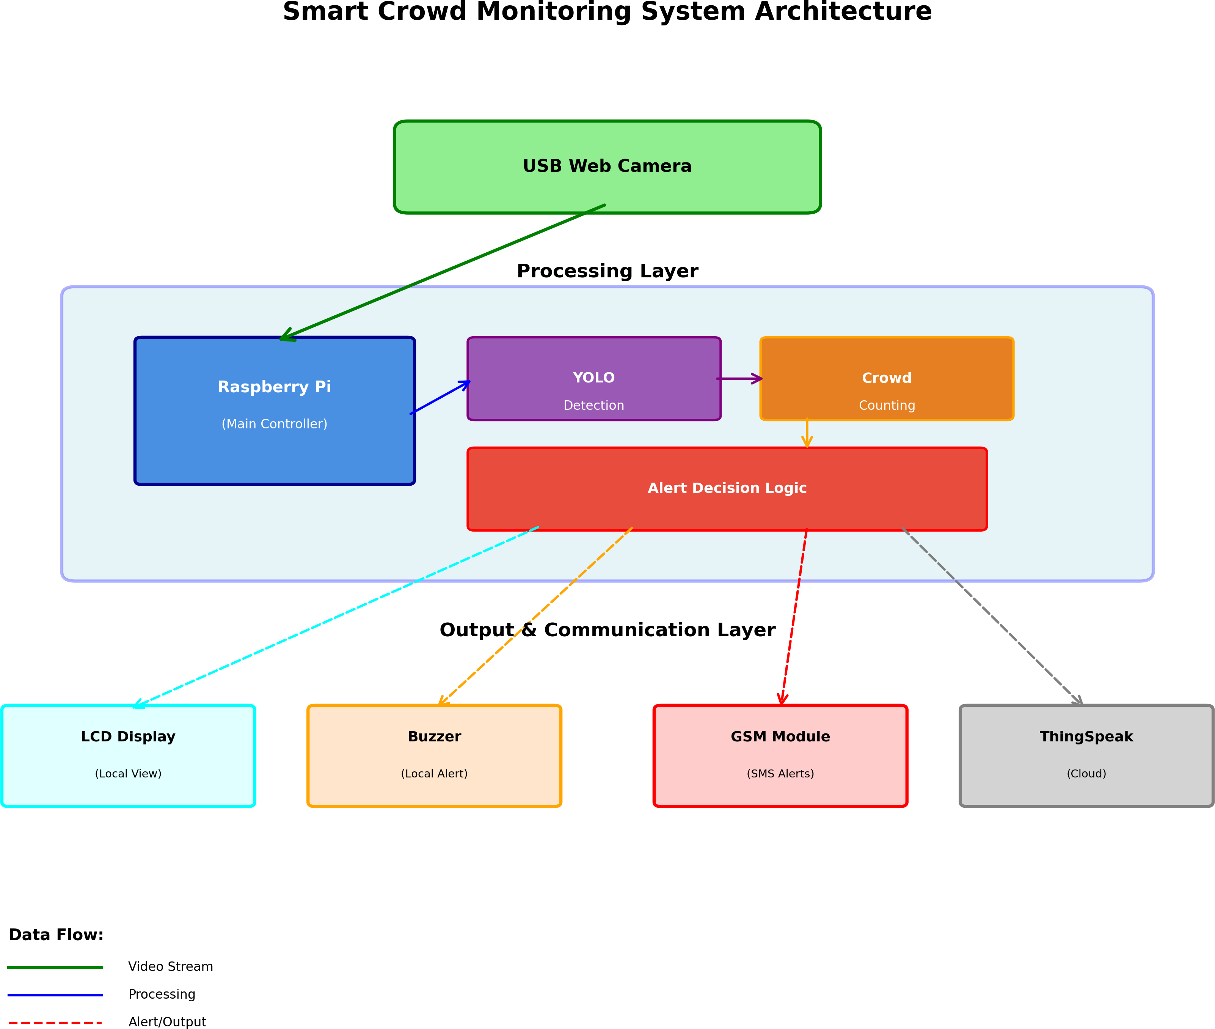

Fig. 2. Detailed System Architecture

  - USB Web Camera: A Logitech C270 HD webcam was selected for its native Linux driver support and cost efficiency. It connects via USB and supplies uncompressed frames to the application layer, where they are downsampled to the resolution required by YOLO before inference begins.
  - Buzzer: An active piezoelectric buzzer rated at 5 V DC is driven via a BC547 NPN transistor, which isolates the 3.3 V GPIO logic level from the 5 V drive rail. Upon a threshold breach, the control script asserts a high level on the designated GPIO pin, switching the transistor on and emitting a continuous audible alert to the surrounding area.

TABLE II
GPIO Pin Configuration

Component | Pin Name | GPIO Pin Number
LCD RS | GPIO 26 | 37
LCD E | GPIO 19 | 35
LCD D4 | GPIO 13 | 33
LCD D5 | GPIO 6 | 31
LCD D6 | GPIO 5 | 29
LCD D7 | GPIO 11 | 23
Buzzer | GPIO 17 | 11
GSM TX | RXD | 10
GSM RX | TXD | 8

  - GSM Module: The SIM900A modem is powered by a dedicated 2 A external power unit — bypassing the Pi’s USB ports, which cannot reliably sustain current surges accompany-ing cellular network registration. UART communication with the Pi uses a standard AT command sequence: AT+CMGF=1 selects text-mode messaging, and AT+CMGS initiates message
6) Aggregation: The count of surviving bounding boxes constitutes the occupancy estimate for that frame.
Spatial overlap between a predicted box and its ground-truth annotation is quantified using the Intersection over Union (IoU) metric:

transmission to a pre-programmed emergency contact.
5) LCD Display: A 16×2 alphanumeric liquid-crystal dis-
IoU = Area(Box_{p} ∩ Box_{gt})
Area(Box_{p} ∪ Box_{gt})
(1)

play furnishes an on-site readout of the most recently com-
puted occupancy figure. The Adafruit_CharLCD Python library manages the four-bit parallel interface and refreshes the display at the conclusion of every detection cycle, typically once every one to two seconds.
where Box_{p} denotes the predicted bounding box and Box_{gt}
its corresponding ground-truth annotation.
The composite YOLO training loss function is formulated as:

S² B
Σ Σ

- Data Flow Description
Each processing cycle begins with frame capture from the webcam. The acquired frame is forwarded to the YOLO inference engine, which returns a list of person-class bounding boxes. The resulting count is: 1. Rendered on the LCD via the Adafruit_CharLCD library. 2. Evaluated against the configurable safety threshold (T_{safe}). 3. Forwarded to ThingSpeak through an HTTP POST request issued by the requests library. If Count > T_{safe}, the GPIO pin driving
L = λ_{coord} ⊮^{obj}[(x_{i} − xˆ_{i})² + (y_{i} − yˆ_{i})²] (2)
i=0 j=0
ij
where λ_{coord} is the coordinate loss weight, S is the spatial grid dimension, B is the number of anchor boxes per cell, and ⊮^{obj} is an indicator that equals one when a ground-truth object is centred in grid cell i.
ij
The objectness confidence score assigned to each candidate detection is:

the buzzer transistor is asserted high and an SMS command sequence is dispatched to the GSM module over the UART link.
  - Methodology
A. Data Collection Process
Raw video is acquired from the webcam and each frame is subsequently rescaled to either 320 × 320 or 416 × 416
C = Pr(Object) × IoU^{truth}
A hard threshold filters the final detection set:
(
pred
Detection = 1 if C ≥ θ
0 otherwise
where θ = 0.5 is the adopted confidence threshold.
C. Workflow Description
(3)

(4)

pixels before being submitted to the detection network. A configurable frame-skip parameter governs the proportion of captured frames that are actually processed, allowing the operator to balance inference latency against the computational load imposed on the Pi’s CPU cores.
B. Algorithmic Approach
The detection backbone employed is the Tiny-YOLOv3 variant, which trades a modest reduction in mean average precision for a substantially lower parameter count and in-ference time, making it feasible to execute on the Raspberry Pi’s ARM Cortex-A53 cores without hardware acceleration. The complete inference pipeline proceeds as follows:
- Acquisition: A raw video frame is retrieved from the webcam buffer.
- Pre-processing: The frame is resized to 416×416 pixels and pixel values are normalised to the [0, 1] range.
- Inference: The normalised tensor is propagated through the YOLO convolutional layers to yield a candidate detection set.
- Class Filtering: Only detections bearing the class label “Person” are retained; all other categories are discarded.
- NMS: Non-Maximum Suppression eliminates redundant boxes attributed to the same physical subject; candidates with confidence scores below 0.5 are removed.
All control logic is implemented in Python. The main execu-tion loop leverages OpenCV for frame acquisition and image manipulation, pyserial for AT-command communication with the GSM modem, RPi.GPIO for buzzer and LCD drive signals, and the requests library for ThingSpeak REST API calls. Algorithm 1 formalises the run-time decision logic.
  - Experimental Setup and Evaluation
- Experimental Environment
Prototype validation was carried out on a Raspberry Pi
3 Model B running Raspbian OS Buster. Video input was provided by a Logitech C270 webcam. A SIM900A GSM development board, equipped with a registered SIM card, handled all SMS dispatches. All tests were performed in an indoor corridor where crowd density could be regulated by admitting a predetermined number of participants into the monitored zone.
- Parameter Configuration
  - Threshold: Configured at 5 persons to reflect the con-strained test corridor capacity.
  - Update Interval: ThingSpeak channel write rate set to 15 seconds (the minimum permitted by the free API tier).
  - Confidence Threshold: YOLO detection confidence fil-ter set at 0.5.

Algorithm Logic
1:
Crowd
Monitoring
1: Initialize Camera, LCD, GSM, GPIO
2: Set Threshold T = 5
3: while True do
4:
5:
6:
7:
8:
9:
10:

11:
12:
13:
14:
Frame ← Camera.Capture()
Count ← Y OLO.Detect(Frame, “Person′′) LCD.Display(Count)
ThingSpeak.Upload(Count)
if Count > T then Buzzer.On() GSM.SendSMS(“Alert OvercrowdingDetected!′′)
else
Buzzer.Off ()
end if
:
Sleep(1)
15: end while
Fig. 3. Pseudocode for the Monitoring System

- Evaluation Metrics
System effectiveness was assessed across three primary dimensions:
  - Counting Accuracy: Ratio of correctly estimated head-counts to corresponding manual reference counts across all test scenarios.
  - Alert Latency: Elapsed time between detection of a threshold breach and generation of the corresponding alert output.
  - Reliability: Success rate of SMS delivery and ThingS-peak data upload measured over repeated trials.
  - Results and Analysis
- Performance Evaluation
Across all evaluated crowd densities — ranging from zero to ten individuals — the YOLO-based detection pipeline achieved a headcount accuracy of 90–95%. Performance de-graded slightly under conditions of severe inter-person occlu-sion, where partial body views caused the network to merge adjacent bounding boxes, resulting in an under-count of one from a true count of six. Overall, the system correctly triggered alerts in every scenario where the crowd was not heavily occluded. Table III summarises per-scenario outcomes.

TABLE III
System Performance under Test Scenarios

Test Case | Actual | System | Status
Empty Room | 0 | 0 | Pass
Single Person | 1 | 1 | Pass
Group (Walking) | 3 | 3 | Pass
Group (Static) | 4 | 4 | Pass
Crowd (Occluded) | 6 | 5 | Fail
Crowd (Clear) | 7 | 7 | Pass
- Alert Mechanism Latency
End-to-end alert latency was decomposed into its constituent stages as follows:
  - Detection Inference: approximately 200 ms (Tiny-YOLOv3 on Pi CPU).
  - Decision Logic Overhead: approximately 50 ms.
  - Buzzer Activation: under 10 ms (GPIO toggle).
  - SMS Transmission: 5–8 seconds (GSM network-dependent).
  - ThingSpeak Write: 1–2 seconds (HTTP round-trip).
Total local alert latency — encompassing detection, decision evaluation, and buzzer activation — remained below 0.5 seconds in all trials. The cellular SMS path added a further delay of up to ten seconds, still within an acceptable window given that dangerous crowd build-up typically develops over minutes rather than seconds.
- ThingSpeak Visualization
Figure 3 presents the occupancy time-series recorded on the ThingSpeak dashboard over a representative six-hour obser-vation window. Headcount peaks were consistently recorded during the midday period (12:00–13:00), during which the monitored zone crossed the alert threshold on multiple oc-casions. Evening intervals exhibited uniformly low occupancy with no threshold breaches, confirming that the system cor-rectly suppresses false-positive alerts under benign conditions.
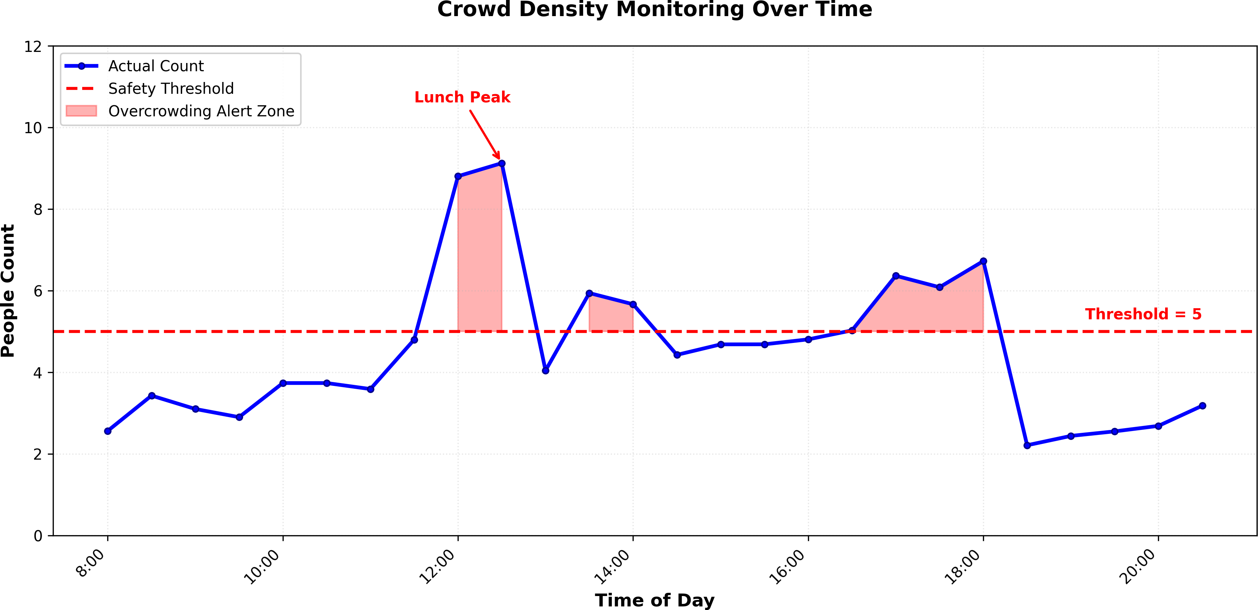

Fig. 4. Crowd Density Monitoring Over Time

  - Discussion
- Cost Analysis
A principal advantage of SmartFlow Vision is its markedly lower acquisition cost relative to proprietary smart-camera solutions, which typically retail at USD 300–500 per unit before recurring licence fees. The hardware bill of materials is as follows:
  - Raspberry Pi 3 Model B: ≈ $35
  - USB Webcam: ≈ $25
  - GSM Module: ≈ $10
  - Miscellaneous (LCD, Buzzer, Power): ≈ $15
At an aggregated cost of approximately $85 per deployment node, the per-unit expenditure is four to six times lower

than proprietary alternatives, making multi-node coverage eco-nomically tractable for resource-constrained municipalities and event organisers.
- Privacy Considerations
Surveillance systems that stream identifiable video to cen-tralised servers raise serious data-protection concerns. Smart-Flow Vision mitigates this by confining all video analysis to the edge node: no facial image, body silhouette, or trajectory record leaves the device. Only the scalar headcount value is transmitted remotely, rendering the system compatible with a privacy-by-design philosophy and broadly aligned with data protection legislation that prohibits the handling of personally identifiable information without explicit consent.
- Hardware Comparison
Table IV benchmarks the Raspberry Pi against two repre-sentative alternatives at opposite ends of the cost-performance spectrum. The Arduino Uno, while inexpensive, lacks the CPU capability and OS support necessary to execute neural-network inference. The NVIDIA Jetson Nano offers superior GPU-accelerated compute but at a substantially higher unit cost that exceeds the budget envelope of many target deployment scenarios. The Raspberry Pi 3 therefore represents the optimal trade-off point for this application domain.

TABLE IV
Comparison of Embedded Platforms for Crowd Monitoring

Feature | Arduino | RPi 3 | Jetson
Processor | 16 MHz | 1.2 GHz | 1.43 GHz
RAM | 2 KB | 1 GB | 4 GB
OS Support | None | Linux | Linux
Comp. Vision | No | OpenCV | CUDA
Power | Low | Medium | High
Cost | Very Low | Low | High
Suitability | Sensors | Real-time CV | High-end AI

  - Challenges and Limitations
- Implementation Challenges
  - Illumination Sensitivity: The standard USB webcam exhibits degraded signal quality in low-light or high-contrast conditions, reducing effective detection range during night-time or dimly lit deployments.
  - Throughput Ceiling: Running the Tiny-YOLOv3 in-ference graph on the Pi’s CPU constrains achievable frame rates to approximately two to four frames per second, which may be insufficient for monitoring very fast-moving or rapidly dispersing crowds.
- Scalability Issues
A single-node deployment addresses one monitoring zone effectively. Extending coverage to a large multi-zone venue such as a stadium or transit hub necessitates a mesh of coor-dinated nodes and a centralised aggregation backend capable of handling data volumes beyond those supported by the free-tier ThingSpeak plan.
  - Future Scope
- Integration with 5G Networks
Replacing the current 2G/3G GSM communication link with a 5G modem would enable selective transmission of high-definition video thumbnail attachments alongside alert messages, permitting remote operators to visually confirm a situation before mobilising response teams.
- Advanced Analytics and Prediction
Supplementing the real-time occupancy feed with a Long Short-Term Memory (LSTM) predictive model trained on historical ThingSpeak data could enable proactive crowd-flow management by forecasting density surges 15–30 minutes in advance of their occurrence.
- Hardware Optimisation
Integrating a USB neural-processing accelerator — such as the Intel Movidius Neural Compute Stick or the Google Coral USB Accelerator — would offload CNN inference from the Pi’s CPU, enabling deployment of heavier, more accurate post-YOLOv5 architectures while maintaining real-time throughput.
- Smart City Integration
Individual monitoring nodes could be networked into a metropolitan crowd-analytics fabric, where anomaly events at one venue trigger coordinated responses at adjacent infrastruc-ture nodes — for instance, adjusting traffic-signal phasing near a crowded stadium or pre-alerting nearby medical facilities during elevated mass-casualty risk.
- Energy Harvesting
For deployment in open-air or infrastructure-poor environ-ments, coupling the node with a solar panel and battery man-agement circuit would eliminate dependence on mains power, supporting persistent autonomous monitoring at temporary venues such as open-air festivals or disaster-relief camps.
  - Conclusion
This paper presented SmartFlow Vision, an integrated IoT and AI-driven crowd monitoring platform built entirely around commodity embedded hardware. By deploying the Tiny-YOLOv3 object detector on a Raspberry Pi and coupling it with ThingSpeak cloud telemetry, local LCD feedback, an audible piezoelectric buzzer, and cellular SMS alerting, the system realises a complete sense-analyse-alert loop at a hardware cost of approximately $85. Experimental validation confirmed headcount accuracy of 90–95% and sub-0.5-second local alert latency across crowd densities of one to ten persons. The edge-computing architecture — in which video frames never leave the local node — provides a natural privacy safe-guard, distinguishing SmartFlow Vision from cloud-streaming alternatives. The modular design lends itself to incremental ca-pability enhancement: adding neural accelerators, 5G connec-tivity, or LSTM-based predictive analytics can progressively expand system performance without requiring a fundamental

architectural redesign. Collectively, these attributes position SmartFlow Vision as a practical, scalable, and ethically re-sponsible tool for public-safety stakeholders operating under real-world resource constraints.
References
- J. Redmon, S. Divvala, R. Girshick, and A. Farhadi, “You Only Look Once: Unified, Real-Time Object Detection,” Proc. IEEE Conf. Computer Vision and Pattern Recognition (CVPR), pp. 779–788, 2016.
- M. Sindhu and K. R. Kashwan, “IoT based Smart Crowd Monitoring System,” International Journal of Pure and Applied Mathematics, vol. 118, no. 20, pp. 473–480, 2018.
- A. W. Malik, H. T. Abbas, M. U. G. Khan, and T. A. Gulliver, “Smart crowd monitoring using Internet of Things (IoT) with predictive analytics,” Journal of Ambient Intelligence and Humanized Computing, vol. 11, no. 3, pp. 1141–1156, 2020.
- H. Al-Khalifa and A. Alamer, “Crowd management at Hajj using IoT and big data analytics,” International Journal of Advanced Computer Science and Applications (IJACSA), vol. 9, no. 2, pp. 71–78, 2018.
- S. Zhang, X. Wu, Z. You, and L. Lu, “Crowd counting via scale-adaptive convolutional neural network,” IEEE Winter Conference on Applications of Computer Vision, pp. 1113–1121, 2018.
- V. A. Sindagi and V. M. Patel, “A survey of recent advances in CNN-based single image crowd counting and density estimation,” Pattern Recognition Letters, vol. 107, pp. 3–16, 2018.
- B. Zhan, D. N. Monekosso, P. Remagnino, S. A. Velastin, and L. Q. Xu, “Crowd analysis: a survey,” Machine Vision and Applications, vol. 19, no. 5-6, pp. 345–357, 2008.
- N. Dalal and B. Triggs, “Histograms of oriented gradients for human detection,” IEEE Computer Society Conference on Computer Vision and Pattern Recognition, vol. 1, pp. 886–893, 2005.
- C. C. Loy, K. Chen, S. Gong, and T. Xiang, “Crowd counting and pro-filing: Methodology and evaluation,” Modeling, Simulation and Visual Analysis of Crowds, pp. 347–382, 2013.
- M. Rodriguez, I. Laptev, J. Sivic, and J. Y. Audibert, “Density-aware person detection and tracking in crowds,” IEEE International Conference on Computer Vision, pp. 2423–2430, 2011.
- T. Li, H. Chang, M. Wang, B. Ni, R. Hong, and S. Yan, “Crowded scene analysis: A survey,” IEEE Transactions on Circuits and Systems for Video Technology, vol. 25, no. 3, pp. 367–386, 2015.
- D. Kong, D. Gray, and H. Tao, “A viewpoint invariant approach for crowd counting,” 18th International Conference on Pattern Recognition, vol. 3, pp. 1187–1190, 2006.
- A. B. Chan, Z. S. J. Liang, and N. Vasconcelos, “Privacy preserving crowd monitoring: Counting people without people models or tracking,” IEEE Conference on Computer Vision and Pattern Recognition, pp. 1–7, 2008.
- V. Rabaud and S. Belongie, “Counting crowded moving objects,” IEEE Computer Society Conference on Computer Vision and Pattern Recognition, vol. 1, pp. 705–711, 2006.
- P. Viola and M. J. Jones, “Robust real-time face detection,” International Journal of Computer Vision, vol. 57, no. 2, pp. 137–154, 2004.
- R. Girshick, J. Donahue, T. Darrell, and J. Malik, “Rich feature hierarchies for accurate object detection and semantic segmentation,” Proceedings of the IEEE Conference on Computer Vision and Pattern Recognition, pp. 580–587, 2014.
- K. He, X. Zhang, S. Ren, and J. Sun, “Deep residual learning for image recognition,” Proceedings of the IEEE Conference on Computer Vision and Pattern Recognition, pp. 770–778, 2016.
- S. Ren, K. He, R. Girshick, and J. Sun, “Faster R-CNN: Towards real-time object detection with region proposal networks,” Advances in Neural Information Processing Systems, pp. 91–99, 2015.
- W. Liu, D. Anguelov, D. Erhan, C. Szegedy, S. Reed, C. Y. Fu, and A.
- Berg, “SSD: Single shot multibox detector,” European Conference on Computer Vision, pp. 21–37, 2016.
- T. Y. Lin, P. Goyal, R. Girshick, K. He, and P. Dollar, “Focal loss for dense object detection,” Proceedings of the IEEE International Conference on Computer Vision, pp. 2980–2988, 2017.

