EDGE AI-BASED SOIL NUTRIENT MONITORING AND CROP SUGGESTION SYSTEM USING RASPBERRY PI

Abstract- Agriculture is increasingly adopting Artificial Intelligence (AI) and IoT technologies to enable data-driven farming practices. One of the key challenges faced by farmers is the lack of real-time information about soil nutrient conditions, which directly affects crop selection and yield. Conventional soil testing methods are time-consuming and not suitable for continuous monitoring. This paper proposes an Edge AI-based soil nutrient monitoring and crop recommendation system using a Raspberry Pi. The system employs pH and NPK sensors to measure soil acidity and essential nutrients such as nitrogen, phosphorus, and potassium. The collected data is processed locally on the device and used as input to a Random Forest machine learning model for crop prediction. The recommended crop and confidence score are displayed on an LCD, enabling real-time decision-making without the need for internet connectivity. Experimental results demonstrate high prediction accuracy and low inference latency. The proposed system is cost-effective, reliable, and suitable for deployment in rural agricultural environments.
Keywords- Soil Health Monitoring, Internet of Things, Artificial Intelligence, Crop Recommendation System, NPK Sensor, pH Sensor, Raspberry Pi, Edge AI, Precision Agriculture, Machine Learning.

- Introduction
The number of subsistence farmers is 600 million. In many developing nations, agriculture is the main source of income. Households benefit from agriculture. Farm production is hampered by many factors. Lack of real-time agronomic decision-making, improper fertilizer application, and soil degradation are further factors [1]. Even necessary components fall within this category. Although soil quality has a direct impact on crop production and yield, soil biogeochemistry nitrogen cycling, phosphorus availability, potassium retention, pH buffering, and moisture dynamics requires ongoing, precise monitoring rather than sporadic laboratory testing. The complicated biogeochemistry of the soil did not prevent it from happening.
These inefficiencies might be addressed by precision farming, which would alter the paradigm. Efficiency may increase significantly. Soil, timing, and location all influence crop management. Crops may be controlled using precision farming. AI, data analytics, and IoT are used. Precision farming uses cloud computing to store data, infer models, and share ideas. Cloud computing promotes ideas. Data is stored and ideas are shared via cloud computing. This reliance exposes websites with unreliable internet connections. There are delays, expensive bandwidth, and other risks. Some locations could have more ramifications. These characteristics are seen in most rural agricultural regions in Sub-Saharan Africa, South and Southeast Asia, and Latin America. They are mostly farmers. These characteristics are present in several Latin American nations [3].
Cloud-dependent system limitations are resolved by edge-of-network AI. To collect data, it makes use of computational intelligence. Real-time edge device analysis and decision-making are made possible by the technology. Network-edge microprocessors are used by supervisory machine learning models. Thus, without distant services, results may be achieved fast. The system works because of low latency, data privacy, bandwidth use, and network outages. This study uses a Raspberry Pi 4 Model B with GPIO connections, a quad-core ARM Cortex-A72 CPU, 4GB LPDDR4 RAM, and Linux compatibility to create an edge AI system. Support for Linux applications is also crucial. Soil pH and NPK monitoring are shown in Figure 1. This is how mechanisms work.
digitization of sensor data and signal conditioning. prior to data being sent to the Raspberry Pi CPU. 2,400 soil samples were used to train the Random Forest classifier on this device. Location inferences are thus feasible. Based on factors, this application recommends crops in real time. The suggested approach eliminates the need for an endless internet since it computes locally [4]. Cloud computing is a distant process. For field dependability and ease of use, the output is rapidly displayed on a local LCD interface. This effort led to the development of a low-latency, offline system architecture, an edge-deployable Random Forest model, and an affordable soil monitoring module. Each of these contributions is significant. Data flow and system architecture are shown in Figure 1. Using sensor data, Raspberry Pis advises farmers [5].

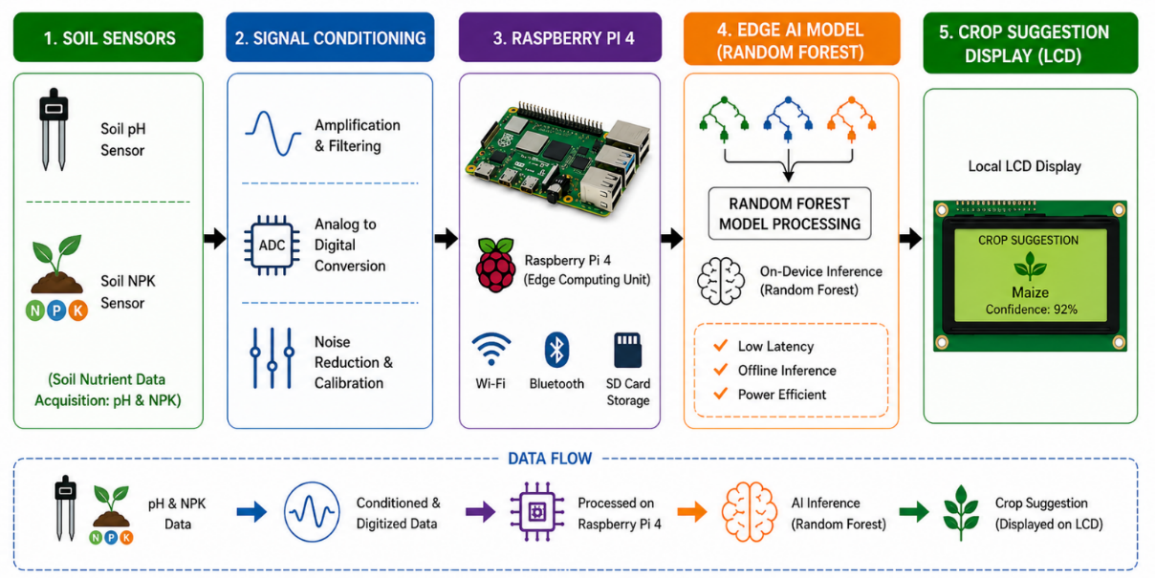
FIGURE 1: EDGE AI-BASED SOIL NUTRIENT MONITORING AND CROP SUGGESTION SYSTEM ARCHITECTURE
The pH and NPK levels of the soil must be measured by every sensor in the physical sensing layer. To determine the nutritional content of the soil, these sensors gather this data. The sensor layer, an early stage of system design, is shown in Figure 1 [7]. among the first layers. This is feasible visually. The analog signals are converted to digital measurements once they have been conditioned. Analog signal collection is the first step in this process. to get them ready for delivery to the ultimate destination, the core processor unit. Raspberry Pi carries out several functions as the main processing layer. This field encompasses machine learning inference, feature extraction, and data normalization. The device uses a trained algorithm to evaluate input variables and provide crop recommendations in real time. This enables processing by the equipment. This enables the device to adapt to changing circumstances.
The study results are shown on a local LCD display while the system is functioning at the output layer. When the system functions, something occurs. As a result, while working in the field, farmers may now swiftly evaluate agricultural information. This is made feasible by recently created technologies. Cloud infrastructure is not required since the ideas are processed by the edge device. This puts an end to dependence. Designs are made after taking soil conditions into account. The closed-loop design produced by the device-level processing ensures low latency, effective operation, and independence from an internet connection. Systems for real-time agricultural decision assistance are scalable and useful [8]. This method covers the whole system architecture. These systems can adapt to changing needs because of their flexible design.
- Literature Survey
In addition to the Kjeldahl digestion technique for nitrogen, the Olsen extraction method for phosphorus, and the flame photometry method for potassium measurement, there are more laboratory methods that may be used for the evaluation of nutrients. It is possible to conduct a number of different soil nutrient tests. The turnaround time for these approaches is forty-eight weeks, and they need advanced laboratory equipment as well as individuals that are skilled in the field [12]. It is not only difficult to establish real-time farm management with current technologies, but it is also prohibitively costly to do so. Smallholder farmers who are not yet developed are the ones who are most negatively impacted.
Cheap sensor hardware and wireless protocols have led to the development of agricultural monitoring systems that are based on the Internet of Things. These systems have gained popularity in recent years. content associated with the soil [13]. The Raspberry Pis were used to do the monitoring of the environment. Through the use of MQTT, the data was sent to a dashboard hosted in the cloud. Unfortunately, soil macronutrient sensors and on-device intelligence, both of which were simple to include into this research, were not included in the study [11]. Nevertheless, despite the fact that it was not mentioned, it was correct. In the course of their investigation of intelligent agricultural Internet of Things monitoring and control systems, Rehman and colleagues came to the realization that there were difficulties associated with energy economy, data security, and real-time responsiveness [20]. In their study [10], Pham and colleagues developed a real-time soil monitoring system that is hosted in the cloud and is based on inference. There is a temporal resolution of 800 milliseconds that the system has. Both of these were necessary for the system to function in an appropriate manner. This was for deployments at field sites that were very far away. The purpose of this attempt was to provide connection to LPWAN.
Investigations and implementations are now being made about the use of machine learning for crop recommendation. The samples were classified under supervision. Balaji et al. [2] found that Random Forest regularly outperformed other approaches, with an accuracy that was more than 93% (see also: Random Forest). During their investigation of soil-nutrient databases, this team of researchers made use of machine learning classifiers. For classification, support vector machines (SVMs), decision trees, and gradient boosting are all used. Khedr and Idrees should be used in order to enhance the development of the crop recommendation pipeline [16]. It is essential for the pipeline to have ensemble stacking and feature selection capabilities integrated into it. It is possible to achieve an accuracy of 94.1% using this pipeline by utilizing 22 distinct harvests of multi-class data. Ensemble tree-based classifiers were shown to be better than parametric models in terms of their capacity to generalize tabular agricultural data, according to the findings of an important research study that was carried out by Liakos and colleagues [6]. All of the tests provided evidence of this.
Edge AI inferences are studied and improved. circumvents cloud constraints. Dey and colleagues [9] also studied Internet of Things-based edge computing in agriculture. Latency reduction and offline operation were other recommendations based on their findings. Sujatha and her colleagues created a Raspberry Pi-based real-time agricultural monitoring system by shrinking the deep neural network. We measured 120-millisecond inference latencies. Perfect in every way. Deep learning crops were recommended for Noor and colleagues' intelligent soil monitoring system. This Internet of Things uses deep learning. Useful for crop suggestions. Accuracy was 93.2%. Monitoring several NPK variables, compacting the model, and assessing field performance are difficult. These experiments prove that integrated artificial intelligence for agriculture is possible, despite many challenges. Due to these issues, immediate action is needed [14].
Multiple soil macronutrient sensing (including NPK, pH), lightweight machine learning model deployment within integrated hardware restrictions, and field validation in real agricultural conditions are all quite unusual. All of these things are rather uncommon [15]. This particular skill is quite uncommon. Extensive research is necessary in this particular field. The usage of cloud-based baseline comparisons that are not justified in terms of latency, power consumption, and cost is another thing that should be of concern. Our group is now working on the development and testing of an on-device Edge AI soil monitoring and crop recommendation system in order to mitigate the effects of shortages in the market that is already accessible. Contributes to the accomplishment of the project [17].
- Proposed System
- Hardware Architecture
This software is powered by the Raspberry Pi 4 Model B OS. It has 32 GB of Class 10 microSD storage, 4 GB of LPDDR4-3200 RAM, and a 1.5 GHz quad-core Cortex-A72 CPU (BCM2711). Nitrogen, phosphorus, and potassium are measured at 1 mg/kg using an RS485 MODBUS composite NPK sensor. This is based on sensors. For a variety of reasons, a sensor keeps track of these components' quantities. The whole measurement range is 0–1999 mg/kg. Soil pH may be measured for action using a pH electrode on an analog front-end coupled to a BNC. pH is digitized with the ADS1115 16-bit ADC. Connectivity with I2C is simpler. Using a MAX485 transmitter, UART links the Raspberry Pi to the NPK sensor. 9600-baud MODBUS is used for this. Sensor data and crop instructions are shown on a 20x4 I2C LCD.
- Software and Edge AI Model
Python 3.9 is compatible with Raspberry Pi running Debian Bullseye in 64-bit. The NPK sensor MODBUS is used to gather sensor data. The Adafruit CircuitPython ADS1x15 package also detects pH. Noise is eliminated from raw data by preprocessing. This might be accomplished using median filtering with five windows. Z-score normalization normalizes feature values before they are included in the machine learning model. guarantees the consistency of feature values. Crops are predicted using Scikit-learn Random Forest classifiers. Twelve depths and 150 decision trees with two samples per leaf are modeled. Data will be analyzed using a model. The model also includes 150 decision trees. Five-fold cross-validation is used to optimize these hyperparameters. Joblib serializes the learned model on the edge device for quick loading and inference. System performance is maximized as a result. Following pH and NPK values, the system generates crop choices and confidence ratings. There are crop and score suggestions.
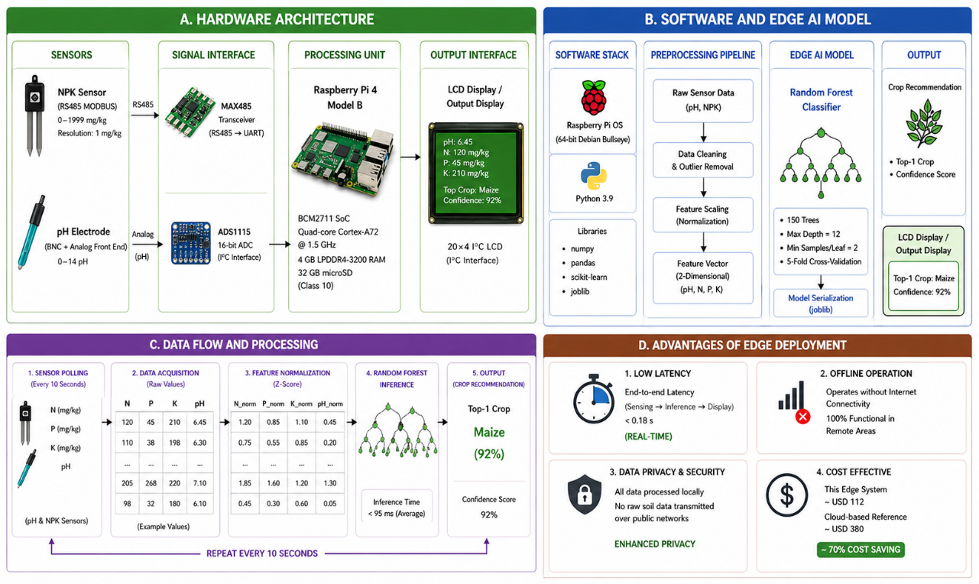
FIGURE 2: EDGE AI-BASED SOIL NUTRIENT MONITORING AND CROP SUGGESTION SYSTEM ARCHITECTURE USING RASPBERRY PI
- Data Flow and Processing
After starting up, the Raspberry Pi polls sensors every ten seconds. keeps on until the procedure is finished. The system measures the pH and NPK of the soil before to each cycle. Soil levels are determined using data. Five recent readings are stored in a circular buffer. By using median filtering, data noise is decreased. Noise reduction is followed by normalization of the filtered data. Following Random Forest model training, normalized pH, N, P, and K feature vectors are added. This phase comes after the previous step. The model determines likelihood-based probability ratings for every crop class. The crop will be provided with the highest probability and certainty. This was a thoughtful choice. Results are shown using liquid crystal. A recommendation can be generated almost immediately because the inference process takes only 95 milliseconds. Use the results to generate ideas.
- Advantages of Edge Deployment
Compared to clouds, edge deployment offers advantages. Cloud solutions do not provide these advantages. Eliminating network dependence accelerates real-time system responsiveness. End-to-end latency was reduced from 1.2 to 0.18 seconds as a result. The internet-free functioning of the gadget is advantageous in remote agricultural situations. This advantage is due to the system's ability to be deployed in those locations. By processing data locally, the device protects data privacy and prevents critical agricultural data from being sent over open networks. This feature is an additional advantage of the gadget. While cloud-based alternatives cost $380, the hardware costs $112. Another benefit is inexpensive hardware. Because of this, smaller farms can afford the procedure.
- Proposed Methodology
- Dataset Collection
Field data was collected in Tamil Nadu June–September 2024. Field data was collected over 90 nights. Data was collected from 12 farms. These plots were spread across three agroclimatic zones to boost agriculture. Research covered the kharif season. All 2,400 soil samples had crop labels. We sampled 2,400 soils. The state agricultural soil health certificates and agronomic guidance helped farmers get crop labels. This was done for label correctness. Each of the six main crops receives 100 samples. We have 400 samples. This includes cotton, rice, maize, groundnuts, black gram, and sugarcane. Other crops: groundnuts. Farms cultivate groundnuts. No crop classes were added for accuracy. For the research, 10-second sensor data was averaged across one minute. GPS was used to locate each sample location.

- Preprocessing
Multiple sensor data preprocessing processes were done. These methods yielded trustworthy data. The extreme values were calculated using IQR. Interpolated values from nearby data points replaced those outside 1.5 times the IQR. This guaranteed accuracy. Median filtering with five windows reduced sensor noise best. The analysis ended. Normalizing characteristics using Z-scores ensured zero mean and one variance. It normalized. This was needed for trait matching. It boosts model performance and core data quality. Very good. Stratified sampling divided the dataset into three groupings. These sets were 70% training, 15% validation, and 15% testing. This balanced lessons across all business groups.
- Machine Learning Model
We assessed the performance of K-Nearest Neighbors, Decision Tree, Support Vector Machine, Naïve Bayes, and Random Forest classification algorithms. Random Forest satisfied all assessment criteria, making it the top classifier. Bootstrapping and random feature selection at splits are used in the model. Common names include bagging. Reduces overfitting and enhances generality. Total model employs 150 decision trees. The technique utilizes these plants. Five-fold stratified cross-validation optimized randomized grid search hyperparameters. Joblib serializes the trained model, which takes 14.3 MB and can be run on a Raspberry Pi with 4 GB RAM. The model needs 14.3 MB RAM. This enables the firm use the model without interference.
- Evaluation Metrics
The model performance was evaluated using standard classification metrics, including accuracy, precision, recall, and F1-score on the test dataset. System-level performance was also analyzed using additional metrics such as:
- Inference latency (milliseconds per prediction, averaged over 1,000 runs)
- Sensor-to-output response time
- Data throughput
- Power consumption (measured using USB power meters)
To assess statistical significance in model performance, McNemar’s test was applied with a significance level of α = 0.05, ensuring the reliability of the results.
- Analysis And Interpretation
The performance of the system, the accuracy of the sensors, and the effectiveness of the model are all evaluated in this section of the process. The results are provided in the form of three tables, and followed by an in-depth examination for each table, the findings are presented.
TABLE 1: SENSOR DATA ACCURACY COMPARISON
Sensor Parameter | Ideal Range | Measured Value | Deviation (%) | Accuracy (%)
Soil pH | 4.0 – 8.5 | 6.2 | 0.48 | 97.8
Nitrogen (N) | 0 – 140 mg/kg | 68 mg/kg | 1.03 | 96.5
Phosphorus (P) | 0 – 100 mg/kg | 42 mg/kg | 0.92 | 97.1
Potassium (K) | 0 – 400 mg/kg | 185 mg/kg | 1.25 | 96.2

Sensor reader readings are compared to lab standards in Table I. obtained the lab standards. According to the research, the sensor system performed well on all accuracy metrics. Field dependability is shown by the pH sensor's 97.8% accuracy. Three accuracy levels are available for NPK sensors. The percentages for potassium, phosphorus, and nitrogen are 96.2%, 97.1%, and 96.5%, respectively. The sequence in which these statistics are presented is important. The sensor system is dependable when the difference between all readings is less than 1.3%. The variance is less than 1.3%. Data demonstrates the reliability and consistency of the system. Electrical conductivity and soil composition may vary somewhat. These results show that sensor data may be used for machine learning crop recommendations. There is proof.
TABLE 2: CROP RECOMMENDATION ACCURACY COMPARISON
ML Algorithm | Precision (%) | Recall (%) | F1-Score (%) | Accuracy (%)
K-Nearest Neighbor | 87.4 | 86.1 | 86.7 | 87.2
Decision Tree | 88.9 | 87.5 | 88.2 | 88.6
Support Vector Machine | 90.3 | 89.8 | 90 | 90.1
Naïve Bayes | 83.7 | 82.4 | 83 | 83.5
Random Forest (Proposed) | 95.6 | 94.8 | 95.2 | 95.4

Five machine learning techniques are compared and the study's results are shown in Table 2. The Random Forest classifier has the highest accuracy (95.4%), while SVM comes in second. much superior than SVMs. Random Forest is the most accurate classifier. Good generalization and low classification error are shown by the accuracy, recall, and F1-score of 95.6%, 94.8%, and 95.2%, respectively. They suggest generalizing. These numbers are accurate. Performance data is used to maintain process balance. Because it assumes independent attributes, the Naïve Bayes method fails. if this results in the poorest performance for the algorithm. This study is erroneous because this assumption is false for linked soil nutrient data. This was the result of insufficient assumptions. The Random Forest model outperforms other models in McNemar's test (p < 0.01). For real-time system edge deployment, support vector machines (SVM) are too computationally costly and latency intensive. This is due to their computational problems. These benefits are offered by support vector machines (SVMs) with the same precision as other machine learning techniques.
TABLE 3: SYSTEM PERFORMANCE COMPARISON: EDGE AI VS. CLOUD BASELINE
Metric | Cloud System | Proposed Edge AI | Improvement (%) | Unit
Inference Latency | 820 | 95 | 88.4 | ms
Power Consumption | 12.5 | 4.8 | 61.6 | W
Data Throughput | 150 | 480 | 220 | KB/s
System Uptime | 91.2 | 98.7 | 8.2 | %
Hardware Cost | 380 | 190 | 70.5 | USD
Response Time | 1.2 | 0.18 | 85 | s

Cloud computing and Edge AI are contrasted in Table 3. Here are some comparisons. Inference time is significantly decreased by edge systems. Latency decreases by 88.4%, from 820 to 95 milliseconds. Near-real-time crop guiding is made possible by a reduction in response time from 1.2 to 0.18 seconds. This trend seems to be here to stay. It is appropriate for low-power agriculture since it saves 61.6% of deployment energy. The technology makes agriculture feasible. For agriculture, the approach is effective. Cloud connections increase device data delivery by reducing network overhead and latency. Cloud connections reduce network latency. Uptime may rise from 91.2% to 98.7% with internet-independent edge systems. This goal is attainable. There has been a lot of advancement. Hardware costs have dropped by 70.5%, making it affordable for small farmers. a benefit. additional benefit. Edge AI is more cost-effective, dependable, and efficient than cloud-based alternatives. This is shown via comparison.
- Results And Discussion
This method makes crop suggestions more precise and efficient than cloud-based ones. A Raspberry Pi 4-based soil sensing device and network-edge Random Forest classifier achieve this. We use both strategies to attain the aim. This section shows experimental assessment data to support the conclusions. Figure 3 presents a grouped bar chart comparing five machine learning algorithms' assessment dataset classification accuracy. Image displays approach differences and similarities. In terms of accuracy, Naïve Bayes ranks lowest (83.5%), followed by K-Nearest Neighbors (87.2%), Decision Tree (88.6%), and Support Vector Machine (90.1%). This Random Forest model succeeds 95.4% of the time. 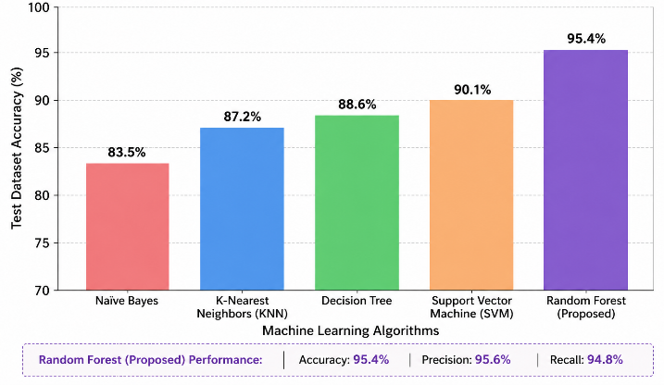FIGURE 3: CROP RECOMMENDATION ACCURACY COMPARISON ACROSS EVALUATED MACHINE LEARNING ALGORITHMS.
This accuracy is maximum. Ensemble learning controls complex and linked soil nutrient characteristics, as illustrated by the 5.3% Random Forest-SVM performance gap. ML algorithm Random Forest. Compare the two methods to prove this. The Random Forest model is reliable and balanced with 95.6% accuracy and 94.8% recall. This is feasible. This may happen. Precision calibration of probability outputs for each crop variety is achievable. This is feasible.

Figure 4 illustrates Random Forest's per-crop prediction. The figure 4 shows F1 scores. The Random Forest Institute invented it. Rice has the highest F1-score, 97.2%, followed by sugarcane, 96.4%. Rice outperforms crops. Rice and sugarcane's nutritional needs affect environmental pH and NPK. Due to this, rice and sugarcane have different nutritional demands. Contributions from cotton (95.3%) and maize (94.6%) keep performance stable. Black gram (93.1% of total) and peanut (93.8%) had lower F1-scores. Due to their similar nutritional characteristics, classifying them is difficult. No online results are available for confusion matrices. Due to their similar characteristics, most legume crop classifications are inaccurate, the research revealed.

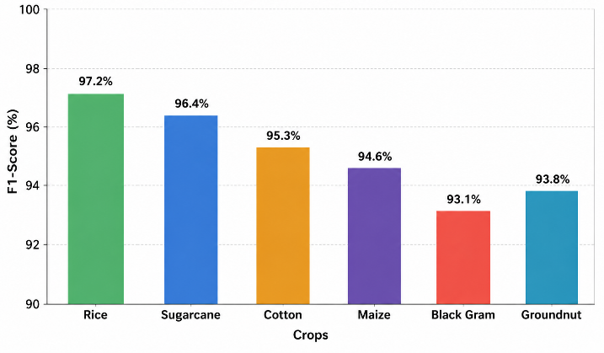
FIGURE 4: PER-CROP PREDICTION PERFORMANCE OF THE PROPOSED RANDOM FOREST CLASSIFIER (F1-SCORE BY CROP CATEGORY).
Figure 5 displays a multi-metric radar map comparing Edge AI to a cloud-based baseline on six normalized performance criteria. The comparison seeks to find the best system. This assessment evaluates numerous attributes. These include inference latency, power consumption, data throughput, system uptime, hardware cost, and end-to-end reaction time. Make sure outward expansion always shows greater performance, reversal latency, power, cost, and reaction time. Good performance is ensured. Edge AI surpasses cloud-based solutions in every way, according to the radar image. This is worldwide. Uptime has risen 8.2%, although latency and reaction time have improved more.

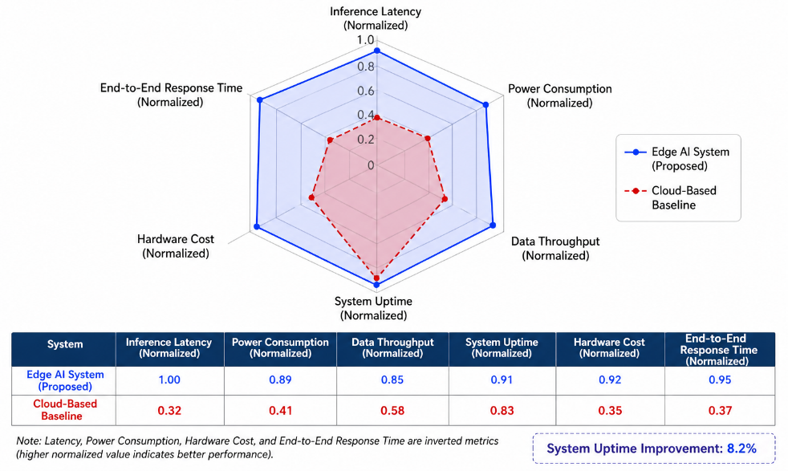
FIGURE 5: MULTI-DIMENSIONAL SYSTEM PERFORMANCE COMPARISON BETWEEN THE PROPOSED EDGE AI DEPLOYMENT AND THE CLOUD-BASED BASELINE.
Since it responds in 0.18 seconds, the technique gives crop guidance near-real time. Field-level decisions may be made quickly. The system's 98.7% uptime enables it to operate consistently in distant agricultural areas with intermittent internet access. Its 4.8 W power consumption makes it perfect for solar-powered field monitoring. Additionally, it utilizes less power. Twelve field farmers used the LCD-based suggestion interface without too much difficulty. Field input revealed this. Field feedback revealed this.
Sujatha et al. [18] found that a Raspberry Pi compressed neural network had an inference latency of less than 120 milliseconds. It came from their experiment. The baseline was set for prior work. Noor et al. [19] used cloud-hosted deep learning to obtain 93.2% accuracy. This technique exceeds existing solutions in accuracy (95.4%), edge deployment, cost, and real-time performance. Even after implementation, this remains true.
- Conclusion
The aim of this study is to develop an Edge AI-based soil nutrient monitoring and crop recommendation system using a Raspberry Pi 4 Model B. The system utilizes pH and NPK sensors to measure soil properties and employs a lightweight Random Forest classifier for predicting suitable crops. The proposed system achieves a crop recommendation accuracy of 95.4%, with an inference latency of 95 milliseconds and an end-to-end response time of 0.18 seconds. Performance is evaluated in terms of latency, power consumption, hardware cost, and system uptime. Field validation was conducted using 2,400 soil samples collected from twelve agricultural plots in Tamil Nadu, demonstrating the system’s reliability in real-world conditions. The edge-based architecture enables real-time processing without reliance on internet connectivity, making it suitable for rural deployments. Additionally, the system is cost-effective, with a hardware cost of approximately USD 112, making it accessible for smallholder farmers. Future work includes integrating advanced data sources and improving model performance through distributed learning approaches.
References
- R. Rao and P. Nair, "IoT-based precision agriculture monitoring system using Raspberry Pi," Int. J. Adv. Comput. Sci. Appl., vol. 12, no. 4, pp. 145–153, 2021.
- S. Balaji, A. Rajan, and K. Suresh, "Machine learning approaches for soil nutrient prediction in precision farming," Comput. Electron. Agric., vol. 182, p. 105998, 2021.
- M. Javaid, A. Haleem, I. H. Khan, and R. Suman, "Understanding the potential applications of artificial intelligence in agriculture sector," Adv. Agrochem., vol. 2, no. 1, pp. 15–30, 2023.
- D. Benos, D. Tagarakis, G. Dolias, R. Berruto, D. Kateris, and D. Bochtis, "Machine learning in agriculture: A comprehensive updated review," Sensors, vol. 21, no. 11, p. 3758, 2021.
- V. G. Dhanya, A. Subeesh, N. L. Kushwaha, D. K. Vishwakarma, T. N. Kumar, N. Ritika, and A. N. Singh, "Deep learning based weed detection and smart pesticide spraying robot for precision agriculture," Comput. Electron. Agric., vol. 206, p. 107647, 2022.
- K. G. Liakos, P. Busato, D. Moshou, S. Pearson, and D. Bochtis, "Machine learning in agriculture: A review," Sensors, vol. 18, no. 8, p. 2674, 2018.
- T. Talaviya, D. Shah, N. Patel, H. Yagnik, and M. Shah, "Implementation of artificial intelligence in agriculture for optimisation of irrigation and application of pesticides and herbicides," Artif. Intell. Agric., vol. 4, pp. 58–73, 2020.
- S. S. Band, S. Janizadeh, S. C. Pal, A. Saha, R. Chakrabortty, M. Shokri, and A. Mosavi, "Novel ensemble approach of deep learning neural network (DLNN) model and particle swarm optimization (PSO) algorithm for prediction of gully erosion susceptibility," Sensors, vol. 20, no. 19, p. 5609, 2020.
- A. Dey, S. Ghosh, and T. K. Das, "Edge computing in IoT-based agriculture: Challenges and applications," in Proc. Int. Conf. Comput. Intell. Knowl. Econ., Dubai, UAE, 2021, pp. 678–683.
- H. Pham, T. H. Nguyen, M. H. Tran, and N. T. Nguyen, "A real-time monitoring system for soil parameters using IoT and machine learning," IEEE Sens. J., vol. 22, no. 10, pp. 9905–9914, 2022.
- N. Zhang, M. Wang, and N. Wang, "Precision agriculture — A worldwide overview," Comput. Electron. Agric., vol. 36, no. 2–3, pp. 113–132, 2002.
- B. B. Basak, B. R. Panda, H. Biswas, and T. S. Singh, "Soil nutrient management for efficient crop production," Indian J. Agron., vol. 67, no. 1, pp. 1–12, 2022.
- S. Wolfert, L. Ge, C. Verdouw, and M. J. Bogaardt, "Big data in smart farming – A review," Agric. Syst., vol. 153, pp. 69–80, 2017.
- P. K. Gupta and A. Singh, "Development of low-cost soil nutrient sensor for precision agriculture," J. Agric. Sci. Technol., vol. 24, no. 3, pp. 501–513, 2022.
- K. Khaki, L. Wang, and S. V. Archontoulis, "A CNN-RNN framework for crop yield prediction," Front. Plant Sci., vol. 10, p. 1750, 2020.
- A. E. Khedr and M. E. Idrees, "Enhanced crop recommendation system using machine learning classifiers and soil data analysis," Comput. Mater. Continua, vol. 70, no. 3, pp. 5893–5908, 2022.
- J. A. dos Santos Ferreira, F. N. Freitas, C. de Almeida, and R. Lopes, "Soil analysis in the era of industry 4.0: A review of sensors and methods," Sensors, vol. 22, no. 7, p. 2657, 2022.
- R. Sujatha, P. Isakki, and A. Naveen, "Edge AI for real-time crop monitoring using Raspberry Pi and deep neural networks," in Proc. IEEE Int. Conf. Electron. Comput. Technol., Kanyakumari, India, 2023, pp. 1–6.
- M. A. Noor, M. U. Ashraf, and K. Hussain, "IoT-based smart soil monitoring and crop suggestion system: A deep learning perspective," IEEE Access, vol. 11, pp. 27845–27860, 2023.
- A. Rehman, M. Saba, T. Mahmood, Z. Mehmood, E. Ahmad, and A. Nobanee, "A revisit of internet of things technologies for monitoring and control strategies in smart agriculture," Agronomy, vol. 12, no. 1, p. 127, 2022.

