Impact of Proactive Quality Management Practices on Construction Project Performance
ABSTRACT
Quality management is one of the most critical aspects of construction project success. In many construction projects, quality control is traditionally implemented in a reactive manner, where defects are identified only after work completion. This approach often results in rework, material wastage, increased costs, and delays in project completion. To overcome these challenges, modern construction management emphasizes the adoption of proactive quality management practices that focus on preventing defects rather than correcting them after occurrence.
The main objective of this research is to evaluate the impact of proactive quality management practices on construction project performance. The study focuses on three major proactive practices commonly implemented at construction sites: preventive inspections, implementation of method statements and quality checklists, and training and skill development programs for workers and engineers.
The research adopts a mixed-method approach combining quantitative and qualitative analysis. Primary data was collected through a structured questionnaire survey conducted among construction professionals such as Project Managers and Construction Managers. The sample size for the survey was determined using the Cochran formula. In addition to the questionnaire survey, semi-structured interviews were conducted with site professionals to obtain practical insights into the challenges and effectiveness of quality management practices. Furthermore, site observation and Non-Conformance Report (NCR) analysis were carried out to validate the findings obtained from the surveys.
The collected data was analysed using statistical tools such as percentage analysis, Relative Importance Index (RII), and ranking methods. The results of the analysis indicate that preventive inspections play a significant role in detecting defects at an early stage and reducing rework in construction activities. Method statements and quality checklists help in standardizing work procedures and maintaining consistency in workmanship quality. Among the three practices analysed, training and skill development programs were found to have the strongest positive impact on productivity, workmanship quality, and reduction of repeated defects.
The findings of this study suggest that the effective implementation of proactive quality management practices can significantly improve construction project performance by reducing defects, minimizing rework, lowering the Cost of Poor Quality (CoPQ), and enhancing overall productivity. The research also highlights the importance of management commitment, systematic training programs, and strict adherence to quality procedures in achieving sustainable improvements in construction quality.
This study contributes to the understanding of proactive quality management in the context of construction projects and provides practical recommendations for improving quality management practices in the construction industry.
INTRODUCTION
The construction industry is a key contributor to economic development and infrastructure growth; however, it is also one of the most challenging sectors to manage due to the involvement of multiple stakeholders, complex execution processes, and high dependency on human resources. Construction projects frequently face quality-related problems such as defective workmanship, non-compliance with specifications, repeated repairs, and productivity losses, which ultimately affect project cost, schedule, and client satisfaction.
In many construction projects, quality control is traditionally carried out after completion of work, making it reactive in nature. This approach leads to identification of defects at a late stage, resulting in rework, wastage of materials, disruption of workflow, and loss of productivity. To overcome these limitations, modern construction management practices emphasize the adoption of proactive quality management, which focuses on preventing defects rather than correcting them after occurrence.
Proactive Quality Management Practices include preventive inspections, preparation and strict implementation of method statements, use of systematic quality checklists, and continuous training of engineers, supervisors, and workers. These practices are consistent with Quality Management System frameworks based on standards issued by the International Organization for Standardization, particularly ISO 9001, which emphasize risk-based thinking, process control, and continuous improvement. Evaluating the effectiveness of such proactive practices is essential to improve construction project performance.

LITERATURE REVIEW
Sr.  No. | Title | Author | Conclusion
1 | Enhancing project efficiency through quality management practices in the construction industry | Sheel, & Pannu, S. (2025) | Implementation of TQM and ISO 9001 improves coordination, efficiency, and quality culture in construction projects.
2 | Exploring quality management practices in construction projects: A comprehensive literature review | Anand, P. D. (2024) | Integration of TQM, BIM, and agile methods improves construction planning efficiency and overall project performance.
3 | Study on quality management in housing and multistorey building construction project | Biju, P. V., Kumar, A., John, N., & Naadhan (2024) | Identification of key quality factors helps improve decision-making in housing and multistorey construction projects.
4 | Quality management challenges in construction projects: Investigating factors, measures, and the role of material quality control | Chin, H. S., Ting, S. N., & Lee, Y. Y. (2024) | Poor materials, weak supervision, and ineffective QC implementation are major causes of quality failures.
5 | Quality management in construction projects | Egbebi, A. O. (2024) | Integration of quality management, BIM, and sustainability improves construction efficiency and stakeholder satisfaction.
6 | A study of quality control management in construction industry | Dhinagaran, S. B. (2023) | Small and medium firms face more quality control challenges due to cost constraints and lack of awareness.
7 | Review paper on quality management practices for construction project delivery | Kwaponga, P., & Pipaliya, J. (2023) | Innovative quality management techniques improve construction project delivery and client satisfaction.
8 | A study on evaluation of quality management systems in construction projects | Sheoran, V., & Thakur, D. J. (2023) | ISO 9001:2015 improves documentation, operational efficiency, and customer trust in construction organizations.
9 | Evaluating quality management system of construction projects | Ali, K., Mubin, S., & Gavrishyk, E. (2022) | Weak planning, monitoring, and limited top management involvement result in ineffective quality management systems in construction companies.
10 | Quality management on construction site | Gadriwala, T., & Solanki, J. V. (2021) | Proper material testing, curing, documentation, and coordination are essential for maintaining site quality.
11 | A study on quality management in construction projects at Amravati | Rawale, P. P., & Mahatme, P. S. (2021) | Structured quality control methods and TQM adoption improve project performance and stakeholder satisfaction.
12 | Analysis of quality on construction and construction cost | Shukla, A. K., & Sakale, R. (2021) | Increased supervision and regular inspections reduce defects and rework costs in construction projects.
13 | Impact of quality management in construction on its productivity | Bharsakhale, S. (2020) | Lack of integrated QMS, poor documentation, and equipment maintenance reduce productivity in construction projects.
14 | Impact of quality control and management in constructions | Priyadharsan, A. K. S., & Raja, M.(2020) | Quality control improves engineering decisions and ensures workers follow construction quality standards.
15 | Quality management of construction project | Cao, J. (2018) | Low skill levels and weak management systems significantly affect construction quality and require improved training and responsibilities.

DATA COLLECTION AND ANALYSIS
There are different methodologies for data collection and analysis:
- Questionnaire Survey (Quantitative Method)
- Interview Survey (Qualitative Method)
- Site Observation / NCR Survey (Evidence-Based Method)

Questionnaire Survey

There are different objectivise justified after using methodologies:
Objective-01: To study the role of preventive inspections in minimizing defects and rework in construction projects.
Figure 1. Bar Chart of responses for objective 1

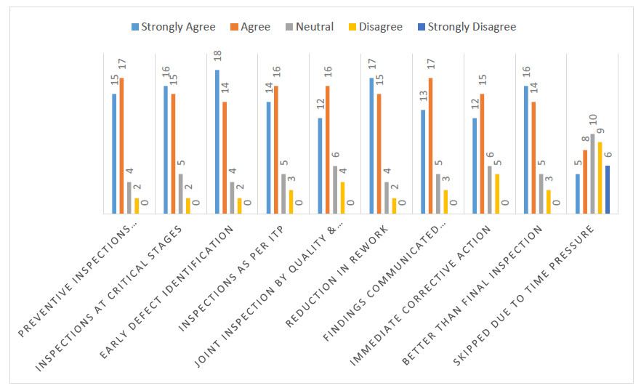
Figure 2. Percentage Analysis of responses
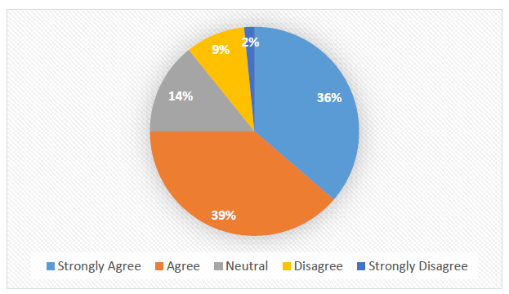

From the analysis of the responses regarding preventive inspections, it is clear that preventive inspections are well-recognized as an important mechanism for reducing defects and rework in construction projects. A large number of respondents agreed or strongly agreed that inspections conducted before the start of work and at critical stages of execution make a significant contribution to quality control.

Objective-02 : To improve workmanship quality by effective implementation of method statements and quality checklists in construction activities.
Figure 3. Bar Chart of responses for objective 2
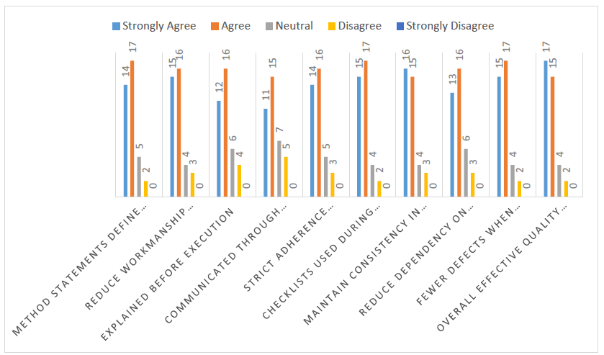
Figure 4. Percentage Analysis of responses for Objective 2
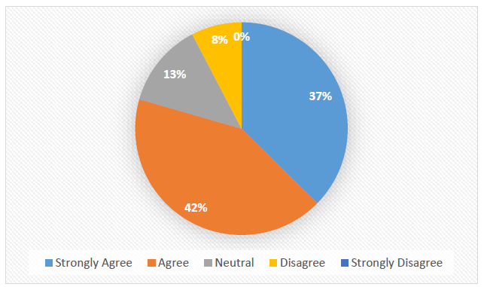
Analysis of the results pertaining to method statements and quality checklists shows that there is a considerable level of agreement among construction professionals regarding the significance of these tools in ensuring workmanship standards. A large number of respondents agreed that method statements help define the sequence of execution and ensure systematic working on site.

Objective-03 : To develop effective training and skill development practices to enhance productivity and quality performance in construction projects.
Figure 5. Bar Chart of responses for objective 3
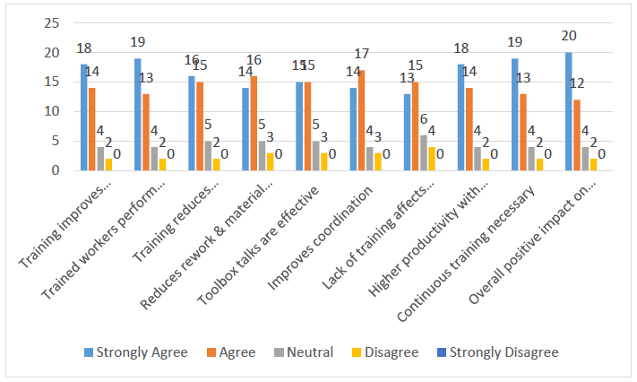

Figure 6. Percentage Analysis of responses for Objective 3
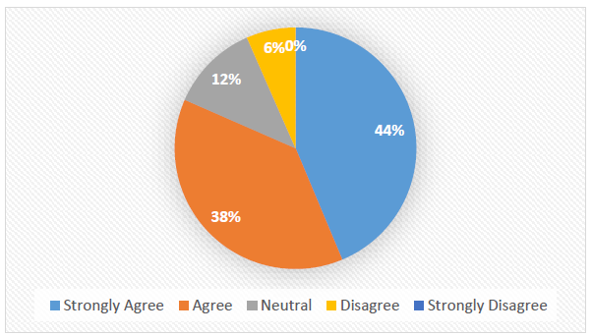

Analysis of the response data related to training and skill development shows that the respondents believe training to be the most significant proactive quality management aspect among the three objectives analyzed. A vast majority of the respondents strongly agreed that training leads to better construction methods, increased efficiency of workers, and fewer workmanship defects.

Interview Survey
The interview survey in this study was conducted using a semi-structured qualitative method to collect detailed and practical insights from experienced construction professionals. While the questionnaire survey provided numerical data through a structured 5-point Likert scale, it could only measure the level of agreement among respondents. It did not fully explain the reasons behind certain practices or challenges observed on site.

Objective 1
To study the role of preventive inspections in minimizing defects and rework in construction projects.
- How do preventive inspections help in reducing defects on site??
- At which construction stages are preventive inspections most important?
- What happens when preventive inspections are skipped due to time pressure?
Interview was conducted with Project Manager, Construction Manager, Site Engineer, Quality Engineer, Site Supervisor were noted.
The interview responses clearly show that preventive inspections are an important factor in reducing defects and rework. All six respondents agreed that conducting inspections prior to commencing critical activities such as concreting, plastering, granite fixing, and waterproofing helps detect defects at an early stage.
The Quality Engineer and Site Engineer explained that detecting defects such as wrongly placed reinforcements, inadequate chipping, incorrect proportions of mortar, and poor surface preparation at an early stage helps prevent extensive rework at a later stage.
The Project Manager agreed that preventive inspections help improve coordination between the execution and quality teams by ensuring mutual verification prior to commencing work.
However, most respondents agreed that time constraints and pressing deadlines sometimes cause inspections to be hurried or partially bypassed. This is consistent with the questionnaire result, where the time pressure factor recorded a lower RII (58.4%), suggesting difficulties in implementing it in practice.
The interview responses strongly confirm the questionnaire result (Objective RII = 80%), showing that preventive inspections are important but sometimes impacted by time constraints.
Objective 2
To improve workmanship quality by effective implementation of method statements and quality checklists in construction activities.
- How do Method Statement help in improving workmanship on site?
- Are Quality Checklist practically useful during site inspections?
- What is main challenge in implementing method statement and checklist on site?
Interview was conducted with Project Manager, Construction Manager, Senior Engineer, Quality Engineer, Site Supervisor were noted.
All participants in the interview agreed that method statements contain effective execution sequences and technical instructions for carrying out construction work. The Construction Manager said that effective explanation of method statements during toolbox talks can eliminate workmanship defects.
The Quality Engineer said that checklists ensure standardized inspection processes and minimize reliance on personal judgment. The Site Supervisor said that activity-based checklists help make critical steps like surface preparation and adhesive application non-negotiable.
However, some participants confessed that method statements are not always strictly adhered to, especially when work is rushed or when experienced personnel think they know the process.
These interview results are consistent with the results of the questionnaire, where Objective 2 achieved a total RII of 81%, indicating a strong level of agreement on the effectiveness of method statements and checklists in enhancing workmanship quality.
Objective 3
To develop effective training and skill development practices to enhance productivity and quality performance in construction projects.
- How does training affect productivity on construction sites?
- Is trained worker more productive than untrained worker?
- What is biggest difficulty in conducting training program on site?
The analysis of the interview showed that training and skill development have the most practical impact on improving productivity and quality. All interviewees agreed that trained manpower is more efficient in performing tasks and produces less defective output.
The Project Manager said that regular training helps minimize repeat NCRs and enhances finishing quality. The Quality Engineer said that after conducting focused training on plastering, measurement box, and granite fixing, defect rates were substantially reduced. The Site Supervisor agreed that untrained new manpower is a significant cause of workmanship defects.
The findings of the interview survey strongly support the questionnaire survey, where Objective has the highest RII of 84% and the highest individual RII of 86.3% on the overall positive impact of training on productivity.
Site Observation/NCR Survey
In this research, the Site Observation / NCR (Non-Conformance Report) survey was conducted specifically for the purpose of validating the findings obtained from the questionnaire and interview surveys. The questionnaire survey and interview survey are primarily based on the opinions, perceptions, and experiences of respondents. Although these methods provide valuable insights and statistical analysis (such as RII values), they reflect what professionals believe or perceive about preventive inspections, method statements, and training practices.
Figure 7. Nos of NCR/Observation and related COPQ
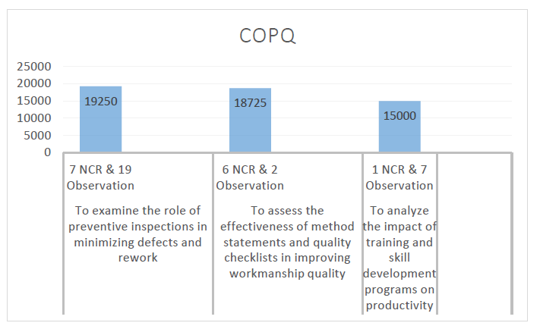
However, opinion-based responses alone are not sufficient to establish practical effectiveness. Therefore, the Site Observation / NCR survey was conducted as an evidence-based assessment tool.
From the above analysis, it is apparent that preventive inspections are a widely adopted and highly effective method in reducing defects and rework in construction projects. The findings from the questionnaire survey revealed that over 80% of the respondents either agreed or strongly agreed that preventive inspections help in:
- Early defect detection,
- Reduction of rework, and
- Overall improvement in construction quality.
The findings show that method statements and quality checklists are very effective tools in ensuring the quality of workmanship and consistency in execution. A significant number of respondents agreed that method statements are effective in defining work sequence, technical specifications, and quality standards.
While the organizational level of method statement preparation is strong, the enforcement level at the site seems to be relatively weaker. This is evident from the number of “Agree” responses in the questions related to method statement adherence and communication to the workers.
The highest RII values were found in the training-related questions, showing a strong level of agreement that trained personnel:
- Do the job right the first time,
- Need less supervision,
- Generate less rework and material waste,
- Enhance overall site productivity.
However, despite the strong recognition of its importance, the consistency and frequency of training programs were found to be inadequate. The interview findings pointed out the challenges of training, including labor turnover, time management issues, and the inability to conduct systematic training sessions during busy project schedules.
CONCLUSION
- The main aim of this research was to assess the impact of proactive Quality Management practices, namely preventive inspections, method statements with quality checklists, and training and skill development activities, on construction project performance. The results were obtained from a questionnaire survey carried out among 38 Project Managers (sample size calculated using Cochran formula), complemented by interview survey results and site Observation/NCR analysis.
- The results have confirmed that preventive inspections are important in reducing defects and rework. Over 80% of the respondents agreed that inspections carried out prior to execution and at critical stages of construction help detect defects at an early stage. The interview results also supported that inspections prior to concreting, plastering, and waterproofing operations prevent irrevocable mistakes. Nevertheless, the results from both questionnaire (lower RII value for time pressure factor) and interview surveys suggest that time pressures and fast-track construction schedules adversely impact the implementation of inspections.
- The study also concludes that method statements and quality checklists are useful tools in improving the quality of workmanship and ensuring consistency in execution. The findings from the questionnaire survey (RII ≈ 81%) show a high level of agreement on the need for standardized work procedures. Interviews showed that, although method statements are available, strict communication and enforcement at the worker level are inconsistent, particularly in finishing works. Analysis of NCRs showed that non-compliance with method statements was a major reason for some defects.
- The study also concludes that training and skill development activities have the strongest positive effect on productivity and quality performance. Questions related to training had the highest RII values (≈ 84-86%), showing a high level of agreement among respondents. Interviews showed that trained workers perform better in terms of workmanship quality, reduced dependency on supervision, and lower repeat NCRs. However, inconsistent training programs and employee turnover were identified as real-world challenges in ensuring consistent skill levels.
- The results of site observation and NCR survey analysis showed that the majority of non-conformities were of preventable type. Root cause analysis showed that the factors contributing to the majority of non-conformities were time pressure, lack of strict supervision, communication, and training. The variability in quality performance was
REFERENCES
[1] | Ali, K., Mubin, S., & Gavrishyk, E. (2022). Evaluating quality management system of construction projects. International Journal of Productivity and Engineering (IJPE), 18(7), 492–501.
[2] | Anand, P. D. (2024). Exploring quality management practices in construction projects: A comprehensive literature review. International Journal of Progressive Research in Engineering Management and Science (IJPREMS), 4(2), 358–365.
[3] | Ashokkumar, D. (2014). Study of quality management in construction industry. International Journal of Innovative Research in Science, Engineering and Technology, 3(Special Issue 1), 36–41.
[4] | Bharsakhale, S. (2020). Impact of quality management in construction on its productivity. Journal of Emerging Technologies and Innovative Research (JETIR), 7(8), 843–848.
[5] | Chin, H. S., Ting, S. N., & Lee, Y. Y. (2024). Quality management challenges in construction projects: Investigating factors, measures, and the role of material quality control. Planning Malaysia: Journal of the Malaysian Institute of Planners, 22(3), 63–78.
[6] | Dhinagaran, S. B. (2023). A study of quality control management in construction industry. International Journal of Novel Research and Development (IJNRD), 8(5), 650–656.
[7] | Gadriwala, T., & Solanki, J. V. (2021). Quality management on construction site. International Research Journal of Engineering and Technology (IRJET), 8(7), 831.
[8] | Kwaponga, P., & Pipaliya, J. (2023). Review paper on quality management practices for construction project delivery. Rabindra Bharati University: Journal of Economics, XVI, 61–70.
[9] | Priyadharsan, A. K. S., & Raja, M. N. (2020). Impact of quality control and management in constructions. International Research Journal of Engineering and Technology (IRJET), 7(5), 3968–3973.
[10] | Rawale, P. P., & Mahatme, P. S. (2021). A study on quality management in construction projects at Amravati. Open Access International Journal of Science and Engineering (OAIJSE), 6(7), 112–118.
[11] | Sheel, & Pannu, S. (2025). Enhancing project efficiency through quality management practices in the construction industry. International Journal of Multidisciplinary Research and Modern Education (IJMRME), 11(1), 139–141.
[12] | Sheoran, V., & Thakur, D. J. (2023). A study on evaluation of quality management systems in construction projects. International Journal of Membrane Science and Technology, 10(4), 2037–2048.
[13] | Shukla, A. K., & Sakale, R. (2021). Analysis of quality on construction and construction cost. International Journal of Scientific Research and Engineering Development, 4(1), 1169–1175.
[14] | Thamilarasu, V., Rajprasad, J., & Ram Prasanna, P. T. (2017). A case study on requirements of quality workmanship in construction projects. International Journal of Civil Engineering and Technology (IJCIET), 8(4), 1061–1067.
[15] | Mane, P. P., & Patil, J. R. (2015). Quality management system at construction project: A questionnaire survey. International Journal of Engineering Research and Applications (IJERA), 5(3, Part 3), 126–130.

