Fire Detection and Automatic Alert System
ABSTRACT
Fire accidents are one of the most dangerous things that can happen and can cause a lot of damage to people and property. To limit losses, it is important to find problems early and act quickly. This paper describes a cheap and effective fire detection and automatic alert system that uses an embedded Arduino platform. The system has a flame sensor that can detect fire and immediately sets off a buzzer alarm to warn people nearby. Also, a GSM module sends the user an SMS alert with real-time location data from a GPS module. An LCD screen on the system also shows live coordinates. The suggested system is good for homes, businesses, and remote areas because it can quickly find things, accurately track their location, and send messages right away.
Keywords: Fire Detection, Arduino, GSM Module, GPS Module, Embedded System, Real-Time Monitoring, Alert System

INTRODUCTION
Fire is one of the most dangerous hazards that can occur in homes, industries, and public places. It can cause severe damage to property and pose a serious risk to human life. A major reason for the high impact of fire accidents is the delay in detecting them at an early stage. In many cases, fires are noticed only after they have already spread, making them difficult to control.
Traditional fire detection systems, such as smoke detectors and heat sensors, mainly provide local alerts in the form of alarms or sirens. These systems are effective only when people are present nearby to respond immediately. In unattended locations or during nighttime, such alerts may go unnoticed, leading to delayed action and increased damage. Moreover, most conventional systems do not provide information about the exact location of the fire, which is important for quick emergency response.
With the advancement in embedded systems and communication technologies, smarter fire detection solutions can be developed. By integrating sensors, microcontrollers, and communication modules, it is possible to detect fire in real time and send alerts to users instantly. Technologies like GSM and GPS enable remote notification and location tracking, making the system more efficient and reliable.
The proposed Fire Detection and Automatic Alert System is designed to address these challenges. The system uses a flame sensor to detect fire and an Arduino microcontroller to process the data. When fire is detected, a buzzer is activated to alert nearby people. At the same time, a GSM module sends an SMS alert to the user along with the location obtained from a GPS module. This ensures both local and remote alerting, even if no one is present at the site.
The system is low-cost, portable, and easy to implement, making it suitable for various applications such as homes, offices, industries, and remote areas. By providing early detection and quick communication, the system helps in reducing damage and improving safety.

PROBLEM STATEMENT
Most traditional fire detection systems rely on alarms that go off in the area. If a fire breaks out in an area that isn't being watched, the alarm might not be heard, which could cause a delay in response. This delay makes it more likely that people will be hurt or killed.
So, we need a system that can:
- Find fires quickly
- Send alerts right away to the area
- Send notifications from a distance with location

OBJECTIVES
- To detect fire using a flame sensor
- To provide immediate alert using a buzzer
- To send SMS alerts using GSM module
- To provide location details using GPS module
- To design a low-cost and portable system

METHODOLOGY
The system works by continuously monitoring the environment using a flame sensor. When fire is detected, the sensor sends a signal to the Arduino microcontroller.
The Arduino processes this signal and performs the following actions:
- Activates a buzzer for local alert
- Fetches location data from GPS module
- Sends SMS alert via GSM module
The SMS contains a message along with a Google Maps link showing the exact location
Dataflow:
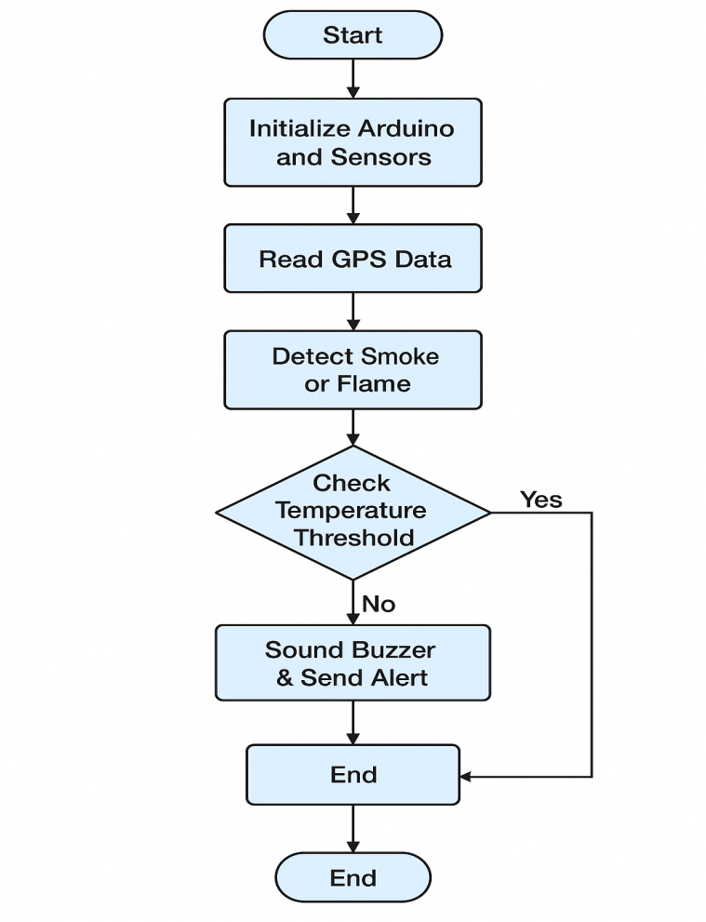
The data flow diagram represents the sequence of operations in the system. The flame sensor continuously monitors the environment and sends signals to the Arduino. Upon detection, the system activates alert mechanisms and transmits location data via GSM.

SYSTEM DESIGN
The system consists of the following components:
- Arduino Uno
- Flame Sensor
- SIM800L GSM Module
- NEO-6M GPS Module
- LCD Display
- Buzzer
- Power Supply

Diagram:
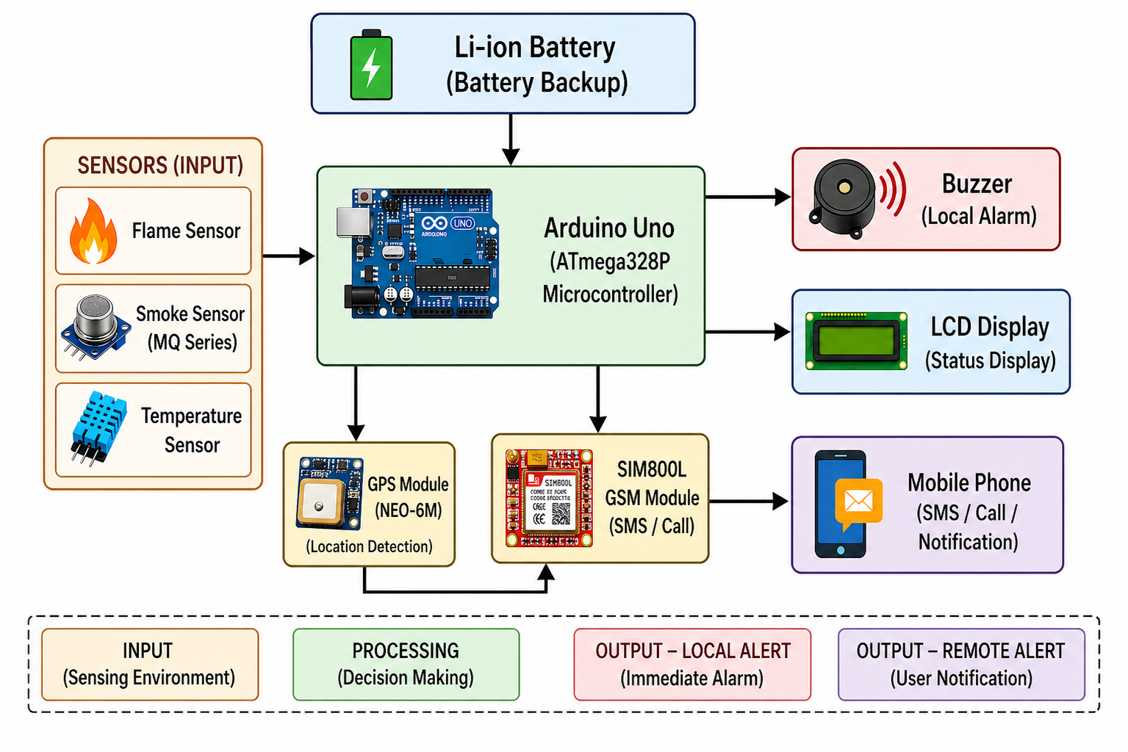
Fig1. Block Diagram
IMPLEMENTATION
The hardware components are connected to the Arduino, and the system is programmed using Arduino IDE.
Steps:
- Initialize all modules
- Read sensor data
- Detect fire condition
- Activate buzzer
- Get GPS coordinates
- Send SMS alert
- Display data on LCD
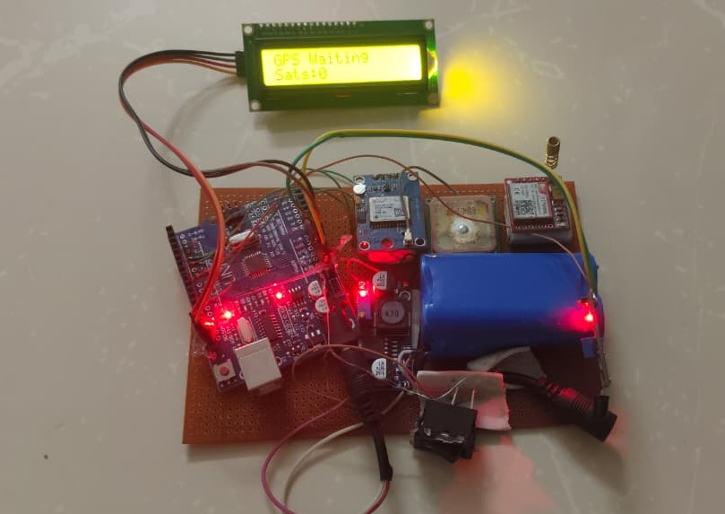
Fig2. Hardware Setup

RESULT AND DISCUSSION
The system was tested in real-time conditions. The results show:
- Fire detection occurs within less than 1 second
- SMS alert is received within 3–4 seconds
- GPS provides accurate location (±3 meters)
- Buzzer activates instantly
The system performs reliably and provides fast response, making it effective for safety applications.

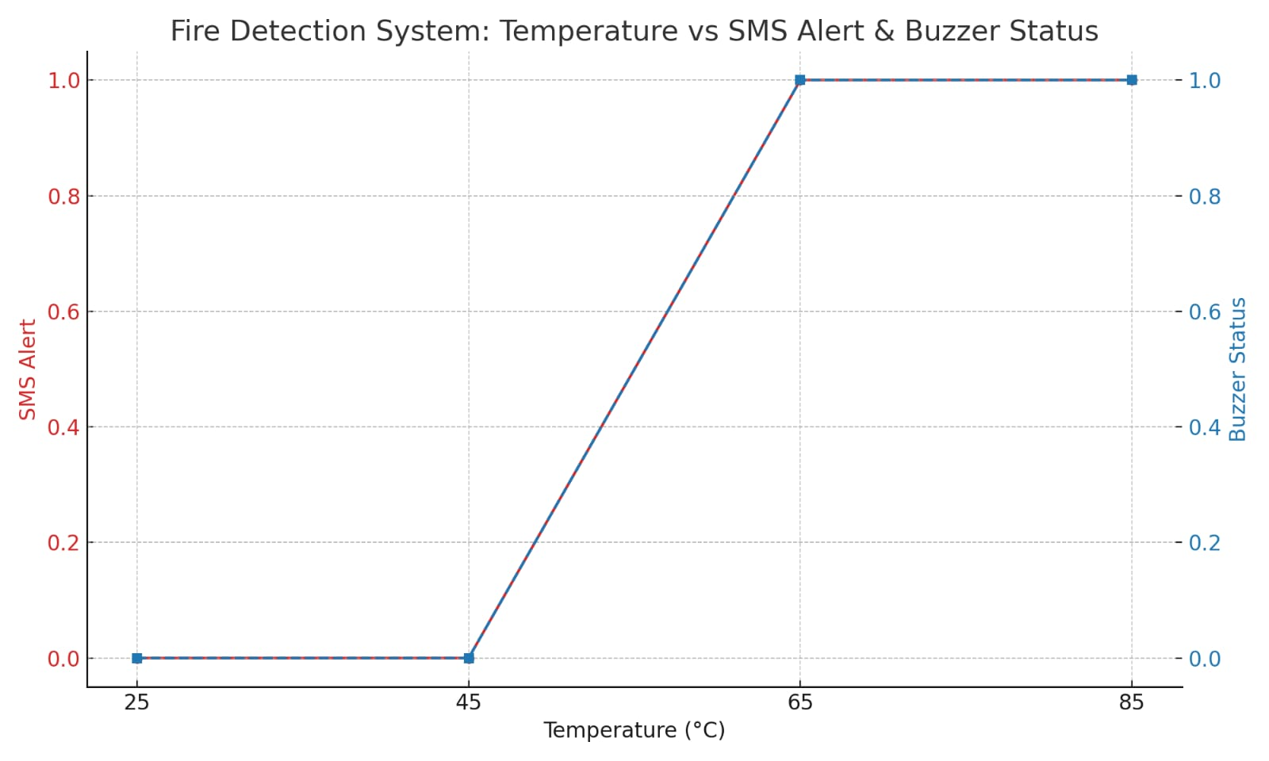
Fig3. Graphical Representation

ADVANTAGES
- Low cost and easy to build
- Fast response time
- Portable system
- Works without internet (GSM based)

APPLICATIONS
- Homes
- Industries
- Vehicles
- Remote areas

CONCLUSION
The proposed fire detection and automatic alert system is an effective and reliable solution for early fire detection. By combining flame sensing, GSM communication, and GPS tracking, the system ensures immediate response and accurate location sharing. This helps in reducing damage and saving lives.

FUTURE SCOPE
- Integration with IoT platforms
- Mobile application development
- Automatic sprinkler system
- AI-based fire prediction

REFERENCES
- S. Sharma, P. Singh, and R. Kaur, “IoT-Based Fire Detection and Alert System Using Arduino and GSM Module,” International Journal of Innovative Research in Science, Engineering and Technology (IJIRSET), Vol. 9, Issue 5, 2023. https://www.ijirset.com
- A. Patel and M. Joshi, “Smart Fire Detection and Automatic Alert System Using IoT,” International Journal of Engineering Research & Technology (IJERT), Vol. 12, Issue 2, 2024. https://www.ijert.org
- N. Gupta, V. Jain, and S. Kumar, “Design and Implementation of an Automated Fire Detection System Using ESP32 and GSM,” International Research Journal of Engineering and Technology (IRJET), Vol. 11, Issue 3, 2025. https://www.irjet.net
- R. Dey and A. Saha, “IoT Enabled Fire Monitoring and Alerting System for Smart Buildings,” IEEE International Conference on Computing, Communication and Automation, 2023. https://ieeexplore.ieee.org
- D. Singh and R. Verma, “Smart Fire Detection System Using Flame and Smoke Sensors,” International Journal of Advanced Research in Computer Science and Electronics Engineering (IJARCSEE), Vol. 13, Issue 1, 2024. https://www.ijarcseeonline.org
- S. Kumar and R. Sharma, “Wireless Sensor Network Based Fire Detection and Alert System,” International Journal of Computer Applications, Vol. 182, Issue 12, 2019.
http://www.ijcaonline.org
- K. Lee et al., “Smart Fire Detection System Using Machine Learning Techniques,” IEEE Access, Vol. 8, 2020.
https://ieeexplore.ieee.org
- J. Brown and T. Wilson,
“Development of Smart Fire Alarm System Using Arduino and GSM,”
International Journal of Scientific & Engineering Research, Vol. 10, Issue 7, 2019. https://www.ijser.org
- L. Wang, Y. Zhang, and H. Liu,
“Intelligent Fire Detection System Based on IoT Technology,”
Journal of Sensors, Vol. 2021, 2021. https://www.hindawi.com/journals/js/
- K. N. Kumar and P. Reddy,
“Real-Time Fire Detection System Using Sensors and Microcontroller,”
International Journal of Advanced Engineering Research and Science (IJAERS), Vol. 7, Issue 6, 2020. https://ijaers.com

