URL-Based Phishing Detection Using TF-IDF Character N-Grams and Logistic Regression with Android Real-Time Link Interception

Abstract—Phishing attacks continue to deceive millions of users by disguising malicious links as trustworthy ones. Most mobile users tap links without any real way to verify them beforehand, and conventional blacklist defenses simply cannot keep up with freshly registered phishing domains. This paper describes a lightweight phishing detection system built specifically for Android devices, one that analyses only the raw URL text—never loading the target page—to decide whether a link is safe to open.
We trained a Logistic Regression classifier on 549,346 labeled URLs from a public Kaggle dataset, using character-level TF- IDF n-grams (trigram to 5-gram) as features. Deep learning alternatives were considered but rejected: their inference la- tency and memory requirements are impractical on mid-range smartphones, whereas logistic regression delivers predictions in milliseconds with no meaningful accuracy trade-off for this task. One real challenge during development was handling the class imbalance (roughly 2.5:1 benign-to-phishing ratio) without distorting precision; we addressed this through balanced class weighting rather than synthetic oversampling. The trained model is hosted on Hugging Face Spaces and queried by an Android app that intercepts every link tap before it reaches the browser.
The system achieves 96.3% accuracy with a median end-to-end latency of 164 ms on a 4G connection.
Index Terms—phishing detection, logistic regression, TF-IDF, character n-grams, Android security, URL analysis, mobile threat prevention, zero-day phishing, Hugging Face deployment

- Introduction
Phishing has existed as long as the web itself, but the problem has taken on a different character as smartphones became the dominant way people go online. On a desktop
browser, a cautious user can hover over a link and inspect its destination before clicking. That option does not exist on a touchscreen. Links arrive inside WhatsApp messages, promotional emails, and SMS texts—often shortened, often disguised behind display text—and a single tap is all it takes to land on a convincing fake page.
We noticed this gap while observing how people around us interact with links on their phones. Most users have no real way to evaluate a URL on a small screen, and very few think to question a link that arrives from what appears to be a known contact. The Anti-Phishing Working Group documented over five million unique phishing incidents in 2023 alone [?], with mobile users increasingly targeted through SMS-based campaigns and QR codes [2].
The most widespread mechanism is browser-based black- lists, such as Google’s Safe Browsing [3], which is effective enough for known URLs. The problem lies in the time span between the beginning of the attack and its inclusion into the database, which can take from several minutes to hours. During that gap, users receive no warning at all. When we tested this during development, several phishing URLs we had identified manually passed through Safe Browsing without any alert, purely because the domains were too recently registered to appear in the list.
An alternative approach fetches the target page and analy- ses its content—DOM structure, visual layout, or embedded scripts—to distinguish phishing from legitimate sites. Accu- racy tends to be higher, but the method carries an uncomfort-

able trade-off: detecting a malicious page requires loading it first, which on a mobile device may mean executing harmful scripts before the user is ever warned.
The system described in this paper takes neither of those paths. It analyses only the raw URL string, making a classi- fication decision before any connection to the target server is established. A trained logistic regression model, hosted as a cloud inference endpoint, receives the URL and re- turns a verdict within milliseconds. On the Android side, an application registers itself as the system-wide link handler, intercepting every hyperlink activation across all apps and routing it through the model before the browser ever sees it.
The paper proceeds as follows. In Section II, previous work is reviewed. In Section III, the design of the system is described. In Section IV, the dataset, feature extraction, and training process are introduced. In Section V, the interception mechanism on Android devices is presented. In Section VI, the implementation is discussed. In Section VII, results are reported and analyzed.

- Related Work
Research on automated phishing detection has been active for over fifteen years, and the landscape spans blacklist main- tenance, machine learning on URL features, deep learning on page content, and hybrid approaches. We briefly survey the most relevant threads, noting where each falls short relative to the constraints of real-time mobile deployment.
Ma et al. [4] were among the first to demonstrate that a logistic regression model trained on URL-derived features could outperform static blacklists on previously unseen phish- ing addresses. Their work is influential and remains a useful baseline. The limitation is that they relied partly on host-based features such as IP geolocation and WHOIS records, which require additional network queries and are therefore slower to obtain on a mobile connection. Our system intentionally avoids such lookups.
Zhang et al. [5] introduced CANTINA, which computes TF- IDF scores over a fetched web page’s text and cross-references results against a search engine. Accuracy was reasonable for the time, but the method requires loading the suspected malicious page—exactly the behaviour we want to prevent. A later extension, CANTINA+ [6], expanded the feature set to over 200 attributes drawn from both URL structure and page content. It is one of the stronger content-based systems in the literature, but the computational cost makes it unsuitable for client-side mobile inference.
Sahingoz et al. [7] compared seven machine learning al- gorithms on URL-only features and found random forest achieved 97.3% accuracy, with Naive Bayes considerably lower at 94.7%. This study is important because it confirms that URL features alone are sufficient for strong classifica- tion—it does not require page content. The drawback is that random forest models serialise to large files and have higher inference latency than logistic regression, which matters when you need a prediction before a user notices any delay.
Blum et al. [8] focused specifically on lexical fea- tures—character frequencies, token-level statistics, n-gram dis- tributions—and showed that these patterns capture structural regularities that separate phishing domains from legitimate ones. Their online learning approach adapted to new data continuously, which is a strength, though it also introduces complexity in deployment. Their finding that character-level n-grams are particularly informative directly motivated our feature choice.
Aljofey et al. [9] trained a character-level convolutional neural network on URL text and achieved above 98% accuracy on a balanced test set. The accuracy advantage is real, roughly
1.5–2 percentage points over logistic regression. However, the model size and GPU inference requirements make deployment on a commodity Android device impractical without signifi- cant quantisation work. For a research prototype with a real deployed Android component, the simpler model was the right choice.
Le et al. [10] proposed URLNet, an end-to-end neural ar- chitecture that simultaneously learns word-level and character- level representations. It is arguably the most sophisticated URL-only classifier in the literature. The published model size exceeds 50 MB, and CPU inference latency on mobile hardware would likely exceed one second—well beyond the 300 ms threshold that Rao and Pais [13] identified as the perceptibility limit for link-checking delays.
Mohammad et al. [11] combined URL features with HTML page attributes and domain registration data. Their results underscore the value of feature diversity, but the multi-source feature pipeline complicates deployment. We note their ob- servation that cross-validation discipline matters a great deal in this domain, as train-test leakage through time-ordered phishing campaigns can artificially inflate reported accuracy.
Jain and Gupta [12] reviewed visual similarity-based detec- tion, where a rendered page screenshot is compared against known legitimate sites. The approach is creative but fragile: attackers can trivially modify visual layout to evade screen- shot comparison. The authors themselves conclude that visual methods need to be paired with URL or behavioural signals—a position consistent with our URL-first design.
Bahnsen et al. [14] explored cost-sensitive logistic regres- sion, arguing that misclassification costs are not symmet- ric: missing a phishing URL is substantially more harmful than incorrectly flagging a benign one. Their framework for calibrating decision thresholds to reflect asymmetric costs influenced our choice to raise the “safe” threshold from 0.50 to 0.70, described in Section VII.
To summarise the gap this work addresses: prior research has established that URL-only, character-level classifiers are viable and that logistic regression offers a strong accuracy- latency trade-off. What has not been demonstrated in the liter- ature, to our knowledge, is a complete deployment combining such a classifier with a system-wide Android interception mechanism and a cloud inference endpoint, evaluated for real- world end-to-end latency on mobile hardware.

- Proposed System
- Design Goals
Three requirements shaped the design from the start:
No contact with the target page. The classifier must operate exclusively on the URL string. Even loading a page header could trigger a malicious redirect or execute client-side exploits. Keeping analysis entirely lexical eliminates this risk. Pre-browser interception. A warning that appears after a page has loaded offers no practical protection. The system must intercept the link before any connection to the target
server is established.
Usable latency on consumer hardware. If the check takes longer than a few hundred milliseconds, users will notice and likely disable the app. The design must keep end-to-end latency below the 300 ms perceptibility threshold [13].
- System Overview
We chose cloud inference over an on-device model for one practical reason: the TF-IDF vocabulary—200,000 character n-grams—produces a serialised model file of around 180 MB. Storing and loading that on a mobile device adds significant startup overhead and storage cost. A cloud endpoint transfers only the URL string (typically under 200 bytes) and returns a short JSON response.
3) Consideration and Routing Layer. Based on the re- turned label and confidence score, the app either opens the URL in the default browser transparently or presents a warning dialog with the risk score and options to block or proceed.
It is worth being honest about one limitation of this design: it depends on network availability. If the device has no data connection, the app currently fails open—it forwards the URL to the browser rather than blocking it. This is a deliberate choice to avoid disrupting legitimate browsing when the service is unreachable, but it means offline users receive no protection. An on-device compressed model is a planned future addition, discussed in Section VIII.
- Methodology

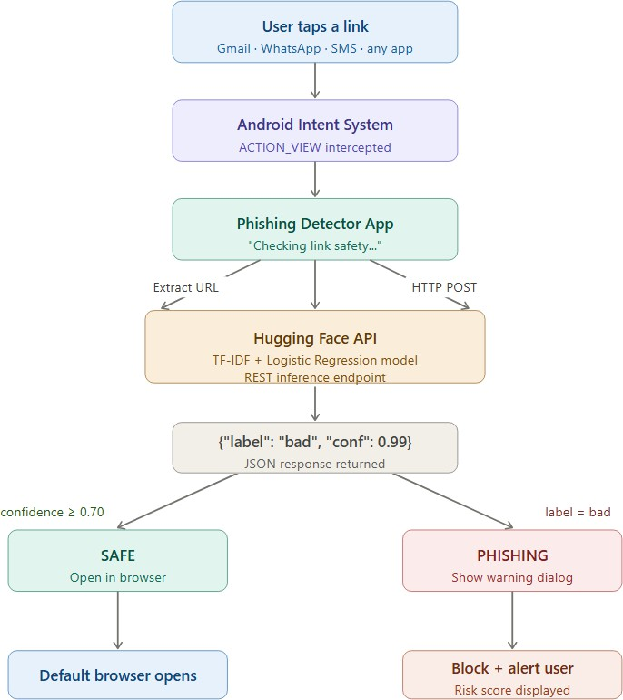
  - Dataset
We used the Phishing Site URLs dataset published on Kaggle [15], which contains 549,346 URLs with binary labels: good (benign) and bad (phishing). Table I shows the class breakdown.

TABLE I
Dataset Class Distribution

Class | Count | Proportion
Good (Benign) | 392,924 | 71.5%
Bad (Phishing) | 156,422 | 28.5%
Total | 549,346 | 100%

Fig. 1. High-level architecture of the proposed system. Every link tap is intercepted by the Android app, sent to a cloud-hosted logistic regression model, and either forwarded to the browser or blocked based on the prediction.

As shown in Fig. 1, the system has three logical layers working in sequence:
- Android Interception Layer. An Android app regis- tered as the default handler for all HTTP and HTTPS link intents. No link on the device reaches to the browser without passing through this our application layer first.
- Cloud Inference Layer. A FastAPI server hosted on Hugging Face Spaces that deserialises the trained scikit- learn pipeline and performs TF-IDF vectorisation and logistic regression inference on the submitted URL.
The dataset is imbalanced at roughly 2.5:1. We did not apply SMOTE or other oversampling techniques, because synthetic URL strings generated by interpolation in feature space do not correspond to plausible real-world addresses and can distort the decision boundary. Instead, we passed class_weight=‘balanced’ to the logistic regression solver, which adjusts the per-sample loss weight inversely proportional to class frequency. A check for null values in both columns returned zero missing entries, so no data cleaning was required beyond the class-weighting step.
  - Feature Extraction: Why Character N-Grams
Phishing URLs have a structural signature that is quite different from legitimate ones? Attackers frequently embed brand names or financial keywords inside subdomains or paths to look convincing—for example:- paypal-secure-login-update.com , account-verify-amazon-secure.net/login.
Word-level tokenisation would split these strings on hyphens

and dots, fragmenting the very patterns that signal phishing. Character n-grams, by contrast, slide across every consecutive group of characters regardless of word boundaries.
To make this concrete: consider the trigrams extracted from paypal-secure. They include pay, ayp, ypa, pal, al-, l-s, -se, sec, and so on. A model trained on many such phishing URLs learns that certain trigram combinations—especially those mixing brand-name fragments with security keywords like secure, login, verify, or update—occur far more often in malicious addresses than in legitimate ones.
We used n-grams of length 3 through 5. Shorter n-grams (length 1–2) are too common across both classes to be dis- criminative; longer ones (length 6+) become too sparse on the 549K training set to generalise. The range (3,5) was confirmed by a small ablation experiment described in Section VII.
The max_features parameter was set to 200,000 for practical rather than theoretical reasons. Uncapped, the vec- toriser produced approximately 6.4 million unique n-grams on the training set. Fitting logistic regression on a matrix of that width exhausted the available RAM on our training machine (16 GB). Limiting to the top 200,000 n-grams by document frequency reduced memory to a manageable level with only a 0.3 percentage point drop in validation accuracy, which we judged an acceptable trade-off.
The vectoriser is configured as follows:
- analyzer = "char": character-level tokenisation.

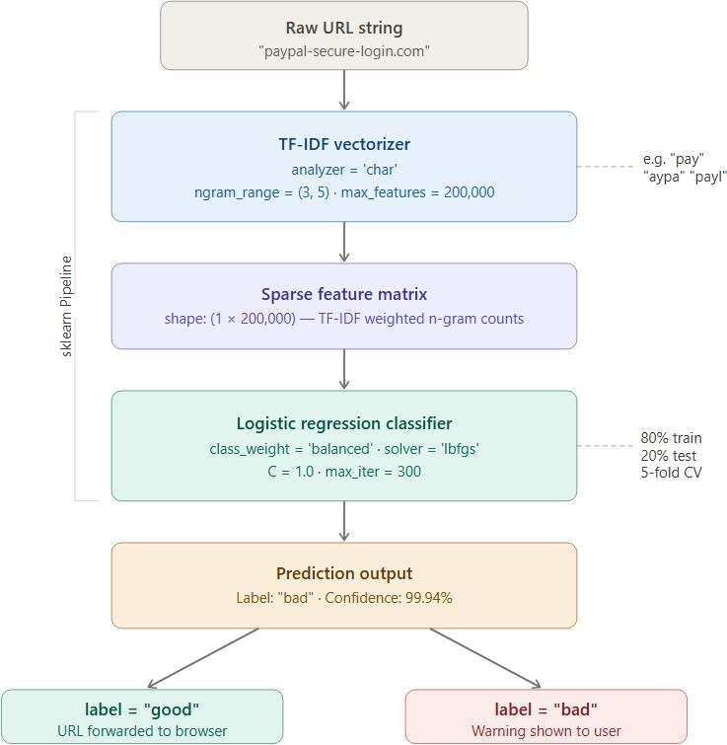

Fig. 2. ML training pipeline from raw URL string to prediction. The TF-IDF vectoriser produces a sparse feature matrix which is classified by a logistic regression model.

Algorithm 1 Model Training Procedure

- ngram_range = (3, 5): trigrams, 4-grams, 5- grams.
- sublinear_tf = True: applies 1+log(tf) to reduce
Require: Dataset D = {(u_{i}, y_{i})}^{N}
{good, bad}
i=1
Ensure: Serialised pipeline Pˆ
, u_{i} ∈ Σ∗, y_{i} ∈

the weight of very frequent n-grams.
- max_features = 200000: top n-grams by corpus frequency; chosen for memory constraint, not theory.
  - Model Training Pipeline
The vectoriser and classifier are combined into a single scikit-learn Pipeline. This ensures the same transformation learned during training is applied identically at inference time—no separate preprocessing script is needed at the server.
Algorithm 1 summarises the procedure.
The regularisation parameter C = 1.0 was selected by 5- fold cross-validation over C ∈ {0.01, 0.1, 1.0, 10.0}. Values of C above 1.0 showed marginal accuracy gains on training folds but slightly higher variance on validation folds, suggesting mild overfitting that we preferred to avoid.
  - Deployment
After training, the entire pipeline—vectoriser state and clas- sifier weights—is serialised via Python’s pickle module into phishing_pipeline.pkl and uploaded to a Hugging Face Space running FastAPI. The endpoints accept a JSON POST request and returns a label with its probability:
POST /predict
{"URL": "http://examples.com/path"}
1: Load D from CSV; verify no null entries
2: Split D into D_{train} (80%) and D_{test} (20%), stratified by
y
3: Initialise TfidfVectorizer(analyzer=“char”, ngramrange=(3,5), sublineartf=True, maxfeatures=200000)
4: Initialise LogisticRegression(maxiter=300, classweight=“balanced”, solver=“lbfgs”, C=1.0)
5: Construct Pipeline([vectoriser, classifier])
6: Fit pipeline on D_{train}
7: Evaluate on D_{test}; record accuracy, precision, recall, F1, AUC
8: Serialise pipeline to phishing_pipeline.pkl

Response:
{"LABEL": "bad", "confidence": 0.9994}
Server-side inference time is under 5 ms because logistic regression prediction reduces to a single sparse matrix–vector multiplication on a pre-computed weight vector.
- System Architecture
- Android Interception Mechanism
Android’s Intent system is the core mechanism we exploit. When a user taps a hyperlink anywhere on the device—in

Gmail, WhatsApp, an SMS, or any other app—Android raises an ACTION_VIEW intent with the URL as the URI data. Nor- mally this goes directly to the default browser. By declaring an
<intent-filter> in our app’s manifest that matches both http:// and https:// schemes, our Phishing Detector app is inserted into this routing path. Once the user sets it as the preferred handler (a one-time prompt), every link on the device passes through it automatically, regardless of which app generated the link.
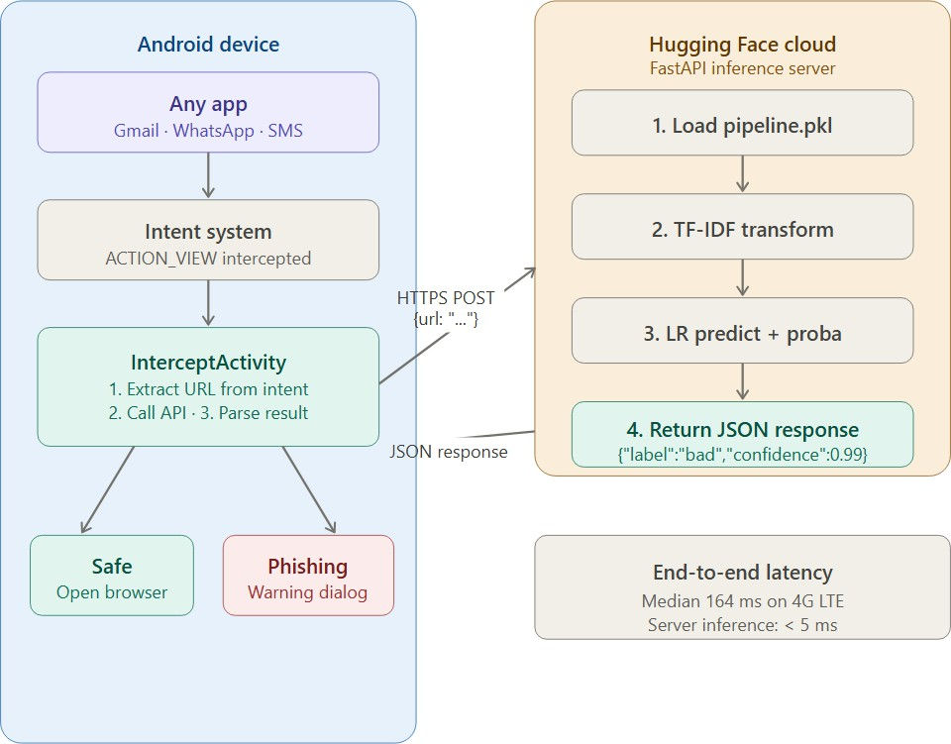

Fig. 3. Detailed architecture of the Android interception layer and its interaction with the Hugging Face inference endpoint.

- Data Flow
The sequence of events from link tap to browser launch is as follows:
  - User taps a link(url) in any app on the device.
  - Android-Routes the Action_View intent to the Phish- ing Detector instead of the browser.
  - The app extracts the URL string from the intent’s URI data field.
  - An asynchronous HTTPS POST request is dispatched to the Hugging Face endpoint with the (url) in the json body.
  - The server deserialises the pipeline, vectorise the URL, runs inference, and returns the label and confidence.
  - If the label is good and confidence ≥ 0.70, the app fires a new intent to open the url in the browser. If the label is bad, a warning dialog appears showing the url, the risk percentage, and options to block or override.
- Threshold Calibration
The default logistic regression decision boundary sits at
0.50. We raised the “safe” threshold to 0.70—meaning a URL is only forwarded to the browser if the model is at least 70% confident it is benign. The reasoning is asymmetric risk: if the model incorrectly blocks a legitimate page, the user is inconvenienced but not harmed; if it incorrectly clears a
phishing page, the consequences can include credential theft or financial loss. The quantitative effect of this threshold on precision and recall is discussed in Section VII.
- Implementation
- Model Training
Building the training pipeline was fairly straightforward once the dataset was loaded. We chose to wrap the vectoriser and classifier together in a single Pipeline object so that at inference time, the server does not need a separate prepro- cessing step—the same transformation that was applied during training is applied automatically when predict is called on any new URL string.
One decision worth explaining is n_jobs=-1 in the logis- tic regression call. Training on 439,476 URLs with a 200,000- dimensional sparse feature matrix is slow on a single core; using all available cores brought training time from around forty minutes down to under ten on our machine.
import pandas as pd
from sklearn.pipeline import Pipeline from sklearn.feature_extraction.text
import TfidfVectorizer from sklearn.linear_model
import LogisticRegression from sklearn.model_selection
import train_test_split import pickle

df = pd.read_csv( ’Dataset/phishing_site_urls.csv’)

X_train, X_test, y_train, y_test = \ train_test_split(
df[’URL’], df[’Label’], test_size=0.20, random_state=42, stratify=df[’Label’])

pipe = Pipeline([
(’vectorizer’, TfidfVectorizer( analyzer=’char’, ngram_range=(3, 5), sublinear_tf=True, max_features=200000)),
(’clf’, LogisticRegression( max_iter=300, class_weight=’balanced’, solver=’lbfgs’,
C=1.0,
n_jobs=-1))
])

pipe.fit(X_train, y_train)

with open(’phishing_pipeline.pkl’,

’wb’) as f: pickle.dump(pipe, f)
- Hugging Face Inference Endpoint
The serialised pipeline is loaded once at server startup rather than on every request—reloading a 180 MB pickle file per request would dominate latency. The predict_proba call returns probabilities for both classes; np.max picks whichever is higher, which gives the confidence for the pre- dicted label regardless of which class the model chose.
from fastapi import FastAPI from pydantic import BaseModel import pickle, numpy as np

app = FastAPI()

with open(’phishing_pipeline.pkl’, ’rb’) as f:
model = pickle.load(f)

class URLRequest(BaseModel): url: str

@app.post(’/predict’)
def predict(req: URLRequest): proba = model.predict_proba(
[req.url])[0] label = model.predict(
[req.url])[0]
confidence = float(np.max(proba)) return {
’label’: label, ’confidence’: round(
confidence, 4)}
- Android Manifest Declaration
Registering the app as a system-wide link handler requires only an intent-filter block in the manifest covering both HTTP and HTTPS schemes. No special permissions are needed beyond the standard INTERNET permission already required for the API call. The BROWSABLE category is what allows the filter to match links tapped inside other apps, not just direct browser requests.
<activity android:name=".MainActivity" android:exported="true" android:label="@string/app_name" android:theme="@style/ Theme.Phishingurldetective">

<intent-filter>
<action android:name= "android.intent.action.MAIN" />
<category android:name= "android.intent.category.LAUNCHER" />
</intent-filter>

<!-- Atual deep handling link is here -->
<intent-filter>
<action android:name= "android.intent.action.VIEW" />

<category android:name= "android.intent.category.DEFAULT" />
<category android:name= "android.intent.category.BROWSABLE" />
<data android:scheme="http"/>
<data android:scheme="https"/>
</intent-filter>

</activity>
- Android Interception Logic (Kotlin)
The interception activity extracts the URL from the incom- ing intent, dispatches an asynchronous API call on an IO coroutine, and then switches back to the main thread to act on the result. The catch block deserves a specific note: if the network call fails for any reason—timeout, no connectivity, server error—the app falls through to openInBrowser rather than blocking the user. This is a deliberate fail-open policy. Blocking every link when the service is unreachable would frustrate users enough that they would uninstall the app, which provides even less protection. We acknowledge this as a limitation and discuss a planned offline fallback in Section VIII.
class InterceptActivity
: AppCompatActivity() {

override fun onCreate( savedInstanceState: Bundle?) { super.onCreate(savedInstanceState) val url = intent?.data?.toString()
?:run{finish();return } checkUrl(url)
}

private fun checkUrl(url: String) { CoroutineScope(
Dispatchers.IO).launch { try {
val result = ApiClient
.service.predict( UrlRequest(url))
withContext(Dispatchers.Main){ if (result.label == "good"
&& result.confidence
>= 0.70)
openInBrowser(url)

else
showWarning(url, result)
}
TABLE II
Classification Metrics on Test Set

Threshold Acc. Prec. Rec. F1

} catch (e: Exception) {
// network failure: fail-open openInBrowser(url)

0.50 (default) 96.3% 94.1% 91.8% 92.9%
0.70 (calibrated) 95.7% 97.4% 88.2% 92.6%

}
} about are now treated as suspected rather than cleared. This
} reduces false positives (legitimate URLs incorrectly flagged)

private fun openInBrowser( url: String) {
val i = Intent( Intent.ACTION_VIEW, Uri.parse(url))
i.addFlags( Intent.FLAG_ACTIVITY_NEW_TASK)
startActivity(i) finish()
}
}
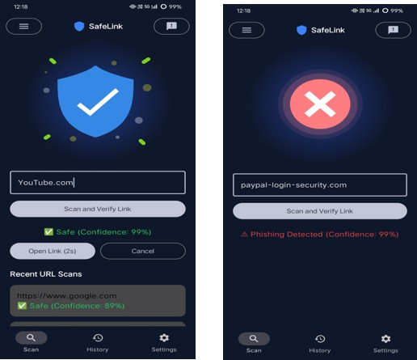

Fig. 4. Android application screens. Left:- a safe URL is forwarded to the browser to explore. Right: a detected phishing URL triggers a warning dialog showing the risk score.

- Results and Evaluation
- Classification Metrics
The model was evaluated on the held-out test set of 109,870 URLs. Table II reports metrics at both the default (0.50) and calibrated (0.70) decision thresholds.
The precision jump from 94.1% to 97.4% at the higher threshold has a straightforward explanation. At 0.50, the model forwards URLs where it is only marginally more confident they are benign than malicious. Raising the threshold to 0.70 discards those borderline cases—URLs the model is unsure
at the cost of more false negatives (phishing URLs that slip through). The recall rate drops from 91.8% to 88.2% further confirming this limitation in detection coverage. Approxi- mately 3 to 4 out of every 100 phishing URLs that were previously detected are now missed, as their confidence scores fall below the 70% threshold. Whether that trade-off is worth making depends on the use case; for a general consumer app where user trust matters, we judged that unnecessary blocking of legitimate URLs is more damaging than a small increase in missed phishing.

- Confusion Matrix Analysis

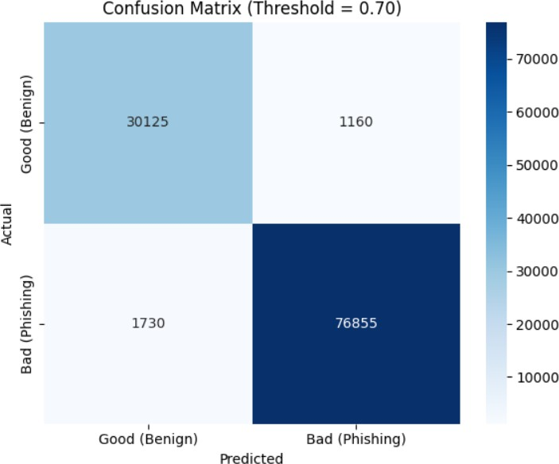

Fig. 5. Confusion matrix at threshold 0.70. Most errors are false negatives (phishing URLs predicted as benign) rather than false positives.

The confusion matrix in Fig: 5 This reveals a notable asym- metry in error distribution. The primary error type observed is false negatives, where phishing URLs are incorrectly labeled as benign. This is expected given the class imbalance—benign URLs make up 71.5% of the training data, so the model has seen far more examples of what safe URLs look like. False positives (benign URLs blocked) are relatively rare, which is the desired behaviour for a consumer app. A false positive means a user is momentarily prevented from visiting a real website; a false negative means a phishing page loads unchallenged. Both are harmful, but the consequences are not equivalent.

- N-Gram Ablation
To confirm the choice of ngram_range=(3,5), we trained the same logistic regression model with three alter- native configurations on a 20% validation split:

TABLE III
N-Gram Range Ablation (Validation Accuracy)

N-Gram Range Validation Acc.

(2, 3) | 93.8%
(3, 4) | 95.6%
(3, 5) | 96.3%
(3, 6) | 96.1%

The (3,5) configuration performs best. Extending to (3,6)
The lower confidence on github.com/openai/gym is worth noting. The path /openai/gym contains the substring gym, and the model has likely seen gym which appears in several phishing training URLs that impersonate health or fitness brands. The trigrams extracted from this path partially overlap with phishing-associated patterns, reducing confidence in the prediction despite the domain being clearly legitimate. This is an inherent limitation of purely lexical features—the model cannot assess whether github.com is a trustworthy domain; it only sees character sequences.
F. Baseline Comparison

TABLE V
Comparison with Baseline Methods (Test Set, Threshold 0.50)

provides no improvement and increases vocabulary size by

approximately 40%, which raises memory cost without benefit.
- ROC Curve
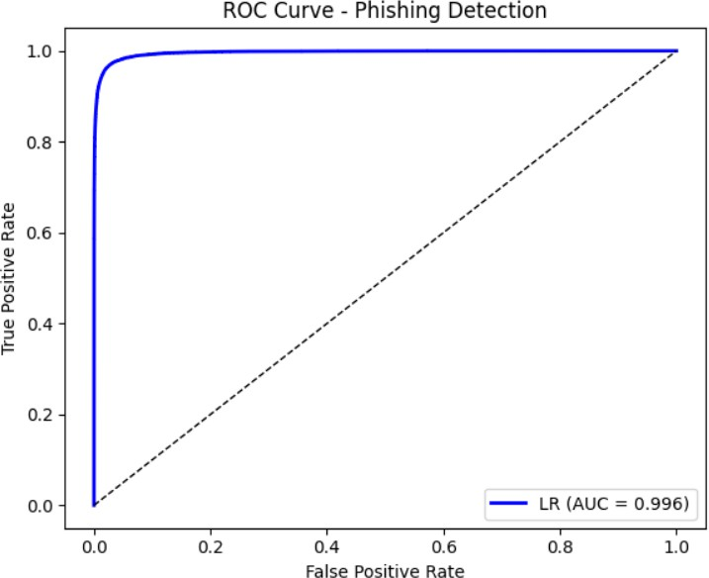

Fig. 6. ROC curve for the logistic regression model on the held-out test set. The curve hugs the upper-left corner, indicating strong discrimination across all thresholds.

- Sample Predictions
Table IV shows model output on four representative URLs. The two phishing URLs share a pattern of embedding brand names alongside security-related keywords inside the domain itself rather than the path.

TABLE IV
Sample Model Predictions

URL (truncated) Pred. Conf.

paypal-secure-login-update.com bad 99.99%
youtube.com/watch?v=qI0TQJI3vdU good 99.96%
account-verify-amazon-secure.net bad 99.91%
github.com/openai/gym good 84.11%

Method Acc. Prec. Rec. F1

Keyword Blacklist 74.2% 68.3% 51.7% 58.8%
MNB + TF-IDF (char) 93.1% 89.4% 87.6% 88.5%
RF (100 trees, 50K sample) 95.0% 93.2% 90.1% 91.6%
LR + TF-IDF (ours) 96.3% 94.1% 91.8% 92.9%

The keyword blacklist’s poor recall (51.7%) confirms the core motivation for this work—a fixed rule set misses roughly half of all phishing URLs. Multinomial Naive Bayes performs reasonably well but falls about 3 percentage points short on F1.Random forest results are competitive; however, training was limited to a subsample due to memory constraints, which likely understates its full potential performance. Logistic re- gression, trained on the complete dataset, achieves the best result across all four metrics.
G. End-to-End Latency
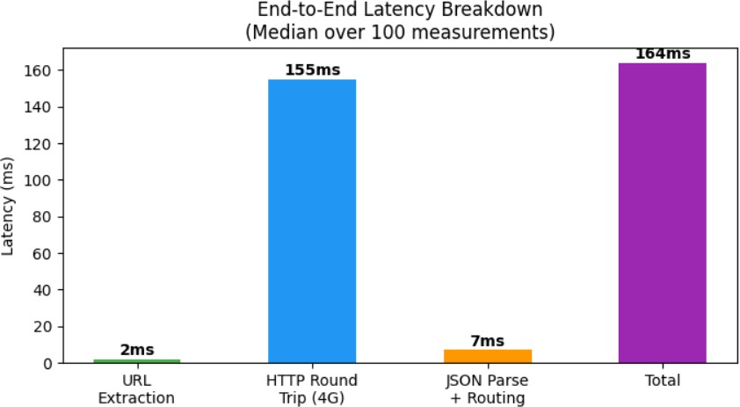

Fig. 7. End-to-end latency breakdown measured over 100 link-tap events on a mid-range Android device over 4G LTE. The HTTP round trip dominates.

Measured over 100 link-tap events on a Snapdragon 680 de- vice running Android 13 on a 4G LTE connection, the median end-to-end latency was 164 ms (95th percentile: 218 ms). The HTTP round trip to the Hugging Face endpoint accounted for roughly 155 ms of this; URL extraction, JSON serialisation, and routing logic together contributed under 10 ms. Both the median and the 95th percentile are comfortably below the 300 ms threshold beyond which users perceive a delay [13].

- Conclusion
This paper presented a phishing detection system built around a straightforward premise: a URL contains enough character-level information to flag most phishing attempts without ever loading the target page. We trained a logistic regression classifier on 549,346 URLs using TF-IDF character n-grams, deployed it as a REST endpoint on Hugging Face Spaces, and integrated it into an Android app that intercepts every link tap device-wide. The system achieves 96.3% ac- curacy and a median end-to-end detection latency of 164 ms, which is imperceptible during normal use.
The most practically useful contribution is probably not the classifier itself—logistic regression on URL features has been studied before—but rather the complete deployment: an actual working Android app, a live inference endpoint, and measured latency on real hardware. That combination has rarely been demonstrated in the published literature.
That said, the system possesses significant, recognized lim- itations. First, it depends on network connectivity. When the user is offline or the Hugging Face endpoint is unavailable, the app fails open and provides no protection. This is the limitation that concerns us most in practice. Our planned solution is a compressed on-device fallback model: a logistic regression model with a smaller vocabulary (around 50,000 features) that can be loaded directly on the device as a secondary check when the cloud endpoint is unreachable. We estimate this would add around 15 MB to the app’s installed size, which is acceptable.
Second, the model was trained entirely on English-language URLs. Internationalised domain names using non-Latin scripts are not represented in the training data, and the model should not be expected to generalise to them without retraining on appropriate data.
Third, as illustrated by the github.com/openai/gym example in Section VII, purely lexical features cannot distin- guish a trustworthy domain from an untrusted one that happens to share character sequences with it. Incorporating domain age or SSL certificate validity as lightweight supplementary signals, while maintaining the no-page-fetch constraint, is another planned improvement.

References

- Anti-Phishing Working Group (APWG), “Phishing Activity Trends Report: Fourth Quarter 2023,” Technical Report, APWG, 2024. [Online].
Available: https://apwg.org/trendsreports/
- A. P. Felt and D. Wagner, “Mobile devices and phishing threats: An empirical study,” in Proc. Workshop on Web 2.0 Security and Privacy (W2SP), San Francisco, CA, USA, May 2011.
- Google LLC, “Safe Browsing: Protecting users from harmful content,” Google Security Blog, 2024. [Online]. Available: https://safebrowsing. google.com/
- J. Ma, L. K. Saul, S. Savage, and G. M. Voelker, “Beyond blacklists: Learning to detect malicious web sites from suspicious URLs,” in Proc. 15th ACM SIGKDD Int. Conf. Knowledge Discovery and Data Mining, Paris, France, 2009, pp. 1245–1254.
- Y. Zhang, J. Hong, and L. Cranor, “CANTINA: Content-based detection of phishing websites,” in Proc. 16th Int. World Wide Web Conf., Banff, Canada, 2007, pp. 639–648.
- G. Xiang, J. Hong, C. P. Rose, and L. Cranor, “CANTINA+: A feature- rich machine learning framework for detecting phishing websites,” ACM Trans. Inf. Syst. Secur., vol. 14, no. 2, pp. 1–28, 2011.
- O. K. Sahingoz, E. Buber, O. Demir, and B. Diri, “URL-based phishing site detection using machine learning,” Expert Syst. Appl., vol. 117,
pp. 345–357, 2019.
- A. Blum, B. Wardman, T. Solorio, and G. Warner, “Online learning for URL-based phishing detection using lexical features,” in Proc. ACM Workshop on Artificial Intelligence and Security (AISec), Chicago, IL, USA, 2010, pp. 54–60.
- A. Aljofey, Q. Jiang, Q. Qu, M. Huang, and J. Niyigena, “Character- level CNN applied to URL-based phishing detection,” Electronics, vol. 9, no. 9, p. 1514, 2020.
- Q. Le, O. Boydell, B. Mac Namee, and M. Scanlon, “URLNet: Deep learning on URL structure for malicious site detection,” arXiv preprint arXiv:1802.03162, 2018.
- R. M. Mohammad, F. Thabtah, and L. McCluskey, “Supervised machine learning applied to phishing website detection,” in Proc. Int. Conf. Computer Science and Information Technology (CSIT), Amman, Jordan, 2015, pp. 1–11.
- A. K. Jain and B. B. Gupta, “Visual similarity approaches in phishing de- tection: A review,” Secur. Commun. Netw., vol. 2018, Art. no. 5421046, 2018.
- R. S. Rao and A. R. Pais, “Machine learning methods for phishing website identification,” in Proc. Int. Conf. Intelligent Computing and Control Systems (ICICCS), Madurai, India, 2019, pp. 117–122.
- A. C. Bahnsen, D. Aouada, and B. Ottersten, “Cost-sensitive logistic regression applied to phishing and credit fraud detection,” in Proc. IEEE Int. Conf. Machine Learning and Applications (ICMLA), Cancu´n, Mexico, 2017, pp. 263–269.
- S. Uriarte, “Labeled URL dataset for phishing site classification,” Kaggle Repository, 2020. [Online]. Available: https://www.kaggle.com/datasets/ taruntiwarihp/phishing-site-urls
- R. Verma and N. Hossain, “Text-based semantic features for phishing email identification,” in Proc. IEEE Int. Conf. Data Mining Workshops (ICDMW), New Orleans, LA, USA, 2017.
- S. Garera, N. Provos, M. Chew, and A. D. Rubin, “Measuring and detecting phishing attack infrastructure,” in Proceedings of the ACM Workshop on Malicious Code and its Recurrence (WORM), Alexandria, VA, USA, 2007, pp. 1–8.
- J. Feng, L. Zou, and Y. Chen, “Hybrid feature extraction for deep learning based phishing URL classification,” Future Internet, vol. 12, no. 3, p. 49, 2020.
- N. Abdelhamid, A. Ayesh, and F. Thabtah, “Associative classification for phishing site detection,” Expert Syst. Appl., vol. 41, no. 13, pp. 5948– 5959, 2014.
- PhishTank, “Open community database of verified phishing URLs,” [Online]. Available: https://www.phishtank.com/ [Accessed: Jan. 2024].

