1

Hidden Markov Model and Future Prediction of Stock Market

Abstract- Stock market is a dynamic and volatile in nature where accurately forecasting prices of shares for future return is challenging. Tackling this complexity, sophisticated statistical models such as Hidden Markov Models (HMMs) have surfaced which are quite handy in predicting future stock price patterns using its historical data. HMM is ideal in case of partially observable system, extracts hidden patterns among stock price fluctuations. The research paper finds its application by analyzing historical data (like opening and closing price, fractional price difference or intraday highs and lows) for predicting stock market prices in the future. Metrics like MAPE, RMSE, and DPA are used to evaluate the performance of this HMM model, with an aim to predict not only the magnitude but also the direction of stock prices changes. The study also provides empirical evidence supporting that HMMs are effective in stock price forecasting, which helps traders and investors to make more accurate decision. The paper also confirms that HMM scaling over the stock dataset for the other predictions across multiple stocks is possible and makes a step towards providing a generic technique for future analysis of the stock market.
Keywords: Hidden Markov Models, Stock Market Prediction, Time Series Forecasting, Mean Absolute Percentage Error (MAPE), Directional Prediction Accuracy (DPA), Root Mean Squared Error (RMSE).

- Introduction
PREDICTION of the stock market has been an area that has captivated the interest of institutional investors, hedge funds and proprietary trading firms for decades; markets are volatile and in the financial world there is always a figure out to predict a way to make a fortune or otherwise beat it. These advanced market players are looking to predict future price action and overall trend health in hopes of providing themselves similar predictive and edge while increasing profits from their investment.
Institutional investors include organizations such as pension funds and insurance companies which manage the large pool of money on behalf of their clients/beneficiaries. Some of these investors are pensions funds who needs to ensure that they pay their current staff and retiring employees now and in 10 years — while meeting other obligations like social security, payroll, etc. The stock market is predictable so they can target more optimal opportunities and reduce exposure to risks, likely resulting in better outcomes for their managed portfolio thus fulfilling their fiduciary duties [1].
On the other hand, hedge funds are simply private invest-ment partnerships which pool funds from accredited investors. Hedge fund managers look to deliver substantial returns on average, often regardless of market trends through combining varied investment processes. True to be told, accurate prediction is the base for hedge funds to spot and exploit mispriced securities or market inefficiencies among other trading strategies that attract investors and piles in huge profit [2].
These savant market participants employ a gamut of quanti-tative and qualitative methodologies to come up with forecasts in the stock market.
Algorithmic trading strategies use computer algorithms which analyze a lot of market data, identify patterns and generate trade signals. Most automated trading systems are designed to trade automatically, the trader having implemented very complex algorithms to use mathematical and statistical techniques. By now, U.S. stock trading volume from algorithmic trading represents an estimated 50% [3].
Algorithmic trading has advantages as it can provide access to data and execute trades quickly, especially for institutional traders but this doesn’t take the discretion out of investors altogether. Algorithmic trading is frequently presumed to be successful as a result of deep research, good infrastructure, and significant resources that might not be easily accessible by the average individual retail investor. Additionally, markets can change quickly, which leaves algorithms unable to perform or potentially making the loss much larger. Algorithmic trading is also perhaps riskier for retail investors who do not have the pockets and risk analysis and management skills of institutions.
There emerged several tactics for algorithmic trading over the years. Hidden Markov Models (HMMs) have come up as a strong tool in the prediction of time series data, and we want to apply them here as well, so they are ideal choice for such problems where stock market is to be predicted.

- Literature Review
Aditya Gupta and Bhuwan Dhingra in [4] used a method to predict the next day’s Close using Hidden Markov Model. Stocks of four different companies viz. TATA Steel, Apple Inc., IBM Corporation and Dell Inc. Were taken into consideration. The input parameters were Open, Close, High and Low. The model for one stock was assumed to be independent of other stocks. The model was first trained for a period of 7 months. The model was tested using MAPE values.

Abhishek, Khairwa, Pratap and Prakash in [5] predicted the stock rate using feed forward architecture. The stocks of Microsoft Corporation of the year 2011 were used. The parameters such as Open, High, Low, Adjacent Close and Volume were considered. Next day’s Close value was
predicted using back propagation with multilayer feed forward network. Mean Squared Error (MSE) was used to check for the accuracy of the proposed system. The author also presented a literature review on application of neural network to predict stock markets.

Luo, Wu, Yan in [6] presented a novel method for the study of Shanghai Stock Exchange (SSE) index time series based on SVM regression combination model (SVR-CM) linear regression with nonlinear regression. Linear regression was used to extract linear features while NN algorithms were used to extract nonlinear features. Finally, SVM regression was used to combine all output results. Mean Absolute Percentage Error (MAPE), Root Mean Square Error (RMSE), Trend Accuracy were used to indicate the effectiveness of the proposed system. SVM-CM was found to have good learning ability and forecasting capability.

Wang and Leu in [7] developed a prediction system useful in forecasting mid-term price trend in Taiwan stock exchange weighted stock index (TSEWSI). The system was based on a recurrent neural network trained by using features extracted from Auto Regressive Integrated Moving Average (ARIMA). The input is same as the standard input given to ARIMA while the output approximates conditional mean predictor. Features were operated using difference operator. The accuracy was found good for six weeks when the training data was taken for 3 years and the testing data for 3 months.

Akinwale adio T, Arogundade O.T and Adekoya Adebayo F in [8] examined the use of error back propagation and regression analysis to predict the untranslated and translated Nigeria Stock Market Price (NSMP). The author used 5-j-1 network topology to adopt the five input variables. The j variables in network determined the number of hidden neurons needed. The translated and untranslated statements were analysed and compared. The accuracy of translated NSMP was better than untranslated NSMP.

Wang, Liu and Dou in [9] presented the first work which shows a service-oriented approach to facilitate the incorporation of multiple factors in stock market volatility prediction. Multi kernel learning approach was used. The system was a two-tier architecture. The top tier was dedicated to preparing the datasets from multiple information while the second tier was dedicated to the market volatility analysis and prediction. The accuracy of the prediction was obtained by checking whether the direction of the predicted volatility and actual trend are the same. The output is either up or down.

Naeini, Taremian and Hashemi in [10] used two methods to predict feed forward multi-layer perceptron and Elman recurrent network. Model based on MLP NN for Tehran Stock Exchange (TSE) was developed to predict next day’s stock based on history without the knowledge of current market. Error percentage was around 1.5%. Main factors in the model were number of layers, neurons and connections, activation function in each neuron and training
algorithm. The input parameters were Lowest, Highest, Average value in d days. Mean Absolute Deviation, Mean Absolute Percentage Error, Mean Squared Error, Root Mean Squared Error were used as the criteria for evaluation. Elman was found to be better than MLP, but it suffered greater errors.

Li and Liu in [11] determined network structure and prediction precision. The sample data was divided into training and testing data. The network was trained in order to fix study sample time order as much as possible. Testing sample data was used to test the trained network. The network giving satisfactory result was used for prediction. Weekly closing price from Shanghai Stock Exchange Centre was used as the dataset. The data was treated by sampling standard, sampling normalization, number of nodes in hidden layer and LM algorithm to modify weight value and threshold.

Schierholt and Dagli in [12] focused mainly on maximizing the performance of portfolios rather than maximizing the percentage of correct decisions. The dataset used was 400 patterns of Standard and Poor's (SNP) 500 index. Only the Closing values were considered. One of three outputs namely buy, sell or keep the current status was given. The two models used were MLP with back propagation and probabilistic NN. MLP worked in static environment with separate training and testing phases whereas probabilistic NN performed better in all the cases.

Hassan and Nath in [13] used Hidden Markov Model to locate patterns from past data sets that matched the current day’s stock price behavior. These two data sets were then interpolated with appropriate neighboring price elements. λ = (A, B, π) was the overall HMM model, where A is the transition matrix consisting of transition probabilities from state i to state j. B is the observation emission matrix and π is the prior probability matrix. Forward backward algorithm was used to compute the probability of occurrence of observation sequence. Viterbi algorithm was used to choose state sequence best explaining the observations. Baum Welch algorithm was used to train HMM. Input features were Open, Close, High, Low. The next day’s closing value of the respective stock was given as the output.

Xiang and Fu in [14] predicted the stock market using multiple models. In this study the S&P 500 return rates are predicted instead of the index as the return rates are more stationery over time. The novel and significant part of this work is in the use of each NN to model a particular trend which are Bear, Choppy and Bull market trends. A second significance of the work is that an attempt is made at evaluating the trading performance considering commission costs which are important when predictions on higher frequency data are made. The model outputs next day’s closing value. The metrics used for performance evaluation are Directional Accuracy and Annual Return rate. The 3 NN system is more consistent in getting better performance than other systems.

- Techniques
- Markov Chains
Everything is a Markov chain! For the purposes of our dis-cussion, we will be considering first-order Markov chains that
satisfy this property. Assume that S = {S₁, S₂, ..., S_{n}} is the set of all possible states and X = {X_{k} | X_{k} ∈ S, k = 1, ..., T} be the time series of states. Now, we also know that the Markov property is: For any k ≥ 0 and any states X₀. . . , X_{k}:
Models (HMMs), which upgrade our elementary Markov chain model by incorporating hidden states we cannot see that in turn affect the observed data.

Layer-wise the hidden state process of a HMM is a Markov chain, and within each state observation are generated where each class of observations has its own probability distribution that more often than not only depends on the class.

P (X_{k+1} = S_{j} | X_{k} = S_{i}, X_{k−1}, ..., X₀
= P (X_{k+1} = S_{j} | X_{k} = S_{i})

(1)
At a high level, we can say O = {O_{k} | O_{k} ∈ O, k = 1, ..., T}, where O is the set of all possible observations. These hidden states evolve according to Equation 2.

That is, the probability of smoothly transitioning to a certain state S_{j} at time step k + 1 depends solely on the current state S_{i} at time step k and not on any earlier states. This is why the probability distribution of the Markov chain at any future time step can be completely determined by its current state. You can formally define a first order Markov chain by giving the set of states S and a transition probability matrix A = [a_{ij}],(with a_{ij} represents the possibility to transit from state S_{i} to state S_{j} in one step).

The probability of symbol o ∈ O being emitted by state S_{i} is captured by the emission probability function b_{i} : o 7→ b_{i}(o) ∈ [0, 1], ∀_{i}.
We will use emission probability matrix B = {b_{ij} = b_{i}(o_{j})}
both in the current and subsequent sections.

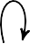
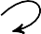
a11
S₁
a21
a12
S₂
b12
b11
b22
b21
o₁
o₂

a11
a22

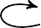
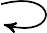
a33
S₁
a21
S₂
a23
a32
a13
S₃

Fig. 1: Example of a Markov Chain with three states.

The transition matrix at each time should follow the standard stochastic conditions:
- 0 ≤ a_{ij} ≤ 1 ∀_{i}, j.
- I:

Fig. 2: Hidden Markov Chain Example with two states and two possible outputs.

C. Applications of HMMs: Common Problems and Solutions
Three main problems that are typically solved with HMMs

Σ
n
k=1
a_{ij} = 1 ∀_{i}.
are evaluation, decoding, and parameter estimation. The liter-ature has broad related research on these problems and their

Let x_{k} ∈ R^{n} be the vector of state probabilities at time k, then the system evolves according to:
solutions [15]. We provide a summary of these issues and their fixes in the subsequent paragraphs.
- Evaluation Problem: The evaluation problem in HMMs is the probability of having a specific observation sequence

T
x
k+1
= x^{T} A (2)
based on the model. That is, for a hidden Markov model

The starting set of state probabilities is referred to as π =
k
{π₁, π₂...π_{n}}.

- Hidden Markov Models
The above formulation implicitly assumes that every state is observable (although that could be made more concrete) and hence each event can be mapped to some state. Markov chains are ubiquitous in modeling sequence data across different fields. Unsurprisingly, however, the world is full of hidden states that drive the observations but are not observed directly. This shortcoming gave birth to Hidden Markov
with state transition parameters π, A, and output obser-vation probabilities B, on input an observation sequence O, we want to compute P (O | π, A, B).
The way of solving this is to calculate its forward variable
α_{k}(i), which is the probability of being in state S_{i} at timek and observing till time k (sequence up to time k observe ), calculated from the recursively on each time step k and state S_{i} .
At the initialization stage, the forward variable for the first time step,k = 1, is calculated as: α₁(i) = π_{i}b_{i}(O₁), ∀_{i} where π_{i} is the initial probability of being in state S_{i} and b_{i}(O₁) is the emission probability for observation O₁.

At every subsequent time step k > 1, α_{k}(i) is calculated as the total probability of all paths that could have generated the observation up to time k and transition onto state S_{i} at this time. This can be expressed with the following equation:
and up to some maximal time). This backward variable is recursively calculated for each time step kand state S_{i}. In the initialization step, the backward variable for the last time step is β_{T} (i) = 1, ∀i.
At every time step k < T , we calculate the backward
variable β (i) in the following manner that models a sum

n
L

α_{k}(i) = α

j=1

k−1

(j)a
ji i k i
 b (O ), ∀

(3)
k
of probabilities of all paths possible from state S_{i} at time
k to the end. That looks like this:
n
L

The algorithm solves this problem by calculating the forward variables once again, however, now for each possible time step, hence evaluating the probability of observing whole sequence based on the HMM parame-ters.
Finally, in our case to get the total probability of observ-ing a sequence we sum up over all possible states i at time t = T .
P (O | π, A, B) = L α_{T} (i) (4)
n
β_{k}(i) = β_{k+1}(j).a_{ij}.b_{j}(O_{k+1}) (5)
j=1
The forward and backward variables are then used to adjust the parameters of the HMM given the observed sequence. Specifically, let ξ_{k}(i, j) be the probability of being in state S_{i} at time k and state S_{j} at time k + 1, given the model and the observation sequence. It can be computed as:

P (X_{k} = i, X_{k+1} = j, O | π, A, B)

i=1
I:
I:
ξ_{k}(i, j) =
P (O | π, A, B)

- The Decoding Problem: The decoding problem is deter-
α_{k}(i).a_{ij}.b_{j}(O_{k+1}).β_{k+1}(j)

mining the most likely sequence of hidden states given an observation sequence and a Hidden Markov Model. In
= _{n}
r=1
n h=1
α_{k}(r).a_{rh}
.b_{h}
(Ok+1
).β

k+1
(6)
(h)

other words, we are interested in finding the hidden state sequence X which maximizes P (X | O, π, A, B), where Given an HMM with the parameters π, A, and B, and an observed sequence O.
The decoding problem is usually solved with the Viterbi algorithm.
At each time step, the algorithm iteratively computes the
Define now γ_{k}(i) as the probability of being in state S_{i} at time k, condition to the observation sequence and the model:

γ_{k}(i) = P (X_{k} = i | O, π, A, B)
α_{k}(i).β_{k}(i)

paths to each state by leveraging both current observation
= I:_{n}
(7)
α (j).β (j)

and previous states probabilities.
It calculates the probability of being in every state at a particular time step and, additionally, keeps track of the most likely path to that state.
- Parameter Estimation Problem:Also Fitting the model parameters such that the probability of the observed sequence is maximum. For a given observed sequence O, we like to estimate the best values for parameters π, A,
and B, that would maximize P (X | O, π, A, B).
The solution to the this problem is usually solved using
the forward-backward algorithm(else Baum-Welch).
Baum-Welch algorithm maximum likelihood solution based on Expectation–Maximization (or EM) tailored for a HMM. It does so by carrying out 3 main steps: Forward, Backward and Update Step. The forward step, where the algorithm calculates the likelihood of each state at every time given everything observed until that point. Previously we described this as the evaluation problem. The backward step computes the probability of observing the remaining part of the sequence from each possible
j=1 k k
We can relate those quantities:
n
L
γ_{k}(i) = ξ_{k}(i, j) (8)
j=1
I: k
In which ^{T} ⁻¹ γ (i) stands for the transition count from the state S_{i} and ^{T} ⁻¹ ξ_{k}(i, j) stands for the transition count from S_{i} to S_{j}.
k=1
k=1
I:
The second is the update step, which gives new values to initial state probabilities, transition probabilities and emission prob abilities. Initial State Probabilities:Updated values are normalize forward-backward probabilities at first time step.

π_{i} = γ₁(i) (9)
The transition probabilities are reweighted by the average number of times you expect to see each event and ( interestlingly) each state in the indices for those elements.
I:T−1 ξ_{k}(i.j)
I:T−1 γ_{k}(i)

state at each time step. The backward procedure com-plements for the forward procedure in calculating what
aij = k=1
k=1
(10)

is known as the backward variable, denoted β_{k}(i), that represents the probability of being in state S_{i} at time k and observing the rest of the sequence (since time k + 1
To estimate the emission probability b_{j}(o) –the proba-bility of observing symbol o from state S_{j} we evaluate how many times are expected to o be emitted from state

j normalizing by how many transitions are expected to
j:
TABLE I: Number of Discrete Points Each Dimension

I:_{T}
b (o) = ^{k=1}
(γ_{k}.δ(O_{k}, o))

j T
I:
(11)
Variable | Number of Point
fracChange | n_{fC} = 50
fracHigh | n_{fH} = 50
fracLow | n_{fL} = 50

k=1
γ_{k}(j)

whereδ(O_{k}, o) is a Kronecker delta function given by 1 if O_{k} = o, and 0 otherwise.
The parameters of the model are trained through this pro-cess until they cannot be revised further (convergence), what leads to a maximum likelihood of the sequence.
Carefully selecting the initial conditions is paramount, as it can have an important influence on the estimation of the HMM parameters.
The Baum-Welch algorithm, however, is more likely to converge on some set of parameters that accurately model the underlying dynamics so long as proper initial conditions are chosen.

D. Gaussian Mixture Models
Gaussian Mixture Models (GMMs) are useful for building complex probability distributions.The components of a GMM are weighted sums of multiple Gaussian distributions, each of which represents a subpopulation within the data.
Multivariate mixture models use GMMs as multivariate data. In a GMM, each Gaussian component corresponds to a multivariate distribution with its own mean vector and covari-ance matrix. The probability density function of a multivariate GMM is:
K
p(y) = L c N (y | µ , Σ ) (12)
i
i
i
i=1
values representing the fractional change, fractional high, and fractional low for the day.
O = Close − Open, High − Open, Open − Low )
k
Open
Open
Open
O_{k} = (fracChange, fracHigh, fracLow)
(13)
The three dimensional array O_{k} is a matrix of actual values. Since the probability of guessing any actual value is mathematically zero, some discretization of the observations was necessary. The number of points used for the discretization are summarized in Table I.
We use dynamic edges for discretization. For every train we are calculating the max and min of fracChange, fracHigh and fracLow. Then for the edges we will create three linearly spaced vectors using min as the lowest values and max values. Lastly, we assign its index in the edges array to every discrete value.
Moreover, compatibility with our monovariate Hidden In the case of Markov Model, it mapped the three-dimensional space to one-dimensional space. Enumerations of mappings were carried out according to Equation 14 that had described the points in the discrete set of three-dimensional space. As an inverse mapping, Equations 15 have been used:

C_{i} is the weight of the i-th component, and N (y | µ_{i}, Σ_{i}
is a normal distribution with mean vector µ_{i} and covariance
n = (z − 1).(x_{max}.y_{max}) + (y − 1).x_{max} + x (14)

matrix Σ_{i}.
The weights C_{i} satisfies the constraint I:K
i=1

C_{i} = 1 denot-
n − 1
z = ⌊
xmax.ymax
⌋ + 1

ing that the probabilities sum to one. These weights define the strength of each Gaussian component in the distribution
Since GMMs can effectively capture the structure and heterogeneity in multivariate data containing multiple modes or clusters, modeling such complex structures are a key area of application for them. Hidden Markov Models use GMMs to initialize emission probabilities of hidden states. Building the GMM is done by fitting to our training dataset: the traininig algorithm will estimate the parameters of each Gaussian component, namely mean vectors and covariance matrices. These parameters are used to initialize the emission probabilities for each of those hidden states.

- Technical Implementation
In our experiment, we used the following three functions from the Statistics and Machine Learning Toolbox^{T} ^{M} in MATLAB to train and test the HMM: hmmtrain,hmmdecode and fitgmdist.
We train and test the model on freely available on the web historic daily prices of Apple, IBM, and Dell stocks. Each observation in our dataset consists of three different
y = ⌊ n − 1 − (z − 1).x_{max}.y_{max} ⌋ + 1
xmax
x = (n − 1)mod(x_{max}) + 1 (15)

- Training
In the first trains, we used four latent hidden states under-neath from which each of them outputs in the form of a GMM having four components. We re-trained our model with varying values. The relevant parameters for each train can be checked on our GitHub repository [16]. The parameters of these GMMs were estimated through the MATLAB function fitgmdist, optimizing the model along the EM algorithm. Parameters of
GMM are first learned by the means of k − means clustering. We assumed the outcome probability density function as
our initial state of the emission matrix. On the other hand, for transition matrix, we establish an initial estimation based on uniform distribution of probabilities.
The training data of HMMs are based on capitalizing on a rolling window method. Here, every observation sequence is the same, fixed at 10 days long. We will call this length latency. As it runs, the window moves incrementally over

the training period: the first sequence takes snapshots of observations at the beginning point, and for every subsequent sequence It displays new observations by advancing the win-dow one day. The vector now reads all of the data set into the MATLAB function, hmmtrain. This function applies the Baum-Welch algorithm in order to estimate the transition and emissions matrices. As discussed above, the initial guesses used to initialise these estimations were.

- Prediction
After the training, we conducted testing of our model for prediction of closing stock prices over various time horizons during the prediction period. The procedure for prediction for day d was the following:
- We accounted for the last latency − 1 = 9 observations available. Such observations preceded the following 9 days.
- Then we added each possible output for the current day d, constructing a sequence of 10 days. The sequence now has the 9 historical observations as well as one possible observation for the next day. There are n_{fc}.n_{fH}.n_{fL} possibilities for the current day.
- We calculated the probabilities for each of the sequences
to be developed by our supervised model. Finally, we selected select the observation with the greatest emission
TABLE II: Comparison Of Mean Absolute Percentage Error

Stock  Name | Our  HMM | HMM-  MAP [18] | HMM + Fuzzy  Model [17] | ARIMA  ANN
Apple  Inc. | 1.50 | 1.51 | 1.77 | 1.80
IBM  Corp. | 0.68 | 0.61 | 0.78 | 0.97
TABLE III: Directional Predictional Accuracy

Stock Name | MAPE | DPA | Training | Testing
Apple Inc. | 1.50% | 52.11% | 2003-02-10  2004-09-10 | 2004-09-13  2005-01-21
 | 1.73% | 63.27% | 2003-02-10  2004-09-10 | 2004-10-13  2005-01-21
 | 1.05% | 53.06% | 2021-01-04  2022-01-03 | 2023-01-03  2023-06-30
 | 1.01% | 40.57% | 2017-01-03  2019-01-03 | 2023-01-03  2023-06-30

to forecast consecutively. Knowing that we are most likely able to predict if the value of the stock is going up or coming down throughout the day, we developed a new metric for its measurement called Directional Prediction Accuracy or DPA. DPA gives the percentage of correct directional predictions thus giving some precious information about how accurate our model is.
np
L

probability as an observation for the day.
In some cases, this probability of emitting historical obser-
DPA = 1 δ (sgn(p
n i
i=1
p
− s_{i}), sgn(c_{i}
− s_{i})) .100% (17)

vations together with a hypothetical observation becomes 0 or close to 0. This may either be due to true circumstances or some constraint on the model. However, we see improvements in our model in the dynamicwindow.
We have modified the prediction to address the issue algorithm: Based on the best probability achieved, if it is 0, we invoke the prediction algorithm again with reduced latency step by step, one day at a time, since decreasing latency enhances the chances of getting a feasible solution with emitted probabilities positive and keep reducing latency in such a way that we have some solution; also the historical sequence should be as long as possible. Thus, for our example we have determined that the historical series must include at least four days.
- Results
We had several metrics to evaluate the performance of our models. Mean Absolute Percentage Error, or MAPE, is Using the closing stock prices between the actual and predicted values.
np
In Equation 17, n_{p} is the number of predictions, δ is the Kronecker delta function, p_{i} is the predicted stock closing price, c_{i} the actual closing price, and s_{i} the stock opening price. Table III emphasizes how MAPE and DPA do not measure equivalent quantities since, generally, they are not correlated.
Testing period 2004-10-13 to 2005-01-21 The dots represent the actual closing prices of the day. As long as they are green, the dots contribute towards DPA. Only then do the dots contribute towards the MAPE when they turn close to the actual closing value of the day.

- Conclusions and Further Developments
We implemented the full version of the originally proposed stock prediction hidden Markov model by Gupta et al. [18]. We searched for some insight into its performance over

Fig. 3: Actual Stock Price for Training Data

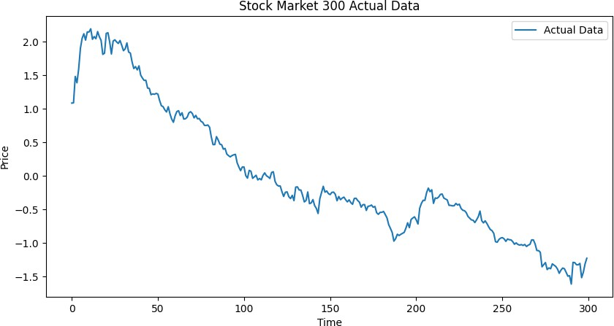
MAPE = 1 L | Pi − ci | .100% (16)
n_{p}
| c_{i} |
i=1
The forecasted stock close price, p_{i} is acquired on day i, where n_{p} is the total number of predictions and c_{i}the actual closing price of the stock.Table II Comparing our results on two different stocks versus the results in other papers [17], [18].
This task is hard enough to forecast the direction in which the price of the stock will move for a day. The next day, ob-viously is much more complicated and sometimes impossible

Fig. 4: Stock Price for Testing Data
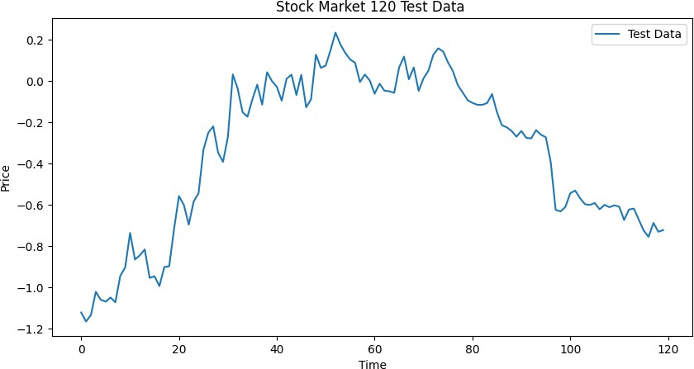

TABLE IV: Predicted Price

Close | Open | High | Low
318.40 | 288.31 | 285.99 | 309.30
301.18 | 283.68 | 307.41 | 289.79
309.61 | 326.11 | 311.03 | 300.55
264.89 | 252.28 | 248.97 | 239.36
249.60 | 235.094 | 261.78 | 256.76
251.65 | 241.58 | 247.82 | 286.90
229.90 | 255.17 | 257.16 | 236.43
249.81 | 253.55 | 286.17 | 273.11
246.66 | 271.95 | 214.93 | 263.56
264.24 | 262.08 | 263.90 | 242.35
254.62 | 269.63 | 283.37 | 266.43
232.56 | 267.02 | 291.67 | 245.41
252.29 | 259.58 | 273.75 | 273.90
228.03 | 250.36 | 240.65 | 270.44
270.99 | 264.20 | 247.24 | 235.72
259.93 | 268.75 | 262.77 | 234.08
258.83 | 227.99 | 250.33 | 243.66
261.37 | 261.43 | 263.01 | 268.95
258.92 | 249.32 | 195.89 | 260.90
257.46 | 267.89 | 265.90 | 224.12

Fig. 5: Comparison of Actual Open Price and Tested Open Price
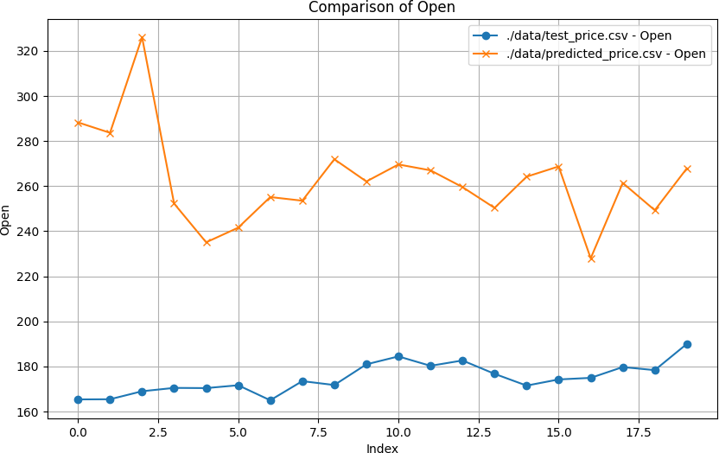
Fig. 6: Comparison of Actual Close Price and Tested Close Price
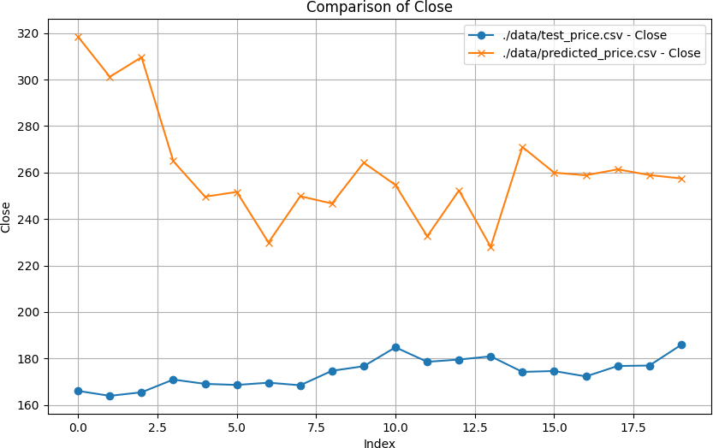

TABLE V: Test Price

Close | Open | High | Low
166.07 | 165.38 | 167.53 | 164.39
163.94 | 165.45 | 168.35 | 162.73
165.48 | 169 | 169.08 | 165.28
170.95 | 170.49 | 172.57 | 169.55
169.1 | 170.4 | 171.92 | 169.02
168.63 | 171.66 | 171.79 | 167
169.6 | 165 | 170.09 | 163.33
168.49 | 173.49 | 174.49 | 168.3
174.72 | 171.76 | 174.78 | 170.42
176.69 | 180.95 | 182.39 | 176.27
184.82 | 184.46 | 184.94 | 181.21
178.58 | 180.29 | 180.33 | 177.03
179.55 | 182.66 | 182.8 | 177.7
180.94 | 176.73 | 181.29 | 174.93
174.24 | 171.51 | 174.77 | 170.88
174.62 | 174.24 | 174.95 | 170.26
172.29 | 174.94 | 176.6 | 172.1
176.78 | 179.73 | 180.27 | 176.55
176.98 | 178.37 | 181.47 | 175.51
185.86 | 190 | 190.7 | 184.99

variant datasets while verifying the proper applicability in the scenario of stock market movement forecasting. After careful replication and extension of their approach, we have done an exhaustive evaluation with benchmark models to actually understand what kind of strength and weakness the model possesses.
Our model was trained on period of one to two.It can be verified using adaptability and reusability for the validation in terms of years and used for prediction at another timescale. Full source code along with characteristics of the pre-trained models are available at GitHub [16].
The proposed method was tested on several stocks, and the results were compared with those in HMM-MAP, HMM-Fuzzy, ARIMA, and ANN models. A complete hyperparam-eters exploration was conducted regarding its influence in achieving the optimal value. The
The outputs produced a much lower Mean Absolute Percent-age Error compared to the HMM-Fuzzy, ARIMA, and ANN models trained on the same years as those reported in [18] and [17]. Moreover, to get an even broader perspective of how well our model was performing, we created a new measure known as the Directional Prediction Accuracy, DPA. The DPA

allowed us not only know our accuracy in simulating real movements for the stock price but also provided an extremely useful method for measuring performance. We therefore advo-cate for the tuning of the Emission and Transmission matrices over the latest time window every day prior to the actual forecast. From that, we first proposed updating the matrices by training the base model on the historical data. Using data from a fairly more recent period before making
All predictions would depend on being calibrated by data from 2022-06-01 up to 2023-06-01 for the matrices in advance of making any prediction for 2023-06-02, for instance, to train the main model from 2021-01-01 up to 2023-01-01. This would capture recent market trends and better predictions. Conclusion: Our implementation of Stock Prediction HMM showed good prediction capability. Fine-tuning gives us sev-eral potential improvements in the future for predictions and is left to be ”warranted”. Further research to capitalize on recent market trends. Our work adds to the body of research on predicting stock markets, offering significant contributions to traders and financial analysts.

References
- “Institutional investors definition— nasdaq.”[Online].Available: https://www.nasdaq.com/glossary/i/institutional-investors
- “Investor bulletin: Hedge funds.” [Online]. Available: https://www.investor.gov/introduction-investing/investing-basics/investment-products/private-investment-funds/hedge-funds
- “Algo or algorithmic trading definition — nasdaq.” [Online]. Available: https://www.nasdaq.com/glossary/a/algo-trading
- Aditya Gupta and Bhuwan Dhingra, “Stock Market Prediction Using Hidden Markov Models”, IEEE 2012.
- Kumar Abhishek, Anshul Khairwa, Tej Pratap and Surya Prakash, “A stock market prediction model using artificial neural network”, ICC-CNT’12, 26th– 28th July 2012, Coimbatore, India.
- F.Luo, J. Wu and K. Yan, “A Novel Nonlinear Combination Model Based on Support Vector Machine for Stock Market Prediction”, Proc. Of the 8th World Congress on Intelligent Control and Automation, July 6-9 2010, Jinan, China.
- J.H.Wang and J.Y.Leu, ”stock market trend prediction using ARIMA-based neural network,”Proc. Of IEEE c onference on neural networks, volA, pp.2 160 -2 165, 1996
- Akinwale Adio T, Arogundade O.T and Adekoya Adebayo F, “ Translated Nigeria stock market price using artificial neural network for effective prediction. Journal of theoretical and Applied Information technology , 2009.
- F. Wang, L. Liu and C. Dou, “Stock Market Volatility Prediction: A Service-Oriented Multi-Kernel Learning Approach”, IEEE 9th Interna-tional Conference on Services Computing, 2012.
- M. Naeini, H. Taremian and H. Hashemi, “Stock Market Value Pre-diction Using Neural Networks”, International Conference on Computer Information Systems and Industrial Management Applications (CISIM) 2010
- F. Li and C. Liu, “Application Study of BP Neural Network on Stock Market Prediction”, 9th International Conference on Hybrid Intelligent Systems 2009.
- K. Schierholt and C. Dagli, “Stock Market Prediction Using Different Neural Network Classification Architecure”, Computational Intelligence for Financial Engineering 1996
- Md. Rafiul Hassan and Baikunth Nath, “Stock Market forecasting using Hidden Markov Model: A New Approach”, Proceeding of the 2005 5th international conference on intelligent Systems Design and Application 0-7695-2286-06/05, IEEE 2005.
- C. Xiang and W.M. Fu, “Predicting the Stock Market using Multiple Models”, ICARCV 2006
- Rabiner, L. R. (1989). A tutorial on hidden Markov models and selected applications in speech recognition. Proceedings of the IEEE, 77(2), 257-
286. https://doi.org/10.1109/5.18626
- (2023) valentinomario/HMM-stock-market-prediction. [Online]. Avail-able: https://github.com/valentinomario/HMM-Stock-Market-Prediction
- M. R. Hassan, “A combination of hidden markov model and fuzzy model for stock market forecasting,” Neurocomputing, vol. 72, no. 16,
pp. 3439–3446, 2009.
- A. Gupta and B. Dhingra, “Stock market prediction using hidden markov models,” in 2012 Students Conference on Engineering and Systems, 2012,
pp. 1–4.
- Baum, L. E.; Petrie, T.; Soules, G., Jr; Weiss, N. (1970). A maximization trick that happens when we get to the statistics of probabilistic functions on Markov chains. Annals of Mathematical Statistics, 41(1), 164–171. Association for Computing Machinery: https://doi. org/10. 1145/1665737 HagertyS., Kumar V., ShahC. · AIT uses C.; Several ISI Masters in Big Data →AOMS/http s:/ /d oi.or g/1 0.12 14 /aom s/1 17 76 97 (2019)
- Luigi Catello, Ludovica Ruggiero, Lucia Schiavone, and Mario Valentino, Hidden Markov Models for Stock Market Prediction, 5 October 2023.
- Bram de Wit,Supervisor: Prof. Dr. L.R.B. Schomaker, Stock prediction using a Hidden Markov Model versus a Long Short-Term Memory.
- Raihan Tanvir, Md Tanvir Rouf Shawon, Md. Golam Rabiul Alam:Ahsanullah University of Science and Technology, Dhaka, Bangladesh:Brac University, Dhaka, Bangladesh,DSE Stock Price Pre-diction using Hidden Markov Model, 26 January 2023.
- Ravindra Nath, Renu Jain, CONF IEEE Using randomized search algo-rithms to estimate HMM learning parameters, 2009 IEEE International Advance Computing Conference DOI: 10.1109/IADCC.2009.4808999
- Ravindra Nath Atmaprakash Singh Santosh Kumar,Peer reviewed open accessHandwritten English Character Recognition using HMM, Baum-Welch and Genetic Algorithm, 02-04 November, 03 January 2019 ISBN Information: INSPEC Accession Number: 18384376 DOI: 10.1109/UP-
CON.2018.8596954
- Jain Renu, Ravindra Nath,Proceedings of the Second Interna-tional Conference on Soft Computing for Problem Solving (SocProS 2012), December 28-30, 2012,Springer, New Delhi ISSN 2194-5357 https://doi.org/10.1007/978-81-322-1602-5₁
- Parameter Estimation of Hidden Markov Models (HMM) using Go With the Winner Algorithms, Ravindra Nath, Renu Jain - International Journal of Computer Applications, 2011

