PosePal: An AI-Powered Human Posture Tracking and Real-Time Alert System

ABSTRACT
Musculoskeletal discomfort caused by prolonged sitting and unmonitored poor posture habits has become a serious occupational health concern among university employees. Without any real-time corrective mechanism, postural deviations accumulate silently into chronic back pain, neck strain, and shoulder tension — conditions widely reported among faculty and staff at Pangasinan State University – Alaminos City Campus (PSU-ACC). Survey results further confirmed that 95% of employees experience posture-related discomfort, yet none had previously used a posture monitoring device, and 55% had no specific method to manage their sitting habits. This study developed PosePal: An AI-Powered Human Posture Tracking and Real-Time Alert System to address these persistent ergonomic challenges in an academic workplace setting. The system was built using Python, Dart, and JavaScript, integrating YOLOv11-Pose for real-time human detection and key point-based posture estimation, supported by Firebase as the cloud database. IP cameras serve as the primary input devices, continuously capturing body alignment for AI-based analysis without requiring any wearable equipment. To enhance accuracy, the system integrates multi-object tracking, face recognition, and a rule-based posture classifier with temporal validation. PosePal automatically detects improper sitting positions and instantly alerts users to correct their posture, while providing posture scoring, analytics reports, personalized recommendations, face recognition for secure identification, and an admin dashboard for institutional monitoring and management. The system was developed following Agile methodology and evaluated by 21 respondents comprising faculty, non-teaching staff, and an IT expert. Assessed against ISO/IEC 25010 quality standards, PosePal achieved an overall weighted mean of 4.19 (Excellent), confirming its effectiveness, reliability, and usability in promoting posture awareness and improving workplace wellness. The study concludes with recommendations to refine posture detection and alert mechanisms, continuously evaluate system accuracy and user satisfaction, and conduct further studies to expand system features and ensure PosePal remains adaptive and reliable across diverse real-world settings.
Index Terms - Artificial Intelligence, Computer Vision, Posture Estimation, Posture Detection, YOLO
INTRODUCTION
Proper posture refers to the correct alignment of body segments supported by balanced muscular effort against gravity. Maintaining an efficient and upright posture contributes significantly to musculoskeletal balance, spinal health, and mental clarity. Good posture enables optimal breathing, enhances blood circulation, reduces fatigue, and supports the natural curvature of the spine (Sharma & Rawat, 2023). Beyond its physiological benefits, upright positioning is also associated with increased alertness, improved focus, and positive emotional states, while slouched or forward-leaning postures are linked to fatigue, stress, and symptoms of anxiety and depression (Sharma & Rawat, 2023).
Despite these well-documented benefits, consistently maintaining proper posture in everyday settings presents a significant challenge. Many individuals are unaware of the subtle postural deviations that occur during routine tasks such as typing, reading, or using mobile devices. These micro-habits, when repeated over time, contribute to cumulative strain and long-term musculoskeletal damage, particularly in academic and professional environments where individuals maintain static positions for extended periods (Szczygiel et al., 2020). One increasingly prevalent condition is Text Neck Syndrome (TNS), a repetitive stress injury resulting from sustained head-down posture during handheld device use, now recognized as a public health concern linked to neck pain, headaches, reduced cervical mobility, and spinal degeneration (Tsantili et al., 2022). Musculoskeletal Disorders (MSDs) are likewise highly prevalent among school staff, particularly teachers who engage in prolonged standing, repetitive writing, and extended computer use, often resulting in shoulder tendinitis, disc prolapse, knee osteoarthritis, and carpal tunnel syndrome (Abdul Rahim et al., 2022).
Traditional ergonomic interventions such as adjustable furniture and posture training programs often lack real-time monitoring and personal adaptability. The emergence of Artificial Intelligence (AI) and computer vision technologies has opened new possibilities for continuous, non-invasive posture assessment in workplace and academic environments (Cheriyan et al., 2025). Incorrect sitting postures during extended computer use have been consistently linked to muscular imbalances, spinal misalignment, backaches, and eye strain, reinforcing the urgent need for automated monitoring solutions (Zaharuddin et al., 2025; Bassino et al., 2023). Improving the accuracy and precision of posture detection through AI has been shown to empower office workers to adopt healthier habits and significantly reduce the risk of developing musculoskeletal disorders (Bassino et al., 2023). Vision-based posture monitoring systems are particularly effective because they are non-invasive, eliminate the need for physical sensors, and preserve user comfort and privacy — making them highly suitable for institutional deployment (Pistolesi et al., 2024; Ota et al., 2020). Furthermore, systems that provide real-time posture feedback and clear corrective alerts are consistently perceived as more helpful and motivating, encouraging users to adjust their behavior accordingly (Mahomed et al., 2024; Sreevani et al., 2024). These findings collectively affirm the technical viability and occupational health value of deploying an AI-powered, camera-based posture monitoring system in an academic workplace setting.
A needs assessment conducted at PSU-ACC revealed that 95% of employees experience posture-related discomfort, with back pain, shoulder pain, and neck strain being the most commonly reported issues. Most staff members spend 3 to 8 hours daily seated at their desks, yet 55% had no specific method to manage their posture, and none had previously used a posture monitoring device. Although 90% reported awareness of proper posture practices, this knowledge had not translated into effective habit formation or prevention of physical strain.
To address these persistent concerns, this study developed PosePal, an AI-powered posture tracking and alert system designed to monitor body alignment in real time using IP cameras and computer vision algorithms. PosePal integrates AI-based posture analysis with user-centered design features, including personalized posture analytics, corrective alerts, and cloud-based data management, to provide continuous ergonomic support in academic workplace environments. The system was guided by the following objectives: (1) to assess the posture-related challenges experienced by PSU-ACC employees and identify factors influencing poor posture habits; (2) to identify the functional and non-functional requirements of the proposed system; (3) to identify appropriate machine learning algorithms for system development; and (4) to determine the acceptability of the proposed system among its intended users.
METHODOLOGY
This study employed a descriptive-developmental research design to systematically assess the posture-related challenges experienced by faculty and non-teaching staff at Pangasinan State University – Alaminos City Campus and to develop a technology-driven solution responsive to their identified needs. The descriptive component allowed the proponents to document respondents' posture habits, awareness levels, and openness to AI-based interventions through structured survey questionnaires, while the developmental component guided the design, construction, and evaluation of the proposed system. Agile methodology was adopted throughout the development process, enabling iterative refinement of system features based on continuous user feedback collected across multiple sprint cycles. Purposive sampling was utilized to select 21 respondents comprising 12 faculty members, 8 non-teaching staff, and 1 IT expert — all of whom regularly engage in prolonged desk-based computer work and were thus directly relevant to the study's objectives. While the sample size is acknowledged as a limitation of this preliminary deployment, purposive sampling is considered appropriate in system evaluation studies where respondents are selected based on direct relevance to the system's intended use context (Kumar et al., 2025; Cheriyan et al., 2025). Similar AI-based posture monitoring studies conducted in institutional settings have employed comparable respondent sizes during pilot evaluations, prioritizing contextual relevance and domain familiarity over statistical breadth. System acceptability was evaluated using a survey instrument adapted from the ISO/IEC 25010 software quality framework, with results interpreted through a five-point Likert scale. Table 1 presents the distribution of respondents.
Table 1. Respondents of the Study
Respondent | Number Of Respondents
Faculty | 12
Non-teaching Staff | 8
IT-expert | 1
Total | 21
The development of PosePal followed the Agile methodology, a modern software development approach that emphasizes iterative progress, flexibility, and continuous user collaboration. As illustrated in Figure 1, the Agile cycle consists of six phases — Plan, Design, Develop, Test, Deploy, and Review — each contributing to a progressively refined and user-centered system. This iterative structure allowed the development team to release functional components regularly, incorporate feedback after each sprint, and make swift adjustments to ensure the final system effectively addressed the real ergonomic needs of PSU-ACC employees.
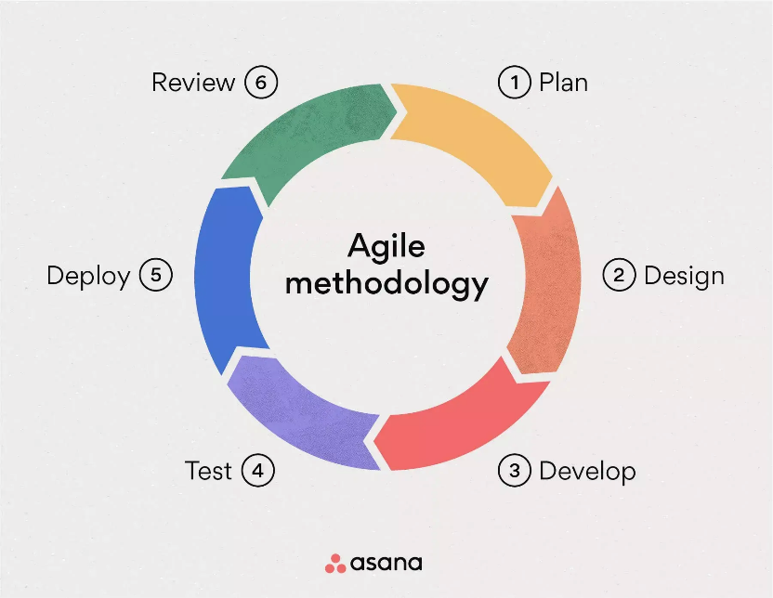
Figure 1. Agile Methodology
Source: https://asana.com/resources/agile-methodology
During the planning phase, key stakeholders including faculty, non-teaching staff, and the IT expert were engaged to define user stories, technical considerations, and the overall project scope. The design phase produced wireframes, UI mockups, and system architecture plans focused on accessibility and user-friendliness. The development phase utilized Python as the core backend language integrated with YOLO for real-time posture detection, while Dart and JavaScript were used for the mobile and web-facing components. Firebase served as the cloud database, managing user authentication, posture logs, and real-time data synchronization. IP cameras were deployed as the primary input devices, capturing live body alignment feeds for continuous AI-based analysis through a Three-Tier Architecture comprising the Presentation, Application, and Data layers.
The testing phase involved both unit and system-level evaluations, with errors and inconsistencies identified and resolved before deployment. PosePal was then deployed at PSU-ACC for pilot implementation, where users received orientation and hands-on training on its features. The review phase gathered user feedback from faculty and non-teaching staff, with observations used to refine alert mechanisms, interface design, and detection accuracy. System acceptability was evaluated using a structured survey instrument based on ISO/IEC 25010 quality standards, with responses analyzed through weighted mean calculations using a five-point Likert scale ranging from 1 (Poor) to 5 (Outstanding). Data gathered from this evaluation provided the empirical basis for determining the system's overall performance, usability, and readiness for institutional adoption.
RESULTS AND DISCUSSION
Employees of Pangasinan State University – Alaminos City Campus (PSU-ACC) are routinely exposed to prolonged sedentary work conditions, with faculty and non-teaching staff spending an average of three to eight hours seated during academic and administrative duties. The absence of ergonomic furniture, posture monitoring tools, and structured correction systems has allowed poor sitting habits to persist unnoticed, increasing the risk of chronic musculoskeletal disorders that compromise both physical health and workplace productivity. To address these occupational health concerns, PosePal was developed as an AI-powered posture monitoring system capable of detecting and alerting users of poor posture in real time. This section presents the findings related to the identified posture problems, the system's requirements and features, the machine learning pipeline developed, and the results of the acceptability evaluation conducted among PSU-ACC personnel.
Common Posture Issues and Contributing Factors Among PSU-ACC Employees
Employees of Pangasinan State University – Alaminos City Campus experience several posture-related difficulties that affect their comfort, health, and overall work productivity. Common complaints include lower back aches, shoulder tension, and neck stiffness — symptoms that result from improper sitting positions sustained over prolonged work periods.
Faculty and non-teaching staff typically spend three to eight hours seated during academic and administrative duties, a sedentary pattern that restricts physical movement, weakens core musculature, and limits blood circulation. Compounding this is the lack of ergonomic furniture, as many offices still rely on traditional chairs and tables that do not support the natural curvature of the body, forcing employees to adapt to their furniture rather than maintaining correct posture.
Despite general awareness of proper sitting habits, heavy workloads and demanding schedules cause many employees to revert to poor posture unconsciously. The complete absence of real-time monitoring tools, posture reminders, and ergonomic support allows these habits to persist unnoticed, increasing the risk of chronic musculoskeletal disorders that compromise both physical health and long-term work performance.
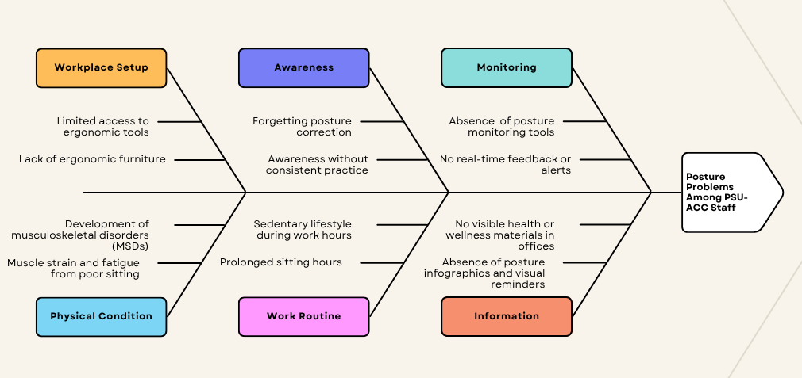
Figure 2. Fishbone Diagram of Contributing Factors to Poor Posture Among PSU-ACC Employees

Figure 2 presents a fishbone diagram that systematically illustrates the root causes of poor posture habits among PSU-ACC employees. The diagram organizes contributing factors into six categories: Workplace Setup, Awareness, Monitoring, Physical Condition, Work Routine, and Information. Each category highlights specific issues — such as the absence of ergonomic furniture, lack of posture monitoring tools, prolonged sitting hours, and absence of visual reminders — that converge to produce the central problem. This analysis served as the primary basis for determining the features and scope of PosePal.
The fishbone diagram confirms that poor posture is not caused by a single isolated factor, but rather results from an interplay of workplace conditions, individual behaviors, and institutional gaps. Identifying these root causes guided the design of PosePal's core features, ensuring the system directly addresses the most significant contributors to poor posture in the campus environment.
Functional and Non-Functional Requirements of PosePal
Based on surveys and interviews conducted with faculty staff, non-teaching staff, and an IT expert at PSU-ACC, the functional and non-functional requirements of PosePal were identified and implemented through a Three-Tier Architecture. This well-established software engineering model separates the system into three logical layers — Presentation, Application, and Data — each playing a distinct role in the flow of data, processing logic, and user interaction. Figure 2 illustrates this architecture.
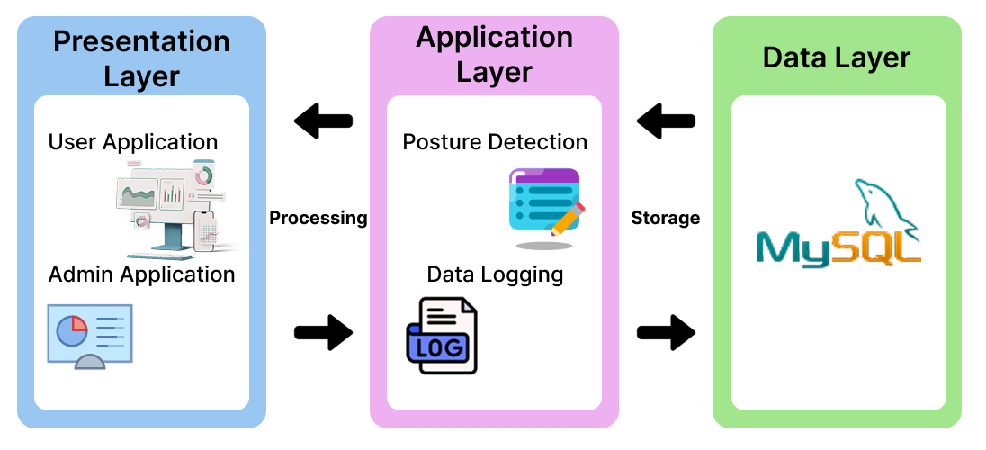

Figure 3. Three-Tier Architecture of the PosePal Posture Tracking System
The Presentation Tier delivers the user-facing interface through a dedicated mobile application for employees and a desktop admin panel for system administrators. The Application Tier, developed in Python, handles all core processing logic — including real-time posture detection, user identification through facial recognition, alert generation, and analytics computation. The Data Tier, powered by Firebase, manages persistent cloud storage, real-time data synchronization, and efficient retrieval across all connected devices. This separation of concerns ensures that each tier can be updated or scaled independently without disrupting the overall system, making PosePal both adaptable to future enhancements and resilient during periods of high usage. Together, these three tiers form a cohesive, scalable, and maintainable architecture that supports continuous and uninterrupted posture monitoring across the institution.
Table 2 summarizes the key functional and non-functional requirements of PosePal. The functional requirements define the essential tasks the system must perform, while the non-functional requirements establish the quality standards that govern how those tasks are carried out. These requirements were systematically derived from the identified needs of PSU-ACC employees and subsequently validated through the system acceptability evaluation presented in the final section of this discussion. Ensuring that both dimensions were clearly defined prior to development guided the design decisions made throughout the system and served as the benchmark against which PosePal's performance was ultimately measured.
Table 2. Summary of PosePal Functional and Non-Functional Requirements

Requirement | Description | System Implementation
User Authentication | Secure account creation and login linked to a unique user ID. | Firebase Authentication with cached session management.
Real-Time Posture Monitoring & Alerts | Continuous posture tracking via camera with instant push notifications upon detecting poor posture. | YOLOv11-Pose + geometric classifier; alerts triggered after 5-second persistence threshold.
Posture Scoring System | Quantifies posture behavior into a score (0–100) computed hourly, daily, weekly, and monthly. | Score inversely weighted by frequency and duration of bad posture episodes.
Analytics & Reports | Visual charts of posture trends and predictive score forecasting based on historical data. | Firebase-synced data rendered as graphs in the mobile app; exportable as CSV or PDF by admin.
Personalized Recommendations | Tailored posture tips, corrective exercises, and movement break reminders per user. | Recommendations prioritized by posture score level and data patterns.
Competitive Leaderboards | Weekly and monthly rankings to motivate users through peer comparison. | Rankings generated from aggregated posture scores stored in Firebase.
Face Registration & Recognition | Biometric user identification using three facial angle captures for accurate posture log attribution. | ArcFace (InsightFace) model; cosine similarity threshold of 0.50.
Admin Dashboard & Log Management | Real-time monitoring of system activity, posture logs, user accounts, and detection settings. | Desktop admin panel with filterable logs, live dashboard, and configurable detection parameters.
Non-Functional Requirements (ISO/IEC 25010)
Performance | Low-latency posture detection and real-time data updates. | GPU-accelerated inference (<30ms per frame); Firebase real-time synchronization.
Security | Protection of personal data and facial recognition profiles. | Firebase Authentication; encrypted data transmission and secure storage.
Reliability | Consistent uptime even during extended monitoring sessions. | Firebase cloud infrastructure with automatic scaling; 99.7% uptime achieved.
Usability & Portability | Accessible interface for users with varying technical skill levels across platforms. | Flutter-based mobile app and PyQt desktop application; intuitive navigation and clear UI.

The core functional feature of the system—real-time posture monitoring with instant alert delivery—is illustrated in Figure 4. This figure presents the Posture Scoring System, where the user’s daily posture behavior is quantified through a live circular score gauge. It is supplemented by key metrics, including episode count and total time spent in poor posture. Additionally, an active push notification banner alerts the user whenever poor posture is detected, enabling timely awareness and intervention.
Figure 4. Real-Time Monitoring and Alert Screen
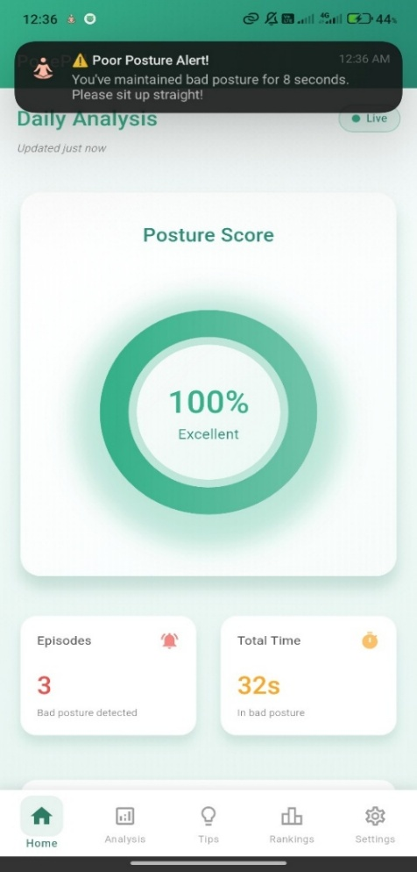
Figure 5, on the other hand, presents the in-app alert screen, which displays a real-time warning directly within the application interface. This feature prompts users to immediately correct their sitting position upon detection of improper posture. Together, these functionalities provide a direct and responsive solution to the posture monitoring gap identified among PSU-ACC employees.
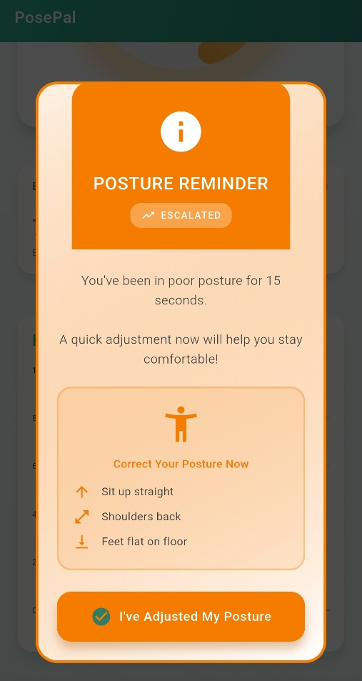
Figure 5. In-App Alert Screen
On the administrative side, Figure 6 presents the Admin Real-Time Dashboard, which provides supervisors with a live view of recognized users, active bad posture alerts, and system session uptime. This administrative layer enables institutional-level monitoring and data management, supporting the campus-wide deployment of PosePal.
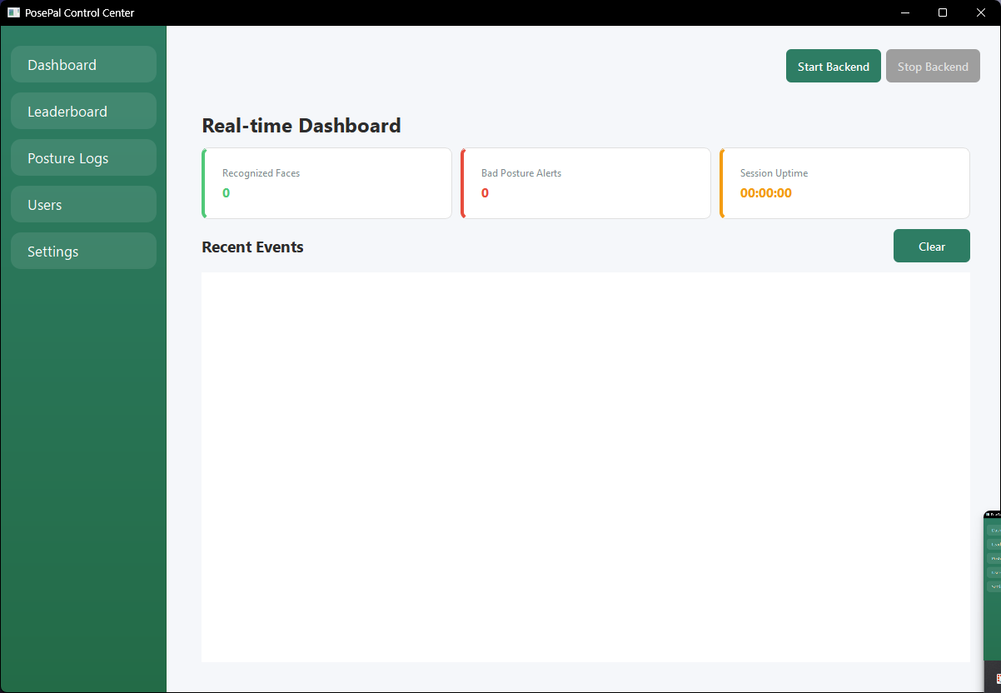
Figure 6. Admin Real-Time Dashboard
Figure 7 illustrates the Posture Detection Logs Interface, which enables administrators to view, organize, and manage all posture detection records generated by users. Each log entry contains essential details, including user identity, posture status, detection timestamp, and posture score. The system also provides filtering options based on user, date, or posture category, allowing administrators to efficiently monitor user activity and evaluate overall posture performance.
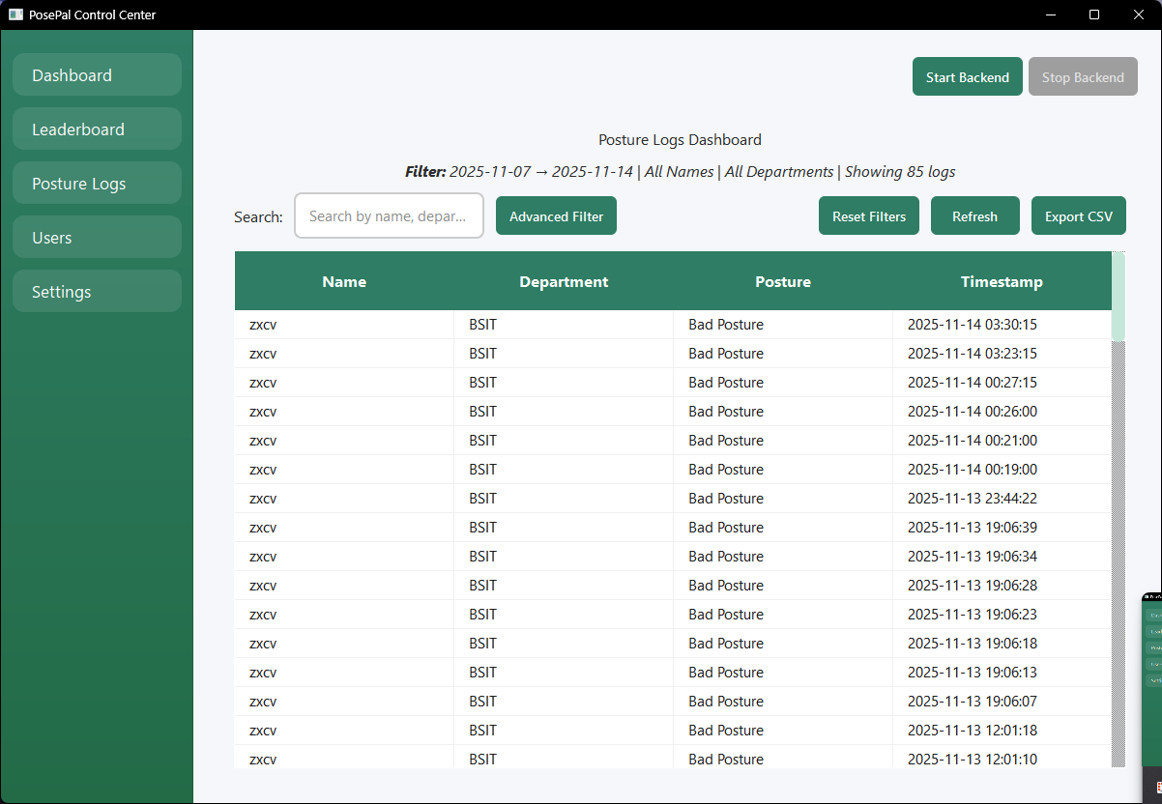
Figure 7. Admin Posture Logs Management
Machine Learning Algorithm Used in Developing PosePal
PosePal employs a sophisticated multi-algorithm pipeline that integrates advanced computer vision and deep learning techniques for real-time posture monitoring and biometric identification. Figure 8 illustrates the complete PosePal Multi-Stage Machine Learning Pipeline Architecture, showing the sequential flow from multi-camera input through detection, tracking, recognition, and classification stages, before final consensus generation and alert delivery to Firebase.
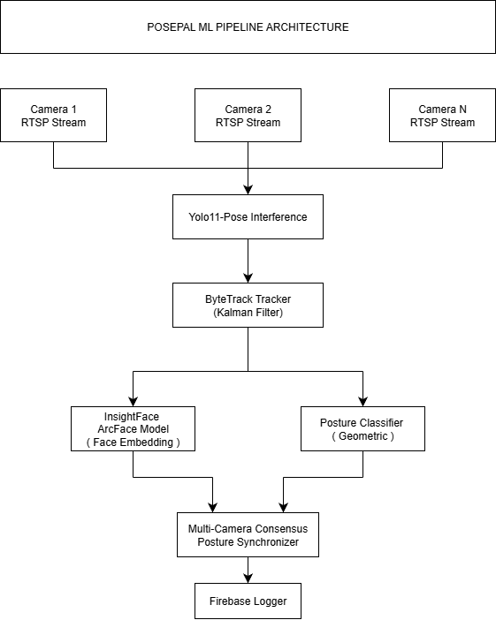
Figure 8. PosePal Multi-Stage Machine Learning Pipeline Architecture
The system pipeline begins with multiple RTSP camera streams, enabling broad spatial coverage and improved detection reliability from different viewing angles. Each video feed is processed using YOLOv11-Pose, an anchor-free model that performs real-time human detection and 17-keypoint pose estimation. Operating at 640×640 resolution with inference times below 30 ms on CUDA-enabled GPUs, the model ensures efficient and continuous posture monitoring.
Detected individuals are tracked using the ByteTrack multi-object tracking algorithm, which employs a Kalman Filter and a two-stage data association strategy based on Intersection over Union (IoU). This approach maintains consistent identity tracking across frames while reducing identity-switch errors. The system is configured to balance tracking stability and responsiveness in dynamic environments.
The pipeline then branches into two parallel processes: biometric identification and posture classification. For identification, the system integrates ArcFace via InsightFace, generating 512-dimensional facial embeddings and performing identity matching using cosine similarity. Deep face recognition models of this class have been shown to achieve over 99% verification accuracy across standard benchmark datasets, demonstrating strong robustness to variations in illumination, pose, and facial expression (Wang & Deng, 2021). For posture analysis, a rule-based geometric classifier evaluates keypoint data to compute metrics such as spine alignment, neck angle, and shoulder tilt. An adaptive baseline calibration mechanism using the 90th percentile of recent good-posture measurements, combined with a 5-frame temporal smoothing strategy, enhances robustness and reduces false detections. The posture classifier achieved 87.3% classification accuracy on manually annotated validation data — a competitive result comparable to recent vision-based posture detection systems that report accuracy ranges of 82–91% using similar keypoint-based geometric approaches (Bassino et al., 2023; Zaharuddin & Shah, 2025; Kumar et al., 2025).
The outputs from both processes are consolidated through a multi-camera consensus mechanism, which applies majority voting across active camera feeds and enforces a temporal persistence threshold before confirming poor posture events. This combined spatial and temporal validation significantly reduces false positives compared to single-camera setups.
Finally, validated posture events are logged to Firebase, enabling real-time synchronization, persistent storage, and analytics generation within the mobile application. Overall, the system achieves high accuracy in posture classification and face recognition while maintaining reliable real-time performance through GPU acceleration and efficient system design.
Acceptability Level of the Proposed System
The acceptability of PosePal was evaluated by 21 respondents — comprising 12 faculty members, 8 non-teaching staff, and 1 IT expert — at Pangasinan State University – Alaminos City Campus. The evaluation used a structured survey instrument adapted from ISO/IEC 25010, assessing eight software quality characteristics. Scores were interpreted using a five-point Likert scale where a range of 4.21–5.00 is rated Outstanding, 3.41–4.20 is Excellent, 2.61–3.40 is Very Good, 1.81–2.60 is Good, and 1.00–1.80 is Poor.
Table 13 presents the overall average weighted mean scores across all eight acceptability dimensions.
Table 13 Overall Average Weighted Mean of System Acceptability
Acceptability Level | Mean | Description
1. Functional Suitability | 4.02 | Excellent
2. Performance Efficiency | 4.30 | Outstanding
3. Compatibility | 3.88 | Excellent
4. Usability | 4.51 | Outstanding
5. Reliability | 4.06 | Excellent
6. Security | 4.10 | Excellent
7. Maintainability | 4.30 | Outstanding
8. Portability | 4.40 | Outstanding
Overall Average Weighted Mean | 4.19 | Excellent
As shown in Table 13, PosePal achieved an overall average weighted mean of 4.19, interpreted as Excellent. The system received its highest ratings in Usability (4.51, Outstanding) and Portability (4.40, Outstanding), indicating that respondents found the system highly accessible, easy to navigate, and deployable across different devices and platforms. Performance Efficiency (4.30, Outstanding) and Maintainability (4.30, Outstanding) also earned outstanding marks, reflecting the system's low-latency processing capabilities and its clearly structured, testable, and modifiable codebase.
Functional Suitability received a mean of 4.02 (Excellent), confirming that the system accurately performs its intended posture monitoring functions and appropriately supports users in their tasks. Reliability (4.06, Excellent) and Security (4.10, Excellent) were likewise rated excellent, confirming that PosePal maintains consistent availability through Firebase's cloud infrastructure and adequately protects user data and facial recognition profiles through Firebase Authentication and encrypted data transmission. Compatibility received the lowest mean at 3.88, still within the Excellent range, suggesting that while the system exchanges and utilizes data effectively across platforms, there remains some room to further strengthen cross-system interoperability.
Overall, the acceptability evaluation affirms that PosePal is a functional, reliable, and user-centered posture monitoring system that satisfactorily meets the needs of faculty and non-teaching staff at PSU-ACC. The consistently high ratings across all eight ISO/IEC 25010 quality dimensions validate PosePal's readiness for broader institutional deployment and its potential to promote healthier posture habits and improved occupational well-being within the campus environment.
CONCLUSION
PosePal successfully addressed posture-related health concerns among faculty and non-teaching staff at Pangasinan State University – Alaminos City Campus through AI-powered real-time monitoring and instant alerts. Built using Python, Dart, and JavaScript with YOLO for posture detection, Firebase as the cloud database, and IP cameras as input devices, the system achieved an overall weighted mean of 4.19 (Excellent) across ISO/IEC 25010 quality standards, confirming its reliability, usability, and effectiveness in promoting workplace wellness.
The system's features — including real-time posture detection, posture scoring, instant alerts, personalized analytics, face recognition, and an admin dashboard — demonstrated that AI-driven computer vision can serve as a practical and accessible ergonomic solution in institutional environments, effectively reducing postural deviations and encouraging long-term behavioral improvement among users.
The study affirms that AI-powered posture monitoring systems like PosePal can serve as proactive solutions for occupational health. Continuous refinement of detection algorithms, alert mechanisms, and user interface design, alongside ongoing evaluation of system accuracy and user satisfaction, will further ensure PosePal's effectiveness across diverse real-world institutional environments.
REFERENCES
- Abdul Rahim, A. R. A., Zahari, Z., Zainuddin, N. Z., & Nordin, N. A. M. (2022). Risk factors and prevalence of musculoskeletal disorders among teachers and school staff: A review. International Journal of Academic Research in Business and Social Sciences, 12(1), 1612–1624. https://doi.org/10.6007/IJARBSS/v12-i1/12190
- Bassino-Riglos, F., Mosqueira-Chacon, C., & Ugarte, W. (2023). AutoPose: Pose estimation for prevention of musculoskeletal disorders using LSTM. Springer, Cham, 223–238. https://link.springer.com/chapter/10.1007/978-3-031-49339-3_14
- Cheriyan, S., Sakthivel, S., Regula, T., Kumar, K., & Al Riyami, S. (2025). Smart posture monitoring and predictive health classification for bedridden patients using IoT and AI. IEEE Xplore, 1–5. https://ieeexplore.ieee.org/abstract/document/10845586
- Kumar, S. S., Madesh, S., Nikitha, B., & Maheshwari, R. (2025). Intelligent posture monitoring system with real-time notifications using MediaPipe and OpenCV. Springer Nature Link, 145–155.
- Mahomed, A. S., & Saha, A. K. (2024). Driver posture recognition: A review. IEEE Xplore, 176301–176345. https://ieeexplore.ieee.org/abstract/document/10750806
- Ota, M., Tateuchi, H., Hashiguchi, T., Kato, T., Ogino, Y., Yamagata, M., & Ichihashi, N. (2020). Verification of reliability and validity of motion analysis systems during bilateral squat using human pose tracking algorithm. Gait & Posture, 80, 62–67. https://doi.org/10.1016/j.gaitpost.2020.05.027
- Pistolesi, F., Baldassini, M., & Lazzerini, B. (2024). A human-centric system combining smartwatch and LiDAR data to assess the risk of musculoskeletal disorders and improve ergonomics of Industry 5.0 manufacturing workers. Computers in Industry. https://www.sciencedirect.com/science/article/abs/pii/S0166361523001926
- Sharma, R., & Rawat, N. (2023). Posture: Its significance in human health. Journal of Health and Allied Sciences NU, 13(1), 48–52. https://doi.org/10.1055/s-0043-1766103
- Sreevani, V., Reddy, B. S., Nithin, K., Vardhan, K. H., Mohammed, K. A., Reddy, U., Lakhanpal, S., & Kalra, R. (2024). Advanced interdisciplinary approaches for bad posture detection using computer vision and IoT. E3S Web of Conferences, 507, 01045. https://doi.org/10.1051/e3sconf/202450701045
- Szczygiel, E., Fudacz, N., Golec, J., & Golec, E. (2020). The impact of the position of the head on the functioning of the human body: A systematic review. International Journal of Occupational Medicine and Environmental Health, 33(5), 559–568. https://doi.org/10.13075/ijomeh.1896.01550
- Tsantili, A. R., Chrysikos, D., & Troupis, T. (2022). Text Neck Syndrome: Disentangling a new epidemic. Acta Medica Academica, 51(2), 123–127. https://doi.org/10.5644/ama2006-124.380
- Wang, M., & Deng, W. (2021). Deep face recognition: A survey. Neurocomputing, 429, 215–244. https://doi.org/10.1016/j.neucom.2020.10.081
- Zaharuddin, M. S. H., & Shah, S. M. (2025). A smart chair for sitting postures monitoring and seat occupancy detection. Journal of Electronic Voltage and Application. https://penerbit.uthm.edu.my/ojs/index.php/jeva/article/view/18203

