Implementation and Deployment of an Internet of Things (IoT) Based Fingerprint Attendance Monitoring System to Evaluate Students’ Academic Performance: A Pilot Study of Moshood Abiola Polytechnic, Abeokuta
Abstract
This study reports the development and pilot evaluation of an Internet-of-Things (IoT)-based fingerprint attendance system at Moshood Abiola Polytechnic, Nigeria. The system was designed to automate attendance monitoring and investigate its relationship with students’ academic performance, thereby addressing the inefficiencies and susceptibility to manipulation associated with manual roll-call methods. By integrating biometric fingerprint authentication with real-time cloud-based data storage, the system ensured accurate, secure, and tamper-resistant attendance records. The implementation was carried out over one academic semester across three engineering departments (Computer Engineering, Electrical/Electronics, and Mechanical Engineering), involving two hundred (200) students and ten (10) academic staff. Attendance data were captured using IoT-enabled fingerprint devices, while academic performance indicators were derived from quizzes, assignments, and examinations. Data analysis employed descriptive statistics alongside inferential techniques, including Pearson correlation, linear regression, and one-way ANOVA. The results revealed mean attendance rates of 85.4%, 78.2%, and 92.1% across the respective departments, with corresponding average academic scores of 75.6%, 68.3%, and 81.2%. A statistically significant and strong positive correlation (p = 0.001) was observed between attendance and academic performance. Regression analysis further established attendance as a significant predictor of academic outcomes, while ANOVA findings indicated that students with high attendance accounted for a substantial proportion (71.3%) of performance variance. In conclusion, the system significantly improved student engagement and established a reliable linkage between attendance and academic outcomes, thereby strengthening academic accountability. Although minor network and device-related constraints were encountered, the results offer a solid basis for extended validation across diverse, multi-institutional educational environments.
Keywords: Internet of Things (IoT), fingerprint authentication, attendance monitoring, academic performance analysis

1.0 Introduction

1.1 Background of the Study
In educational institutions, tracking student attendance plays a vital role in shaping academic success and improving administrative effectiveness. Regular class attendance enhances continuous learning, promotes active participation, and strengthens interaction between instructors and students, all of which contribute positively to academic achievement. However, conventional attendance methods that rely on manual registers or logbooks are often inefficient, susceptible to human error, and prone to malpractice such as impersonation or falsification of records. To improve reliability and transparency, many institutions are adopting digital solutions. Biometric attendance systems, particularly fingerprint-based technologies, provide secure identity verification. When integrated with the Internet of Things (IoT) and cloud platforms, these systems enable accurate, real-time attendance monitoring and efficient data management. Moshood Abiola Polytechnic, Abeokuta, like many other higher education institutions in Nigeria, faces challenges in ensuring accurate attendance records and linking them to student performance metrics. While traditional approaches are still widely used, there is an increasing recognition of the need for scalable and intelligent systems that can provide data-driven insights into student engagement. Implementing an IoT-based fingerprint attendance monitoring system is a timely intervention that can bridge the gap between physical presence and academic accountability.

1.2 Statement of the Problem

Manual attendance methods are often unreliable and inefficient for monitoring students’ participation in lectures and practical sessions. They are prone to delays, recording errors, misplaced records, and impersonation, making it difficult for institutions to enforce attendance policies or accurately link attendance with academic performance. In addition, traditional systems lack real-time monitoring capabilities, preventing timely intervention when students begin to disengage. Their limited analytical and visualisation features also restrict data-driven decision-making for improving learning outcomes. To address these challenges, this study proposes an IoT-based fingerprint attendance monitoring system designed to automate attendance tracking while generating actionable data to evaluate and enhance students’ academic performance.

1.3 Objectives of the Study
The primary objective of this study is to design, implement, and evaluate an IoT-based fingerprint attendance monitoring system and its impact on students’ academic performance at Moshood Abiola Polytechnic. Specifically, the study aims to develop a biometric attendance system with IoT integration, automate real-time data capture and storage, examine the relationship between attendance and academic performance, assess system usability and effectiveness among users, and provide recommendations for institutional adoption and scalability.

1.4 Research Questions

The study examines the effectiveness of an IoT-based fingerprint system for automating attendance, its relationship with academic performance, its role in improving administrative efficiency and reducing fraud, and the perceptions of students and staff regarding its usability and reliability.

1.5 Research Hypotheses

To guide the empirical analysis, three hypotheses are formulated. H1 posits a statistically significant positive relationship between students’ attendance and academic performance. H2 proposes that the IoT-based fingerprint system reduces proxy attendance and administrative workload. H3 assumes that users will report high satisfaction and perceived ease of use of the system.

1.6 Significance of the Study

This study holds relevance for key stakeholders within the education sector. It offers institutions a reliable and transparent mechanism for monitoring attendance in relation to academic performance. Administrators benefit from reduced manual processes and enhanced efficiency, while students gain a fair and accountable tracking system. Additionally, the study contributes to smart campus research by demonstrating how IoT technologies can modernise traditional educational practices and provide adaptable implementation frameworks.

1.7 Scope and Limitations
The study is limited to Moshood Abiola Polytechnic, Abeokuta, and focuses specifically on the implementation and assessment of the attendance system within selected departments. While the system is scalable, the pilot phase involved approximately 200 students over one academic semester.

2. Literature Review

2.1 Introduction
The Internet of Things (IoT) refers to a network of interconnected physical devices embedded with sensors, communication modules, and processing capabilities that enable them to collect, transmit, and exchange data through the internet with minimal human intervention. Within the educational sector, IoT has emerged as a significant technological enabler for the development of smart campuses and intelligent learning environments. Applications of IoT in education include smart classrooms, automated attendance systems, real-time monitoring of students, and efficient management of institutional resources (Al-Fuqaha et al., 2015). Through these applications, educational institutions can improve operational efficiency and enhance learning experiences. IoT technologies provide several advantages to educational institutions. These include real-time monitoring and automation of administrative processes, enhanced student engagement through data-driven feedback mechanisms, and improved utilisation of resources and campus safety through intelligent monitoring systems (Ray, 2018, Adenekan et al., 2021 and Ramgopal et.al, 2025). Although the adoption of IoT in educational institutions across sub-Saharan Africa remains relatively limited, the increasing availability of affordable microcontrollers, sensors, and cloud-based computing platforms has made the deployment of IoT-based solutions increasingly feasible. Institutions such as Moshood Abiola Polytechnic, Abeokuta, can therefore leverage IoT technologies to improve classroom monitoring, attendance management, and administrative efficiency.

Complementing IoT-based systems is the use of biometric authentication technologies, which identify individuals based on unique physiological or behavioural characteristics such as fingerprints, facial features, iris patterns, or voice recognition. Among these modalities, fingerprint recognition remains one of the most widely adopted due to its uniqueness, permanence, and ease of integration with low-cost sensors. Fingerprint-based systems provide high accuracy in identity verification, are difficult to forge or replicate, and are relatively cost-effective and durable. According to Jain et al. (2004) and Maltoni et al. (2009), fingerprint authentication significantly reduces impersonation and strengthens the reliability of identity-based systems. In educational environments, biometric systems have been applied for access control, verification of examination candidates, and automated attendance recording (Ahmed et al., 2017). When integrated with IoT technologies, biometric attendance systems can support remote monitoring, real-time uploading of attendance data to cloud servers, integration with academic management systems, and automated alerts through performance dashboards. For example, Patil and Patil (2021) implemented an IoT-based fingerprint attendance system using Raspberry Pi, demonstrating improved accuracy and reduced administrative workload. Similarly, Yadav et al. (2019) developed a cloud-connected biometric attendance system using Google Firebase for real-time data access. However, many existing systems primarily focus on attendance recording and lack analytical tools for linking attendance data with students’ academic performance, which represents an important research gap addressed in this study.

Several empirical studies have demonstrated a strong relationship between student attendance and academic performance in higher education. Rodgers (2001) reported that students with consistent class attendance tend to achieve significantly higher academic grades than those who frequently miss lectures. Similarly, Credé et al. (2010), through a comprehensive meta-analysis, found that attendance is a stronger predictor of academic success than many traditional assessment indicators, including standardised test scores. In the Nigerian educational context, Oghuvbu (2010) and Adeyemi (2011) also observed that regular class attendance positively influences students’ continuous assessment and examination outcomes. However, the absence of reliable automated attendance systems often limits institutions’ ability to analyse attendance data effectively. The proposed system addresses this limitation by integrating biometric attendance records with academic performance data for structured analysis.

2.2 Related Works

Early standalone biometric attendance systems relied on fingerprint modules connected to local databases to record student attendance. For instance, the system developed by Mukhopadhyay et al. (2015) successfully authenticated students using fingerprint recognition; however, the system operated locally and lacked remote monitoring capabilities and real-time analytics, thereby limiting its usefulness for institutional decision-making. Alternative approaches such as RFID-based systems have also been explored. Sharma et al. (2016) reported that although radio frequency identification (RFID) systems enable faster attendance recording, they are vulnerable to manipulation because students can exchange or carry multiple RFID tags. Similarly, quick response (QR) code-based attendance systems provide quick scanning but require additional verification measures to prevent misuse. More recently, Singh et al. (2020) developed a cloud-based facial recognition attendance system. While effective in automated identification, facial recognition systems often raise privacy concerns and are sensitive to environmental factors such as lighting conditions and camera quality. Consequently, fingerprint-based IoT attendance systems offer a more secure, reliable, and user-friendly alternative, particularly when integrated with cloud platforms and academic performance dashboards for enhanced monitoring and analysis.

2.3 Theoretical Framework

The theoretical foundation of this study is based on the Technology Acceptance Model (TAM) and Constructivist Learning Theory. The Technology Acceptance Model proposed by Davis (1989) explains that users’ acceptance of a technological system depends largely on perceived usefulness and perceived ease of use. This framework helps evaluate how students and staff respond to the implemented system. Additionally, Constructivist Learning Theory, advanced by Vygotsky (1978), emphasises that learning occurs through active participation and social interaction. Regular class attendance therefore enhances engagement and collaborative learning, which can positively influence academic performance.

2.4 Gaps Identified in Existing Literature

A review of existing literature on biometric and IoT-based attendance systems reveals several significant research gaps. First, many studies concentrate primarily on attendance capture and monitoring, with little attention given to analysing how attendance patterns influence students’ academic performance. Secondly, practical deployments within African higher institutions remain limited, as most studies are either conceptual or implemented in non-African environments. Furthermore, user experience evaluation particularly regarding usability and satisfaction among students and staff is often overlooked. In addition, many existing systems lack seamless integration with institutional databases for advanced data analytics. This study addresses these limitations through a pilot implementation in a Nigerian institution, linking biometric attendance records with academic performance indicators and incorporating user feedback for system evaluation. In conclusion, the reviewed literature reveals an increasing adoption of IoT and biometric technologies within educational institutions. Fingerprint-based attendance systems provide secure and reliable identification; however, their effectiveness improves significantly when integrated with IoT platforms and academic data analytics. Building on previous studies, this research implements an IoT-based fingerprint attendance system at Moshood Abiola Polytechnic and evaluates its relationship with students’ academic performance, thereby supporting data-driven institutional monitoring and advancing the development of smart learning environments in Nigeria.

3.0 Research Methodology

This section outlines the research framework, system architecture, and data acquisition procedures used in developing and deploying the IoT-based fingerprint attendance monitoring system. It details the integration of biometric hardware with software components for accurate identification, data transmission, and storage. A quantitative experimental approach was adopted to evaluate system performance and its impact on students’ academic outcomes.

3.1 Research Design

This study adopts a descriptive research design supported by an experimental component involving the deployment of an IoT-based fingerprint attendance system. The approach includes system development, implementation, pilot testing, and the collection of attendance and academic performance data for analysis. A quasi-experimental framework was employed, observing students in their natural classroom environment within the School of Engineering, Moshood Abiola Polytechnic, Abeokuta, without random assignment to control or experimental groups.

3.2 System Architecture
The IoT-based fingerprint attendance monitoring system is structured on an integrated hardware–software architecture operating within a client–server framework and cloud-enabled data environment. The workflow commences with biometric fingerprint authentication to ensure secure identity validation prior to attendance logging. Upon successful verification, data are transmitted to a centralised database via a server for storage and analytics. Administrators access records through a dedicated user interface for real-time monitoring and evaluation. The IoT infrastructure facilitates seamless device-to-server communication, minimises manual processes, prevents proxy attendance, enhances accuracy, and ensures scalability for institutional deployment.
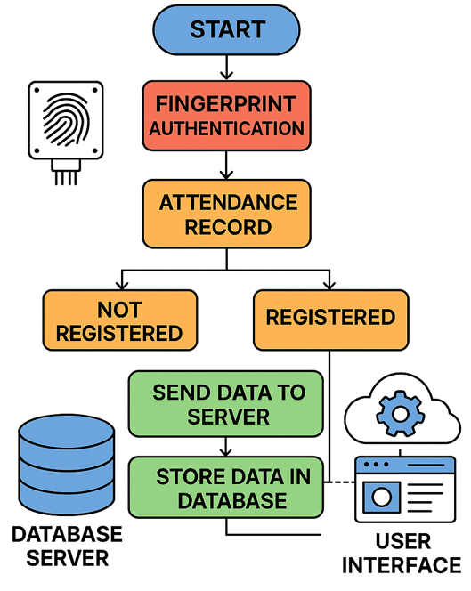
Figure 3.1: Shows the flowchart of a typical Internet of Things (IoT) based fingerprint attendance monitoring system.
3.3 Hardware and Software Components
The system integrates both hardware and software subsystems to ensure efficient real-time attendance management. Hardware components comprise biometric fingerprint scanners for image acquisition and identity verification, a microcontroller platform (Arduino or Raspberry Pi) for device coordination and data processing, and an IoT communication module (Wi-Fi or GSM) for real-time transmission to a cloud server. Personal computers support administrative configuration and monitoring. The software framework includes fingerprint recognition algorithms for template extraction and matching, cloud storage services such as Google Firebase or AWS for secure and scalable data management, and a web-based dashboard for real-time supervision and reporting. An optional mobile application provides students with immediate attendance feedback.

3.4 Data Collection Methods

Data collection incorporated both primary and secondary sources to ensure methodological robustness. Primary data were generated during system deployment and included real-time attendance logs captured through biometric fingerprint authentication, where each verified entry was timestamped and stored in the database. Academic performance data were obtained from the institution’s academic records office for the pilot semester to enable correlation analysis between attendance patterns and grade outcomes. Additionally, structured surveys and interviews were administered to students and academic staff to evaluate system usability, acceptance, and perceived effectiveness. Secondary data were drawn from scholarly literature on attendance monitoring technologies, biometric authentication systems, and empirical studies examining the relationship between attendance and academic performance.

3.5 Pilot Study

A pilot study was conducted over one academic semester across the Computer, ElectricaL\Electronics, and Mechanical Engineering departments in the School of Engineering at Moshood Abiola Polytechnic. The study involved two hundred (200) students (50, 80, and 70 from each department, respectively) alongside ten (10) academic staff, selected based on course registration and willingness to participate. Prior to commencement, students were briefed on the study’s objectives and procedures, and informed consent was obtained. School administrators and staff received hands-on training to operate the fingerprint attendance system and actively supervised its use, ensuring accurate data collection and effective monitoring. Deployment involved three key stages: installing fingerprint scanners at lecture venues for convenient student access, configuring the backend system to link scans to unique student IDs and integrate attendance with academic performance data, and conducting initial tests with staff and students to verify accurate recognition and logging. Attendance was recorded for every class session and continuously uploaded to the cloud, while academic performance metrics, including midterm quizzes, assignments and exam scores, were retrieved at the semester’s end for analysis.

3.6 Data Analysis

The data from system deployment were analysed using both descriptive and inferential statistics. Descriptive analysis summarised attendance records, departmental averages, and student performance across core courses. Inferential techniques, including Pearson’s correlation, regression, and one-way ANOVA, examined the relationship between attendance and academic performance. Additionally, thematic analysis of student and staff feedback assessed system usability, effectiveness, and overall satisfaction, providing a comprehensive evaluation of its impact.

3.7 Ethical Considerations and Limitations of the Study

Ethical approval was granted by the Academic Board of Moshood Abiola Polytechnic, and the study followed ethical guidelines, ensuring informed consent, data confidentiality, and protection of student records. Limitations included technical issues such as scanner malfunctions and connectivity problems, accessibility challenges for students with deteriorated ridge patterns, and the pilot’s restriction to three departments, which limited the generalisability of the findings to other institutions or educational contexts.

4.0 System Implementation and Architectural Design

This section outlines the implementation of the IoT-based fingerprint attendance monitoring system at Moshood Abiola Polytechnic, Abeokuta, including system design, configuration, deployment processes, and encountered challenges. It highlights the tools and methodologies used for seamless integration with existing infrastructure. The system architecture incorporates biometric authentication, cloud storage, and real-time data transmission, with interconnected layers that efficiently capture, store, and process attendance data.

4.1 Hardware Components
The hardware architecture of the fingerprint attendance system was developed to ensure cost-effectiveness, operational reliability, and ease of deployment within an institutional setting. The primary component is the R307 fingerprint scanner, selected for its high accuracy and affordability in biometric identification and authentication. The scanner interfaces with a Raspberry Pi 4 via a UART communication protocol, enabling efficient data exchange. The Raspberry Pi functions as the central processing unit, managing fingerprint verification and transmitting attendance data through its integrated Wi-Fi module to a cloud server. A Google Firebase platform securely stores student IDs, timestamps, fingerprint templates, and course-related metadata for analysis. Additionally, a web-based dashboard supports real-time monitoring and report generation, while a mobile application prototype allows students to access attendance records and receive notifications.

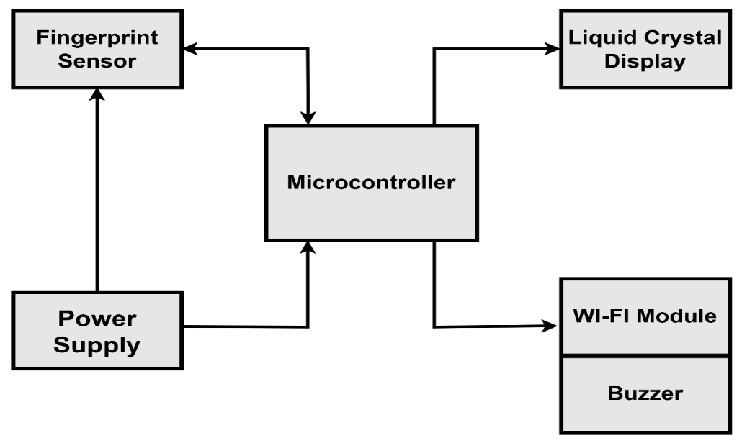
Fig. 4.1: Shows the block diagram of the Internet of Things (IoT)-based fingerprint attendance monitoring system.
Figure 4.1 presents the system architecture, with the microcontroller serving as the central processing unit for system logic and peripheral interfacing. The R307 sensor performs biometric capture and authentication, while the liquid crystal display (LCD) displays attendance status. The Wi-Fi module enables cloud synchronisation, supported by a buzzer for feedback and a regulated power supply for stable operation.

4.2.1 System Circuit Configuration and Operation
The core of the system is an ESP32 Wi-Fi–enabled microcontroller, which functions as the central processing and control unit responsible for managing data acquisition, device coordination, and communication tasks. Interfaced to the controller are an OLED display module and a fingerprint sensor, both of which serve as essential peripheral components for user interaction and biometric authentication. The OLED display communicates with the ESP32 through the Inter-Integrated Circuit (I²C) protocol, where its Serial Data (SDA) and Serial Clock (SCL) lines are connected to GPIO pins D21 and D22, respectively. This interface allows efficient two-wire digital communication for transmitting display instructions and system feedback information. In parallel, the fingerprint sensor module is connected via the ESP32’s hardware Universal Asynchronous Receiver/Transmitter (UART) interface. The sensor’s transmit (Tx) and receive (Rx) pins are linked to GPIO pins D17 and D18 of the microcontroller, establishing a reliable serial communication channel for biometric data transfer and command exchange. This configuration supports both hardware serial communication and software-based serial implementation during programming or debugging, thereby improving system flexibility and development efficiency.
The entire circuit is powered by a rechargeable 3.7 V lithium-ion battery selected for its portability, high energy density, and stable discharge characteristics. Because the ESP32 and associated peripherals require a higher operating voltage, the battery output is stepped up to a regulated +5 V DC using an MT3608-based DC-DC boost converter module. The regulated output is then distributed to the ESP32 board, OLED display, and fingerprint sensor to ensure stable and consistent operation. Battery charging is accomplished through a TP4056 lithium-ion charging module supplied with a 5 V DC input via a USB connection or external cable. This charging module provides controlled current and voltage regulation, protecting the battery against overcharging, excessive discharge, and thermal stress, thereby enhancing operational safety, improving charging efficiency, and prolonging battery service life.
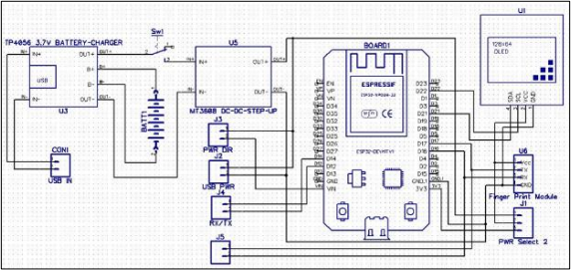
Figure 4.2: Displays the Circuit Diagram of the Internet of Things (IoT) Fingerprint-Based Attendance and Monitoring System
4.2.2 Design Simulation
The design simulation of the IoT Fingerprint-Based Attendance and Monitoring System was implemented using Proteus Simulation software to validate circuit functionality prior to physical prototyping. During the simulation process, all system components (including the microcontroller unit, biometric sensor interface, display module, and power regulation circuitry) were virtually assembled and interconnected according to the schematic design. The embedded program was then loaded into the simulated controller to emulate real-time operation. Signal transmission, logic responses, voltage levels, and serial communication processes were monitored to verify correct interfacing, detect design errors, and optimise performance, thereby ensuring reliable system behaviour before hardware deployment.
Figure 4.3: Shows the Proteus simulation layout of the Internet of Things (IoT) fingerprint-based attendance and monitoring system.
4.2.3 Design System Construction, Mounting and Soldering
The implementation of the system commenced with thorough project planning, which established the foundation for subsequent development activities. The design stage was carried out using Computer-Aided Design (CAD) software, where a circuit schematic was created to provide a virtual representation of the architecture. This schematic allowed verification of component connectivity, signal flow, and power distribution before any hardware was realised. Once the schematic was completed and validated, it was translated into a Printed Circuit Board (PCB) layout that defined the physical placement of components and conductive traces. PCB fabrication was immediately undertaken to ensure consistency between the conceptual design and the physical hardware. The construction of the prototype was said to have followed a systematic process, structured into four major phases. The first phase involved the accurate positioning and soldering of electronic components. The second phase focused on configuring the web-based user interface for monitoring and interaction. The third phase was dedicated to programming the embedded controller, enabling it to coordinate sensing, processing, and communication tasks. The final phase consisted of comprehensive testing and validation to confirm operational reliability.
During hardware assembly, jumper wires and resistors were installed first, with each resistor verified using a digital multimeter to ensure correct resistance values before soldering. Power supply diodes were then mounted with strict attention to polarity orientation to prevent malfunction. Integrated circuits, particularly the microcontroller, were installed next with proper alignment to avoid damage or incorrect operation. Capacitors followed, with electrolytic types orientated according to polarity markings. Finally, the three-terminal voltage regulator was mounted, with its leads carefully shaped to fit the PCB holes, ensuring secure placement, proper electrical contact, and stable voltage regulation throughout system operation.
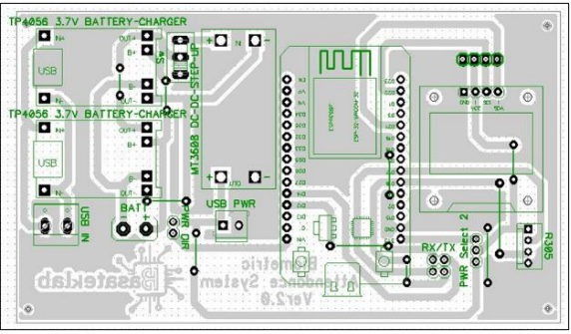
Figure 4.4: Layout schematic of the Internet of Things (IoT) Fingerprint-Based Attendance and Monitoring System

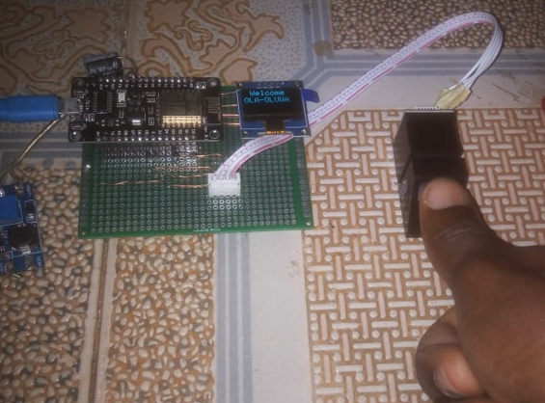
Figure 4.5 (a)
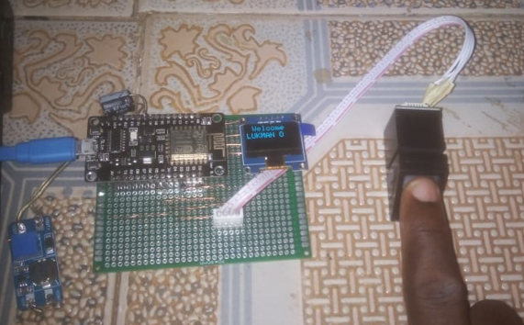
Figure 4.5 (b)

Figure 4.5(a) and (b) present the basic hardware configuration and interconnection of components in the IoT-based fingerprint attendance monitoring system, illustrating biometric data acquisition through the use of the thumb in (a) and the index finger in (b).

Figure 4.6 presents the implemented system output in casing, highlighting the user interface and real-time feedback mechanism employed for attendance verification and efficient monitoring of student participation.

4.2.4 Software Architecture and Integrated System Framework
The software architecture was systematically developed to ensure seamless integration with hardware components and institutional databases, thereby enabling real-time data updates and advanced analytical processing. Central to the system is a fingerprint-matching algorithm implemented through dedicated Software Development Kits (SDKs), which authenticate captured biometric data against a pre-enrolled student database and return verification outcomes. The Attendance Management System (AMS) is responsible for managing attendance records, including student arrivals, absences, and timestamps, while maintaining continuous synchronisation with the cloud server for data consistency and accessibility. Cloud integration, achieved through platforms such as Firebase or AWS, provides scalable storage infrastructure and supports instantaneous data updates across all connected devices. Furthermore, a web-based dashboard developed using React.js and Node.js, with MongoDB serving as the backend database, facilitates efficient monitoring and management. This interface enables faculty and administrators to access attendance reports, track participation trends, and generate statistical analyses, thereby supporting informed decision-making and enhancing overall system efficiency.

4.3 System Configuration
System configuration involved setting up both the hardware and software elements in a way that ensured seamless integration and data flow. The following configuration steps were essential for the successful deployment of the system:

4.3.1 Hardware Setup

Fingerprint scanners were strategically installed at lecture hall entrances to enable efficient attendance capture. Each device was thoroughly tested to ensure proper functionality and secure connection to the Raspberry Pi. The Raspberry Pi was configured with the required software, including the operating system, and connected to the Wi-Fi network for internet access. The scanners interfaced with the Raspberry Pi through General-Purpose Input/Output (GPIO) pins, enabling accurate acquisition and processing of biometric data for real-time attendance monitoring.

4.3.2 Software Setup

The software architecture was systematically configured to support biometric attendance operations. Fingerprint enrolment was conducted at the start of the semester, during which students’ biometric data were captured and securely linked to unique identifiers within a protected database. A cloud-based infrastructure was established using Google Firebase Firestore to enable real-time data synchronisation across connected devices. Furthermore, the Attendance Management System (AMS) was integrated with the cloud database to automatically log verified attendance with timestamps, generate analytical reports, and facilitate correlation of attendance records with academic performance metrics.

4.4 Pilot Study Deployment
The system was deployed for a pilot study involving two hundred (200) students and ten (10) academic staff across three departments in the School of Engineering. The deployment process was conducted in the following stages:

4.4.1 Training and Orientation

Prior to full deployment, comprehensive training was conducted for both students and staff to ensure effective system usage. Students were guided on proper fingerprint scanning procedures at designated points for attendance recording. Staff received training on monitoring and updating records, accessing the web-based dashboard, interpreting attendance data, and utilising the system to support academic performance analysis and informed decision-making.

4.4.2 Biometric Enrolment and Attendance Monitoring Process

During the enrolment phase, each student registered their fingerprint, linking biometric data to a unique student ID. This step ensured that only authorised students could record attendance. In the daily attendance logging phase, attendance was automatically captured at the start of each lecture using fingerprint scanners. The system verified each fingerprint against the database, after which attendance was time-stamped and transmitted to the cloud. Records were continuously updated and monitored in real time via an administrative dashboard. Data collection spanned the entire semester, providing sufficient and reliable data for comprehensive analysis and evaluation.

4.5 System Challenges and Mitigation Measures
Although the system performed effectively overall, several challenges emerged during deployment. Fingerprint recognition issues occurred for some students due to worn-out prints, skin damage, or dirt, resulting in occasional false rejections. To mitigate this, the system permitted up to three scan attempts and incorporated alternative authentication options such as manual check-ins and optional facial recognition. Internet connectivity limitations in certain campus locations also delayed real-time data synchronisation. This was addressed by enabling local data storage with automatic synchronisation once connectivity was restored. Additionally, initial user adaptation challenges were resolved through structured training sessions and the provision of a dedicated help desk for continuous technical support and guidance.

4.6 System Evaluation and User Feedback
Following full deployment, feedback was obtained from students and academic staff to assess the system’s usability, functionality, and overall impact. Data were collected through structured surveys and interviews focusing on usability, system reliability, impact on attendance and academic performance, and overall user satisfaction. Respondents evaluated how easily they could register, scan, and access attendance records, as well as the accuracy and efficiency of fingerprint recognition. Findings indicated a high level of satisfaction, with users highlighting speed, accuracy, and ease of use as major strengths. Although minor concerns such as occasional fingerprint errors and network issues were reported, these were generally viewed as minor setbacks.

5.0 Results and Discussion

5.1 Introduction
This section presents the analysis of data collected from the IoT-based fingerprint attendance monitoring system during the pilot study at Moshood Abiola Polytechnic, Abeokuta. It covers descriptive and inferential analyses of attendance and academic performance, discusses key findings, and evaluates the system’s effectiveness in improving attendance and its relationship with students’ academic outcomes.

5.2 Data Analysis and Results

5.2.1 Descriptive Statistics
The first stage of analysis involves summarising the attendance data and academic performance data using descriptive statistics. These statistics provide an overview of the trends observed during the pilot study.

5.2.1.1 Attendance Rates
The average attendance rates for each department were calculated, and the overall attendance rate for the entire pilot study was computed. Table 5.1 shows the average attendance rate for the three departments involved in the study.
Department | Average Attendance Rate (%)
Computer Engineering | 85.4%
Electrical\Electronics Engineering | 78.2%
Mechanical Engineering | 92.1%
Overall Average | 85.2%
Table 5.1: Displays the average attendance over a period of one semester.
Table 5.1 indicates that Mechanical Engineering recorded the highest attendance rate (92.1%), while Electrical/Electronics Engineering had the lowest (78.2%). The overall average of 85.2% suggests effective attendance capture during the study period.
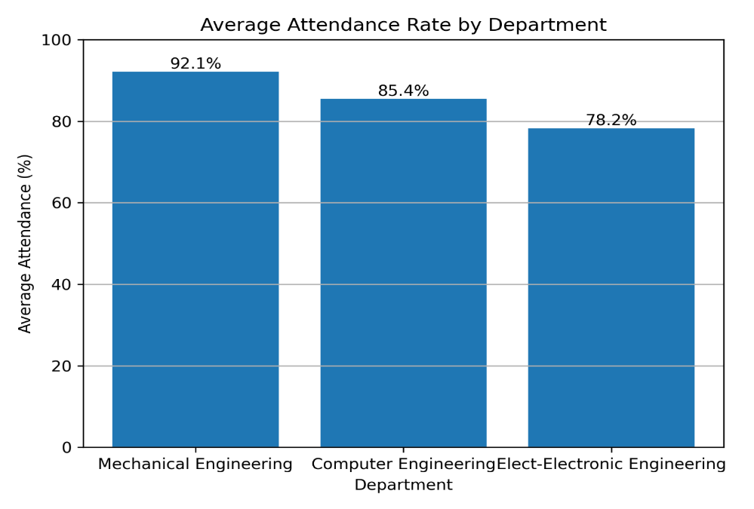
Figure 5.1: Shows the bar chart showing the average attendance rate for the departments.

Figure 5.1 presents a bar chart illustrating the average attendance rates across the three departments. Mechanical Engineering recorded the highest attendance (92.1%), followed by Computer Engineering (85.4%), while Electrical/Electronics Engineering had the lowest rate (78.2%), indicating comparatively lower student participation.

5.2.1.2 Frequency of Attendance Logging and Trends
The frequency of attendance logging was also analysed. The data showed that, on average, 95% of the students were able to scan their fingerprints successfully at the start of each lecture. The remaining 5% faced issues, mainly due to fingerprint recognition problems or technical glitches with the devices. A trend analysis was conducted to determine if there were any significant changes in attendance patterns over the semester. The results indicated that the attendance rate improved gradually throughout the semester, particularly after the initial orientation and training phases. By the fourth week, the attendance rate had stabilised, with minor fluctuations due to students' personal schedules or technical issues with the fingerprint scanners.

5.2.2 Academic Performance
The next stage of the data analysis involved correlating attendance data with academic performance. Academic performance data was collected from student grades in quizzes, assignments and exams. Table 5.2 presents the average academic performance scores for students across the three departments.
Department | Average Academic Performance (Score)
Computer Engineering | 75.6%
Electrical\Electronics Engineering | 68.3%
Mechanical Engineering | 81.2%
Overall Average | 75.0%
Table 5.2: Shows the average academic performance scores for students across the three departments.
Table 5.2 shows Mechanical Engineering with the highest average score (81.2%), followed by Computer Engineering (75.6%) and Electrical/Electronics Engineering (68.3%), with an overall mean of 75.0%.

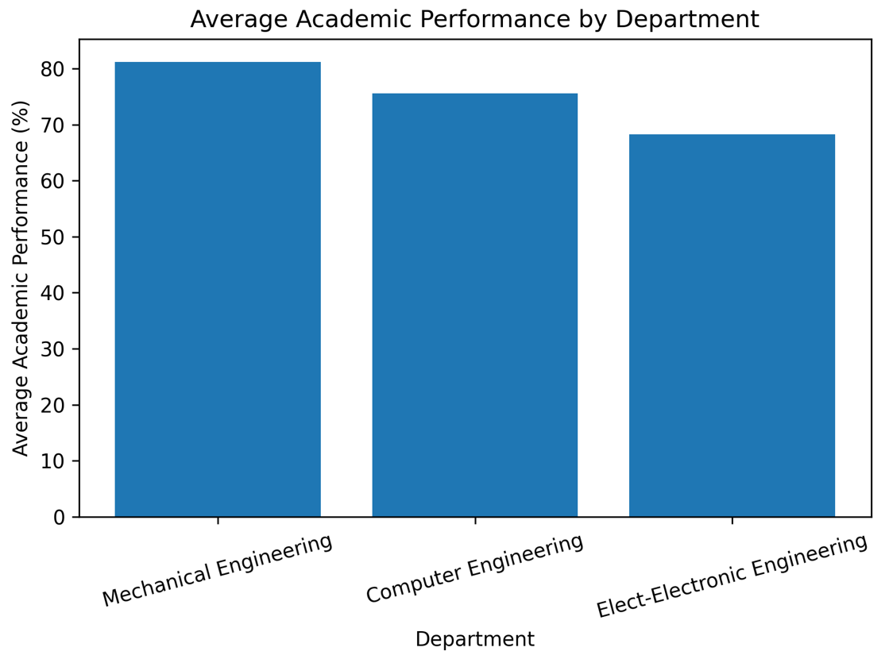
Figure 5.2: Illustrates the bar chart showing the average attendance rate for the departments.

Figure 5.2 presents a bar chart showing that Mechanical Engineering achieved the highest average performance (81.2%), followed by Computer Engineering (75.6%), while Electrical/Electronics Engineering recorded the lowest (68.3%), nearly 13 points lower than Mechanical Engineering.

5.2.3 Inferential Statistics
Inferential statistical methods, specifically Pearson’s correlation coefficient, regression analysis, and one-way analysis of variance (ANOVA), were used to explore the relationship between attendance and academic performance. The hypothesis tested was that there would be a positive correlation between the two variables.

5.2.3.1 Correlation Between Attendance and Academic Performance
Pearson’s correlation coefficient was calculated to determine the strength and direction of the relationship between attendance and academic performance. The formula for Pearson’s correlation is:
$r= \frac{n\sum{x_{i}y_{i} -\sum{x_{i}\sum{y_{i}}}}}{\sqrt{\left[n\sum{x_{i}^{2} - {\left(\sum{x_{i}}\right)}^{2} }\right] ∙\left[n\sum{y_{i}^{2}- {\left(\sum{y_{i}}\right)}^{2}}\right]}} ………. eqn 1$
$where:$
$r is the Pearson Correlation Coefficient$
$n is the number of paired scores$
$x is the number of attendance scores$
$y is the number of academic performance scores$

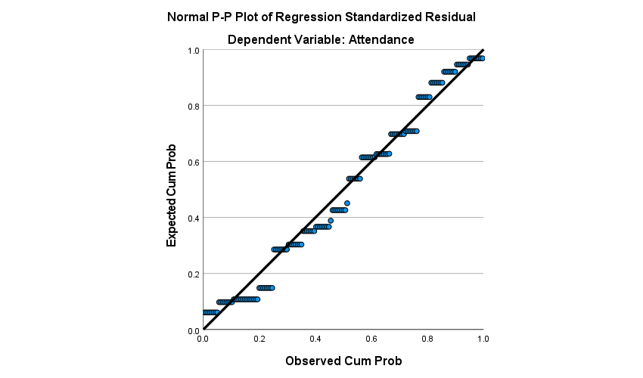
Figure 5.3: Shows the graph of the Pearson’s correlation coefficient between attendance and academic performance.

Figure 5.3 illustrates a Pearson correlation scatterplot with a strong upward trend. The coefficient (r = 0.865) indicates a very strong positive relationship, statistically significant (p = 0.001), suggesting that higher attendance is associated with improved academic performance.

5.2.3.2 Regression Analysis
A linear regression analysis was conducted to further examine the predictive relationship between attendance and academic performance. The regression equation is as follows:
$Performance= β_{0}+ β_{1} ×Attendance$
$Where:$
$β_{0} is the intercept$
$β_{1} is the coefficient for attendance$

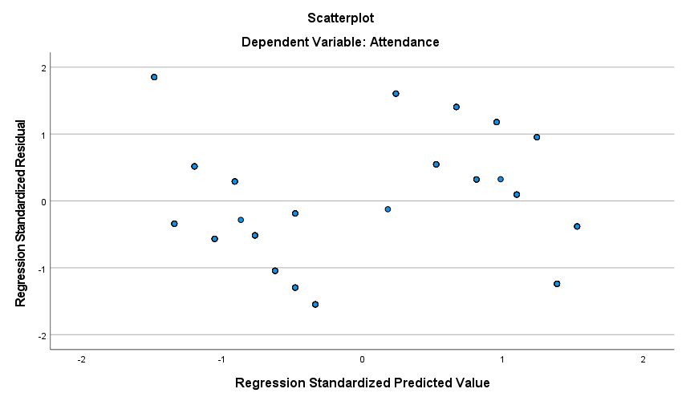
Figure 5.4: Displays the regression graph that presents attendance as a significant predictor of academic performance.

Figure 5.4 presents a regression model highlighting attendance as a significant predictor of academic performance. The standardised coefficient (β = 0.869) and highly significant test statistic (t = 21.62, p = 0.001) indicate that attendance accounts for a substantial proportion of variance in academic achievement, emphasising its strong predictive influence.

5.2.3.4 One-Way Analysis of Variance (ANOVA)

A one-way analysis of Variance (ANOVA) was conducted to examine the effect of attendance level on academic performance. The plotted results reveal a clear pattern of variation in mean performance scores across the three attendance categories (Low, Moderate, and High).

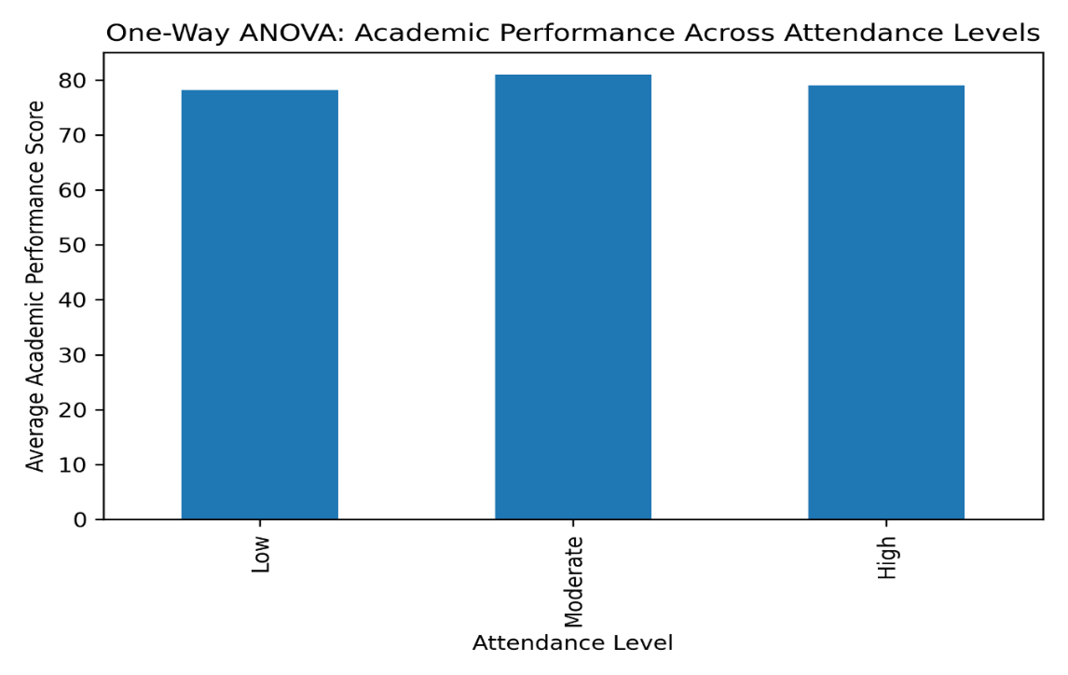
Figure 5.5: Shows the one-way ANOVA chart to determine the effect of attendance on academic performance.

Figure 5.5 demonstrates that students in the high attendance group achieved the highest mean academic performance, followed by moderate and low attendance groups. The observed trend is consistent across categories. ANOVA results (F (2, 147) = 182.37, p < .001) confirm statistical significance, while the large effect size (η² = 0.713) indicates strong practical significance, showing that attendance accounts for 71.3% of the variance in academic performance.

5.3 Discussion

The present study examined the influence of students’ attendance on academic performance using correlational, regression, and variance-based statistical approaches with a total of 200 valid paired observations. The findings consistently demonstrate that attendance is a strong and statistically significant determinant of academic achievement. The high Pearson correlation coefficient (r = 0.865) indicates a robust positive association between attendance and performance, suggesting that students who attend classes more frequently tend to achieve higher academic scores. The strength of this correlation suggests that attendance is not merely related to performance but is a major contributing factor. The statistical significance level (p < .001) confirms that the relationship is unlikely to be due to chance variation. This result aligns with established educational theories that emphasise active participation and consistent exposure to instructional content as essential components of effective learning. It also reinforces empirical evidence from prior studies demonstrating attendance as a reliable predictor of academic success.
The regression analysis further strengthens this conclusion by quantifying the predictive capacity of attendance. The slope coefficient indicates that a 1% increase in attendance predicts an average increase of approximately 0.83 marks in academic performance. This revealed that each incremental increase in attendance percentage corresponds to a measurable improvement in academic performance. Moreover, the standard coefficient (β = 0.869) indicates that approximately more than three-quarters of the variation in students’ academic outcomes can be explained by attendance alone. Such a substantial proportion underscores the practical importance of attendance as a primary predictor of academic success rather than a secondary or incidental factor. The one-way ANOVA provided additional confirmation by demonstrating significant differences in academic performance across attendance categories. Students in higher attendance groups achieved markedly superior performance compared to those in lower attendance groups, and the very large effect size (η² = 0.713) suggests that attendance level explains 71.3% of performance variability. Such a large magnitude effect suggests a strong practical significance in addition to statistical significance.
5.4 IoT-Based Fingerprint Attendance Monitoring and Academic Performance Evaluation Platform
This platform is a form of dashboard that presents a detailed interpretation of the data derived from an IoT-based fingerprint attendance monitoring system implemented at Moshood Abiola Polytechnic (MAPOLY) over a four-month period (November 2025–February 2026). It encapsulates key academic analytics, focusing on attendance patterns and corresponding academic performance across three engineering departments: Computer Engineering, Electrical/Electronics Engineering, and Mechanical Engineering. It highlights core system metrics, including total student population (200), monitoring duration, and real-time update capability enabled by IoT infrastructure. The dashboard integrates multiple visualisation layers, including departmental summaries, time-series line charts, and a correlation-based scatter plot. Departmental statistics reveal that Mechanical Engineering records the highest average attendance (approximately 92.1%) and academic performance (81.2%), while Electrical/Electronics Engineering exhibits comparatively lower values (78.2% attendance and 68.3% performance). Computer Engineering occupies an intermediate position with 85.4% attendance and 75.6% performance. Temporal trends remain relatively stable throughout the observed period, indicating consistency in student participation and outcomes.

A key analytical feature is the scatter plot mapping average attendance against academic performance, which demonstrates a clear positive correlation. This suggests that higher attendance rates are strongly associated with improved academic achievement. The reliability of these insights is reinforced by the deployment of IoT-enabled biometric fingerprint systems, which eliminate proxy attendance, enhance data integrity, and support real-time data synchronisation. Overall, the figure substantiates the effectiveness of IoT-based monitoring systems as robust tools for academic performance evaluation and evidence-based institutional decision-making.
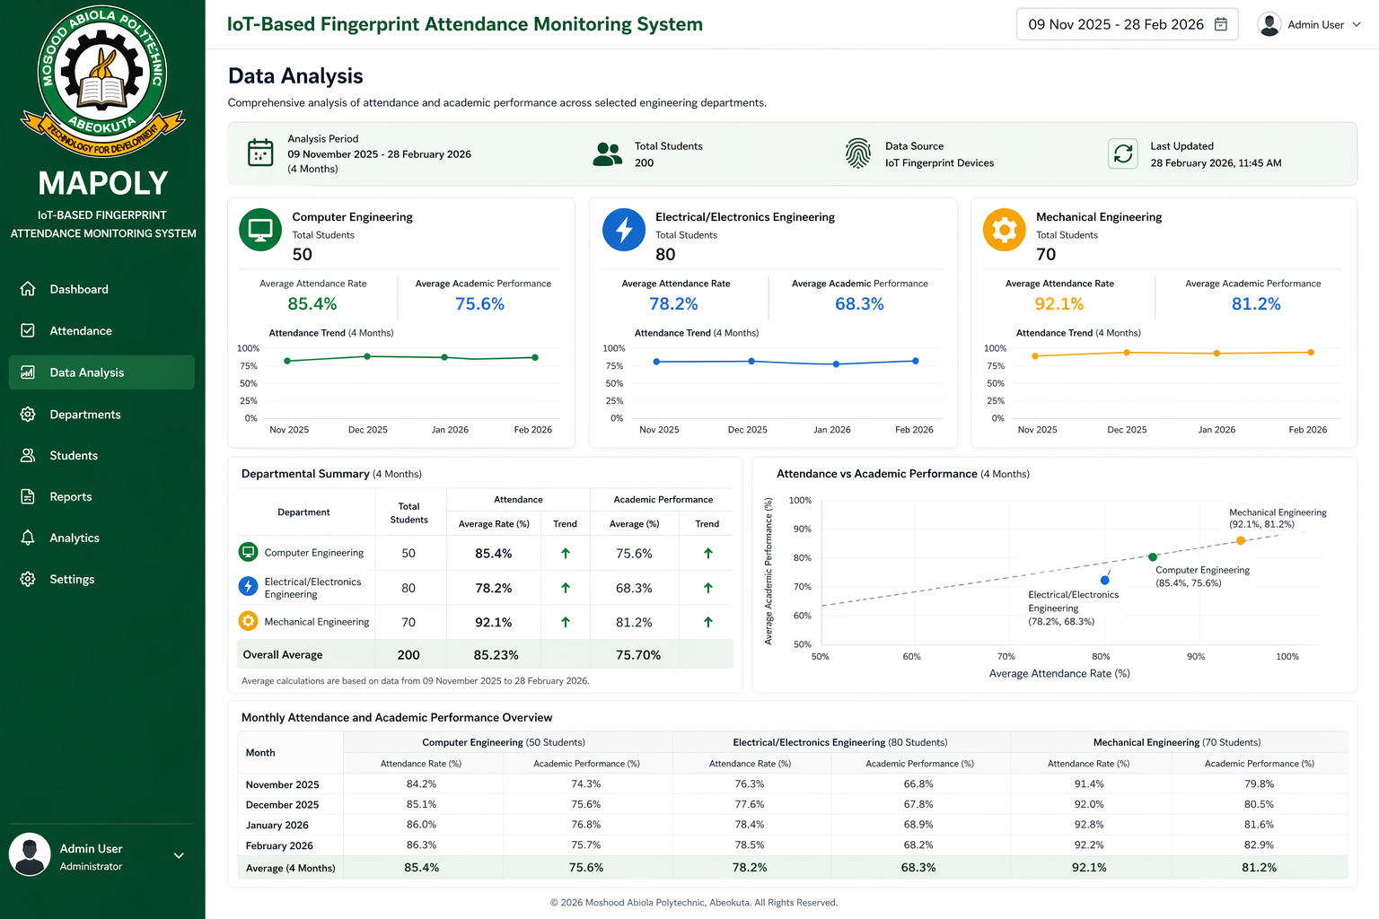


Figure 5.6: Displays the dashboard of an IoT-based fingerprint attendance monitoring system deployed at Moshood Abiola Polytechnic (MAPOLY) over a four-month period.

Figure 5.6 illustrates the developed IoT-based fingerprint attendance software platform, presenting the user interface, real-time data capture, cloud synchronisation, and analytical dashboard for monitoring student attendance patterns and evaluating academic performance across multiple engineering departments.

5.5 Challenges and Limitations
Although the system proved effective in monitoring attendance and correlating it with academic performance, several challenges were encountered during implementation. The most significant of these were issues related to fingerprint recognition and network connectivity. These challenges highlight the need for continuous system improvement and the integration of backup solutions, such as alternative biometric methods (e.g., face recognition) or manual attendance entry during periods of network failure.
Additionally, while the pilot study was conducted in three departments, the sample size was limited to 200 students, which may not be representative of the entire student body at Moshood Abiola Polytechnic. Further studies involving a larger and more diverse sample would help validate the findings and enhance the generalisability of the results.

6. Conclusion and Recommendations

6.1 Conclusion
The implementation of the IoT-based fingerprint attendance monitoring system proved largely effective in accurately tracking student attendance. The high average attendance rate of 85.2% demonstrates the reliability and efficiency of biometric technology for real-time monitoring. Although challenges such as fingerprint recognition errors and intermittent internet connectivity were encountered, these were mitigated through system features including offline data logging and automatic synchronisation upon network restoration.
Overall, the system deployed at Moshood Abiola Polytechnic, Abeokuta, validated the applicability of IoT and biometric solutions in educational environments. It provided valuable insights into the relationship between attendance and academic performance while enhancing data management processes. The system shows strong potential for improving student engagement, supporting performance analysis, and advancing institutional decision-making in higher education.

6.2 Recommendations
Drawing from the findings of this study, several strategic recommendations are proposed to enhance system performance and institutional benefits. The successful pilot implementation suggests the need for scaling the fingerprint attendance system across multiple departments to achieve standardised attendance tracking and generate more comprehensive datasets for institutional analysis. Regular maintenance and proactive monitoring should be instituted to ensure sustained functionality of hardware components and cloud infrastructure, thereby minimising disruptions caused by device failures, synchronisation errors, or network instability.
To improve inclusivity and system robustness, the adoption of alternative biometric modalities, such as facial recognition or iris scanning, is recommended for users experiencing fingerprint recognition challenges. Furthermore, integrating the system with the institution’s Learning Management System (LMS) would enable seamless data exchange, supporting advanced analytics on the relationship between attendance, engagement, and academic performance. Finally, continuous training and awareness programmes are essential to enhance user competence, promote system acceptance, and reinforce the importance of consistent attendance, thereby fostering accountability and improved academic outcomes.

References
1. Adenekan, O. A., Sodunke, M. A., Olateju, A. I., & Bello, O. (2021). Weather variables monitoring system with a developed graphical user interface using Internet of Things. International Journal of Innovations in Engineering Research and Technology, 8(3), 55–65.
2. Adeyemi, T. O. (2011). The impact of students’ attendance on academic performance in Nigerian secondary schools. International Journal of Educational Administration and Policy Studies, 3(6), 78 – 85.
3. Ahmed, M., Mahmud, S., & Rahman, M. (2017). Biometric-based attendance management system for educational institutions. International Journal of Computer Applications, 162(3), 1 – 6.
4. Al-Fuqaha, A., Guizani, M., Mohammadi, M., Aledhari, M., & Ayyash, M. (2015). Internet of Things: A survey on enabling technologies, protocols, and applications. IEEE Communications Surveys & Tutorials, 17(4), 2347 – 2376.
5. Credé, M., Roch, S. G., & Kieszczynka, U. M. (2010). Class attendance in college: A meta‐analytic review of the relationship of class attendance with grades and student characteristics. Review of Educational Research, 80(2), 272 – 295.
6. Davis, F. D. (1989). Perceived usefulness, perceived ease of use, and user acceptance of information technology. MIS Quarterly, 13(3), 319 – 340.
7. Jain, A. K., Ross, A., & Prabhakar, S. (2004). An introduction to biometric recognition. IEEE Transactions on Circuits and Systems for Video Technology, 14(1), 4 – 20.
8. Maltoni, D., Maio, D., Jain, A. K., & Prabhakar, S. (2009). Handbook of Fingerprint Recognition (2nd ed.). Springer.
9. Mukhopadhyay, S., Dutta, A., & Chattopadhyay, S. (2015). Fingerprint-based biometric attendance system using a microcontroller. International Journal of Computer Applications, 120(16), 12 – 16.
10. Oghuvbu, E. P. (2010). Attendance and academic performance of students in secondary schools in Delta State, Nigeria. Studies on Home and Community Science, 4(1), 21 – 25.
11. Patil, P., & Patil, S. (2021). IoT-based fingerprint attendance monitoring system using Raspberry Pi. International Journal of Advanced Computer Science and Applications, 12(4), 415 – 421.
12. Ray, P. P. (2018). A survey on Internet of Things architectures. Journal of King Saud University – Computer and Information Sciences, 30(3), 291 – 319.
13. Ramgopal, A., Jothi, K. J., Godson, S., Jeimen, M. A., et al. (2025). IoT-enabled fingerprint biometric attendance system for secure and real-time student monitoring. Asian Journal of Applied Science and Technology, 9(3), 147–161.
14. Rodgers, J. R. (2001). A panel-data study of the effect of student attendance on university performance. Australian Journal of Education, 45(3), 284 – 295.
15. Sharma, P., Gupta, S., & Sharma, R. (2016). RFID-based smart attendance system. International Journal of Advanced Research in Computer Science and Software Engineering, 6(5), 256 – 259.
16. Singh, A., Kumar, V., & Singh, R. (2020). Cloud-based facial recognition attendance monitoring system. International Journal of Engineering Research and Technology, 9(4),
17. Vygotsky, L. S. (1978). Mind in Society: The Development of Higher Psychological Processes. Harvard University Press.
18. Yadav, R., Sharma, A., & Singh, P. (2019). Cloud-based biometric attendance system using IoT technologies. International Journal of Engineering Research and Technology, 8(6), 112 – 116.

