Deciphering Groundwater Geochemical Signatures in Central Odisha Using Multivariate Techniques
Pragnya Paramita Das^{1*}, Nandita Mahanta²
ABSTRACT
The current study aims at evaluating the hydrogeochemical characteristics of groundwater and its associate geochemical processes occur in different aquifer system in Kaniha Block of Angul District, Odisha, using graphical techniques, multivariate statistical techniques and ionic ratio analysis. The study is carried out by using 81 groundwater samples during premonsoon season. The groundwater in the study area is mostly alkaline, with moderately hard to hard. The order of dominance of the chemical parameters in the study area is Ca²⁺>Na⁺>Mg²⁺>K⁺ and HCO₃⁻>Cl⁻> SO₄²⁻>NO₃⁻ respectively. The analysed data were plotted in Piper-trilinear, and Gibbs diagrams for the evaluation of hydrochemical facies and the geochemical processes responsible for the water chemistry. The water chemistry of the study area is varied from Ca²⁺-Mg²⁺-HCO₃⁻ type to Ca²⁺-Mg²⁺-Cl⁻ type which controlled by rock-water interactions with the influence of evaporation, particularly in a shallow aquifer. The impact of mineral weathering and ion exchange reactions within the aquifer system is confirmed by Gibbs plots, molar ratios, bivariate plots, and chloro-alkaline indices (CAI-I & CAI-II). This study also utilizes chemometric methods (Correlation Coefficient, Principal component Analysis, Hierarchical cluster analysis) to explore the geochemical evolution and the key factors influence the groundwater chemistry. Three major processes, such as anthropogenic carbonate-sulphate dissolution, ion exchange with silicate weathering, and geogenic fluoride enrichment, which account for a total of 73.72% of groundwater chemistry variance, were extracted using Principal component analysis. Cluster analysis was performed to classify the parameters based on key hydrogeochemical processes occurring on the flow path.
Keywords: Geochemical evolution, Correlation co-efficient Analysis, Principal component Analysis, Hierarchical cluster analysis, Kaniha Block.

INTRODUCTION
Water is the most important and vital resource for drinking, agriculture, industry and natural eco system [1]. The surface water reservoirs are insufficient for household activities and irrigation. Due to increase of human settlement, the groundwater dependency is intensified day by day for the purpose of household as well as for agricultural activities and industrialisation [2][3]. The quality of groundwater is impacted by the expansion of industrialization, urbanization, and agricultural activities [4][5]. Therefore, it is very much essential to assess the groundwater resources and manage the resource strategically. For which, proper understanding of the hydrogeological processes and regular monitoring of water quality is mostly needed. Groundwater chemistry and quality depend on geological factors and anthropogenic sources [6][7][8]. Groundwater quality is primarily controlled by lithology, dissolution, mineral precipitation, ion exchange in irrigated areas and residence time of dissolve ions [7][9]. The comprehensive knowledge of the groundwater chemistry and aquifer characteristics is essential for the hydrological and chemical evaluation of groundwater. The geochemical development of groundwater is characterized by processes such as silicate weathering, carbonate dissolution, cation exchange, and evaporation [10][11]. The quality and quantity of dissolved ions in the groundwater system depends upon primarily the chemical composition, solubility properties of minerals present in the host rock and the anthropogenic activities as secondary sources [6]. In the hydrological cycle after precipitation the water recharged in the soil through the process of infiltration reaches the aquifer system through the interaction of different rock materials [12]. The infiltration rate is also determined by the porosity and permeability of the host rock. During movement of water from surface soil to aquifer system so many geochemical reactions such as adsorption, precipitation, dissolution takes place along its path [12]. The other external factors such as climatic condition, topographical variation also affect the geochemical processes [13]. The rate of geochemical reactions depends upon the thermodynamics and kinetic characteristics of reactants and products as well as the rate of actual interfacial reactions or the transport process that moves reactant and products [14]. The geochemistry of the groundwater studied by the rock-water interaction and the surface and interfacial reaction processes. The aim of this research is to analyse chemical properties of groundwater and hydrogeochemical Evolution using graphical analysis, binary diagrams, chemometric analysis methods in the Kaniha block of Angul district, Odisha.
Study area
The study area is Kaniha block which is situated on the northeastern part of the Angul district, Odisha. The block lies between east longitude 84°56´41.571ʺand85°12´35.663ʺ and north latitude 21°00´47.9ʺ and 21°15´10.8ʺ having geographical area of about 723 sq.km (Figure 1). The region experiences a subtropical to tropical temperate monsoon climate. The normal rainfall for this region is 1219 mm.
Geological Setting
The study area is geographically divided into two regions. The northern and northeastern sections of the block are composed of charnockite and khondalite, along with granitic gneiss from the Precambrian basement [15]. The rocks of Iron-Ore Supergroup are exposed to the north of Brahmani River and central part of the block, consisting mainly of quartzites and mica schists [16]. The southern section of the area is occupied by Gondwana Supergroup with sandstone, shale, coal, conglomerate and boulder beds. Barakar Formation is the main coal bearing formation with water bearing aquifer [15]. The primary drainage system in the study area is managed by the Tikra Jhora, Singhada jhora, and Bhalutungri nullah are traversed by the Brahmani River. Most of the area is occupied by “Alfisols” which includes red sandy soil, red loamy soil, and mixed red and black soils. [16][17].

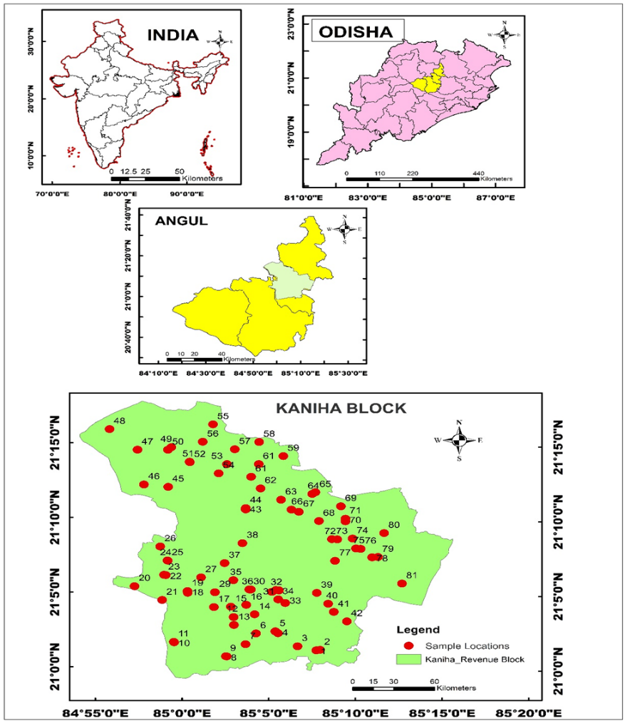
Figure 1: Location map of study area with sampling points.
MATERIALS AND METHODS
Sampling and Analysis of groundwater
A total of 81 representative groundwater samples were collected from different bore-wells and dug-wells, which are widely used for drinking with other domestic purposes in pre pre-monsoon season, 2022. Before sampling, 500 ml bottles have been soaked with 1:1 HCl for twenty-four hours and then washed twice with distilled water. For quality determination, groundwater samples were analysed for various physicochemical parameters. The physical parameters are “hydrogen-ion concentration (pH), electrical conductivity (EC), total dissolved solids (TDS), and total hardness (TH) as CaCO₃” and the chemical parameters are concentration of major cations (Calcium (Ca²⁺), Magnesium (Mg²⁺), Sodium (Na⁺), Potassium (K⁺) with major anions (Bicarbonate (HCO₃⁻ ), Chloride (Cl⁻), Sulphate (SO₄²⁻), Nitrate (NO₃⁻), and Fluoride (F⁻) ). All analyses were performed in the laboratory following standard laboratory procedures suggested by the “American Public Health Association” [18]. The parameters such as pH, electrical conductivity (EC) and temperature were analysed at the field using the water analyser 371 (Systronics), and other chemical parameters were analysed in the laboratory. The parameters like Total hardness (TH), calcium (Ca²⁺), bicarbonate (HCO₃⁻ ), chloride (Cl⁻) were analysed in the laboratory using the titration method, sodium (Na⁺), potassium (K⁺) using Flame photometer and sulphate (SO₄²⁻) using UV Spectrophotometer. The concentration of all the chemical parameters were expressed in milligrams per litre, except pH (no units) and EC μS/cm. The ionic balance error percentage (IBE%) was calculated between all cations and anions concentrations which are within its acceptable limit of ± 5% [19] (Equation 1).
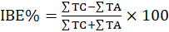 (1)
∑TC=total ionic concentration of cation expressed in milliequivalent per litre (meq/l).
∑TA=total ionic concentration of anion expressed in milliequivalent per litre (meq/l).

Graphical Methods for Evaluation of Geochemical Processes
The geochemical properties of groundwater and facies analysis along with its origin at different aquifer system were assessed using Piper-Trilinear, Gibbs diagram, and ion-scatter diagrams [8][19][20][21][22]. For the study of water rock interaction and mechanisms which are controlling the water chemistry, Gibbs (1970) introduced Gibbs scatter diagram [19][20]. Gibbs ratio for anion and cation was calculated by using the Equations (2) and (3).
Gibbs Ratio (1) = Cl⁻/ (Cl⁻ +HCO₃⁻) (2)
Gibbs Ratio (2) = (Na⁺ +K⁺) / (Na⁺ +K⁺ +Ca²⁺) (3)
Ionic ratio
By identifying the predominant geochemical processes governing groundwater evolution, ionic ratios like Na⁺/Cl⁻, Ca²⁺/Mg²⁺, HCO₃⁻/Cl⁻, and (Ca²⁺ + Mg²⁺)/HCO₃⁻, chloro-alkaline indices offer further evidence to support the chemometric findings [23][24][25]. The Chloro-alkaline indices (CAI-1 & CAI-2) as proposed by Scholler (1977), calculated as given below in Equations 4 and 5 (ions are in meq/l).
CAI-1= {Cl⁻ - (Na⁺ +K⁺)}/Cl⁻ (4)
CAI-2= {Cl⁻ - (Na⁺ +K⁺)}/ {SO₄²⁻+ HCO₃⁻+NO₃⁻} (5)
These indices show the different contributions of silicate weathering, evaporite (gypsum/halite) dissolution, carbonate dissolution, and cation exchange processes along the flow routes. In wells with longer residence times, deeper circulation, or constrained aquifer conditions, the integrated interpretation confirms a progressive hydrochemical change from fresh, recharge-zone Ca–HCO₃ facies towards more developed, saline, Na-rich types. [10] [26-29] Both the indices have negative value indicate that base ion exchange process whereas positive value of both CAI represents the reverse ion exchange takes place [30][31].
Chemometric analysis
The chemometric analysis using different statistical and mathematical modelling such as correlation coefficients, PCA, Cluster analysis, is used to extensive and accurate study of the geochemical processes (geogenic or anthropogenic) and other factors which affects the groundwater chemistry [32][33][34]. The statistics analysis has been done by using SPSS software and XLSTAT and DATATAB statistical calculator.
Bivariate Coefficient Correlation Analysis
The coefficient Correlation Analysis is applied to find the correlation among the two variables, factors or dataset. The correlation is measured by computing Pearson’s Coefficient (r) and tested the significance of the parameters. The relationship among variables is measured by the numerical value of correlation coefficient (r ranges from +1 to -1). The positive sign indicates that one variable is directly related to the other whereas the negative sign indicates the inversely mutual relationship among them. The value of r is from 0.7 to 0.9 and 0.5 to 0.7 indicates that there is strong and moderate correlation among the variables respectively.
Principal Component Analysis of Physico-chemical parameters
The principal component analysis has been used to interpret all the complex variables or parameters and formed a reduced data frame which explains all the geochemical processes such as aquifer mineralization which affect the water chemistry [35]. PCA is performed using the varimax rotation and the principal components are extracted from the analysis using Kaiser Criterion [36] which is based on eigen values greater or equal to one. The principal components arranged in diminishing order of variance; the greatest variance is the first principal component (PC1). Principal component analysis reduces all the parameters or variables to a simpler factor or component that represents all the elements associated with the significant change in water quality in both dimensions [33][37].
Factor Analysis of Ionic ratio
To gain a deeper insight into the geochemical processes influencing groundwater development, a selection of diagnostic ionic ratios was utilized for factor analysis. These ratios were specifically chosen because they are effective indicators of mineral weathering, ion-exchange reactions, salinity sources, and human activities [38]. To capture essential hydrogeochemical processes, a range of diagnostic ionic ratios was chosen for factor analysis, ratios are Ca/Mg, Ca/(HCO₃+SO₄), Ca+Mg /HCO₃, Na/Cl, Na/Ca, (Na+K)/(Ca+Mg), (Na+K)/Cl, Cl/HCO₃, CAI-1, CAI-2, SO₄/Cl and NO₃/Cl.
Cluster Analysis
The classification of variables has been performed by using Hierarchical cluster analysis of 81 groundwater samples and 13 parameters. The analysis is done by the ward’s method of linkage with squared Euclidean distance as measure of similarity [39]. By the method of R-mode cluster analysis, the key geochemical processes affecting the groundwater quality have been highlighted.
RESULTS AND DISCUSSION
Physical Parameters and Ion Concentrations
The descriptive statistical summary of all the physical and chemical parameters is presented in Table 1. The pH value of the study area is from 6.52 to 8.7 with mean 7.67, which shows the ground water quality is slightly acidic to alkaline. The EC Value of the groundwater of the study area is varying from 390.00 to 2473.00µS/cm with an average of 1323.50µS/cm. The high EC value indicates high mineral content, which is attributed due to nature of aquifers, low runoff, high infiltration and discharged water type and the low value of EC indicates low salt enrichment due to high elevated topography, high runoff, low infiltration, recharge water type [40]. Based on classification 51 samples fall under the Type-I (EC<1500µS/cm; with low salt enrichment), 30 samples fall under Type-II (EC 1500 µS/cm -3000 µS/cm; with medium salt enrichment) and none of the samples fall in Type-III(EC>3000 µS/cm; high salt enrichment) [41]. The TDS Value in the study area are from 253.5 to 1607.45 with an average 860.28 Mg/L. The total hardness value of the study area is from 90.00 to 393.00 with an average 216.58 mg/l. According to sawyer and Macarthy (1967) classification [42], 15 samples are moderately hard,55 samples are hard, 11 samples are very hard. The groundwater of the study area is moderately hard to hard but within permissible limit. The order of abundance of cations and anions of the study area are in order as Ca²⁺> Na⁺> Mg²⁺> K⁺ and HCO₃⁻> Cl⁻ > SO₄²⁻>NO₃⁻ respectively. The Concentration of Calcium (Ca²⁺⁾) is the dominant cation (with mean 58.856mg/l) followed by Na⁺(with avg. 43.369 mg/l), Mg²⁺(avg. 16.57 mg/l), K⁺(avg.5.76 mg/l)
Parameters | Minimum | Maximum | Mean | Standard deviation (n-1) | Skewness (Pearson) | Kurtosis (Pearson) | Shapiro-Wilk-p
pH | 6.520 | 8.700 | 7.673 | 0.448 | -0.180 | -0.489 | 0.441
EC | 390.000 | 2473.000 | 1328.175 | 515.152 | 0.367 | -0.521 | 0.094
TDS | 249.600 | 1582.720 | 850.032 | 329.697 | 0.367 | -0.521 | 0.094
TA | 50.000 | 550.000 | 265.679 | 115.775 | 0.313 | -0.322 | 0.343
TH | 90.000 | 393.000 | 216.580 | 72.918 | 0.394 | -0.555 | 0.155
Ca²⁺ | 13.650 | 119.000 | 58.856 | 24.609 | 0.446 | -0.016 | 0.085
Mg²⁺ | 5.710 | 30.490 | 16.577 | 5.771 | 0.462 | -0.330 | 0.064
Na⁺ | 9.470 | 85.000 | 43.369 | 19.417 | 0.089 | -0.913 | 0.118
K⁺ | 0.470 | 12.360 | 5.769 | 2.973 | 0.231 | -0.817 | 0.052
Cl | 12.200 | 110.650 | 60.044 | 23.887 | 0.183 | -0.646 | 0.271
HCO₃⁻ | 100.540 | 312.540 | 220.426 | 49.597 | -0.193 | -0.785 | 0.137
SO₄²⁻ | 1.800 | 77.560 | 37.491 | 18.504 | 0.251 | -0.513 | 0.154
F | 0.050 | 1.580 | 0.665 | 0.320 | 0.402 | -0.229 | 0.204
NO₃⁻ | 1.230 | 29.650 | 13.418 | 6.691 | 0.425 | -0.277 | 0.094
Table 1: Descriptive statistical summary of all physical and chemical parameters groundwater in Kaniha block

The main source of Ca²⁺is due to calcium bearing minerals present in the rock like plagioclase, amphibole and pyroxene [43]. The increase of Na⁺ level in the groundwater due to cation exchange from the source rock containing sodium feldspar and clay minerals as well as domestic wastes, septic tank leakage and agricultural practices are responsible for enrichment of Na⁺ in the groundwater chemistry [7].
The Mg²⁺ occurs in the groundwater in association with Ca²⁺ and derived from the weathering of ferromagnesium minerals like biotite, hornblende present in the rock and may be due to anthropogenic sources like mining or industrial activities [19]. The concentration of Potassium(K⁺) in the groundwater due to the application of chemical fertilizer in agriculture rather than source from weathering of potassium feldspar bearing mineral rocks [40].
Among anions the value of HCO₃⁻ having concentration avg. 221.1 mg/L is followed by Cl⁻(avg. 60.04 mg/l), SO₄²⁻(avg. 37.491 mg/l), NO₃⁻(avg. 13.418 mg/l), F⁻( avg.0.665 mg/l) are present in the groundwater. The higher concentration of bicarbonate is due to weathering of silicate rock with content of CO₂ in the soil, which produces the water alkaline in nature [40].
Another important anion presents in the ground water is chloride (Cl⁻) which derived from the various sources such as rock weathering, leaching in semi-arid climate with poor drainage condition and from irrigation return flow and may be due to sea water intrusion [19]. The sulphate (SO₄) present in the groundwater comes from the weathering of sulphate bearing minerals and from the use of gypsum in agricultural field [40].
The fluorite content in the groundwater body due to the dissolution of fluorine into groundwater from fluorine-containing minerals present in rocks (apatite, biotite, amphibole) and the excessive use of chemical fertilizers, especially phosphate fertilizers along with anthropogenic influences, such as fly ash from burning fossil fuels, also contribute to fluoride concentrations [2][44].

Hydro-Chemical Facies of Groundwater
The facies analysis of the study area is obtained from the piper trilinear diagram (Figure 2), which shows that water samples fall in the “Ca-HCO₃”, Ca-Mg-Cl -SO₄ and mixed type of facies. Dug well samples are clustered in the Ca-HCO3 and mixed Ca-Mg-Cl-SO₄ facies which represent the recent recharge with limited mineralisation. The facies Ca-HCO₃ is thought to be due to rock weathering and cation exchange reactions [23][45]. For An alkaline pH with comparatively greater Ca²⁺ and Mg²⁺ concentrations and lower SO₄²⁻ concentration could have regulated the ion dissolution in the coal-bearing aquifer [33]. Tube well samples are mostly falling in the Na⁺-K-HCO₃⁻ and mixed type of facies which suggested that groundwater influenced by ion exchange, silicate weathering and longer subsurface circulation. Some of the tube well samples are trending towards chloride and sulphide dominant facies which signifies that mineral dissolution or influence of anthropogenic inputs.
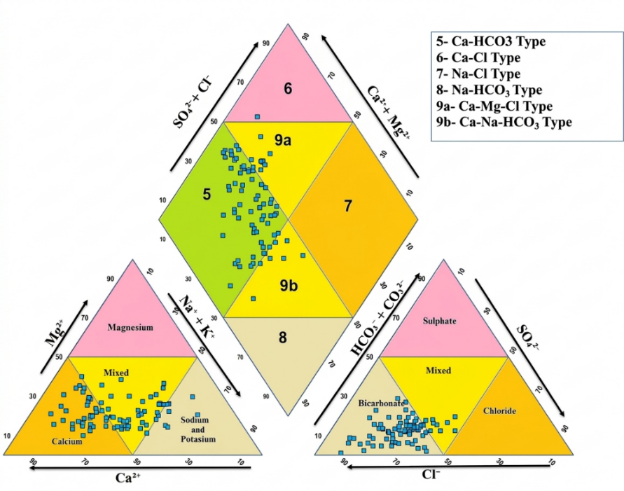
Figure 2: Piper trilinear diagram showing hydrochemical facies.
Gibbs Diagram and Rock-Water interaction
Gibbs diagrams use the relationship TDS vs. (Na⁺+ K⁺)/ (Na⁺+K⁺+Ca²⁺) and TDS vs. (C1⁻) / (C1⁻+HCO₃⁻) to explain the origin of chemical components in water in relation to precipitation (atmosphere), rock (lithology), and evaporation (climate) in groundwater systems which shown in Figure 3a and 3b [21]. According to Gibbs plot, it is found that “all most all the water samples fall in the rock dominance field”, which indicates that the ionic dominance due to weathering of the host rock and ion exchange. Few samples are drifted towards evaporation dominance due to surface exposure and anthropogenic contact.
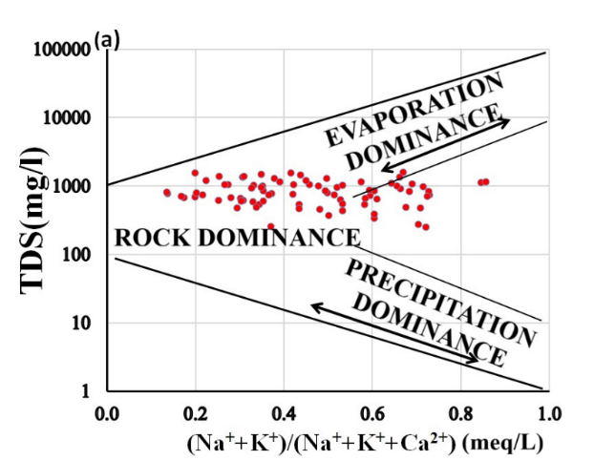 | 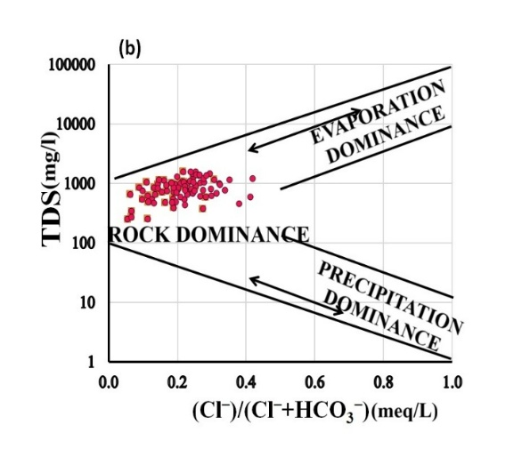
Figure 3: (a)Gibbs Diagram (Cation) (b) Gibbs Diagram (Anion)

Ion Exchange Process
For further evaluation of the geochemical characteristics and reactions, from the plot of “Ca²⁺/Na⁺ vs Mg²⁺/Na⁺” and “Ca²⁺/Na⁺ vs HCO₃⁻/Na⁺” (Figure 4a and 4b), it is found that most of the samples from deep and shallow aquifers are exhibiting a clear positive trend. The pattern indicates the progressive transitional in geochemical control. The samples are falling in the lower Ca²⁺/Na⁺ and HCO₃⁻/Na⁺ ratio range, indicating comparatively longer groundwater residence times and ion exchange reactions whereas greater ratios, indicating that the hydrochemistry is primarily influenced by the dissolution of silicate and carbonate minerals [46].
The detailed study about the mechanism of rock weathering by using the diagram Ca²⁺ +Mg²⁺ vs HCO₃⁻ which is shown in Figure 4c. All the groundwater sampling points in this diagram fall above the equiline that the dissolution of silicate minerals like feldspars and pyroxenes is mostly responsible for the release of divalent cations [47].
The scatter plot between HCO₃⁻+ SO₄²⁻ and Ca²⁺ +Mg²⁺ provide in Figure 4d where the sampling points deviate from the theoretical line (1:1) and move towards HCO₃⁻+ SO₄²⁻ which indicating the excess of HCO₃⁻concentration due to ion exchange process by weathering of Na⁺ and K⁺ silicates [30][48]. From the scatter diagram “Ca²⁺+Mg²⁺ vs Na⁺+K⁺” which shown in Figure 4e, the points move towards Ca²⁺+Mg²⁺, so that they have appeared as major contributor and lower Na⁺+K⁺ due to Ca²⁺/Na⁺ exchange reaction. The weathering of sodium feldspar and potassium feldspar which are present in the biotite gneiss, is the prime contributor of Na⁺ and K⁺ in the groundwater [47][49].
From the scatter diagram “Ca²⁺+Mg²⁺ vs Total Cation” which shown in Figure 4f, some points lies above and close to line 1:1 which shows dominance of alkaline earth metals in the groundwater over alkalis. Most of the points moved towards total cation from Ca²⁺+Mg²⁺ dominance zone, so that weathering of carbonate and silicate minerals may release Mg²⁺ and Ca²⁺ ions into the system during rock-water interaction. [45].
The molar ratio of Na⁺/Cl⁻ is ranging between 0.202 to 5.522 with an average 1.394. Most of the samples have ratio more than one, which implies that the cation ion exchange takes place in the aquifer system and ratio less than 1 also indicated that reverse ion exchange process takes place in the aquifer system [9]. In the Figure 4g, the samples from dug well (Shallow aquifer) are fall above the equiline, which indicated that higher Cl⁻ values, reflecting the influence of surface recharge mixed with minor anthropogenic inputs.
From the Figure 4h, the Na/Cl ratio exhibits a modest negative connection with EC (R² = 0.0837), suggesting that sodium's proportionate contribution to chloride reduces as salinity rises samples having elevated Na/Cl ratios at lower EC values likely correspond to recharge zones influenced by silicate weathering or initial stages of cation exchange [9][50]. However, samples with reduced Na/Cl ratios along with higher EC values suggest progressive salinization may be due to evaporation process in shallow aquifer and enhanced ion-exchange reactions occurring in deeper aquifer sections [51][52].
The ion exchange processes are further explained by calculation of chloro-alkaline indices (CAI-1 and CAI-2) in Equation 4 and 5. The values of CAI-1and CAI-2 of the study area, 47 samples have negative value which implies that the ion exchange process takes place where Ca²⁺ and Mg²⁺ in water exchanged with Na⁺ and K⁺ from the host rock (Figure 4i and 4j). Whereas 34 samples have positive value which defines that reverse ion exchange process takes place where Ca²⁺ and Mg²⁺ in water exchanged with Na⁺ and K⁺ from the host rock [31][53].
Chemometric Analysis
The chemometric analysis refers to various statistical methods for extensive study of ground water quality as well as geochemical evolution. The methods are “bivariate coefficient correlation analysis, multivariate factor analysis, principal component analysis, cluster analysis” for assessment and management of water quality and explore the different geochemical processes affect the water chemistry [32]. These techniques are organized and simplified by the dataset.

Bivariate Coefficient Correlation Analysis
The correlation matrix dataset is presented at Table 2. There is a strong correlation(r=1.000) exist among Total dissolve solid (TDS) and Electrical conductivity (EC), indicating that groundwater conductivity is directly governed by ionic concentration.
Total hardness (TH) is highly correlated with both Ca²⁺ (r=0.926) and Mg²⁺ (r=0.495), suggesting that the dissolution of carbonate and silicate minerals is the primary source of groundwater hardness. The significant positive correlations between TH–Cl⁻ (r=0.645) and TH–SO₄²⁻ (r=0.524) indicate that minerals containing sulphate and chloride, possibly enhanced by anthropogenic influences like domestic effluents.
The relationship between Ca²⁺–Cl⁻ (r=0.618) and Ca²⁺–SO₄²⁻ (r=0.478) suggests that calcium coexists with chloride and sulphate because of mineral weathering and concentration driven by evaporation [8]. The strong correlation of Ca²⁺⁻Cl⁻, Ca²⁺-NO₃⁻,Ca²⁺-SO₄²⁻ indicates the dissolution of plagioclase feldspar, sulphate bearing minerals (Gypsum) which are used as fertilizer [15]. The positive correlation of Na⁺–HCO₃⁻ (r =0.520) indicates the occurrence of cation exchange reactions and feldspar weathering, which implies that the enrichment of sodium is a consequence of rock–water interactions rather than the dissolution of halite, given the weak Na⁺–Cl⁻ correlation.
In a similar manner, the Na⁺–K⁺ (r =0.441) correlation illustrates their release from silicate minerals during the weathering process. The NO₃⁻ ion demonstrates significant positive correlations with TH (r =0.633), Ca²⁺ (r =0.576), and Cl⁻ (r =0.477), highlighting the impact of human activities, particularly from agricultural fertilizers and the leaching of organic waste.
Additionally, the negative correlation between pH and NO₃⁻ (r = –0.406) suggests that a lower pH level increases the mobility of nitrate and the dissolution of minerals within the aquifer system. The weak relationship between Ca²⁺ and Mg²⁺ indicates the base ion exchange reaction takes place in aquifer system [2].
The strong relationship between Cl- -SO₄²⁻ and weak relationship between Cl-HCO₃⁻ may be due to anthropogenic sources such as mineral dissolution, irrigation return water flow, drainage waste, septic tank leakage, chemical fertilizer [15]. Overall, the correlation findings indicate that the chemistry of groundwater is influenced by a mix of geogenic and anthropogenic factors, such as the dissolution of carbonates and silicates, ion exchange processes, and specific instances of anthropogenic contamination.

Table 2: Correlation Matrix of Physio-Chemical parameters

Variables | pH | EC | TDS | TA | TH | Ca²⁺ | Mg²⁺ | Na⁺ | K⁺ | Cl⁻ | HCO₃⁻ | SO₄²⁻ | F | NO₃⁻
pH | 1
EC | -0.207 | 1
TDS | -0.207 | 1.000 | 1
TA | 0.347 | 0.498 | 0.498 | 1
TH | -0.342 | 0.449 | 0.449 | 0.159 | 1
Ca²⁺ | -0.302 | 0.432 | 0.432 | 0.163 | 0.926 | 1
Mg²⁺ | -0.149 | 0.240 | 0.240 | 0.093 | 0.495 | 0.166 | 1
Na⁺ | 0.357 | 0.292 | 0.292 | 0.458 | -0.318 | -0.286 | -0.125 | 1
K⁺ | 0.370 | -0.175 | -0.175 | 0.059 | -0.434 | -0.437 | -0.137 | 0.441 | 1
Cl⁻ | -0.274 | 0.620 | 0.620 | 0.268 | 0.645 | 0.618 | 0.330 | -0.007 | -0.369 | 1
HCO₃⁻ | 0.208 | 0.236 | 0.236 | 0.353 | 0.366 | 0.340 | 0.249 | 0.520 | 0.218 | 0.061 | 1
SO₄²⁻ | -0.230 | 0.584 | 0.584 | 0.289 | 0.524 | 0.478 | 0.314 | 0.071 | -0.131 | 0.368 | 0.116 | 1
F | 0.159 | 0.197 | 0.197 | 0.126 | -0.171 | -0.190 | 0.028 | 0.271 | 0.037 | -0.081 | -0.002 | 0.182 | 1
NO₃⁻ | -0.406 | 0.412 | 0.412 | 0.011 | 0.633 | 0.576 | 0.319 | -0.266 | -0.474 | 0.477 | 0.046 | 0.388 | -0.194 | 1

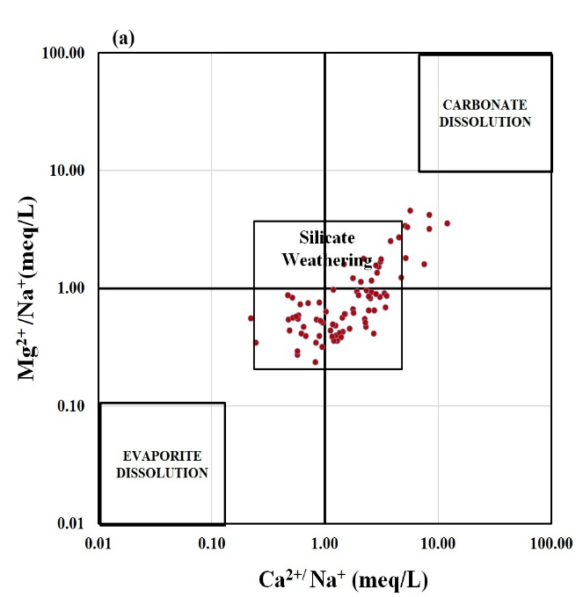 | 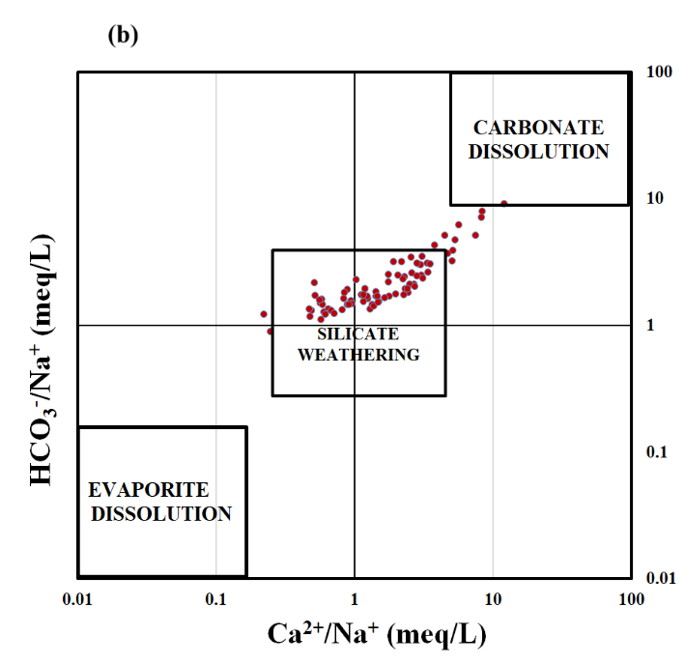
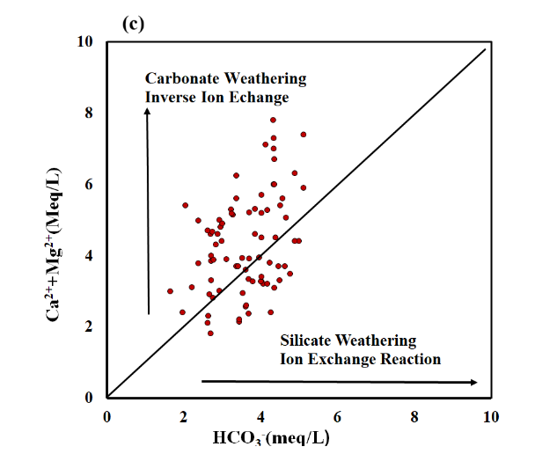 | 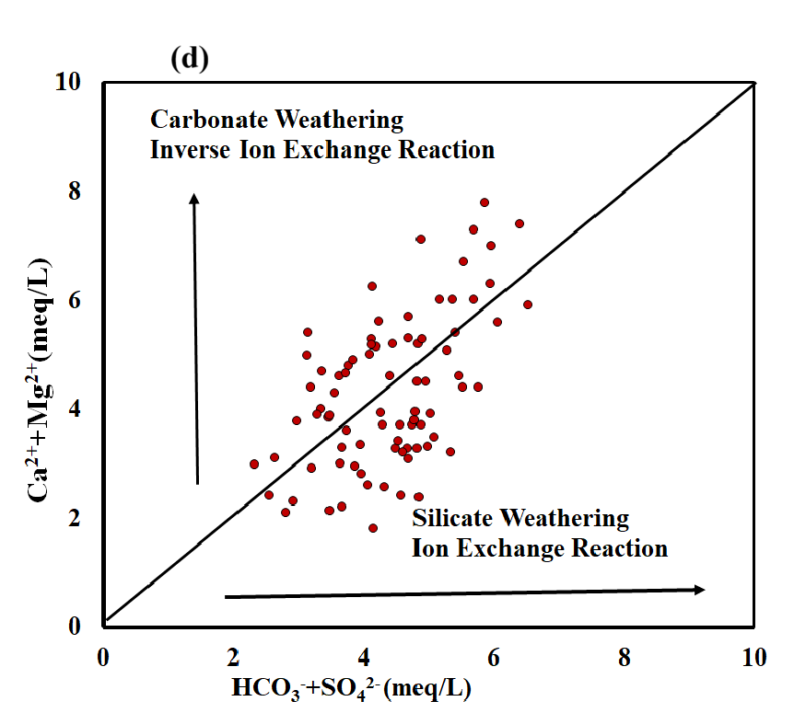
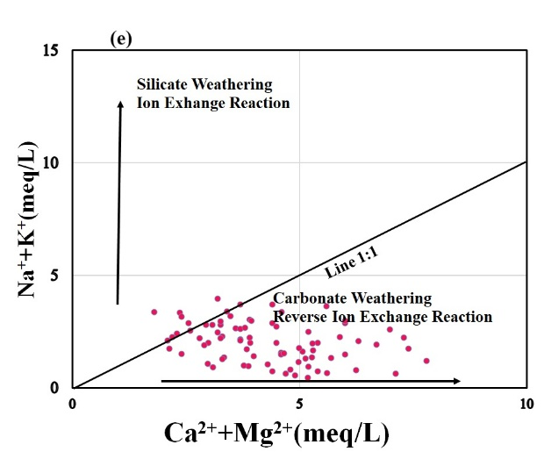 | 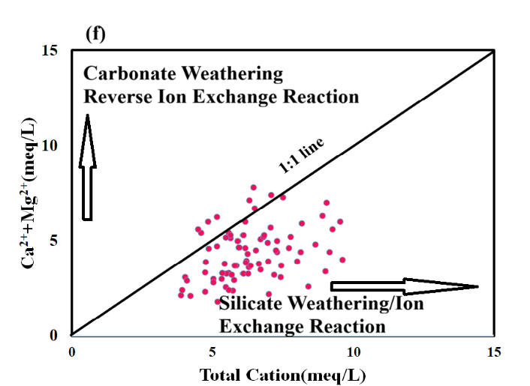
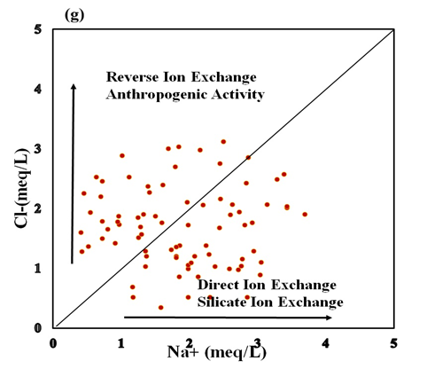 | 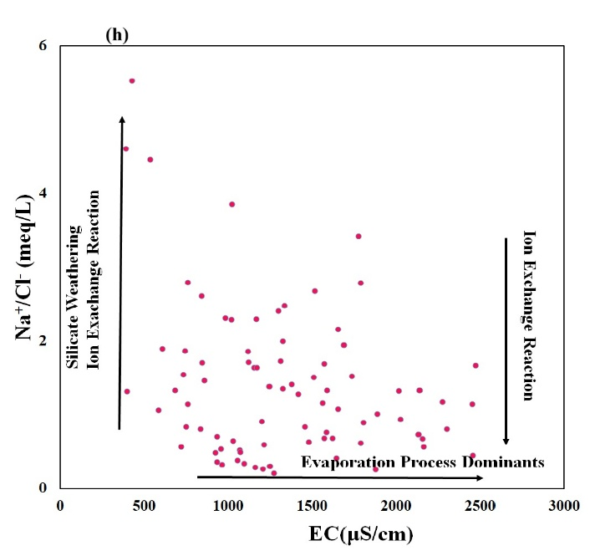
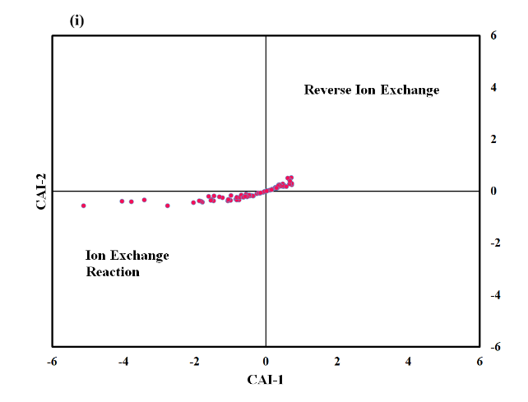 | 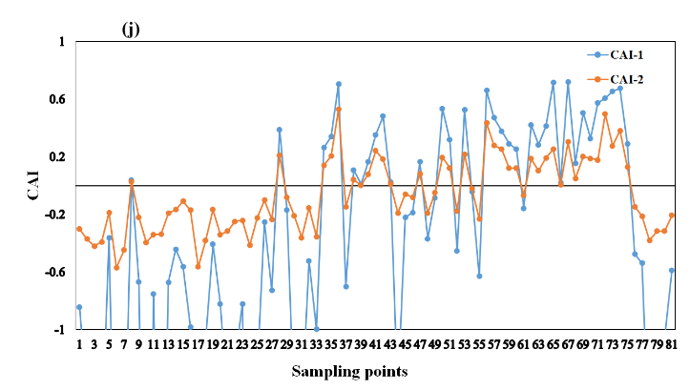
Figure 4: (a) Scatter Diagram of (Ca²⁺/Na⁺ ) vs (Mg²⁺/ Na⁺), (b) Scatter Diagram of (Ca²⁺/Na⁺ ) vs (HCO₃⁻/ Na⁺), (c) Scatter Diagram (Ca²⁺+Mg²⁺) vs (HCO₃⁻), (d)Scatter Diagram (Ca²⁺+Mg²⁺) vs (HCO₃-+ SO₄²⁻), (e) Scatter Diagram (Ca²⁺ +Mg²⁺) vs (Na⁺+K⁺),(f) Scatter Diagram (Ca²⁺ +Mg²⁺) vs Total Cation, (g) Scatter Diagram Na⁺ vs Cl⁻ , (h) Scatter Diagram (Na⁺/Cl⁻) vs EC, (i) Schoeller’s Diagram (CA1-1 vs CAI-2) (j)Graph of Chloro-Alkaline Indices

Principal component analysis
The principal Component Analysis was carried out using ten physicochemical parameters of groundwater to determine the primary hydrogeochemical processes that are active during the pre-monsoon period. According to Kaiser-Meyer-Olkin (KMO) and Bartlett’s tests, the data set was sufficient for PCA [54]. From Bartlett’s test of sphericity X² value is 570.87(df=45, p<0.001), which confirmed that correlation matrix differs significantly from identity matrix and that intervariable correlations are sufficient for PCA. The Scree plot and the three-dimensional component plot in rotated space are presented in Figure 5a and 5b respectively.
The result showed that three components have eigenvalue greater than 1, whose cumulative variance is 73.72% of the total variance and three components describe the different attributes to signify the water chemistry (Table 3). The first component has a variance of 40.80 % and contains large positive loading of TH (0.931), Ca²⁺(0.903), Cl⁻ (0.770), SO₄²⁻(0.630), TDS (0.668) and NO₃⁻(0.746).

Table 3: Principal component analysis of the parameters for the groundwater studied
Variable | PC1 | PC2 | PC3
TDS | .668 | .218 | .532
TH | .931 | .010 | -.200
Ca²⁺ | .903 | .016 | -.219
Na⁺ | -.168 | .788 | .422
K⁺ | -.505 | .610 | .014
Cl⁻ | .770 | -.037 | .144
HCO₃⁻ | .300 | .855 | -.163
SO₄²⁻ | .630 | .069 | .448
F⁻ | -.133 | .011 | .818
NO₃⁻ | .746 | -.228 | -.086
Eigen value | 4.080 | 2.055 | 1.236
Variance% | 40.801 | 20.553 | 12.361
Cumulative % | 40.801 | 61.354 | 73.715

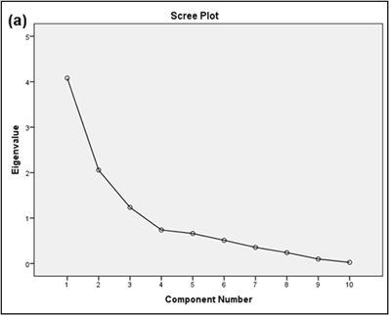 | 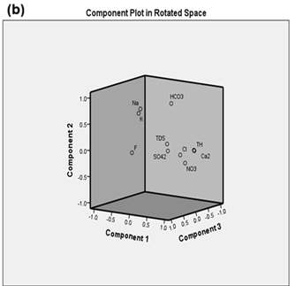

Figure 5: (a) Scree plot for PCA of the study area and (b) Component plots in rotated space.

The Factor loadings of PC1 indicates that the water chemistry influenced by carbonate and sulphate mineral dissolution, and anthropogenic inputs such as nitrate contamination from fertilizers or sewage infiltration [10]. The PC1 reflects mineral dissolution and anthropogenic enrichment governing groundwater salinity and Total hardness during the premonsoon period.
The PC2 has an eigen value of 2.055 with variance 20.553% of the total variance, having strong positive loading of Na⁺(0.788), K⁺(0.610), and HCO₃⁻(0.855). The robust correlation between Na⁺ and HCO₃⁻ suggests cation exchange and silicate weathering processes, wherein Na⁺ replaces Ca²⁺ and Mg²⁺ on clay mineral exchange sites. Prolonged water-rock contact within the aquifer system is suggested by elevated bicarbonate levels and somewhat higher pH values [10][55]. Thus, this factor represents groundwater's alkali enrichment and natural geochemical evolution [56].
PC3 having 12.36 % variance with moderate correlations with TDS (0.532) and SO₄²⁻ (0.448), as well as a substantial positive loading for F⁻ (0.818). This factor indicates the dissolution of fluoride-bearing minerals like fluorite, biotite, and apatite, indicates fluoride mobilization under high bicarbonate and low calcium circumstances [2][57]. This factor, which is often obtained from the alkaline conditions, the correlation with total dissolved solids implies that fluoride enrichment rises with residence duration and water–rock contact [58][59][27].
The PCA findings revealed that groundwater chemistry in the pre-monsoon period is primarily influenced by three interconnected processes such as carbonate and sulphate dissolution with anthropogenic influence (PC1), Ion exchange and silicate weathering (PC2), Fluoride enrichment from geogenic sources (PC3).
Factor Analysis of Ionic ratios
The main hydrogeochemical processes were identified by three key factors, with two having eigenvalues greater than one and the third having an eigenvalue of less than one, collectively explaining 85.75% of the total variation in the ionic ratio dataset (Table 4). The Scree plot for determination of factor using kaiser norm and three-dimensional component plot in rotated space are presented are shown in Figure 6a and 6b.

Table 4: Factor loadings of the ionic ratios.

 | F1 | F2 | F3
Ca/Mg | 0.458 | 0.482 | -0.624
Na/cl | -0.931 | 0.192 | -0.103
Ca/(HCO₃+SO₄) | 0.909 | 0.285 | -0.196
Ca+Mg/HCO₃ | 0.908 | 0.147 | 0.248
Cl/HCO₃ | 0.758 | -0.357 | 0.209
Na/Ca | -0.812 | -0.339 | 0.234
(Na+K)/Ca+Mg) | -0.868 | -0.330 | -0.025
(Na+K)/Cl | -0.928 | 0.200 | -0.099
CAI-1 | 0.928 | -0.200 | 0.099
CAI-2 | 0.947 | 0.020 | 0.184
SO₄/Cl | -0.337 | 0.641 | 0.440
NO₃/Cl | -0.192 | 0.814 | 0.294
Eigen value | 7.482 | 1.877 | 0.932
Variance% | 62.348 | 15.642 | 7.769
Cumulative % | 62.348 | 77.989 | 85.758

Although the third factor has an eigenvalue of 0.932, it exhibits distinct and significant ionic loadings (Ca/Mg = –0.624), that indicate a unique hydro-chemical process and omitting it would result in the loss of essential geochemical information [60]. Therefore, it is appropriate to retain this factor.
Three principal factors explained 85.76% of variance. Factor-1 (62.35%) reflects carbonate/silicate weathering and reverse ion exchange, responsible for Ca–Mg–HCO₃ water type and geogenic fluoride enrichment due to Ca depletion [38][10]. Factor-2 (15.64%) represents anthropogenic influence, dominated by NO₃⁻ and SO₄²⁻ inputs from fertilizers and wastewater [2]. Factor-3 (7.77%) indicates groundwater evolution through cation exchange and mixing of deep and shallow flow paths. Overall, groundwater quality is primarily geogenically controlled with localized anthropogenic impacts.

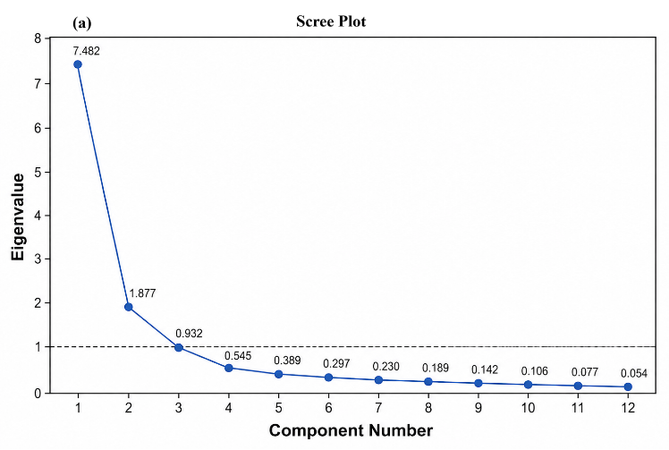 | 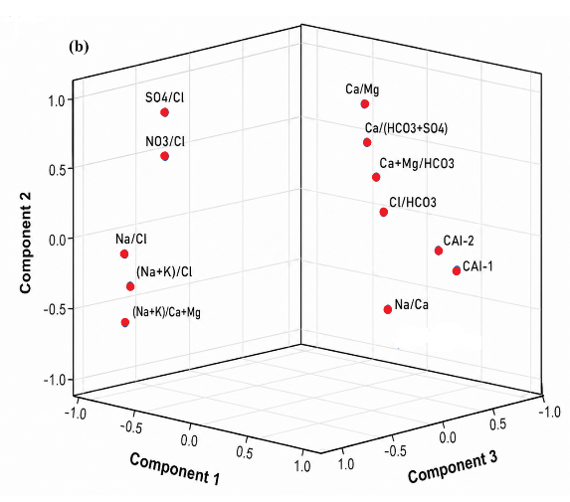
Figure 6: (a) Scree plot for ionic ratio (b) Component plot in the rotated space (PCA).

R-Mode cluster analysis
Hierarchical Cluster Analysis identified three unique hydrogeochemical categories within the groundwater of the Gondwana sedimentary and nearby metamorphic regions (Figure 7).

Cluster1 (HCO₃⁻, TH, TA) is indicative of carbonate dissolution processes that are prevalent in the weathered sedimentary layers [61][62]. Cluster2, which includes major cations and anions (Na⁺, Ca²⁺, Mg²⁺, K⁺, Cl⁻, SO₄²⁻, NO₃⁻, F⁻, pH), signifies a mixed system shaped by the weathering of silicate minerals in khondalite–charnockite rocks, evapo-concentration, and human activities [63]. Cluster3 (TDS) stands as a separate group, reflecting the combined impact of all geochemical processes and the accumulation of salinity. This clustering method effectively differentiates groundwater systems based on lithology, duration of water residence, and external factors, offering a solid foundation for evaluating groundwater development and quality throughout the study region [27][64].

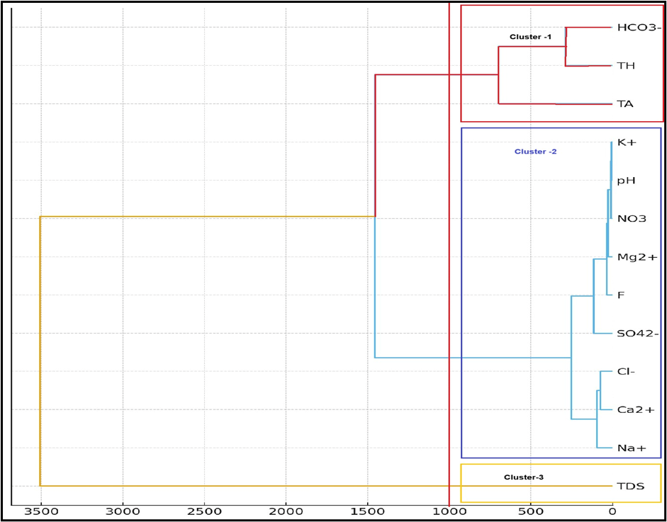

Figure 7: Clustering dendrogram of water quality parameters from the study area
CONCLUSION
The hydrochemical analysis of the study area (Kaniha Block, Angul district, Odisha) reveals that the groundwater of the region is moderately hard to hard type and are alkaline in nature. The abundance of the minerals is in order Ca²⁺> Na⁺> Mg²⁺> K⁺ and HCO₃⁻>Cl⁻> SO₄²⁻>NO₃^{-.} The Piper diagram shows that the facies of the study area move from Ca²⁺-HCO₃⁻, Ca-Mg-Cl -SO₄ and mixed type of facies. The water chemistry is heavily influenced by rock-water interaction, with varying lithologies, determined from Gibbs diagram. The ion exchange process is the most dominant part of groundwater evolution which, is determined from the value of chloro-alkaline indices (CAI). From the study of ionic ratio, it was found that in the initial phases of groundwater development in recharge zones, leading to a transformation from Ca-Mg-HCO₃ water types to Na-HCO₃ types as silicate hydrolysis progresses. In deeper aquifer sections, samples showing lower Na/Cl ratios along with elevated electrical conductivity (EC) values suggest ongoing salinization and intensified ion-exchange reactions. The correlation findings have been indicated that groundwater is influenced by a mix of dissolution of carbonates and silicates, ion exchange processes, and specific instances of anthropogenic contamination. This aligns with the occurrence of inverse or direct cation-exchange reactions that modify groundwater chemistry during mixing or salinization. The PCA results indicated that during the pre-monsoon season, groundwater chemistry is shaped by three related processes: the dissolution of carbonates and sulphates influenced by human activities (PC1), ion exchange and the weathering of silicates (PC2), and the enrichment of fluoride from natural sources (PC3). From the clustering technique, the groundwater systems has been distinguished by considering lithology, water residence time, and external influences, with providing a robust basis for assessing groundwater development across the study area.
Author contributions
PD: Conceptualization, Fieldwork, Data Analysis, Statistical Analysis, Validation, Software, GIS Maps and Original Draft. NM: Discussions, Guidance, Conceptualization, Reviewing and Editing.
Conflict of Interest
Authors declare that they have no conflict of interests.
Acknowledgements
The authors would like to thank Officer-In-Charge, CMPDI, Talcher camp along with survey personal for providing support for collection of samples. The authors extend their gratitude to the Institute of Minerals and Materials Technology, Bhubaneswar for the sample analysis of this study. The study has not received any funds from any organization

REFERENCES
- Amalraj, A. and Pius, A. (2018). Assessment of groundwater quality for drinking and agricultural purposes of a few selected areas in Tamilnadu, South India: a GIS-based study. Sustainable Water Resource Management.4,1–21.doi:10.1007/s40899-017-0113-8.
- Mahanta, N. and Goswami, S. (2024). Groundwater vulnerability to fluoride pollution and health risk assessment in the western part of Odisha, India. Environmental Science and Pollution Research International, 31(24), 35878–35896. doi:10.1007/s11356-024-33620-3.
- Adimalla, N., Dhakate, R., Kasarla, A. and Taloor, A.K. (2020). Appraisal of groundwater quality for drinking and irrigation purposes in Central Telangana, India. Groundwater for Sustainable Development, 10(100334), 100334. doi:10.1016/j.gsd.2020.100334.
- Jena MR, Tripathy JK, Sahoo D (2024) Geochemical Evaluation of Groundwater Quality in the Coastal Aquifers of Kujang Block, Jagatsinghpur District, Eastern Odisha, India. Water, Air & Soil Pollution, 235, 349.https://doi.org/10.1007/s11270-024-07153-x.
- Das, S. and Nag, S.K. (2022). Hydrogeochemical assessment and appraisal of groundwater quality in Saltora Block, Bankura District, West Bengal, India. International Journal of Energy and Water Resources, 6(2), 209–230. doi:10.1007/s42108-021-00132-6.
- Choudhary, S., Subba Rao, N., Chaudhary, M., Das, Sahu, R. (2024). Assessing sources of groundwater quality and health risks using graphical, multivariate, and index techniques from a part of Rajasthan, India, Groundwater for Sustainable Development,27. https://doi.org/10.1016/j.gsd.2024.101356.
- Subba Rao, N., Das, R. and Gugulothu, S. (2022). Understanding the factors contributing to groundwater salinity in the coastal region of Andhra Pradesh, India. Journal of Contaminant Hydrology, 250(104053), 104053. doi:10.1016/j.jconhyd.2022.104053.
- Mahanta, N., Mishra, I., Hatui, A., Mahanta, P.S., Sahoo, H.K., Goswami, S. (2020). Geochemical appraisal of groundwater qualities and its uses in and around Maneswar Block of Sambalpur District, Odisha, India. Environmental Earth Science, 79,1–13. https://doi.org/10.1007/ s12665-019-8719-9.
- Krishan, G., Kumar, M., Rao, M.S., Garg, R., Yadav, B.K., Kansal, M.L., Sharma, L.M. (2023). Integrated approach for the investigation of groundwater quality through hydrochemistry and water quality index (WQI). Urban Climate, 47(101383), 101383. doi:10.1016/j.uclim.2022.101383.
- Liu, N., Chen, M., Gao, D., Wu, Y. and Wang, X. (2025). Identification of hydrogeochemical processes in shallow groundwater using multivariate statistical analysis and inverse geochemical modelling. Environmental Monitoring and Assessment, 197(2). doi:10.1007/s10661-024-13528-8.
- Bakshe, P., Chandran, M., Viju, B.J., Narikkatan, A.K. and Jugade, R.M. (2024). Hydrogeochemical factors influencing the dynamics of groundwater characteristics in eco-sensitive areas of the Southern Western Ghats, India. Scientific Reports, 14(1). doi:10.1038/s41598-024-67988-6.
- Xin, P., Wilson, A., Shen, C., Ge, Z., Moffett, K.B., Santos, I.R. and Barry, D.A. (2022). Surface water and groundwater interactions in salt marshes and their impact on plant ecology and coastal biogeochemistry. Reviews of Geophysics (Washington, D.C.: 1985), 60(1). doi:10.1029/2021rg000740.
- Subba Rao, N. and Chaudhary, M. (2019) Hydrogeochemical processes regulating the spatial distribution of groundwater contamination, using pollution index of groundwater (PIG) and hierarchical cluster analysis (HCA): a case study. Groundwater Sustainable Development, 9,100238. https:// doi.org/10.1016/j.gsd.2019.100238.
- Abd, A.S. and Abushaikha, A.S. (2021). Reactive transport in porous media: a review of recent mathematical efforts in modeling geochemical reactions in petroleum subsurface reservoirs. SN Applied Sciences, 3(4). doi:10.1007/s42452-021-04396-9.
- Sinha, H., Rai, S.C. and Kumar, S. (2023). Post-monsoon groundwater hydrogeochemical characterization and quality assessment using geospatial and multivariate analysis in Chhotanagpur Plateau, India. Environment Development and Sustainability, 26(8), 20127–20157. doi:10.1007/s10668-023-03459-8.
- CGWB (2022). Dynamic Ground Water Resources of Odisha ,2022.
- CGWB (2020). Hydrogeological framework, ground water development prospects & aquifer management plan in angul district, Odisha (revised).
- APHA. (2012). Standard methods for the examination of water and wastewater.American Public Health Association, Washington DC.
- Subba Rao, N., Das, R., Sahoo, H.K. and Gugulothu, S. (2024). Hydrochemical characterization and water quality perspectives for groundwater management for urban development. Groundwater for Sustainable Development, 24(101071), 101071. doi:10.1016/j.gsd.2023.101071.
- Nayak, P., Mohanty, A.K., Samal, P., Khaoash, S. and Mishra, P. (2023). Groundwater quality, hydrogeochemical characteristics, and potential health risk assessment in the Bhubaneswar city of eastern India. Water, Air, and Soil Pollution, 234(9). doi:10.1007/s11270-023-06614-z.
- Gibbs, R.J. (1970). Mechanisms controlling worlds water chemistry. Science, 170,1088–1090
- Piper, A.M. (1944). A graphic procedure in the geochemical interpretation of water analyses. American Geophysical Union Transactions, 25, 914–923.
- Khan, A.F., Srinivasamoorthy, K., Rabina, C. (2020). Hydrochemical characteristics and quality assessment of groundwater along the coastal tracts of Tamil Nadu and Puducherry, India. Applied Water Science, 10, 2. https://doi.org/10.1007/s13201-020- 1158-7.
- Kumar, P. and Singh, A.K. (2022). Hydrogeochemistry and quality assessment of surface and sub-surface water resources in Raniganj coalfield area, Damodar Valley, India. International Journal of Environmental Analytical Chemistry, 102(19), 8346–8369. doi:10.1080/03067319.2020.1849653.
- Sheikhy Narany, T., Ramli, M.F., Aris, A.Z., Sulaiman, W.N.A., Juahir, H. and Fakharian, K. (2014). Identification of the hydrogeochemical processes in groundwater using classic integrated geochemical methods and geostatistical techniques, in Amol-Babol Plain, Iran. The Scientific World Journal, 2014, 419058. doi:10.1155/2014/419058.
- Aish, A. M., Zaqoot, H. A., Sethar, W. A., & Aish, D. A. (2023). Prediction of groundwater quality index in the Gaza coastal aquifer using supervised machine learning techniques. Water Practice & Technology, 18(3), 501-521.
- Liu, Y., Li, M., Zhang, Y., Wu, X. and Zhang, C. (2024). Analysis of the hydrogeochemical characteristics and origins of groundwater in the Changbai Mountain region via inverse hydrogeochemical modelling and unsupervised machine learning. Water, 16(13), 1853. doi:10.3390/w16131853.
- Ren, X., Gao, Z., An, Y., Liu, J., Wu, X., He, M. and Feng, J. (2020). Hydrochemical and isotopic characteristics of groundwater in the Jiuquan East Basin, China. Arabian Journal of Geosciences, 13(13). doi:10.1007/s12517-020-05573-7.
- Zhang, H., Xu, G., Chen, X., Mabaire, A., Zhou, J., Zhang, Y. and Zhu, L. (2020). Groundwater hydrogeochemical processes and the connectivity of multilayer aquifers in a Coal Mine with Karst collapse columns. Mine Water and the Environment, 39(2), 356–368. doi:10.1007/s10230-020-00667-w.
- Gugulothu, S., Subbarao, N., Das, R. and Dhakate, R. (2022). Geochemical evaluation of groundwater and suitability of groundwater quality for irrigation purpose in an agricultural region of South India. Applied Water Science, 12(6). doi:10.1007/s13201-022-01583-w.
- Ekbal, E. and Khan, T.A. (2022). Hydrogeochemical characterization of groundwater quality in parts of amroha district, western Uttar pradesh, India. Hydro Research, 5, 54–70. doi: 10.1016/j.hydres.2022.07.002.
- Mahanta, N., Sahoo, H.K. (2016) Hydrogeochemical characterization and potability studies of Kuchinda-Bamra area in Sambalpur district, Odisha, India. Journal of Environmental Geochemistry, 21,19–23.
- Samal, P., Mohanty, A.K., Khaoash, S. and Mishra, P. (2023). Hydrogeochemical characteristics and spatial analysis of groundwater quality in a semi-arid region of Western Odisha, India. Arabian Journal of Geosciences, 16(1). doi:10.1007/s12517-022-11127-w.
- Saikrishna, K., Purushotham, D., Sunitha, V., Reddy, Y.S., Linga, D. and Kumar, B.K. (2020). Data for the evaluation of groundwater quality using water quality index and regression analysis in parts of Nalgonda district, Telangana, Southern India. Data in Brief, 32(106235), 106235. doi:10.1016/j.dib.2020.106235.
- Islam, M.S. and Mostafa, M.G. (2022). Evaluation of hydrogeochemical processes in groundwater using geochemical and geostatistical approaches in the upper Bengal basin. Geofluids, 2022, 1–21 https://doi.org/10.1155/2022/9591717.
- Kaiser, H.F. (1958). The varimax criterion for analytic rotation in factor analysis. Psychometrika, 23, 187–200.
- Mohanty, C.R. and Nayak, S.K. (2017). Assessment of seasonal variations in water quality of Brahmani River using PCA. Advances in Environmental Research, 6(1), 53–65. doi:10.12989/aer.2017.6.1.053.
- Kumar, M., Garg, V., Kumar, R. and Kumar, R. (2024). Geochemical evaluation and the mechanism controlling groundwater chemistry using chemometric approach and groundwater pollution index (GPI) in the Kishangarh city of Rajasthan, India. Environmental Science and Pollution Research International, 31(25), 36894–36909. doi:10.1007/s11356-024-33669-0.
- Ward, J.H. (1963). Hierarchical grouping to optimize an objective function. Journal of the American Statistical Association, 69, 236–244.
- Kumar, R., Sharma, S. and Prashant, M. (2024). Assessment of groundwater quality for drinking, irrigation and industrial purposes in Aik Watershed, Jammu and Kashmir, India. Discover Geoscience, 2(1). doi:10.1007/s44288-024-00065-7.
- Ghalib, H.B. (2017). Groundwater chemistry evaluation for drinking and irrigation utilities in east Wasit province, Central Iraq. Applied Water Science, 7(7), 3447–3467. doi:10.1007/s13201-017-0575-8.
- Sawyer, G.N. and Mccarthy, D.L. (1967). Chemistry of Sanitary Engineers. McGraw Hill, New York.
- Mahanta, N.,and Sahoo, H. K. (2012). Assessment of groundwater quality for irrigation in the Kuchinda-Bamra area in Sambalpur district, Odisha. Int J Earth Sci Eng 05 (05): 1229-1234.
- Subba Rao, N. (2017). Controlling factors of fluoride in groundwater in a part of South India. Arabian Journal of Geosciences, 10(23). doi:10.1007/s12517-017-3291-7.
- Ribinu, S.K., Prakash, P., Khan, A.F., Bhaskar, N.P. and Arunkumar, K.S. (2023). Hydrogeochemical characteristics of groundwater in Thoothapuzha River Basin, Kerala, South India. Total Environment Research Themes, 5(100021), 100021. doi:10.1016/j.totert.2022.100021.
- Shuaibu, A., Kalin, R. M., Phoenix, V., & Lawal, I. M. (2025). Geochemical evolution and mechanisms controlling groundwater chemistry in the transboundary Komadugu–Yobe Basin, Lake Chad region: An integrated approach of chemometric analysis and geochemical modeling. Journal of Hydrology: Regional Studies, 57, 102098.
- Subba Rao, N. (2021). Spatial distribution of quality of groundwater and probabilistic non-carcinogenic risk from a rural dry climatic region of South India. Environmental Geochemistry and Health, 43(2), 971–993. doi:10.1007/s10653-020-00621-3.
- Kallon, H.D.S. (2024). Hydrochemical characteristics, controlling factors and water quality evaluation of groundwater quality in Kono, Sierra Leone. Adv Earth & Env Sci, 5(2):1-17. https://doi.org/10.47485/2766-2624.1044
- Subramani, T., Rajmohan, N. and Elango, L. (2010). Groundwater geochemistry and identification of hydrogeochemical processes in a hard rock region, Southern India. Environmental Monitoring and Assessment, 162(1–4), 123–137. doi:10.1007/s10661-009-0781-4.
- Zaryab, A., Nassery, H.R. and Alijani, F. (2021). Identifying sources of groundwater salinity and major hydrogeochemical processes in the Lower Kabul Basin aquifer, Afghanistan. Environmental Science. Processes & Impacts, 23(10), 1589–1599. doi:10.1039/d1em00262g.
- Bauer, J., Börsig, N., Pham, V.C., Hoan, T.V., Nguyen, H.T. and Norra, S. (2022). Geochemistry and evolution of groundwater resources in the context of salinization and freshening in the southernmost Mekong Delta, Vietnam. Journal of Hydrology. Regional Studies, 40(101010), 101010. doi:10.1016/j.ejrh.2022.101010.
- Gopinath, S., Srinivasamoorthy, K., Saravanan, K. and Prakash, R. (2019). Discriminating groundwater salinization processes in coastal aquifers of southeastern India: geophysical, hydrogeochemical and numerical modeling approach. Environment Development and Sustainability, 21(5), 2443–2458. doi:10.1007/s10668-018-0143-x.
- Schoeller, H. (1977). Geochemistry of groundwater. An international guide for research and practice, chapter15 (pp. 1–18). Paris: UNESCO.
- Liu, T., Gao, X., Zhang, X. and Li, C. (2020). Distribution and assessment of hydrogeochemical processes of F-rich groundwater using PCA model: a case study in the Yuncheng Basin, China. Acta Geochimica, 39(2), 216–225. doi:10.1007/s11631-019-00374-6.
- Roy, A., Keesari, T., Mohokar, H., Pant, D., Sinha, U.K. and Mendhekar, G.N. (2020). Geochemical evolution of groundwater in hard-rock aquifers of South India using statistical and modelling techniques. Journal Des Sciences Hydrologiques [Hydrological Sciences Journal], 65(6), 951–968. doi:10.1080/02626667.2019.1708914.
- Yang, W., Yue, Z., Dong, W., Huihui, W., Aijun, L. and Li, H. (2020). Using Principal Components Analysis and IDW Interpolation to determine Spatial and Temporal Changes of Surface Water Quality of Xin’ anjiang River in Huangshan, China. International Journal of Environmental Research and Public Health,18,2942. https://doi.org/10.3390/ijerph17082942.
- Schafer, D., Sun, J., Jamieson, J., Siade, A.J., Atteia, O. and Prommer, H. (2020). Model-based analysis of reactive transport processes governing fluoride and phosphate release and attenuation during managed aquifer recharge. Environmental Science & Technology, 54(5), 2800–2811. doi:10.1021/acs.est.9b06972.
- Aravinthasamy, P., Karunanidhi, D., Jayasena, H.C. and Subramani, T. (2024). Assessment of groundwater fluoride and human health effects in a hard rock province of south India: Implications from Pollution Index Model (PIM) and Geographical Information System (GIS) techniques. Environmental Geochemistry and Health, 46(9). doi:10.1007/s10653-024-02111-2.
- Nandi, R., Mondal, S., Mandal, J. and Bhattacharyya, P. (2024). Deciphering geochemical fingerprints and health implications of groundwater fluoride contamination in mica mining regions using machine learning tactics. Environmental Geochemistry and Health, 46(10). doi:10.1007/s10653-024-02177-y.
- Vitale, R., De Noord, O. E., Næs, T., Ferrer, A., Westerhuis, J. A., & Smilde, A. K. (2017). Selecting the number of factors in principal component analysis by permutation testing—Numerical and practical aspects.Journal of Chemometrics,31(12), e2937. https://doi.org/10.1002/cem.2937.
- Chung, S.Y., Rajendran, R., Senapathi, V., Sekar, S., Ranganathan, P.C., Oh, Y.Y. and Elzain, H.E. (2020). Processes and characteristics of hydrogeochemical variations between unconfined and confined aquifer systems: a case study of the Nakdong River Basin in Busan City, Korea. Environmental Science and Pollution Research International, 27(9), 10087–10102. doi:10.1007/s11356-019-07451-6.
- Wang, P.L., Tu, T.H., Lin, L.H., Chou, H.L., Wang, Y.J., Chen, J.N., Ke, C.C. (2024). Microbial communities modulate chemical weathering and carbon dioxide cycling in an active orogen in Taiwan. Communications Earth & Environment, 5(1). doi:10.1038/s43247-024-01345-3.
- Bhanot, K., Sharma, M.K. and Kaushik, R.D. (2024). Hydrochemical characterization and pCO2 dynamics in the surface waters of Himalayan River: A case study of river Alaknanda. Environmental Monitoring and Assessment, 196(11), 1138. doi:10.1007/s10661-024-13310-w.
- Rahbar, A., Vadiati, M., Talkhabi, M., Nadiri, A.A., Nakhaei, M. and Rahimian, M. (2020). A hydrogeochemical analysis of groundwater using hierarchical clustering analysis and fuzzy C-mean clustering methods in Arak plain, Iran. Environmental Earth Sciences, 79(13). doi:10.1007/s12665-020-09064-6.

