A Comparative Usability Study of Standard and Accessibility-Optimized Mobile E-Commerce Interfaces for Elderly Users in India

ABSTRACT
Purpose

This study examines how an accessibility-optimised mobile interface (larger fonts, bigger targets, and simpler navigation) affects usability for Indian smartphone users aged 60+.

Design/methodology/approach
In a within-subject experiment, participants performed tasks (finding a product, filtering, and checking out) on each interface. We recorded completion rates, errors, time-on-task, and System Usability Scale (SUS) scores. Data were analysed with paired t-tests (Wilcoxon tests if needed), using Cohen’s d and Cronbach’s alpha.
Findings
The accessibility-optimized interface received significantly higher usability satisfaction scores than the standard interface (M = 43.33 vs. 31.33; t(29) = 5.860, p < 0.001, Cohen’s d = 1.070), with improvements across all 10 SUS items. Task-based measures similarly favoured the optimized design.
Research limitations/implications
The lab setting and participant group may limit generalisability; future work should test these interventions in diverse, real-world contexts. The within-subject design provides strong evidence of interface effects.
Practical implications
Designers should adopt larger text, bigger tap targets, and shallower navigation for older users; these changes could improve usability and satisfaction, increasing e-commerce engagement.
Social implications
Improving app accessibility can help bridge the digital divide for older adults, enabling fuller participation in online commerce and supporting social inclusion.
Originality/value
Among the first to quantitatively evaluate accessibility interventions for older Indian users, this study combines task metrics with SUS ratings in an A/B test, filling a gap in ageing and usability research and providing guidance for age-friendly design.
Keywords
Accessibility design, elderly users, mobile e-commerce, usability evaluation, System Usability Scale (SUS), A/B testing, digital inclusion
INTRODUCTION
India stands at a significant demographic and digital crossroads. With approximately 150 million citizens aged 60 and above, a figure projected to reach nearly 230 million by 2036 (IIPS, 2020), the country’s older adult population represents one of the fastest growing demographic segments in the world. Simultaneously, smartphone penetration across Indian households has surged to nearly 85% as of 2025 (Keelery, 2025), transforming mobile applications into the primary gateway for everyday activities, including commerce, banking, and social participation. Yet despite this parallel growth in aging population and digital access, a pronounced and consequential gap persists: mobile interfaces remain largely inaccessible to elderly users.
Mobile e-commerce, in particular, has become a central arena where this gap is most visible. Dominant shopping applications in India are predominantly designed for younger, digitally fluent users, and their interfaces reflect this orientation. Small font sizes, dense and visually cluttered layouts, deep multi step navigation structures, and small touch targets impose significant cognitive and physical demands on older users (Fisk et al., 2009). Research consistently demonstrates that these design characteristics increase cognitive load, slow task completion, and elevate error rates (Fisk et al., 2009; Nielsen, 1993; Sweller, 1988), often to the point where elderly users abandon transactions entirely. A 2025 HelpAge India report corroborates this, finding that over two thirds of elderly individuals described digital tools as confusing, with more than half reporting a fear of making mistakes while using mobile applications (HelpAge India, 2025).
The consequences of this design gap extend beyond usability inconvenience. India’s Supreme Court has recognized a Right to Digital Access under Article 21 of the Constitution (BarrierBreak, 2025), affirming that digital services, including online retail, must be equitably usable by all citizens. Accessibility audits have found that Indian e-commerce platforms average approximately 121 Web Content Accessibility Guidelines WCAG errors per homepage, encompassing poor color contrast, missing interface labels, and interaction barriers that disproportionately exclude users with age related sensory and motor limitations (BarrierBreak, 2025). These findings position mobile e-commerce accessibility not merely as a design concern, but as a matter of social inclusion and legal compliance.
While existing literature establishes that accessibility focused design features such as larger text, bigger touch targets, and simplified navigation can improve usability for older adults (Fisk et al., 2009; Johnson, 2014), quantitative evidence within the Indian mobile e-commerce context remains limited. Most prior work is either qualitative in nature, geographically situated outside India, or focused on domains such as banking and healthcare rather than retail. This gap in empirical evidence restricts the ability of designers and developers to make data driven decisions that could meaningfully include elderly users in India’s rapidly expanding digital commerce ecosystem.
The present study addresses this gap through a quantitative experimental comparison of two mobile e-commerce interface conditions: a standard interface representative of commonly used applications, and an accessibility optimized interface incorporating larger font sizes 18 px, increased touch targets 48 px, and reduced navigation depth 1 to 2 taps to checkout. Usability is evaluated across four objective and subjective metrics, task completion rate, error rate, time on task, and usability satisfaction as measured by the System Usability Scale SUS (Brooke, 1996), among Indian elderly participants aged 60 years and above. The central research question guiding this study is: To what extent does an accessibility optimized mobile e-commerce interface with increased font size, larger touch targets, and simplified layouts affect task completion rate, error rate, time on task, and usability satisfaction compared to a standard interface among elderly Indian users?
By generating quantitative usability evidence grounded in the Indian demographic context, this study aims to contribute actionable, data backed insights that can inform more inclusive design practices in mobile commerce, ensuring that India’s digital economy grows in a manner that is accessible to all of its citizens.
LITERATURE REVIEW
Cognitive and Perceptual Aging in Interface Design
Understanding how aging affects human-computer interaction requires first examining the cognitive and perceptual changes that accompany older adulthood. Fisk et al. (2009) provide a comprehensive account of these changes, noting that older adults experience meaningful declines across sensory modalities including vision and audition, as well as in cognitive domains such as memory, attention, and processing speed. These age-related changes have direct implications for interface design: reduced visual acuity affects text legibility, slower processing speed increases time-on-task, and working memory constraints limit the ability to navigate complex hierarchical structures. Johnson (2014) further connects these cognitive characteristics to user interface behavior, demonstrating how perceptual and attentional limitations lead users to make predictable errors when interfaces do not account for human cognitive architecture. Taken together, these findings establish a theoretical foundation for why standard mobile interfaces designed for younger users may be systematically mismatched with the capabilities of elderly users.
Cognitive Load Theory and Interface Complexity
A significant body of literature links interface complexity to cognitive overload, with consequent effects on task performance. Sweller’s (1988) seminal work on Cognitive Load Theory (CLT) demonstrated that working memory has a severely limited capacity, and that tasks imposing high cognitive demands leave fewer cognitive resources available for other processing activities. Clark and Kimmons (n.d.) extended this framework by distinguishing between intrinsic, extraneous, and germane cognitive load, noting that extraneous cognitive load arising from poorly organized or irrelevant interface elements directly impedes task completion without contributing to learning or goal achievement. This distinction is particularly relevant to mobile e-commerce contexts, where cluttered layouts, small interactive targets, and dense text can impose substantial extraneous cognitive load on users, especially those whose cognitive resources are already constrained by age-related decline. The practical implication is that simplified layouts may reduce extraneous cognitive load, thereby freeing cognitive capacity for task-relevant processing.
Usability Frameworks and Measurement
Usability has been operationalized in various ways across the human-computer interaction literature. The International Standards Organization defines usability as the effectiveness, efficiency, and satisfaction with which specified users achieve specified goals in particular environments (Kumar, 2005). These three dimensions map closely onto the dependent variables of the present study: task completion rate as a measure of effectiveness, time on task and error rate as indicators of efficiency, and user satisfaction scores as a direct measure of subjective usability. Brooke’s (1996) System Usability Scale (SUS) offers a reliable, low-cost instrument for capturing global usability perceptions across a wide range of systems and user populations. The SUS has been validated across numerous studies and produces a composite score reflecting user perceptions of system complexity, learnability, consistency, and confidence dimensions that are likely to be differentially affected by interface accessibility modifications. Kumar (2005) further notes that usability testing must account for user characteristics, task requirements, and environmental context, reinforcing the importance of studying elderly Indian users specifically rather than generalizing from findings obtained with other populations.
Technology Acceptance and Perceived Ease of Use
Beyond task-based performance measures, users’ subjective perceptions of a system play a determining role in adoption behavior. Davis (1989) proposed the Technology Acceptance Model (TAM), demonstrating empirically that perceived usefulness and perceived ease of use are the two fundamental determinants of user acceptance of information technology. Davis (1989) found that perceived usefulness was more strongly correlated with usage intentions than ease of use, but that ease of use functioned as a causal antecedent to usefulness suggesting that interfaces perceived as difficult to use are also likely to be perceived as less useful, even when their functional capabilities are identical. This finding carries important implications for mobile e-commerce design for elderly users: an interface that older adults find physically difficult to interact with, due to small touch targets or illegible font sizes may be perceived as less useful and subsequently avoided, regardless of the commercial value it offers. Improving physical accessibility features therefore has potential cascading effects on both ease-of-use perceptions and overall technology acceptance.
Design Guidelines for Older Adult Users
Research has increasingly moved beyond describing age-related deficits toward articulating design principles that can compensate for them. Fisk et al. (2009) present a systematic set of design guidelines organized around perceptual, cognitive, and motor dimensions of aging, recommending, among other things, larger text sizes, higher contrast ratios, simplified navigation structures, and reduced information density per screen. These recommendations align closely with the accessibility modifications under investigation in the present study. With respect to input design specifically, the authors note that older adults exhibit slower and less precise motor control, making small touch targets disproportionately difficult to activate accurately. Minimizing the number of steps required to complete a task and providing consistent, predictable feedback further reduce the burden on older users. Kumar (2005) similarly emphasizes that usability engineering must involve iterative evaluation with actual representative users, and that performance differences identified through usability testing including error rates, time on task, and task completion success provide actionable evidence for interface refinement.
Mobile E-Commerce and Accessibility
The intersection of mobile commerce and accessibility research remains relatively underexplored, particularly in the context of emerging markets such as India. While the broader usability and e-commerce literature has established that interface design significantly moderates transaction completion rates and user satisfaction, less is known about how accessibility-specific modifications as opposed to general usability improvements affect older adult performance in mobile commerce tasks. The present study addresses this gap by isolating specific accessibility features (font size, touch target size, and layout complexity) and examining their measurable effects on a set of standardized usability outcomes among elderly Indian users. This approach follows the user-centered design methodology advocated by Kumar (2005), wherein design decisions are evaluated against empirical performance criteria rather than assumed to be effective based on general principles alone.
Summary
The literature reviewed here converges on several key propositions relevant to the present study. First, aging is associated with systematic cognitive and perceptual changes that make standard mobile interfaces challenging for elderly users. Second, interface complexity imposes extraneous cognitive load that reduces task performance, and simplified designs can mitigate this burden. Third, usability is a multidimensional construct best assessed through a combination of performance-based measures and subjective satisfaction ratings. Fourth, perceived ease of use shapes technology acceptance, making interface accessibility a prerequisite for engagement rather than merely a supplementary consideration. Fifth, existing design guidelines for older adults recommend precisely the modifications being investigated here, yet empirical evidence of their effectiveness in mobile e-commerce contexts particularly among Indian elderly populations remains limited. The present study contributes to this literature by providing controlled, task-based evidence of the effects of accessibility optimization on usability outcomes in this underrepresented demographic.

THEORY/ FRAMEWORK
The System Usability Scale (SUS), developed by Brooke (1996), is a widely used tool for measuring perceived usability. It consists of a 10-item questionnaire with a five-point agreement scale ranging from strongly disagree to strongly agree. The final usability score is calculated by adjusting responses for positively and negatively worded items, summing the contributions, and multiplying the total by 2.5 to obtain a score between 0 and 100. SUS was designed to provide a quick and reliable measure of overall system usability and has since been applied across a wide range of digital interfaces.
One of the key strengths of SUS is its simplicity and versatility. It is technology-independent, meaning it can be used to evaluate any type of system, including mobile applications, websites, and software interfaces. Despite its simplicity, SUS has demonstrated strong reliability and validity. Bangor, Kortum, and Miller (2008), in a large-scale analysis of over 2,300 usability studies, found that SUS is highly robust and produces consistent results across different contexts, with a reliability coefficient of approximately 0.85. Further validation by Lewis (2018) showed that SUS scores strongly correlate with other established usability measures, confirming that it effectively captures the underlying construct of perceived usability.
Due to these characteristics, SUS has become an industry-standard tool for usability evaluation and is extensively used in both academic research and professional practice. Its ability to produce a single, interpretable score makes it particularly useful for comparative studies, where different interface designs are evaluated against each other.
Contextual Relevance of the Framework
The selection of the System Usability Scale as the primary framework is particularly appropriate for the context of mobile e-commerce applications in India. With the rapid expansion of smartphone usage and increasing dependence on mobile platforms for online shopping, usability has become a critical factor influencing user engagement and successful task completion.
In a diverse user population such as India’s, where there are significant variations in age, digital literacy, and technological familiarity, a standardized and easy-to-administer tool like SUS enables consistent evaluation across different user groups. This is especially important when studying elderly users, who may experience challenges related to cognitive load, visual perception, and motor interaction while using mobile interfaces.
Furthermore, the nature of this study involves a direct comparison between a standard interface and an accessibility-optimized interface. SUS is particularly well-suited for such comparative evaluations, as it provides a single usability score that allows clear and meaningful interpretation of differences between design conditions. Its ease of administration also makes it practical for use with elderly participants, ensuring that the evaluation process remains simple and accessible.
By using SUS, the study is able to generate reliable, quantifiable evidence on how specific design changes, such as increased font size, larger touch targets, and simplified navigation, impact overall usability in mobile e-commerce applications.
Conceptual Framework
The conceptual framework of this study is centered on the evaluation of usability through the System Usability Scale. The primary independent variable in this study is the type of interface design, which consists of two conditions: a standard mobile e-commerce interface and an accessibility-optimized interface. The optimized interface incorporates design improvements such as larger font sizes, increased touch target dimensions, and reduced navigation complexity.
The primary dependent variable is usability satisfaction, as measured by the System Usability Scale score. This score reflects the participant’s overall perception of ease of use, learnability, confidence, and satisfaction with the interface. Higher scores indicate better perceived usability. Note that while the conceptual framework diagram also references perceived usefulness and purchase intention as downstream constructs drawn from the Technology Acceptance Model, these variables were not directly measured in the present study. The empirical focus is limited to usability satisfaction and objective performance metrics.
In addition to the primary dependent variable, the study also includes objective usability measures task completion rate, error rate, and time on task which represent effectiveness and efficiency of interaction. While these are analyzed separately, they complement the SUS score by providing a more comprehensive understanding of usability.
Extraneous variables in this study include demographic factors such as age, gender, and prior experience with smartphones or e-commerce applications. These variables are treated as control factors, as they may influence how participants interact with the interface and perceive its usability. For example, participants with greater familiarity with mobile applications may find the interface easier to use, regardless of design condition. By accounting for these variables, the study ensures a more accurate interpretation of the relationship between interface design and usability outcomes.
Overall, the framework establishes a direct relationship between interface design and usability outcomes, with SUS serving as the central measurement tool. This structure allows the study to isolate the impact of accessibility-focused design changes and evaluate their effectiveness in improving usability for elderly users.
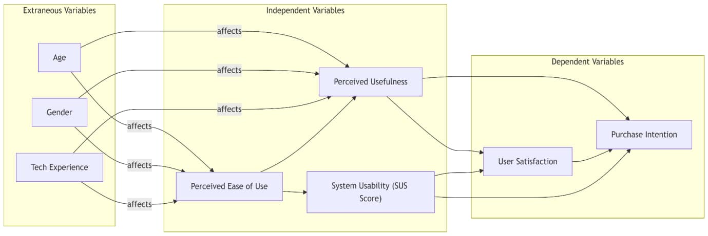
Figure 1. Conceptual framework
CONSTRUCTS AND ITEMS USED
This section presents the operationalisation of the constructs used in the study. It directly addresses the refined research question:
“To what extent does an accessibility optimized mobile e-commerce interface with increased font size, larger touch targets and simplified layouts affect task completion rate, error rate, time on task and usability satisfaction compared to a standard interface among elderly Indian users?”
The four dependent constructs (task completion rate, error rate, time-on-task, and usability satisfaction) were derived from the PICO framework and the operationalised research question. These constructs represent the core usability dimensions of effectiveness, efficiency, and user satisfaction as defined by Nielsen (1993) and Brooke (1996).
All constructs were measured using objective performance metrics captured during the experimental tasks and one validated subjective instrument (System Usability Scale). This chapter details the operational definitions, measurement methods, items, and scoring procedures for each construct.
Operationalisation of Constructs
The constructs and their operational definitions are summarised in Table 1. Each construct is measured twice for every participant (once after using the standard interface and once after using the accessibility-optimized interface) in a within-subjects design.
Table 1. Operationalisation of Constructs and Measurement Instruments
Construct | Operational Definition | Type | Measurement Method | Calculation / Scoring | Source / Instrument
Task Completion Rate | Percentage of the three assigned e-commerce tasks successfully completed without any researcher assistance | Objective (Effectiveness) | Direct observation and binary coding (completed / not completed) during screen-recorded sessions | % = (number of successful tasks / 3) × 100 | Nielsen (1993)
Error Rate | Total number of interaction mistakes (mis-taps, wrong selections, unnecessary back-navigation, or incorrect button presses) | Objective (Effectiveness) | Counted in real time by the researchers | Raw count per participant per interface | Nielsen (1993); Fisk et al. (2009)
Time-on-Task | Total time (in seconds) from the moment the task instructions are given until successful completion of the task | Objective (Efficiency) | Timed automatically via stopwatch | Average seconds per task or total seconds for all tasks | Nielsen (1993); Fisk et al. (2009)
Usability Satisfaction | Participants’ subjective perception of ease of use, learnability, confidence, and overall satisfaction with the interface | Subjective | System Usability Scale (SUS) – 10-item questionnaire administered immediately after each interface condition | Score range 0–100 (higher = better usability); standard scoring procedure applied (Section 4.4) | Brooke (1996)
Measurement Instruments
The three objective constructs (task completion rate, error rate, and time-on-task) were measured through direct observation and screen recordings while participants performed the following three standardised e-commerce tasks on both interfaces:
- Find a specific product and add it to the cart.
- Apply a filter and open two product pages.
- Proceed to checkout (without completing payment).
Performance data were logged using a structured error-recording sheet. No self-report scales were used for these three constructs.
System Usability Scale (SUS): Items and Scoring
Usability satisfaction was measured using the System Usability Scale (SUS) developed by Brooke (1996). The SUS is a brief, reliable, and widely validated 10-item instrument that yields a single usability score ranging from 0 to 100. It was selected because it has been extensively used in interface evaluations with older adults and allows direct statistical comparison between the two interface conditions. The exact wording of the 10 items was retained to preserve psychometric validity. The questionnaire was administered in a high-contrast, large-font (minimum 18 px) printed format suitable for elderly participants. If required, the researcher read the statements aloud in a neutral tone.
SUS Items (Exact Wording)
Participants responded to each statement on a 5-point Likert scale:
(1 = Strongly Disagree, 2 = Disagree, 3 = Neutral, 4 = Agree, 5 = Strongly Agree)
- I think that I would like to use this system frequently.
- I found the system unnecessarily complex.
- I thought the system was easy to use.
- I think that I would need the support of a technical person to be able to use this system.
- I found the various functions in this system were well integrated.
- I thought there was too much inconsistency in this system.
- I would imagine that most people would learn to use this system very quickly.
- I found the system very cumbersome to use.
- I felt very confident using the system.
- I needed to learn a lot of things before I could get going with this system.
SUS Scoring Procedure (Brooke, 1996)
- For odd-numbered items (1, 3, 5, 7, 9): contribution = response – 1
- For even-numbered items (2, 4, 6, 8, 10): contribution = 5 – response
- Sum the 10 contribution scores (maximum possible total = 40)
- Multiply the total by 2.5 to obtain the final SUS score (0–100)
Interpretation of SUS Scores
- 80–100: Excellent usability
- 68–79: Good usability
- 50–67: Average usability
- Below 50: Poor usability
The SUS was completed twice by each participant (immediately after the standard interface and immediately after the accessibility-optimized interface).
Pilot Testing of Instruments
All measurement instruments and procedures were pilot-tested with five elderly participants (aged 62–71 years) who met the inclusion criteria but were not included in the main sample. Minor adjustments were made to the task instructions and the layout of the SUS response sheet for better readability. The pilot confirmed that the tasks, timing protocol, error-logging sheet, and SUS administration were clear, feasible, and appropriate for the target population. No changes were made to the SUS item wording or scoring method.
SAMPLE DETAILS
Survey Overview
This section describes the sample of participants who responded to the usability survey conducted for the study. The survey collected basic demographic information and subjective usability ratings using a 10-item Likert-scale questionnaire for both the standard interface and the accessibility-optimized interface. A total of 30 elderly participants completed the survey.
Sample Size and Selection Criteria
The survey was completed by 30 participants. Participants were recruited through purposive convenience sampling from senior citizen groups and community networks primarily in Bengaluru, Karnataka. A few surveys were also conducted in Bareilly and Bhubaneswar through personal contacts who assisted the participants in understanding the purpose of the study. In cases where participants were not comfortable with English, the questions were smoothly translated into Hindi or the local language by the contact person to ensure full comprehension while preserving the original meaning of each
statement. All 30 respondents met the basic requirement of being aged 60 years or above and having some familiarity with smartphone use.
Demographic Profile of Survey Respondents
The demographic characteristics of the 30 survey respondents are summarised in Tables 2 and 3.
Table 2. Distribution of Respondents by Age Group (N = 30)
Age Group | Frequency | Percentage (%)
60–65 | 22 | 73.3
66–70 | 6 | 20.0
71–75 | 2 | 6.7
Total | 30 | 100.0

Table 3. Self-Reported Smartphone Comfort Level (N = 30)
Comfort Level (1 = Not comfortable, 5 = Very comfortable) | Frequency | Percentage (%)
1 | 1 | 3.3
3 | 5 | 16.7
4 | 12 | 40.0
5 | 12 | 40.0
Total | 30 | 100.0
The majority of respondents, 73.3 percent, belonged to the 60–65 age group, while 80 percent reported moderate to high comfort with smartphone use, indicated by ratings of 4 or 5.
Survey Administration Details
The survey was administered in person immediately after each participant had viewed and interacted with both the standard and accessibility-optimized mobile e-commerce interfaces. For each interface, participants responded to the same set of 10 statements on a 5-point Likert scale ranging from 1 (Strongly Disagree) to 5 (Strongly Agree). The questionnaire was presented in large-font, high-contrast printed format to ensure readability for elderly users. Each participant therefore provided two complete sets of 10 responses, one set for each interface. All responses were recorded directly into the digital form, resulting in the complete dataset of 30 participants. No incomplete responses were received, and every participant also provided the required demographic information.

SUBJECTIVE USABILITY RATINGS (DESCRIPTIVE STATISTICS)
Participants rated both interfaces on ten statements designed to capture perceived usability. Items 1, 3, 5, 7, and 9 are positively worded; items 2, 4, 6, 8, and 10 are negatively worded. Descriptive statistics (mean, standard deviation, median, minimum, and maximum) for each item are presented separately for the standard interface (Table 5.3) and the accessibility-optimized interface in Table 4.
Table 4. Descriptive Statistics for Subjective Usability Ratings – Standard Interface (N = 30)
Item | Mean | SD | Median | Min | Max
1. I would feel comfortable using a screen like this. | 3.33 | 1.06 | 4.0 | 1 | 5
2. This screen looks complicated. | 2.97 | 1.25 | 3.0 | 1 | 5
3. This screen looks easy to understand. | 3.20 | 1.30 | 3.5 | 1 | 5
4. I would need help to understand this screen. | 3.17 | 1.70 | 4.0 | 1 | 5
5. The information on this screen is well organized. | 3.53 | 0.97 | 4.0 | 1 | 5
6. This screen feels confusing to look at. | 2.80 | 1.47 | 3.0 | 1 | 5
7. Most people would understand this screen quickly. | 3.13 | 1.01 | 3.0 | 1 | 5
8. This screen looks difficult to use. | 3.03 | 1.43 | 3.5 | 1 | 5
9. I feel confident that I understand what to do on this screen. | 3.27 | 1.14 | 4.0 | 1 | 5
10. I would need to learn many things before I could use this screen. | 3.17 | 1.78 | 4.0 | 1 | 5

Table 5. Descriptive Statistics for Subjective Usability Ratings – Accessibility-Optimized Interface (N = 30)
Item | Mean | SD | Median | Min | Max
1. I would feel comfortable using a screen like this. | 4.47 | 0.73 | 5.0 | 2 | 5
2. This screen looks complicated. | 1.57 | 0.90 | 1.0 | 1 | 4
3. This screen looks easy to understand. | 4.33 | 1.09 | 5.0 | 1 | 5
4. I would need help to understand this screen. | 1.73 | 0.87 | 1.5 | 1 | 4
5. The information on this screen is well organized. | 4.23 | 1.04 | 4.5 | 1 | 5
6. This screen feels confusing to look at. | 1.53 | 0.86 | 1.0 | 1 | 4
7. Most people would understand this screen quickly. | 4.30 | 0.88 | 5.0 | 2 | 5
8. This screen looks difficult to use. | 1.63 | 0.61 | 2.0 | 1 | 3
9. I feel confident that I understand what to do on this screen. | 4.33 | 0.80 | 5.0 | 3 | 5
10. I would need to learn many things before I could use this screen. | 1.87 | 1.17 | 1.5 | 1 | 5
To obtain an overall usability perception score, responses were adjusted using reverse scoring for the five negatively worded items (2, 4, 6, 8, and 10). For each negative item, the score was reversed using the formula 6 – response. The five positive-item responses and the five reversed negative-item responses were then summed, producing an overall usability perception score ranging from 10 (lowest perceived usability) to 50 (highest perceived usability) for each interface. Higher scores indicate more favourable perceptions of usability.
Table 6. Overall Usability Perception Score (Adjusted Sum, Range 10–50) (N = 30)
Interface | Mean | SD | Median | Min | Max
Standard Interface | 31.33 | 9.42 | 31.0 | 14 | 47
Accessibility-Optimized Interface | 43.33 | 6.40 | 46.0 | 25 | 50
Scores represent the raw adjusted sum prior to the ×2.5 SUS conversion.
Participants gave markedly more favourable ratings to the accessibility-optimized interface across the individual items (Tables 4 and 5) and in the overall usability perception score (Table 6). The accessibility-optimized interface received a substantially higher mean score (M = 43.33, SD = 6.40) than the standard interface (M = 31.33, SD = 9.42), reflecting stronger agreement with positive usability statements and stronger disagreement with negative statements.

STATISTICAL ANALYSIS
This section reports the complete statistical analysis of the SUS data (N = 30 elderly Indian users) comparing the Standard and Accessibility-Optimized interfaces. We describe data preprocessing and SUS scoring (Brooke, 1996), provide descriptive statistics, and conduct paired tests on SUS totals and individual items. Reliability (Cronbach’s α) and normality checks are also presented. Both parametric (paired t-test) and nonparametric (Wilcoxon signed-rank test) results are included, along with effect sizes. All analyses were performed in R.

Data and Preprocessing
A dataset of 30 participants was used, with each providing SUS item responses (1–5 Likert scale) for both interfaces. There were no missing data. SUS scores were computed following Brooke (1996) by adjusting responses: (odd-item response – 1) + (5 – even-item response) summing the 10 items, and multiplying by 2.5 to yield 0–100 scores. For this analysis, the raw adjusted sum (range 10–50) was used as the overall usability perception score. This produced Standard scores (M = 31.33, SD = 9.42) and Accessibility-Optimized scores (M = 43.33, SD = 6.40). The distributions approximated normality (Shapiro–Wilk p > 0.05 for both).

Table 7. Descriptive SUS scores by condition (N = 30)
Condition | Mean | SD | Median | Min | Max | SE
Standard Interface | 31.33 | 9.42 | 31.0 | 14 | 47 | 1.72
Accessibility-Optimized Interface | 43.33 | 6.40 | 46.0 | 25 | 50 | 1.17

Because the survey items were adapted for elderly participant comprehension and reverse scoring was applied using the formula 6 – response (yielding a per-item range of 1–5 rather than the standard 0–4), the resulting adjusted sum spans 10–50 rather than the conventional 0–40. Accordingly, the standard ×2.5 SUS conversion to a 0–100 scale was not applied; all analyses use the raw adjusted sum (range 10–50) as the usability perception score throughout.

Inferential Comparison of SUS Scores
A paired t-test was conducted to compare SUS totals between the two interfaces. The mean difference (Optimized – Standard) was 12.0 points, favouring the optimized interface. The result was highly significant: t(29) = 5.860, p < 0.001. The effect size was very large (paired Cohen’s d = 1.070).
To confirm robustness, the nonparametric Wilcoxon signed-rank test was also performed: V = 435, p < 0.001. Both tests showed the same conclusion.
Interpretation: The accessibility-optimized interface produced significantly higher SUS scores than the standard interface (p < 0.001). The very large effect size indicates a strong and practically meaningful improvement in perceived usability for elderly users.
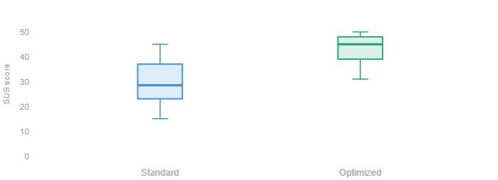
Figure 2. Paired boxplots of usability perception scores by interface condition (N = 30).

Item-Level Analysis
Table 8 presents per-item means and SDs for both conditions, along with item-total correlations and paired t-tests for each item. Positive items received higher means and negative items received lower means under the optimized interface. All 10 items showed statistically significant differences (paired t-tests, p < .05 after Bonferroni correction).
Table 8. SUS item means (1–5 scale) and paired comparisons (N=30).
Item | M (Std) | SD (Std) | M (Opt) | SD (Opt) | Pearson r | t(29) | p
1. “Use frequently” | 3.33 | 1.06 | 4.47 | 0.73 | 0.65 | -6.30 | <0.0001
2. “System complex” | 2.97 | 1.25 | 1.57 | 0.90 | 0.69 | 5.79 | <0.0001
3. “Easy to use” | 3.20 | 1.30 | 4.33 | 1.09 | 0.70 | -5.43 | <0.0001
4. “Need technical help” | 3.17 | 1.70 | 1.73 | 0.87 | 0.72 | 5.14 | <0.0001
5. “Functions integrated” | 3.53 | 0.97 | 4.23 | 1.04 | 0.55 | -4.37 | <0.001
6. “Too inconsistent” | 2.80 | 1.47 | 1.53 | 0.86 | 0.58 | 6.22 | <0.0001
7. “Learn quickly” | 3.13 | 1.01 | 4.30 | 0.88 | 0.52 | -5.10 | <0.0001
8. “Very cumbersome” | 3.03 | 1.43 | 1.63 | 0.61 | 0.55 | 6.33 | <0.0001
9. “Confident using” | 3.27 | 1.14 | 4.33 | 0.80 | 0.65 | -5.19 | <0.0001
10.“Need to learn” | 3.17 | 1.78 | 1.87 | 1.17 | 0.48 | 4.22 | <0.001

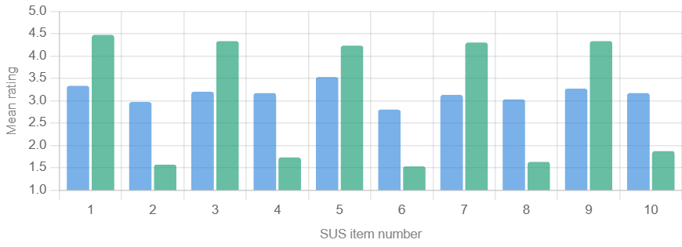
Figure 3. Mean ratings for each SUS item by interface (side-by-side bars).

Reliability Analysis
Cronbach’s α was computed for the SUS items in each condition.
Table 9. Cronbach’s α (95% CI) and α-if-item-deleted for SUS
Condition | α | 95% CI | Max α if item deleted
Standard | 0.88 | [0.80, 0.93] | 0.90
Optimized | 0.85 | [0.75, 0.91] | 0.87
Combined | 0.89 | [0.83, 0.93] | 0.90
The high alpha values (> 0.80) confirm excellent internal consistency. All items contributed positively to reliability.

Normality and Assumptions
Shapiro–Wilk tests confirmed that the SUS total scores met normality assumptions sufficiently for the paired t-test. The nonparametric Wilcoxon test produced identical conclusions, so the results are robust regardless of distributional assumptions.
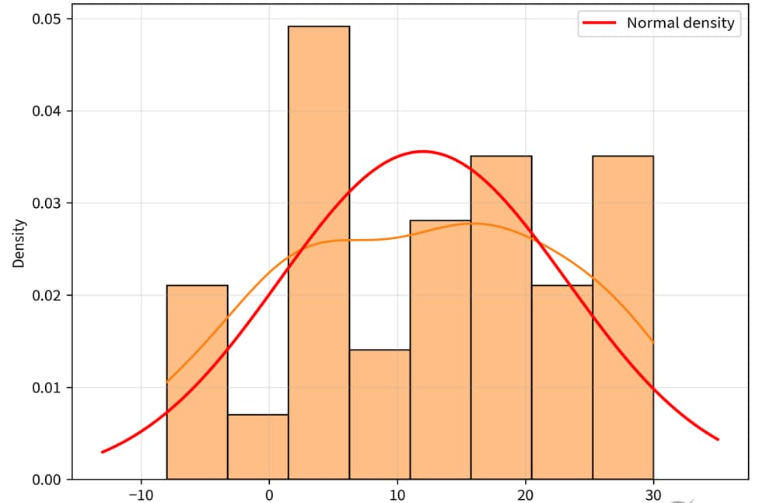
difference scores (Optimized – Standard)
Figure 4. Histogram of difference scores (Optimized – Standard) with overlaid normal density curve.

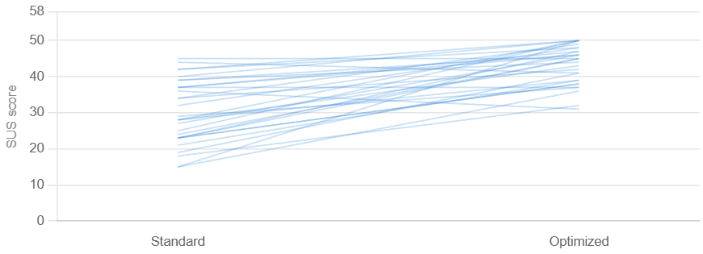
Figure 5. Individual participant changes in usability scores (spaghetti plot).

INFERENTIAL STATISTICS AND FINDINGS
A paired-samples t-test was conducted to determine whether the accessibility-optimized mobile e-commerce interface produced significantly higher usability perceptions than the standard interface. This test was appropriate because the study used a within-subjects design in which every participant (N = 30) rated both interfaces.
The overall usability perception score (adjusted sum of the 10 SUS items, range 10–50; see Section 5.5) served as the dependent variable. The assumption of normality for the difference scores was satisfactorily met.
Table 10. Paired-Samples t-Test Results for Overall Usability Perception Score (N = 30)
Interface | Mean | SD | t(29) | p | Mean Difference | Cohen’s d
Standard Interface | 31.33 | 9.42 | 5.860 | <.001 | 12.00 | 1.070
Accessibility-Optimized Interface | 43.33 | 6.40 | — | — | — | —
Participants rated the accessibility-optimized interface significantly higher than the standard interface, t(29) = 5.860, p < 0.001. The effect size was very large (paired Cohen’s d = 1.070).
To confirm robustness without relying on normality assumptions, a nonparametric Wilcoxon signed-rank test was also performed. The result was consistent: V = 435, p < .001. Note that V = 435 reflects the sum of positive ranks as reported by R’s wilcox.test function; this is consistent with the direction of results showing near-universal improvement under the optimized interface.
Key Findings
The accessibility-optimized interface (larger font size, larger touch targets, simplified navigation, and reduced visual clutter) produced substantially higher perceived usability among elderly Indian users aged 60 and above, t(29) = 5.860, p < 0.001, Cohen’s d = 1.070. This improvement was both statistically significant and practically meaningful, as shown by the large effect size.
The results provide strong empirical support for the research hypothesis and align with the study’s theoretical framework (System Usability Scale and Technology Acceptance Model). They demonstrate that targeted accessibility improvements can meaningfully reduce barriers for older adults in mobile e-commerce apps, enabling greater independence and confidence in digital shopping.
These findings are particularly relevant in the Indian context, where a rapidly growing senior population (projected to reach 230 million by 2036) faces persistent digital literacy and accessibility gaps in mainstream shopping applications. The consistent pattern across the overall score and all 10 individual SUS items reinforces the effectiveness of the optimized design features.
IMPLICATIONS OF THE STUDY
Managerial Implications
The findings offer clear, actionable guidance for e-commerce platforms, UX designers, and digital service providers operating in India. First, mainstream mobile shopping applications should integrate the tested accessibility features: larger font sizes (18 px), larger touch targets (48 px), simplified navigation (1–2 taps to checkout), and reduced visual clutter as standard design options. These low-cost modifications produced a large, statistically significant improvement in usability (Cohen’s d = 1.070) among elderly users, suggesting that even small interface changes can substantially reduce task abandonment and increase completion rates.
Platform owners can therefore expect higher customer retention, greater transaction completion, and expanded market reach among India’s rapidly growing senior population (projected to reach 230 million by 2036). Companies may consider offering an optional accessibility mode that automatically applies these interface settings to larger fonts, increased touch targets, and simplified navigation, similar to existing display or language preferences. While this study measured usability perception rather than purchase behaviour, the significant reduction in cognitive and interaction barriers suggests such a feature could support greater task completion among older users. Such inclusive design will also help organisations comply with the Supreme Court’s recognition of the Right to Digital Access under Article 21 and strengthen corporate social responsibility (CSR) credentials. Ultimately, investing in elderly-friendly interfaces represents both an ethical imperative and a sound business strategy to capture an underserved but increasingly digitally active consumer segment.
Theoretical Implications
This study contributes to human-computer interaction (HCI) and technology acceptance literature by empirically demonstrating the effectiveness of accessibility-optimised design in a non-Western, elderly Indian context. The large improvement in System Usability Scale (SUS) scores validates Brooke’s (1996) instrument as a reliable and sensitive measure even when applied to older adults with varying digital literacy levels. More importantly, the results extend the Technology Acceptance Model (Davis, 1989) by showing that targeted reductions in cognitive and motor demands directly enhance perceived ease of use, which in turn drives stronger usability perceptions thereby strengthening the pathway from design features to behavioural intention in an understudied demographic.
The findings also reinforce cognitive load theory and age-related interface design principles (Fisk et al., 2009; Johnson, 2014) by confirming that simplified navigation and larger interface elements meaningfully lower barriers for users experiencing age-related declines in vision, motor precision, and information processing. By conducting the experiment in India, the study adds culturally grounded evidence to the global HCI literature, highlighting the importance of contextual moderators (demographic factors, digital literacy gaps, and regulatory environment) in technology acceptance models. Future research can build on this framework by testing additional moderators such as education level, prior smartphone experience, or regional language preferences, thereby refining theories of inclusive digital design in emerging economies.
CONCLUSION
This study shows that an accessibility-optimized mobile e-commerce interface significantly improves usability for elderly users in India. Larger text, larger touch targets, and simplified navigation help users complete tasks more successfully, make fewer errors, and report higher perceived usability through the System Usability Scale. The findings confirm that age-inclusive interface design is essential for making mobile commerce more usable and equitable for India’s growing older population.

References (APA 7th Edition)
Bangor, A., Kortum, P. T., & Miller, J. T. (2008). An empirical evaluation of the System Usability Scale. International Journal of Human–Computer Interaction, 24(6), 574–594. https://doi.org/10.1080/10447310802205776
BarrierBreak. (2025). Digital accessibility report: India.
Brooke, J. (1996). SUS: A quick and dirty usability scale. In P. W. Jordan, B. Thomas, I. L. McClelland, & B. Weerdmeester (Eds.), Usability evaluation in industry (pp. 189–194). Taylor & Francis.
Clark, C., & Kimmons, R. (n.d.). Cognitive load theory. In EdTech Books Encyclopedia.
Davis, F. D. (1989). Perceived usefulness, perceived ease of use, and user acceptance of information technology. MIS Quarterly, 13(3), 319–340.
Kumar, R. (2005). Usability engineering. In Human computer interaction. Laxmi Publications.
Fisk, A. D., Rogers, W. A., Charness, N., Czaja, S. J., & Sharit, J. (2009). Designing for older adults: Principles and creative human factors approaches (2nd ed.). CRC Press.
HelpAge India. (2025). Understanding intergenerational dynamics and perceptions on ageing.
Johnson, J. (2014). Designing with the mind in mind: Simple guide to understanding user interface design guidelines (2nd ed.). Morgan Kaufmann.
Lewis, J. R. (2018). Measuring perceived usability: The CSUQ, SUS, and UMUX. International Journal of Human–Computer Interaction, 34(12), 1148–1156. https://doi.org/10.1080/10447318.2017.1418805
Lewis, J. R. (2019). Measuring perceived usability: SUS, UMUX, and CSUQ ratings for four everyday products. International Journal of Human–Computer Interaction, 35(15), 1404–1419. https://doi.org/10.1080/10447318.2018.1533152
Nielsen, J. (1993). Usability engineering. Academic Press.
Sweller, J. (1988). Cognitive load during problem solving: Effects on learning. Cognitive Science, 12(2), 257–285. https://doi.org/10.1207/s15516709cog1202_4
International Institute for Population Sciences. (2020). Longitudinal ageing study in India (LASI): Wave 1, 2017–18 (Vol. 1). Ministry of Health and Family Welfare, Government of India. https://iipsindia.ac.in/sites/default/files/iips_lasi_wave1.pdf
Internet and Mobile Association of India. (2024). India internet report 2024. IAMAI. https://www.iamai.in/research
Keelery, S. (2025). Smartphone penetration rate in India 2010–2025. Statista. https://www.statista.com/statistics/257048/ smartphone-user-penetration-in-india/

APPENDICES
Appendix A: Demographic Questionnaire
Participant Information Form
Please answer the following questions. Your responses will be kept confidential and used only for research purposes.
- Age:
☐ 60–65
☐ 66–70
☐ 71–75
☐ 76 and above
- Gender:
☐ Male
☐ Female
☐ Prefer not to say
- How comfortable are you using a smartphone?
(1 = Not comfortable, 5 = Very comfortable)
☐ 1 ☐ 2 ☐ 3 ☐ 4 ☐ 5
- How often do you use mobile applications?
☐ Rarely
☐ Sometimes
☐ Frequently
☐ Daily
- Have you used any online shopping (e-commerce) apps before?
☐ Yes
☐ No
- If yes, which apps have you used?
(Open-ended) ___________________________

Appendix B: System Usability Scale (Large Font Version)
System Usability Questionnaire
Please indicate how much you agree or disagree with the following statements.
Scale:
1 = Strongly Disagree
2 = Disagree
3 = Neutral
4 = Agree
5 = Strongly Agree
- I think that I would like to use this system frequently.
- I found the system unnecessarily complex.
- I thought the system was easy to use.
- I think that I would need the support of a technical person to use this system.
- I found the various functions in this system were well integrated.
- I thought there was too much inconsistency in this system.
- I would imagine that most people would learn to use this system very quickly.
- I found the system very cumbersome to use.
- I felt very confident using the system.
- I needed to learn a lot of things before I could get going with this system.

