Comparative Study of RC Column with RC Jacketing and FRP Jacketing

Abstract
Reinforced concrete columns are key structural members in multistorey buildings that carry loads from superstructure to the foundation. Retrofitting is required when columns can no more meet structural requirements due to aging, increased loading, or revised seismic design provisions. In this study, a G+10 RC moment-resisting building in Pune was analysed in ETABS using response spectrum analysis as per IS 1893 (Part 1): 2016. Axial load and biaxial bending checks carried out as per IS 456:2000 identified Column C3 as unsafe, with a demand–capacity ratio (DCR) greater than 1.0. To strengthen the deficient column, RC jacketing was designed according to IS 15988:2013 and SP-16 guidelines. The original 400 × 700 mm column was jacketed to 600 × 1000 mm using M35 concrete and 12 longitudinal bars of 20 mm diameter. Under an axial load of 408.77 kN, the retrofitted section was within the interaction limit with a DCR of 0.43, resulting in sufficient capacity. Strengthening using CFRP wraps was also assessed according to ACI 440.2R-17 provisions. The confinement ratio of 0.204 met recommended limits and increased the effective concrete compressive strength to 26.41 MPa. Comparative results show that RC jacketing considerably enhances stiffness and load capacity but increases member size and self-weight. In contrast, CFRP jacketing improves confinement and ductility without increasing cross-sectional dimensions and easy installation. However, limited studies compare RC and CFRP jacketing using a building-level demand–capacity approach. This study presents such an approach to support selection of suitable seismic retrofitting techniques based on performance requirements.
Keywords -RC Column, Retrofitting, RC Jacketing, FRP Jacketing, ETABS, Numerical Analysis.
1. Introduction
Reinforced concrete columns play an important role in a building by safely transferring loads from slabs and beams to the foundation, forming the main load path of the structure. During seismic conditions, columns resist gravity load with a combination of lateral forces, resulting in combined axial force and bending moments. If the column is weak or inadequately designed, this load transfer mechanism gets disturbed, which can lead to excessive damage, soft-storey formation, or even collapse of the building[1] Therefore, it is crucial to give RC columns the strength, stiffness, and ductility to guarantee appropriate load transfer and adequate seismic performance, particularly in existing structures that need to be retrofitted.
The RC columns in the structure can be deficient due to various factors related to design, construction and service conditions. An additional storey or installing heavy equipment in an existing building increases the loading on the building, which exceeds the load-carrying capacity of the columns, leading to the failure of columns[2]. Many existing buildings are designed using earlier seismic provisions against the current seismic demands[3].Construction defects such as improper reinforcement detailing, poor quality control, and inadequate beam–column joint behaviour further reduce column performance under seismic loading. [4] In addition, ageing and deterioration due to environmental exposure, corrosion of reinforcement, and material degradation over time can significantly reduce the load-transfer efficiency and seismic resistance of RC columns [5]. In these cases, retrofitting of deficient columns is adopted as it effectively improve structural capacity while reducing cost, time, and inconvenience to building occupants[6]. Reconstruction requires demolition of the existing structure and complete rebuilding, making it least practical solution for existing building[7]. Several studies have indicated RC jacketing and FRP wrapping can effectively increase the load-carrying capacity, stiffness, and seismic performance of deficient columns without changing the overall structural system. Therefore, strengthening method provides a practical and sustainable key for addressing column deficiencies and increasing the service life of existing structures.
RC jacketing is most commonly adopted retrofitting method, which involves surrounding the existing column with an extra layer of concrete and reinforcement to improve its strength and stiffness[7]. This technique increases the axial and flexural capacity of deficient columns and enhances their seismic performance by providing better confinement[8]. Due to its simplicity and compatibility with existing RC members, RC jacketing is widely adopted for seismic strengthening of older structures[9]. Fibre-reinforced polymer (FRP) jacketing is an advanced strengthening technique in which high-strength composite materials are externally bonded or wrapped around RC columns to enhance their structural performance. FRP jacketing improves axial load capacity and ductility by providing effective lateral confinement to the concrete core, with minimal increase in member dimensions[2]. Compared to conventional RC jacketing, FRP systems offer advantages such as light weight, corrosion resistance, rapid installation, and reduced construction time [10]. However, most previous studies have focused on isolated column behaviour under laboratory conditions. Limited research has evaluated and compared RC and FRP jacketing at the building level using unified demand–capacity assessment under seismic loading. Several experimental and analytical studies have stated that FRP-wrapped columns improve seismic behaviour, making FRP jacketing suitable for retrofitting in space-constrained and architecturally sensitive structures [11].
2. Objectives of the Study
Many previous studies have examined RC and FRP jacketing methods, but most of them focus on testing individual columns under laboratory conditions. Very few studies have compared RC jacketing and FRP jacketing techniques using a common demand–capacity approach under seismic loading. Therefore, there is a need to study how both methods perform under realistic building conditions and evaluate their effectiveness in improving structural behaviour.
Based on identified research gap, the objectives of the present study are:
- To model and analyse an existing G+10 RC building in ETABS using available structural data, identify the deficient column through seismic demand–capacity assessment, and retrofit it using the RC jacketing method while evaluating FRP strengthening through numerical confinement analysis.
- To compare RC jacketing and FRP jacketing in terms of strength enhancement and stiffness improvement at the building level.
3. Literature Review
3.1 Studies on Reinforce concrete jacketing of columns-
Reinforced concrete (RC) jacketing is considered one of the most widely adopted techniques for strengthening deficient or damaged RC columns, particularly in earthquake prone regions, due to its reliability and practical applicability. This method effectively increases axial load capacity, flexural strength, stiffness, and overall ductility of columns [7]. The method comprises covering the existing column with an additional layer of concrete, along with longitudinal reinforcement and transverse ties [12]. The improvement in performance is mainly due to the increase in cross-sectional area and the confinement effect provided by the jacket. Various experimental studies show that RC-jacketed columns improves energy dissipation and delayed failure under seismic loading[13]. This method is particularly effective for strengthening buildings designed as per old seismic codes or gravity-load-only provisions. In India design and detailing of RC jacketing are commonly carried out following the guidelines of IS 15988:2013 [12]. In Comparison to advanced retrofitting techniques, RC jacketing is cost-effective and does not require specialised materials or skilled labour[7]. Studies based on analytical and numerical approaches have shown a considerable reduction in demand-capacity ratios of columns after RC jacketing [14]. RC jacketing also helps in achieving a more uniform distribution of lateral strength throughout the structure[7]. Experimental investigations have proved that proper interface bonding between old and new concrete is key for effective load transfer[15]. High-performance and higher-grade concrete used in jacketing further improves the shear resistance and durability of columns[16]. Overall, RC jacketing remains a proven, strong, and widely preferred retrofitting solution for improving the seismic performance of existing RC structures[7].

3.2 Studies on Fibre Reinforced Polymer jacketing of RC columns-
Fibre Reinforced Polymer (FRP) jacketing has increasingly used as a strengthening technique due to its high strength-to-weight ratio and corrosion resistance[2]. FRP jacketing primarily works by providing external confinement to concrete, which results in improved axial load capacity and ductility[17]. Several experimental studies have shown that FRP-confined columns display delayed cracking and higher ultimate strain compared to unconfined columns[18]. Carbon Fibre Reinforced Polymer (CFRP) is generally considered to be more effective than GFRP due to its higher stiffness and confinement efficiency. The effectiveness of FRP jacketing is largely depended upon parameters such as fibre type, number of layers, wrap orientation, and concrete strength[19]. FRP jacketing is particularly suitable for seismic retrofitting, as it improves energy dissipation and deformation capacity of RC columns[20]. Finite element studies have authorised experimental findings and highlighted the role of FRP confinement in improving load–displacement behaviour[19]. FRP jacketing causes minimal increase in column size, making it advantageous in space-restricted and existing buildings[2]. Studies on square and rectangular columns indicate that rounding of corners significantly increases FRP confinement efficiency[18]. FRP-strengthened columns show improved behaviour under axial, eccentric, and cyclic loading conditions[21]. Another advantage of FRP materials is that it provide excellent corrosion resistance, making them suitable for aggressive environmental conditions [22]. In spite of its advantages, FRP jacketing is limited by brittle failure and premature debonding, highlighting the need for proper surface preparation and design rules [23]. Overall, previous studies approve that FRP jacketing is a highly efficient and practical solution for strengthening RC columns when designed and applied suitably[2].

3.3 Comparative studies between RC and FRP jacketing-
Several comparative studies have evaluated RC jacketing and FRP jacketing to identify the most effective retrofitting technique for deficient reinforced concrete columns. RC jacketing is reported to significantly enhance axial load capacity, stiffness, and overall strength due to the increase in cross-sectional area[7]. In contrast, FRP jacketing primarily improves column performance through external confinement without increasing member dimensions[10]. Comparative experimental studies indicate that RC jacketing provides higher strength enhancement, while FRP jacketing offers better ductility improvement. RC jacketing is generally more cost-effective, especially in developing countries where material and labour costs are critical factors. [24]. FRP jacketing, however, requires significantly less construction time and causes minimal disturbance to existing structures[25]. Finite element and numerical studies show that both techniques effectively reduce seismic demand and eliminate plastic hinge formation in columns [26]. RC jacketing increases the mass and stiffness of the structure, which may attract higher seismic forces during earthquakes[25]. FRP jacketing avoids this drawback and is therefore preferred in cases where weight addition is a concern [27]. Comparative seismic studies reveal that RC jacketing provides better global strength, while FRP jacketing improves local confinement efficiency[24]. Durability studies highlight the superior corrosion resistance of FRP jacketing compared to conventional RC jacketing[10]. However, FRP jacketing is prone to brittle failure and debonding if not properly detailed [27]. Overall, literature concludes that RC jacketing is suitable for strength-critical retrofitting, whereas FRP jacketing is ideal for rapid and space-restricted strengthening applications[24].

3.4 Limitations of past research-
Most past research on retrofitting of RC columns has primarily focused on experimental studies on isolated column specimens under controlled laboratory conditions [28].These studies often neglect the interaction between retrofitted columns and the overall structural system of a building[29].Several investigations on RC jacketing emphasise strength enhancement but provide limited insight into post-retrofitting seismic demand redistribution[28]. FRP jacketing studies largely concentrate on axial or uniaxial loading, with fewer studies addressing biaxial bending and realistic seismic loading conditions [23]. Many experimental works do not adequately consider long-term durability issues such as fire resistance, environmental exposure, and bond degradation[30]. Comparative studies between RC and FRP jacketing are limited and existing studies lack consistent performance-based evaluation framework [3]. Several numerical studies use simplified material models that may not fully capture the nonlinear behaviour of retrofitted columns[30]. Cost, constructability, and practical implementation tests are rarely focused in detail in existing literature[31]. In many studies, structural performance is primarily assessed using strength parameters, with less emphasis on serviceability and functionality-related performance levels. [29]. Few researchers have combined ETABS-based building-level analysis with detailed manual design of retrofitted columns[28]. The influence of retrofitting techniques on demand–capacity ratios of individual columns within an existing building remains unsatisfactorily discovered[28]. Therefore, a clear research gap exists in performing a comprehensive comparative study of RC and FRP jacketing at the building level, combining ETABS-based seismic analysis with detailed column design to evaluate strength, ductility, and overall performance enhancement[29].

4. Methodology

4.1 Identification of Critical RC Column-

4.1.1 Details of existing Reinforced Concrete building.
The existing reinforced concrete (RC) building considered in this study is a multi-storey moment-resisting frame structure designed as per the earlier provisions of Indian Standards. It is a G+10 store residential building with 36.60 m in X direction, 34.8 m in Y direction. The building consists of RC beams, columns, and slabs, and is located in Pune, India. The original structural configuration, material properties, member dimensions, and reinforcement details were obtained from the available design drawings. The building was modelled in ETABS using beam and shell elements to realistically represent the structural behaviour. The lateral load resisting system consists of a flat slab with RC shear walls. Since the building consists of a conventional slab arrangement with RC frames detailed as per the requirements of IS13920:2016, R=5 is adopted. Type of soil considered as Hard (Type-I).

4.1.2 Load combinations and seismic parameters.
The building was studied under gravity and seismic loads as per provision of IS 456:2000 and IS 1893 (Part 1):2016. Dead loads were estimated from the self-weight of structural elements along with floor finishing loads, whereas live loads were assigned based on the occupancy type of the building. The response spectrum method was used to explain seismic loads, considering parameters such as seismic zone factor, importance factor, response reduction factor, and soil type. For ultimate limit state analysis, appropriate load combinations of dead load, live load, and earthquake load in both principal directions were created in ETABS.

4.1.3 ETABS Analysis for Identification of Deficient Columns.
Linear dynamic analysis was carried out in ETABS to obtain axial forces and biaxial bending moments in all columns under the governing load combinations. The critical columns were identified based on maximum axial load and bending moment demands. Particular attention was given to columns at lower storeys, corner locations, and columns subjected to high biaxial bending due to seismic effects. The demand parameters (axial force Pu, bending moments Mux and Muy) obtained from ETABS were compared against the capacity of the columns calculated as per IS 456:2000 using interaction equations for axial load and biaxial bending. ETABS design output and manual verification were used to ensure the reliability of results.

4.1.4 Criteria for Column Failure.
The performance of each column was evaluated using P–M interaction checks and Demand–Capacity Ratio (DCR). A column was considered deficient or critical if any of the following conditions were satisfied:
- The demand point (Pu, Mux, Muy) lies outside the P–M interaction curve for the given column section and reinforcement.
- The Demand–Capacity Ratio (DCR) exceeds unity (DCR > 1.0).
- Excessive drift-induced moments lead to overstressing under seismic load combinations.
Columns C3 and C14 were considered structurally deficient due to insufficient reinforcement. It is especially lacking in flexural strength and shear resistance.

4.2 Strengthening Using RC Jacketing in ETABS.
After identifying the deficient RC columns from the seismic analysis, strengthening was carried out using the RC jacketing technique. RC jacketing involves increasing the cross-sectional area of the existing column and providing additional longitudinal and transverse reinforcement to enhance its strength, stiffness, and ductility. In the present study, RC jacketing was modelled numerically using ETABS to evaluate the effectiveness of the retrofitting scheme.

 | 
Fig 1 Existing building with C14 & C3 failed (before RC jacketing). | Fig 2 Building with C14 & C3 Column after RC jacketing.

4.2.1 Jacketing Details.
Increase in Column Dimensions-
C3 Column has dimensions of 400 mm x 700 mm, constructed with M30 grade concrete. The column is jacketed with an additional 100 mm thickness on shorter side and 150 mm thickness on longer side for structural strengthening. This increase in column size results in a higher load-carrying capacity and improved stiffness of the structural member.
Longitudinal Reinforcement-
Additional longitudinal reinforcement bars are provided in the jacketed portion of the column to enhance axial and flexural capacity. The amount and arrangement of reinforcement are designed as per the provisions of IS 456:2000, ensuring adequate development length and continuity with the existing column reinforcement. The reinforcement ratio was maintained within permissible limits to avoid congestion and brittle behaviour. 12 bars of 20mm diameter HYSD500 are provided as longitudinal reinforcement.
Lateral Ties-
Closely spaced lateral ties are introduced in the jacketed section to ensure concrete confinement and prevent longitudinal bar buckling. The spacing and diameter of ties are selected in accordance with seismic detailing requirements of IS 13920:2016, particularly in potential plastic hinge regions. 10mm diameter ties are provided as lateral ties.
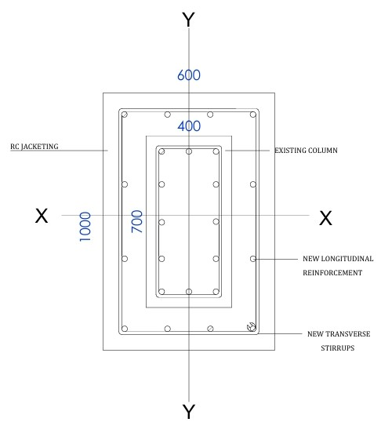

Fig 3 Geometry and Reinforcement details of C3 RC Jacketed column in Section designer.

4.2.2 Material Properties.
The material properties for the RC jacket are defined separately from the existing concrete for better material quality. M35 grade of concrete is adopted for the jacketed section. Higher-grade concrete and reinforcement steel are assumed for the jacketed portion to achieve better performance under seismic loading.

4.2.3 Modelling Procedure in ETABS.
After section modification of the deficient columns, the entire building was reanalysed in ETABS under the same load combinations. Due to the increased stiffness of jacketed columns, internal forces are redistributed within the structural system. After strengthening a portion of the lateral and gravity loads that were previously carried by weaker member resulting in a more uniform load distribution and enhanced overall structural performance.

4.2.4 Performance Parameters Evaluated.
The effectiveness of RC jacketing was assessed by comparing the structural performance of the building before and after retrofitting using the following parameters:
Axial Load Capacity:
The axial load capacity of jacketed columns was studied and compared with the existing columns to estimate the enhancement due to increased cross-sectional area and reinforcement. The existing column has a lower axial capacity due to its smaller cross-sectional area and limited reinforcement. RC jacketing increases section size and adds reinforcement, thereby increasing the axial load capacity.

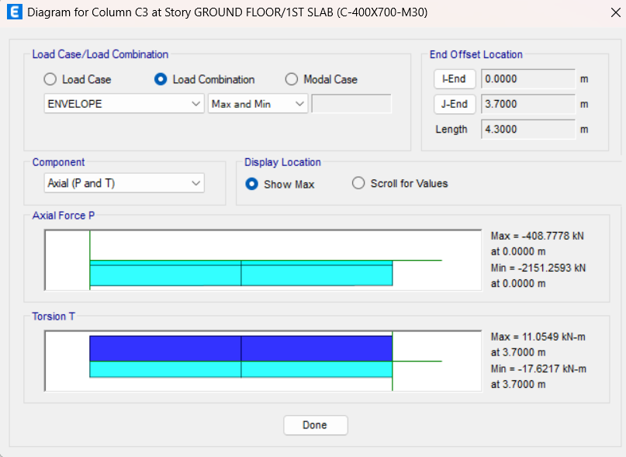

Fig 4 Axial load capacity of C3 Column of existing building.

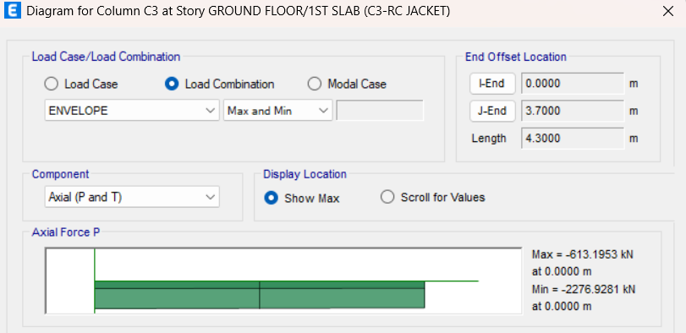

Fig 5 Axial load capacity of C3 Column of RC Jacketed building.

Storey Drift:
Storey drift values are obtained from ETABS analysis to assess the improvement in lateral deformation characteristics of the structure. Reduced drift indicates enhanced seismic performance.

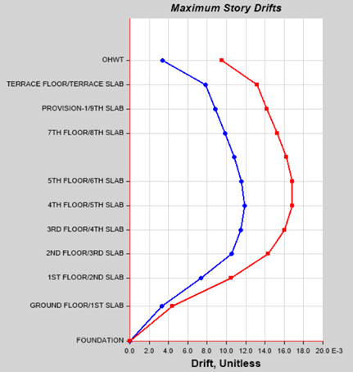 | 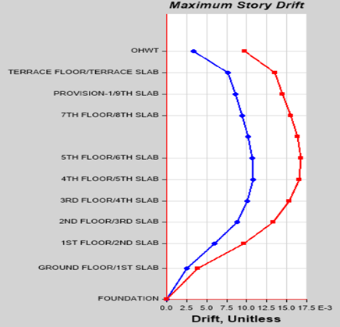
Fig 6 Max. Storey drift of existing building | Fig 7 Max. Storey drift of RC Jacketed building

Stiffness Improvement:
The overall stiffness improvement due to RC jacketing was evaluated by comparing storey stiffness structure before and after retrofitting.

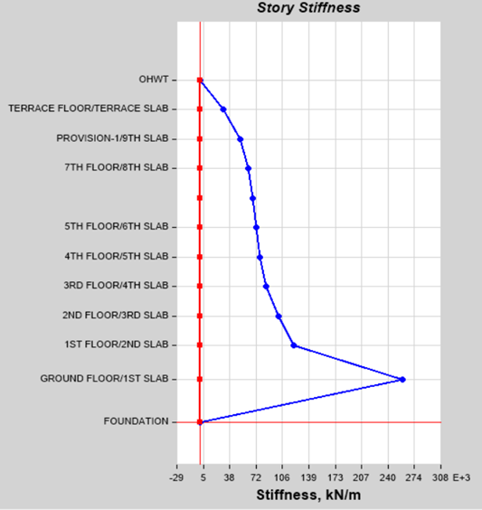 | 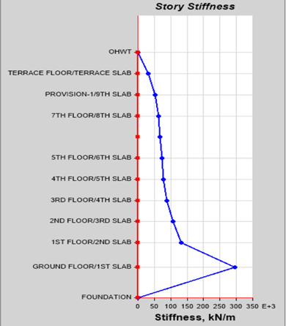
Fig 8 Storey Stiffness existing building in EQx direction. | Fig 9 Storey Stiffness of RC Jacketed building in EQy direction.

4.3 MANUAL DESIGN FOR CHECKING THE RC JACKETED SECTION UNDER AXIAL COMPRESSION AND BIAXIAL BENDING.

Column C3 has existing dimensions of 400x700mm, constructed with M30 grade concrete. The column was RC Jacketing with an additional 150mm thickness on the longer side and 100mm thickness on the shorter side for structural strengthening. For the jacked section design, the column under axial compression load and biaxial bending with reference to IS 456:2000 and SP-16
Column No- C3
Height of column= 3500mm; Width (b) =600mm; Depth (D)=1000mm; Clear cover =40mm
fy = 500 MPa; fck =30 MPa. Pu =408.77 kN; Mux =64.4 kN.m; Muy = 207.123 kN.m
Assume diameter of tie =10mm and bar diameter =20mm
Effective cover (d’) = 40+10+20/2 = 60mm
According to the provisions provided in Cl-8.5.1.2 (a) of IS 15988: 2013, the concrete strength shall be at least 5 MPa greater than the strength of the existing concrete.
Thus, taking the value of fck = 35 N/mm²
For x-x axis $\frac{d'}{D}$= 60/600 = 0.1 and for y-y axis $\frac{d'}{D}$ = 60/1000 = 0.06=0.1
$\frac{Pu}{Fck.b.D}$ = 408.77/35*600*1000= 0.019
Assume Reinforcement= 12-20mmФ; Asc = 12x$\frac{π}{4}$x20²= 4561.021mm²
P= $\frac{Asc}{((600*1000)/100)}$ = 0.76%; Therefore $\frac{P}{fck}$ = 0.76/35 = 0.02
Assuming As = $\frac{P.b.D}{100}$ = 408.77*600*1000/100 = 6000mm².
For 1) $\frac{d'}{D}$ = 0.1; 2) fy= 500; 3) $\frac{Pu}{Fck.b.D}$= 0.019; 4) $\frac{P}{fck}$ = 0.02
Referring to chart 48 of SP: 16 (“equal reinforcement on all sides”),
$\frac{Mux1}{fck.b.D2}$= 0.0533; Therefore Mux1 =1119.3 Kn.m
$\frac{Muy1}{fck.b.D2}$ = 0.04375; Therefore Muy1 =551.25 Kn.m
For values of Puz and αn.
Puz = 0. 45fck.Ac + (0.75fyAsc) = 0.45x35x595459 +(0.75x500x4561.02)
Puz = 11088.54Kn
For Pu/Puz = 0.036 Value of α= 1
According to the equation, ${\left(\frac{Mux}{Mux1}\right)}^{∝n}$+ ${\left(\frac{Muy}{Muy1}\right)}^{∝n}$≤ 1.0

${\left(\frac{64.4}{1119.3}\right)}^{1}$+ ${\left(\frac{207.123}{551.25}\right)}^{1}$= 0.43 ≤ 1.0
Hence, the trial section is safe under the applied loading.

4.4 Strengthening Using FRP Jacketing.
For the identified weak RC columns, Fiber Reinforced Polymer (FRP) jacketing is used as an alternate strengthening method in addition to RC jacketing. Without appreciably increasing member size or self-weight, FRP jacketing mainly boosts the axial load capacity and ductility of columns through lateral confinement of concrete. The efficiency of FRP strengthening under seismic loading conditions was assessed in this study by numerical implementation.

4.4.1 Type of FRP Used
Carbon Fibre Reinforced Polymer (CFRP) and Glass Fibre Reinforced Polymer (GFRP) are commonly used in structural retrofitting because of their high strength-to-weight ratio and corrosion resistance. In the present study, CFRP was selected due to its higher tensile strength, elastic modulus, and superior confinement efficiency compared to GFRP. The FRP was assumed to be externally bonded to the column surface using epoxy resin.

4.4.2 Assumptions for FRP Column Retrofitting (As per ACI 440.2R-17)

FRP Behaviour is Linear Elastic- FRP materials are assumed to behave in a linear elastic manner up to failure, as they do not exhibit yielding like steel.
Perfect Bond Between FRP and Concrete- It is assumed that there is a perfect bond between the FRP wrap and the concrete surface, ensuring full strain compatibility (no slip occurs at the interface).
Confinement Provided by FRP is Passive- The confinement effect provided by FRP wraps is considered passive, meaning it is only activated once the concrete starts to expand laterally under axial load.
FRP Contribution is Only in Hoop Direction- In circular or rectangular columns, only the hoop (transverse) direction of FRP contributes to confinement; FRP in the longitudinal direction is not effective in axial load resistance unless specifically designed for that purpose.
Concrete Fails in Compression Before FRP Rupture-The confined concrete is assumed to reach its ultimate strain capacity before the FRP wrap ruptures, unless otherwise calculated.
Design is based on the Ultimate Limit State. FRP strengthening is designed considering ultimate limit states, ensuring adequate safety margins against failure under extreme loads.
FRP Wrap Does Not Increase Axial Capacity Directly-FRP confinement improves ductility and compressive strain capacity of concrete, but does not directly increase the compressive strength of concrete significantly unless properly confined.

4.4.3 Material Properties
Table:1 Material Properties.
Sika CarboDur S
Thickness per ply (tf) | 1.4 | mm
Ultimate tensile strength (ffu) | 3100 | Mpa
Rupture Strain | 0.018 | mm/mm
Modulus of Elasticity | 165000 | Mpa
4.4.4 Numerical Analysis of FRP.
Column No- C3
Width (b) =400mm; Depth (D)=700mm; Pu=408770 N
fy = 500 MPa; fck =30 MPa.
Specified compressive strength of concrete (fc’) = fck x 0.8 = 24 Mpa
Area of concrete =Ag= 400x700 = 280000mm2
Ast provided= $\frac{π}{4}$x 20²= 314.15mm2; Ast% =$\frac{Ast prov}{Area of concrete}$ x 100= $\frac{314.15}{280000}$ x100 =0.11%
Effective Area of Concrete = Ac= Ag-Ast prov = 279685.85mm2
Compressive strength of confined concrete (fcc’) = $\frac{Pu}{0.8 x 0.65}$ - $\frac{Fy x Ast prov}{0.85 x Ac}$ = 2.65Mpa
Strain with environment reduction factor (Efu) =0.95 x Rupture strain =0.95x0.018 = 0.0171
Strain with Creep reduction factor (Efe) = 0.5x Efu= 0.00855
Ratio of effective confined concrete/area of concrete $\left(\frac{Ae}{Ac}\right)$ = $\frac{1-\frac{\left\{\left(\frac{b}{h}\right){\left(h-2rc\right)}^{2}+\left(\frac{h}{b}\right){\left(b-2rc\right)}^{2}\right\}}{3.Ag}- pg}{1-pg}$ = 0.4573
Shape Factor (Ka) = $\frac{Ae}{Ac}{\left(\frac{b}{h}\right)}^{2}$= 0.149
Consider no of Wrap =n=1
Maximum Confining Pressure due to FRP (fl) =$\frac{2Ef.n.tf.Efe}{\sqrt{b^{2}+h^{2}}}$ = 4.90Mpa
Checking Minimum Confinement Ratio (fl/fc’) = 0.204 >0.08; Hence Safe
Maximum Confined pressure of confined concrete (fcc’) = Fc’+3.3. Ka.fl =26.41Mpa >Fcc’req; Hence Safe.
The FRP wrap applies lateral pressure to the column, which prevents the concrete from expanding under compression. This increases the concrete strength from 24 MPa to 26.41 MPa and improves the axial capacity and ductility without changing the column dimensions
5. Results and Discussion
5.1. Seismic Deficiency of the Existing Column- According to the response spectrum study, Column C3 is dangerous when subjected to seismic loads. The column is supporting an axial load of 408.77 kN and two bending moments of 64.4 kN·m and 207.12 kN·m. The demand point is beyond the safe limit and the demand–capacity ratio is 1.062, which is greater than 1.0, when these values are examined using the interaction diagram in accordance with IS 456:2000. This indicates that the column lacks the strength to withstand the combined effects of biaxial bending and axial load during an earthquake. The lack of longitudinal reinforcement, inadequate flexural strength in both directions, and increased bending moments brought on by storey drift are the primary causes of this subpar performance.
Therefore, the existing 400 mm × 700 mm column with 24 MPa concrete cannot resist the seismic demand and needs strengthening.
5.2. Structural Strength and Global Stiffness Enhancement Using RC Jacketing- After applying RC jacketing, the column size was increased to 600 mm × 1000 mm, which increased the cross-sectional area by about 114%. Due to this increase in size, the axial load capacity of the column improved from 408.77 kN to 613.19 kN, which is about a 50% increase the interaction check showed:$\frac{Mux}{Mux1}$ + $\frac{Muy}{Muy1}$ =0.43 ≤ 1. This demonstrates the reinforced column's safety under combined loads. The column's flexural rigidity (EI) rose after jacketing because it grew bigger and stiffer. As a result, the building's total storey stiffness increased, storey drift decreased, and lateral pressures were better distributed among the structural sections. As a result, RC jacketing enhances the building's total seismic performance in addition to the column's strength. However, the self-weight of the structure is also increased by the larger columns, which may result in a little increase in the seismic forces operating on the building.
5.3. Confinement-Based Performance Enhancement Using FRP Jacketing-The concrete strength increased from 24 MPa to 26.41 MPa, or around 10%, using FRP strengthening employing a single layer of CFRP wrap. The FRP wrap produced a confinement pressure of 4.90 MPa, and the confinement ratio of 0.204 is greater than the necessary minimum of 0.08. This demonstrates that the column is sufficiently confined by the FRP wrap. FRP jacketing does not enlarge the column, in contrast to RC jacketing. The FRP wrap's lateral confinement, which stops the concrete from expanding, is primarily responsible for the improvement. These raise the final compressive strain and postpone the concrete's breaking and crushing. The improvement in ductility and deformation capacity is substantial, even if the strength gain achieved with FRP jacketing is less than that with RC jacketing. As a result, FRP jacketing is more suited for enhancing energy absorption and lowering the possibility of abrupt brittle failure during seismic activity.

5.4. Comparative Performance at Building Level-The comparative evaluation highlights distinct behavioural differences:
RC Jacketing-
- 50% increase in axial capacity
- Significantly increase stiffness of the building
- Effectively reduces storey drift
- Increases column size and structural mass
- Changes the original geometry of the building
FRP Jacketing
- 10% increase in compressive strength
- Provides high improvement in ductility
- Improves deformation and energy dissipation capacity
- Does not change column size
- Adds negligible weight to the structure
From a building-level seismic perspective,
RC jacketing is more suitable when the building is weak in strength and stiffness.
FRP jacketing is more suitable when the main requirement is ductility and deformation control, especially where increasing the member size is not possible due to architectural limitations.
6. Conclusion.
6.1. Structural Strength and Stiffness Enhancement- In addition to the larger member size and added longitudinal and transverse steel reinforcement, RC jacketing improves the axial and flexural resistance of columns and exhibits a discernible increase in overall structural stiffness. Conversely, FRP jacketing enhances column performance by giving the concrete core lateral confinement, which greatly boosts ductility and deformation capacity. FRP strengthening has relatively little effect on the structure's overall stiffness since it does not change the original cross-sectional dimensions.

6.2. Geometric Impact and Space Requirements- RC jacketing increases column size as well as the overall weight of the structure which can be a challenging in buildings where available space is restricted in contrast FRP jacketing requires only a very thin external layer and does not significantly increase the original dimensions of the column making it more suitable for locations with limited space or where architectural appearance and clearance must be maintained

6.3. Constructability and Installation Considerations- RC jacketing is generally feasible since it uses traditional materials and labour, but it takes a long time because of the formwork and curing requirements. Although FRP jacketing provides quicker and less invasive installation, successful adhesion and dependable structural performance during installation necessitate expert craftsmanship and stringent quality control.

6.4. Durability and Environmental Resistance- FRP jacketing works well in challenging environmental conditions and has strong corrosion resistance. In contrast, RC jacketing is more susceptible to long-term deterioration brought on by steel corrosion and extended exposure to environmental conditions, while being sturdy when planned and built correctly.

8. References
[1] K. Singh and A. Uniyal, “Analysis of Seismic Retrofitting on RC Building,” vol. 7, no. 12, pp. 1–6, 2019.
[2] A. Parvin and D. Brighton, “FRP Composites Strengthening of Concrete Columns under Various Loading Conditions,” pp. 1040–1056, 2014, doi: 10.3390/polym6041040.
[3] J. P. P. Camayang and J. A. Padilla, “Seismic Retrofitting : Techniques and Innovations for Structural Resilience,” vol. 1450, pp. 1–10, 2025, doi: 10.1088/1755-1315/1450/1/012008.
[4] “SEISMIC STRENGTHENING OF BEAM-COLUMN JOINTS WITH,” pp. 1–8.
[5] M. R. Shendkar, A. Tantri, and A. U. Rao, “Seismic evaluation and retrofit of reinforced concrete structures,” J. Infrastruct. Preserv. Resil., 2025, doi: 10.1186/s43065-024-00114-y.
[6] S. Raza, M. K. I. Khan, S. J. Menegon, H. Tsang, and J. L. Wilson, “Strengthening and Repair of Reinforced Concrete Columns by Jacketing : State-of-the-Art Review,” 2019.
[7] A. Habib, U. Yildirim, and O. Eren, “Column repair and strengthening using RC jacketing: a brief state-of-the-art review,” Innov. Infrastruct. Solut., vol. 5, no. 3, pp. 4–6, 2020, doi: 10.1007/s41062-020-00329-4.
[8] U. Dongre, “A Review on Strengthening and Repair of RC Column by,” vol. 7, no. 3, pp. 113–117, 2020.
[9] A. I. Basha and G. M. Asst, “Comparative Study on Column Jacketing Using Three Alternative Materials ( RCC , Steel , FRC ) in the Seismic Performance of a RC Framed Building Abstract :,” vol. 5, no. 1, pp. 56–61, 2022.
[10] F. Effectiveness, “A State-of-the-Art Review on Structural Strengthening Techniques with FRPs: Effectiveness, Shortcomings, and Future Research Directions,” 2024.
[11] P. Ranjan and P. Dhiman, “Retrofitting of Columns of an Existing Building by RC , FRP and SFRC Jacketing Techniques,” pp. 40–46, 1987.
[12] N. Gupta, P. Dhiman, and A. Dhiman, “Design and Detailing of RC Jacketting for Concrete Columns,” IOSR J. Mech. Civ. Eng., pp. 54–58, 2013, [Online]. Available: www.iosrjournals.org
[13] M Gomaa, “ Seismic Assessment of Retrofitted RC Structures Using Traditional and New Repair Techniques,” 15th World Conf. Earthq. Eng., no. October, 2012.
[14] G. D. Lakade, S. S. Kadam, Y. P. Pawar, D. D. Mohite, and C. M. Deshmukh, “PERFORMANCE OF RC BUILDING UNDER DYNAMIC FORCES AND SUITABILITY OF STRENGTHENING BY FRP JACKETING Department of Civil Engineering,” vol. 6, no. 9, pp. 147–159, 2015.
[15] S. C, A. K. Sambasivan, K. R. Kannan, and M. Jegan, “Investigation on the performance of reinforced concrete columns jacketed by conventional concrete and geopolymer concrete,” Eng. Sci. Technol. an Int. J., vol. 36, p. 101275, 2022, doi: 10.1016/j.jestch.2022.101275.
[16] M. Hadzima-nyarko, I. Ercan, D. Radu, and B. Bulaji, “Effectiveness of High-Performance Concrete Jacketing in Improving the Performance of RC Structures,” pp. 1–25, 2025.
[17] M. Hosseini, B. Jian, H. Li, D. Yang, Z. Wang, and Z. Feng, “A Review of Fibre Reinforced Polymer ( FRP ) Reinforced Concrete Composite Column Members Modelling and Analysis Techniques,” 2022, doi: 10.32604/jrm.2022.022171.
[18] A. Parvin and T. S. Shah, “Fiber Reinforced Polymer Strengthening of Structures by Near-Surface Mounting Method,” 2016, doi: 10.3390/polym8080298.
[19] M. Awad, “Influence of Key Parameters on the Load – Displacement Response of FRP-Confined Concrete Columns : A Finite Element Investigation,” vol. 1, no. 3, pp. 58–63, 2025.
[20] A. Siddika, M. A. Al Mamun, W. Ferdous, and R. Alyousef, “Performances, challenges and opportunities in strengthening reinforced concrete structures by using FRPs – A state-of-the-art review,” Eng. Fail. Anal., vol. 111, p. 104480, Apr. 2020, doi: 10.1016/j.engfailanal.2020.104480.
[21] F. R. Mahmoud, L. M. E. Abd, G. F. Naglaa, and Y. R. Tawfic, “Behaviour of Strengthened Columns with Basalt Fiber-Reinforced Polymers : Review,” vol. 12, no. 05, pp. 92–100, 2023.
[22] T. Tafsirojjaman, A. Ur, R. Dogar, Y. Liu, A. Manalo, and D. P. Thambiratnam, “Performance and design of steel structures reinforced with FRP composites : A state-of-the-art review,” Eng. Fail. Anal., vol. 138, no. November 2021, p. 106371, 2022, doi: 10.1016/j.engfailanal.2022.106371.
[23] R. Palanivelu, B. Panchanatham, and L. Eva, “Case Studies in Construction Materials Strengthening of axially loaded RC columns using FRP with inorganic binder : A review on engineered geopolymer composites ( EGC ),” Case Stud. Constr. Mater., vol. 22, no. March, p. e04590, 2025, doi: 10.1016/j.cscm.2025.e04590.
[24] I. Journal and O. F. Science, “A comparative study on retrofitting concrete column by FRP-Wrapping and RC-Jacketing methods : A feasibility study for Afghanistan,” no. 1, pp. 652–664, 2021.
[25] W. Wang, M. Xie, Z. Xu, J. Liao, and M. Abdullah, “A Comparative Experimental Study on Seismic Retrofitting Techniques for RC Frames : RC Jacketing , Steel Jacketing , and Base Isolation,” pp. 1–23, 2025.
[26] B. Talahmeh, B. Almassri, and H. Ayyad, “Seismic Assessment and Retrofitting of Rc Building Using Concrete Jacketing and Cfrp (a Finite Element Modelling Study),” J. Appl. Eng. Sci., vol. 23, no. 2, pp. 198–207, 2025, doi: 10.5937/jaes0-52568.
[27] S. S. Sagare, R. Kirthiga, S. Elavenil, S. Surendra, R. Kirthiga, and S. Elavenil, A state of art of review on strengthening of concrete structures using fabric reinforced cementitious matrix Online Publication Date : 30 February 2024 To cite this article Sagare SS , Kirthiga R , Elavenil S . A state of art of review on strengthening of, no. February. 2024.
[28] O. Prakash Pal, “Structural Performance of Jacketing in Reinforced Concrete Columns: A Brief Survey,” Int. Res. J. Eng. Technol., pp. 1043–1046, 2022, [Online]. Available: www.irjet.net
[29] H. A. Ahmed and W. A. Tanoli, “Seismic Retrofitting of RC Buildings Using a Performance-Based Approach for Risk Resilience and Vulnerability Assessment,” 2025.
[30] M. Haris, E. Xiong, W. Gao, M. A. Samuel, N. U. Sahar, and A. Saleem, “Strengthening Reinforced Concrete Members Using FRP — Evaluating Fire Performance , Challenges , and Future Research Directions : A State-of-the-Art Review,” 2025.
[31] K. Bedi, “Study on Various Methods and Techniques of Retrofitting,” vol. 2, no. 9, pp. 621–627, 2013.

