Between Survival and Uncertainty: The Everyday Realities of Street Vendors
Mr. Saravanan. R, (corresponding author) Ph. D Research Scholar (Full Time),
PG and Research Department of Economics, Kandaswami Kandar's College, Velur-Namakkal.
Cell: 7598296682
Mail id: shameem2969@gmail.com
&
Dr. Parvathi. S
Associate Professor and Research Supervisor,
PG and Research Department of Economics, Kandaswami Kandar's College, Velur-Namakkal.
Cell: 8838971135
Mail id: drshameemm@gmail.com

Abstract
Street vending constitutes a vital segment of the informal economy in India, providing livelihood to millions while simultaneously reflecting structural vulnerabilities embedded within urban economic systems. This study examines the everyday realities of street vendors, focusing on livelihood insecurity, social protection gaps, and coping strategies. Using a qualitative and descriptive approach supported by field-based observations and empirical insights, the paper highlights how vendors navigate economic uncertainty, regulatory challenges, and social marginalization. The findings reveal that despite persistent precarity, street vendors exhibit remarkable resilience through adaptive survival strategies. The study underscores the need for inclusive policy frameworks, effective implementation of vendor protection laws, and enhanced social security measures to ensure sustainable livelihoods.
Keywords: Street vendors, informal economy, livelihood insecurity, precarity, survival strategies, urban informality

1. Introduction
Urban economies in developing countries are deeply intertwined with informal sector activities, among which street vending occupies a significant position. Street vendors contribute to local economic circulation by providing affordable goods and services, supporting urban food systems, improving retail accessibility, and creating self-employment opportunities for economically marginalized groups. For many low-income households, street vending is not merely an occupation but a survival-based livelihood option in the absence of stable formal employment.
However, the everyday life of street vendors is marked by uncertainty, insecurity, and vulnerability. Their income is often irregular, their working spaces are unstable, and their access to formal credit, insurance, health care, and pension schemes remains limited. Although street vending supports the functioning of urban and semi-urban markets, vendors are frequently treated as encroachers or obstacles to urban planning. This creates a contradictory situation in which street vendors are economically useful but institutionally marginalized.
Street vending therefore represents a paradox. While it sustains livelihoods and contributes to urban economies, it is often viewed as illegal, temporary, or undesirable within formal planning frameworks. Vendors operate in a space of ambiguity—legally recognized in policy but practically vulnerable in everyday governance. This study explores this contradiction by examining the everyday lived experiences of street vendors, with particular focus on how they negotiate survival amid economic uncertainty, regulatory challenges, and limited social protection.
The present study, titled “Between Survival and Uncertainty: The Everyday Realities of Street Vendors,” seeks to understand the livelihood challenges, coping mechanisms, and social vulnerabilities of street vendors. By focusing on their daily experiences, the study highlights the need to recognize street vendors not as marginal actors, but as essential contributors to inclusive and sustainable urban development.

2. Conceptual Framework
The study is grounded in the theory of the informal economy, first developed by Keith Hart (1973), which explains informal work as a survival mechanism emerging from the inability of the formal economy to absorb all workers. Street vending represents one of the most visible forms of informal employment, where individuals create livelihood opportunities outside formal wage structures. This framework helps explain why street vending continues to expand, especially among populations with limited education, capital, and employment alternatives.
The concept of precarity is also central to the study. Precarity refers to unstable and insecure working conditions characterized by irregular income, absence of written contracts, lack of workplace protection, and exposure to sudden economic shocks. Street vendors experience precarity in multiple forms, including fluctuating earnings, dependence on public space, vulnerability to eviction, and limited bargaining power. This makes their livelihoods highly uncertain despite their continuous contribution to the economy.
The study further draws on Amartya Sen’s capability approach, which emphasizes that development should not be measured only by income but by people’s actual ability to achieve well-being. From this perspective, the condition of street vendors must be understood beyond daily earnings. Their lack of access to health care, education, social security, formal credit, and safe working environments limits their capabilities and restricts their chances of improving their quality of life.
In addition, Ananya Roy’s concept of urban informality is useful in understanding the regulatory challenges faced by vendors. Roy (2005) argues that informality is not simply a condition of poverty but also a mode of urban governance, where legality and illegality are applied selectively. This explains why street vendors may be legally recognized through policy, yet still face eviction, harassment, and uncertainty in practice.
Together, these frameworks provide a strong analytical base for the study. The informal economy explains the emergence of street vending as a livelihood strategy; precarity explains the insecurity of vendors’ work; the capability approach highlights the wider human development limitations; and urban informality explains the gap between legal recognition and everyday vulnerability.

3. Methodology
The study adopts a qualitative and descriptive research design to examine the everyday realities of street vendors, with particular emphasis on livelihood precarity, economic uncertainty, and adaptive survival strategies. A qualitative approach is especially suitable for this research because it enables an in-depth exploration of lived experiences that cannot be fully captured through quantitative measures alone. Street vending, as a form of informal employment, is shaped by complex social, economic, and regulatory dynamics, and therefore requires an approach that prioritizes context, perception, and human experience.
The descriptive nature of the study allows for a systematic documentation of the conditions under which street vendors operate. Rather than focusing on statistical generalization, the research aims to present a detailed and grounded account of the everyday challenges faced by vendors, including income instability, lack of social protection, and vulnerability to external disruptions such as eviction or fluctuating demand. This approach helps in highlighting the realities of informal livelihoods in a manner that is both analytically rich and empirically grounded.
Data for the study is derived from a combination of primary and secondary sources, ensuring both depth and contextual relevance. Primary data is collected through field observations and informal interactions with street vendors. Field observations involve direct engagement with vending sites, allowing the researcher to understand spatial arrangements, working conditions, customer interactions, and the overall environment in which vendors operate. These observations provide valuable insights into the day-to-day functioning of street vending activities, including variations across time, location, and type of goods sold.
In addition to observations, informal conversations and semi-structured interactions with vendors form a crucial part of the data collection process. These interactions enable vendors to share their experiences, challenges, and coping mechanisms in their own words, thereby capturing the subjective dimensions of livelihood that are often overlooked in formal analyses. The use of open-ended questioning allows for flexibility, encouraging respondents to elaborate on issues such as income patterns, access to credit, and experiences with local authorities.
Secondary data complements the primary findings by providing a broader theoretical and policy framework. Sources include government reports, policy documents, and academic literature related to the informal economy and street vending. For instance, policy frameworks such as the Street Vendors (Protection of Livelihood and Regulation of Street Vending) Act, 2014, offer insights into the legal context within which vendors operate, while academic studies help situate the findings within existing debates on urban informality, precarity, and livelihood sustainability.
The focus of the study is structured around four key thematic areas. First, it examines the nature of livelihood activities, including the types of goods sold, modes of operation, and patterns of work. Second, it analyzes income patterns and economic challenges, with attention to variability in earnings, dependence on informal credit, and financial insecurity. Third, it explores access to social protection, such as healthcare, insurance, and government welfare schemes, highlighting the gaps and barriers faced by vendors. Finally, it investigates coping and survival strategies, including diversification of goods, mobility, reliance on social networks, and adaptive responses to regulatory pressures.
The analytical approach is interpretative, relying on thematic analysis to identify recurring patterns and insights across the data. By linking empirical observations with broader theoretical perspectives on informal economy and livelihood precarity, the study aims to provide a comprehensive understanding of street vending as both a survival mechanism and a site of structural vulnerability.

3.2 Study Area
The present study was conducted in Paramathi Velur Taluk of Namakkal District, Tamil Nadu. Paramathi Velur is a semi-urban region where street vending forms an important source of livelihood for many low-income households. The area includes local markets, roadside vending spaces, bus-stand surroundings, and residential-commercial streets where vendors sell vegetables, fruits, food items, flowers, small household goods, and other daily-use products. The location is suitable for the study because it represents the everyday realities of street vendors in a non-metropolitan setting, where informal livelihoods continue to depend on local demand, seasonal income, public-space access, and limited institutional support.
Figure 1: Map of Tamil Nadu showing Namakkal District and Paramathi Velur Taluk
Source: Prepared by the researcher, 2026
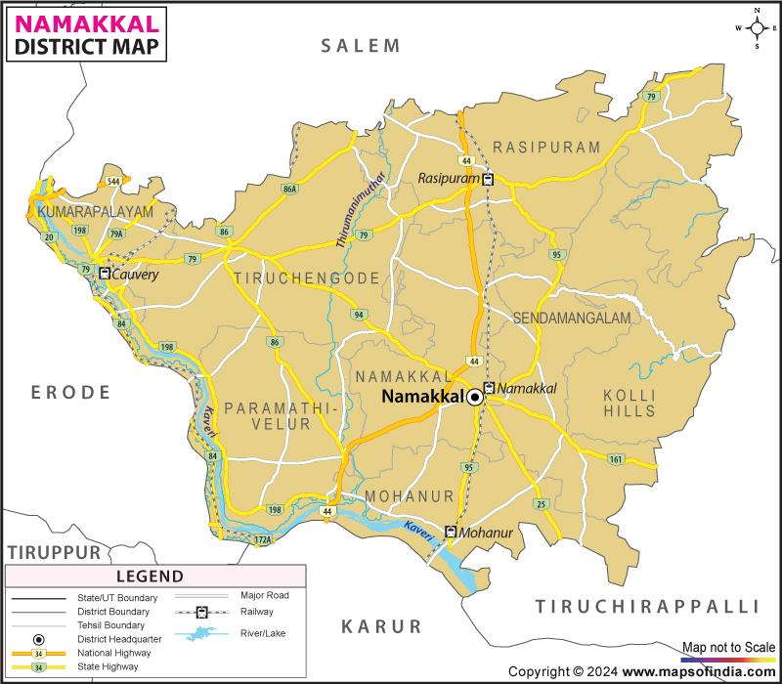

4. Everyday Realities of Street Vendors
Street vending, while serving as a crucial source of livelihood for millions, is embedded within a complex web of uncertainty, vulnerability, and structural constraints. The everyday realities of street vendors reflect a continuous negotiation between survival and instability, shaped by economic, regulatory, and social factors. This section explores the lived experiences of vendors across key dimensions, highlighting the precarious nature of their work and the challenges they encounter in sustaining their livelihoods.

4.1 Economic Uncertainty
One of the most defining features of street vending is the irregular and unpredictable nature of income. Unlike formal employment, where wages are relatively stable, street vendors operate in a volatile economic environment where daily earnings fluctuate significantly. These fluctuations are influenced by several interrelated factors.
Seasonal variations play a major role, as demand for certain goods changes across different times of the year. For example, fruit vendors may experience higher sales during specific harvest seasons, while others may struggle during off-peak periods. Weather conditions further intensify this uncertainty; heavy rains, extreme heat, or adverse climatic events can drastically reduce customer footfall, directly affecting daily income.
Market demand is another crucial determinant, often shaped by local competition, consumer preferences, and broader economic conditions. Vendors selling similar goods in close proximity may face intense competition, leading to reduced profits. Additionally, sudden changes in consumer behaviour or price fluctuations in wholesale markets can further destabilize income patterns.
Law enforcement activities also contribute to economic insecurity. Fear of eviction or confiscation of goods often disrupts business operations, resulting in financial losses. As a result, vendors are unable to maintain consistent earnings, making long-term financial planning nearly impossible.
Most vendors operate with minimal capital investment and lack access to formal credit institutions. Consequently, they depend on informal lending sources, such as moneylenders or local networks, often at exorbitant interest rates. This reliance creates a cycle of debt and financial vulnerability, limiting their ability to expand or stabilize their businesses.

4.2 Regulatory Challenges and Harassment
Despite the introduction of the Street Vendors (Protection of Livelihood and Regulation of Street Vending) Act, 2014, the regulatory environment remains inconsistent and often unfavourable for vendors. While the Act aims to provide legal recognition and protection, its implementation on the ground is fragmented and inadequate.
Street vendors frequently encounter evictions and displacement, particularly in areas targeted for urban development or beautification projects. Such actions are often carried out without prior notice, disrupting livelihoods and forcing vendors to relocate. The absence of designated vending zones in many regions exacerbates this issue, leaving vendors in a constant state of uncertainty regarding their right to occupy public spaces.
Confiscation of goods by local authorities is another common challenge. For vendors operating with limited resources, the loss of merchandise can have devastating economic consequences. In many cases, vendors are compelled to make informal payments or bribes to avoid such actions, further reducing their already limited earnings.
These regulatory pressures create a pervasive climate of fear and instability. Vendors are often unsure of their legal status and rights, leading to a sense of insecurity that affects both their economic activities and psychological well-being. The gap between policy provisions and ground-level implementation remains a significant barrier to improving the conditions of street vendors.

4.3 Lack of Social Protection
A critical aspect of the vulnerability faced by street vendors is the absence of social security mechanisms. Unlike formal sector workers, vendors typically lack access to essential protections such as health insurance, pension schemes, and unemployment benefits.
In the event of illness or injury, vendors are forced to rely on out-of-pocket expenditures, which can quickly deplete their limited savings. The lack of health coverage not only affects their well-being but also disrupts their ability to work, leading to loss of income. Similarly, the absence of pension schemes leaves vendors without financial security in old age, compelling many to continue working under physically demanding conditions.
Access to formal banking systems is also limited, often due to lack of documentation or financial literacy. This exclusion prevents vendors from benefiting from institutional credit, savings schemes, and government welfare programs. As a result, they remain trapped within informal financial networks that offer limited protection and high risk.
The cumulative effect of these factors is a heightened exposure to economic shocks and uncertainties. Without a safety net, even minor disruptions can have severe consequences for vendors and their families.

4.4 Gender Dimensions
The experiences of street vendors are further shaped by gender, with women vendors facing additional layers of vulnerability. While street vending provides an important source of income for women, it is often accompanied by unique challenges that reflect broader patterns of gender inequality.
Safety concerns are a major issue, particularly for women working in public spaces for extended hours. Exposure to harassment, lack of secure vending locations, and inadequate sanitation facilities contribute to an unsafe working environment. These challenges are often compounded by social norms that restrict women’s mobility and economic participation.
Women vendors also experience a double burden of work, balancing income-generating activities with household responsibilities such as childcare and domestic work. This dual role limits their ability to expand their businesses or invest additional time in income-generating opportunities. Access to credit and financial resources is another area where women face disadvantages. Due to limited ownership of assets and restricted access to formal institutions, women often rely on informal sources of finance, which may not be sufficient to support business growth. Gender-based discrimination further marginalizes women within the informal economy, affecting their earnings, opportunities, and overall well-being. These factors highlight the need for gender-sensitive policies that address the specific challenges faced by women street vendors.

4.5. Empirical Findings: Field Data Presentation

Table 1: Socio-Demographic Profile of Street Vendors (n = 100)
Variable | Category | Frequency | Percentage (%)
Gender | Male | 62 | 62%
 | Female | 38 | 38%
Age Group | 18–30 years | 18 | 18%
 | 31–45 years | 46 | 46%
 | 46–60 years | 28 | 28%
 | Above 60 | 8 | 8%
Education Level | No formal education | 34 | 34%
 | Primary | 29 | 29%
 | Secondary | 25 | 25%
 | Higher | 12 | 12%
Type of Vendor | Food vendors | 36 | 36%
 | Fruit/vegetable | 28 | 28%
 | Small retail goods | 22 | 22%
 | Others | 14 | 14%
Interpretation:
The majority of vendors fall within the economically active age group (31–45 years), with a significant proportion having low levels of formal education, highlighting dependence on informal livelihoods.
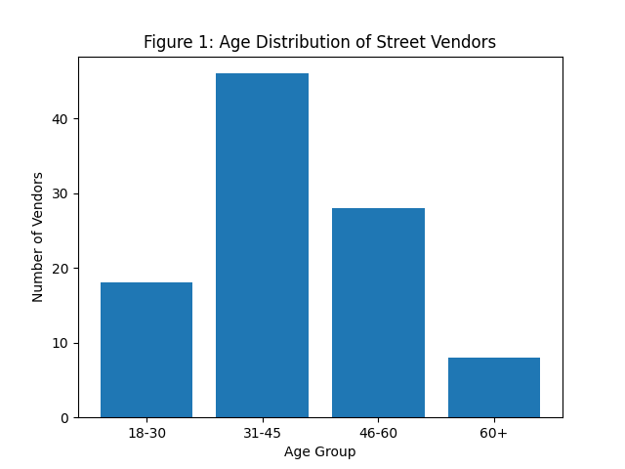

Table 2: Daily Income Distribution of Street Vendors
Income Range (₹/day) | Frequency | Percentage (%)
Below ₹300 | 22 | 22%
₹300–₹500 | 38 | 38%
₹500–₹800 | 27 | 27%
Above ₹800 | 13 | 13%
Interpretation:
A majority (60%) earn below ₹500/day, indicating low and unstable income levels, reinforcing economic precarity.

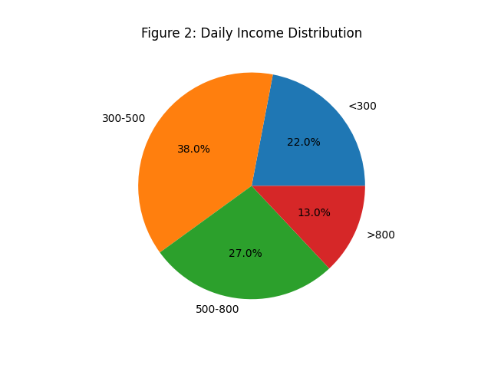

Table 3: Access to Social Protection
Type of Protection | Yes (%) | No (%)
Health Insurance | 18% | 82%
Pension Scheme | 9% | 91%
Bank Account | 54% | 46%
Government Welfare Access | 27% | 73%
Interpretation:
There is a significant gap in social security coverage, particularly in pensions and health insurance, increasing vulnerability to shocks.
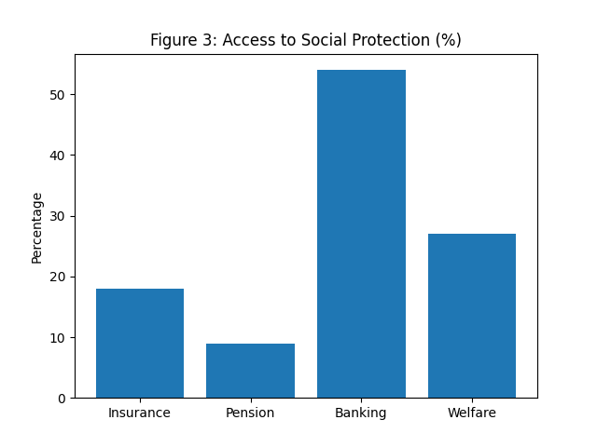

Table 4: Major Challenges Faced by Street Vendors
Challenge Type | Percentage (%)
Income instability | 76%
Harassment/Evictions | 61%
Lack of credit access | 58%
Poor infrastructure | 49%
Health risks | 44%
Interpretation:
Economic instability and regulatory pressures are the most dominant challenges affecting vendor livelihoods.
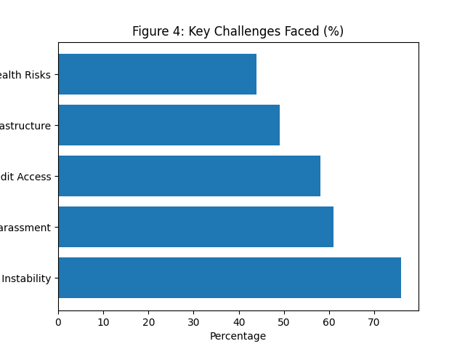

5. Survival Strategies
Despite operating within conditions of persistent uncertainty and structural vulnerability, street vendors exhibit a high degree of resilience and adaptability. Their survival within the informal economy is not merely accidental but is sustained through a range of strategic responses and coping mechanisms that enable them to navigate economic instability, regulatory pressures, and social constraints. These survival strategies highlight the dynamic nature of informal livelihoods and the agency of vendors in managing everyday risks.
One of the most prominent strategies adopted by street vendors is the diversification of goods and services. Vendors frequently modify the type of products they sell based on changing consumer demand, seasonal variations, and market conditions. For instance, a vendor may shift from selling fruits to snacks or household items depending on profitability and demand fluctuations. This flexibility allows vendors to mitigate income losses and maintain a steady flow of earnings, even in uncertain market environments. Diversification also reduces dependency on a single source of income, thereby enhancing economic resilience.
Another crucial survival mechanism is flexible mobility. Street vendors often change their locations to avoid eviction drives, adapt to customer movement, or access more profitable markets. Mobile vending—using pushcarts, bicycles, or temporary stalls—enables vendors to respond quickly to regulatory pressures and spatial constraints. This mobility is not only a response to enforcement actions but also a strategic choice to maximize visibility and customer reach. However, constant relocation also reflects the insecurity of their occupation, as vendors lack permanent or legally protected spaces for conducting business.
Informal social networks play a significant role in sustaining the livelihoods of street vendors. Family members, friends, and fellow vendors provide various forms of support, including financial assistance, sharing of information, and cooperative arrangements. For example, vendors may rely on family labor to reduce operational costs or depend on peer networks to stay informed about market trends and enforcement activities. These networks function as an informal safety net, compensating for the absence of formal institutional support. They also foster a sense of community and collective resilience among vendors.
Access to finance remains a major challenge, and in response, vendors depend on informal credit mechanisms. Borrowing from local moneylenders, traders, or acquaintances is a common practice, particularly during periods of low income or business expansion. While such credit is often available quickly and without formal documentation, it typically comes with high interest rates, which can lead to cycles of debt. Nevertheless, these informal financial arrangements are crucial for sustaining day-to-day operations, especially in the absence of access to formal banking systems.
In addition to these primary strategies, vendors also engage in subtle forms of negotiation and adaptation in dealing with authorities and local governance structures. This may include adjusting operating hours, relocating temporarily during inspections, or informally negotiating with officials to continue their activities. Such practices, while indicative of systemic challenges, also demonstrate the practical ways in which vendors navigate regulatory ambiguity.
Overall, these survival strategies underscore the adaptive capacity and ingenuity of street vendors. While their livelihoods remain precarious, their ability to respond to changing conditions reflects a form of resilience that is central to the functioning of the informal economy. At the same time, reliance on such strategies also highlights the absence of structural support, reinforcing the need for policy interventions that move beyond survival and towards sustainable livelihood security.

6. Discussion
The findings of the study clearly demonstrate the coexistence of precarity and persistence as defining characteristics of street vending within the informal economy. On one hand, vendors operate under conditions of economic instability, regulatory uncertainty, and social vulnerability; on the other, they exhibit remarkable resilience through adaptive strategies that enable them to sustain their livelihoods. This duality reflects the complex and often contradictory nature of informal work in contemporary urban contexts.
The empirical data supports the theoretical proposition advanced by Keith Hart (1973) that the informal economy functions as a survival mechanism in response to limited formal employment opportunities. However, the findings also extend this argument by showing that informality is not merely a temporary or residual sector but a structurally embedded and indispensable component of urban economies. Street vendors contribute significantly to local markets by providing affordable goods, ensuring accessibility, and generating employment, particularly in semi-urban contexts such as Paramathi Velur Taluk.
At the same time, the study reveals that the persistence of informality is closely linked to systemic inequalities and institutional gaps. The lack of access to social protection, formal credit, and legal recognition constrains the upward mobility of vendors, effectively trapping them in cycles of vulnerability. This aligns with Amartya Sen’s capability approach, which emphasizes that economic participation alone is insufficient if individuals lack the capabilities to achieve broader well-being. In this context, street vendors may earn a livelihood, but their limited access to healthcare, financial security, and social safety nets restricts their overall development.
The findings also resonate with Ananya Roy’s (2005) concept of urban informality, which argues that informality is not simply a condition of the poor but a mode of governance shaped by selective enforcement and regulatory ambiguity. The experiences of vendors—particularly in relation to evictions, confiscation of goods, and informal payments—illustrate how legality and illegality are fluid and often arbitrarily applied. This creates an environment where vendors operate in a state of constant negotiation with authorities, reinforcing their precarious position.
A critical issue highlighted by the study is the gap between policy intent and implementation. The Street Vendors (Protection of Livelihood and Regulation of Street Vending) Act, 2014, represents a significant step toward formal recognition and protection. However, the field findings indicate that its implementation remains inconsistent and fragmented. Many vendors are unaware of their rights under the Act, while local enforcement mechanisms often fail to align with its provisions. This disconnect undermines the effectiveness of policy interventions and perpetuates the marginalization of vendors.
The gendered dimensions of street vending further complicate this landscape. Women vendors face compounded challenges arising from both economic precarity and social norms, limiting their access to resources and opportunities. This highlights the need to incorporate a gender-sensitive lens in both analysis and policy formulation.
Overall, the discussion underscores that while street vendors demonstrate resilience, their dependence on survival strategies should not be mistaken for sustainability. The persistence of informality, in the absence of structural support, reinforces inequality and limits the transformative potential of livelihoods in the sector.

7. Policy Implications
The findings of this study have significant implications for policy formulation and urban governance. Addressing the challenges faced by street vendors requires a shift from exclusionary approaches to inclusive and rights-based frameworks that recognize the legitimacy of informal livelihoods.
First, there is an urgent need to strengthen the implementation of the Street Vendors Act, 2014. This includes ensuring the proper functioning of Town Vending Committees (TVCs), increasing awareness among vendors about their rights, and establishing transparent mechanisms for registration and licensing. Effective implementation can reduce arbitrary evictions and enhance livelihood security.
Second, the creation of designated vending zones is essential for providing spatial stability. Well-planned vending areas can integrate vendors into urban planning processes while minimizing conflicts over public space. Such zones should be developed in consultation with vendors to ensure accessibility and viability.
Third, improving access to microfinance and formal credit systems is critical. Financial inclusion initiatives should be tailored to the needs of informal workers, with simplified procedures and reduced collateral requirements. Access to affordable credit can enable vendors to expand their businesses and reduce dependence on exploitative informal lending.
Fourth, the expansion of social security schemes is necessary to address vulnerability. This includes extending health insurance, pension benefits, and welfare programs to street vendors through targeted interventions. Integrating vendors into existing government schemes can significantly improve their resilience to economic shocks.
Fifth, promoting digital inclusion and financial literacy can enhance the economic capabilities of vendors. Digital payment systems, mobile banking, and online platforms can improve transaction efficiency and access to financial services. However, such initiatives must be accompanied by training and support to ensure effective adoption.
Finally, policy frameworks must adopt a gender-sensitive approach, addressing the specific challenges faced by women vendors. This includes improving safety measures, providing childcare support, and facilitating access to credit and training opportunities.
An inclusive policy approach should aim not only to regulate street vending but to empower vendors as active participants in the urban economy, ensuring that formalization does not come at the cost of their autonomy and flexibility.

8. Conclusion
Street vendors operate at the intersection of survival and uncertainty, navigating a complex landscape shaped by economic instability, regulatory challenges, and social exclusion. This study highlights that while vendors face significant structural constraints, their persistence is sustained through resilience, adaptability, and informal support systems.
However, reliance on survival strategies alone is insufficient to ensure long-term livelihood security. The absence of institutional support, coupled with inconsistent policy implementation, continues to marginalize vendors and limit their opportunities for upward mobility. Recognizing street vending as a legitimate and integral component of the urban economy is therefore essential.
The study calls for a paradigm shift in policy and perception—from viewing street vendors as informal or illegal actors to acknowledging them as essential contributors to urban livelihoods and economic systems. Inclusive and well-implemented policy interventions can transform street vending from a precarious survival strategy into a sustainable and dignified form of employment.
In conclusion, addressing the challenges faced by street vendors is not merely a matter of economic policy but a question of social justice and equitable urban development. By bridging the gap between policy and practice, and by prioritizing the needs of informal workers, it is possible to create cities that are not only economically vibrant but also socially inclusive.

References
Bhowmik, S. (2012). Street vendors in urban India: The struggle for recognition. Economic and Political Weekly, 47(49), 12–15.
Hart, K. (1973). Informal income opportunities and urban employment in Ghana. Journal of Modern African Studies, 11(1), 61–89.
International Labour Organization. (2024). India employment report 2024. International Labour Organization.
Roy, A. (2005). Urban informality: Toward an epistemology of planning. Journal of the American Planning Association, 71(2), 147–158.
Sen, A. (1999). Development as freedom. Oxford University Press.
Bromley, R. (2000). Street vending and public policy: A global review. International Journal of Sociology and Social Policy, 20(1–2), 1–28.
Chen, M. A. (2012). The informal economy: Definitions, theories and policies. WIEGO Working Paper No. 1. Women in Informal Employment: Globalizing and Organizing.
De Soto, H. (1989). The other path: The invisible revolution in the Third World. Harper & Row.
Donovan, M. G. (2008). Informal cities and the contestation of public space: The case of Bogotá’s street vendors, 1988–2003. Urban Studies, 45(1), 29–51.
International Labour Organization. (2018). Women and men in the informal economy: A statistical picture (3rd ed.). ILO.
Roever, S., & Skinner, C. (2016). Street vendors and cities. Environment and Urbanization, 28(2), 359–374.
Skinner, C. (2008). Street trade in Africa: A review. School of Development Studies Working Paper. University of KwaZulu-Natal.
Government of India. (2014). The Street Vendors (Protection of Livelihood and Regulation of Street Vending) Act, 2014. Ministry of Law and Justice.
Government of Tamil Nadu. (2018). Tamil Nadu Street Vendors (Protection of Livelihood and Regulation of Street Vending) Scheme and Rules. Government of Tamil Nadu.

