Assessment of Fecal Sludge Containment Practices in Urban areas of Bangladesh and Identifies Improvement Strategies: A Case Study of Savar Paurashava, Bangladesh

ABSTRACT
This thesis investigates the current status of fecal sludge (FS) containment in Savar Paurashava, a rapidly urbanizing municipality in Bangladesh, and indentifies strategies to improve safe sanitation practices. The majority of urban households rely on on-site sanitation systems such as septic tanks and pit latrines. The study particularly focuses on the dimensions of the septic tanks, the provision of soak wells in comparison with standard requirements, and overall containment management practices.
A mixed-methods approach was adopted, involving literature review, policy analysis, household-level surveys, field observations, key informant interviews (KII), and the development of a Shit Flow Diagram (SFD). The findings reveal that while most households depend on septic tanks and pit latrines, the majority of these facilities are poorly designed and do not comply with standard guidelines.
Out of the total surveyed holdings, 30.87% have septic tanks. However, most of the constructed septic tanks are non-compliant with the requirements of the BNBC code. Only 8.97% household’s containments are connected to soak wells for effluent disposal. The remaining household’s containments are directly connected to the drain or open water bodies for effluent outflow. This indicates poor containment practice and potential environmental contamination
The study also identifies major challenges such as limited public awareness, unskilled construction practices, insufficient space for retrofitting, and lack of regulatory enforcement at the municipal level.
To address these issues, the thesis recommends the implementation of the Paurashava Sanitation Management By-Laws (2021), enhanced community awareness programs, capacity building for masons on standard septic tank construction, and the formation of a dedicated Fecal Sludge Containment Management Committee. These interventions align with Sustainable Development Goal (SDG) target 6.2, aiming to ensure equitable access to adequate sanitation and promote a healthier urban environment. The study highlights the essential role of local government institutions in effectively managing urban sanitation systems.
Keywords: fecal sludge management; containment; septic tank; urban sanitation; Bangladesh

1. INTRODUCTION
Urban sanitation systems in municipalities of Bangladesh rely mostly on on-site technologies such as septic tanks and pit latrines due to the absence of sewer networks. In such contexts, effective fecal sludge management (FSM) depends primarily on the performance of containment systems.
Containment has been identified as the weakest link in the sanitation service chain in many developing countries (Strande et al., 2014; Peal et al., 2020). In Bangladesh, septic tanks are often poorly designed and directly connected to drains, resulting in untreated effluent discharge (World Bank, 2019).
Savar Paurashava, located near Dhaka, represents a rapidly urbanizing municipality facing increasing sanitation challenges. This study aims to:
- Assess the status of fecal sludge containment
- Identify key technical and institutional gaps
- Propose practical strategies for improvement

2. MATERIALS AND METHODS

The materials and methods used to analyze fecal sludge (FS) containment practices and to identify existing gaps and improvement opportunities in Savar Paurashava are described below.

2.1 Study Area
Savar Paurashava is a rapidly growing municipality near Dhaka in Bangladesh exemplified by high population density and reliance on on-site sanitation systems.

2.2 Data Collection
A mixed-methods approach was adopted to ensure comprehensive data collection. This included:
- Household survey (n = 379)
- Field observations
- Key informant interviews (KII)
- Secondary data (WSUP survey reports, municipal records)

2.3 Assessment Indicators

The study assessed the following key indicators:
- Type of containment system
- Design compliance (BNBC)
- Effluent discharge pathway
- Availability of space for upgrading existing containment systems

2.4 Data Analysis

Descriptive statistical analysis was performed to interpret the collected data. In addition, a Shit Flow Diagram (SFD) was developed (Presented in figure 1) to evaluate the proportion of safe and unsafe fecal sludge flows within the study area.
Figure 1: Shit Flow diagram of Sanitaion System in Savar Paurashava
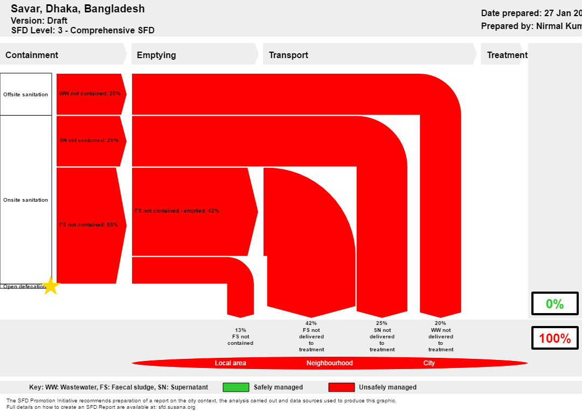

3. RESULTS

The observations from this study are summarized under four key aspects: containment types, effluent disposal pathways, design compliance, and the availability of land space for upgrading existing containment systems.

3.1 Containment Types
The study reveals that a significant proportion of households lack proper containment or rely on substandard systems, as presented in Table 1.
Table 1: Containment Type

Containment Type | Percentage (%)
Septic tanks | 57.3
Pit latrines (with slab) | 21.4
Pit latrines (without slab) | 1.1
No containment | 20.3

3.2 Effluent Disposal Pathways

The study found that a major proportion of effluent is discharged directly into drains in Savar Paurashava, reflecting unsafe sanitation practices which is illustrated graphically in Figure 2.

Figure 2: Effluent Disposal Pathways
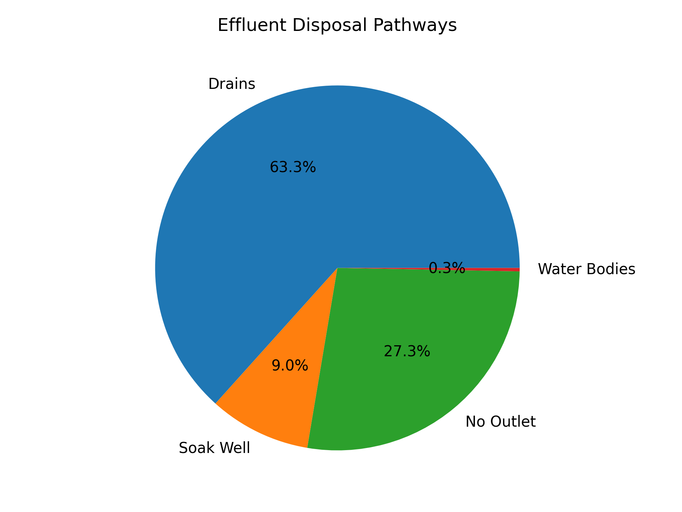

3.3 Design Compliance
Field observations revealed:
- Major septic tanks are substandard and tanks are made as a reservoir tank without partition wall
- Absence of inlet/outlet tees in septic tanks
- Non-compliance with BNBC standards
- Construction largely done by untrained masons

3.4 Availability of Space
The study found that there is limited space for retrofitting or upgrading existing containment systems, as shown in Table 2.
Table 2: Availability of land for Containment upgrading
using category | Space available (%)
Overall | 39
Apartments | 20.4
Pucca | 48.9
Semi-pucca | 49.0
Tin-shed | 55.2

3.5 Institutional Challenges
- Weak enforcement of building and sanitation codes
- Lack of technical manpower in Paurashava
- Limited monitoring and inspection
- Low public awareness

4. DISCUSSION
The findings confirm that containment is the weakest link in FSM in Savar Paurashava. Despite widespread access to sanitation facilities, most systems are not safely managed.
The high rate of direct discharge of effluent to drains indicates that septic tanks often function as holding tanks rather than treatment units. Similar trends have been reported in other South Asian cities (Blackett et al., 2014; Peal et al., 2020).
Key barriers include:
- Technical: Poor design and construction
- Institutional: Weak regulatory enforcement
- Behavioral: Low awareness among users and builders
The findings suggest that improving containment systems should be prioritized over downstream investments such as treatment facilities. Without effective containment, fecal sludge cannot be safely collected, transported, or treated. Similar observations have been reported in other South Asian cities, indicating that containment failure is a systemic issue requiring coordinated technical and regulatory interventions.

6. RECOMMENDATIONS
To address the pressing issues identified in this study, the following key recommendations are proposed:

Technical Interventions
- Enforce construction of maintaining BNBC compliant septic tank design
- Promote soak wells for effluent disposal
- Retrofit existing systems where feasible
Support for Infrastructure Improvement
Paurashava should take programs to assist urban residents in reconstructing/retrofitting defective fecal sludge containers (e.g., septic tanks or pits) and constructing soak wells to prevent effluent discharge into municipal drains

Institutional Measures
- Implement sanitation by-laws
- Strengthen inspection and approval processes by establish a dedicated Fecal Sludge Containment Management Committee at Paurashava level comprising GO, NGO and public representative.

Capacity Building and Community Awareness
- Train local masons and engineers
- Conduct public awareness campaigns

7. CONCLUSION
Fecal sludge containment practices in Savar Paurashava are largely inadequate and non-compliant with standard practices. The widespread discharge of untreated effluent into drains poses significant environmental and health risks.
Strengthening containment systems through improved design, enforcement, awareness, and institutional coordination is essential. Addressing these issues will play a critical role in achieving SDG target 6.2 and ensuring sustainable urban sanitation in Bangladesh.

8. ACKNOWLEDGEMENTS
The author acknowledges the support of Savar Paurashava and WSUP, Dhaka Office.

9. DATA AVAILABILITY
Data are available from the corresponding author upon reasonable request.

10. REFERENCES
- World Bank (2019). Bangladesh sanitation sector review.
- GoB (2017). Institutional and Regulatory Framework for FSM
- BNBC (2017). Bangladesh National Building Code.
- WSUP (2019). FSM Survey Report in Savar Paurashava.
- LGD, GoB (2021), Paurashava fecal waste/sanitation management by-law 2021. (Proposed)
- GoB (2009), Paurashava act 2009, LGD

