DISPOSAL METHOD OF MYCELIA WASTE IN ENVIRONMENTAL SOUND MANNER

- The Background

Spent mycelium shows up because microbes are used to make antibiotics, enzymes, and similar compounds. Because of how these processes work, leftover material builds up after fermentation finishes. This residue holds dead cells, leftover liquid, by-products from metabolism, along with traces of medicines still present. Its makeup tends to be messy, tangled in many layers. That complexity leads regulators to label it as biological waste without hesitation.

Years go by, yet leftover mushroom roots pile up more each day - thanks to drug-making factories getting bigger. When these waste bits aren’t tossed right, trouble follows: dirt gets dirty, rivers suffer, and stinks spread through air, even medicine stops working since old antibiotics linger behind.

Spent mycelium often ends up burned, buried, or heated without oxygen. Burning it demands a lot of power; what leaks out could harm nature. Hidden inside that leftover mass? Nutrients - plenty of them - but old-school handling ignores these treasures entirely. Wasted chance, really.

These days, methods like composting, advanced oxidation, and pulling resources from waste have started drawing more eyes. Spent mycelium can harm nature, but turning it into things like fertilizer, gas for fuel, or raw material softens that impact - thanks to reuse strategies. Picking the right method, one that works well without costing too much, still trips people up though.
Spent mycelium piles up, so handling it well matters. A way forward must make sense money-wise while sparing the planet harm. Looking close at current hurdles shapes this study's path. Answers might come from digging into what goes wrong now.

- What is Mycelium?

Fungi and streptomycetes grow thread-like networks that handle multiple life tasks all at once. While pulling in food through enzyme release, these threads also move what they absorb across their whole community. Changes happen along those strands - both chemical and shape-based - that lead to new substances forming inside them. Some of those products turn into medicines, lab materials, or farm chemicals because of how useful they are. Antibiotics come from this process. So do fungus fighters, immune system blockers, color molecules, working proteins, and other active ingredients. People now rely on these outputs heavily when making medical or biotech solutions.

Years of work aimed at boosting output of valuable compounds in thread-like microorganisms reflect strong interest driven by their worth. Still, most progress came through repeated guesswork methods - altering growth environments, tweaking nutrient mixes, or exposing cultures to mutation triggers. These approaches worked well sometimes, yet overlooked inner workings behind compound creation inside cells. Rarely did researchers examine where or when molecules formed during life phases or within cellular zones (Papagianni, 2004).

Some studies now show the thread-like growth in certain Streptomyces kinds isn’t uniform - instead it varies in shape and role. This variation ties closely to how the organism matures, playing a key part in making complex compounds. Scientists point out that regular growth unfolds across at least two phases, where individual cells shift into specialized forms (Manteca et al., 2005a; Manteca et al., 2005b). Once spores wake up, the new life form stretches into a network known as MI mycelium - a type packed with enclosed segments. Tiny chambers inside the mycelium measure around 1 micrometer across, separated by membranes or slim partitions containing peptidoglycans (Yagüe et al., 2013; Yagüe et al., 2016). After MI mycelium forms, cells begin breaking down in an organized way - this shift looks like developmental change, yet it's not always self-digestion. Out of this breakdown emerges MII mycelium, where multiple nuclei appear within shared cellular space. Unlike MI, the MII phase shows uninterrupted cytoplasm flow, along with higher metabolic rates, upward-growing filaments, plus spore creation in numerous organisms. Notably, making secondary compounds rises sharply during the MII stage.

One step beyond basic observation lies understanding how fungal threads grow and behave. Where chemicals form inside these structures reveals clues for better strains and smarter fermentation setups. Moving past old-style trial-and-error screens, combining life cycle studies with system-wide data offers clearer paths forward. A closer look at uneven growth patterns ties directly to useful compound creation - this link matters deeply in academic work. When scientists track changes during maturation, key control points emerge that shape chemical output. Such findings feed into building hardier, more reliable microbes for large-scale uses.

Using Mycelium to Make Antibiotics Through Fermentation
From mold strands comes medicine made by feeding fungi in soups of food stuffs. Under watchful settings, these tiny growers make penicillin while doing their natural work. Out of the thick liquid left behind, helpers pull out the useful parts carefully.
Process of Fermentation:-
Inoculum Preparation:-
Starting things off, fermentation begins when scientists pick out just the right type of microbe - often one that grows in threadlike forms and produces solid results. This picked strain often comes from either old-school breeding techniques or newer gene-based tweaks meant to boost performance. Kept safe inside lab settings where temperature, moisture, and nutrients are carefully watched, it stays strong and consistent over time.
To kick off large-scale fermentation, technicians grow the microbe in tightly managed settings with starter nutrient mixes to create a lively inoculant. After that comes transfer into the main fermenter, where it rapidly adjusts to its new surroundings. Getting this initial batch right makes or breaks the entire run.
Fermenting begins when the starter mix moves into a big tank filled with food for microbes - sugars, proteins, minerals, and B-complex helpers join in so bacteria thrive and make useful byproducts. Though quiet outside, inside the chamber busy transformations unfold steadily as tiny lives multiply.
After growing a while, microbes start making substances like rifampicin through quiet chemical shifts. These changes kick in once active division ends. During stillness, tiny life turns energy into complex byproducts. Not right away - only when crowded and busy times fade. Then comes the slow build of special compounds.
Temperature plays a role. What happens next depends on time. Yeast type matters too. Oxygen levels make a difference. Nutrient availability shapes results. Acidity affects progress. Container material sometimes counts. Stirring frequency can shift outcomes Aeration: Oxygen is supplied to support metabolism and cellular respiration because it is necessary in this stage.
Temperature: Fermentation usually occurs at temperatures between 25°C-26°C because this is suitable for fungal or actinomycete growth.
pH: Regulation of the acidity or alkalinity of the medium, pH, is usually maintained at 6.5 in order to support enzymatic activities.
Stirring: This allows for mixing of culture medium, bacteria, and oxygen throughout the fermenter.
Fermentation is the most important stage in the production process; at this stage, rifampicin is secreted by the microorganism.
Downstream Processing:
Once fermentation is over, the broth is processed further to extract the desired product.
Filtration
The broth obtained from fermentation is filtered to isolate the microbial biomass (mycelium) from the liquid fraction which contains the soluble metabolite. This helps in eliminating the cell debris and makes the broth ready for extraction.
Extraction
Rifampicin is extracted from the filtered broth using appropriate organic solvents such as butyl acetate or amyl acetate. The solvents allow selective transfer of the metabolite to the organic layer.
Purification
The extracted metabolite is purified through several rounds of chemical and physical separation processes. These could include:
Back extraction using buffers to eliminate contaminants
Acidification for increased stability and isolation of the product
Further extraction using fresh organic solvent
These steps are vital to ensure the required pharmaceutical standards.
Crystallization:
The purified rifampicin is then crystallized under controlled conditions to obtain the final solid product. The crystals are subsequently dried to produce stable, high-purity rifampicin suitable for pharmaceutical applications.
Final Output
The final output is crystallized rifampicin salt, which will undergo processing and packaging before use in the pharmaceutical industry as one of the antibiotics used in treating bacterial infections, especially tuberculosis.
Waste Production and Valorization
An important waste produced during the fermentation process is the mycelium biomass waste. Conventionally regarded as industrial waste, it is now gaining importance as a potential source of value.
The use of mycelium biomass as waste includes its utilization in:
Animal feed additives (once evaluated for safety)
Composting/bio fertilizer production
Production of biogas via anaerobic digestion
Extraction of bioactive compounds/enzymes
Biomaterials production in the sustainable industry
Consequently, waste valorization techniques will improve the sustainability of the fermentation process.

What is Mycelium Waste?
From time to time, leftover stuff shows up when making helpful compounds like medicines through fungal growth. This byproduct holds what remains after the nutrients are used - old cells, spent liquid base, bits made during processing, even traces of the medicine meant to be extracted. When found in drug production zones, folks call it Antibiotic Mycelium Residue because small amounts of active drugs still linger inside.
Something often found in mycelium waste is RX mycelial dreg, known as RMD. Because it holds leftover rifampicin, called RIF, this material poses risks - living things and people could face harm if exposed. That substance might push microbes to resist medicines we rely on. So viewing this type of waste as industrial makes more sense than treating it like natural compost. Though grown from biological sources, its impact aligns closer to factory byproducts.

Composition and Features of Mycelium Residues
The composition of mycelium residues may include:
Residual antibiotics (such as rifampicin, penicillin, or other active substances);
Intermediate products resulting from the process of biosynthesis;
Residuals of fermentation substrates, namely sugar, protein, and minerals;
Microbial biomass rich in organic substances;
High content of water, usually more than 90%.
High content of water makes treatment and subsequent elimination extremely complicated because of its negative influence on transport and energy-intensive processes, as well as because of difficulties in thermal processing. On the other hand, the existence of nutrients implies that the wastes can be reused in certain ways.

Treatment Methodology for Mycelium waste: - Mycelium waste is having high organic content. So we developed mycelium waste treatment technology.
FERMENTTAION PROCESS FOR ANTIBOITIC PRODUCTION

Mycelium waste

Product
Mycelium waste treatment done by anaerobic & aerobic treatment process (Result Methane gas & Fertilizer)

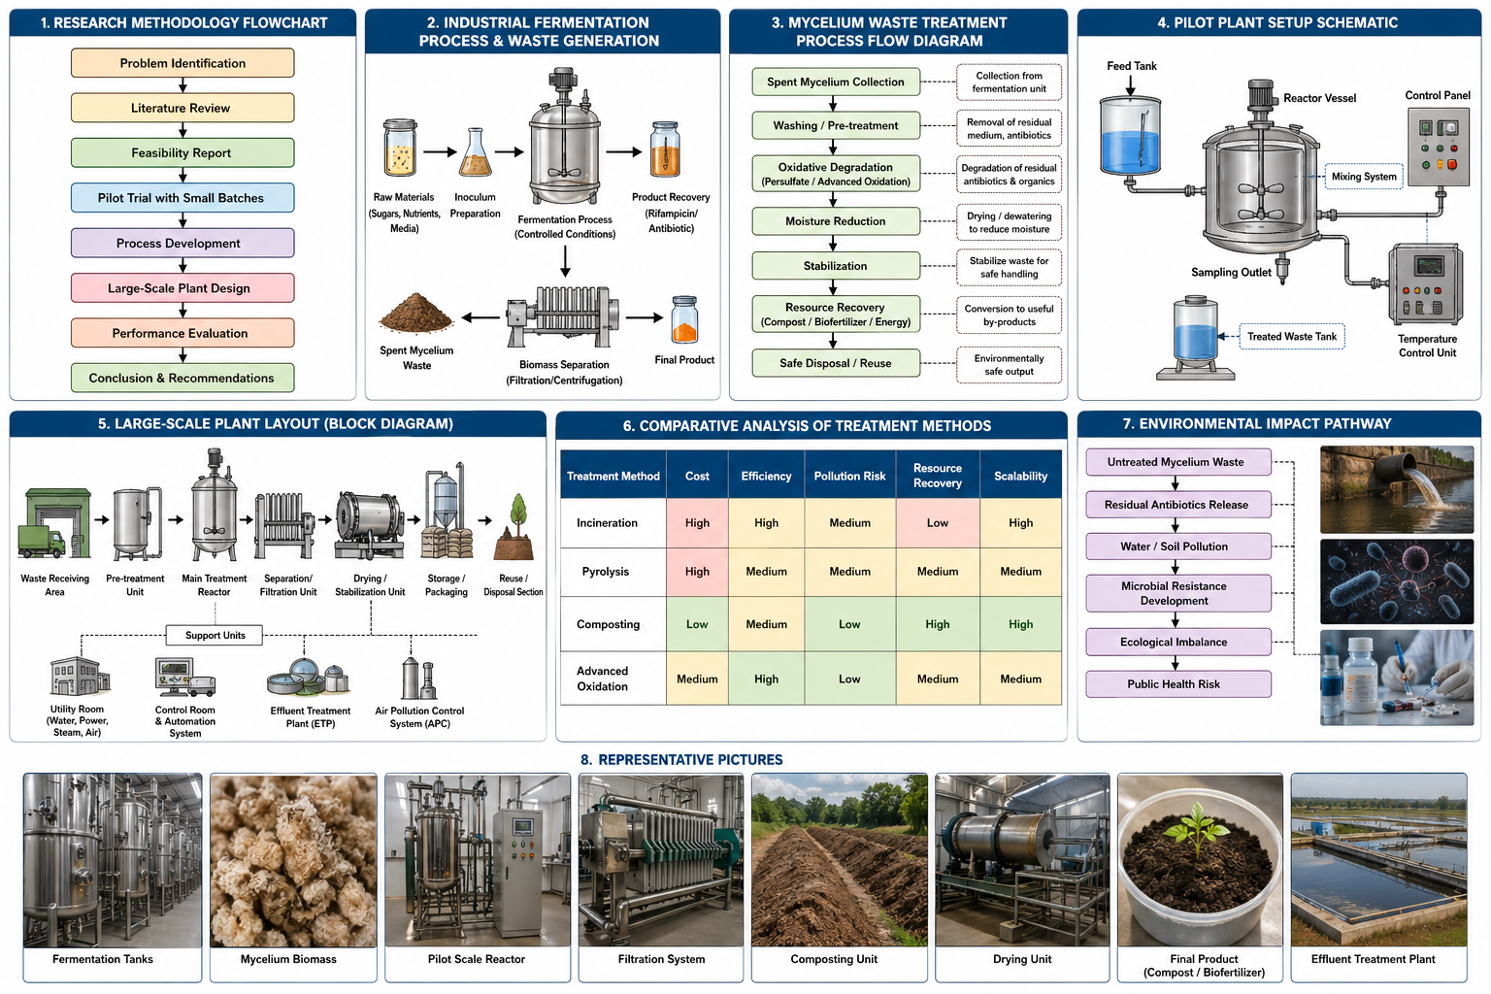

- Why Is It Necessary To Treat Industrial Wastewater?
Out in the yards where factories run, dirty water comes out loaded with gunk - stuff like oily films, poisons, muck floating inside, rotten chemicals, dangerous minerals, and invisible bugs. When that slop gets dumped straight into rivers or soil, life nearby pays a price: animals sicken, people risk harm, nature stumbles off track.
Water life struggles when factories release dirty runoff. Pollutants like toxic metals, synthetic compounds, or decaying waste slip into rivers. Oxygen levels drop because of these contaminants. Life beneath the surface suffers as a result. Farms drawing from tainted sources see weaker harvests over time.

People stay safer when factories clean their dirty water first. Dirty water often carries harmful stuff like lead, toxic chemicals, oil, greasy residues, leftover medicines, even germs. When this waste flows out untreated, those who drink nearby water - or eat food grown with it - could get sick.

One more key point ties into following rules. Because factories can pollute, environmental groups set tight limits on what gets released. To meet national laws like the Water Act, companies must clean wastewater first - no exceptions. These rules come from pollution oversight bodies that monitor output closely. Skipping treatment risks penalties while also hurting how people see the business. Reputation takes a hit when legal steps are ignored.

Worthwhile gains come when dirty water gets cleaned, simply because useful stuff hides inside what we once tossed away. Used again, that cleansed flow runs factories where machines cool down or surfaces scrub clean. Hidden treasures emerge through smart cleanup steps - think power, plant food, or materials waiting to be pulled out.

Waste flows grow when factories get bigger. Because of that, cleaning water before release matters more. Using cleanup systems shows a company pays attention to impact. Bigger operations mean messier byproducts - fixing that starts with better habits.

MATERIAL AND METHOD

Problem Identification
Literature Review
Feasibility Report
Pilot Trial with Small Batches
Process Development
Large-Scale Plant Design
Performance Evaluation
Conclusion & Recommendations
Research Methodology Flowchart
- Feasibility Report
Before any real work begins, someone checks if the chosen way to handle waste actually works. This check looks at how well it runs on paper before anyone tries it out. It might reveal problems that are hard to fix later. Technical success matters - can machines do what they must? Money plays a role too - is the cost reasonable for what it delivers? Nature gets considered - not every solution fits the environment around it. Running day to day brings more questions - will staff manage it without constant trouble? Each part connects, yet stands apart in importance. What seems smart today could fail tomorrow without testing first.

Looking closely at how wet the waste is, along with traces of antibiotics, amount of organic material, nutrients present, and similar traits helped point toward the best way to handle it. Each detail played a role in shaping which method would work well under these conditions.

Composting popped up early in the review, followed by methods like burning trash at high heat. One after another, options got weighed - advanced oxidation made the list too. Resource recovery showed potential, though not every approach fit neatly into plans. Other ideas floated around, none clearly better than the rest.

From how well it runs, we checked if the method works technically alongside current factory methods. Running costs, upkeep, people needed, and gains shaped the money-side review. Less pollution and less trash were weighed up when looking at environmental fit. How smoothly it fits into daily work hinged on staffing demands and system links.
Out of the blue, results from the feasibility study pointed toward the top choice for handling waste. Though not obvious at first, one method stood out once details were compared. Instead of guessing, decisions followed where data led. Because of this, picking a strategy felt less like chance. Even so, every option had trade-offs, yet clarity came through analysis.

- Pilot Trial with Small Batches
After the completion of the feasibility study, pilot-scale testing was conducted using smaller batch sizes in order to confirm the suitability of the chosen methodology for treating the mycelium waste. Pilot testing is an important intermediary step between conceptually designing a process and applying it industrially. The major purpose of this type of testing is the verification of technological feasibility and treatment efficiency prior to implementing the process on a larger scale.
There are several reasons why pilot-scale tests are considered essential for process development. Firstly, they provide an insight into whether the chosen technology will be able to provide effective results when implemented. Secondly, through this type of testing, potential technological barriers can be identified and studied. Thirdly, useful data will be obtained that can be further used to improve the parameters of treatment and to develop the engineering designs.
In order to conduct these tests, limited amounts of the organic material were processed in laboratory or pilot-scale reactors under certain industrial conditions. This kind of testing requires systematic changes in certain operational variables and the analysis of their effects on the result achieved. Such operational variables included:
• Temperature control and thermal exposure duration
• pH adjustment and buffering requirements
• Reaction or retention time
• Chemical dosage and reagent concentration
• Agitation or mixing intensity
• Aeration levels (where applicable)
• Solid-liquid ratio and moisture management
• Pressure conditions for specialized treatment methods
The pilot trials were designed to evaluate key treatment performance indicators that are essential for assessing process success and environmental compliance. These included:
• Reduction or elimination of residual antibiotics and pharmaceutical compounds
• Significant moisture content reduction for easier handling and disposal
• Stabilization of organic matter to prevent decomposition-related issues
• Toxicity minimization to ensure environmental safety
• Reduction in odor generation and pathogen load
• Improvement in physical characteristics of treated waste
• Suitability of the treated material for reuse, recovery, or final disposal
Scientific precision and effective procedures were ensured through the use of advanced methodologies during the pilot study. Various samples were taken and subjected to chemical, biological, and physical examination procedures to determine whether there were any positive effects of the treatment procedure. The measurements of factors such as the level of contaminant remaining, bio-chemical stability, moisture content, nutrients, and toxicity level were undertaken.
The information gathered from the pilot-scale tests was crucial in determining how the process could be improved to achieve maximum efficiency. Several factors were taken into consideration based on the observations, and these helped in optimizing the process parameter.
Pilot Plant Setup

Start by testing just a little amount - it helps shape how the whole system should work when dealing with mycelium leftovers. Picture it: real insights come through practice, not theory, once you see how things behave outside full-scale chaos. Think of the first round as groundwork; without it, handling messy biological material gets risky, especially something stubborn like antibiotic residue.

A handful of items makes sense when testing because real materials need real situations. Tests in labs work with perfect examples, yet everything there stays tightly managed, so predictions fall short before they start.
Starting off, sample collection kicks things into motion - actual mycelium waste gets pulled for close examination. Moisture levels show up early in testing, followed by checks on acidity, organic strength, leftover antibiotic traces, also what solids are present. Before any processing begins, these traits need clear understanding through analysis. Findings shape how the waste should be prepared, guiding which oxidation method fits best. Water weight plays a role - it's noticeable because higher amounts affect breakdown efficiency. Organic richness adds complexity, making small-scale trials useful for spotting response patterns. Variability hides in each batch, so trial runs reveal if systems can adjust when material shifts unexpectedly.

Running several trials under different setups happens inside compact reactors or blending units. Temperature shifts, alongside altered acidity levels, shape every round. Oxidizing agent amounts change from one cycle to another. Time spent reacting gets adjusted deliberately each time. Mixing speed varies across samples too. Success means breaking down poisons most effectively. Yet efficiency matters just as much - less chemical load, lower power draw. Finding that balance becomes the real target. Data tools such as design of experiments guide the way. Response surface methods help interpret outcomes later. Each step builds toward spotting optimal zones.

Pilot testing shines by catching hiccups long before full rollout. Early signs of trouble - excessive foam, sludge buildup, blockages, wild pH swings, weak oxidation, or gear that underperforms - show up clearly here. Fixing these glitches happens quietly, behind the scenes, well ahead of mass production. Safety steps take shape during these runs, shaped by what the system actually does. Waste handling gets mapped out too, built to meet real-world environmental rules.

Looking at how well the trial runs means checking results through lab tools. Because it matters what numbers come back, things like COD, BOD, TOC show up in tests along with antibiotic levels and how harmful they are. Since breakdown speed counts, machines pick apart reaction details using methods such as HPLC or FTIR. Structure changes get spotted thanks to images from SEM plus signals tracked by ESR. Each tool adds its own piece when measuring progress made during reactions.

One key part of pilot-scale testing looks at whether the project makes financial sense. From batch test results, experts figure out expenses tied to chemicals, power use, upkeep, and staff needs. When treated waste can go into things like compost, fertilizer production, or creating electricity, it’s worth gets weighed right then. That value shapes what happens next in planning.

Pilot tests deliver real data that shapes how systems grow and get built. When the setup runs well on a smaller level, belief in its potential rises sharply - this paves the way forward into bigger production phases.

- Process Development
Process development involved the optimization and standardization of the selected treatment methodology based on data obtained from pilot trials. This stage focused on transforming the validated small-scale procedure into a structured and efficient operational process suitable for industrial application.
Detailed process flow diagrams were prepared to map each stage of treatment, from waste collection and pre-treatment to final product recovery or disposal. Operational parameters were optimized to maximize efficiency while minimizing costs and environmental impact.
At this stage, process control strategies were established, including:
- Monitoring of temperature, pH, and reaction kinetics
- Selection of equipment and reactor configuration
- Standard operating procedures (SOPs) for handling and safety
- Quality assurance measures for treated outputs
Process development also included the identification of bottlenecks, risk mitigation strategies, and contingency planning. Special attention was given to ensuring compliance with environmental regulations and biosafety standards.
The outcome of this phase was a scalable, reproducible, and technically robust process framework that could be implemented at industrial scale.

Process development represents the step that turns the experimentally verified technique into a more refined, effective and large-scale production procedure. Here, scientific findings are used to create a process for safe and environmentally friendly disposal of large amounts of mycelium waste. As one can see from the flowchart, the process development sequence involves multiple stages aimed at ensuring complete decomposition of hazardous substances and utilization of available resources.
- Spent Mycelium Collection
The first step in process development is the systematic collection of spent mycelium waste generated from fermentation industries, particularly pharmaceutical and biotechnology sectors. This waste typically contains fungal biomass, residual nutrients, antibiotics, and moisture.
A proper collection system is essential to avoid contamination, leakage, and odor issues. Waste is transferred from fermentation units into sealed containers or pipelines and then transported to the treatment area. At this stage, segregation from other industrial wastes is crucial because mixed waste streams can reduce treatment efficiency.
The objective of this step is to ensure that the raw waste is safely captured and prepared for further handling without causing environmental exposure.
- Washing / Pre-treatment
After collection, the waste undergoes washing or pre-treatment to remove loosely attached impurities, excess nutrients, and soluble antibiotic residues. This stage improves the effectiveness of downstream oxidation processes.
Pre-treatment may involve:
- Water washing
- Mechanical stirring
- pH adjustment
- Dewatering or filtration
- Particle size reduction
For high-moisture mycelium waste, dewatering is especially important because excess water can dilute chemical oxidants and reduce reaction efficiency.
This stage stabilizes the waste and creates uniform feed characteristics for the next processing step.
- Oxidative Degradation (Advanced Oxidation Process)
This is the core stage of the treatment system. Advanced oxidation processes (AOPs) are applied to break down refractory organic compounds and residual antibiotics.
In the proposed process, thermally activated persulfate is used as the oxidizing agent. Under heat, persulfate generates sulphate radicals, which are highly reactive and capable of degrading complex pollutants.
Key operating parameters include:
- Temperature (e.g., 90°C)
- Persulfate dosage
- Reaction time
- pH control
The goal is to destroy harmful contaminants at the molecular level and reduce toxicity.
This stage is considered the most critical because it directly determines treatment efficiency and environmental safety.

- Moisture Reduction
Following oxidation, the treated material still contains significant moisture. Moisture reduction is necessary to improve handling, storage, and further utilization.
Methods may include:
- Mechanical pressing
- Centrifugation
- Thermal drying
- Solar drying
Reducing moisture lowers transportation costs, prevents microbial regrowth, and increases the stability of the final product.
This step also prepares the material for resource recovery applications such as composting or biofuel production.
- Stabilization
Stabilization ensures that the treated waste remains chemically and biologically safe over time.
This may involve:
- Neutralization of residual chemicals
- Addition of stabilizing agents
- Controlled curing
- pH balancing
The objective is to prevent reactivation of harmful substances and ensure the material does not release pollutants during storage or disposal.
A stabilized product is easier to manage and safer for downstream applications.
- Resource Recovery
Instead of treating the waste as a disposal burden, process development focuses on converting it into useful products.
Possible resource recovery options include:
- Organic compost
- Soil conditioner
- Bio fertilizer
- Energy generation through biomass conversion
Since mycelium waste contains nutrients and organic matter, proper treatment can transform it into valuable secondary resources.
This stage supports circular economy principles by reducing waste and promoting reuse.

- Safe Disposal / Reuse
The final stage involves either safe disposal of unusable residues or beneficial reuse of treated materials.
Disposal methods may include:
- Secure landfill
- Controlled incineration of rejects
- Regulatory-approved discharge systems
If the material meets environmental standards, it can be reused in agriculture, landscaping, or industrial applications.
This stage ensures compliance with environmental regulations and completes the waste management cycle.
Significance of Process Development
Each step in process development is interlinked and impacts the performance of the whole system. Any problem within any step may lead to problems within the entire process treatment.
Process development leads to:
- Increased process efficiency
- Decreased costs of operation
- Ensuring environmental regulations are met
- Scale up to an industrial level
- Sustainable use of resources
To conclude, process development is what transforms the process idea developed from a research perspective into an efficient process for handling the mycelium waste.
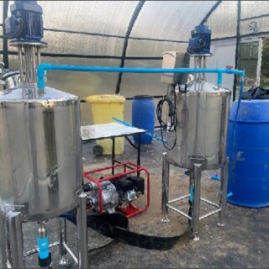
As per feasibility report found 49%Metahne gas generation & 47.2% Carbon dioxide gas generation along with COD reduction found about 65% TDS reduction 50% . So Feasibility report given positive result. We have started pilot trail.

Installed 200 ltr SS tank with agitator , Feed pipe line deep , Circulation pump installed for continuous circulation . One pipe line from collection of Gas in HDPE drum.

Pilot trail started after setup of equipment .

- First charged 50 Litre Cow dung slurry & maintain PH 10.5 by addition of lime
- Maintain four days agitation & maintain PH also
- Sixth day charged 50 Litre Mycelia slurry & Maintain PH about 10 by using of lime slurry
- Continuous agitation PH maintaining done
- After 5 days found Gas generation started
- Addition of 10 ltr Mycelia waste alternative days.
- After 10th day we found about 30 Kg gas accumulated in tank.
- We have taken sampling found methane is available
- After purification we can conduct burning test. In burning test found positive.
- Plant Designing on Large Scale
The final stage involved designing a large-scale treatment plant capable of handling industrial volumes of mycelium waste efficiently and sustainably. The plant design was based on the optimized process developed in previous stages and tailored to meet operational demands.
Engineering considerations included:
- Capacity planning based on waste generation rates
- Layout design for material flow efficiency
- Selection and sizing of reactors, mixers, filters, and storage units
- Utility requirements such as water, power, and ventilation systems
- Automation and process monitoring systems
Safety features were integrated into the plant design, including containment measures, emergency response systems, and waste segregation protocols. Environmental safeguards such as effluent treatment, air pollution control, and odor management were also incorporated.
Economic analysis was conducted to estimate capital expenditure, operational costs, and projected return on investment. The design emphasized scalability, flexibility, and sustainability to ensure long-term operational success.
The large-scale plant design represented the practical realization of the research, translating laboratory findings into an industrially applicable solution for effective mycelium waste management.

After successful pilot trial we have design one large scale plant for capacity of 600 KLD. In 500 KLD plant 420 KLD Low COD effluent & 80 KLD High COD (Mycelia waste) effluent .Treatment scheme is mention below.
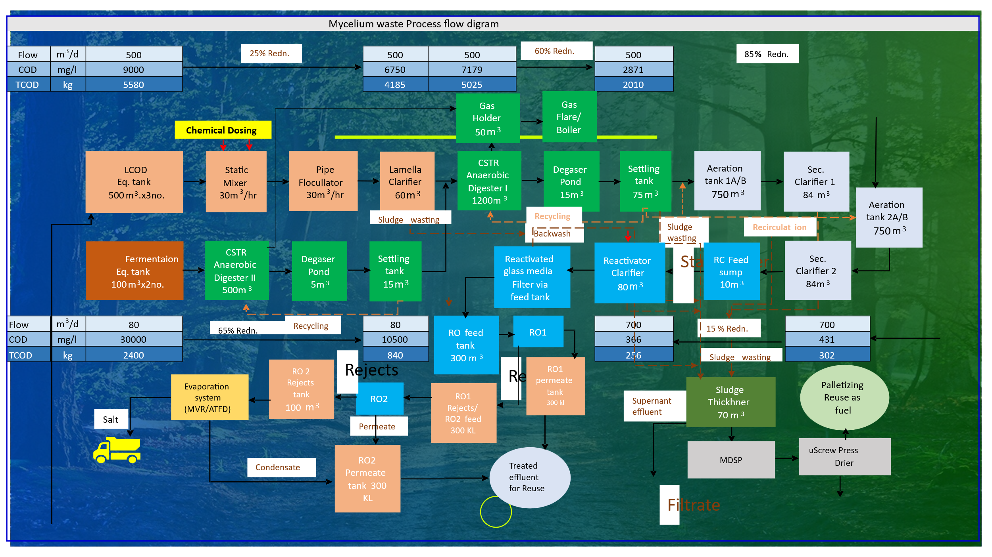
The process handles two major streams:
- Main wastewater stream (500 m³/day)
- High-strength fermentation waste stream (80 m³/day)
The overall objective is to reduce COD (Chemical Oxygen Demand) and TCOD (Total COD load) step by step while recovering energy and reusable resources.
- Influent Characteristics

Main Wastewater Stream
- Flow: 500 m³/day
- COD: 9000 mg/L
- TCOD: 5580 kg/day

Fermentation Waste Stream
- Flow: 80 m³/day
- COD: 30000 mg/L
- TCOD: 2400 kg/day
This stream is highly concentrated and requires specialized treatment.

- Equalization Tanks

LCOD Equalization Tank (500 m³ × 3 units)
This tank receives the main wastewater stream.

Purpose:
- Balances fluctuations in flow and pollutant concentration
- Provides uniform wastewater quality for downstream treatment
- Prevents shock loading to treatment units
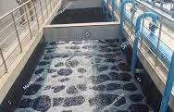
The equalization tank is an important piece of infrastructure in any wastewater treatment facility for industries. The main aim of the equalization tank is to provide a place for temporary storage where the variations in flow rate, pollution levels, temperatures, and pH levels are balanced out before the next stages of wastewater treatment.
The variations in mycelium waste treatment occur at different times of the day, and without an equalization tank, the peaks could create a problem in subsequent stages of treatment such as biological reactions, clarification, and even filtration. Through equalization, the treatment is done in a consistent manner, hence improved effectiveness.
Apart from ensuring consistency and stabilization of water quality and flow rate, other advantages of the equalization tank include the prevention of peak loads, which may lead to overworking of equipment, and maintenance operations become easier.
The equalization tank thus becomes very important in wastewater treatment.
Functions of an Equalization Tank:
- Flow regulation – This helps absorb any changes in the rate of flow and ensures that the rate of discharge of the effluent is uniform.
- Limitations of shock loads – It ensures there is no problem associated with sudden shock loads due to high flow rate and high amount of pollutant concentration.
- Homogenization - Mixing is necessary in order to get a homogeneous mixture of wastewater, which is essential for biological or chemical processing
- Preservation of biological activity – Helps maintain biological activity by regulating pH level.
- Emergency Storage Capacity – The unit serves as an emergency storage facility for excess inflow in the treatment system.
- Preventing Shock Loadings – Helps prevent shock loadings caused by high concentrations of pollutants entering the treatment system at once
- Suspension of Solids – Helps prevent sedimentation of solids in the unit
- Static Mixter: - Static mixers are static devices that continually mix the flow of liquid streams into a homogeneous solution without any moving parts. The mixing of the liquid is done with the help of some stationary components inside the mixer. The movement of the liquid stream occurs through external energy sources, such as a pump. Static mixers are best suited for non-viscous liquids and gases, but not for solid substances.

- Chemical Treatment Section

Chemical Dosing
Chemicals are added to improve pollutant removal.

Common Chemicals: Coagulants, Flocculants & pH adjusters

Purpose:
- Neutralize charges on suspended particles
- Improve settling efficiency
- Enhance organic matter removal
Coagulation
Water begins to change when a chemical gets mixed into it. Alum shows up often, known as aluminium sulphate on labels. Ferric chloride joins the mix in many treatments too. Instead of sticking with just one option, facilities might choose ferric sulphate. PAC, short for polyaluminum chloride, also plays a role here.
Most of the time, dirty water holds tiny bits floating around - bits so small you can’t see them. These specks push away from one another due to their electric charge. Since they never get close, gravity fails to pull them down. As a result, they just stay mixed in the liquid, refusing to sink.
Particles stop pushing apart once the coagulant arrives. With their negative charges canceled, they drift nearer, held by quiet shifts instead of force.
So begins the shift - tiny bits once steady in liquid now wobble, lose balance. Their calm breaks when forces nudge them toward clinging. Clumping follows, slow at first, then faster as links form. Size grows not by addition but by gathering, like dust bunched in corners. What flows free soon drags itself into heavier knots.
Faster than most notice, this phase kicks in - uniform spread of the coagulant needs intense stirring. Mixing must be thorough, or uneven results follow.
Mixing
After adding the coagulant, water flows into a mixer causing chaotic movement. These mixers might work by moving parts, stay fixed in place, or twist inside the piping to stir things up.
Water moving roughly helps spread the coagulant evenly throughout. Because of this motion, the coagulant meets more floating particles. Mixing improves when flow is chaotic instead of smooth. Particles collide often where currents twist and turn. The chemical reaches every part faster under such conditions. When swirls are strong, contact time increases naturally. This kind of movement supports better clumping overall
Right away, things must blend fast - slow mixing drags down performance. Swirling motion inside pipes pushes every drop to meet the treatment substance.
Called rapid mixing because it happens fast with strong force. Though brief, the process packs a powerful push right away. Quick in timing, still intense in action throughout.
When ingredients do not blend well, the whole operation slows down. Poor contact between components drags performance lower. Without proper blending, results turn weak. Uneven distribution causes delays that ripple through each stage. The system stumbles when elements stay separate.
Flocculation
After shaking up the tiny bits, glue-like stuff gets mixed in. These sticky helpers - usually long-chain molecules - pull the scattered specks into clumps when they meet. Clusters start forming once everything slows down.
Pulling apart from coagulation’s reliance on balancing charges, flocculation works by linking particles together, forming larger clusters through physical bridging rather than electrical changes.
Fine movement shapes the water, keeping swirls smaller than fast blends create. Particles meet softly this way, linking up because they aren’t torn by rough motion.
Falling through the water, each clump grabs more particles, slowly thickening. Heavier by degrees, they drag downward with a quiet pull.
Flocks that are big and tightly packed form faster when water moves just right. Heavy clumps sink on their own without help later down the line. When particles stick close, filters catch them before they slip through. Thick clusters break apart less once settled at the bottom. Size matters because larger masses resist being stirred up again.
Besides cutting cloudiness, clumping helps pull out floating particles along with some carbon-based pollutants. Clusters form slowly, trapping debris that would otherwise stay dispersed in water. As those clusters grow heavier, they drag contaminants downward when settling. This process handles gunk most filters miss on their own.
Retention

Flocs need time to develop fully inside the treatment setup. This period lets them reach the best possible size. What matters is how long they stay in process. Growth happens step by step, not all at once. The duration built into the system shapes their final form.

Pipe-based mixing units hold dirty water still long enough for clumping chemicals to work properly. Flow speed matters inside these holding zones where particles start sticking together.

Flocculation needs enough time since clumps do not form right away. When flow speeds up, particles stay tiny and fragile, which slows how fast they drop.

Too much holding time might break apart clumps or slow things down without reason.

How long stuff stays inside depends on how big the chamber is, how fast liquid moves, then also the tube’s reach.

Flocs hold together better when retention is right, standing up to later processing steps. Their shape stays intact if conditions are stable through the line.

Static Mixer (30 m³/hr.)
Ensures rapid mixing of chemicals with wastewater.
Functions of Static Mixter:-
Flow and Elements: The fluid is pumped through a tube or channel containing stationary mixing elements.
Flow Division and Redistribution: These elements divide the fluid streams and redirect them into a series of complex paths
Mixing Action: As the fluid passes through these elements, it moves in alternating clockwise and counter clockwise motions, colliding with each other and the mixer walls. This action ensures thorough mixing and dispersion, creating a homogeneous product from separate streams.

Pipe Flocculator (30 m³/hr.)

Pipes twist together, creating clumps called flocs when water moves steadily inside them. These clusters grow because chemicals react during flow, guided by motion within enclosed channels. Movement does not stop, allowing changes to happen without pauses along the route. Each section holds space for transformation before passing it forward. Reactions need time - this setup gives just enough, hidden in plain sight.

Tiny bits floating in water stick around because of their outer charge. Chemical mix shifts that, making clumps possible. Next step brings another substance into play - this one pulls those loosened specks together. Clumping kicks off once they start linking up. Groups grow heavier only after sticking begins. Heavier clusters sink later on. Movement slows when gathering finishes. Separation shows up clearly at the bottom. That stage marks progress toward cleaner liquid. Final drop clears space above where gunk settles. Clear flow emerges last, leaving mess behind.

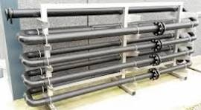

Twisting pathways inside the pipe, along with shifts in width and speed of flow, stir things up naturally. Turbulence builds as waste moves through, doing the job usually done by machines. No moving parts needed - just smart shaping does the work. Mixing happens on its own when design guides motion.

With each turn, particles keep meeting again and again, forming tiny clumps. These clusters slowly swell, gaining weight as they gather more material. Heavier than before, they settle faster when reaching tanks built for still water. After that, sideways plates help guide them out, followed by layers of sand or gravel finishing the job.

A pipe flocculator works inside wastewater plants by helping solids clump together naturally. Movement happens only through water flowing steadily through tubes. No motors push or stir the mixture anywhere along the way. Clumping forms happen just because of how long pipes stretch and how fast water moves. This kind stays quiet, needing little attention once set up right.

Function:
- Aggregates fine particles
- Improves downstream clarification

Lamella Clarifier (60 m³)
Inside an ETP, a lamella clarifier sorts out tiny solid bits from dirty water using slanted layers stacked close together. These angled surfaces create more space for gunk to settle, even though the unit itself takes up less room. Instead of spreading wide like old-style tanks, it builds upward with plates that trap muck faster. Factories pick this setup when floor space is tight but cleaning power matters. It handles goopy stuff and fine floating junk just as well at the start or middle of cleanup steps. Most plants rely on it before pushing water further down the line.

Purpose:
- Removes suspended solids and formed flocs
- Reduces COD load before biological treatment

Result:
- Approximately 25% COD reduction
This lowers COD from 9000 mg/L to ~6750 mg/L.
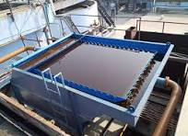
Function of Lamela Clarifier :-
• Inlet: The liquid containing suspended particles enters the clarifier and is distributed into the spaces between the inclined plates.
• Settling: As the liquid flows upward through the angled plates, solids settle downward and accumulate on the plate surfaces. The inclined plates significantly increase the settling surface area within a small footprint, which enhances the settling process compared to a traditional tank.
• Sludge removal: The settled solids slide down the plates into a sludge collection zone at the bottom, where they are then removed.
• Clean water outlet: The clarified liquid flows over the top of the plates and is discharged as clean water.

- Biological Treatment – Anaerobic Digestion
ANAEROBIC DIGESTOR: - Anaerobic digestion refers to a biological process in wastewater treatment in which organic materials are broken down in the absence of oxygen. Anaerobic digestion takes place in a closed container known as a bioreactor, where microorganisms digest the waste and produce two major outputs: biogas (methane and carbon dioxide) and biosolids (nutrient-rich solid waste). Biogas can be harnessed and utilized as an alternative energy source, while biosolids are processed and can be used as fertilizers.

CSTR Anaerobic Digester I (1200 m³)
Treats pre-clarified wastewater.

Purpose:
- Breaks down organic pollutants without oxygen
- Converts organics into biogas

Benefits:
- High COD removal
- Energy recovery

Result:
- Around 60% reduction after this stage

CSTR Anaerobic Digester II (500 m³)
Handles concentrated fermentation waste separately.

Purpose:
- Treats stronger organic loads
- Stabilizes waste before integration
Function of Anaerobic Digestor: - The breakdown of organic material happens in four stages: hydrolysis, acidogenesis, acetogenesis, and methanogens.
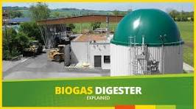
- Hydrolysis: Complex organic polymers are broken down into simpler molecules like sugars and amino acids.
- Acidogenesis: Microorganisms convert the simple molecules into volatile organic acids, such as acetic acid.
- Acetogenesis: Other microbes further convert these acids into acetate
- Methanogenesis: Methane-producing archaea convert acetate into methane (CH4) and carbon dioxide (Co2)
Input materials: Mycelia waste use as a input material in anaerobic Biodigester along with lime & Cow dung.
Out Put material:-
- Biogas: The primary output is a renewable energy source that can power the treatment plant or be sold.
- Biosolids/Digestate: The leftover liquid and solid material is nutrient-rich and can be used as fertilizer in agriculture.

- Gas Recovery System

Gas Holder (50 m³)
Stores biogas produced in digesters.

Contents:
- Methane
- Carbon dioxide

Gas Flare / Boiler

Purpose:
- Burns excess gas safely
- Can be used as fuel for boilers

Benefit:
- Converts waste into energy
- Reduces greenhouse emissions

- Degassing and Settling

Degaser Pond
Degassing’ is the removal odorous, or even noxious vapor from a tank, vessel, or pipeline under pressure/vacuum and controlling that vapor through chemical reactions, typically Oxidation. Oxidation uses high temperatures to convert VOC’s to water vapour and carbon dioxide.

Purpose:
- Prevents gas interference in later stages
- Stabilizes flow

Settling Tank

A settling tank, or clarifier, in an ETP (Effluent Treatment Plant) uses gravity to separate suspended solids from wastewater, with solids settling to the bottom as sludge and clarified water flowing out. These tanks are crucial for both primary and secondary treatment stages, working by reducing turbulence to allow particles to settle, which a key step in purification is.
- Sedimentation of sludge
- Clarified liquid moves forward
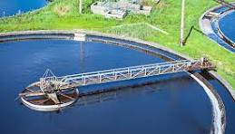
Function of Settling Tank:-
Influent: Wastewater enters the tank, often after pre-treatment steps like screening and grit removal
Settling zone: The flow slows down significantly within the tank, creating a calm environment. Gravity pulls suspended solids downward, where they accumulate as sludge.
Removal: The clarified liquid, which now has fewer suspended particles, is discharged from the top, while the sludge at the bottom is periodically removed.

- Aeration Treatment
Aeration tank is an important element in a waste water treatment plant, especially in the activated sludge process. An aeration tank is a basin where oxygen or air is added to waste water to form a suitable environment for the growth of aerobic bacteria. The aerobic bacteria use oxygen to metabolize the organic waste in the water.
The main function of an aeration tank is to reduce the concentration of the biodegradable waste in the water so as to reduce its biological oxygen demand (BOD). This process converts pollutants to simpler compounds such as carbon dioxide and water.

The aeration tanks ensure that the water conforms to the environmental standards before it can be used or discharged.
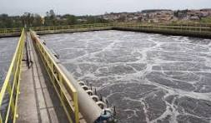
Functions of an Aeration Tank:-
Pollutant decomposition: The aerated tanks contain oxygen, allowing aerobic microorganisms to digest pollutants into carbon dioxide, water, and cellular material.
Biological Oxygen Demand (BOD) decrease: With the help of the decomposition of pollutants, it decreases BOD, an indicator of water pollution.
Activated Sludge Process: It stimulates the growth of microorganisms that coalesce to form "floc." These flocs will settle out of the water.
Aerobic bacteria activation: It enables even distribution of oxygen in the wastewater, which is important for the functioning of microorganisms.
Control of odor: Odor control in the process is one of the functions of aeration.
Stabilization of sludge: It is an essential step in sludge stabilization prior to treatment and disposal.

- Secondary Clarifier
Secondary Clarifier – Secondary clarifiers are very important components of any Effluent Treatment Plant (ETP), which function after the biological process like activated sludge or aeration tank. The main role of the secondary clarifier is the separation of biological solids (microbial solids and suspended solids) from the effluent by the sedimentation process.

In the biological process, microorganisms digest the pollutants present in the effluent and create sludge. This sludge is called activated sludge floc and remains in suspension in the mixed liquor present in the aeration tank. It is essential to separate these solids from the effluent before the next stage of treatment or discharge of the effluent.
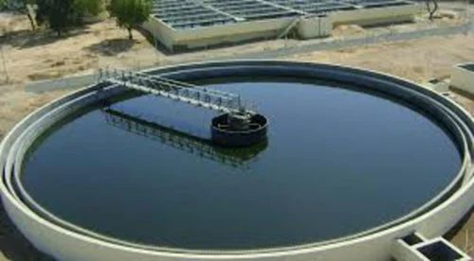
Function of Secondary Clarifier:-
Process: Wastewater flows into the tank, where the flow is slowed to a calm state. Gravity causes the biological flocs (microorganisms that consume organic waste) and other suspended solids to settle to the bottom of the tank
- Output: The clear, treated water is drawn from the top of the tank.
- Sludge return: The settled solids, called activated sludge, are collected and returned to the aeration basin to help maintain the biological treatment process.
- Sludge removal: Excess or waste sludge is removed from the tank to prevent the system from becoming overloaded.

- Gas Holder for Methane Gas( Bio Gas)
Gas holders are crucial elements in a biogas plant, meant to act as collection tanks that hold, store and control the biogas produced from the anaerobic decomposition process. In wastewater plants and biogas facilities, gas holders help ensure that there is a steady and manageable flow of biogas which may be used for power generation, combustion, or further refining.
Biogas mainly comprises methane, carbon dioxide, and some other gases. The reason why there is need for a storage device is due to the fact that gas production is inconsistent depending on digestion conditions and therefore needs to be stored. This way there is a smooth supply of biogas and at the same time maintains system pressure.
There are several models of gas holders in use in industry and agriculture and the main models include fixed dome, floating drum, and flexible membrane.
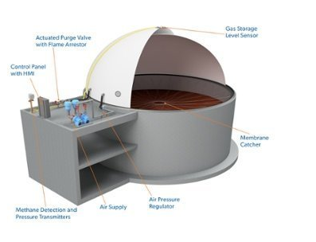

1. Fixed Dome Gas Holder
A fixed dome gas holder is a rigid, permanently constructed structure, often built using concrete, brick masonry, or reinforced materials. It is typically integrated into the digester itself, forming a sealed dome-shaped chamber above the slurry or digestion zone.

Working Principle
As biogas is produced, it accumulates in the upper dome section, creating pressure that displaces the slurry level inside the digester.

Advantages
- Durable and long-lasting
- Low maintenance requirements
- No moving parts
- Suitable for large-scale installations

Limitations
- Gas pressure can vary depending on storage volume
- Difficult to inspect or repair once constructed
- Requires precise engineering during installation
Fixed dome systems are widely used in permanent industrial and rural biogas setups due to their structural stability and cost-effectiveness over time.

2. Floating Drum Gas Holder
A floating drum gas holder consists of a movable steel or plastic drum that floats on top of the digester slurry or within a separate water jacket.

Working Principle
As gas is produced, the drum rises upward, and as gas is consumed, it descends. The movement of the drum provides a nearly constant gas pressure.

Advantages
- Stable and predictable gas pressure
- Easy visual indication of stored gas volume
- Simple operation and monitoring

Limitations
- Requires regular maintenance due to corrosion (if steel is used)
- Higher installation and maintenance costs
- Moving parts may wear over time
Floating drum systems are suitable where constant pressure is essential, especially in applications involving direct gas use.

3. Flexible Membrane Gas Holder
Flexible membrane gas holders are modern storage systems made from durable synthetic materials such as PVC or reinforced polymer membranes.
They typically consist of two membranes:
- Inner membrane: Stores the biogas
- Outer membrane: Filled with air to maintain structural shape and pressure

Working Principle
As gas enters the inner chamber, the membrane expands. Air pressure between the membranes ensures consistent gas pressure and system stability.

Advantages
- Lightweight and easy to install
- Flexible capacity for varying gas volumes
- Corrosion-resistant
- Suitable for large industrial applications
- Requires less structural support

Limitations
- Membrane lifespan depends on material quality
- Requires monitoring of air pressure systems
- Vulnerable to punctures if not properly maintained
Flexible membrane holders are increasingly preferred in modern wastewater treatment plants because of their adaptability, scalability, and low operational complexity.

Importance of Gas Holders in Biogas Systems
Gas holders serve several critical functions:
- Storage: Retain surplus gas during low demand periods
- Pressure Regulation: Maintain steady gas delivery to downstream systems
- Buffering: Balance fluctuations in production and consumption
- Safety: Prevent overpressure and uncontrolled gas release
- Operational Continuity: Ensure uninterrupted energy supply
Without an efficient gas holder, biogas utilization systems would face instability, reduced efficiency, and increased safety risks.

- Final Performance Summary
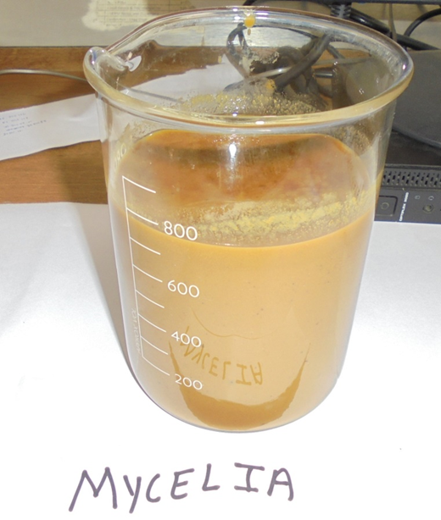
FEED

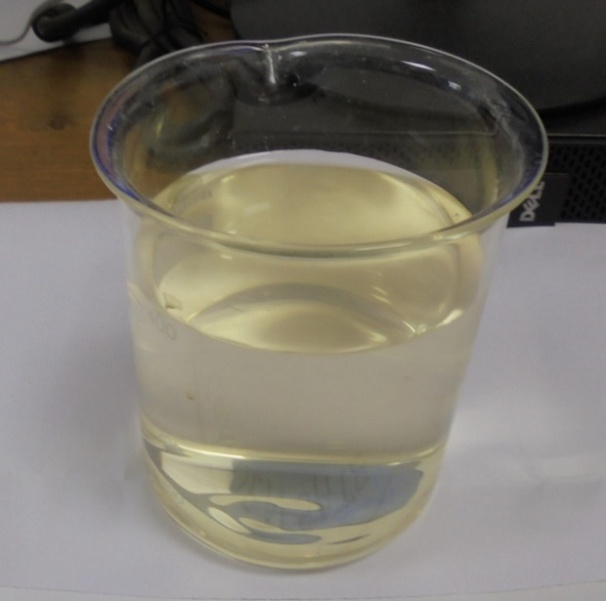
TREATED WATER

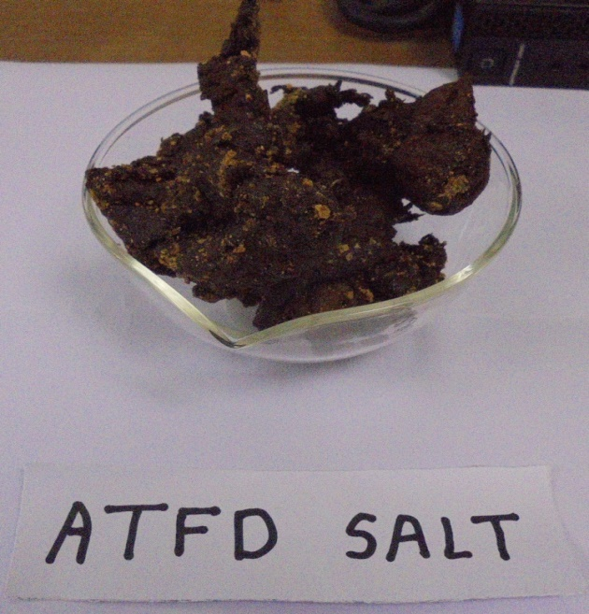
DRY POWDER USE AS A FERTILIZER FOR AGGRICULTURE

PROCESS FOR TREATMENT OF MYCELIA WASTE

- Introduction
Mycelial waste management is an essential aspect of sustainable waste management when considering fermentation-based industries like pharmaceutical and biotech firms. Mycelium wastes are formed from the production of antibiotics using fermentation and comprise many organics, excess nutrients, fungi, and other components including small quantities of active substances. The lack of waste management in this regard can lead to pollution of the environment and toxic effluents.
A waste management approach would be required in order to ensure minimal pollutant concentrations, material recovery, and regulatory compliance.

- Waste Water Collection and Preliminary Treatment
The first step in the treatment process of wastewater entails the proper collection and transport of wastewater emanating from various industrial activities in the plant. The main sources of wastewater include fermenter effluents, equipment washing, cleaning operations, floor washes, utility discharges, and other production wastewaters. Considering that the individual streams of wastewater may vary in their strength and volume, it becomes important to develop a suitable wastewater collection network where all wastewater is transported to a central treatment system.

This network serves not only to convey the wastewater efficiently but also without any leakages, overflow, and cross-mixing. Segregation of wastewater streams based on their strength can also be performed at this stage to improve treatment efficiency. Flow monitoring points for assessing the characteristics of the wastewater streams are normally provided within the collection network.

The next step involves the pre-treatment of the wastewater, which is the first barrier of protection in the entire process of treatment. The main aim of this stage is the removal of materials from the wastewater, which may cause disruptions during further processing of the wastewater or may cause problems for the mechanical devices being used. These materials can be coarse materials, fiber, suspended particles, plastic, sand, grease, oil, etc.

Preliminary treatment commonly consists of several unit operations, such as:
• Screening – to capture large solids, rags, plastics, and fibrous materials using bar screens or mesh filters.
• Grit Removal – to separate sand, silt, and heavy inorganic particles that can cause abrasion or accumulation in pipelines and tanks.
• Oil and Grease Separation – to remove floating oils, fats, and grease through skimming tanks or separators, preventing interference with biological treatment systems.
• Flow Regulation (if required) – to maintain steady hydraulic conditions for smoother downstream processing.

This step is important in ensuring that pumps, pipes, valves, mixers, and reactors used in advanced treatment processes are not clogged, corroded, or worn out due to prolonged use. Through the removal of unnecessary particles, preliminary treatment increases the safety, efficiency, and longevity of the entire wastewater treatment system.

Apart from protecting the machinery, preliminary treatment makes the following treatment processes more efficient since there are fewer pollutants for the machines to filter.

- Wastewater Equalization
Equalization is carried out in dedicated storage tanks where wastewater from different sources is collected and mixed to achieve uniform characteristics.
This process balances variations in flow rate, pollutant concentration, pH, and temperature, ensuring a steady and controlled feed to subsequent treatment stages.
Equalization prevents shock loading on biological systems and enhances treatment consistency.

- pH Adjustment
Industrial wastewater often exhibits fluctuating acidity or alkalinity, which can negatively impact chemical reactions and microbial activity.
At this stage, acids or alkalis are added to adjust the pH to an optimal range suitable for downstream treatment.
Maintaining proper pH is essential for coagulation efficiency, anaerobic digestion stability, and biological performance in aerobic systems.

- Primary Treatment
Primary treatment focuses on the removal of suspended solids, colloidal matter, and part of the organic load.
This stage commonly includes coagulation, flocculation, and sedimentation in clarifiers or lamella separators.
Chemical coagulants destabilize particles, while flocculants help form larger aggregates that settle more easily.
Primary treatment significantly reduces turbidity and prepares wastewater for biological treatment.

- Anaerobic Treatment
Anaerobic treatment is applied to high-strength organic wastewater under oxygen-free conditions.
Specialized microorganisms break down organic compounds into simpler substances, producing biogas—mainly methane and carbon dioxide—as a by-product.
This stage is highly effective for reducing Chemical Oxygen Demand (COD) and recovering renewable energy.
Anaerobic digesters such as CSTRs are commonly used in this process.

- Aerobic Treatment
Following anaerobic treatment, aerobic systems further polish the wastewater by degrading remaining biodegradable organics.
In aeration tanks, oxygen is supplied to support aerobic microorganisms that convert pollutants into carbon dioxide, water, and biomass.
This stage reduces Biological Oxygen Demand (BOD), improves effluent quality, and ensures compliance with discharge standards.
Secondary clarifiers are used afterward to separate biomass from treated water.

- Sludge Dewatering & Disposal Method
Sludge generated from primary and biological treatment contains water, solids, and microbial biomass.
Dewatering processes such as centrifuges, filter presses, or screw presses are used to reduce moisture content and volume.
The dried sludge can be disposed of in secure landfills, incinerated, or reused as fuel or soil amendment depending on its characteristics and regulatory approval.
Proper sludge management minimizes environmental risks and disposal costs.

- Methane Gas Generation & Consumption
During anaerobic digestion, organic matter is converted into biogas containing methane.
This methane is collected in gas holders and can be used as a renewable energy source for boilers, heating systems, or electricity generation.
Excess gas may be safely flared if not immediately utilized.
Methane recovery improves process sustainability and reduces dependence on conventional fuels.

- Treatment Water Reuse Process
Treated wastewater is further processed for reuse in industrial operations such as cooling, washing, or utility systems.
Water reuse reduces freshwater consumption and supports sustainable resource management.
Additional polishing steps may include filtration, disinfection, and membrane treatment to ensure water quality meets reuse standards.
This approach contributes to circular economy practices.

- Reverse Osmosis Plant Usages
Reverse Osmosis (RO) is employed as an advanced purification step to remove dissolved salts, residual organics, and fine contaminants.
RO systems produce high-quality permeate suitable for reuse in critical industrial applications.
The reject stream is managed separately through evaporation or concentration systems.
The use of RO enhances water recovery efficiency and supports zero-liquid-discharge objectives in modern treatment plants.

Conclusion

Waste from mycelia, left behind by drug and fermentation makers, brings tough problems for nature. Moisture runs high in this leftover stuff, making it thick, hard to handle. Left unchecked, pollution risks grow. Traces of antibiotics linger inside, adding to the trouble. How we deal with it matters more than most realize.
One study shows burning waste or breaking it down with heat can backfire - expensive, often dirty. On the flip side, letting microbes digest trash without air, or using oxygen-loving bacteria, runs cleaner. These greener paths handle garbage better, last longer. Cost drops. Pollution risks shrink too.
From small lab tests to larger trial runs, breaking down mushroom waste without oxygen works well. It slashes pollutants like COD and total dissolved solids. Methane-heavy gas comes out during the process. So does a natural plant food full of nutrients. Results stay strong across different test sizes.
What stands out is how crucial early preparation turns out to be. Controlled settings - like pH levels, heat, and mixing - make a real difference when managed carefully. Handling matters just as much along the whole path. Waste doesn’t vanish neatly unless these pieces line up right. Mycelia leftovers? They’re more than trash. Think of them feeding soil instead of sitting idle. Energy can come from what gets tossed aside. Seeing it differently changes everything.
Putting it together, the new way to handle mycelia waste works well without harming nature, fits within budget limits, while lasting over time. This work pushes ahead real progress in how factories deal with leftover materials, turning what was trash into useful stuff instead of letting it pile up.

References

- Central Pollution Control Board (CPCB). Guidelines for Hazardous Waste Management. New Delhi, India.
- Ministry of Environment, Forest and Climate Change (MoEFCC). Hazardous and Other Wastes (Management and Transboundary Movement) Rules, 2016.
- World Health Organization. Safe Management of Wastes from Health-Care Activities. Geneva.
- United States Environmental Protection Agency. Industrial Waste Treatment and Disposal Guidelines.
- Food and Agriculture Organization. Waste Management and Resource Recovery in Agriculture.
- Tchobanoglous, G., & Burton, F. L. Wastewater Engineering: Treatment and Reuse. McGraw-Hill.
- Metcalf & Eddy. Wastewater Engineering: Treatment and Resource Recovery. McGraw-Hill Education.
- Chen, Y., Cheng, J. J., & Creamer, K. S. (2008). Inhibition of anaerobic digestion process: A review. Bioresource Technology.
- Zhang, R., El-Mashad, H. M., Hartman, K., et al. (2007). Characterization of food waste as feedstock for anaerobic digestion. Bioresource Technology.
- Singh, J., & Kalamdhad, A. S. (2013). Effects of organic waste on composting process: A review. Environmental Technology.

