COMPARATIVE STUDY ON POPULATION OF EARTHWORM BY TEMPERATURE AND MOISTURE OF SOIL IN DIFFERENT SEASONS OF MANGO AND LITCHI AGRICULTURE FARMING OF BAILPARAO VILLAGE OF RAMNAGAR, DISTRICT NAINITAL, UTTARAKHAND.

ABSTRACT

Earthworms are advantageous for soil system. Soil temperature and moisture are the primary factors for earthworm survival and growth. The introduction of earthworms in agro-ecosystem changes soil pro-characteristics. They play a vital role in the ecosystem by aerating the soil and allowing air and water to circulate. They are semi-aquatic animals which extract water continuously from the surrounding soil in order to maintain their cuticle in a moist state to facilitate gas exchange. Thus, moisture status is a major limitation to earthworm activities and distribution. Earthworm biomass,

activity and abundance increase with increasing temperature with high soil water content. The ideal temperature for earthworms is 10-20°C for growth and development. Earthworms prefer medium textured soil that’s not too sandy, providing a good balance of water retention and organic matter such as decaying leaves, compost, plant matter for its survival and reproduction. They constantly till the soil as it passes through them. They eat the soil; removing nutrients they need from it and returning what remains in the form of “castings”. The present study was conducted in Bailparao village of Ramnagar, district Nainital of Uttarakhand state during different climate of the year from March 2022 to February 2023, therefore in this paper we compare the influence of soil temperature and moisture on earthworm distribution.
KEYWORDS: Biodiversity, Growth, Organic matter, Reproduction, Soil moisture, Temperature.

INTRODUCTION
Earthworms are the major component of the soil system in temperate ecosystems (Lavelle,1988)[30]. They constitute the members of a large ubiquitous group of the soil and are commonly referred as ecosystem engineers (Lavelle et al.,1997; Hale et al., 2005)[31,22]. Earthworms are macro-fauna commonly found in tilled soils, grasslands and other agro- ecosystems. They have a significant role in soil aggregation and soil porosity (Sharma,2005)[42]. Aristotle recognized their importance as the “Intestines of Earth", as they decompose organic matter like plants leaves decaying fruits and soil. Earthworms are “natural tillers” because they increase aeration porosity (Knight et al., 1992)[27], infiltration capacity (Stock dill,1966)[36] and hydraulic conductivity (Ehlers, 1975; Johnson-Maynard et.al., 2002)[9,25] of soil, water stable aggregates (Zeiglar and Zech, 1992;Ketterlings et al.,1997)^{[45,28]} of soil, decrease bulk density (Johnson-Maynard et al., 2007)^{[26]}.
They are the organisms that may create their habitat and thus influence availability of resources to other species and soil properties due to their lasting effects on soil physical and biochemical properties (Emmerling et al.,2002)[10].

Earthworm’s activity, abundance, metabolism and biomass are all greatly influenced by temperature. It has been observed that earthworms can resist cold and moist conditions as a comparison to hot and dry soil (Edwards and Bohlen, (1996)[9], Holmastrup et al., (1991)[21] and indirectly influencing the earthworm habitat and availability of food (Curry, 2004)[5]. Earthworms soil ecosystem modifiers as they are improving the soil nutrient profiles (Jones et al., 1994)^{[24]}. The best conditions for earthworm activities are the night temperatures in the soil not reaching 10.5 °C (Baker et al., 1992; Duiker et al., 2007; Hale et al., (2005)[1,7,22]. Earthworms are semi-aquatic animals which extract water continuously from the surrounding soil in order to maintain their cuticle in moist state to facilitate gas exchange, thus moisture status is a major limitation. The humble earthworm might not seem the most exciting of animals, but they significantly affect soil physical structures and organic matter and nutrient dynamics and promote plant growth (Lee,1985; Lavelle et al.,1988)[29,30]. Earthworm food consists of decaying

plants and other organisms, as they eat, however, earthworms also ingest large amounts of soil, sand and tiny pebbles. They ingest and discard its own weight in soil every day. Earthworms feed on decaying organic waste and soil and excrete approximately 60 to 80% of their feed (Sharma, P.D. 2005)[42].

The aim of this paper is to compare the density of earthworms in mango and litchi cultivation by soil temperature and moisture in different seasons.

LITERATURE REVIEW

Many studies have focused on how variations in soil temperature and moisture impact earthworm growth, survival and population distribution. Early work by Satchell^{[38]} in 1983, reported that seasonal variations that seasonal variations in number of earthworms are closely related to changes in soil temperature and moisture as populations rise during rainy seasons. Soil moisture plays a vital role in regulating earthworm population and needs sufficient water for their movement, growth, feeding and reproduction. Lee (1985)^{[29]} further found that soil moisture is essential for earthworms because they respire through their moist skin as reduced soil moisture decreases number of earthworms and their surface activity.
Lavelle (1988)^{[30]} observed that tropical earthworm population grew rapidly in warm and moist soils, while long dry periods reduce their activity. Edwards and Bohlen (1996)^{[9]} reported that moderate temperature and adequate moisture favor earthworm growth, reproduction and biomass production whereas unfavorable temperature reduces abundance of earthworm. In 1996, Presley et al.^{[33]} studied moderate combined effects of soil temperature and moisture on earthworm Eisenia fetida improve its growth, survival and reproduction.
Zaller et al. (1997, 2009)^{[46,48]} studied ecological effects of earthworms under environmental stress and land management. Later, a detailed experimental study by Wever, Clapperton, Holmgren and Timothy (2001)^{[44]} showed that maximum growth occurred at 15-20°C with sufficient soil moisture.
Sara Si moussi et al. (2005)^{[43]} found that temperature, rainfall and land use are major factors controlling earthworm distribution. This was followed by Curry (2004)^{[5]} who observed that population of earthworm decreases during extreme dry or cold conditions. Perrault and Whalen (2006)^{[34]} noted that casting and burrowing activity are more in moist soils as compared to dry soils.

In 2008, Zorn et al^{[47]} reported species-specific earthworm responses to flooding and soil moisture stress. In 2009, multiple studies contributed meaningfully: Eggleton et al. (2009)^{[11]} found that density and diversity of earthworm increase under suitable soil conditions. Briones et al. (2009)^{[2]} worked on climate change, drought and earthworm ecology and Eisenhauer et al. (2009)^{[12]} showed the role of earthworms in enhancing soil fertility and ecosystem functioning.

Subsequent, overall studies by Eisenhauer et al (2010, 2011, 2012, 2013, 2014, 2016, 2018, 2019) ^{[13,14,15,16,17,18,20,19]} found that earthworms improve soil fertility, plant productivity, decomposition, soil biodiversity and ecosystem functioning while warming alter their activity. In India, Lalthanzara, Ramanujam and Jha in 2011^{[32]} studied seasonal earthworm dynamics.

More recently, Phillips et al. (2019)^{[35]} reviewed that global climate warming and changes in rainfall can alter earthworm abundance and distribution.

Overall, previous studies clearly indicate that optimal soil temperature and adequate moisture provide the most favourable conditions for earthworm growth, activity, and population stability.

MATERIALS AND METHODS

STUDY AREA

The present research was carried out on Bailparao village, about 14km from Ramnagar (Longitude-79.12°E and Latitude- 29.40°N) of Nainital district of Uttarakhand State, aiming the influence of soil temperature and moisture on earthworm population. The location of the study site is shown in figure 1.

Earthworms were gathered by conventional digging method and hand sorting method (Satchell, J.E. (1969)^{[[37]}. Using visible features, earthworms were categorized into clitellates and aclitellates. The soil samples were collected from five places of each study site in different seasons (Summer season: March – June; Rainy season: July- October; and Winter season: November-February) for one year from March 2022 to February 2023. They were then manually counted to analyze their numbers for all three seasons. Two samples were collected from each 5 sampling units of 50×50 cm, from each of the quadrates at 0-10cm and 10-20cm depth and kept in airtight plastic bag. Soil temperature was measured in the field with the help of digital soil thermometer. Soil moisture content was determined by the oven-dry method, in which 10g soil sample were dried at 105℃ for 24 hours and the loss in weight was recorded as moisture content. The mean worm abundance for each sampling unit together with standard error (SE), was calculated.

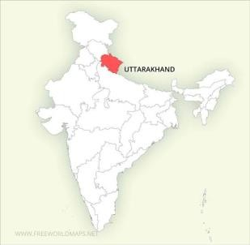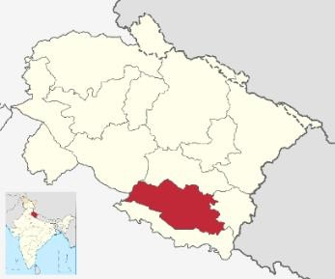
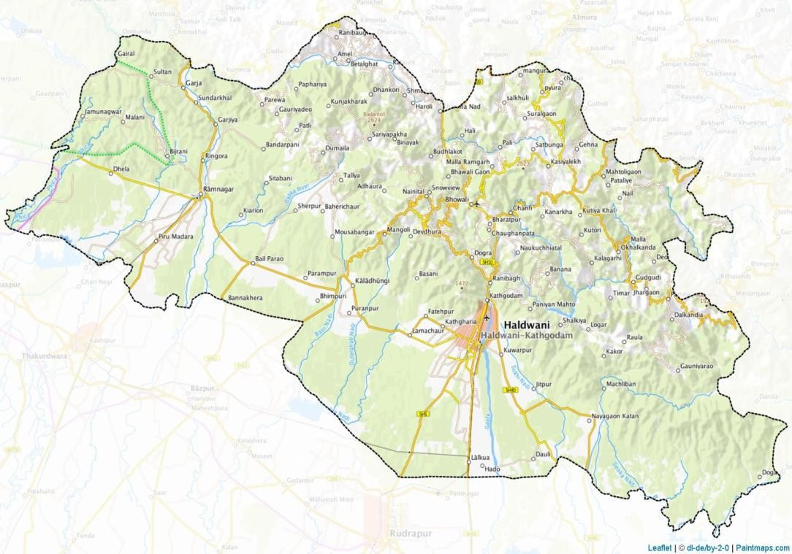
Map of India Map of Uttarakhand state showing Nainital district in color.
Geographic map of the study area and dark dot indicate the place of research area.

Fig. 1. Study area map

TABLE 1: Average earthworm abundance per m² (SE) of temperature (℃) and moisture of soil for 1 year at different depths in mango khet of Bailparao in summer, rainy and winter season.

STUDY AREA | SEASONS | SOIL TEMPERATURE | SOIL MOISTURE | NUMBER OF EARTHWORMS
MANGO | SUMMER | 24.5±2.05 | 19.9±1.82 | 6.9±1.54
(0-10cm) | RAINY | 25.2±1.78 | 32.5±5.42 | 10.1±3.04
 | WINTER | 15.5±0.95 | 13.2±0.89 | 2.2±0.50
MANGO | SUMMER | 23.9±1.92 | 21.2±0.67 | 7.7±0.94
(0-20cm) | RAINY | 24.7±1.58 | 23.0±3.16 | 10.1±1.49
 | WINTER | 15.7±0.96 | 19.8±1.45 | 5.3±1.03

TABLE 2: Average earthworm abundance per m² (SE) of temperature (℃) and moisture of soil for 1 year at different depths in litchi cultivation of Bailparao in summer, rainy and winter season.

STUDY AREA | SEASONS | SOIL TEMPERATURE | SOIL MOISTURE | NUMBER OF EARTHWORMS
LITCHI | SUMMER | 24.6±1.86 | 25.1±3.61 | 8.4±2.59
(0-10cm) | RAINY | 26.2±1.57 | 33.6±5.49 | 8.7±2.33
 | WINTER | 16.4±0.88 | 19.4±1.75 | 3.5±0.83
LITCHI | SUMMER | 24.3±2.34 | 25.8±1.06 | 7.4±0.58
(0-20cm) | RAINY | 25.4±1.57 | 30.0±4.23 | 7.5±0.92
 | WINTER | 18.4±2.75 | 23.5±2.31 | 4.7±0.58

Fig. 2. Seasonal variation of soil temperature and moisture in earthworm population in mango cultivation of Bailparao village.
Earthworms were gathered by conventional digging method and hand sorting method
(Satchell, J.E. (1969)^{[[21]}. Using visible features, earthworms were categorized into clit acl
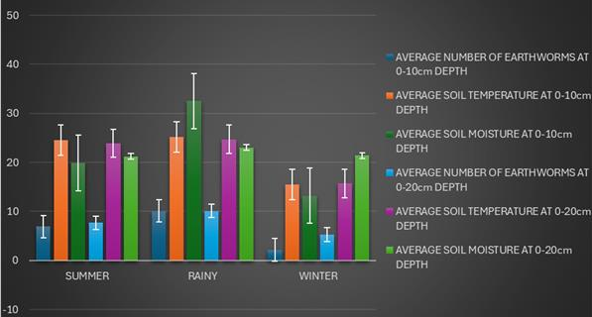

Fig. 3. Seasonal variation of soil temperature and moisture in earthworm population in litchi cultivation of Bailparao village.




































50
40

30

20

10

0
SUMMER
RAINY
WINTER
AVERAGE NUMBER OF EARTHWORMS AT
0-10cm DEPTH
AVERAGE SOIL TEMPERATURE AT 0-10cm
DEPTH
AVERAGE SOIL MOISTURE AT 0-10cm DEPTH
AVERAGE NUMBER OF EARTHWORMS AT 10-20CM DEPTH
AVERAGE SOIL TEMPERATURE AT 10-20CM DEPTH
AVERAGE SOIL MOISTURE AT 10-20CM DEPTH
-10

RESULT AND DISCUSSION
In this present experiment, the effect of temperature and moisture of soil on number of earthworms were studied in different seasons (summer, rainy and winter) for one year at different depths (0-10cm) and (10-20cm). Table 1 and 2 shows the mean values of soil temperature, soil moisture and number of earthworms in mango and litchi cultivation of Bailparao respectively. Figure 1 and 2 shows the maximum number of earthworms in rainy season as compared to winter and summer season both in mango and litchi cultivation. At the mango field study site in Bailparao, an uncommon pattern was noted, mean soil temperature peaked in the rainy season (25.2℃), then decreased in summer (24.5℃) and further declined in winter (15.5℃) (Table1) at (0-10cm) depth.
Likewise, at (10-20cm) depth, an exceptional pattern was seen, mean soil temperature was again highest in rainy season (24.7℃), decreased in summer season (23.9℃) and further dropped in winter season (15.7℃) (Table 1). At the litchi field study site in Bailparao, an unusual pattern was again observed same as mango site where mean soil temperature was highest in rainy season (26.2℃) than summer (24.6℃) and winter season (16.4℃) (Table2) at 0-10cm depth. Similarly, at (10-20cm) depth, a distinct pattern was observed with mean soil temperature reaching their highest level during rainy season (25.4℃) declined in summer (24.3℃), and dropped further in winter (18.4℃) at litchi field study site (Table 2). The results also indicated that average soil moisture peaked in the rainy season and was least in winter at both sampling depths in both study sites (Table 1 and 2). Also, the number of earthworms were higher in rainy season as compared to summer and winter season at both study sites (mango and litchi) and at both sampling depths (0-10cm and 0-20cm) (Table 1 and Table 2). When both sites were compared, the number of earthworms at 0-10cm soil depth was found to be higher at litchi site than mango site and the number of earthworms at 0-20cm soil depth, was higher in mango cultivation than litchi.

CONCLUSION
The present experiment results imply that soil with optimal moisture content comprises more number of earthworms and it increases from rainy to summer to winter season in both study sites.

The present study also concluded that at moderate(comfortable) temperature the number of earthworms is more. So, we conclude from present study that the most favourable season for earthworm population is rainy season than heated summer or winter season. During these times soil temperature and moisture are optimal for their activity and reproduction.

REFERENCES
- Baker, G.H.; Barrett, V.J.; Grey-Gardner, R.; Bucker, J.C. The life history and abundance of the introduced earthworms Aporrectodae.trapezoids and Aporrectodae caliginosa in pasture soils in the Mount Lofty Range, South Australia. Aust. J. Ecol. 1992, 17, 177–188.
- Briones, M.J.I., Ostle, N.J., McNamara, N.P., & Poskitt, J. (2009). Functional shifts of grassland soil communities in response to soil warming. Soil Biology and Biochemistry, 41, 315–322.
- . Bhadauria, T. and Saxena, K.G. (2010). Role of earthworms in soil fertility maintenance through the production of biogenic structures. Applied and Environmental Soil Science, 1-10.

- Blouin, M., Sery, N., Cluzeau, d., Brun, J.J., Bedecarrats, A., Eisenhauer, N. (2013). Balkanised research in ecological engineering revealed by a bibliometric analysis of earthworms and ecosystem services. Environmental Management, 52:309-320.

- Curry, J.P., 2004. Factors affecting the abundance of earthworms in soil. In: Edwards, C.A. (Ed.), Earthworm ecology. CRC Press, Boka Raton, pp. 91-113.

- Dash, M.C. and Patra, U.C(1977) Density, biomass and energy budget of tropical earthworm population form a grassland site in Orissa, India. Revved`Ecologie et Biologie du Sol., 14 (3): 461-471.

- Duiker, S.; Stehouwer, R. Earthworms. 2007. Available online: http://pubs.cas.psu.edu/freepubs/pdfs/uc182.pdf (accessed on 16 March 2022).
- Ehlers, W.1975. Observation on earthworm channels and infiltration on tilled and untilled loess soil. Soil Science,119:242-247.

- Edwards, C.A. & Bohlen, P.J. 1996. Biology and Ecology of Earthworms. Chapman & Hall, London. ŚŚ

- Emmerling C., Schloter M., Hartmann A., Kandeler E., 2002. Functional diversity of soil organisms- a review of recent research activities in Germany. J. Plant Nutr. Soil Sci. 165:408-420.

- Eggleton, P., Inward, K., Smith, J., Jones, D.T., and Sherlock, E. (2009). A six- year study of earthworm populations in pasture woodland in southern England: responses to soil temperature and moisture. Soil Biology and Biochemistry.

- Eisenhauer, N., Straube, D., Johnson, E.A., Parkinson, D., Scheu, S. (2009). Exotic ecosystem
engineers change the emergence of plants from the seed bank of a deciduous forest. Ecosystems.

- Eisenhauer, N. (2010). The action of an animal ecosystem engineer: Identification of the main mechanisms of earthworm impacts on soil microarthropods. Pedobiologia, 53: 343-352.

- Eisenhauer, N., Schlaghamerský, J., Reich, P.B., & Frelich, L.E. (2011). The wave towards a new steady state: Effects of earthworm invasion on soil microbial functions. Biological Invasions, 13(10), 2191–2196.

- Eisenhauer, N., Cesarz, S., Koller, R., Worm, K., Reich, P.B. (2012). Global change belowground: impacts of altered biodiversity on earthworm communities and soil processes.

- Eisenhauer, N., et al. (2013). Earthworms and global change. Soil Biology and Biochemistry, 57, 1–7.

- Eisenhauer, N., Reich, P.B., Isbell.Isbell, F., et al. (2014). Biodiversity effects on soil processes are mediated by earthworm activity and litter decomposition.

- Eisenhauer, N., et al. (2016). Earthworms, soil food webs and ecosystem multifunctionality under global change.

- Eisenhauer, N., et al. (2019). Global patterns of soil biodiversity. Science, 366(6464), 1–10.

- Ferlian, O., Nico Eisenhauer, Aguirrebengoa, M., et al. (2018).Invasive earthworms erode soil biodiversity: A meta-analysis.Journal of Animal Ecology, 87(1), 162–172.

- Holmstrup M, Østergaard IK, Nielsen A, Hansen BT. The relationship between temperature and cocoon incubation time for some Lumbricid earthworm species. Pedobiologia (Jena). 1991;35(3):179-184.

- Hale,C.M.,L.E.Frelich,P.B.Reich,andJ.Pastor,2005. Effect of European earthworm invasion on soil characteristics in northern hardwood forest of Minnesota USA. Ecosystem,8:911-927.

- Hendrix, P.F.; Callaham, M.A.; Drake, J.M.; Huang, C.Y.; James, S.W.; Snyder, B.A. Pandora’s box contained bait: The global problem of introduced earthworms. Annu. Rev. Ecol. Evol.
Syst. 2008, 39, 593–613.

- Jones, C.G. Lawton, J.H. and Shachak, M. 1994. Organisms as ecosystem engineers. Oikos,69, 373-386.

- Johnson-Maynard,J.L.,Graham,R.C.,Wu,l.,Shore, P.J.,2002. Modification of soil structural and hydraulic properties after 50 years of impact chaparral and pine vegetation. Geoderma, 110:227-240.

- Johnsonmaynard, J.; Umiker, K.; Guy, S. Earthworm dynamics and soil physical properties in the first three years of no-till management. Soil Tillage Res. 2007, 94, 338–345.
- Knight,D.,Elliot,P.W.,Anderson,J.M.,Scholefield,D.,1992.The role of earthworms in managed, permanent pasture in Devon. England Soil Biology and Biochemistry,24:1511-1517.

- Ketterlings QM, Blair JM, Marinissen JCY. 1997. Effects of earthworm on soil aggregate stability and carbon and nitrogen storage in a legume cover crop agroecosystem. Soil Biochem. 29: 401-408.
- Lee, K.E. (1985): Earthworm- their ecology and relationship with soil and land use. Academic Press. Sydney.

- .LavelleP,Barois,L.,Blanchart,E.,G.G.,BrusardL.,DecaensF.J.,JimeuezK,Kajondo,M.A.,Martiniz,A.
G.,Moreno,P.,Senapati,B. and Villenance C. (1988): Earthworm as a resource in tropical agroecosystems. Natural Resources 39:26-41.

- Lavelle P. 1997. Faunal activities and soil processes: adaptive strategies that determine ecosystem function. Adv. Ecol. Res., 27: 93-132.

- Lalthanzara, H., Ramanujam, S. N., & Jha, L. K. (2011). Population dynamics of earthworms in relation to soil parameters. Journal of Environmental Biology, 32(3), 1–6.

- Presley, M.L., McElroy, T.C., nd Diehl, W.J.(1996). Soil moisture and temperature interact to affect growth, survivorship, fecundity, and fitness in the earthworm Eisenia fetida. Coomparative Biochemistry and Physiology Part A, 114(4): 319-326.

- Perreault, J.M., and Whalen, J.K. (2006). Earthworm burrowing in laboratory microcosms as influenced by soil temperature and moisture. Pedobiologia, 50:397-403.

- Phillips, H.R.P., Guerra, C.A., Bartz, M.L.C., Briones, M.J.I., Brown, G., Crowther, T.W., Ferlian, O., van den Hoogen, J., et al., & Eisenhauer, N. (2019). Global distribution of earthworm diversity. Science, 366(6464), 480–485.
- Stockdill,S.M.J.andG.G.Correns.1966.The role of earthworms in pasture production and moisture conservation. Proceeding of New Zealand Ecology Grassland Associaton, 28:168-183.
- Satchell, J.E. (1969). Methods of sampling earthworm populations. Pedobiologia, 9,20-25.

- Satchell, J.E. (Ed.). 1983. Earthworm Ecology: From Darwin to Vermiculture. Chapman and Hall, London.

- Senapati, B.K. and Dash, M.C. (1981) Effect of grazing on the elements of production in the vegetation and oligochaete components of a tropical pastureland. Revue d’Ecologie et Biologie du Sol., 18: 487-505.

- Saxena, M.M. (1990) Environmental Analysis: Water, Soil and Air. 2nd ed., Agro Botanical Publishers, New Delhi.

- Sinha, R.K., Herat, S., Agarwal, S., Asadi, R. and Carretero, E. (2002). Vermiculture and waste management: the study of the action of
earthworms Eisenia foetida, Eudrilus euginae, and Perionyx excavatus on biodegradation of some community wastes in India and Australia. Environmentalist, 22(3): 261-268.

- Sharma, P.D. (2005) Ecology and Environment Rastogi Publications, Meerut, India.

- Si-moussi, S., Thuiller, W., Galbrun, E., Decaëns, T., Gérard, S., Marchán, D.F., Marsden, C., Capowiez, Y., & Hedde, M. (2005). Digging deeper: deep joint species distribution modeling reveals environmental drivers of Earthworm Communities.

- Wever, L.A., Lysyk, T.J., and Clapperton, M.J.2001. The influence of soil moisture and temperature on the survival, aestivation, growth and development of juvenile Aporrectodea tuberculata (Eisen)(Lumbricidae). Paedobiologia, 45(2): 121-133.

- Ziegler,F.andZech, W.1992.Formation of water stable aggregates through the action of earthworms: Implications from laboratory experiments. Pedobiologia36:91-96.

- Zaller, J.G., & Arnone III, J.A. (1999). Earthworm and soil moisture effects on the productivity and structure of grassland communities. Soil Biology and Biochemistry, 31, 517–523.

- Zorn, M.I., van Gestel, C.A.M., Morrien, E., Wagenaar, M., and Eijsackers, H.J.P. (2008). Flooding responses of three earthworm species, Allolobophora chlorotica, Aporrectodea caliginosa and Lumbricus rubellus, in a laboratory- controlled environment. Soil Biology and Biochemistry, 40(3): 587-593.

- Zaller, J.G., Caldwell, M.M., Flint, S.D., Ballaré, C.L., Scopel, A.L., & Sala, O.E. (2009). Solar UV-B and warming affect decomposition and earthworms in a fen ecosystem in Tierra del Fuego, Argentina. Global Change Biology, 15, 2493–2502. https://doi.org/10.1111/j.1365-2486.2009.01970.

- www.freeworldmaps.net

- https://commons.wikimedia.org/wiki/File:Nainital_district.svg

- https://tools.paintmaps.com/map-cropping/IN/4-890504093/samples#google_vignette

