Socio-Technical Governance of AI: Addressing Bias, Opacity, and Accountability in Algorithmic Decision

Abstract — Decision-making powered by artificial intelligence (AI) has become pervasive in high-stakes domains such as healthcare, criminal justice, finance, and human resource management. While AI systems promise greater efficiency, consistency, and objectivity, they introduce significant ethical risks including algorithmic bias, opacity, accountability gaps, and privacy erosion. This paper provides a comprehensive analysis of these challenges, examining the origins and manifestations of bias, the technical and ethical imperatives for explainability, responsibility diffusion in complex AI supply chains, and tensions between data-driven innovation and fundamental rights. It evaluates major regulatory responses, notably the European Union AI Act, and proposes a multi-stakeholder ethical governance framework. The study argues that responsible AI deployment requires continuous co-evolution of technical solutions, organizational practices, and adaptive regulation to ensure fairness, transparency, and human-centric outcomes.
Keywords — Algorithmic bias, Explainable AI, AI ethics, Fairness, Transparency, Accountability, Data governance, EU AI Act
I. Introduction
The rapid integration of artificial intelligence into organizational and societal decision-making constitutes one of the defining technological transformations of the 21st century. Machine learning models now influence critical outcomes in predictive policing, automated recruitment, medical diagnosis, credit scoring, and judicial risk assessment [1], [2]. Proponents emphasize AI’s potential to reduce human subjectivity, improve consistency, and extend expert-level decision support to broader populations.
However, AI systems are not neutral. They inherit and often amplify societal biases embedded in historical data, reflect the values and limitations of their developers, and frequently operate as opaque “black boxes.” The scale, speed, and impact of algorithmic decisions create unique ethical challenges that transcend purely technical considerations, entering the realm of socio-technical and political governance [3].
This paper examines the primary ethical dimensions of AI decision-making: algorithmic bias and fairness, transparency and explain ability, accountability, privacy, and regulatory responses. Drawing upon real-world cases, mathematical insights, and emerging policy frameworks, it demonstrates that ethical AI demands interdisciplinary collaboration and proactive governance. The analysis concludes with a proposed ethical framework aimed at guiding responsible development and deployment.

II. Algorithmic Bias and Fairness

A. Origins of Bias in AI Systems
Bias in AI systems arises systematically across the machine learning lifecycle. Primary sources include historical bias in training data, representation bias, measurement bias, and aggregation bias [1], [4].
Historical bias occurs when models are trained on data reflecting past discriminatory human decisions. A landmark example is the COMPAS recidivism prediction tool used in the U.S. criminal justice system. ProPublica’s 2016 investigation revealed that COMPAS assigned significantly higher risk scores to Black defendants compared to White defendants with similar criminal histories, demonstrating clear racial disparity [1].
Representation bias emerges when certain demographic groups are underrepresented in training datasets. The Gender Shades study by Buolamwini and Gebru (2018) exposed severe performance gaps in commercial facial recognition systems, which exhibited error rates up to 34.7% higher for darker-skinned females than for lighter-skinned males due to skewed training data dominated by lighter-skinned male faces [2].
These biases are not merely technical artifacts but reflections of deeper societal inequalities encoded in data. Once deployed at scale, biased systems can perpetuate and even exacerbate discrimination, creating feedback loops that entrench unfair outcomes.
Bias in AI systems arises systematically across the machine learning lifecycle. Primary sources include historical bias in training data, representation bias, measurement bias, and aggregation bias [1], [4].
Figure 1 shows the key stages where bias can enter or be amplified in the AI system lifecycle.

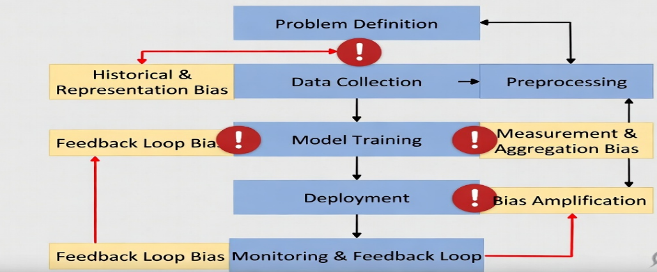
Figure 1: Bias Introduction Points in the AI System Lifecycle

Table I: Categories of Algorithmic Bias and Examples
Bias Type | Description | Real-World Example | Reference
Historical Bias | Bias from past human decisions | COMPAS recidivism tool | [1]
Representation Bias | Underrepresentation of groups | Gender Shades facial recognition | [2]
Measurement Bias | Flawed proxies or labels | Biased healthcare datasets | [4]
Aggregation Bias | One-size-fits-all modeling | Generic credit scoring models | [5]

B. Competing Definitions of Fairness
Defining and operationalizing “fairness” remains one of the most contested areas in AI ethics. Literature documents over twenty distinct mathematical definitions, including demographic parity (equal positive prediction rates across groups), equalized odds (equal true and false positive rates), calibration (equal prediction accuracy), and individual fairness (similar individuals receive similar outcomes) [5], [6].
Importantly, Chouldechova (2017) and Kleinberg et al. (2016) proved the “impossibility theorem” for algorithmic fairness: when base rates differ across groups, certain fairness criteria are mutually incompatible. Optimizing for one definition necessarily violates another, forcing developers and policymakers to make explicit normative choices [5], [6]. These trade-offs are inherently ethical and political decisions rather than purely technical optimizations.
Contextual appropriateness becomes crucial. Fairness in hiring may prioritize different criteria than fairness in medical diagnosis or criminal risk assessment.
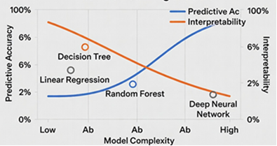
Figure 2 illustrates the fundamental trade-off between model accuracy and interpretability, a core challenge in Explainable AI.
Table II: Comparison of Fairness Definitions
Fairness Metric | Definition | Advantage | Limitation | Incompatible With
Demographic Parity | Equal positive rates across groups | Simple | Ignores actual outcomes | Equalized Odds
Equalized Odds | Equal TPR & FPR across groups | Balances errors | Requires equal base rates | Calibration
Calibration | Predicted probabilities match true outcomes | Reliable predictions | Allows disparate impact | Demographic Parity
Individual Fairness | Similar individuals treated similarly | Person-centric | Difficult to measure | Group metrics

III. Transparency and Explainability

A. The Black Box Problem
Deep learning models, particularly neural networks, often function as black boxes, delivering high-accuracy predictions without intelligible explanations of their reasoning processes. This opacity undermines procedural justice and individual autonomy. Affected persons cannot understand, challenge, or seek redress for adverse decisions such as loan denials, job rejections, or parole refusals [7].
The European Union’s General Data Protection Regulation (GDPR, 2018) responded to this concern through Article 22, which provides a “right to explanation” for decisions made solely by automated processing with significant effects on individuals [8].

B. Explainable AI (XAI) Techniques
Significant research efforts have produced methods to mitigate opacity. Local Interpretable Model-agnostic Explanations (LIME) approximates complex model behavior locally using simpler interpretable models [9]. SHAP (SHapley Additive exPlanations) offers theoretically grounded feature attribution based on cooperative game theory [10]. Counterfactual explanations communicate actionable insights by showing what minimal changes would alter the outcome [11].
Despite these advances, fundamental limitations persist. Post-hoc explanations may not faithfully reflect the model’s actual decision logic. Moreover, a persistent trade-off exists between model accuracy and interpretability: simpler models (e.g., linear regression, decision trees) are more transparent but often less accurate than complex deep learning architectures [7]. Achieving optimal balance requires domain-specific judgment and stakeholder involvement.
To address the black box problem, researchers have developed various Explainable AI (XAI) methods. Table III summarizes the most popular approaches currently used in practice.
Table III: Popular XAI Methods
Method | Type | Key Strength | Limitation
LIME | Local, Model-agnostic | Easy to understand, flexible | May not reflect global model behavior
SHAP | Game-theoretic | Theoretically sound, consistent attributions | Computationally expensive for large models
Counterfactual | Example-based | Highly actionable insights | May not always be feasible or realistic
Figure 2 further illustrates the fundamental trade-off between predictive accuracy and interpretability that XAI methods attempt to balance.
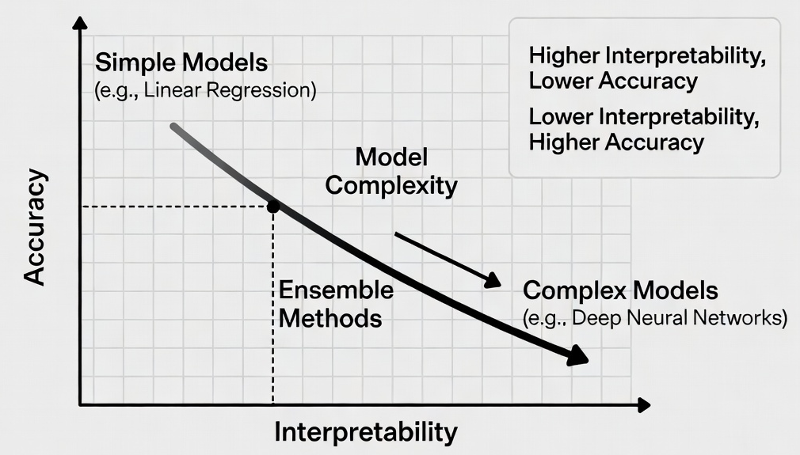
Figure 3 further illustrates the fundamental trade-off between predictive accuracy and interpretability that XAI methods attempt to balance.
While these techniques significantly improve transparency, they are not perfect solutions. Post-hoc explanations may not always faithfully represent the underlying model logic, and there remains an inherent tension between model performance and human interpretability. Therefore, the choice of XAI method should be context-dependent, especially in high-stakes decision-making domains.

IV. Accountability and Responsibility Gaps
AI systems create “accountability gaps” due to the distributed nature of modern development pipelines involving data providers, model developers, system integrators, deploying organizations, and end users. This “problem of many hands” makes it difficult to assign moral and legal responsibility when harm occurs [12].
Automation bias compounds the issue, as human overseers tend to over-rely on algorithmic recommendations, even when they conflict with professional judgment. Consequently, high-stakes decisions are effectively delegated to systems incapable of ethical reasoning or legal accountability [12].
Clear accountability mechanisms—such as designated responsible parties, mandatory human oversight for high-risk applications, and auditable decision logs—are essential to close these gaps.

V. Privacy, Surveillance and Data Ethics
Training state-of-the-art AI models requires massive volumes of personal and behavioral data, creating inherent conflict with privacy as a fundamental right. Data is frequently collected at scale with limited informed consent, repurposed beyond original contexts, and aggregated in ways individuals cannot anticipate [13].
Shoshana Zuboff’s framework of “surveillance capitalism” describes how human experience is commodified into behavioral data for predictive modeling and decision-making [13]. The deployment of facial recognition technology in law enforcement has triggered widespread concern, leading several U.S. cities (San Francisco, Boston, Portland) to impose bans due to documented bias, inaccuracy, and chilling effects on civil liberties [2].

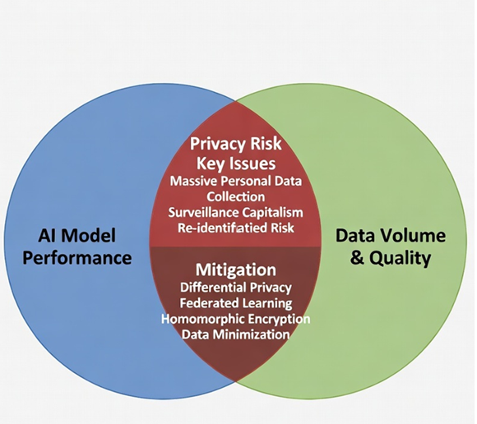
Figure 4: Tension Between AI Performance and Privacy

Privacy-preserving techniques such as federated learning, differential privacy, and homomorphic encryption offer promising technical mitigations, but must be complemented by strong regulatory oversight.

VI. Governance Frameworks and Regulatory Responses

A. The EU AI Act
The European Union Artificial Intelligence Act (2024) represents the most comprehensive regulatory framework to date. It adopts a risk-based approach categorizing AI systems into unacceptable, high, limited, and minimal risk tiers [14].
Unacceptable-risk applications—including social scoring and manipulative subliminal techniques—are prohibited. High-risk systems (employment, education, law enforcement, critical infrastructure) face stringent requirements covering risk assessment, data governance, transparency, human oversight, robustness, and conformity assessment.
While the EU AI Act sets a global benchmark, challenges remain regarding enforcement consistency across member states, compliance burdens on small and medium enterprises (SMEs), and the risk that exceptions may dilute effectiveness.
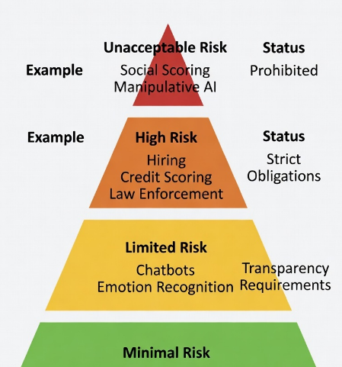
Figure 5: Risk-Based Approach of EU AI Act
The EU AI Act prohibits unacceptable-risk applications outright and imposes rigorous compliance requirements on high-risk systems, which include most AI applications in employment, education, critical infrastructure, and law enforcement. While the Act is widely regarded as a global benchmark, concerns remain regarding enforcement consistency across EU member states, potential compliance burdens on small and medium-sized enterprises (SMEs), and the effectiveness of exceptions.
Table IV: EU AI Act Risk Categories
Risk Level | Examples | Requirements | Status
Unacceptable | Social scoring, Manipulative subliminal AI | Prohibited | Banned
High | Hiring systems, Credit scoring, Law enforcement, Medical diagnosis | Risk assessment, data governance, transparency, human oversight, conformity assessment | Strict obligations
Limited | Chatbots, Emotion recognition systems | Transparency obligations | Light requirements
Minimal | Spam filters, Video games, Inventory management | Voluntary codes of conduct | Minimal regulation

B. Algorithmic Auditing and Impact Assessments
Beyond legislation, third-party algorithmic audits and AI Impact Assessments (similar to environmental impact assessments) provide essential proactive accountability tools. Effective auditing requires access to training data, model weights, and decision logs while balancing legitimate intellectual property concerns. Secure audit environments and independent regulatory bodies may help resolve these tensions.

VII. Proposed Ethical Framework for AI Decision-Making
This paper proposes an integrated ethical framework consisting of the following core pillars:
- Fairness by Design: Embed multiple fairness metrics and bias detection/mitigation techniques throughout the development lifecycle, with context-aware selection of fairness definitions.
- Transparency and Explainability: Prioritize inherently interpretable models where performance requirements permit, supplemented by state-of-the-art XAI methods and clear documentation.
- Accountability Mechanisms: Define clear responsibility chains across the AI value chain, mandate human oversight for high-stakes decisions, and establish accessible redress mechanisms.
- Privacy by Design: Implement data minimization, meaningful consent, and privacy-enhancing technologies as default practices.
- Multi-Stakeholder Governance: Involve developers, deployers, affected communities, ethicists, and regulators in co-design, evaluation, and ongoing monitoring.
- Continuous Auditing and Adaptive Regulation: Require periodic independent audits and support regulatory sandboxes that encourage innovation while protecting public interest.
This framework emphasizes that ethical AI is an ongoing process rather than a one-time certification.
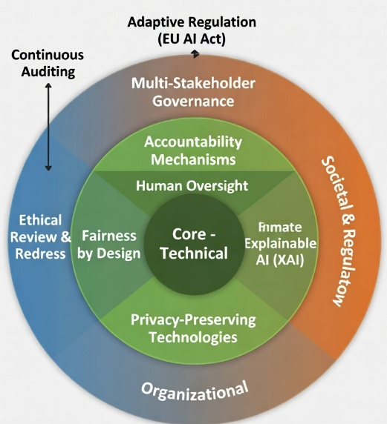
Figure 6: Proposed Multi-Layered Ethical AI Governance Framework

VIII. Conclusion
Ethical challenges in AI decision-making systems—algorithmic bias, lack of transparency, accountability gaps, and privacy erosion—are not incidental flaws but structural characteristics emerging from the interplay between technical design choices and social contexts. Addressing them effectively requires sustained interdisciplinary collaboration among computer scientists, ethicists, policymakers, legal experts, and civil society.
Regulatory initiatives such as the GDPR and EU AI Act mark important progress toward responsible innovation. However, regulation alone is insufficient. Technical advances in fairness-aware learning, explainable AI, and privacy-preserving computation must evolve in tandem with organizational cultural shifts and societal capacity for democratic oversight.
The ultimate goal is not to restrict AI-driven decision-making but to ensure that such decisions are fair, contestable, explainable, and accountable to the individuals and communities they affect. Achieving this vision remains one of the central technological governance challenges of our era.

References
[1] J. Angwin, J. Larson, S. Mattu, and L. Kirchner, “Machine bias,” ProPublica, May 23, 2016.
[2] J. Buolamwini and T. Gebru, “Gender shades: Intersectional accuracy disparities in commercial gender classification,” in Proc. 1st Conf. Fairness, Accountability and Transparency, 2018, pp. 77–91.
[3] A. Jobin, M. Ienca, and E. Vayena, “The global landscape of AI ethics guidelines,” Nat. Mach. Intell., vol. 1, no. 9, pp. 389–399, Sep. 2019.
[4] S. Barocas, M. Hardt, and A. Narayanan, Fairness and Machine Learning: Limitations and Opportunities. MIT Press, 2023.
[5] A. Chouldechova, “Fair prediction with disparate impact: A study of bias in recidivism prediction instruments,” Big Data, vol. 5, no. 2, pp. 153–163, 2017.
[6] J. Kleinberg, S. Mullainathan, and M. Raghavan, “Inherent trade-offs in the fair determination of risk scores,” in Proc. 8th Innovations in Theoretical Computer Science Conf., 2017, pp. 1–23.
[7] B. D. Mittelstadt, P. Allo, M. Taddeo, S. Wachter, and L. Floridi, “The ethics of algorithms: Mapping the debate,” Big Data Soc., vol. 3, no. 2, pp. 1–21, 2016.
[8] European Union, “General Data Protection Regulation (GDPR),” Regulation (EU) 2016/679, Apr. 2016.
[9] M. T. Ribeiro, S. Singh, and C. Guestrin, “‘Why should I trust you?’: Explaining the predictions of any classifier,” in Proc. 22nd ACM SIGKDD Int. Conf. Knowl. Discovery Data Mining, 2016, pp. 1135–1144.
[10] S. M. Lundberg and S.-I. Lee, “A unified approach to interpreting model predictions,” in Proc. 31st Int. Conf. Neural Inf. Process. Syst. (NeurIPS), 2017, pp. 4765–4774.
[11] S. Wachter, B. Mittelstadt, and C. Russell, “Counterfactual explanations without opening the black box: Automated decisions and the GDPR,” Harv. J. Law Technol., vol. 31, no. 2, pp. 841–887, 2018.
[12] S. Zuboff, The Age of Surveillance Capitalism: The Fight for a Human Future at the New Frontier of Power. PublicAffairs, 2019.
[13] European Parliament and Council, “Artificial Intelligence Act,” Regulation (EU) 2024/1689, June 2024.
[14] D. Leslie, “Understanding artificial intelligence ethics and safety,” The Alan Turing Institute, London, UK, Tech. Rep., 2019.
[15] C. Rudin, “Stop explaining black box machine learning models for high stakes decisions and use interpretable models instead,” Nat. Mach. Intell., vol. 1, no. 5, pp. 206–215, 2019.
[16] T. Gebru et al., “Datasheets for datasets,” Commun. ACM, vol. 64, no. 12, pp. 86–92, Dec. 2021.
[17] M. Mitchell et al., “Model cards for model reporting,” in Proc. Conf. Fairness, Accountability, and Transparency (FAT)*, 2019, pp. 220–229.
[18] A. D. Selbst, D. Boyd, S. A. Friedler, S. Venkatasubramanian, and J. Vertesi, “Fairness and abstraction in sociotechnical systems,” in Proc. Conf. Fairness, Accountability, and Transparency (FAT)*, 2019, pp. 59–68.
[19] P. B. de Laat, “The ethics of algorithms: A critical review,” Ethics Inf. Technol., vol. 23, no. 3, pp. 411–425, 2021.
[20] High-Level Expert Group on Artificial Intelligence, “Ethics guidelines for trustworthy AI,” European Commission, Brussels, Apr. 2019.

