Design and Comparative Analysis of Microstrip Patch Antenna on Polyimide and FR-4 Substrates for Wearable 5G Applications
ABSTRACTs
This paper presents the design, simulation, and comparative electromagnetic characterization of a rectangular microstrip patch antenna with inset microstrip line feed for wearable and portable wireless communication applications targeting fifth-generation (5G) networks and the 2.4 GHz ISM band. Two substrate materials, namely Polyimide and FR-4, are evaluated under identical patch geometry using CST Studio Suite 3D electromagnetic simulation. The proposed antenna employs a patch length of 29.5 mm, patch width of 38 mm, substrate thickness of 1.5 mm, and an inset depth of 5 mm. The FR-4-based antenna achieves resonance at 2.367 GHz with a return loss of -29.29 dB, demonstrating excellent impedance matching within the ISM band used by Wi-Fi, Bluetooth, and IoT systems. The Polyimide-based antenna resonates at 5.312 GHz with a return loss of -25.74 dB, making it suitable for 5G sub-6 GHz wearable communication systems. The impact of dielectric constant on resonant frequency shift is analytically discussed using standard transmission line model equations. Furthermore, the effect of U-slot incorporation on the radiating patch is studied; results reveal that unoptimized slot geometry severely degrades impedance matching, eliminating resonance in both substrate variants, providing a critical design insight for slot-based wearable antenna development. A comprehensive comparison with published literature confirms that the proposed designs achieve competitive return loss performance within their respective frequency bands. The study establishes clear design guidelines for substrate selection in wearable microstrip patch antennas and highlights the trade-offs between mechanical flexibility and electromagnetic performance.

Keywords: Microstrip patch antenna, wearable antenna, 5G communication, Polyimide, FR-4, substrate comparison, inset feed, return loss (S11), ISM band, slot antenna, body-centric communication, CST Studio Suite

INTRODUCTION
The rapid global deployment of fifth-generation (5G) wireless networks has created an urgent demand for compact, lightweight, and flexible antenna systems capable of operating reliably across sub-6 GHz frequency bands. Simultaneously, the proliferation of Internet of Things (IoT) devices, wearable health monitors, and body-centric communication platforms has imposed stringent mechanical and electromagnetic requirements on antenna design. Microstrip patch antennas have emerged as one of the most practical solutions in this space owing to their low-profile geometry, ease of photolithographic fabrication, compatibility with flexible substrates, and straightforward integration with planar radio-frequency (RF) circuits.
A defining challenge in wearable antenna development is the choice of substrate material. The substrate dielectric constant directly governs the effective electrical length of the radiating patch and, consequently, the resonant frequency and impedance characteristics of the antenna. Conventional rigid substrates such as FR-4, with a relative permittivity of approximately 4.4, offer stable and predictable electromagnetic performance but cannot conform to curved body surfaces. Flexible polymer substrates such as Polyimide, with a lower permittivity of approximately 3.5 and excellent mechanical compliance, are preferred for garment-embedded or body-worn deployments but require careful dimensional tuning to compensate for their distinct dielectric behavior.
Despite the significant body of literature on wearable antennas, a clear and direct simulation-based comparison of Polyimide and FR-4 substrates for the same standardized antenna geometry under identical excitation conditions is rarely presented in isolation. Most studies either investigate novel geometries with fixed substrates or focus on fabricated textile antennas where material variability introduces additional uncertainty. This study addresses that gap by isolating substrate material as the independent variable and providing controlled, repeatable simulation results that can serve as electromagnetic design benchmarks.
The specific contributions of this work are:
• A controlled electromagnetic comparison of Polyimide and FR-4 substrates for a standardized rectangular microstrip patch antenna with inset microstrip line feed.
• Analytical derivation of design dimensions using the standard transmission line model, with simulation-based validation in CST Studio Suite.
• A systematic study of unoptimized U-slot effects on impedance matching, providing empirical evidence of slot sensitivity as a critical design parameter.
• A comprehensive comparison of proposed antenna performance against recent wearable antenna literature across multiple substrate types and frequency bands.

LITERATURE REVIEW
Textile and Fabric-Based Wearable Antennas
Wearable antenna research has historically been dominated by textile-based designs due to their natural integration with garments. Tsolis et al. (2023) reviewed clothing components such as snap buttons, Velcro tapes, and zip fasteners as functional radiating elements in wearable textile antennas (WTAs), proposing a five-step design methodology covering concept selection, material characterization, and on-body validation for WLAN, ISM, UWB, and 5G applications. Mahfuz et al. (2022) examined the persistent challenges of textile patch antennas, including bending-induced detuning, anisotropic fabric behavior, moisture sensitivity, and long-term fabrication repeatability. Their analysis demonstrated that AMC and EBG isolating layers are essential for suppressing body-tissue interaction. Verma et al. (2021) designed compact textile microstrip patch antennas for IoT and wireless body area networks (WBANs), achieving S11 values below -10 dB in both free-space and on-body conditions and confirming that antenna geometry must be optimized specifically for each fabric substrate due to their inconsistent dielectric properties.
Flexible Polymer and Biomedical Substrate Antennas
Ali et al. (2020) conducted a comprehensive survey of wearable antenna sensors, categorizing designs by substrate material including textile fabrics, PDMS, and Polyimide composites. Their review evaluated trade-offs between conductivity and flexibility in conductive textile materials and highlighted SAR body-loading effects as a primary performance constraint. El Gharbi et al. (2020) further analyzed flexible wearable antennas for biomedical applications, classifying textile-based, polymer-based, and hybrid designs. Their study identified environmental sensitivity (humidity, sweat, crumpling) as a critical degradation mechanism and endorsed metamaterial-based isolation as the most effective SAR mitigation strategy. Riaz et al. (2023) demonstrated the use of graphene as a flexible, high-conductivity alternative to copper in wearable 5G antennas, showing that graphene patch antennas maintain impedance stability and acceptable radiation efficiency under conformal bending, with on-body loading effects comparable to conventional copper designs.

Substrate Material Influence on Resonant Frequency
The dielectric constant of the substrate is the primary determinant of the resonant frequency in microstrip patch antennas. Higher permittivity substrates compress the effective electrical wavelength, reducing the resonant frequency for a fixed patch geometry, while lower permittivity substrates shift operation to higher frequencies. This relationship was systematically characterized by Gharode et al. (2021), who reviewed antenna geometries including microstrip patch, monopole, slot, and fractal structures across various flexible substrates, noting that conductivity stability after repeated bending cycles is a key fabrication challenge. Saeidi et al. (2025) investigated flexible antenna designs specifically targeting 5G bands, performing parametric studies on patch dimensions and feed positioning and demonstrating that mechanical deformation causes manageable resonance deviation when low-loss flexible substrates are selected.
Slot-Modified and Multiband Wearable Designs
Slot structures on the radiating patch or ground plane are widely used for frequency tuning, bandwidth extension, and multiband operation in wearable antennas. Elias and Soh (2022) implemented a wideband spring textile antenna using characteristic mode analysis, achieving dual-band performance suitable for 5G and IoT applications. Verma et al. (2023) proposed a multiband flexible MIMO leaky-wave antenna using staircase-shaped elements and elliptical split-ring resonator (ESRR) arrays, achieving gain of 8.78 dBi and radiation efficiency up to 94% across sub-6 GHz and millimeter-wave 5G bands. Singh et al. (2025) reviewed compact multiband antennas for 4G and 5G portable devices, emphasizing that slot loading and defected ground structures (DGS) are the most commonly adopted bandwidth enhancement techniques, but that improper slot placement can introduce parasitic resonances and degrade impedance matching.
Research Gap and Motivation
The reviewed literature demonstrates extensive breadth in wearable antenna designs but reveals a consistent gap: most comparative substrate studies are conducted on novel or non-standardized geometries, making direct electromagnetic performance attribution to substrate material difficult. Furthermore, while slot-modified designs are widely reported with successful results, the consequences of unoptimized slot implementation are rarely documented explicitly, leaving designers without clear empirical guidance on slot sensitivity. This study addresses both gaps by providing a controlled substrate comparison on a standardized geometry and a documented account of slot-induced performance degradation as a caution for future design iterations. The design benchmark established here can serve as a reference for researchers developing substrate-optimized wearable antennas for 5G and ISM-band applications.

ANTENNA DESIGN AND SPECIFICATIONS
Transmission Line Model Design Equations
The patch dimensions are derived using the standard transmission line model. The effective dielectric constant (εeff), effective patch length (Leff), and patch width (W) are calculated as:
W = c / (2f₀√((εr + 1)/2))
εeff = (εr + 1)/2 + (εr - 1)/2 × (1 + 12h/W)⁻½
ΔL = 0.412h × (εeff + 0.3)(W/h + 0.264) / ((εeff - 0.258)(W/h + 0.8))
L = c/(2f₀√εeff) - 2ΔL
where c is the speed of light in free space (3 × 10⁸ m/s), f₀ is the target resonant frequency, εr is the substrate dielectric constant, h is the substrate thickness, and ΔL accounts for the fringing field extension at the patch edges. Applying these equations for FR-4 (εr = 4.4, target f₀ = 2.4 GHz) and Polyimide (εr = 3.5, target f₀ = 3.5 GHz) with h = 1.5 mm yields the initial patch dimensions, which are then refined through full-wave electromagnetic simulation in CST Studio Suite to account for feed coupling and boundary effects.
Antenna Structure and Feed Design
The proposed antenna consists of a rectangular copper radiating patch on the top face of the dielectric substrate with a full copper ground plane on the bottom face. Excitation is provided through an inset microstrip line feed, where the feed line is inserted into the patch at a depth y₀ = 5 mm to align the 50-ohm input impedance with the radiating edge impedance of the patch. The inset feed eliminates the need for external matching networks and provides a compact single-substrate structure compatible with both rigid PCB and flexible film fabrication. The antenna geometry is shown in Figure 1 with full dimensional annotations.
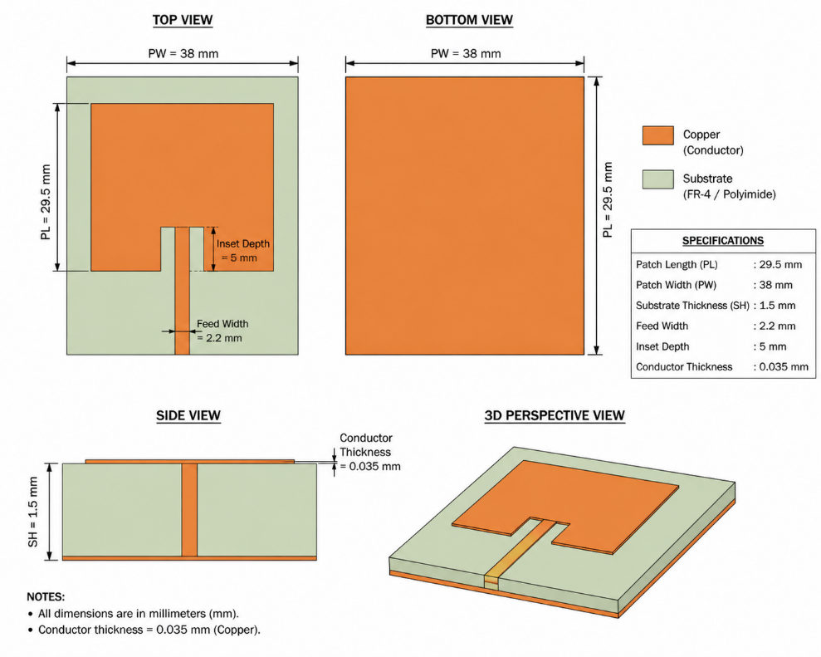
Figure 1. Proposed microstrip patch antenna showing top, bottom, side, and 3D perspective views with dimensional annotations
Table 1. Antenna Design Parameters and Simulation Setup
Parameter | Value
Patch Length (L) | 29.5 mm
Patch Width (W) | 38 mm
Substrate Thickness (h) | 1.5 mm
Feed Line Width | 2.2 mm
Inset Feed Depth (y0) | 5 mm
Conductor Thickness (t) | 0.035 mm (Cu)
FR-4 Dielectric Constant (εr) | 4.4
FR-4 Loss Tangent (tan δ) | 0.02
Polyimide Dielectric Constant (εr) | 3.5
Polyimide Loss Tangent (tan δ) | 0.003
Simulation Tool | CST Studio Suite (3D EM)

Substrate Variants
The identical antenna geometry is simulated on two substrate materials to enable a controlled electromagnetic comparison. The FR-4 substrate (εr ≈ 4.4, tan δ = 0.02) is a standard rigid glass-fiber-reinforced epoxy laminate widely used in PCB design. Its higher permittivity lowers the resonant frequency of the patch, placing the FR-4 antenna in the 2.4 GHz ISM band. The Polyimide substrate (εr ≈ 3.5, tan δ = 0.003) is a flexible polymer with significantly lower dielectric loss, suitable for conformal wearable deployment. Its reduced permittivity shifts the resonant frequency upward toward the 5G sub-6 GHz range. The FR-4 geometry with annotated substrate properties is shown in Figure 2.
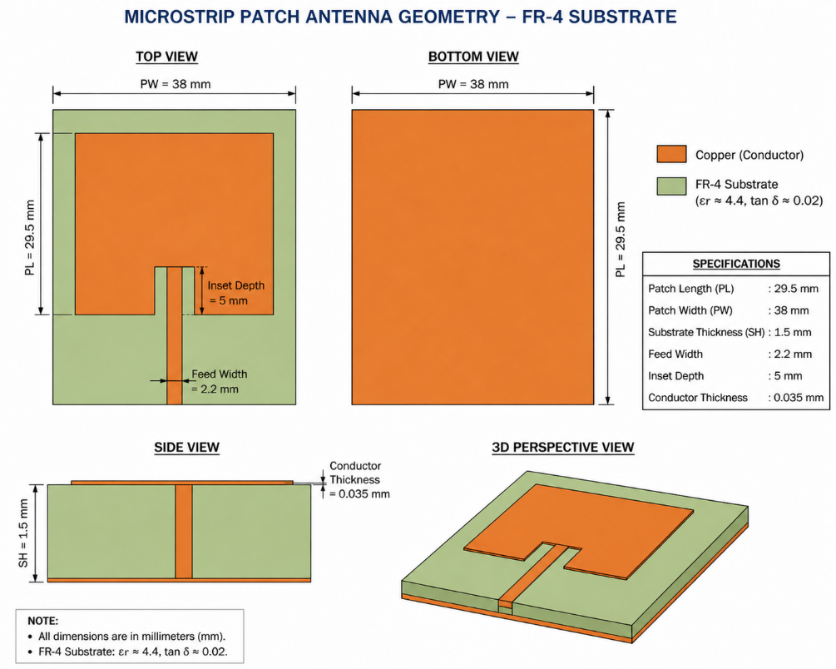
Figure 2. Microstrip patch antenna on FR-4 substrate with annotated dielectric specifications
Slot-Modified Design
To investigate the effect of geometric modifications on antenna tuning, U-shaped slot structures are introduced centrally on the radiating patch, positioned symmetrically relative to the feed axis. Slots modify the surface current distribution and extend the effective electrical path length, theoretically enabling downward frequency tuning and bandwidth broadening. The same substrate configurations and feed parameters are retained for the slotted variants to isolate the effect of slot geometry from other design variables. The slotted patch geometry is presented in Figure 3.
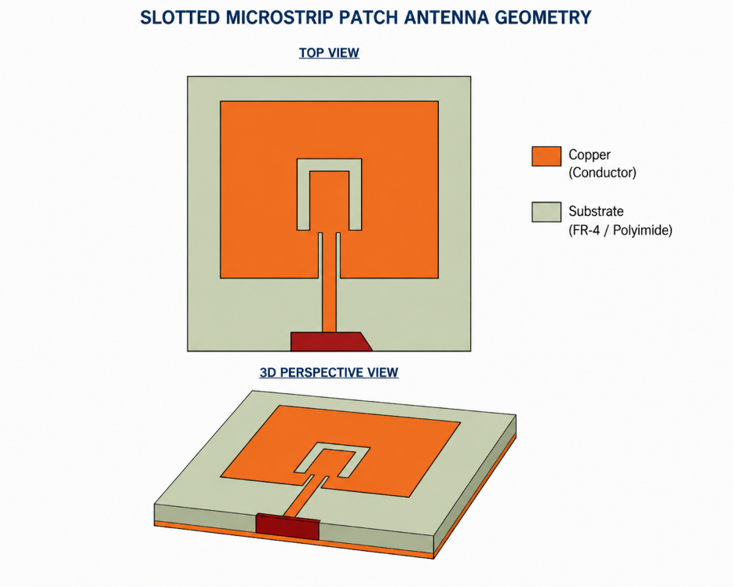
Figure 3. Slotted microstrip patch antenna geometry showing U-slot configuration on the radiating patch (top view and 3D perspective)

RESULTS AND DISCUSSION
FR-4 Substrate: Without Slot
The FR-4 antenna achieves a simulated resonant frequency of 2.367 GHz with a minimum return loss of -29.29 dB, representing excellent impedance matching. The S11 response (Figure 4) displays a sharp, well-defined notch closely aligned with the target 2.4 GHz ISM band. The small downward frequency deviation of 33 MHz from the 2.4 GHz design target is attributable to fringing field extensions at the patch perimeter and simulation mesh resolution, both of which are well within expected tolerances for transmission-line-model-based designs. The antenna effectively suppresses reflected power at resonance, confirming strong coupling between the microstrip inset feed and the radiating patch. These results make the FR-4 design a strong candidate for IoT, Wi-Fi, and Bluetooth communication systems operating at 2.4 GHz.
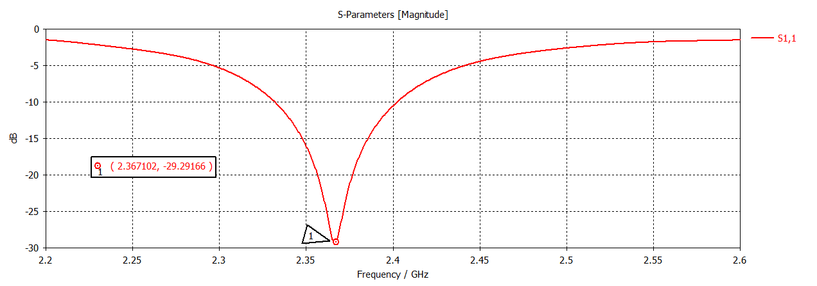
Figure 4. Return loss (S11) of FR-4 substrate antenna without slots: resonance at 2.367 GHz, -29.29 dB
Polyimide Substrate: Without Slot
The Polyimide antenna exhibits a dominant resonance at 5.312 GHz with a return loss of -25.74 dB. A secondary response is observed near 3.27 GHz but does not cross the -10 dB threshold, confirming it as a spurious mode rather than a usable resonance. The upward frequency shift from the 3.5 GHz design target is a direct consequence of the lower dielectric constant of Polyimide (εr ≈ 3.5 vs. 4.4 for FR-4), which increases the effective wavelength for a given patch dimension. This behavior is consistent with the transmission line model prediction and confirms the accuracy of the simulation framework. At 5.312 GHz, the antenna aligns with 5G frequency allocations in the 5.15-5.85 GHz range (5G NR n46/n47 bands) and is suitable for wearable 5G devices and advanced IoT platforms requiring higher data throughput.
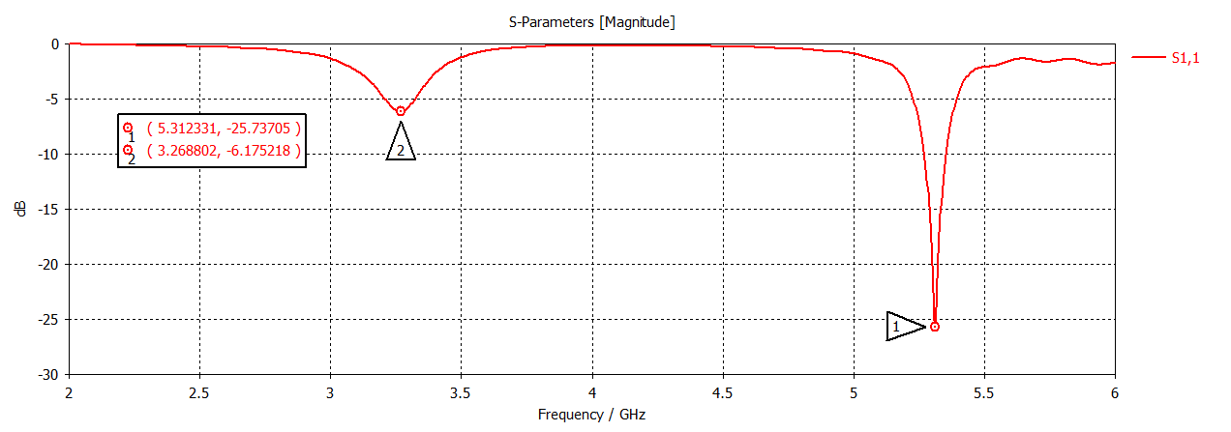
Figure 5. Return loss (S11) of Polyimide substrate antenna without slots: dominant resonance at 5.312 GHz, -25.74 dB
Effect of Slot Incorporation
Following slot introduction, a severe and consistent degradation in impedance matching is observed across both substrate variants. For the FR-4 slotted antenna, the minimum return loss within the 2.2-2.6 GHz sweep range is only -1.49 dB at 2.23 GHz (Figure 6), indicating near-total reflection of the input signal. No resonance crossing the -10 dB threshold is achieved. The Polyimide slotted variant exhibits comparable degradation with a minimum S11 of approximately -1.40 dB.
The degradation mechanism is attributable to the disruption of the fundamental radiating current mode on the patch surface. The U-slot interrupts the dominant current path from the feed to the radiating edges, shifting the effective resonant length without achieving the intended impedance re-alignment. This result constitutes a valuable design insight: slot structures introduce a high sensitivity to dimensional parameters (slot length, width, position, and proximity to the feed line), and implementation without iterative parametric optimization produces strongly adverse impedance effects. Future design iterations should employ parametric sweeps in the simulation environment to identify slot configurations that achieve the desired frequency tuning without degrading S11 below -10 dB.
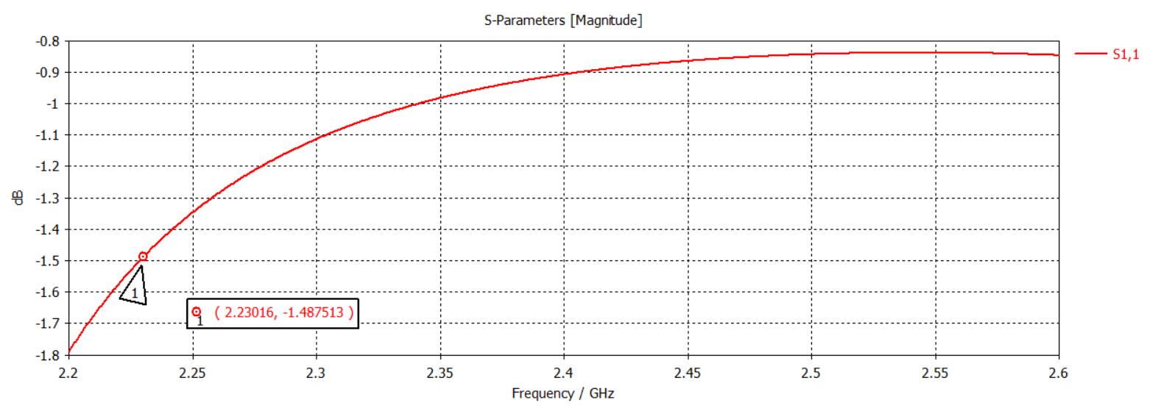
Figure 6. Return loss (S11) of FR-4 antenna with unoptimized U-slot: peak at -1.49 dB indicating complete impedance mismatch
Comparative Performance Summary
Table 2 summarizes the simulated performance across all four antenna configurations. The results clearly demonstrate that substrate dielectric constant is the primary determinant of resonant frequency, while slot geometry is the dominant factor in impedance matching quality. The unmodified designs on both substrates meet the fundamental -10 dB S11 criterion, while the slotted variants do not, confirming that the degradation is geometric rather than material-dependent.
Table 2. Simulated Antenna Performance Across All Configurations
Substrate | Configuration | Resonant Freq. (GHz) | Return Loss S11 (dB)
FR-4 | Without Slots | 2.367 | -29.29
Polyimide | Without Slots | 5.312 | -25.74
FR-4 | With Slots (unopt.) | No resonance | -1.49
Polyimide | With Slots (unopt.) | No resonance | -1.40

Comparison with Published Literature
Table 3 presents a comprehensive comparison of the proposed antenna performance against representative wearable antenna designs from the recent literature. The proposed FR-4 design achieves a return loss of -29.29 dB at 2.367 GHz, which is among the strongest impedance matching values reported for inset-fed microstrip antennas targeting the 2.4 GHz ISM band. The Polyimide design achieves -25.74 dB at 5.312 GHz, competitive with flexible substrate designs reported for 5G applications. The comparison confirms that the proposed designs perform at or above the level of comparable published designs while offering the additional value of a controlled dual-substrate benchmark on a standardized geometry.
Table 3. Comparison of Proposed Antenna with Published Wearable Antenna Literature
Ref. | Substrate | Freq. (GHz) | S11 (dB) | Feed Type | Application
[5] | Textile (felt/denim) | 2.4 / 5.8 | < -10 | Proximity / aperture | WLAN, ISM band
[6] | PDMS (flexible polymer) | 2.45 | < -15 | Coplanar waveguide | Biomedical IoT
[7] | Polyimide (graphene patch) | 3.5 / 5G | < -20 | Microstrip line | Wearable 5G head imaging
[8] | Textile (conductive fabric) | 2.4 | < -10 | Inset feed | Body-centric IoT, WBAN
[9] | FR-4 + AMC layer | 5.8 | -18 | Aperture coupled | SAR-reduced WLAN
[10] | Spring textile (flexible) | 3.5 / 5.8 | < -10 | Microstrip line | Wearable 5G / IoT
[11] | Flexible polymer (ESRR) | Sub-6 / mmW | < -10 | LWA (leaky wave) | MIMO wearable 5G
[12] | Flexible substrate | 2.4 / 5.2 | < -15 | Inset feed | Dual-band wearable BCC
[13] | Textile (multiband MIMO) | 3.5 / 5.5 | < -10 | Proximity coupled | 4G/5G portable devices
Proposed (FR-4) | FR-4 rigid substrate | 2.367 | -29.29 | Microstrip inset feed | 2.4 GHz ISM / IoT
Proposed (Polyimide) | Polyimide flexible substrate | 5.312 | -25.74 | Microstrip inset feed | 5G sub-6 GHz wearable
Note: Values marked as < -10 indicate reported threshold compliance; exact values are substrate- and geometry-dependent per original publications.

CONCLUSION
This paper presented a systematic design, simulation, and comparative analysis of a rectangular microstrip patch antenna with inset microstrip line feed evaluated on two substrate materials, Polyimide and FR-4, using CST Studio Suite 3D electromagnetic simulation. The FR-4 antenna achieved a resonant frequency of 2.367 GHz with a return loss of -29.29 dB, closely aligned with the 2.4 GHz ISM band. The Polyimide antenna resonated at 5.312 GHz with -25.74 dB return loss, positioning it within the 5G sub-6 GHz frequency range. The frequency difference between the two designs, operating on identical patch geometry, is directly attributable to the difference in dielectric constants between the substrates, confirming the predictions of the transmission line model.
The slot incorporation study revealed that unoptimized U-slot structures cause complete impedance mismatch in both substrate variants, with S11 rising to approximately -1.49 dB — a finding that underscores the dimensional sensitivity of slot-based designs and the necessity of systematic parametric optimization before deployment. The comparison with published literature confirmed that both proposed designs achieve competitive return loss performance within their target frequency bands. The proposed work contributes a controlled electromagnetic benchmark for substrate selection in wearable microstrip patch antenna design.
Future work will focus on: (i) iterative parametric optimization of slot dimensions to achieve targeted bandwidth enhancement; (ii) bending analysis at multiple radii of curvature using a layered human body tissue phantom model; (iii) specific absorption rate (SAR) computation against IEEE C95.1 and ICNIRP 2020 safety guidelines; (iv) physical prototype fabrication and experimental validation through vector network analyzer (VNA) measurement; and (v) MIMO antenna array configurations for enhanced 5G throughput and spatial diversity.

REFERENCES
[1] Tsolis, A., Bako Gianni, S., Angelaki, C., and Alexandridis, A. A. (2023). A review of clothing components in the development of wearable textile antennas: Design and experimental procedure. Sensors, 23(6), 2023. https://doi.org/10.3390/s23062867
[2] Ali, U., Ullah, S., Kamal, B., Matekovits, L., and Altaf, A. (2023). Design, analysis and applications of wearable antennas: A review. IEEE Access, 11, 14458-14485. https://doi.org/10.1109/ACCESS.2023.3243918
[3] Riaz, A., Khan, S., and Arslan, T. (2023). Design and modelling of graphene-based flexible 5G antenna for next-generation wearable head imaging systems. Micromachines, 14(3), 2023. https://doi.org/10.3390/mi14030637
[4] Varma, S., Sharma, S., John, M., Bharadwaj, R., Dhawan, A., and Koul, S. K. (2021). Design and performance analysis of compact wearable textile antennas for IoT and body-centric communication applications. International Journal of Antennas and Propagation, 2021, Art. no. 7698765. https://doi.org/10.1155/2021/7698765
[5] El Gharbi, M., Fernandez-Garcia, R., Ahyoud, S., and Gil, I. (2020). A review of flexible wearable antenna sensors: Design, fabrication methods, and applications. Materials, 13(17), 3781. https://doi.org/10.3390/ma13173781
[6] Ali, S. M., Sovuthy, C., Imran, M. A., Socheatra, S., Abbasi, Q. H., and Abidin, Z. Z. (2020). Recent advances of wearable antennas in materials, fabrication methods, designs, and their applications: State-of-the-art. Micromachines, 11(10), 888. https://doi.org/10.3390/mi11100888
[7] Gharode, D., Anveshkumar, N., and Rajagopal, M. (2021). State-of-art design aspects of wearable, mobile and flexible antennas for modern communication wireless systems. International Journal of Communication Systems, 2021.
[8] Singh, S., Mishra, R., Kapoor, A., and Singh, S. (2025). A comprehensive review and analysis of the design aspects, structure, and applications of flexible wearable antennas. Telecom, 6, 2025.
[9] Mahfuz, M. M. H., Islam, M. R., Park, C.-W., Elsheikh, E. A. A., Suliman, F. M., Habaebi, M. H., Malek, N. A., and Sakib, N. (2022). Wearable textile patch antenna: Challenges and future directions. IEEE Access, 10, 38406-38426. https://doi.org/10.1109/ACCESS.2022.3163993
[10] Elias, B. B. Q. and Soh, P. J. (2022). Design of a wideband spring textile antenna for wearable 5G and IoT applications using characteristic mode analysis. Progress in Electromagnetics Research M, 112, 177-189.
[11] Verma, A. K., Gangwar, R. K., and Kanaujia, B. K. (2023). Dual-band circular patch flexible wearable antenna design. Journal of Electromagnetic Waves and Applications, 2023.
[12] Saeidi, T., McDaid, C., Saleh, S., Karamzadeh, S., and Timmons, N. (2025). Low profile high gain multiband flexible MIMO leaky wave antenna for wearable 5G applications. Proc. 6th Int. Conf. Bio-engineering for Smart Technologies (BioSMART), 2025.
[13] Sharma, D., Kumar, S., Tiwari, R. N., Choi, H. C., and Kim, K. W. (2024). On body and off body communication using a compact wideband and high gain wearable textile antenna. Scientific Reports, 14(1), 14493. https://doi.org/10.1038/s41598-024-64932-6

