Decentralized AI for Cyber Defense: A Multi-Agent System for Advanced Persistent Threat Detection and Response
Abstract
Advanced Persistent Threats (APTs) represent a critical and escalating challenge in cybersecurity, characterized by multi-stage execution, extended dwell times exceeding 200 days, and systematic evasion of conventional detection mechanisms. Traditional centralized Security Information and Event Management (SIEM) architectures have proven increasingly insufficient due to operational bottlenecks, high false-positive rates, and latency constraints under heterogeneous, high-volume telemetry conditions. This paper proposes a Distributed Artificial Intelligence (DAI)-enabled multi-agent system (MAS) for APT detection and automated response. The architecture comprises four specialized agents a Network Sentinel Agent (NSA), Host Intelligence Agent (HIA), Threat Correlation Agent (TCA), and Response Orchestration Agent (ROA) each assigned complementary functions spanning network anomaly detection, endpoint monitoring, cross-source campaign correlation, and automated containment. Agent coordination is facilitated through an asynchronous publish-subscribe message bus, a blockchain-secured shared threat ledger, and STIX 2.1-standardized intelligence exchange. Decision-making integrates unsupervised machine learning, reinforcement learning, belief–desire–intention (BDI) reasoning, and Markov decision processes to support adaptive, context-aware responses. The system is evaluated against defined performance criteria, including a target detection rate of ≥90%, mean time to detect of under 60 seconds for network-level indicators, and automated response within 30 seconds of a high-confidence alert. Technical vulnerabilities, ethical concerns, and governance requirements, including federated learning with differential privacy and explainable AI audit mechanisms, are addressed as first-class design constraints. Future directions include quantum-enhanced correlation, self-healing agent networks, and cross-sector federated intelligence sharing.
Keywords: Advanced Persistent Threats, Distributed Artificial Intelligence, Multi-Agent Systems, Cyber Defense, Anomaly Detection, Automated Response

INTRODUCTION
Advanced Persistent Threats (APTs) are recognized as a very significant concern in cybersecurity due to the level of their sustained operations, sophisticated procedures, and goal-driven target approach, all of which are on the rise as artificial intelligence provides a boost to their operational abilities. APT activity is typically distinguishable from conventional malware campaigns because objectives are strategic rather than opportunistic, and because execution is commonly performed by well-resourced and organized actors. APT campaigns are often multi-stage attacks specifically directed at organizations with the aim of achieving outcomes such as the unauthorized acquisition of sensitive information and/or disruption of critical operations within an organization.
Distributed Artificial Intelligence (DAI) and Multi-Agent Systems (MAS) have been proposed as viable approaches for addressing APT-related detection and response constraints, particularly constraints associated with scale, telemetry heterogeneity, and the requirement for coordinated action across multiple security surfaces. In this paper, a DAI-enabled multi-agent architecture is proposed for APT detection and response. The architecture proposed is designed and organized around specialized agent functions, including a Network Sentinel Agent, a Threat Correlation Agent, a Host Intelligence Agent, and a Response Orchestration Agent. The performance of this system is evaluated using a defined set of criteria, while the design is examined with respect to the operational risks, implementation limitations, and future research directions of APT threats within the cyber-defense industry.
Domain and Problem Definition
- Cyber Defense as the Domain
The cyber defense sector functions under an evolving threat landscape that is characterized by heterogeneous attack types as well as an increasing adversarial sophistication. Conventional threats which include but not limited to Distributed Denial of Service (DDoS), phishing, and malware, have remained persistent, while advanced persistent threats (APTs) and artificial intelligence (AI)-enabled attacks have been reported with increasing prevalence and operational impact (Omar, 2025). The current scope of exposure in the cybersecurity industry has been described as a broad attack landscape in which effects are not limited to local organizational compromise; rather, attack vectors have been associated with cascading impacts on national security, continuity of critical infrastructure, and individual privacy at global scale (Obi et al., 2024).
In the United States, elevated risk has been associated with extensive reliance on interconnected digital systems, under which cyber espionage and nation-state campaigns have been identified as salient threat drivers (Olafuyi, 2023). Under these conditions, conventional controls commonly used for mitigation of advanced persistent threats have been argued to be increasingly insufficient for timely detection and effective response. As a result, emerging analytic approaches, including machine learning and artificial intelligence (AI), have been positioned as necessary enablers of modern detection and response capability (CIUCHI, 2024).
Characteristics of Advanced Persistent Threat Campaigns
Advanced persistent threats for a while have always been treated as a distributed detection and response problem, and this is mainly due to the multi-stage progression, extended dwell time, and systematic evasion of the conventional threat monitoring systems put in place to safeguard against such attacks Bi et al., 2021). The initial access point of these attacks has often times been achieved through vulnerability exploitation or credential abuse, after which lateral movement of the attack malware is then used to expand privilege with the aim of reaching a high-value assets. This phase has been characterized as difficult to detect because activity is frequently low-signal and compatible with normal administrative behavior. As a result, signature-based intrusion detection systems (IDS) are often less effective, and increased reliance has been placed on endpoint detection and response (EDR), machine learning methods, and graph-oriented detection strategies (Smiliotopoulos et al., 2024).
The extended dwell time that has been reported is a defining operational feature, which averages over 200 days in some observations, thereby enabling objectives to be pursued while remaining undetected (Lajevardi & Amini, 2021). This persistence has been supported by “low-and-slow” patterns that exploit short-window monitoring assumptions and alert-fatigue constraints. Evasion has also been strengthened through techniques such as code injection and the use of trusted components to conceal malicious actions from signature-based tools (Lajevardi & Amini, 2021).
Rationale for Distributed Artificial Intelligence as an Architectural Response
The distributed and multi-vector structure of advanced persistent threat activity has been used to motivate a shift away from exclusively centralized Security Information and Event Management (SIEM) architectures toward distributed intelligence frameworks. Centralized SIEM deployments have been associated with operational bottlenecks, single points of failure, and latency constraints, which can reduce responsiveness under high-volume and high-variance telemetry conditions. High false-positive and false-negative rates have also been reported as persistent limitations, resulting in alert overload or missed detections (Khayat et al., 2024).
In contrast, the application of Distributed Artificial Intelligence (DAI) to advanced persistent threat detection and response has been positioned as an architectural response that supports local autonomy, resilience, and parallel processing across multiple sensing and decision nodes. End-to-edge-to-cloud computing has been described as enabling heterogeneous resource orchestration for distributed AI workloads, thereby improving detection and response capacity under real-time constraints (Duan et al., 2023).
System Design
- Multi-Agent Architecture Overview
Specialized agent collaboration is used to cover the detection-to-response lifecycle. The Network Sentinel Agent (NSA), Host Intelligence Agent (HIA), Threat Correlation Agent (TCA), and Response Orchestration Agent (ROA) are assigned complementary functions. Coverage is extended across network telemetry, endpoint telemetry, cross-source correlation, and automated response execution. Limitations of static, rule-based detection are addressed through learning-based and correlation-based methods. Large language models and multi-agent coordination are treated as mechanisms for improved semantic interpretation and cross-domain visibility for complex patterns such as spear-phishing and APT campaigns.
- Agent Roles and Responsibilities
- Network Sentinel Agent (NSA)
The NSA Agent performs real-time network traffic monitoring and anomaly detection using unsupervised machine learning methods, including isolation forests and autoencoders. These techniques are applied to identify deviations from baseline behavior. The detection of reconnaissance and command-and-control indicators is supported through these methods. The Improvements in detection accuracy and the reductions in false positives have been reported under adaptive modeling approaches (Sharma & Grover, 2024; Gunnam, 2023).
- Host Intelligence Agent (HIA)
Endpoint-level monitoring is performed by the HIA. This agent apply the signature-based rules which are combined with reinforcement learning to enable adaptive re-weighting of threat indicators based on observed patterns. Hybrid reinforcement learning has been described as enabling dynamic adaptation to emerging threats through methods such as Deep Q-Networks and Proximal Policy Optimization (Ishaque et al., 2023).
- Threat Correlation Agent (TCA)
Alert aggregation and multi-stage campaign correlation are performed by the TCA. Alerts produced by NSA and HIA are correlated and represented using graph-based reasoning to identify attack chains. Situational awareness is supported through model-based correlation and knowledge-base construction under heterogeneous data conditions. Multi-stage campaign detection has been treated as essential in environments such as industrial control systems where coordinated steps are executed (Sen et al., 2022).
- Response Orchestration Agent (ROA)
Automated responses to high-confidence alerts are executed by the ROA. Markov decision processes are utilized to balance containment speed against business disruption risk. Probabilistic modeling of attacker and system dynamics is enabled under this approach. Improved long-horizon response optimization has been reported relative to short-term reactive measures (Iannucci & Abdelwahed, 2018).

Figure 1: Agent DAI Architecture

Environment Characteristics (PEAS Framework)
- NSA — PEAS
- Performance: anomalous-traffic detection rate; false-positive rate; alert generation latency
- Environment: live network traffic streams; dynamic; partially observable; adversarial
- Actuators: alert publishing to message bus; logging to shared threat ledger; triggering full packet capture
- Sensors: NetFlow/IPFIX collectors; deep packet inspection probes; firewall and IDS log feeds
- HIA — PEAS
- Performance: host anomaly detection rate; process-level false-positive rate; indicator publication latency to TCA
- Environment: endpoint operating environment; partially observable; dynamic; adversarial
- Actuators: STIX indicator publishing; local process termination; alert escalation to TCA; forensic log capture
- Sensors: process execution logs; file integrity monitoring; registry events; authentication/behavior logs; EDR telemetry
- TCA — PEAS
- Performance: multi-stage identification accuracy; confidence score precision; ATT&CK mapping coverage
- Environment: alert stream inputs; episodic at alert level; sequential at campaign level; competitive/adaptive
- Actuators: knowledge graph updates; confidence scoring outputs; dispatch to ROA
- Sensors: publish-subscribe alerts; MITRE ATT&CK knowledge base; blockchain-stored threat intelligence
- ROA — PEAS
- Performance: MTTR; containment success rate; disruption rate from false isolations
- Environment: enterprise IT environment; dynamic; partially observable; sequential decision effects
- Actuators: firewall APIs; endpoint isolation tools; IAM suspension commands; ticketing integrations
- Sensors: high-confidence alerts; asset inventory; business-criticality scoring
Communication and Coordination Strategy
An asynchronous publish-subscribe message bus is used for real-time telemetry exchange between agents. High-throughput dissemination is supported under decoupled one-to-many communication requirements (Zhang et al., 2024). A blockchain-secured shared threat ledger is used for tamper-evident storage of shared intelligence. Integrity, traceability, and trust are supported through immutability properties (Wang et al., 2024). Structured Threat Information Expression (STIX) 2.1 is used for standardized indicator exchange to support interoperability and automated sharing (Li et al., 2023). The Byzantine Fault Tolerance (PBFT) technique is applied when distributed agreement is required under disagreement conditions, this is because Low-latency, high-throughput consensus under Byzantine faults is supported by PBFT in permissioned environments (Li et al., 2021).
Planning and Decision-Making Approaches
- Individual Agent Methods
A two-layer agent design is applied. A reactive layer is used for near-instant event decisions using predefined rules and lightweight classifiers. A deliberative layer is used for higher-level reasoning using a Belief–Desire–Intention (BDI) architecture. Dynamic world-model updates are supported as new evidence is received. Autonomy and reasoning under uncertainty are supported under this approach (Traldi et al., 2022; Karaduman et al., 2023). Fuzzy logic integration is used to manage uncertainty in real time (Karaduman et al., 2023).
- Collaborative Methods
Sequential response optimization is performed using an MDP within the ROA. Strategy adjustment is executed as system state evolves (Villegas-Ch et al., 2025). Consensus is applied when agent assessments of conflict, using PBFT as the conflict-resolution mechanism. Throughput and confirmation latency improvements have been reported when consensus difficulty and validator selection are adaptively adjusted under reinforcement learning enhancements (Villegas-Ch et al., 2025). Shared belief-state exchange can be supported using partially observable Markov decision processes to improve coordination (Wang, 2022).
Evaluation Criteria
- Performance Metrics
- Detection accuracy: true positive rate ≥ 90%; false positive rate ≤ 5% (benchmarked against DARPA Transparent Computing or MITRE ATT&CK evaluation datasets)
- MTTD: < 60 seconds for network-level indicators; < 5 minutes for correlated multi-stage campaigns
- MTTR: automated response within 30 seconds of high-confidence TCA alert
- Resilience: performance degradation under simulated agent failure, partitions, and adversarial evasion
- Scalability: throughput (events/sec/agent) and accuracy from 100 to 10,000 endpoints
Testbed and Simulation Methods
A MESA Python agent-based simulation is used to evaluate DAI-based APT detection and response. The scheduling of agents, graph-based topology representation, and data collection modules are utilized to model network traffic and agent interactions(Xuan & Nguyen, 2024). Using this simulation approach, adversarial agents are configured to inject scripted scenarios based on MITRE ATT&CK tactics and techniques, which enables the emulation of realistic APT behaviors (Ajmal et al., 2022). Comparative evaluation is performed between the four-agent DAI system and a baseline centralized SIEM system (Choi et al., 2021).
Figure 2. Testbeds Simulation
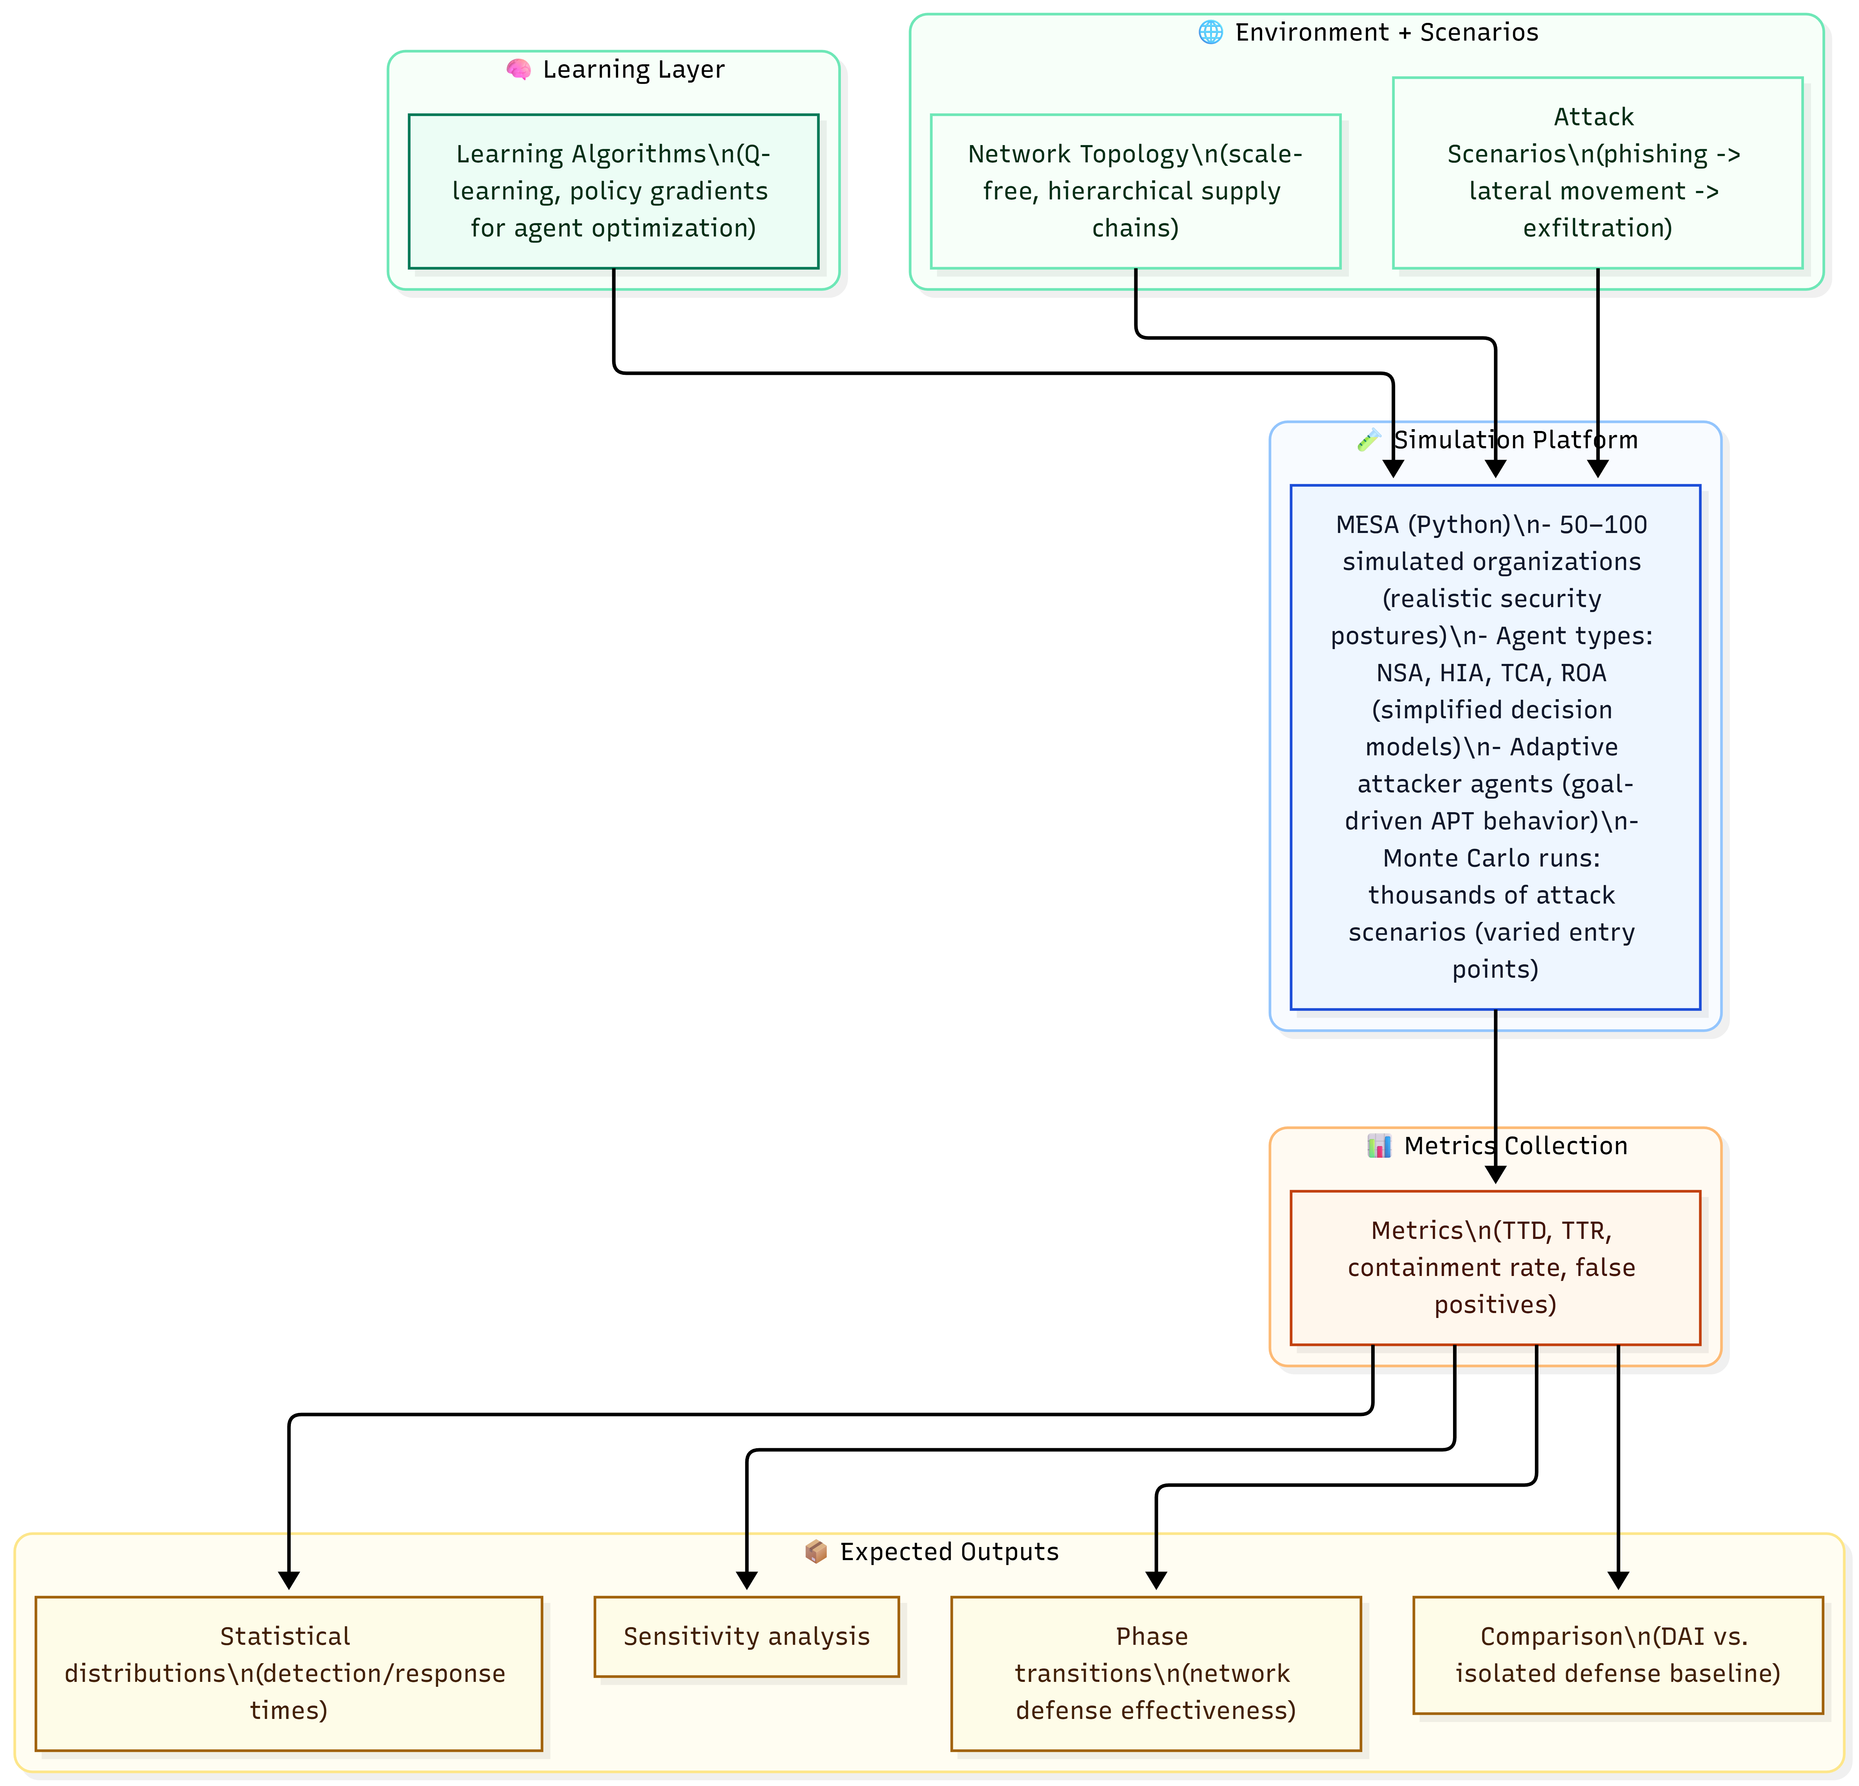
Risk, Security, and Ethical Implications
- Technical Vulnerabilities
- Synchronization failures: Vulnerabilities such as state inconsistency under partitions; consensus deadlock during mass attacks; clock manipulation affecting correlation are some technical lapses that could be expected with this DAI system
- Data integrity attacks: The poisoning of data ledgers; model inversion by threat actors exposing training signals; majority attack undermining tamper-evidence assumptions
- Agent compromise: impersonation via credential theft; covert exfiltration via message bus; adaptive evasion of detection models
- Availability threats: DDoS against message bus; cascading failure under TCA outage; resource exhaustion against individual agents
- Ethical and Privacy Concerns
- Bias risks are introduced when training data over-represents specific network profiles, producing inconsistent enforcement outcomes.
- Transparency limitations are introduced when automated ROA actions (lockout/isolation) are executed with significant operational consequences.
- Regulatory implications are introduced when automated decisions affect individuals under privacy and governance regimes.
- Proposed Safeguards
- Federated Learning with Differential Privacy
Local model training is performed per agent. Only model updates are shared. Raw telemetry is not shared. Differential privacy noise injection is applied to updates before aggregation. Reverse-engineering risk is reduced. Poisoning attack surfaces are reduced through constrained sharing.
- Explainable AI Audit Layer
High-confidence TCA alerts and automated ROA actions are accompanied by explanation artifacts would provide more information on the action carried out by the agents, as well as detail on the reasoning and decision making. Feature contribution summaries (e.g., LIME/SHAP outputs) are logged with mapped ATT&CK techniques. Also, a tamper-evident audit trail is maintained for analyst review, compliance support, and continuous improvement of the entire system.
Future Vision
- Quantum-enhanced correlation is explored for accelerated campaign attribution under large-scale graphs.
- Self-healing agent networks are explored for compromise detection, quarantine, and verified restoration.
- LLM augmentation is explored for threat report generation and cross-organization intelligence exchange.
- Autonomous deception is explored through coordinated honeypots and moving-target defense.
Cross-sector federated coalitions are explored for collective defense through distributed intelligence sharing.
Conclusion
Advance Persistent Threats are treated as a sophisticated, long-term cyberattacks that does challenge conventional detection due to their stealth, persistence, and multi-stage execution approach. The reliance on traditional controls such as firewalls and signature-oriented intrusion detection are often insufficient for timely detection and coordinated response. A DAI-enabled multi-agent architecture as proposed in this paper to distribute sensing, correlation, and response functions across NSA, HIA, TCA, and ROA components. The AI-driven anomaly detection, correlation reasoning, and automated response are integrated together to improve detection speed and response effectiveness while reducing analyst burden. Governance requirements are treated as design constraints. Explainability, privacy protection, robustness against adversarial manipulation, and accountability mechanisms are required for operational deployment.

References
Ajmal, A. B., Khan, S., Alam, M., Mehbodniya, A., Webber, J., & Waheed, A. (2023). Towards Effective Evaluation of Cyber Defense: Threat Based Adversary Emulation Approach. IEEE Access, 1. https://doi.org/10.1109/access.2023.3272629
Alhakami, W. (2024). Evaluating modern intrusion detection methods in the face of Gen V multi-vector attacks with fuzzy AHP-TOPSIS. PLOS ONE, 19. https://doi.org/10.1371/journal.pone.0302559
Bi, J., He, S., Luo, F., Meng, W., Ji, L., & Huang, D.-W. (2022). Defense of Advanced Persistent Threat on Industrial Internet of Things with Lateral Movement Modelling. IEEE Transactions on Industrial Informatics, 1–11. https://doi.org/10.1109/tii.2022.3231406
Choi, S., Yun, J.-H., & Min, B.-G. (2021). Probabilistic Attack Sequence Generation and Execution Based on MITRE ATT&CK for ICS Datasets. USENIX Security Symposium, 41–48. https://doi.org/10.1145/3474718.3474722
Ciuchi, C. (2024). Operationalizing the Cyber Threat Landscape: Key Considerations and Challenges in Developing a Specific Organizational Program. 61–68. https://doi.org/10.19107/cybercon.2024.08
Coppolino, L., D’Antonio, S., Nardone, R., & Romano, L. (2023). A self-adaptation-based approach to resilience improvement of complex internets of utility systems. Environment Systems and Decisions, 43, 708–720. https://doi.org/10.1007/s10669-023-09937-8
Duan, S., Wang, D., Ren, J., Lyu, F., Zhang, Y., Wu, H., & Shen, X. (2023). Distributed Artificial Intelligence empowered by end-edge-cloud computing: A survey. IEEE Communications Surveys &amp; Tutorials, 25(1), 591–624. https://doi.org/10.1109/comst.2022.3218527
González-Santamarta, M. Á., Rodríguez-Lera, F. J., Fernández, C., & Matellán Olivera, V. (2024). A Hybrid Cognitive Architecture to Generate, Control, Plan, and Monitor Behaviors for Interactive Autonomous Robots. International Journal of Social Robotics. https://doi.org/10.1007/s12369-024-01192-4
Gunnam, V. (2023). Detecting cyber threats in real-time: a novel autoencoder framework for network anomaly detection. https://doi.org/10.36676/jrps.v14.i5.1603
Hmimou, Y., Tabaa, M., Khiat, A., & Hidila, Z. (2025). A Multi-Agent System for Cybersecurity Threat Detection and Correlation using Large Language Models. IEEE Access, 1. https://doi.org/10.1109/access.2025.3602681
Ishaque, M., Md Johar, M. G., Khatibi, A., & Yamin, M. (2024). Dynamic Adaptive Intrusion Detection System Using Hybrid Reinforcement Learning (pp. 245–253). Springer International Publishing. https://doi.org/10.1007/978-3-031-55911-2_23
Karaduman, B., Tezel, B. T., & Challenger, M. (2023). On the impact of fuzzy-logic based BDI agent model for cyber-physical systems. Expert Systems With Applications. https://doi.org/10.1016/j.eswa.2023.122265
Khayat, M., Barka, E., Serhani, M. A., Sallabi, F., Shuaib, K., & Khater, H. M. (2025). Advanced Techniques for Alert Management in Security Information and Event Management Systems With Ensembled Deep Learning, Hybrid Optimization, and Multi-feature Extraction. IEEE Open Journal of the Communications Society, 1. https://doi.org/10.1109/ojcoms.2025.3603000
Iannucci, S., & Abdelwahed, S. (2018). Model-Based Response Planning Strategies for Autonomic Intrusion Protection. ACM Transactions on Autonomous and Adaptive Systems, 13(1), 4. https://doi.org/10.1145/3168446
Li, W., Stidsen, C. T., & Adam, T. (2023). A blockchain-assisted security management framework for collaborative intrusion detection in smart cities. Computers & Electrical Engineering, 111, 108884. https://doi.org/10.1016/j.compeleceng.2023.108884
Mohammadzade Lajevardi, A., & Amini, M. (2021). Big knowledge-based semantic correlation for detecting slow and low-level advanced persistent threats. Journal of Big Data, 8(1), 1–40. https://doi.org/10.1186/S40537-021-00532-9
Moothedath, S., Sahabandu, D., Allen, J., Clark, A., Bushnell, L., Lee, W., & Poovendran, R. (2024). Dynamic Information Flow Tracking for Detection of Advanced Persistent Threats: A Stochastic Game Approach. IEEE Transactions on Automatic Control, 1–16. https://doi.org/10.1109/tac.2024.3403675
Obi, O. C., Akagha, O. V., Dawodu, S. O., Anyanwu, A. C., Onwusinkwue, S., & Ahmad, I. A. I. (2024). Comprehensive review on cybersecurity: modern threats and advanced defense strategies. https://doi.org/10.51594/csitrj.v5i2.758
Omar, M. (2025). Evolving Cyber Threats: Understanding the New Battlefield. 23–50. https://doi.org/10.1002/9781394340750.ch2
Sen, Ö., Eze, C. G., Ulbig, A., & Monti, A. (2022). On Holistic Multi-Step Cyberattack Detection via a Graph-based Correlation Approach. IEEE International Conference on Smart Grid Communications, 380–386. https://doi.org/10.1109/SmartGridComm52983.2022.9961016
Sharma, R., & Grover, M. (2024). Enhancing Cybersecurity with Machine Learning: Evaluating the Efficacy of Isolation Forests and Autoencoders in Anomaly Detection. 11, 1017–1021. https://doi.org/10.1109/iccpct61902.2024.10673338
Smiliotopoulos, C., Kambourakis, G., & Kolias, C. (2024). Detecting Lateral Movement: A Systematic Survey. Heliyon. https://doi.org/10.1016/j.heliyon.2024.e26317
Traldi, A., Bruschetti, F., Robol, M., Roveri, M., & Giorgini, P. (2022). Real-Time BDI Agents: a model and its implementation. International Joint Conference on Artificial Intelligence, 511–517. https://doi.org/10.48550/arXiv.2205.00979
Wang, Y. (2022). Blockchain: A potential technology to improve the performance of collaborative emergency management with multi-agent participation. International Journal of Disaster Risk Reduction, 72, 102867. https://doi.org/10.1016/j.ijdrr.2022.102867
Wang, M., Zhu, T., Zuo, X., Ye, D., Yu, S., & Zhou, W. (2024). Blockchain-empowered multiagent systems: Advancing IOT security and transaction efficiency. IEEE Internet of Things Journal, 11(7), 11217–11231. https://doi.org/10.1109/jiot.2023.3329961
Xuan, C. D., & Nguyen, T. T. (2024). A novel approach for APT attack detection based on an advanced computing. Dental Science Reports, 14(1). https://doi.org/10.1038/s41598-024-72957-0
Zhang, B., Gao, Y., Kuang, B., Yu, C., Fu, A., & Susilo, W. (2024). A Survey on Advanced Persistent Threat Detection: A Unified Framework, Challenges, and Countermeasures. ACM Computing Surveys. https://doi.org/10.1145/3700749

