DESIGNING A FIXED ASSET INVENTORY WEBSITE AT SMAN 1 BANTARAN

ABSTRACT
The development of information technology is increasingly rapid and has undergone many changes in several fields, including in the field of education. Education plays an important role in the development of the quality of human resources. Schools are educational institutions as a place for educational activities, not only that schools are also required to be able to manage school inventory. An inventory is a list or record that contains all the belongings belonging to an organization or company that are used to support operational activities. Inventory is very important to be made by an organization or institution in order to change the collection of data or the existence of goods in the organization or institution. [1], [2] [2]
By:
Luridza Ladzilla Ikhwana (Nim:24132515)
D-3 Information Systems Study Program
Academy of Informatics and Computer Management Cadets
Email: luridzal@gmail.com

Table of Contents
FOREWORD 5
BAB I 11
INTRODUCTION 11
1.1 Background 11
1.2 Problem Formulation 12
1.3 Research Objectives 12
1.4 Research Benefits 12
BAB II 13
DISCUSSION 13
2.1 Relevant Research 13
2.2Literature Review 13
2.2.2 Fixed Assets 14
2.2.3 Aset Inventory System 14
2.2.4 Database 14
2.2.5 Supporting Technologies 14
BAB III 15
RESEARCH METHODS 15
3.1 Research Framework 15
3.2 Development Model 15
3.2 Data collection techniques 18
BAB IV 24
Results 24
4.1 Planning 24
Bibliography 30

CHAPTER I

INTRODUCTION

1.1 Background
The development of information technology is increasingly rapid and has undergone many changes in several fields, including in the field of education. Education plays an important role in the development of the quality of human resources. Schools are educational institutions as a place for educational activities, not only that schools are also required to be able to manage school inventory. An inventory is a list or record that contains all the belongings belonging to an organization or company that are used to support operational activities. Inventory is very important to be made by an organization or institution in order to change the collection of data or the existence of goods in the organization or institution. [1],[2] . [2]
However, in reality, there are still many schools that record inventory manually, as happened at SMAN 1 Bantaran. To ensure that Inventory can be used to its fullest, good and structured inventory management is required. The inventory includes all equipment, supplies, practicum materials, and supporting facilities that the laboratory has. With a good inventory system, schools can find out the condition and amount of equipment available, monitor the use of tools, and plan the procurement or maintenance of tools in a timely manner.
At SMAN 1 Bantaran, Inventory should be important, especially in collecting data on goods or equipment owned by the agency so that there is no loss or damage to goods. However, SMAN 1 Bantaran does not have an accurate inventory so that the condition and whereabouts of goods are not recorded, such as damaged tools, lack of goods or tools, improper recording, or the absence of a consistent monitoring system.
Therefore, it is important for schools to conduct periodic evaluations and reviews of the condition of their inventory. This evaluation aims to find out the extent of the readiness of goods or tools to support the learning process, as well as to identify problems and find the right solutions. With effective and efficient inventory management,
Based on this description, the author compiled this paper with the aim of examining more deeply the condition of inventory at SMAN 1 Bantaran, including the type of available space, the completeness of tools and materials, and its management system. It is hoped that this paper can be a source of useful information and input for schools in an effort to improve the quality of education through optimizing the inventory function. [3]

Problem Formulation
- What is the inventory management process at SMAN 1 Bantaran so that there are no damaged tools, a shortage of goods or tools, and untidy recording?
- What are the benefits of having an inventory at SMAN 1Bantaran.

Research Objectives
      - To facilitate the inventory processing process at SMAN 1 Bantaran so that there is no damage to goods or loss of goods.
- With a good inventory system, schools can find out the condition and amount of equipment available, monitor the use of tools,

1.4 Research Benefits
1. Simplify the inventory processing process
2. Narrowing the likelihood of losing goods

CHAPTER II

LITERATURE REVIEW

Relevant Research
Some of the research relevant to the topics I discussed include:
            - This research on fixed asset inventory will use the concept of a web-based system to improve the efficiency of the fixed asset processing process.
            - Other research also mentions that inventory systems can help minimize recording errors and speed up the reporting process. [4]

Literature Review

2.2.1 Education
Formal education is a structured education path in schools with a standard curriculum and an official diploma. In contrast, non-formal education is a pathway outside of formal systems, such as courses or training, that is more flexible, skill-focused, and tailored to learners' needs

2.2.2 Inventory
Inventory is a list or record that contains all goods, assets, or resources owned by an organization, company, or agency, which are used for operational activities and support the smooth running of its activities. This inventory includes all types of tools, materials, supplies, and facilities. [2]
In general, inventory also functions as a list of goods, but also records various important information such as the name of the item, specifications, quantity, condition (good, slightly damaged, severely damaged). storage location, date of acquisition, and last use. The main purpose of this inventory is to ensure that all equipment is available in sufficient quantities, is in a suitable condition for use, and is used and stored in accordance with applicable procedures. [5]
Inventory has a very important role in supporting the smooth learning process. With a well-organized inventory, learning activities can run more safely, orderly, and efficiently. In addition, the inventory also makes it easier for schools to evaluate needs, procure new equipment, and report to related parties such as the education office or school committees.
In other words, laboratory inventory is not just a record of goods, but an important part of the management of educational facilities and infrastructure that directly contributes to the quality and quality of learning in schools.

2.2.3 Fixed Assets
Fixed assets are very important resources for individuals and the organizations that own them, because they are tools that support activities in an organization and are also useful for achieving a goal. Fixed assets in SMAN 1 Bantaran are goods or tools that are available to support the smooth learning process. Without fixed assets, the learning process will be hampered due to the lack of goods or tools needed during the learning proposal. [6]

2.2.4 Aset Inventory System
An asset inventory system is a system that will be used to record, manage, and also monitor assets in a structured manner. Asset inventory systems are useful for monitoring assets so that there is no loss or damage to goods. This system aims to make it easier to report on goods in SMAN 1 Bantaran. [5], [7]

2.2.5 Database
A database is a place to store data that has been entered so that it is easily accessed and managed by users. So that it makes the work easier to make reports. The database can also be stored periodically so that the data that is entered periodically will not be easily lost and makes it easier to find items. [3], [8]

2.2.6 Supporting Technologies
Supporting technology is technology that is applied to make new innovations in a change according to the user's capabilities. The supporting technologies that will be used are PHP, HTML, CSS, MySQL, [9]
- PHP (Hypertext Preprocessor) is a language that is widely used in web creation by developers.
- HTML, CSS is something that is used to beautify the appearance of a website. CSS and HTML have attachments that are codes that are used to design.
- MySQL is an open-source relational data-based management system (RDBMS) that is used to manage and store existing data.

CHAPTER III

RESEARCH METHODS

3.1 Research Framework
In this study, the methods carried out are:
1. Identify Problems
This stage starts by going directly to the field and observing and analyzing how the inventory system of goods is ongoing. Trace problems in the inventory of goods as a place to store and record. Observing and tracing the system and process of inventory of goods that already have data on sman 1 bantaran,
2. Trace problems in the inventory of goods as
Where to store data at SMAN 1 Bantaran, observe and trace the system and inventory process of goods that already have data. In this study, the main goal is to make a design of an inventory of goods in SMAN 1
3. Study Literature
In this stage, the process carried out is to study and review and provide solutions learned from various references or references to books, journals that are related to the problem being researched. [10]
4. Analyze the Problem
The method used in analyzing this research problem is by conducting a descriptive method where in this method the data obtained and collected, compiled, grouped and analyzed so that several clear descriptions of the problems discussed are obtained, so that they are obtained later
a clear picture of the implementation of a web-based system that can provide inventory solutions to the North Sumatra Youth and Sports Office. [7]

Development Model

2.2.4 Inventory Management and Maintenance
Inventory management and maintenance is an important process in ensuring the continuity of the function of goods as a means of supporting learning. Good inventory management will ensure that all equipment and materials owned by the school are in a ready-to-use, safe to use, and available as needed. At SMAN 1 Bantaran, inventory management and maintenance activities are carried out systematically and continuously by involving various parties, such as teachers, staff and students at SAMN 1 Bantaran. [11]

2.2.4.1 Inventory Management of SMAN 1 Bantaran
Inventory management at SMAN 1 Bantaran is carried out through the following stages:
1. Recording and Data Collection of Tools and Materials
All tools and materials owned by each laboratory are recorded in a book or digital inventory system that contains complete information, such as the name of the tool, specifications, quantity, storage location, date of acquisition, condition of the tool (good, slightly damaged, severely damaged), and the last user's name. This recording is carried out by the laboratory or teacher in charge of the laboratory periodically, at least at the beginning and end of each semester. [9], [12]
2. Labeling and Inventory Code
Each tool and material is labeled or inventory code to make it easier to identify and search. This code also helps in the reporting and accountability process in the event of damage or loss. [13]
3. Control and Monitoring of Usage
The use of laboratory equipment is recorded through a borrowed book filled out by teachers and students. This aims to control the flow of equipment in and out and prevent use that is not in accordance with procedures.
4. Evaluation of Needs and Procurement
Based on the results of monitoring, an evaluation was carried out on equipment that was damaged or unfit for use. Teachers then make reports and recommendations for the procurement or replacement of equipment through the school budget such as BOS funds or other government assistance. [14]

2.2.4.2 Inventory Maintenance of SMAN 1 Bantaran
Maintenance of laboratory equipment is essential to maintain the durability and functionality of the equipment. At SMAN 1 Bantaran, maintenance activities are carried out periodically with the following steps:
1. Regular Cleaning and Maintenance
Guarding goods from damage. After use, the tools are cleaned and stored back to their original place. Equipment maintenance is carried out by teachers and assisted by students.
2. Periodic Check-Ups
Inspection of the condition of the equipment is carried out at least once every semester. Slightly damaged tools will be repaired immediately, while severely damaged tools will be reported to the school for consideration of replacement or repair through technicians. [15]
3. Reporting and Documentation
Each maintenance activity is documented in the maintenance logbook. This report is important to know the history of the condition of the tool and is the basis for making decisions about the procurement or destruction of the tool. [16]

2.2.4.3 Challenges and Solutions in Inventory Management
In practice, inventory management is inseparable from challenges. Some of the obstacles that often arise include limited funds, lack of professionals, and the unavailability of a full inventory digitization system. To overcome this, SMAN 1 Bantaran is trying to collaborate with the school committee, apply for assistance from the local government, and start implementing a spreadsheet-based digital recording system managed by the school infrastructure team. [17]

2.2.5 Problems and Solutions
Problem:
- Data collection is still manual
- Lack of Periodic Checks
- Lack of Inventory Code Labeling
- No Item Removal System
- Coordination between parties is still weak
Solution:
- Digitizing School Inventory
- Routine Check-Up Schedule
- Application of Goods and Labels Codes
- Preparation of SOP for Disposal of Goods
- School Inventory Team Formation

3.2 Data collection techniques

2.2.2 Rooms at SMAN 1 Bantaran
SMAN 1 Bantaran as one of the public high schools in Probolinggo Regency has a strong commitment to providing learning facilities that support academic activities. Inventory is a list or record that contains all goods, assets, or resources owned by an organization, company, or agency, which are used for operational activities and support the smooth running of its activities
- Types of Spaces at SMAN 1 Bantaran
Based on the latest data for the 2025/2026 school year, the following is a list of room types at SMAN 1 Bantaran:

Yes | Room Name | Quantity | Remarks
1 | Classrooms X, XI, XII | 9 | Each level of 3 classes
2 | Teacher's Room | 1 | Used by all educators
3 | Principal's Room | 1 | Principals only
4 | Administrative Room | 1 | Admin and archiving
5 | IPA Laboratory | 1 | For physics/chemistry practicum
6 | Computer Laboratory | 1 | Used during ICT learning
7 | Library | 1 | Collection of textbooks and readings
8 | UKS | 1 | School Health Unit
9 | Worship Room | 1 | Prayer room for spiritual activities
10 | School Warehouse | 1 | Storage of unused items

2.2.3 Laboratory Inventory Data
Inventory is one of the important components that must be managed systematically and regularly. The existence of accurate and up-to-date inventory data is indispensable to ensure the smooth running of learning activities, as well as efficiency in the use and maintenance of goods and tools. At SMAN 1 Bantaran, each room has inventory data that reflects the real condition of the available tools, materials, and facilities. [6] [18]
The following is the data of the laboratory inventory at SMAN 1 Bantaran based on the results of observation and recording carried out directly by the school:
The inventory data continues to be updated every semester by laboratory officers and teachers of related subjects. Equipment condition checks are carried out periodically to ensure that all equipment is still suitable for use and safe for use by students. In addition, if damage or lack of equipment is found, the school will immediately apply for procurement through BOS funds or assistance from other parties. [19], [20]

NO | ITEM NAME | QUANTITY | CONDITIONS
1 | Meja Kursi | 10 | Good
2 | Teacher's Chair | 10 | Good
3 | Cabinet % Swing Door Rack | 2 | Good
4 | 2 Door Iron Locker | 1 | Good
5 | Mdf Student Desk | 60 | Good
6 | Mdf Student Chair | 60 | Good
7 | Table Chair 2 Drawer | 3 | Good
8 | Teacher's Chair | 3 | Good
9 | Slate Plus | 3 | Good
10 | Vault 4 RACK Swing Door | 3 | Good
11 | Mdf Student Desk | 22 | Good
12 | Mdf Student Chair | 22 | Good
13 | Table Chair 2 Drawer | 1 | Good
14 | PVC Meeting Chair | 1 | Good
15 | Whiteboard is expected | 1 | Good
16 | 3 Drawer Chair Table | 4 | Good
17 | Director's Chair | 4 | Good
18 | Secretary's Chair | 2 | Good
19 | Iron Cabinet 5 SHELVES Sliding Glass Door | 3 | Good
20 | Informatics Books | 10 | Good
21 | PPKN Book | 10 | Good
22 | PPKN Book | 10 | Good
23 | Informatics Books | 20 | Good
24 | The Religion of Islam | 30 | Good
25 | Other Social Studies Books | 10 | Good
26 | B.INDONESIA | 10 | Good
27 | B.INDONESIA | 20 | Good
28 | B.ENGLISH | 10 | Good
29 | B.ENGLISH | 20 | Good
30 | PHYSICS AND MECHANICS | 6 | Good
31 | CHEMISTRY | 10 | Good
32 | Biology Aniropology | 10 | Good
33 | Math | 10 | Good
34 | Math | 20 | Good
35 | General Science Science | 12 | Good
36 | RIDK | 10 | Good
37 | Fine Arts | 5 | Good
38 | Geography | 20 | Good
39 | Sosiologi | 20 | Good
40 | History | 20 | Good
41 | Economy | 20 | Good
42 | Funnel | 1 | Good
43 | Lcd Hanger | 2 | Good
44 | Lcd Projector | 1 | Good
45 | Printer cenon loso | 1 | Good
46 | Laptop | 1 | Good
47 | Speaker TDA | 1 | Good
48 | Active Speakers | 1 | Good
49 | Laptop Linovo Core 15 | 1 | Good
50 | Scanner Plusiek | 1 | Good
51 | Printer Pot Metrik Ekno Lx 310 | 1 | Good
52 | Miscellaneous Books | 25 | Good
53 | Miscellaneous Books | 25 | Good
54 | The Religion of Islam | 25 | Good
55 | Geography | 25 | Good
56 | History | 25 | Good
57 | Sosiologi | 25 | Good
58 | Economy | 25 | Good
59 | B.ENGLISH | 25 | Good
60 | B.INDONESIA | 25 | Good
61 | Biology | 25 | Good
62 | Math | 25 | Good
63 | Chemistry | 25 | Good
64 | Physics | 25 | Good
65 | Physical Therapist | 25 | Good
66 | Arts/Culture | 25 | Good
67 | Jam Diniding | 5 | Good
68 | Aldinone multifunction Inkjei printer | 2 | Good
69 | Ac Split-Hood 1/2 HP | 2 | Good
70 | Ac Split-Hood 1 HP | 2 | Good
71 | Other Informatics | 5 | Good
72 | Other pkn | 5 | Good
73 | Other pkn | 5 | Good
74 | Other Informatics | 5 | Good
75 | Other pkn | 5 | Good
76 | Other Informatics | 5 | Good
77 | Religious Books | 5 | Good
78 | Religion | 5 | Good
79 | Religion | 5 | Good
80 | History | 5 | Good
81 | Economy | 5 | Good
82 | Economy | 5 | Good
83 | Economy | 5 | Good
84 | sosiologi | 5 | Good
85 | Geography | 5 | Good
86 | Geography | 5 | Good
87 | Sosiologi | 5 | Good
88 | Sosiologi | 5 | Good
89 | Geography | 5 | Good
90 | History | 5 | Good
91 | History | 5 | Good
92 | B.INDONESIA | 5 | Good
93 | B.INDONESIA | 5 | Good
94 | B.ENGLISH | 5 | Good
95 | B.INDONESIA | 5 | Good
96 | B.ENGLISH | 5 | Good
97 | B.ENGLISH | 5 | Good
98 | Chemistry | 5 | Good
99 | Chemistry | 5 | Good
100 | Physics | 5 | Good
101 | Physics | 5 | Good
102 | Biology | 5 | Good
103 | Biology | 5 | Good
104 | Biology | 5 | Good
105 | Math | 5 | Good
106 | Physics | 5 | Good
107 | Chemistry | 5 | Good
108 | Math | 5 | Good
109 | Math | 5 | Good
110 | Physical Therapist | 5 | Good
111 | Physical Therapist | 5 | Good
112 | Physical Therapist | 5 | Good
113 | Iron and Glass Cabinets,2 Doors | 5 | Good

BAB IV

RESULTS AND DISCUSSION

4.1 Planning
- Flowchart Manual
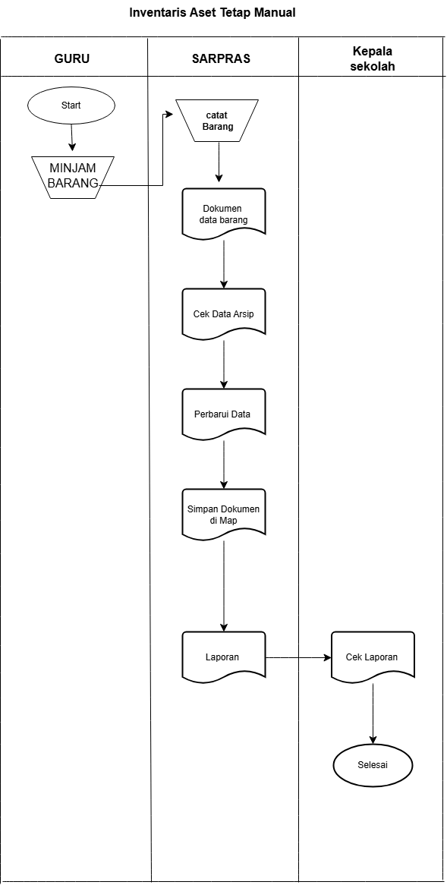

- System Requirements Analysis Flowchart
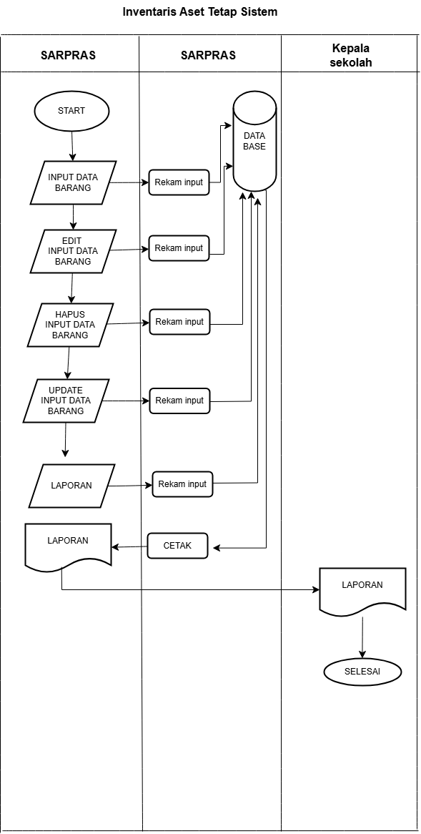
- Use Case
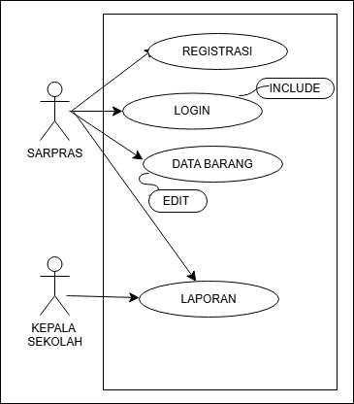
- Activity Diagram
      - LOGIN
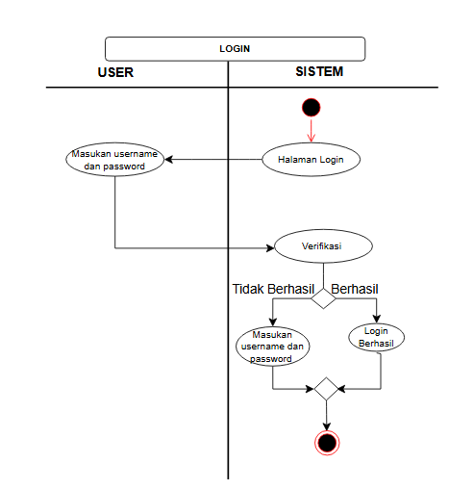

      - GOODS DATA

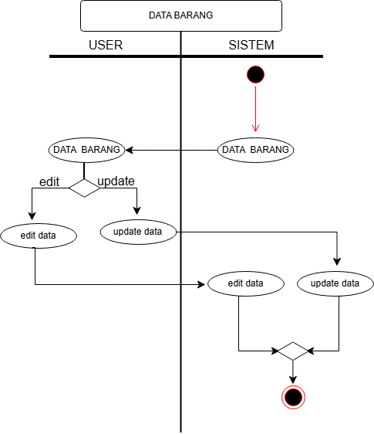

      - REPORT
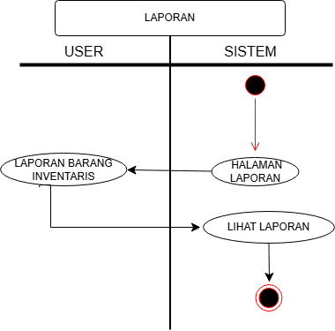

- Class Diagram
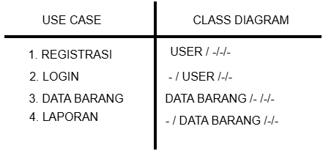

D. Table
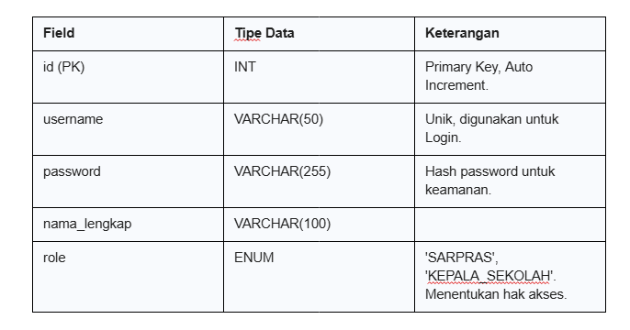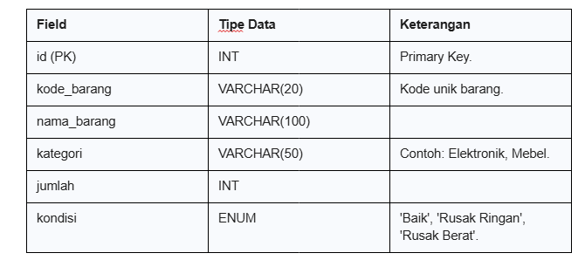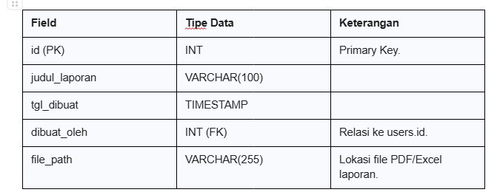

Bibliography
[1] A. Crisna and R. I. Handayani, “Web-Based Call Center Service Device Inventory Management Information System at PT . Mitracomm Ekasarana,” vol. 5, no. 2, pp. 258–270, 2026.
[2] Y. Anis, E. N. Wahyudi, and H. C. Kurniawan, "Waterfall Method in the Development of Inventory Systems to Improve the Efficiency of Goods Stock Management," J. Techno. Then Sist. Business Inf., vol. 6, no. 2, pp. 329–338, 2024, doi: 10.47233/jteksis.v6i2.1351.
[3] F. Wahyudi, I. K. Putri, N. Noor, and K. Sari, "Development of a Web-Based Goods Inventory Information System Using the Waterfall Method at BPS Central Kalimantan Province," pp. 116–127.
[4] A. R. P. Wibowo et al., "Design and Build a Web-Based Information System for Borrowing School Inventory and Goods," RIGGS J. Artif. Intell. Digit. Bus., vol. 4, no. 4, pp. 8364–8373, 2026, doi: 10.31004/riggs.v4i4.4533.
[5] B. P. Kamilah, A. R. Sulvi, and S. Putri, "E-Inventory: Digital Transformation Improves the Efficiency of Goods Management at SMAN 3 Pariaman," J. Educ. Manag. Strateg., vol. 3, no. 01, pp. 50–61, 2024, doi: 10.57255/jemast.v3i01.612.
[6] I. Muzdhalifatul Ijfi, M. Furqoon Khalilullah, Z. Putri Leri, V. Farezy, and E. Arribe, "Designing a Web-Based Inventory Information System," JATI (Journal of Mhs. Tek. Inform., vol. 9, no. 1, pp. 275–283, 2024, doi: 10.36040/jati.v9i1.12173.
[7] S. Al Amin, J. Devitra, M. S. Information, U. D. Bangsa, J. Jend, and S. T. Tel, "BMN Inventory System," vol. 6, no. 2, 2021.
[8] S. Christian Andi, "337383-Implementation-Model-Prototype-On-Peranc-2Ef03793," Implementation of the prototype model in Peranc. Sist. Inf. Invent., vol. 1, no. 2, pp. 1–10, 2019.
[9] R. Annisa and P. A. Rahayuningsih, "Designing a Web-Based School Facilities and Infrastructure Inventory Information System The development of information technology is currently taking place rapidly to facilitate and support the dissemination of information. Information itself plays an important role in keh," vol. 6, no. 1, pp. 60–70, 2023.
[10] R. Yanti, F. Annas, Y. E. Yuspita, G. Darmawati, and S. Article, "Kodular Implementation in the Design of Android-Based School Inventory Management Applications Abstract Article Information," Intellect Indones. J. Innov. Learn. Technol., vol. 02, no. 02, pp. 185–200, 2023, [Online]. Available: https://10.0.223.167/intellect.v2i2.294
[11] J. A. W. A. Y. Right, "Journal of al-Hikmah way kanan," vol. 4, 2023.
[12] M. Alda and D. R. Sahendra, "Design of a Web-Based Goods Inventory Information System in the North Sumatra Dispora," Simtek J. Sist. Inf. and Tek. Computer., vol. 8, no. 1, pp. 7–11, 2023, doi: 10.51876/simtek.v8i1.163.
[13] J. Teknologi, P. Dan, P. Jtpp, D. Barata, S. Andika, and A. Widhi, "Development of a Desktop-Based School Inventory Information System "Inventago" Using Visual Basic and MySQL Journal of Education and Learning Technology (JTPP)," vol. 03, no. 02, pp. 743–750, 2025.
[14] D. I. Sma and P. Pekanbaru, "Management+Inventory+Facilities+Education[1]," vol. 35, no. 1, 2024.
[15] R. Samsinar, H. Isyanto, R. D. Risanty, N. Nelfiyanti, S. Z. Pasha, and I. M. Putra, "Design and Build Web Profile of Al-Qur'an Education Park (TPA) Raudhatul Atfal (RA) and Madrasah Ibtidaiyah (MI) at the Baitul Ulum Foundation," RENATA J. Pengabdi. Mass. All of us, vol. 2, no. 2, Jul. 2024, doi: 10.61124/1.renata.55.
[16] R. N. Dewi, ) Indah, and U. Wardati, "Design of a Website Development System for the Profile of Madrasah Ibtidaiyah Negeri Sidoharjo Pacitan." [Online]. Available: http://ijns.org
[1][1] A. Crisna and R. I. Handayani, “Web-Based Call Center Service Device Inventory Management Information System at PT . Mitracomm Ekasarana,” vol. 5, no. 2, pp. 258–270, 2026.
[2] Y. Anis, E. N. Wahyudi, and H. C. Kurniawan, "Waterfall Method in the Development of Inventory Systems to Improve the Efficiency of Goods Stock Management," J. Techno. Then Sist. Business Inf., vol. 6, no. 2, pp. 329–338, 2024, doi: 10.47233/jteksis.v6i2.1351.
[3] F. Wahyudi, I. K. Putri, N. Noor, and K. Sari, "Development of a Web-Based Goods Inventory Information System Using the Waterfall Method at BPS Central Kalimantan Province," pp. 116–127.
[4] A. R. P. Wibowo et al., "Design and Build a Web-Based Information System for Borrowing School Inventory and Goods," RIGGS J. Artif. Intell. Digit. Bus., vol. 4, no. 4, pp. 8364–8373, 2026, doi: 10.31004/riggs.v4i4.4533.
[5] B. P. Kamilah, A. R. Sulvi, and S. Putri, "E-Inventory: Digital Transformation Improves the Efficiency of Goods Management at SMAN 3 Pariaman," J. Educ. Manag. Strateg., vol. 3, no. 01, pp. 50–61, 2024, doi: 10.57255/jemast.v3i01.612.
[6] I. Muzdhalifatul Ijfi, M. Furqoon Khalilullah, Z. Putri Leri, V. Farezy, and E. Arribe, "Designing a Web-Based Inventory Information System," JATI (Journal of Mhs. Tek. Inform., vol. 9, no. 1, pp. 275–283, 2024, doi: 10.36040/jati.v9i1.12173.
[7] S. Al Amin, J. Devitra, M. S. Information, U. D. Bangsa, J. Jend, and S. T. Tel, "BMN Inventory System," vol. 6, no. 2, 2021.
[8] S. Christian Andi, "337383-Implementation-Model-Prototype-On-Peranc-2Ef03793," Implementation of the prototype model in Peranc. Sist. Inf. Invent., vol. 1, no. 2, pp. 1–10, 2019.
[9] R. Annisa and P. A. Rahayuningsih, "Designing a Web-Based School Facilities and Infrastructure Inventory Information System The development of information technology is currently taking place rapidly to facilitate and support the dissemination of information. Information itself plays an important role in keh," vol. 6, no. 1, pp. 60–70, 2023.
[10] R. Yanti, F. Annas, Y. E. Yuspita, G. Darmawati, and S. Article, "Kodular Implementation in the Design of Android-Based School Inventory Management Applications Abstract Article Information," Intellect Indones. J. Innov. Learn. Technol., vol. 02, no. 02, pp. 185–200, 2023, [Online]. Available: https://10.0.223.167/intellect.v2i2.294
[11] J. A. W. A. Y. Right, "Journal of al-Hikmah way kanan," vol. 4, 2023.
[12] M. Alda and D. R. Sahendra, "Design of a Web-Based Goods Inventory Information System in the North Sumatra Dispora," Simtek J. Sist. Inf. and Tek. Computer., vol. 8, no. 1, pp. 7–11, 2023, doi: 10.51876/simtek.v8i1.163.
[13] J. Teknologi, P. Dan, P. Jtpp, D. Barata, S. Andika, and A. Widhi, "Development of a Desktop-Based School Inventory Information System "Inventago" Using Visual Basic and MySQL Journal of Education and Learning Technology (JTPP)," vol. 03, no. 02, pp. 743–750, 2025.
[14] D. I. Sma and P. Pekanbaru, "Management+Inventory+Facilities+Education[1]," vol. 35, no. 1, 2024.
[15] R. Samsinar, H. Isyanto, R. D. Risanty, N. Nelfiyanti, S. Z. Pasha, and I. M. Putra, "Design and Build Web Profile of Al-Qur'an Education Park (TPA) Raudhatul Atfal (RA) and Madrasah Ibtidaiyah (MI) at the Baitul Ulum Foundation," RENATA J. Pengabdi. Mass. All of us, vol. 2, no. 2, Jul. 2024, doi: 10.61124/1.renata.55.
[16] R. N. Dewi, ) Indah, and U. Wardati, "Design of a Website Development System for the Profile of Madrasah Ibtidaiyah Negeri Sidoharjo Pacitan." [Online]. Available: http://ijns.org
[2][3][4][5][6][7][8][9][10][11][4][12][12][13][14][15][16]

