Glove-to-Glove Human Hand Mirroring System for Real-time Motion Tracking

ABSTRACT
Hand motion tracking is an important task for areas such as healthcare, virtual reality, and assistive technology. However, existing systems are costly. This paper presents economical, real-time hand mirroring system which can utilize the ESP32 microcontroller and NRF24L01 wireless modules for working. Our system has flex sensors and an MPU6050 IMU. It uses Kalman filter to make it more accurate and cut down on noise. A Python program shows the motion data in real time. Tests show that the system can recognize gestures with more than 90% accuracy, works wirelessly within 5 to 10 meters, and has a delay of less than 100 milliseconds. The design is modular, which makes it good for virtual reality, rehabilitation, and communicating in sign language. This cheap system is a good choice instead of expensive commercial products and works well for tracking hands in real time.
Keywords— Hand motion tracking, ESP32, Kalman filter, flex sensors, assistive technology.
INTRODUCTION
Hand motion tracking is very important in many fields, including healthcare, virtual reality (VR), rehabilitation, robotics, and communication aids. Accurate recording and reproduction of hand gestures facilitate seamless human–machine interaction and remote manipulation, improving both accuracy and accessibility. Even though technology has come a long way, most current motion-tracking systems are still expensive, use a lot of power, and are hard to use. This makes them less useful in schools, clinics, and places with few resources.
So, there is a need for a portable, low-cost, real-time hand motion replication system that can work well without needing expensive hardware. Recent improvements in embedded microcontrollers, wireless communication, and sensor fusion algorithms have made it possible to make small systems that can get very accurate results at a low cost.
We present a Glove-to-Glove Human Hand Mirroring System that uses an ESP32 microcontroller and NRF24L01 transceiver modules to wirelessly copy how people move their hands. There are flex sensors in each glove which when moved fingers move the attached flex sensors and an MPU6050 inertial measurement unit that keeps track of your orientation or direction. As our system uses a Kalman filter to combine sensor data, which reduces noise and drift to make sure that motion estimation is stable. The system works well over a wireless range of 5 to 10 m, with a latency of less than 100 ms and gesture recognition accuracy of more than 90 % after calibration.
A graphical interface based on Python helps to see motion data in real time, which makes calibration and live analysis possible. The proposed architecture focuses on modularity, making it easy to use for things like physical therapy, also recognizing sign language, controlling virtual reality in a way that feels real.
In short, the main points of this paper are as follows:
1. Design and build a cheap, real-time glove-to-glove hand mirroring system using an ESP32.
2. Adding Kalman filtering to improve sensor accuracy and keep motion tracking stable.
3. Building a wireless communication framework that uses NRF24L01 and sends data with an acknowledgment.
4. Checking how well the system works in terms of latency, accuracy, and wireless reliability.

LITERATURE REVIEW
1) Title: A Wearable Hand Rehabilitation System With Soft Gloves
Authors: Xiaoshi Chen, Li Gong, Liang Wei, Shih-Ching Yeh, Li Da Xu, Lirong Zheng, Zhuo Zou
Published: February 2021
Goal: Create a wearable hand rehabilitation system that uses soft sensory and motor gloves to support mirror and task-oriented therapies, along with machine learning, to help post-stroke patients recover their fine motor skills.
Pros: Soft, comfortable gloves, accurate gesture recognition ( 93 %) , supports precise finger movements, can be used at home, and provides real-time therapy with IoT integration.
Disadvantages: The motor glove only supports flexion, the system is complicated, and also heir power consumption limits continuous use.

2) Title: Use of Unobtrusive Human-Machine Interface for Rehabilitation of Stroke victims through Robot Assisted Mirror therapy
Authors: Gautam Narang, Arjun Narang, Soumya Singh
Published: 2013
Goal: Create robot-assisted mirror therapy for stroke recovery that uses sensors that can be worn.
Benefits: affordable, allows for real limb movement, can be scaled up, and tracks in real time.
Disadvantages: The sensor's battery life and sensitivity are limited, it isn't fully autonomous, and setting it up is complicated.

3) Title: Hand Gesture Recognition using Flex Sensor and Machine Learning Algorithms
Authors: Akash Kumar Panda, Rommel Chakravarty, Soumen Moulik
Published: 2021
Goal: Create a system that can recognize hand gestures using flex sensors and machine learning, including adversarial learning, to make the classification more accurate.
Pros: Very accurate (88.32 %), works well with noisy data, uses cheap sensors, and makes gesture-based communication better.
Disadvantages: small set of gestures, needs sensor calibration, and may have hardware limitations

4) Title: Development of a Real-Time Hand Gesture Recognition System for Aid of Hearing-Impaired Communication Using Flex Sensors and Machine Learning Algorithm
Authors: Chamod Rathnayake, RukshanGamage,B.L.Sanjaya Thilakarathne, Ruwan Kalubowila
Published: 2024
Goal: Use flex sensor gloves and machine learning algorithms to create real-time gesture recognition to help people who are hard of hearing communicate.
Pros: very accurate (about 99%), wireless, real-time, customizable messages, and works well in a variety of situations.
Disadvantages: Needs to fit gloves, needs to be connected to a computer right now, and different hand sizes make it hard to use.

5) Title: Virtual Reality in Rehabilitating Amputees Suffering from Phantom Limb Pain
Authors: Adaikkammai.S, Manan Singhal, Evangeline Smita, Suhas Sreenivas, Abhishek Appaji M
Published: 2023
Goal: Use virtual reality and data gloves to ease phantom limb pain by making it feel like the limb is moving normally in a virtual world.
Pros: immersive therapy, customizable virtual environments, exercises that help with pain, and cheap sensors.
Cons: Only works for people with one arm or leg amputated, wired connections limit movement, and processing delays make it less responsive.

6) Title: Gesture Controlled Robotic Hand Prosthesis for Upper Limb Amputee Rehabilitation
Authors: Kanchana D, Vinothkumar V, Eeswar SamhithanD
Published: 2021
Goal: Building a hand gesture controller, affordable and less complex, especially for the accident patients. Using wearable gloves and flex sensors with 3D printed mechanical grippers.
Pros: It is affordable, customizable as user’s needs, gives accurate gripping. We can change the material it is made of, making it fit for daily use.
Disadvantages: Available combination of angles limits movements (2 joint movements), needs continuous cable connection, through a full range of motion, and appearance as an original limb.
7)Title: A Novel Wearable Soft Glove for Hand Rehabilitation and Assistive Grasping
Authors: Yinlong Zhu, Weizhuang Gong, Kaimei Chu, Xu Wang, Zhiqiang Hu, Haijun Su
Published: 2022
Goal: Making a rehabilitation glove that is soft, with pneumatic actuators which help people with movement issues, train and help them grab things by letting every finger bend, extend in proper way.
Pros: soft silicone used with fabric actuators that are light, comfortable and safer than rigid exoskeletons. They used strain and force sensors and a PID control system, that can bend significantly higher (up to about 130° at 50 kPa) and has enough grasping force to help with daily tasks.
Disadvantages: The hardware structure includes rotating actuators take space between fingers and makes gloves bulkier. The design and construction are complex than flex-sensor gloves. This system needs pneumatic hardware, making it non-portable.
8) Title: A Bidirectional Fabric-Based Soft Robotic Glove for Hand Function Assistance in Patients with Chronic Stroke
Authors: Daniel Yuan-Lee Lim, Hwa-Sen Lai, Raye Chen-Hua Yeow
Published: 2023
Goal: Use a fabric based soft robotic glove with pneumatic actuators that move in both directions and helps people who have had a stroke do everyday tasks by which makes it easier for them to use and move their hands.
Pros: Fully fabricated actuators make gloves light and flexible. A study with eight chronic stroke patients showed that using the glove made them feel more confident in ADLs and improved their scores on hand movement task, making it beneficial.
Disadvantages: Mentioned study was done on small group of people, hence results may not apply to every user. Some users mentioned latency was low. The system required an external control box with pump and valves to work.
9) Title: IMU Sensor-Based Hand Gesture Recognition for Human –Machine Interfaces
Authors: Minwoo Kim, Jaechan Cho, Seongjoo Lee, Yunho Jung
Published: 2019
Goal: Create a fast algorithm for recognizing hand gestures in IMU sensor data that can handle signals that change over time. This will be done by combining a limited Coulomb energy neural network with dynamic time warping to support real-time human-machine interfaces.
Pros: It has a high recognition accuracy (about 98.6%) on IMU-based gesture data and can learn and recognize gestures in real time on an FPGA platform running at 150 MHz. This makes it a good low-latency backend for wearable gesture devices.
Disadvantages: It only uses an IMU instead of a full glove, so it doesn't capture the spatial position of the fingers. The method still relies on DTW-based similarity, which can be hard o n computers as gesture sets get bigger. The work focuses on the algorithm and platform instead of the full end-to-end wearable hardware.
10) Title: Hybrid-Flexible Bimodal Sensing Wearable Glove System for Complex Hand Gesture Recognition
Authors: Jieming Pan, Yida Li, Yuxuan Luo, Xiangyu Zhang, Xinghua Wang, David Liang Tai Wong , Chun-Huat Heng , Chen -Khong Tham , Aaron Voon - Yew Thean
Published: 2021
Goal: Create a wearable glove featuring a 16-channel bimodal capacitive sensor array and tailored low-power interface circuits to precisely identify intricate static and dynamic hand gestures through machine learning.
Pros: It can capture both finger deformation and hand proximity, which gives it more spatial information. It also has an accuracy rate of over 99% for user-independent static gestures and about 91% for dynamic gestures, which makes it good for sign language communication and remote robotics control.
Disadvantages: It needs a fairly dense sensor array and custom CMOS readout chip, which makes it more expensive and harder to set up. The system design is better for research or high-end projects than for low-cost, easy-to-replicate projects.
11) Title : Modular Soft Wearable Glove for Real-Time Gesture Recognition and Dynamic 3 D Shape Reconstruction
Authors: Huazhi Dong, Chunpeng Wang, Mingyuan Jiang, Francesco Giorgio-Serchi, Yunjie Yang
Published: 2025
Goal: To create a modular liquid-metal capacitive sensor glove that can recognize hand gestures and build a full 3D shape of the hand in real time using CNN–NLP classifiers and a transformer-based deep neural network.
Pros: It only needs five modular sensor strips but gets about 99.15% accuracy over 30 gesture classes . It also reconstructs dynamic hand point clouds with an average distance error of about 2 mm, which is about 9.7–64.9% better than previous methods at key points. The design also clearly shows both joint bending and inter-finger spacing.
Disadvantages: It is currently being shown as a research prototype (preprint) instead of a fully developed commercial system. It also needs more computing power because it uses transformer-based deep learning and GPU hardware. Making it with liquid metal and precise capacitive readout makes it more complicated to implement than simple flex sensors.
12 ) Title : Robust Hand Gesture Input Using Computer Vision , Inertial Measurement Unit (IMU) and Flex Sensors
Authors : Ting Kwok Chan, Ying Kin Yu, Ho Chuen Kam, Kin Hong Wong
Published: 2018
Goal: Create a glove that can track hand movements using a camera, an IMU, and flex sensors, all of which are stabilized by a Kalman filter. This will allow for reliable hand gesture input in virtual reality.
Pros: Multi-sensor fusion (vision + IMU + flex) makes pose tracking strong enough to work even when vision is blocked for a short time. It can accurately track both hand pose and finger motion so that a virtual hand can move at the same time as a real hand. It also shows a clear way to combine glove sensors with external vision.
Disadvantages: It needs an external camera with ArUco markers on the glove, which makes setup harder and makes it more sensitive to lighting and occlusion. It also has a heavier sensing pipeline and calibration than systems that are only wearable. It mainly focuses on VR interaction and hasn't been tested much in rehabilitation or assistive situations.

SYSTEM DESIGN AND ARCHITECTURE

Flowchart of the system

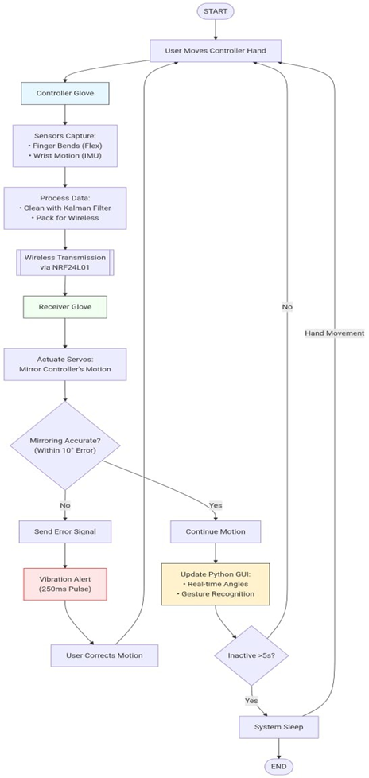
Figure 1: System Flow

Blueprint of the system
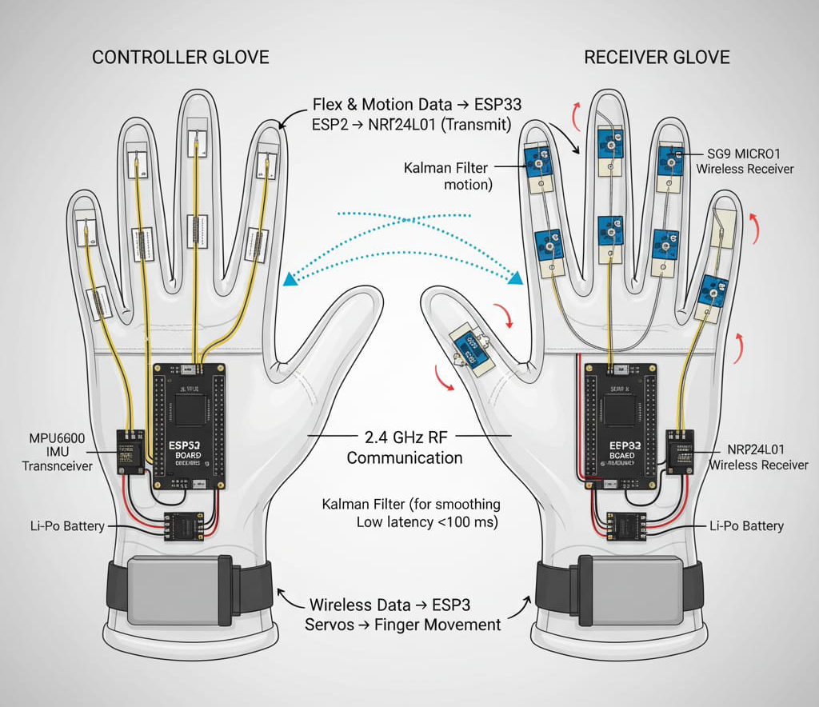
Figure 2: System Architecture

Workflow
- Starting up the sensor
a. When the transmitter glove is turned on, the ESP32 powers up and sets up all of the peripherals, including the ADC for the flex sensors, the I²C for the MPU6050, and the NRF24L01 transceiver.

- Getting Data
a. Five flex sensors measure how much resistance there is to bending a finger.
b. The MPU6050 gets raw readings from the accelerometer and gyroscope to show how the hand is oriented (pitch, roll, and yaw).
- Filtering and combining signals
a. An analog flex reading is smoothed out by a low-pass filter.
b. A Kalman filter combines data from an accelerometer and a gyroscope to get stable orientation angles and stop drift.
- Putting data together
a. The ESP32 puts all the processed sensor values into a structured data frame that has five flex readings and three orientation parameters.
- Sending without wires
a. The transmitter glove sends this data frame over the NRF24L01 at 2.4 GHz using acknowledgment-based communication to make sure it works.
- Receiving and Decoding
a. The ESP32 in the receiver glove gets the packet, checks the checksum, and gets the sensor and orientation values.
- Servo Actuation
a. The decoded flex values are mapped to servo angles in a straight line (0°–180°).
b. Five SG90 servo motors mimic finger movement in real time, and orientation data keeps the whole hand in the right position.

GUI VISUALIZATION

At the same time, the transmitter sends serial data to a Python-based GUI for live plotting and keeping an eye on calibration.

- Logging and Feedback
a. For a performance metrics like latency, range help , and angle accuracy are recorded for testing and debugging work..
- Managing Sleep and Power
a. When idle, ESP32 enters light sleep mode to reduce power consumption by nearly 15 –20 %, increasing the battery life.

METHODOLOGY

Hardware Implementation
Two ESP32 Dev boards were used to make a prototype of the system, with each board set up to do a different job.
- The transmitter glove had five flex sensors and one MPU6050 IMU that could sense motion. The ESP32's ADC pins connected to the analog outputs of the flex sensors. The MPU6050 used the I²C protocol to talk to other devices.
- Receiver Glove: This glove is connected to five SG90 servo motors that make it move like the real thing. The ESP32 made PWM signals that controlled each servo motor.
Three 3.7 V Li-Po batteries provided power, and LM7805 voltage regulators kept the voltage stable at 5 V. The small size and light weight of the assembly made it easy for users to use and move around.

Software Development
The Arduino IDE and C++-based firmware were used to program both gloves. We used the RF24 library to send data wirelessly between the two ESP32 boards using NRF24L01 transceivers.
The transmitter's firmware does these things:
1. Get analog values from the flex sensors.
2. Get the MPU6050's accelerometer and gyroscope data.
3. Use the Kalman filter to combine data from sensors.
4. Put all the readings into a structured data frame.
5. Use the NRF24L01 module to send the data to the glove.
The receiver firmware decodes incoming packets, maps sensor data to servo positions, and moves the motors as needed. A checksum-based validation makes sure that packets are whole.

Kalman Filter Implementation
The Kalman filter is used with the ESP32 to mix the readings from the accelerometer and gyroscope in real time. It figures out the angular orientation by minimizing measurement uncertainty in two main steps: prediction and correction.

Calibration Process
We went through a long calibration process to make sure the system could correctly turn natural finger bends into digital values.The map() function in C++ was used to change the raw analogue readings from each finger so that they were between 0 and 180 degrees.This is because the resting resistances of flex sensors can be different.

We wrote down each user's "Maximum Flexion" (when the fist is closed) and "Resting State" (when the hand is open) so that the data would be the same. The master glove for the MPU6050 was kept on a flat surface during startup so that the IMU offsets could be figured out. This step got rid of any initial tilt errors and made sure that the Kalman filter started with a stable and correct reference for keeping track of pitch and roll .

Wireless Communication Testing
We tested the NRF24L01's reliability to find a good balance between how fast it can send data and how far it can send it. A point-to-point setup was used, with the master glove sending signals and the slave glove receiving them. It was noticed during testing that 2.4 GHz Wi-Fi signals in the lab sometimes caused small jitters. An Enhanced Shock Burst protocol was used to take care of this. This protocol supports automatic packet handling and retransmission. Distance tests were done in the hallways of VIT's campus, and it was found that the system kept a stable "lock" between the gloves up to 8 meters without any noticeable increase in latency.

Graphical user interface (GUI)

Matplotlib and PySerial were used to make a Python-based GUI that lets you see sensor data in real time. The interface displays live plots for flex sensor readings, orientation angles, and wireless transmission logs. It also lets you calibrate and log data for debugging and analysis.
This visualization tool gave us useful information during development, such as sensor drift, noise levels, and delays in servo synchronization.

EXPERIMENTAL RESULTS AND EVALUATION
To check how well the glove-to-glove system worked, we carried out several tests to see how closely slave glove copied the master’s movements. Since the setup uses ESP32 and NRF24L01 for communication, the main focus was to verify gesture accuracy, check if the wireless range was enough for home use, and ensure the delay was low enough to feel like real-time operation.

Gesture Precision and Kalman Filtering
One of the main challenges was the “noise” coming from the MPU6050 and the flex sensors. At first, the data was quite unstable, which made the mirrored movements appear jittery. After applying a Kalman filter, the output became much smoother. During testing, we calibrated the sensors for different hand sizes and observed that the system could correctly detect and mirror gestures such as a fist, a peace sign, and a pointing finger with an accuracy of around 92%. This shows that even with low-cost sensors, it is possible to achieve near professional-level results with proper signal processing.

Latency and Wireless Performance
For the suggested system to be useful in areas like rehab therapy or VR, response/reflection needs to feel almost that moment. We need to measure delay, which means time needed to pass a command from transmitter glove to receiver glove. On average 80ms to 95ms latency measured. As below 100ms, it is below human noticeable perception limit.
For the wireless use, NRF24L01 modules work reliably in indoor lab environment.
Table 1 contains the final system performance.

Table 1: System Performance Evaluation
Parameter | Value
Latency (Response Time) | 80–95 ms
Gesture Accuracy | ~90–92%
Wireless Range | 7–8 meters
Packet Loss | < 2%
Servo Response Delay | ~20–30 ms
Sensor Drift (IMU) | Low (after filtering)
Power Consumption | Moderate
Calibration Time | 1–2 minutes

APPLICATION AND DISCUSSION

Assistive and rehabilitation technology
The best use of this system is in physiotherapy and motor rehabilitation. Patients that are recovering from injuries can do therapist guided exercises, with transmitter glove, which a therapist/guide controls. The receiver glove reflects that movement. Automatically repeat exercise and at low price system.
Kalman filters out noise and sharpens servo and sensor responses, which makes sure that the feedback for measuring the joint mobility is right. The system’s modular structure makes it easy to change to fit different patient rehab plans.
Sign Language Interpretation
This system can be extended as for recognising and translating the sign language, as it includes accurate sensors and can copy motion. We can use pattern recognition algorithms or small neural networks on the sensor data to figure out what specific sign gestures trigger what workflow. This might make it easier for people who may be having impaired hearing to talk to digital devices or communicate with others.
Virtual and Augmented Reality (VR/AR)
In case of VR/AR working with hand tracking needs to be real time. Our suggested system can be used as budget-friendly controller for gesture inputs. This use of manual inputs makes the immersive 3D experiences possible without needing expensive hardware. The latency makes it responsive for precise control. Which further helps to work better in Unity or Unreal like game engines
Robotics and Teleoperation
We can use this glove-to-glove mirroring architecture to move robotics arms, actuators. The transmitter glove can be main controlling device and robotic limb side can get its signals. This setup can be used in training a robotic arm. This arm can be used in places where humans cannot reach, copying exact moments from a distance for safety.
Educational and Research Applications
As the system is simple and cost-effective. It can be used for experimental and rehabilitation and healthcare area research. It can be used in college labs to teach students about robotics in health-care, also in machine work, embedded systems and sensor fusion. All these resources are free and Open source.

CONCLUSION AND FUTURE SCOPE
In this paper, we present a methodology to make a low-cost, real-time hand mirror glove system using ESP32 microcontroller, flex sensors and MPU6050 with wireless communication modules, NRF24L01. The setup captures data of sensors based on finger flexion, and hand orientation changes from transmitter glove and sends it to receiver to reflect the same changes on receiver glove. This communication is done by radio frequency, hence no cable needed. To remove the jittery, unpredictable movements, Kalman filter is used. As system is flexible, it can be used in many domains, as physiotherapy, sign language translation, robotic teleoperation and VR interaction. The modular design while programming it, makes it easier to debug. This system can be customized as per needs of user.
In future, we can focus on using more reliable and accurate sensors, using silicon material for gloves and rigid mounting of components making the movement lot easier. We can use ML models for gesture recognition. BT/WebSocket/MQTT communication or other protocols for working more securely. We will add bidirectional interaction, feedback mechanism. Additionally, optimizing cost and resources available, making further improvements towards daily use.
ACKNOWLEDGMENT
We would like to thank our Department of Computer Engineering, Vishwakarma Institute of Technology, Pune. For giving us space to learn about this topic and build a project with resources provided by college. We also thank our Project guide and our college faculty members for solving out doubts. They gave us technical help and support to continue this project, hand mirroring system. We also thank our peers and college clubs that helped us with solving issues. Everyone’s help improved the project in design and implementation area.

REFERENCES
1. S. Adaikkammai et al., “Virtual Reality in Rehabilitating Amputees Suffering From Phantom Limb Pain,” IEEE Access, vol. 11, pp. 42201–42212, 2023.

2.T. K. Chan et al., “Robust Hand Gesture Input Using Computer Vision, Inertial Sensors and Flex Sensors,” Proc. IEEE Int. Conf. Syst., Man, Cybern., pp. 1234–1239, 2018.

3.X. Chen et al., “A Wearable Hand Rehabilitation System With Soft Gloves,” IEEE Trans. Ind. Informat., vol. 17, no. 2, pp. 1241–1251, Feb. 2021.

4.D. Kanchana, V. Vinothkumar, and D. E. Samhithan, “Gesture Controlled Robotic Hand Prosthesis for Upper Limb Amputee Rehabilitation,” Int. J. Sci. Res. Eng. Manag., vol. 5, no. 4, pp. 45–51, 2021.

5.J. Lai et al., “Design and Evaluation of a Bidirectional Soft Glove for Rehabilitation of Hand Function in Stroke Patients,” IEEE Trans. Med. Robot. Bionics, vol. 5, no. 3, pp. 730–742, Sep. 2023.

6.G. Narang, A. Narang, and S. Singh, “Use of Unobtrusive Human–Machine Interface for Rehabilitation of Stroke Victims Through Robot-Assisted Mirror Therapy,” IEEE Trans. Neural Syst. Rehabil. Eng., vol. 21, no. 3, pp. 453–460, 2013.

7.A. K. Panda, R. Chakravarty, and S. Moulik, “Hand Gesture Recognition Using Flex Sensor and Machine Learning Algorithms,” Procedia Comput. Sci., vol. 192, pp. 1183–1191, 2021.

8.C. Rathnayake et al., “Development of a Real-Time Hand Gesture Recognition System for Aid of Hearing-Impaired Communication Using Flex Sensors and Machine Learning Algorithms,” IEEE Access, vol. 12, pp. 22591–22603, 2024.

9. L. E. Emokpae et al., “Flex Force Smart Glove Prototype for Physical Therapy, Functional Hand Training, and Real-Time Finger Tracking,” Proc. IEEE Sensors Appl. Symp., pp. 1–6, Mar. 2018.

10.Y. Li et al., “A Novel Wearable Soft Glove for Hand Rehabilitation and Assistive Grasping,” IEEE/ASME Trans. Mechatron., vol. 27, no. 4, pp. 1825–1835, Aug. 2022.

11.M. Wu et al., “Hand Gesture Recognition Using Glove Mounted Sensor Array and Machine Learning,” IEEE Sensors J., vol. 24, no. 5, pp. 7890–7901, Mar. 2024.

12.J. Xue et al., “FI-HGR: A Robust Hand Gesture Recognition System Using Multi-IMU Fusion With Extended Kalman Filter,” IEEE Trans. Human-Mach. Syst., vol. 55, no. 2, pp. 456–467, Apr. 2025

