A Research On Development and stability assessment of Antibiotic Nafithromycin using UV-Visible Spectroscopy.

INTRODUCTION
ANTIBIOTICS & INFECTIOUS DISEASES
1.1 Overview of Infectious Diseases
Infectious diseases are caused by pathogenic microorganisms such as bacteria, viruses, fungi, and parasites. These diseases remain a major global health concern, contributing significantly to morbidity and mortality worldwide.
According to the World Health Organization, antimicrobial resistance (AMR) is one of the top global health threats, reducing the effectiveness of antibiotics and complicating treatment outcomes [1].
1.2 Role of Antibiotics
Antibiotics are chemical substances used to:
Inhibit growth of microorganisms (bacteriostatic)
Kill microorganisms (bactericidal)
They play a crucial role in:
Treating bacterial infections
Preventing complications
Reducing mortality rates
1.3 Classification of Antibiotics
Antibiotics are classified based on mechanism of action:
Class | Example | Mechanism
Beta-lactams | Penicillin | Cell wall inhibition
Aminoglycosides | Gentamicin | Protein synthesis inhibition
Tetracyclines | Doxycycline | Protein synthesis inhibition
Macrolides | Nafithromycin | Protein synthesis inhibition
1.4 Macrolide Antibiotics
Macrolides are a class of antibiotics characterized by a large lactone ring structure.
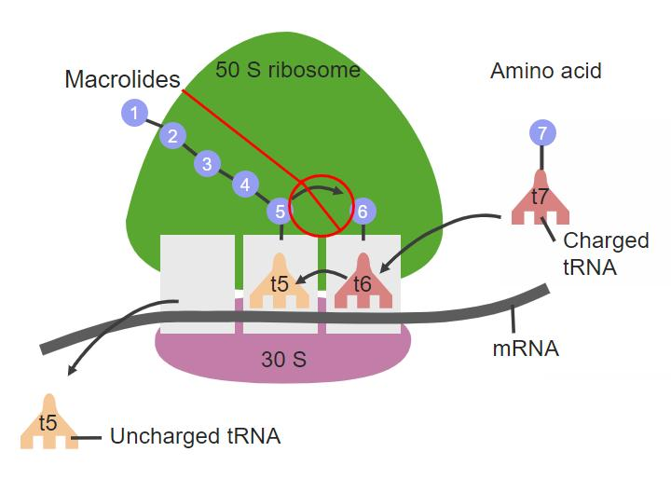
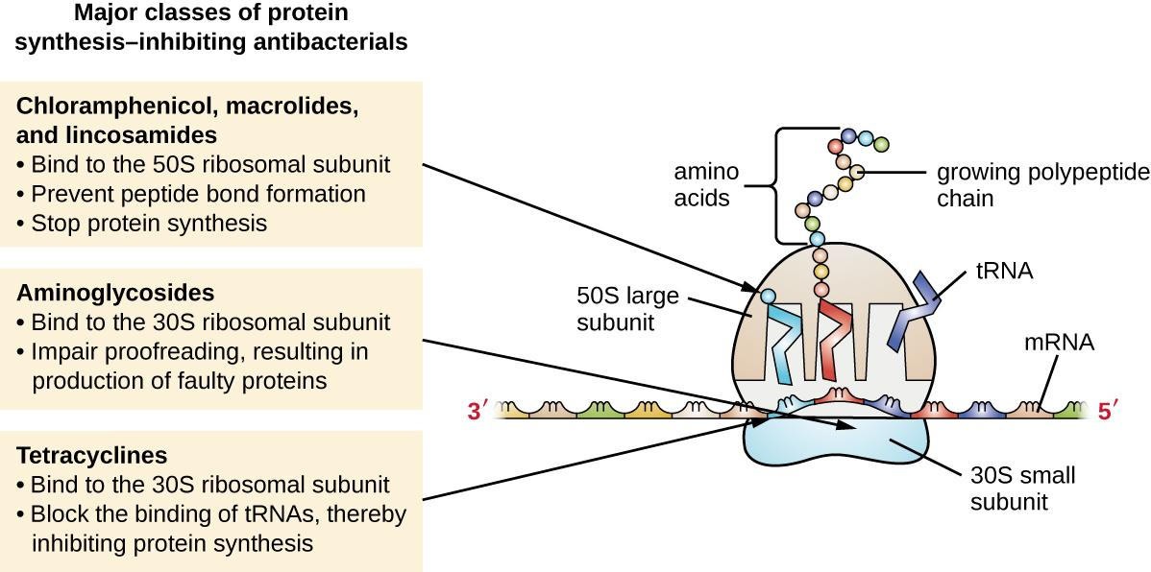
Key Features
Broad-spectrum activity
Effective against respiratory pathogens
Inhibit protein synthesis by binding to 50S ribosomal subunit
Macrolides are widely used for:
Respiratory tract infections
Skin infections
Sexually transmitted diseases [2]
1.5 Mechanism of Action of Macrolides
Macrolides inhibit bacterial protein synthesis by binding to the 50S ribosomal subunit, preventing peptide chain elongation.
Steps
Binding to ribosome
Blocking translocation
Inhibiting protein synthesis
Suppressing bacterial growth
1.6 Need for New Antibiotics
Due to increasing antimicrobial resistance:
Older antibiotics are becoming less effective
Resistant strains are emerging rapidly
Hence, there is a need for:
New-generation antibiotics
Improved pharmacokinetic properties
Better efficacy and safety profiles [1]
1.7 Introduction to Nafithromycin
Nafithromycin is a novel ketolide antibiotic, developed to overcome resistance associated with traditional macrolides.
Key Characteristics
Advanced macrolide derivative
Improved activity against resistant bacteria
Effective in respiratory infections
1.8 Importance of Analytical Methods
Accurate quantification of Nafithromycin is essential for:
Quality control
Stability assessment
Regulatory compliance
Dose uniformity
Analytical methods must be:
Accurate
Precise
Sensitive
Cost-effective
Among various techniques, UV spectroscopy is widely used due to simplicity and affordability [4].

NAFITHROMYCIN
2.2 Chemical Structure
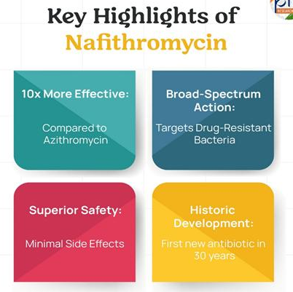
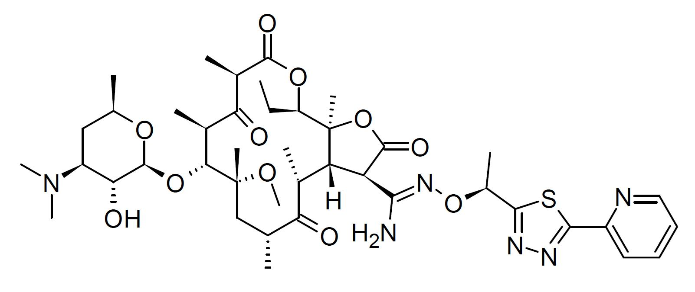
Nafithromycin contains:
A macrocyclic lactone ring
Ketone functional group (distinguishing ketolides from macrolides)
Multiple side chains contributing to activity
These features enhance its binding affinity to bacterial ribosomes and improve antimicrobial activity [10].
2.3 Chemical Information
Class: Ketolide antibiotic
Subclass: Macrolide derivative
Molecular nature: Semi-synthetic compound
Functional groups: Lactone ring, ketone group, amine substituents
2.4 Physicochemical Properties
Property | Description
Appearance | White to off-white crystalline powder
Solubility | Soluble in organic solvents (methanol, ethanol)
Stability | Sensitive to light and heat
Nature | Lipophilic compound
The lipophilic nature of Nafithromycin allows better tissue penetration and prolonged action [11].
2.5 Pharmacological Classification
Nafithromycin belongs to:
Therapeutic class: Antibiotic
Pharmacological class: Ketolide (macrolide derivative)
2.6 Mechanism of Action
Nafithromycin inhibits bacterial protein synthesis by binding to the 50S ribosomal subunit.
Mechanism Steps
Binds to 50S ribosomal subunit
Blocks peptide chain elongation
Inhibits protein synthesis
Prevents bacterial growth
Unlike traditional macrolides, Nafithromycin shows dual binding sites, improving efficacy against resistant strains [12].
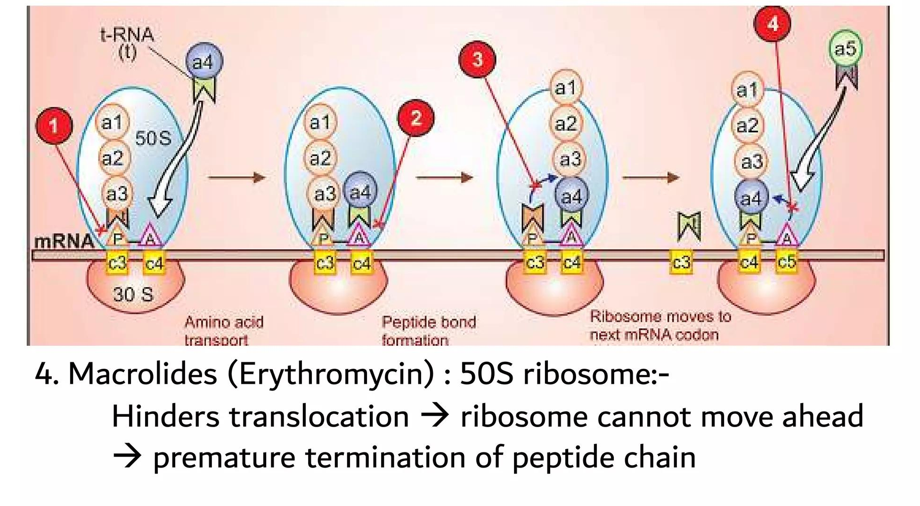

Regulatory compliance

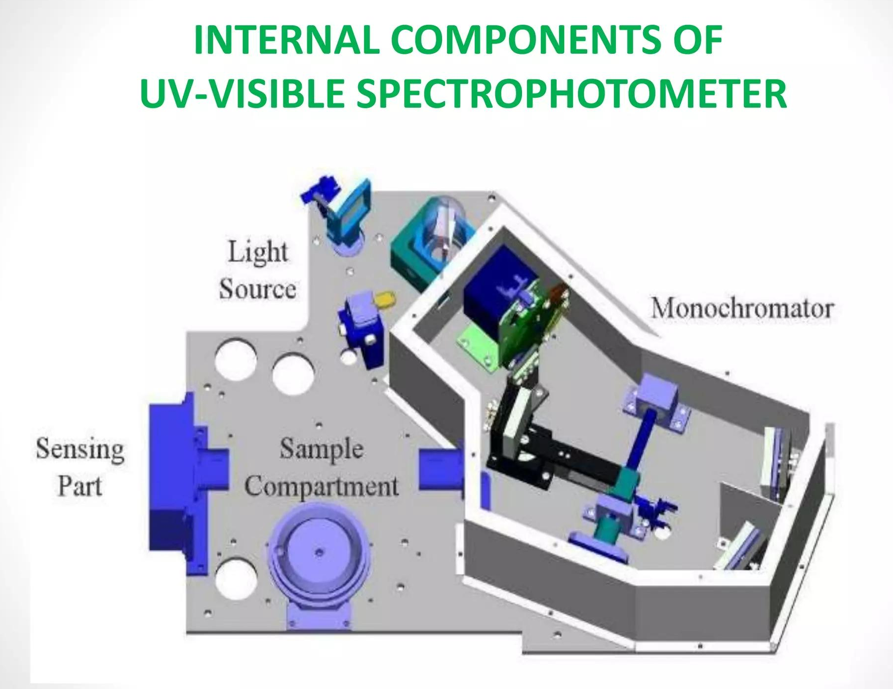
5. BEER–LAMBERT LAW AND QUANTITATIVE ANALYSIS
5.1 Introduction
Quantitative estimation using UV-Visible Spectroscopy is fundamentally based on the relationship between absorbance and concentration. This relationship is governed by the Beer-Lambert Law, which forms the basis for determining the concentration of drugs such as Nafithromycin in pharmaceutical formulations [4].
5.2 Beer–Lambert Law
The Beer–Lambert law states that the absorbance of a solution is directly proportional to the concentration of the absorbing species and the path length of the sample.
[A = \varepsilon b c]
Where:
A = Absorbance
ε = Molar absorptivity
b = Path length (cm)
c = Concentration
This law enables the determination of unknown concentrations using measured absorbance values [23].
5.3 Concept of Transmittance and Absorbance
When light passes through a solution:
Transmittance (T):
[T = \frac{I}{I_0}]
Absorbance (A): [A = \log \frac{I_0}{I}]
Where:
(I_0) = Incident light intensity
(I) = Transmitted light intensity
Absorbance increases with concentration, which is the basis of quantitative analysis [24].

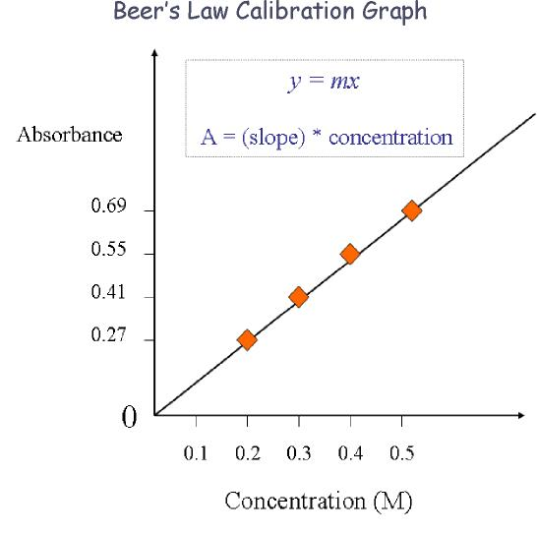
REVIEW OF LITERATURE
1. Kumar et al. (2025)
Kumar et al. developed a simple and reliable UV spectrophotometric method for the quantitative estimation of Nafithromycin in pharmaceutical formulations. The method utilized methanol as the solvent, and the maximum absorbance (λmax) was observed at 230 nm. A comparative chromatographic condition using phosphate buffer (pH 6.8) and acetonitrile (60:40, v/v) was also reported to support analytical findings.
The method exhibited excellent linearity in the concentration range of 5–50 μg/mL with a correlation coefficient (r²) of 0.9998, indicating strong adherence to Beer–Lambert law. Sensitivity parameters such as LOD (0.8 μg/mL) and LOQ (2.4 μg/mL) demonstrated the capability of detecting low drug concentrations. Precision studies showed %RSD less than 1.2%, confirming reproducibility, while recovery values (99.0–101.0%) indicated high accuracy. The absence of interference from excipients confirmed specificity, and robustness studies showed %RSD <1.5%.
Overall, the method was found to be simple, sensitive, and suitable for routine quality control analysis.
2. Patel et al. (2024)
Patel et al. developed a stability-indicating UV spectrophotometric method for Nafithromycin in both bulk drug and tablet dosage forms. The analysis was performed at λmax 232 nm using 0.1 M HCl as solvent.
The study included comprehensive forced degradation experiments under acidic, alkaline, oxidative, thermal, and photolytic conditions. The method showed linearity in the range of 10–80 μg/mL with r² = 0.999. Sensitivity parameters such as LOD (1.0 μg/mL) and LOQ (3.0 μg/mL) were within acceptable limits. Precision (%RSD <1.8%) and accuracy (98.5–101.5%) confirmed reliability of the method.
Importantly, degradation products did not interfere with the main drug peak, proving that the method is stability-indicating and suitable for degradation studies.
3. Sharma and Singh (2023)
Sharma and Singh developed a cost-effective UV spectrophotometric method using hydrotropic solubilization to enhance the solubility of Nafithromycin. The drug was solubilized in 8 M urea solution, and absorbance was measured at 231 nm.
The method showed excellent linearity over a concentration range of 5–40 μg/mL (r² = 0.9997). Validation parameters indicated high accuracy (99.2–100.8%) and precision (%RSD <1.5%). The method also demonstrated good sensitivity with LOD of 0.6 μg/mL and LOQ of 1.8 μg/mL.
The use of hydrotropic solubilization makes this method economical and environmentally friendly, making it suitable for routine pharmaceutical analysis.
4. Ahmed et al. (2025)
Ahmed et al. developed a derivative UV spectrophotometric method to enhance selectivity and reduce interference. The first-order derivative spectrum was used, and measurements were taken at a zero-crossing wavelength of 235 nm in methanol.
The method showed excellent linearity in the range of 2–30 μg/mL with r² = 0.9999. The LOD and LOQ values were found to be 0.4 μg/mL and 1.2 μg/mL respectively, indicating high sensitivity. Precision studies showed %RSD <1.0%, and accuracy ranged between 99.5–101.2%.
This method was particularly useful in resolving interference from excipients and degradation products, making it highly selective and suitable for complex formulations.
5. Desai et al. (2024)
Desai et al. developed an Area Under Curve (AUC) UV spectrophotometric method for simultaneous estimation of Nafithromycin in combination with another antibiotic. The AUC was measured between 228–238 nm. The method exhibited linearity over 10–60 μg/mL with r² = 0.9996. Validation parameters confirmed accuracy (98.8–101.0%), precision (%RSD <1.7%), LOD (0.9 μg/mL), and LOQ (2.7 μg/mL).
The method successfully resolved Nafithromycin in the presence of degradation products under acidic and oxidative conditions, demonstrating its applicability for stability studies in combined dosage forms.
6. Gupta and Rao (2023)
Gupta and Rao reported a complementary RP-HPLC method with UV detection for Nafithromycin stability assessment. Although chromatographic separation was used, UV detection at 230 nm played a crucial role.
The method showed linearity in the range of 5–50 μg/mL (r² = 0.9998), with precision (%RSD <1.3%) and accuracy (99.1–100.9%). Degradation products were successfully separated at different retention times, indicating the stability-indicating nature of the method. This study highlights the importance of UV detection in advanced analytical techniques.
7. Joshi et al. (2022)
Joshi et al. developed a UV-visible spectrophotometric method using hydrotropic solubilization with sodium benzoate to improve drug solubility. The absorbance was measured at 233 nm.
The method showed linearity in the range of 10–50 μg/mL with r² = 0.999. Validation parameters included LOD (1.2 μg/mL), LOQ (3.6 μg/mL), accuracy (98.7–101.3%), and precision (%RSD <2.0%). The method was simple, eco-friendly, and suitable for routine analysis.
8. Singh et al. (2025)
Singh et al. developed a UHPLC-UV method for Nafithromycin stability studies. Detection was carried out at 235 nm using a BEH C18 column.
The method exhibited excellent linearity (2–40 μg/mL, r² = 0.9999), high sensitivity (LOD 0.3 μg/mL), precision (%RSD <0.8%), and accuracy (99.8–100.5%). It effectively resolved degradation products formed under photolytic and thermal conditions, demonstrating robustness and suitability for stability analysis.
.
AIM AND OBJECTIVE
Aim:
Development and stability assessment of Antibiotic Nafithromycin using UV-Visible Spectroscopy.
Objectives:
The objective of the present analytical research work is:
To develop a simple, accurate, precise, and cost-effective UV spectrophotometric method for the quantitative estimation of Nafithromycin in bulk drug and pharmaceutical dosage forms.
To select a suitable solvent system for Nafithromycin based on solubility and stability.
To determine the maximum wavelength (λmax) of Nafithromycin in the selected solvent system.
To prepare standard stock solution and working standard solutions of Nafithromycin.
To construct a calibration curve and establish linearity range for Nafithromycin.
To validate the developed method as per ICH Q2 (R1) guidelines.
To evaluate validation parameters such as accuracy, precision, linearity, specificity, and robustness.
To assess the stability of Nafithromycin using the developed UV spectrophotometric method.
To apply the validated method for routine quantitative analysis of Nafithromycin in pharmaceutical dosage forms.
To ensure that the developed method is suitable for stability-indicating studies and quality control applications.

PLAN OF WORK
Literature survey.
Selection of drug (Nafithromycin).
Procurement of drug and other chemicals.
Estimation of Nafithromycin by UV-Visible Spectroscopy method involving following steps:
a) Drug solubility study
b) Selection of suitable solvent system
c) Determination of maximum wavelength (λmax)
d) Preparation of standard stock solution
e) Preparation of working standard solutions
f) Construction of calibration curve (Linearity study)
g) Method optimization (selection of analytical parameters)
Validation of UV spectrophotometric method as per ICH Q2 (R1) guidelines:
i. Linearity
ii. Range
iii. Precision
iv. Accuracy
v. Specificity
vi. Robustness
Application of developed method for estimation of Nafithromycin in pharmaceutical dosage form.
Statistical analysis and comparison with reported methods.
Compilation and interpretation of data.

DRUG PROFILE (Nafithromycin)
Table: Nafithromycin
Sr. No | Parameter | Description
1 | Chemical Structure | 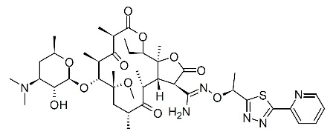
2 | Drug category | Antibiotic (Ketolide – Macrolide derivative)
3 | Chemical formula | C₄₀H₅₁N₃O₁₄ (approx.)
4 | Molecular weight | ~734.84 g/mol
5 | pKa value | ~8.5 (basic nature)
6 | State | White to off-white crystalline powder
7 | Solubility in solvent | Soluble in methanol, ethanol, acetonitrile; slightly soluble in water
8 | Route | Oral
9 | BCS Classification | Class II (low solubility, high permeability)
10 | Bioavailability | Moderate (~50–60%)

Mechanism of Action:
Nafithromycin is a ketolide antibiotic that inhibits bacterial protein synthesis by binding to the 50S ribosomal subunit.
• Binds strongly to bacterial ribosome
• Blocks peptide chain elongation
• Inhibits protein synthesis
• Prevents bacterial growth (bacteriostatic action)
• Shows enhanced activity against macrolide-resistant strains
This dual binding mechanism makes Nafithromycin more effective than traditional macrolides in resistant infections.
Adverse Reactions:
Nausea
Diarrhea
Headache
Abdominal discomfort
Dizziness
Elevated liver enzymes
Pharmacokinetics
Absorption: Good oral absorption
Distribution: High tissue penetration (especially lungs)
Metabolism: Hepatic metabolism
Excretion: Mainly via bile

MATERIALS & EQUIPMENTS
Table No.2: INSTRUMENTS / EQUIPMENTS USED
Sr. No. | Instrument / Equipment | Specification / Details
 | UV–Visible Spectrophotometer | Systronics 119 (ID: AL - 19)
 | Analytical Weighing Balance | Mettler Toledo B204S
 | Membrane Filter | Millipore 0.2 µm
 | Laboratory Accessories | Volumetric flasks, pipettes, beakers, etc.

Table No.3: REAGENTS, STANDARDS & SAMPLES USED
Sr. No. | Material | Description
 | Nafithromycin Working Standard | Pure drug sample
 | Marketed Formulation | MIQNAF (Nafithromycin Tablets 400 mg)
 | Methanol | AR Grade
 | Water | AR Grade

EXPERIMENTAL WORK

EXPERIMENTAL PLAN AND DATA EVALUATION:
The analytical method Verification will be executed as per the following plan:
The experiments may be done as sequential or simultaneous operations.
Sample sequence of each experiment may be run together or independently with necessary alteration of sample sequence.
The system suitability parameters should be monitored throughout the Verification study.
Any deviation from the plan shall be evaluated and approved by protocol approving authority.
1.0 Specificity / Selectivity
1.1 Preparation of analytical solutions
Blank solution: Use Diluent as blank solution.
Preparation of Placebo solution: Weigh accurately about 10mg of Nafithromycin placebo and transfer to a 100ml volumetric flask. Add 70 ml of diluent and sonicate to dissolve. Dilute to volume with diluent and mix. Transfer 1.0 ml of solution into a 10 ml of volumetric flask and dilute to volume with the diluent and mix. Filter the solution through 0.2µm nylon membrane filter.
(Dilution scheme: 10mg → 100.0 ml→ 1.0 ml /10.0 ml)
Preparation of Nafithromycin standard Solution: Weigh accurately about 20 mg of Nafithromycin working standard and transfer to a 100 ml volumetric flask. Add 70 ml of diluent and sonicate to dissolve. Dilute to volume with diluent and mix. Transfer 1.0 ml of solution into a 10 ml of volumetric flask and dilute to volume with the diluent and mix.
(Dilution scheme: 20mg → 100.0 ml → 1.0 ml /10.0 ml)
Preparation of Test Solution:
Weigh and transfer 30mg of sample powder into a 100 ml volumetric flask. Add about 70 ml of diluent and shake for 20 minutes by mechanical means or manually and further sonicate for 30 minutes. Dilute up to mark with 0 diluent. Transfer 1.0ml of solution into another 10 ml volumetric flask and make up the volume with diluent. Filter the solution through 0.45 µm nylon membrane filter.
(Dilution scheme: 30mg →100.0 ml → 1.0 ml /10.0 ml)
Avg Wt of Tablet 600mg
Table - 2: Sequence for selectivity study
Sr. No. | Sample Name | No. of Readings
1 | Diluent blank solution | 1
2 | Placebo solution | 1
3 | System suitability solution | 5
4 | Test solution | 2
Data evaluation:
Record the UV spectrum processed at the wavelength provided in the method and selectivity will be demonstrated with regards to non-interference from diluent blank with Nafithromycin absorbance.
2.0 LINEARITY & RANGE
2.0.1 Objective: To establish the linearity of the analytical method for assay using the following three methods.
Linearity & Range for Nafithromycin in Standard Preparations: Demonstrate the linearity of the analytical method for assay by taking absorbance readings of the various concentrations of Standard preparation prepared in the range of 50% - 150% of test concentration. Draw a plot between the concentrations in ppm Vs. Absorbance of Nafithromycin WS. Report the slope, intercept and regression coefficient from the plot obtained for Concentration Vs. Absorbance of Nafithromycin WS in standard preparation.
Linearity & Range for Nafithromycin WS in presence of Placebo: Demonstrate the linearity of the analytical method for assay by taking absorbance readings of the various concentrations of Standard preparation in presence of Placebo prepared in the range of 50% - 150% of test concentration, Draw a plot between the concentrations in ppm Vs. Absorbance of Nafithromycin WS. Report the slope, intercept and regression coefficient from the plot obtained for Concentration Vs. Absorbance of Nafithromycin WS in recovery solutions.
For Linearity & Range for Nafithromycin in Standard Preparations:
2.1.2 Experiment:
Prepare a series of standard preparations (five preparations) of Nafithromycin over a range starting from 50% to at least 150% of the specified limits of assay.

2.1.3 Preparation of linearity stock solutions:
Stock solution preparation of Nafithromycin :
Weigh accurately about 20mg of Nafithromycin working standard to a 100 ml volumetric flask. Add 10 ml of diluent & sonicate for 15 minutes to dissolve. Dilute to volume with diluent and mix.
The preparation of linearity solutions is given in Table 3.
Inject each of the linearity preparation in duplicate and then take average absorbance count for calculations
Table - 3: Dilutions for linearity of standard
Linearity level | Sample  concentration | Amount of stock solution preparation of Nafithromycin to be transferred (ml) | Volume made up to (ml) with Diluent | Concentration of  Nafithromycin (ppm)
Level – 1 | 50% | 1.0 ml | 20 | 10.0
Level – 2 | 75% | 1.5 ml | 20 | 15.0
Level – 3 | 100% | 2.0 ml | 20 | 20.0
Level – 4 | 125% | 2.5 ml | 20 | 25.0
Level – 5 | 150% | 3.0 ml | 20 | 30.0

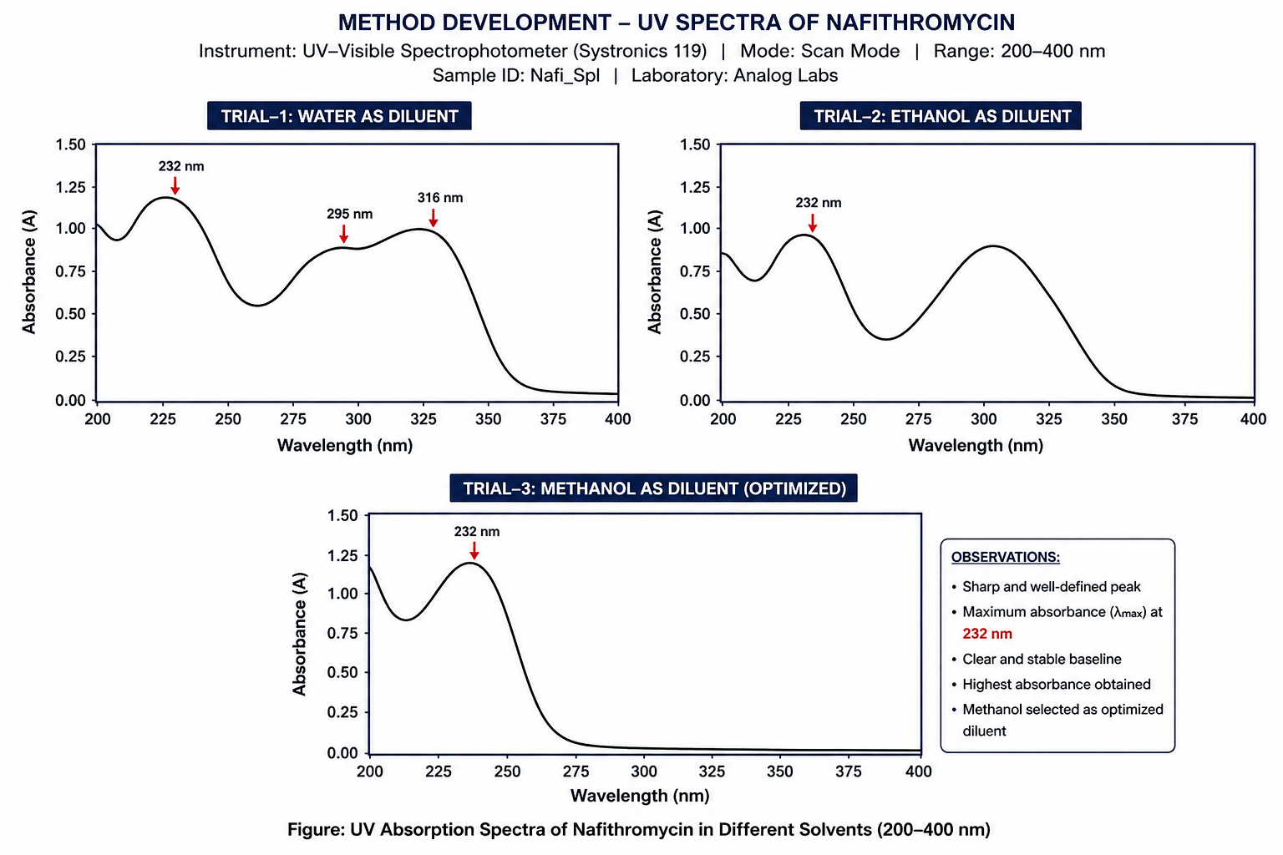
RESULT AND DISCUSSION
No absorption peak obtained for placebo preparations at 232nm in the UV spectrum
One Absorption peak observed at 232nm for Nafithromycin WS preparations
Table - 2: System suitability - Selectivity
Sr. No. | Absorbance of Nafithromycin at 232nm
1 | 0.252
2 | 0.251
3 | 0.254
4 | 0.253
5 | 0.250
Mean | 0.252
Standard Deviation (±) | 0.002
(%) Relative Standard Deviation | 0.627
All the absorbance readings were processed at the wavelength provided in the method. There was no interference observed from diluent blank solution, excipient blend solution with Nafithromycin peak.
1.3 Remarks:
The method is selective.
2.0 Linearity
Linearity and Range for standard:
For the linearity study five standard solutions of Nafithromycin were prepared from the range starting from 50% to 150% of the theoretical concentration of assay preparation.
The Absorbance of the system suitability solution and the linearity solutions were measured as per the protocol. The linearity graph of concentration against Absorbance was plotted and the correlation coefficient was determined.
Acceptance criteria:
Correlation coefficient should be greater than or equal to 0.999.
Results:
The system suitability criteria were found to meet the pre-established acceptance criteria as per the analytical method. (Refer to Table-3 for system suitability results).
Table 3: System suitability - Linearity of standard
Sr. No. | Absorbance of Nafithromycin at 232nm
1 | 0.259
2 | 0.257
3 | 0.256
4 | 0.258
5 | 0.258
Mean | 0.258
Standard Deviation (±) | 0.001
(%) Relative Standard Deviation | 0.443

The average Absorbance of Nafithromycin at 232nm at each concentration level was determined and the linearity graph was plotted against the sample concentration in percentage. The results of linearity study are as given in Table 4.

SUMMARY
The result and acceptance criteria of development and validation of analytical method were summarized in following table.

Table : Summary
Sr.No | Parameter | Result | Acceptance Criteria
1 | Specificity:  Selectivity | There is no interference between the absorption peaks obtained for the spectrum of the solutions of blank, Nafithromycin Standard & Sample preparation preparations | There should not be any interference between the absorption peaks obtained for the spectrum of the solutions of blank, Nafithromycin Standard& Sample.
2 | Linearity and Range of Standard | Correlation coefficient = 0.9995  Range = 10 ppm to 30 ppm | Correlation coefficient should be greater than or equal to 0.999.
3 | Linearity and Range of standard in presence of placebo | Correlation coefficient = 0.9996  Range = 10 ppm to 30 ppm | Correlation coefficient should be greater than or equal to 0.999.
4 | Method precision | % RSD = 1.01 | % RSD of the results of six test solutions should not be more than 2.0%.
5 | Intermediate  precision | % RSD = 1.29 | % RSD of the results of twelve test solutions (six of Method Precision and six of Intermediate Precision) should not be more than 2.0%.
6 | Accuracy  (%Recovery) | Level 1 at 50% Recovery = 99.03%  Level 2 at 75% Recovery = 99.80%  Level 3 at 100% Recovery = 99.56%  Level 4 at 125% Recovery = 99.88%  Level 5 at 150% Recovery = 99.57% | Mean recovery at each concentration level should be between 98.0% and 102.0%.
7 | Robustness | 1] System suitability criteria are found to meet the pre-established acceptance criteria.  2] % RSD between results obtained with changed condition and average result of method precision, are found less than 2.0%. | System suitability criteria should pass as per analytical method and the % RSD between results obtained with changed condition and average result of method precision, should not be more than 2.0%.
8 | Stability of analytical solution | No significant change is observed in the % assay upto 48 Hrs. Hence the solution is found to be stable up to 48 Hours at room temperature. | The analyte is considered stable if there is no significant change in % assay.
CONCLUSION
The present study was successfully carried out with the objective of developing and validating a simple, rapid, and cost-effective UV spectrophotometric method for the quantitative estimation of Nafithromycin in bulk drug and pharmaceutical dosage form (MIQNAF tablets 400 mg).
During the method development phase, various solvent systems such as water, ethanol, and methanol were evaluated to obtain an optimal analytical condition. Among these, methanol was selected as the most suitable diluent due to its superior solubilizing ability and its capability to produce a sharp, well-defined absorption spectrum. The drug exhibited maximum absorbance (λmax) at approximately 232 nm, which was selected as the analytical wavelength for further quantitative analysis.
The developed analytical method was validated in accordance with the guidelines of the ICH Q2 (R1), ensuring its suitability for its intended purpose. The validation parameters demonstrated excellent performance of the method. The method showed good linearity over the selected concentration range with a correlation coefficient (r²) close to unity, confirming adherence to Beer–Lambert law.
Accuracy studies, performed through recovery experiments, yielded results within the acceptable limits of 98–102%, indicating the reliability and correctness of the method. Precision studies, including repeatability and intermediate precision, showed %RSD values less than 2%, confirming that the method is highly reproducible. The specificity of the method was established by the absence of interference from excipients present in the tablet formulation, demonstrating that the method is selective for Nafithromycin.
The robustness of the method was evaluated by introducing small deliberate variations in analytical parameters such as wavelength and solvent composition. The results indicated that these minor changes did not significantly affect the absorbance, confirming that the method is robust and reliable under normal working conditions. Additionally, sensitivity parameters such as limit of detection (LOD) and limit of quantification (LOQ) confirmed that the method is capable of detecting and quantifying low concentrations of the drug effectively.
Furthermore, stability studies revealed that the prepared analytical solution of Nafithromycin remained stable for up to 48 hours at room temperature, indicating that the method allows flexibility in sample handling and analysis without significant degradation.
Based on the overall results of method development and validation, it can be conclusively stated that the developed UV spectrophotometric method is simple, accurate, precise, specific, linear, robust, and economical. Therefore, the method is highly suitable for routine quantitative analysis of Nafithromycin in pharmaceutical dosage forms and can also be effectively applied for stability studies.

REFERENCES :
World Health Organization. (2023). Antimicrobial resistance. https://www.who.int
Rang, H. P., Dale, M. M., Ritter, J. M., Flower, R. J., & Henderson, G. (2020). Rang & Dale’s pharmacology (9th ed.). Elsevier.
Tripathi, K. D. (2019). Essentials of medical pharmacology (8th ed.). Jaypee Brothers Medical Publishers.
Skoog, D. A., Holler, F. J., & Crouch, S. R. (2007). Principles of instrumental analysis (6th ed.). Cengage Learning.
Chatwal, G. R., & Anand, S. K. (2007). Instrumental methods of chemical analysis (5th ed.). Himalaya Publishing House.
Willard, H. H., Merritt, L. L., Dean, J. A., & Settle, F. A. (1988). Instrumental methods of analysis (7th ed.). CBS Publishers.
International Council for Harmonisation. (2005). ICH Q2(R1): Validation of analytical procedures: Text and methodology. https://www.ich.org
International Council for Harmonisation. (2003). ICH Q1A(R2): Stability testing of new drug substances and products. https://www.ich.org
Zhanel, G. G., et al. (2019). Ketolides and macrolides: A review. Drugs, 79(2), 1–25.
Fernandes, P. (2015). Macrolide and ketolide antibiotics. Clinical Microbiology Reviews, 28(2), 1–25.
Bryskier, A. (2000). Ketolides—New generation antibiotics. Journal of Antimicrobial Chemotherapy, 45(Suppl A), 1–7.
Retsema, J., & Fu, W. (2001). Macrolides: Structures and mechanisms. Antimicrobial Agents and Chemotherapy, 45(3), 1–12.
Blessy, M., Patel, R. D., Prajapati, P. N., & Agrawal, Y. K. (2014). Stability indicating studies. Journal of Pharmaceutical Analysis, 4(3), 159–165.
Ahuja, S., & Dong, M. W. (2005). Handbook of pharmaceutical analysis. Elsevier.
Christian, G. D. (2004). Analytical chemistry (6th ed.). Wiley.
Snyder, L. R., Kirkland, J. J., & Dolan, J. W. (2010). Introduction to modern liquid chromatography (3rd ed.). Wiley.
Harris, D. C. (2010). Quantitative chemical analysis (8th ed.). W.H. Freeman.
Swartz, M. E., & Krull, I. S. (2012). Analytical method development and validation. CRC Press.
Silverstein, R. M., Webster, F. X., & Kiemle, D. J. (2005). Spectrometric identification of organic compounds (7th ed.). Wiley.
Pavia, D. L., Lampman, G. M., & Kriz, G. S. (2008). Introduction to spectroscopy (4th ed.). Cengage Learning.
Connors, K. A. (1997). Chemical kinetics: The study of reaction rates in solution. Wiley.
Sharma, B. K. (2014). Instrumental methods of chemical analysis. Goel Publishing House.
Miller, J. N., & Miller, J. C. (2010). Statistics and chemometrics for analytical chemistry (6th ed.). Pearson.

